

Saint John’s Lutheran Church
810 Broad Street
Clifton, New Jersey
Office: 973-778-141
www.StJohnsClifton.org

The Third Sunday of Easter
Sunday, April 19, 2026
9:00 AM

The church of the praying hands

Hymn of Invocation

490 Jesus Lives! The Victory’s Won sts. 1–4

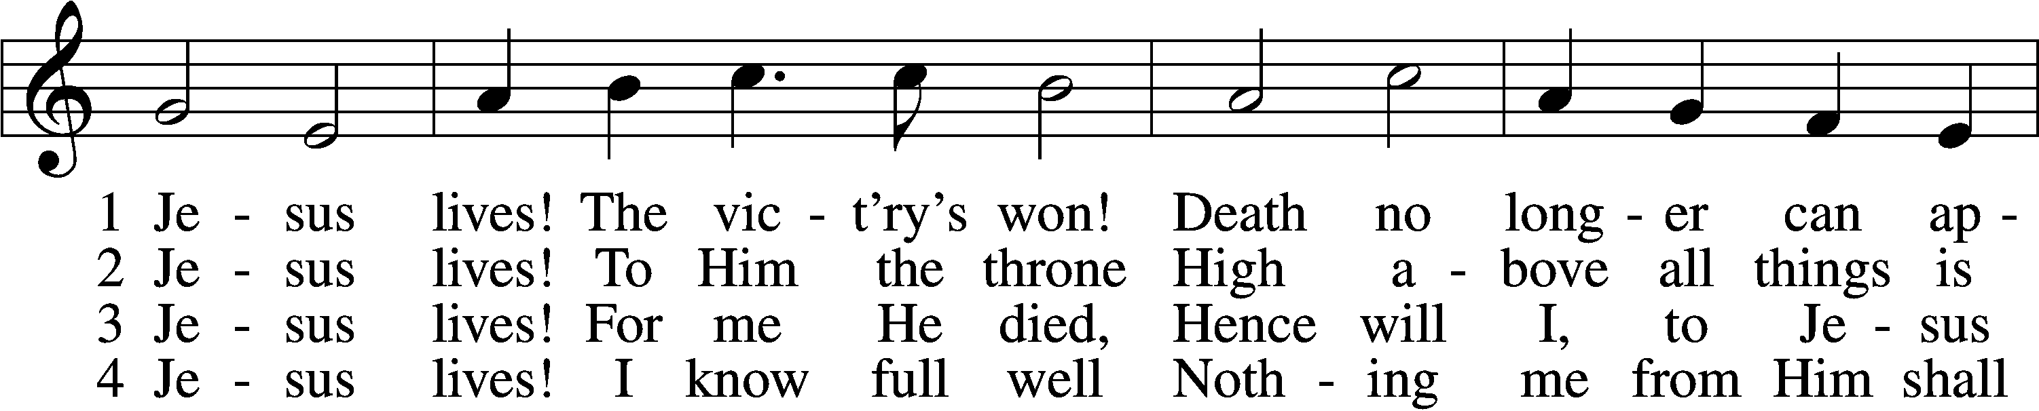
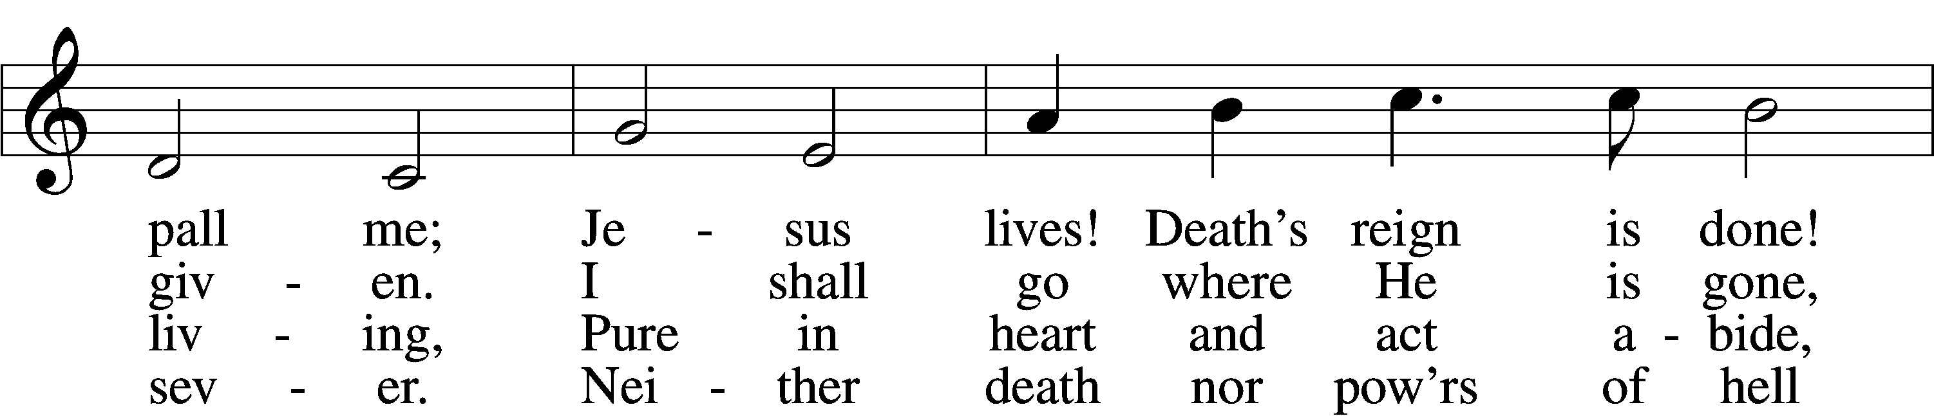
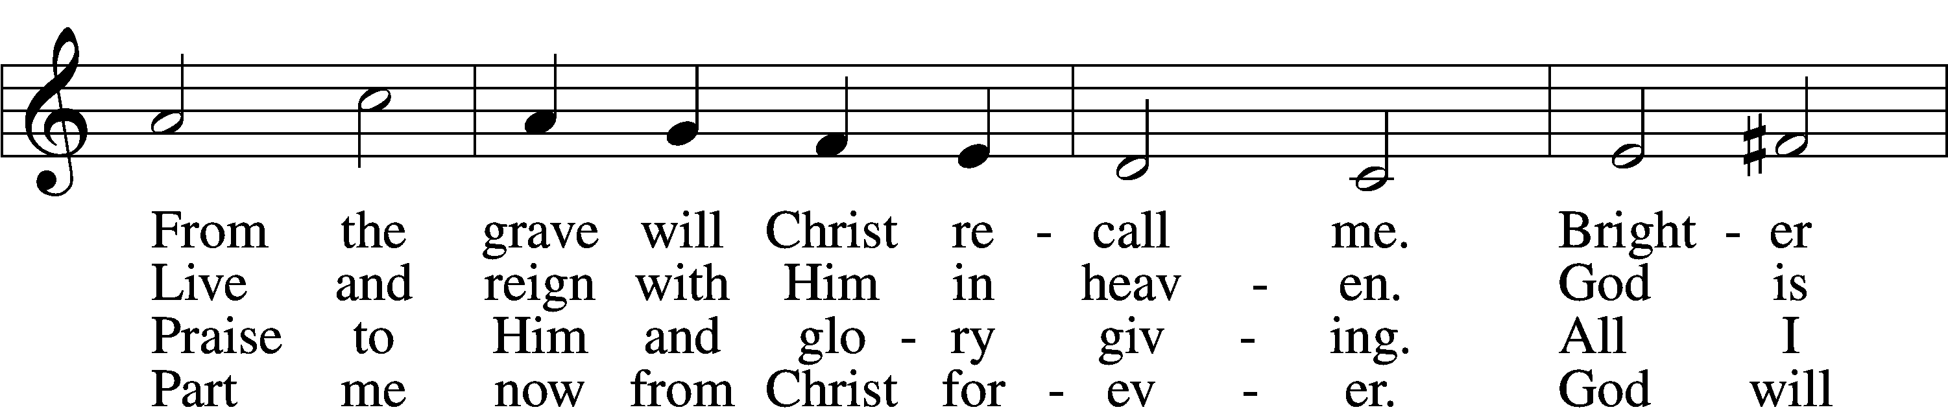
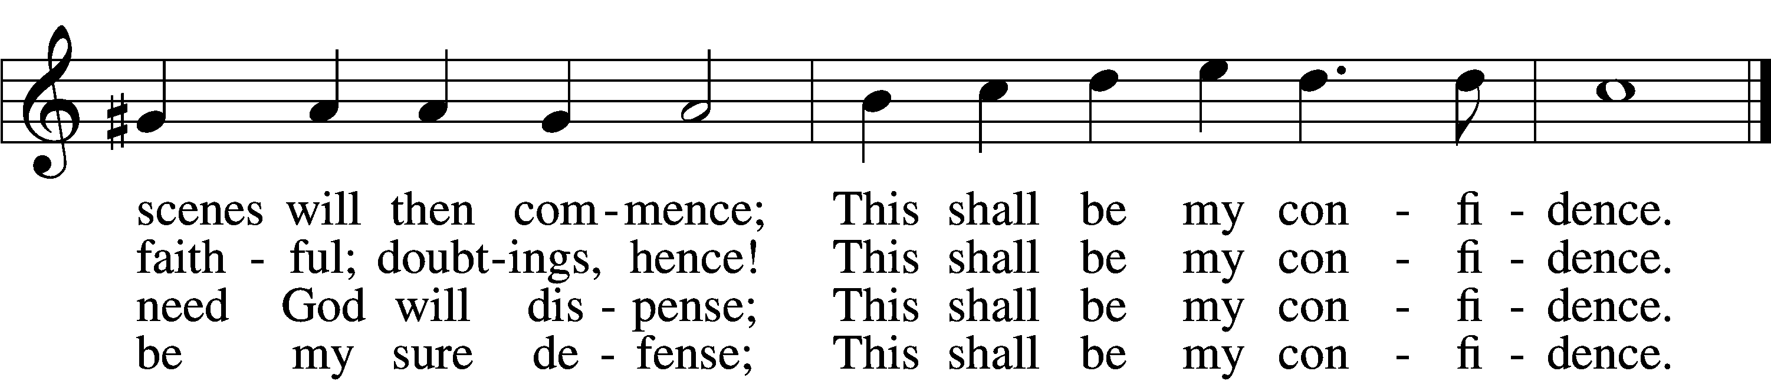
Text: Christian Fürchtegott Gellert, 1715–69; tr. Frances E. Cox, 1812–97, alt.
Tune: Johann Crüger, 1598–1662
Text and tune: Public domain

Stand

Confession and Absolution

The sign of the cross may be made by all in remembrance of their Baptism.

Invocation

P In the name of the Father and of the T Son and of the Holy Spirit.
C Amen.

Exhortation LSB 151

P If we say we have no sin, we deceive ourselves, and the truth is not in us.
C But if we confess our sins, God, who is faithful and just, will forgive our sins and cleanse us from all unrighteousness.

Silence for reflection on God’s Word and for self-examination.

Confession of Sins LSB 151

P Let us then confess our sins to God our Father.
C Most merciful God, we confess that we are by nature sinful and unclean. We have sinned against You in thought, word, and deed, by what we have done and by what we have left undone. We have not loved You with our whole heart; we have not loved our neighbors as ourselves. We justly deserve Your present and eternal punishment. For the sake of Your Son, Jesus Christ, have mercy on us. Forgive us, renew us, and lead us, so that we may delight in Your will and walk in Your ways to the glory of Your holy name. Amen.

Declaration of Grace LSB 185

P Almighty God, our heavenly Father, has had mercy upon us and has given His only Son to die for us and for His sake forgives us all our sins. To those who believe on His name He gives power to become the children of God and has promised them His Holy Spirit. He that believes and is baptized shall be saved.
Grant this, Lord, unto us all.
C Amen.

Service of the Word

Introit Psalm 133; antiphon: v. 1

Behold, how good and pleasant it is
when brothers dwell in unity!
It is like the precious oil on the head, running down on the beard, on the beard of Aaron,
running down on the collar of his robes!
It is like the dew of Hermon,
which falls on the mountains of Zion!
For there the Lord has commanded the
blessing, life forevermore.
Glory be to the Father and to the Son and to the Holy Spirit; as it was in the beginning, is now, and will be forever. Amen.
Behold, how good and pleasant it is
when brothers dwell in unity!

Kyrie LSB 186

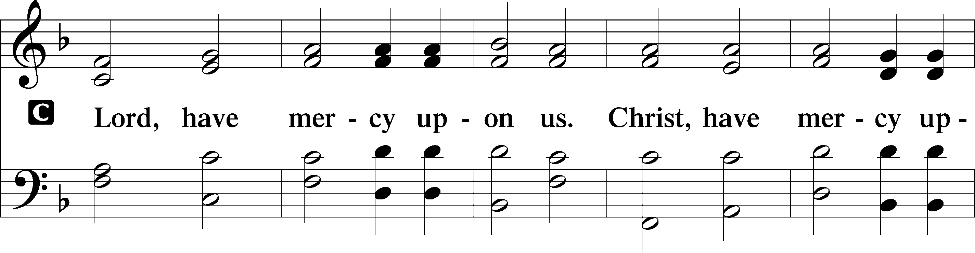
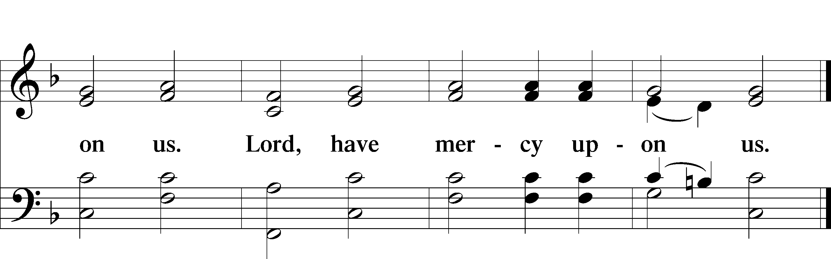

Gloria in Excelsis LSB 187

P Glory be to God on high:
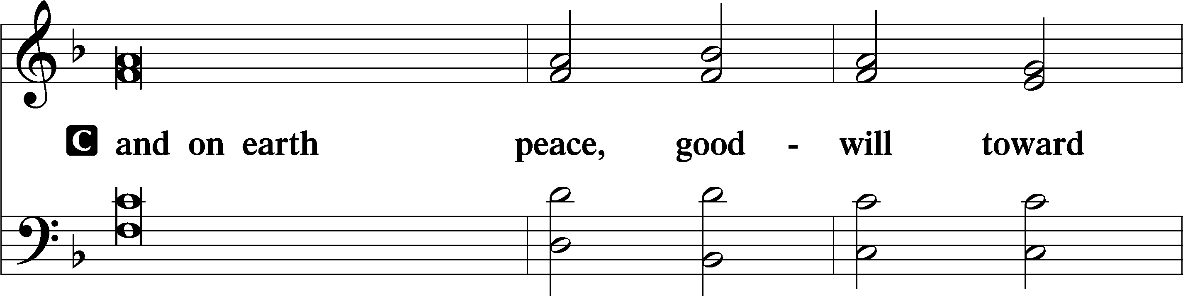
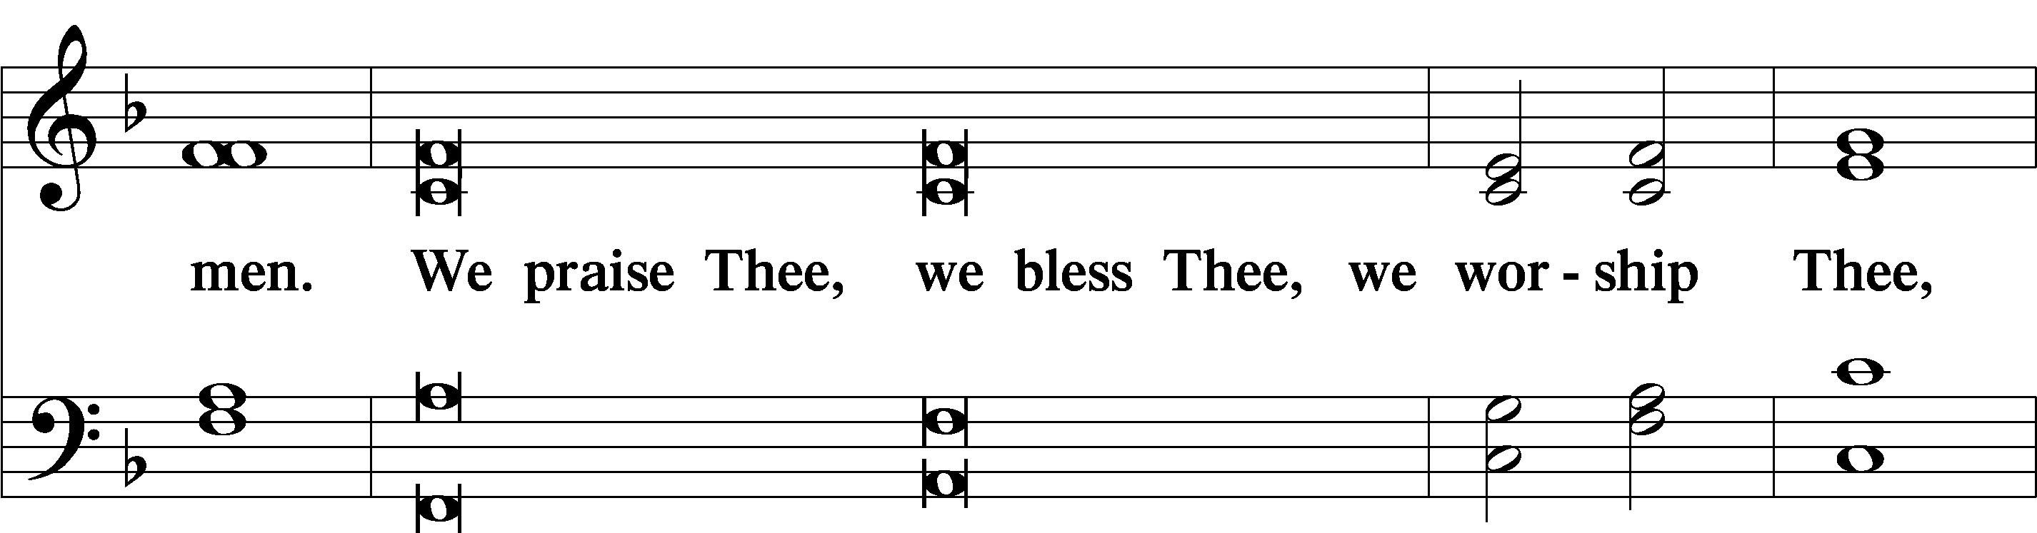
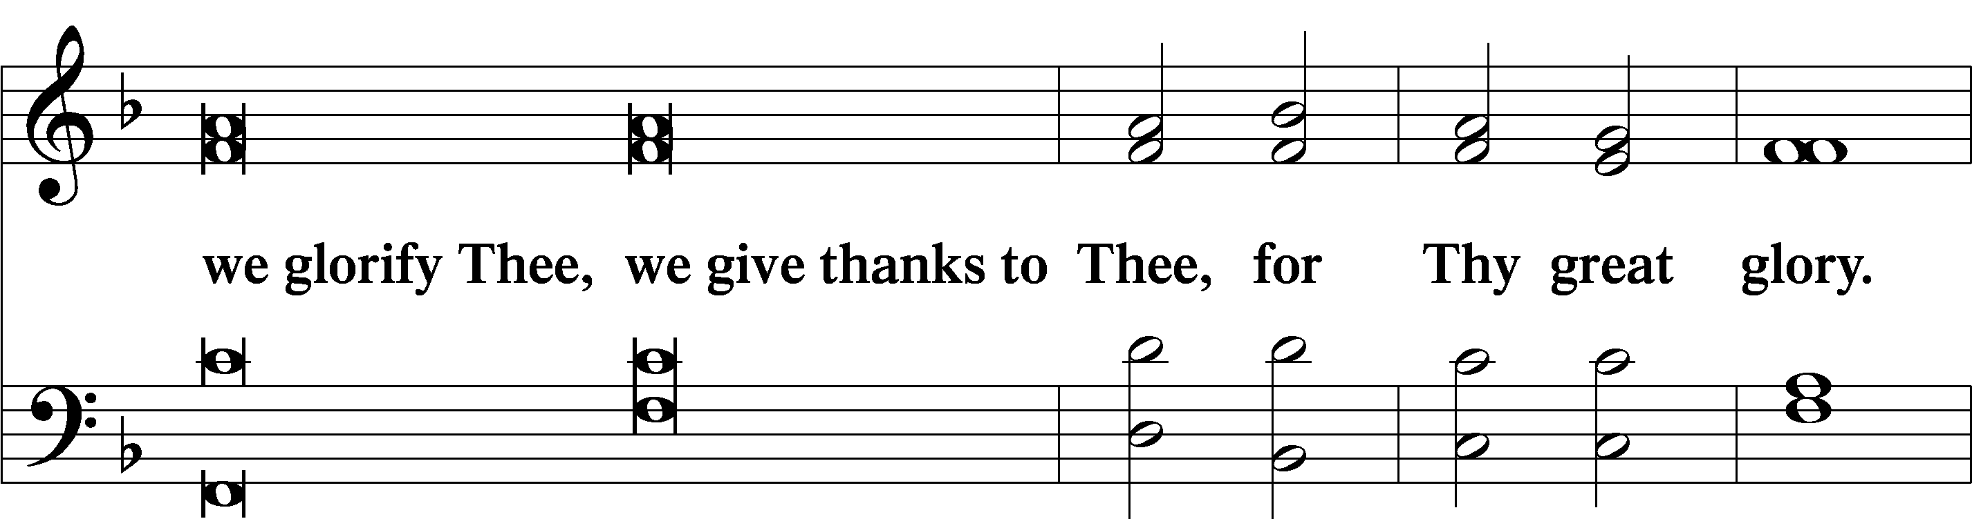
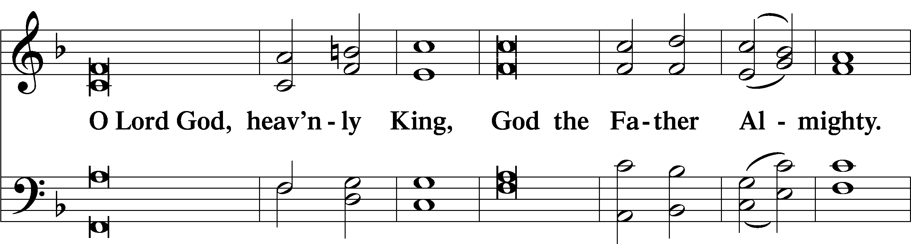
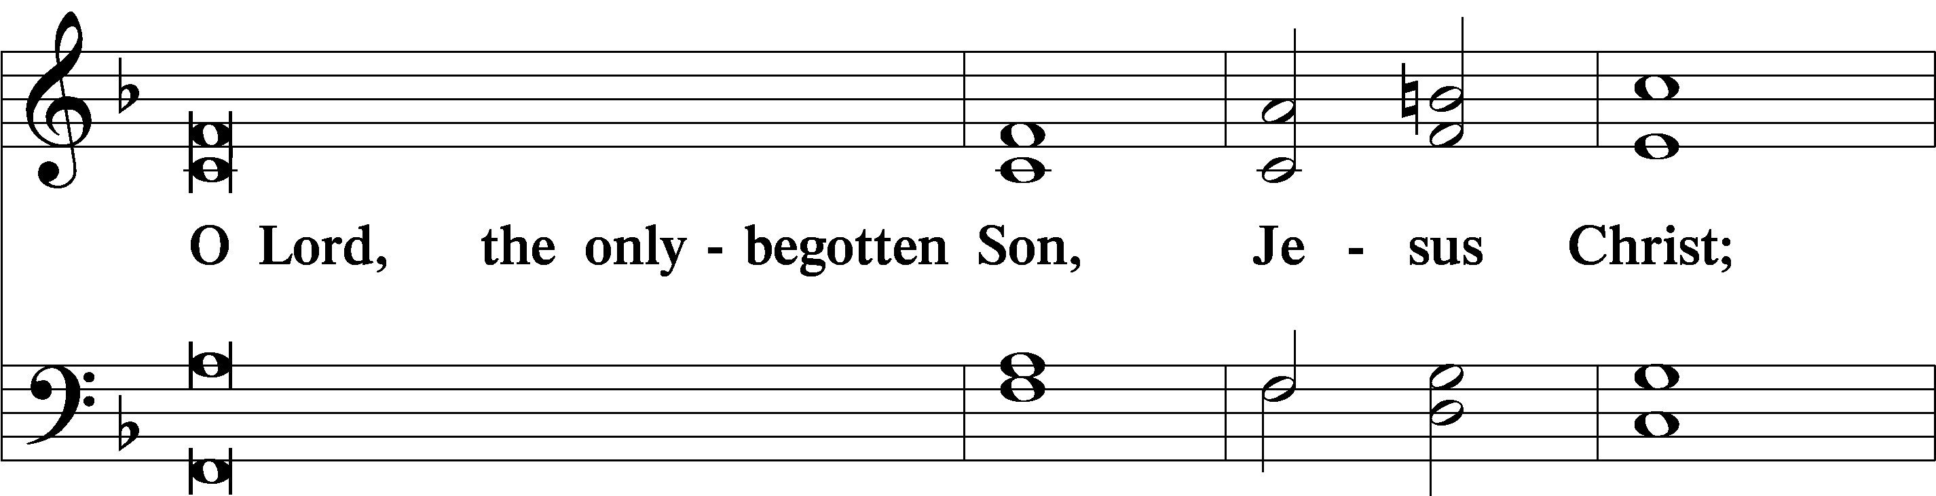
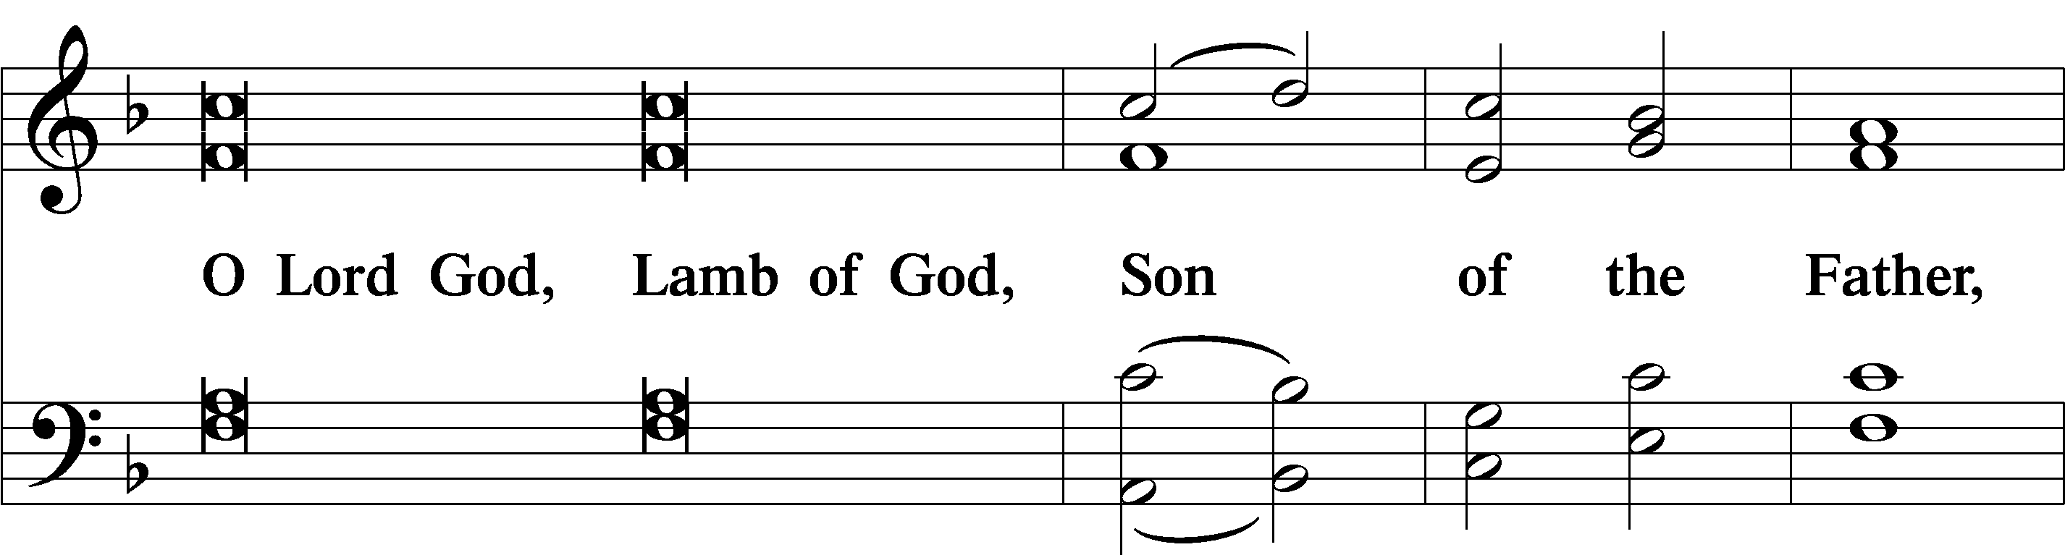
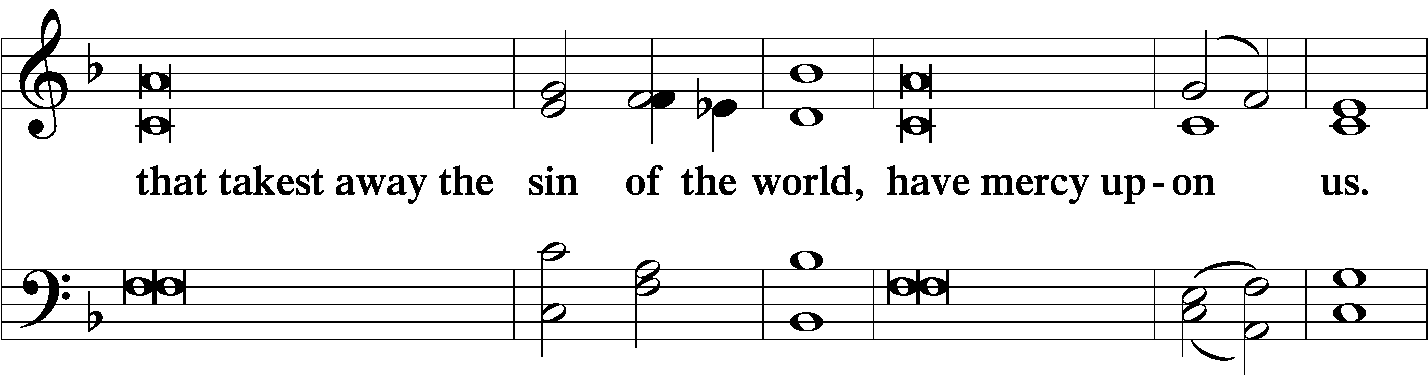
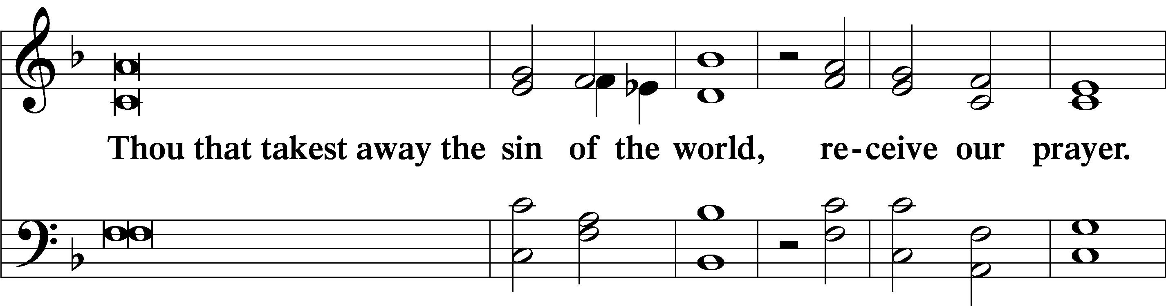
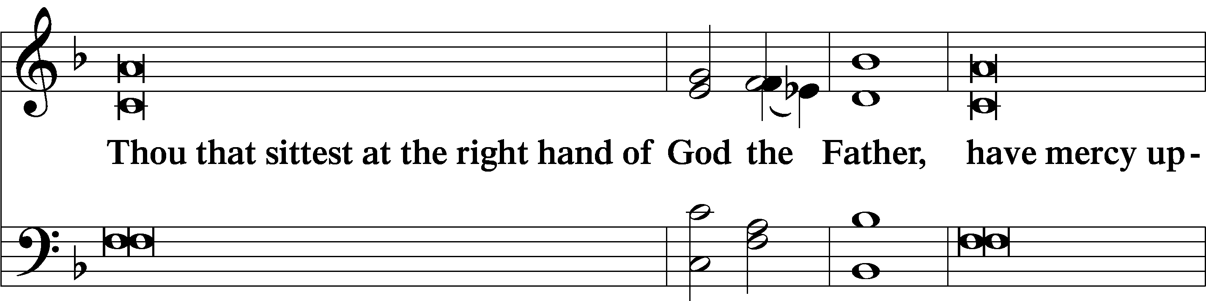
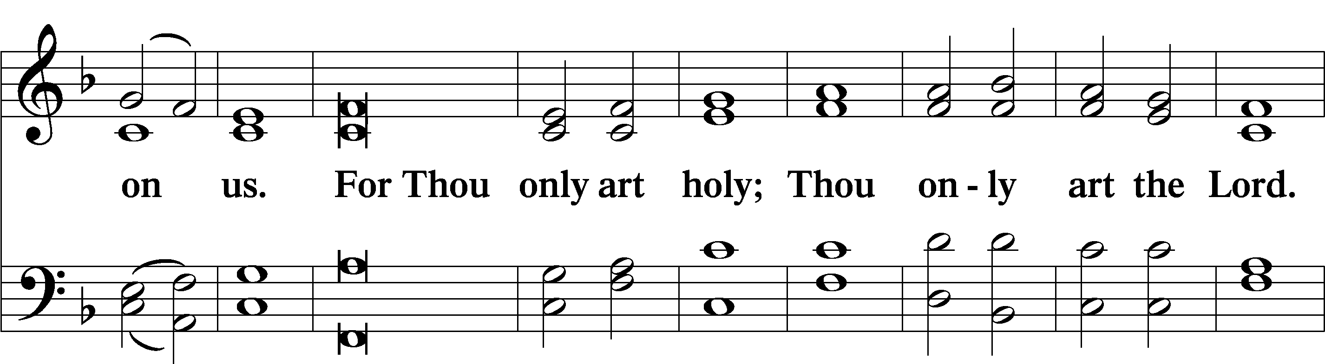
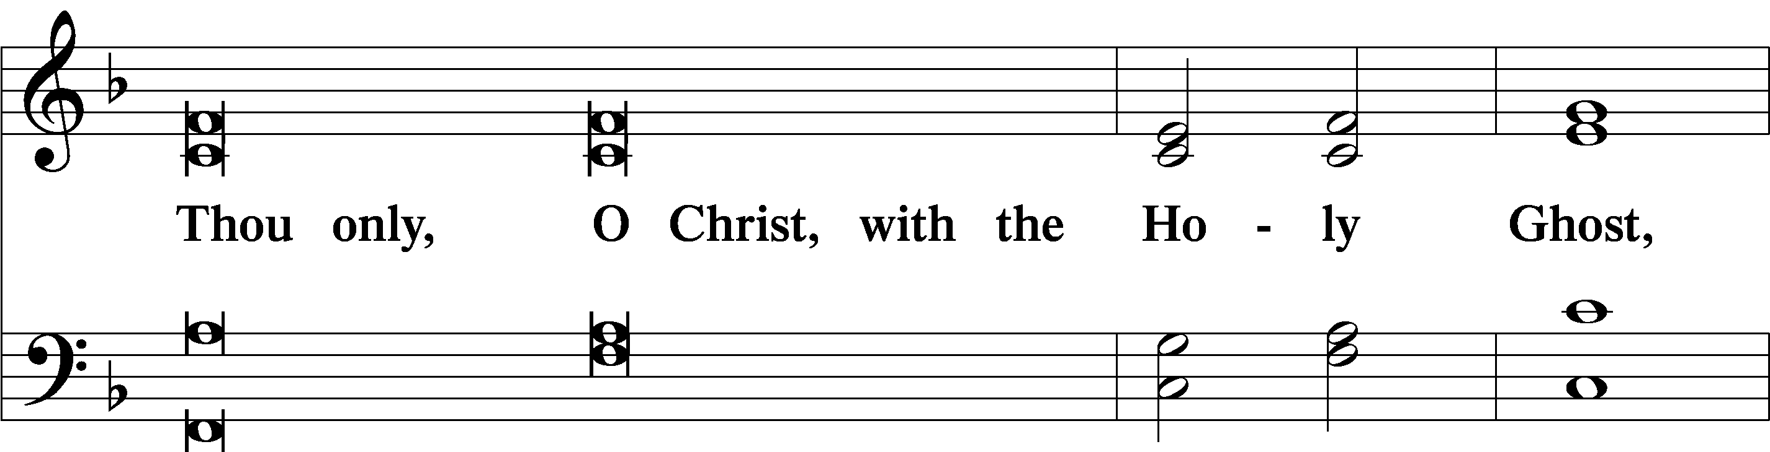
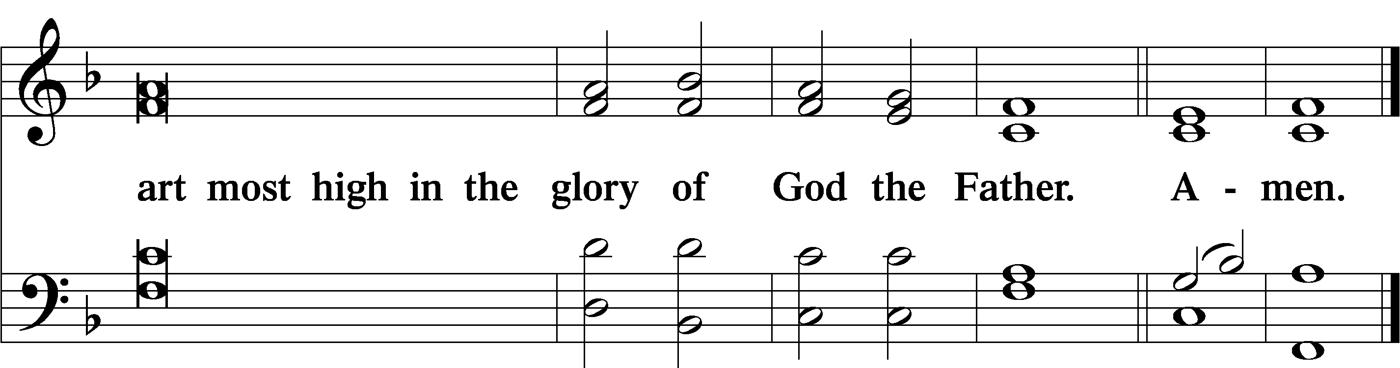

Salutation and Collect of the Day

P The Lord be with you.
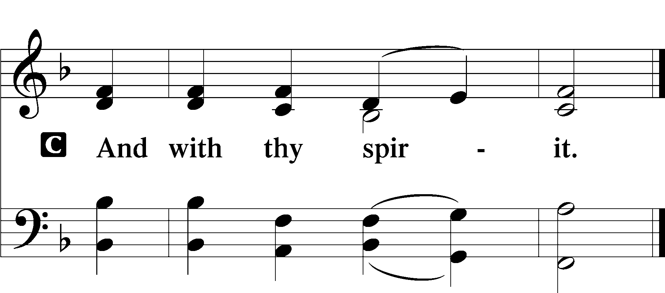
P Let us pray.
O God, through the humiliation of Your Son You raised up the fallen world. Grant to Your faithful people, rescued from the peril of everlasting death, perpetual gladness and eternal joys; through Jesus Christ, our Lord, who lives and reigns with You and the Holy Spirit, one God, now and forever.

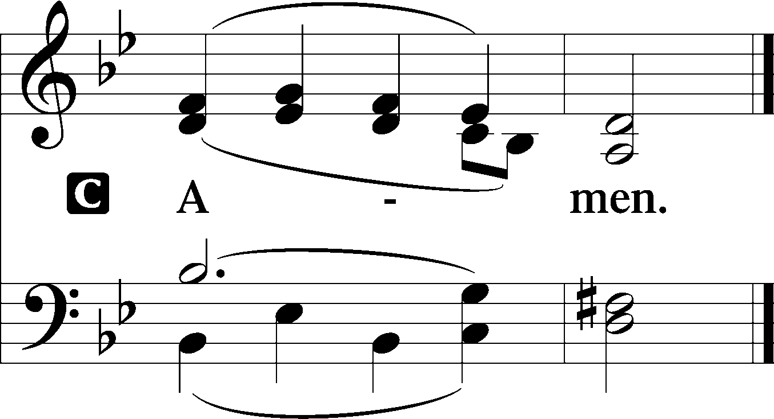

Sit

First Reading Acts 2:14a, 36–41

Peter, standing with the eleven, lifted up his voice and addressed them, . . .
Let all the house of Israel therefore know for certain that God has made him both Lord and Christ, this Jesus whom you crucified.”
Now when they heard this they were cut to the heart, and said to Peter and the rest of the apostles, “Brothers, what shall we do?” And Peter said to them, “Repent and be baptized every one of you in the name of Jesus Christ for the forgiveness of your sins, and you will receive the gift of the Holy Spirit. For the promise is for you and for your children and for all who are far off, everyone whom the Lord our God calls to himself.” And with many other words he bore witness and continued to exhort them, saying, “Save yourselves from this crooked generation.” So those who received his word were baptized, and there were added that day about three thousand souls.

A This is the Word of the Lord.
C Thanks be to God.

Epistle 1 Peter 1:17–25

If you call on him as Father who judges impartially according to each one’s deeds, conduct yourselves with fear throughout the time of your exile, knowing that you were ransomed from the futile ways inherited from your forefathers, not with perishable things such as silver or gold, but with the precious blood of Christ, like that of a lamb without blemish or spot. He was foreknown before the foundation of the world but was made manifest in the last times for your sake, who through him are believers in God, who raised him from the dead and gave him glory, so that your faith and hope are in God.
Having purified your souls by your obedience to the truth for a sincere brotherly love, love one another earnestly from a pure heart, since you have been born again, not of perishable seed but of imperishable, through the living and abiding word of God; for
“All flesh is like grass and all its glory like the flower of grass. The grass withers, and the flower falls, but the word of the Lord remains forever.”
And this word is the good news that was preached to you.

A This is the Word of the Lord.
C Thanks be to God.

Stand

Alleluia LSB 190

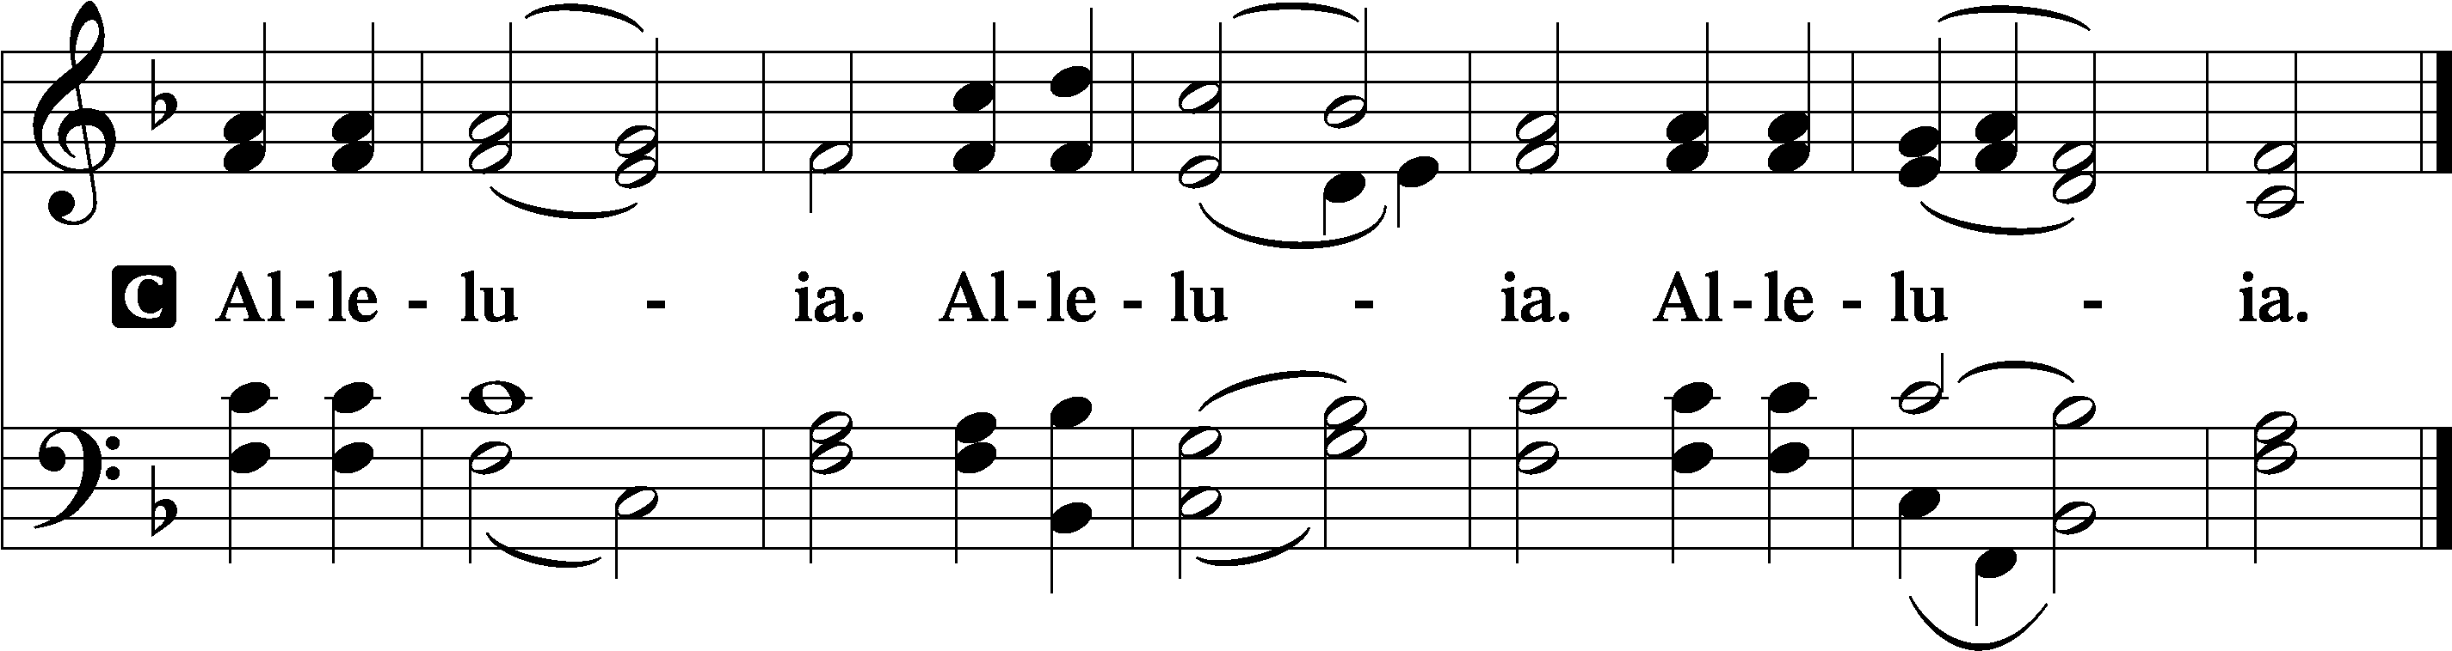

Holy Gospel Luke 24:13–35

P The Holy Gospel according to St. Luke, the twenty-fourth chapter.

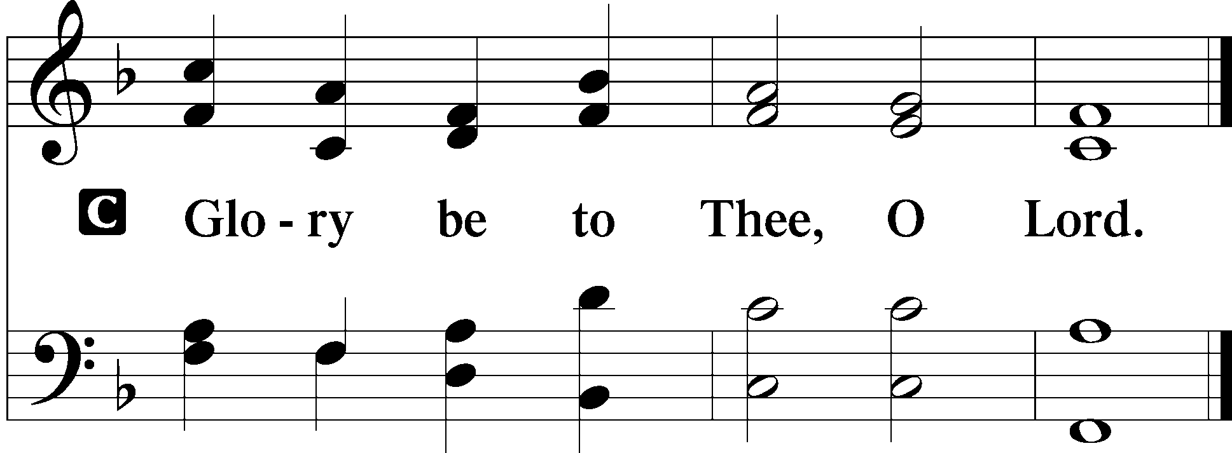

That very day two of them were going to a village named Emmaus, about seven miles from Jerusalem, and they were talking with each other about all these things that had happened. While they were talking and discussing together, Jesus himself drew near and went with them. But their eyes were kept from recognizing him. And he said to them, “What is this conversation that you are holding with each other as you walk?” And they stood still, looking sad. Then one of them, named Cleopas, answered him, “Are you the only visitor to Jerusalem who does not know the things that have happened there in these days?” And he said to them, “What things?” And they said to him, “Concerning Jesus of Nazareth, a man who was a prophet mighty in deed and word before God and all the people, and how our chief priests and rulers delivered him up to be condemned to death, and crucified him. But we had hoped that he was the one to redeem Israel. Yes, and besides all this, it is now the third day since these things happened. Moreover, some women of our company amazed us. They were at the tomb early in the morning, and when they did not find his body, they came back saying that they had even seen a vision of angels, who said that he was alive. Some of those who were with us went to the tomb and found it just as the women had said, but him they did not see.” And he said to them, “O foolish ones, and slow of heart to believe all that the prophets have spoken! Was it not necessary that the Christ should suffer these things and enter into his glory?” And beginning with Moses and all the Prophets, he interpreted to them in all the Scriptures the things concerning himself.
So they drew near to the village to which they were going. He acted as if he were going farther, but they urged him strongly, saying, “Stay with us, for it is toward evening and the day is now far spent.” So he went in to stay with them. When he was at table with them, he took the bread and blessed and broke it and gave it to them. And their eyes were opened, and they recognized him. And he vanished from their sight. They said to each other, “Did not our hearts burn within us while he talked to us on the road, while he opened to us the Scriptures?” And they rose that same hour and returned to Jerusalem. And they found the eleven and those who were with them gathered together, saying, “The Lord has risen indeed, and has appeared to Simon!” Then they told what had happened on the road, and how he was known to them in the breaking of the bread.

P This is the Gospel of the Lord.
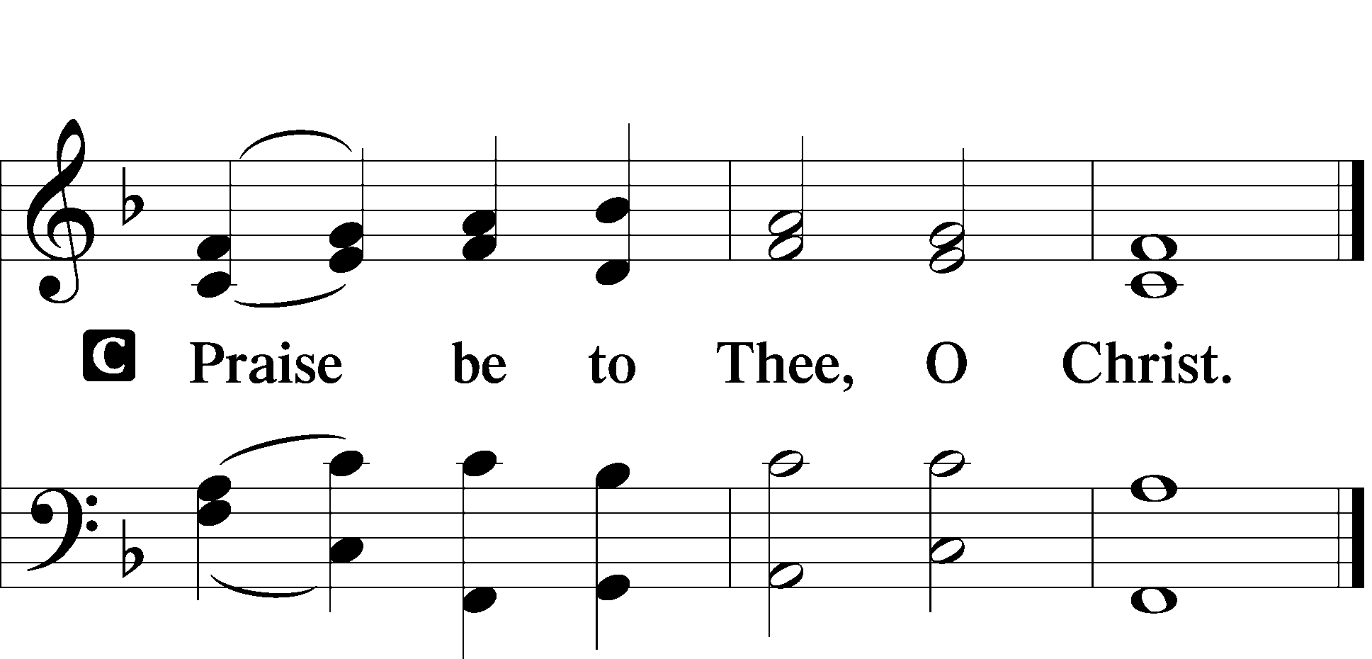

Apostles’ Creed

I believe in God, the Father Almighty, maker of
heaven and earth.
And in Jesus Christ, His only Son, our Lord, who was conceived by the Holy Spirit, born of the virgin Mary, suffered under Pontius Pilate, was crucified, died and was buried.

He descended into hell. The third day He rose again from the dead. He ascended into heaven and sits at the right hand of God the Father Almighty. From thence He will come to judge the living and the dead.

I believe in the Holy Spirit, the holy Christian Church, the communion of saints, the forgiveness of sins, the resurrection of the body, and the life T everlasting. Amen.
Sit

Hymn of the Day

483 With High Delight Let Us Unite

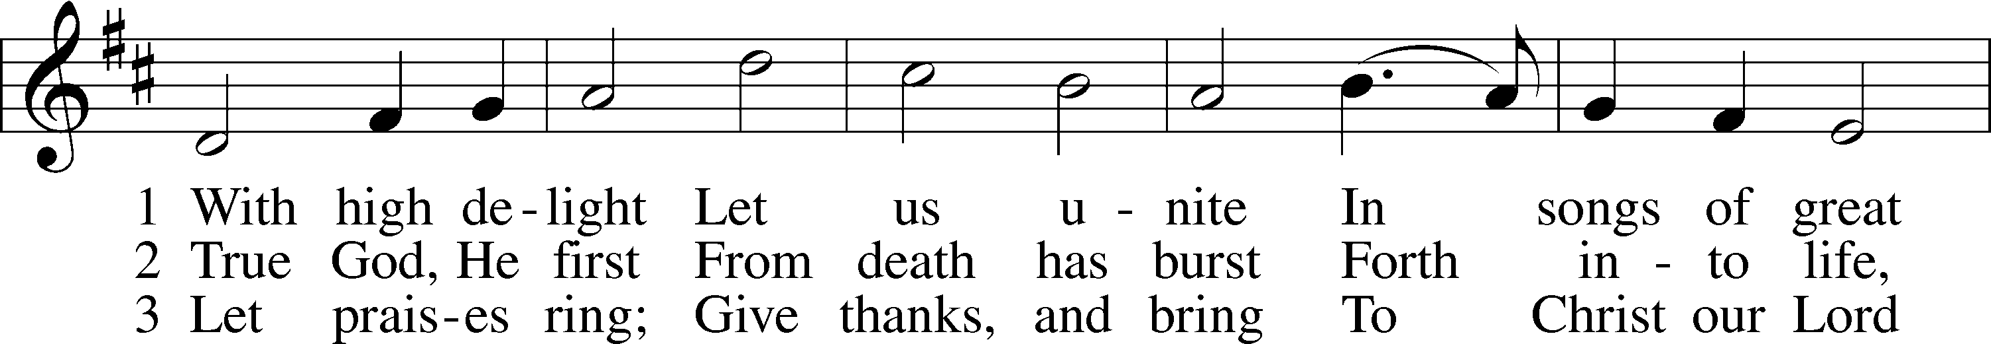
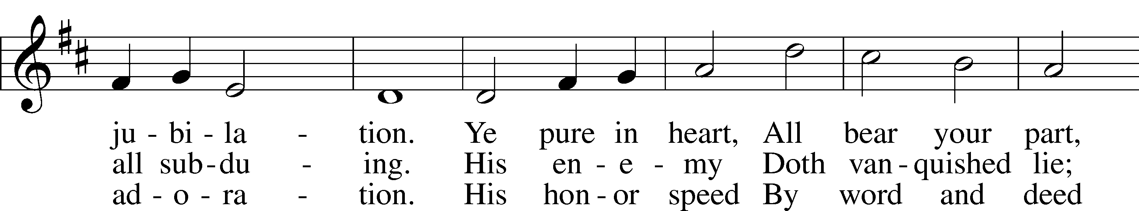
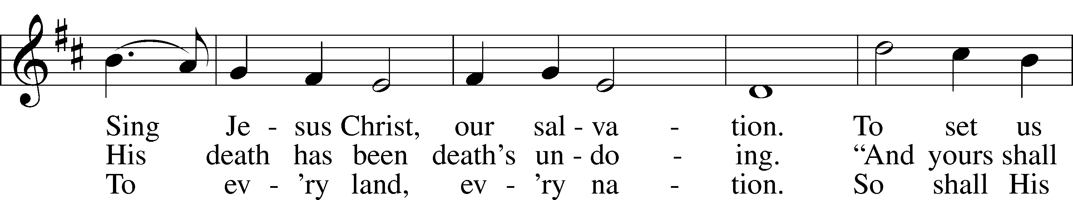
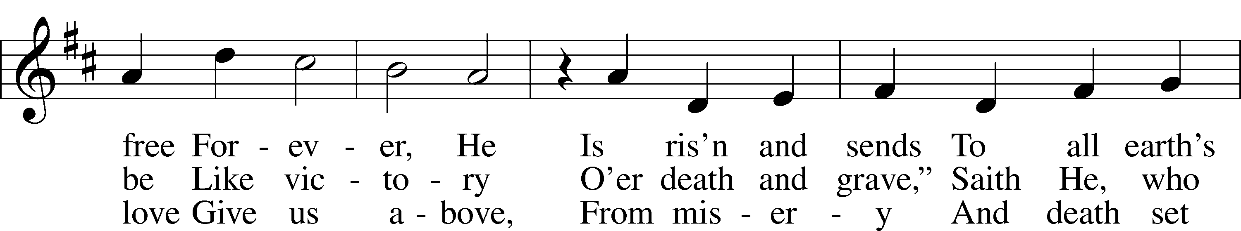
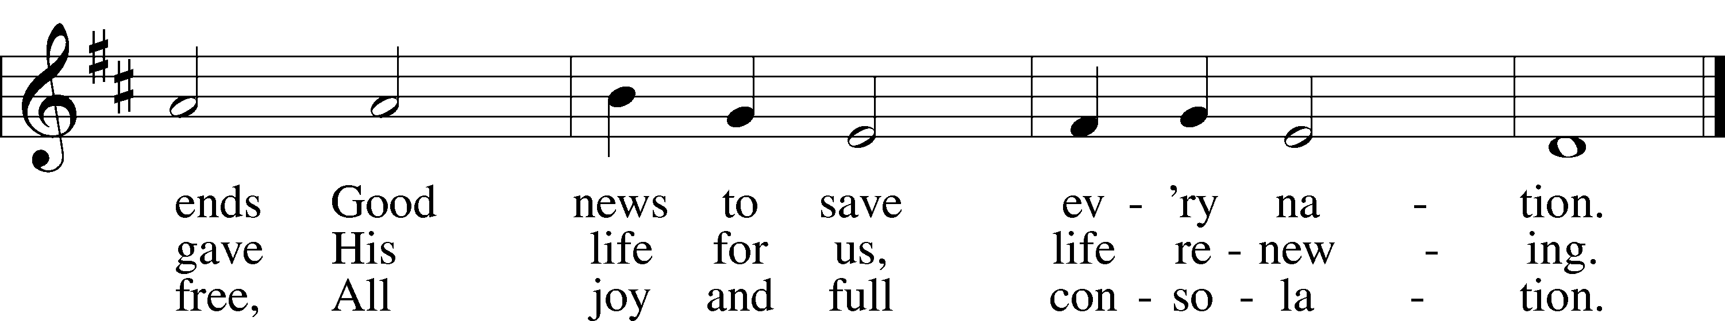
Text: Georg Vetter, 1536–99; tr. Martin H. Franzmann, 1907–76
Tune: Cinquante Pseaumes, 1543, Geneva
Text: © 1969 Concordia Publishing House. Used by permission: LSB Hymn License no. 110003925
Tune: Public domain

Sermon

Offering

Psalm for Mediation Psalm 116:1–14; antiphon: v. 5
I love the Lord, because he has heard my voice and my pleas for mercy. Because he inclined his ear to me, therefore I will call on him as long as I live.
The snares of death encompassed me; the pangs of Sheol laid hold on me; I suffered distress and anguish.
Then I called on the name of the Lord: “O Lord, I pray, deliver my soul!”
Gracious is the Lord, and righteous; our God is merciful.
The Lord preserves the simple; when I was brought low, he saved me. Return, O my soul, to your rest; for the Lord has dealt bountifully with you.
For you have delivered my soul from death, my eyes from tears, my feet from stumbling; I will walk before the Lord in the land of the living.
I believed, even when I spoke, “I am greatly afflicted”;
I said in my alarm, “All mankind are liars.”
What shall I render to the Lord for all his benefits to me?
I will lift up the cup of salvation and call on the name of the Lord, I will pay my vows to the Lord in the presence of all his people.
Stand

781 We Give Thee But Thine Own sts. 1–2

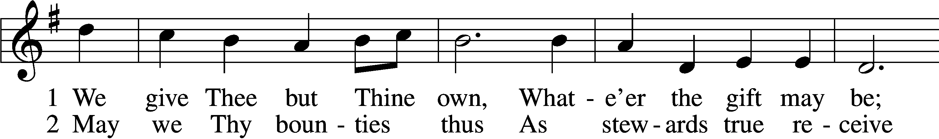
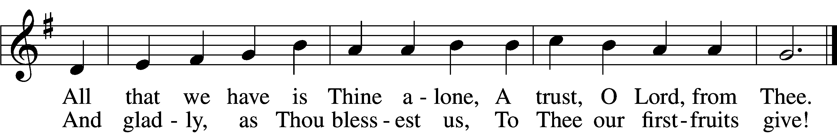
Text: William W. How, 1823–97
Tune: William H. Monk, 1823–89
Text and tune: Public domain

Prayer of the Church

P Let us pray for the whole people of God in Christ Jesus and for all people according to their needs.
P For the faithful proclamation of Christ’s saving name, that God’s people may be strengthened in the true faith and His kingdom extended, let us pray to the Lord:
C Lord, have mercy.
P For the holy Christian Church throughout the world and for all who confess the name of Christ, that God would guard and defend us from the temptations of the devil, the world, and our sinful nature, let us pray to the Lord:
C Lord, have mercy.
P For those who have wandered from the faith, that the Holy Spirit would use us to call them home to the Father, let us pray to the Lord:
C Lord, have mercy.
P For the government and all who have been set into positions of leadership, that they may use the authority entrusted to them honorably and for the good of the people, let us pray to the Lord:
C Lord, have mercy.
P For those who suffer from hunger, homelessness, poverty, or unemployment, that God’s great mercy and love would preserve and relieve them, let us pray to the Lord:
C Lord, have mercy.
P For those who are sick especially Kristine, Joshua, Hunter, Dorothy, Marge, Tony, Bill M., Patricia, Phil, Lidia, Michele, Giuseppe, Alfred, and Nancy that God would grant healing to their bodies and strength to bear their infirmities with patience and grace, let us pray to the Lord:
C Lord, have mercy.
P For those who rejoice in the rich blessings of God, that they may always remember the Giver of every gift and give Him heartfelt thanks, let us pray to the Lord:
C Lord, have mercy.
P O Lord, heavenly Father, we gratefully remember the sufferings and death of Your dear Son, Jesus Christ, for our salvation. Rejoicing in His victorious resurrection from the dead, we draw strength from His ascension before You, where He ever stands for us as our own High Priest. Gather us together from the ends of the earth to celebrate with all the faithful the marriage feast of the Lamb in His kingdom, which has no end. Graciously receive our prayers, deliver and preserve us, for to You alone we give all glory, honor, and worship, Father, Son, and Holy Spirit, one God, now and forever.
C Amen.

Lord’s Prayer

Our Father who art in heaven, hallowed be Thy name, Thy kingdom come, Thy will be done on earth as it is in heaven.

Give us this day our daily bread; and forgive us our trespasses as we forgive those who trespass against us; and lead us not into temptation but deliver us from evil.
For Thine is the kingdom and the power and the glory forever and ever. Amen.

Benediction LSB 202

P The Lord bless you and keep you.
The Lord make His face shine upon you and be gracious unto you.
The Lord lift up His countenance upon you and T give you peace.

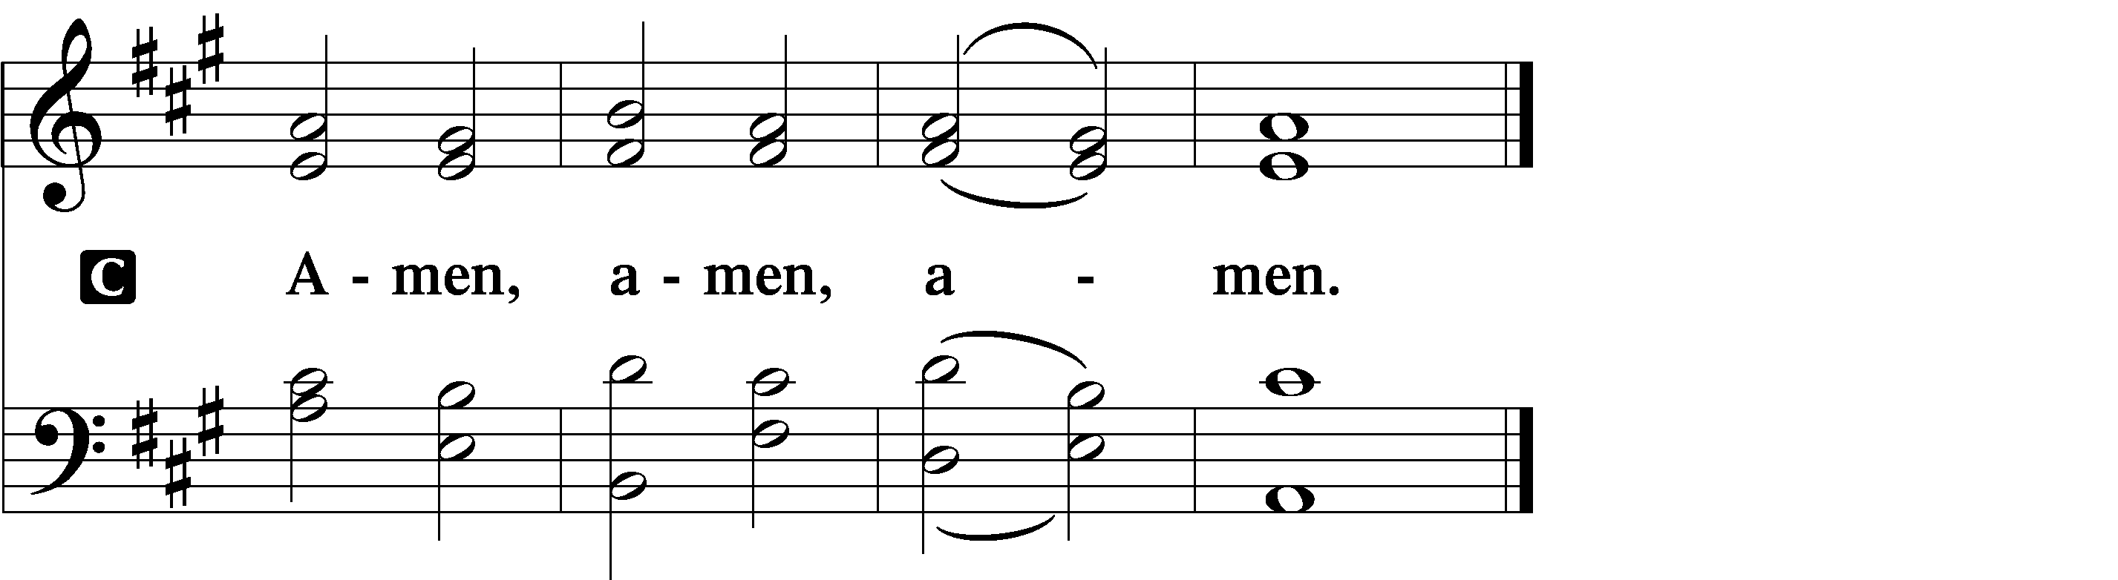

Hymn to Depart

525 Crown Him with Many Crowns

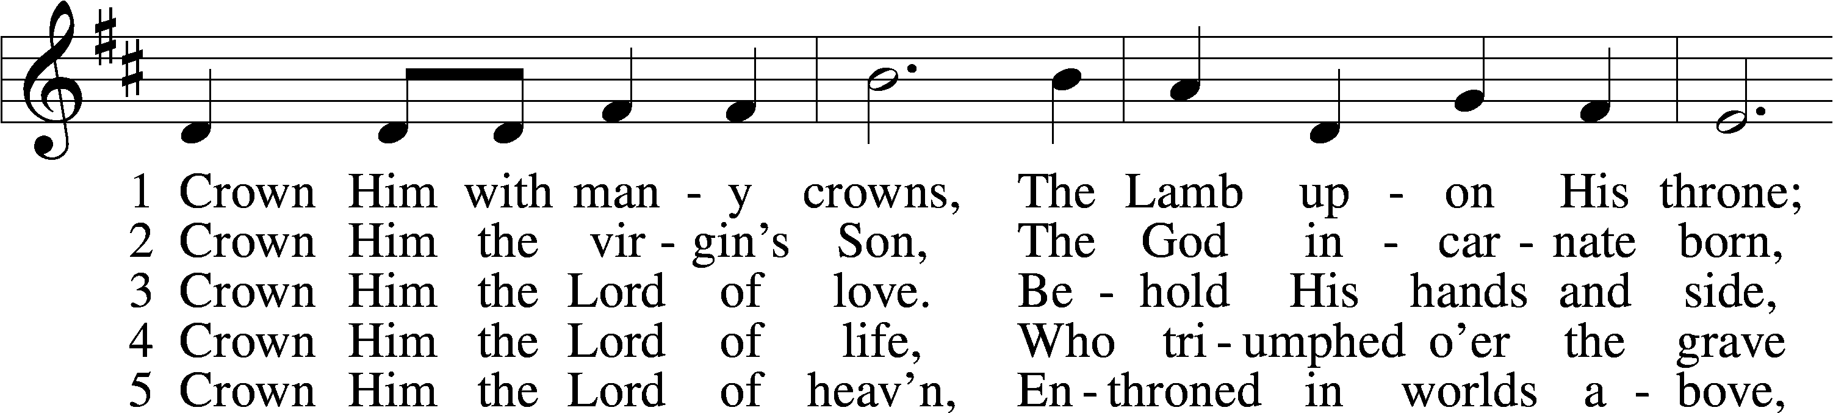
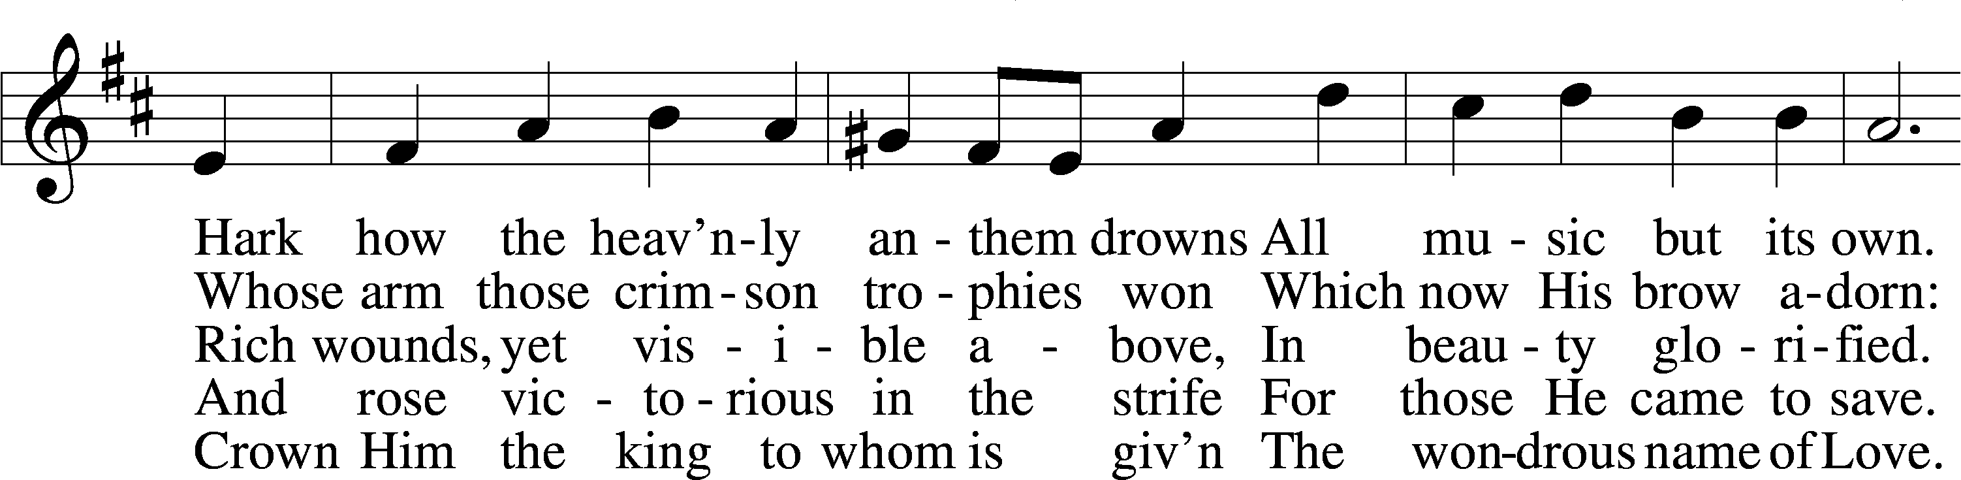
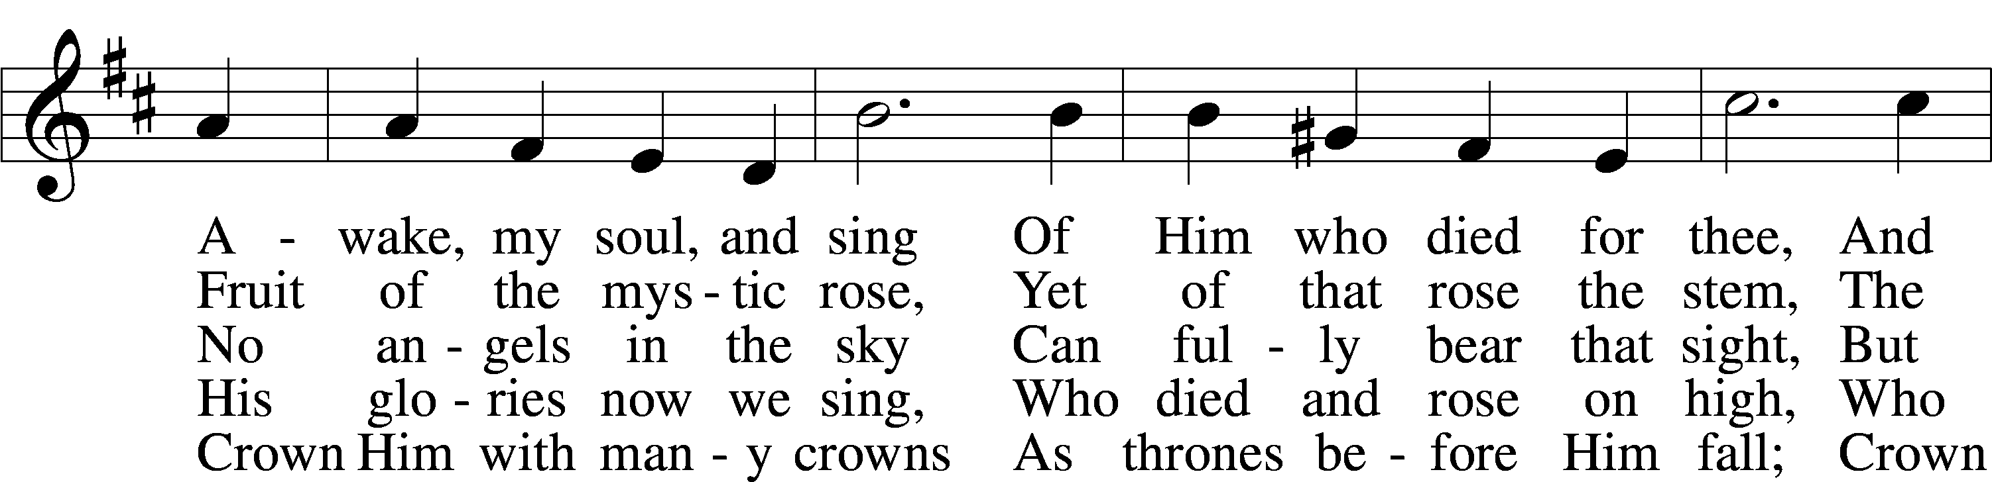
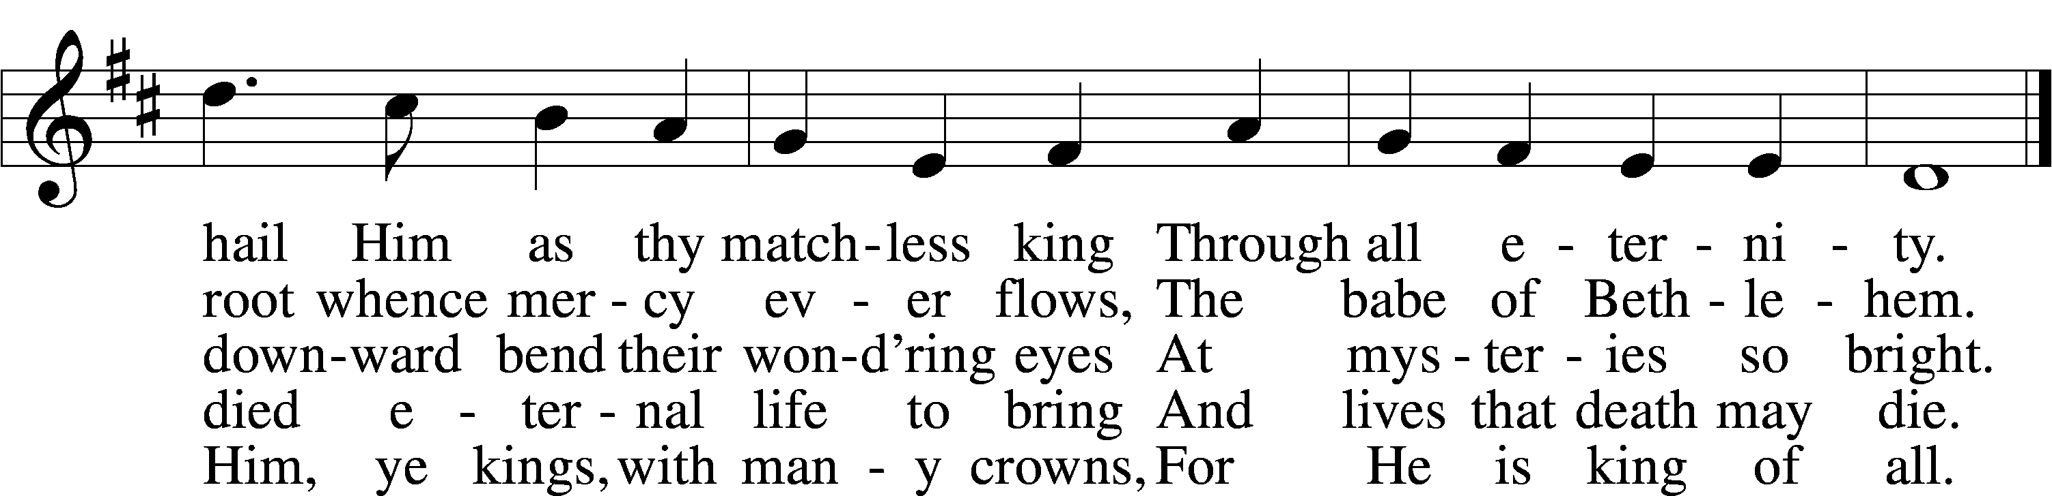
Text (sts. 1–3, 5): Matthew Bridges, 1800–94, alt.; (st. 4): Godfrey Thring, 1823–1903
Tune: George J. Elvey, 1816–93
Text and tune: Public domain

Announcements

Acknowledgments
Divine Service, Setting One from Lutheran Service Book
Unless otherwise indicated, Scripture quotations are from the ESV® Bible (The Holy Bible, English Standard Version®), copyright © 2001 by Crossway, a publishing ministry of Good News Publishers. Used by permission. All rights reserved.
Created by Lutheran Service Builder © 2026 Concordia Publishing House

