Eighth Sunday after Pentecost August 3, 2025 – Lectionary Series

St. John’s Lutheran Church



Order of Worship

by

Lutheran Service Builder

902 Lord Jesus Christ, Be Present Now

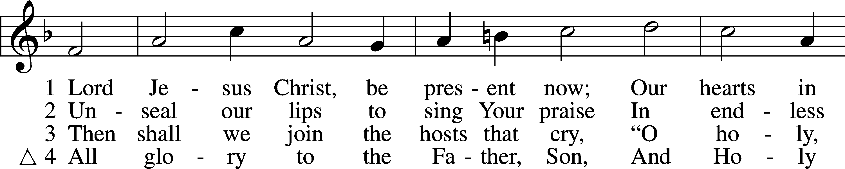

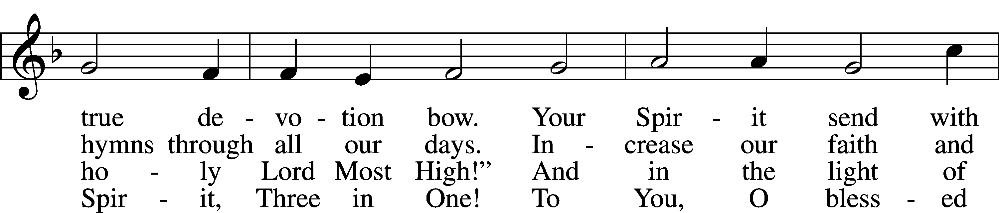

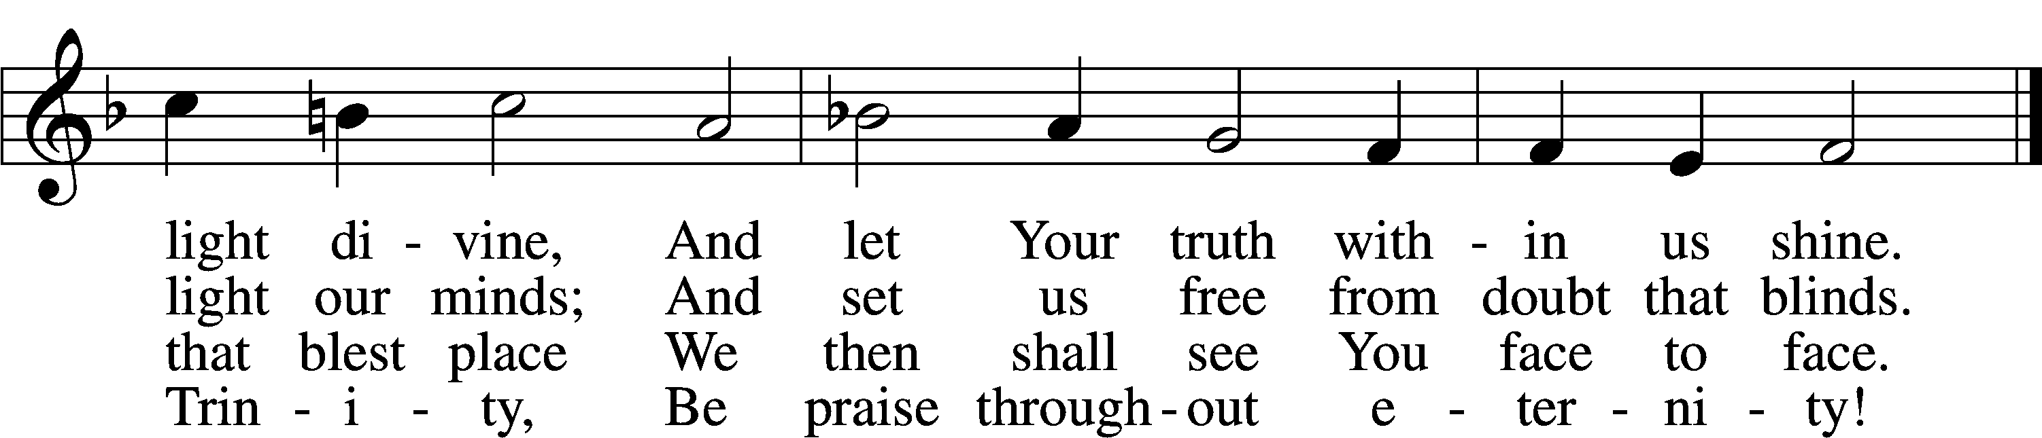

Δ – *Stand for last verse*

# Confession and Absolution

The sign of the cross may be made by all in remembrance of their Baptism.

Invocation

P In the name of the Father and of the T Son and of the Holy Spirit.

C **Amen.**

Exhortation LSB 184

P Beloved in the Lord! Let us draw near with a true heart and confess our sins unto God our Father, beseeching Him in the name of our Lord Jesus Christ to grant us forgiveness.

P Our help is in the name of the Lord,

C **who made heaven and earth.**

P I said, I will confess my transgressions unto the Lord,

C **and You forgave the iniquity of my sin.**

Silence for reflection on God’s Word and for self-examination.

Confession of Sins LSB 184

P O almighty God, merciful Father,

C **I, a poor, miserable sinner, confess unto You all my sins and iniquities with which I have ever offended You and justly deserved Your temporal and eternal punishment. But I am heartily sorry for them and sincerely repent of them, and I pray You of Your boundless mercy and for the sake of the holy, innocent, bitter sufferings and death of Your beloved Son, Jesus Christ, to be gracious and merciful to me, a poor, sinful being.**

Absolution LSB 185

P Upon this your confession, I, by virtue of my office, as a called and ordained servant of the Word, announce the grace of God unto all of you, and in the stead and by the command of my Lord Jesus Christ I forgive you all your sins in the name of the Father and of the T Son and of the Holy Spirit.

C **Amen.**

# Service of the Word

Introit Psalm 49:7–8, 13–14a, 15; antiphon: vv. 1–2

Hear this, all peoples!  
 **Give ear, all inhabitants of the world,**  
both low and high,  
 **rich and poor together!**Truly no man can ransom another,  
 **or give to God the price of his life,**  
for the ransom of their life is costly  
 **and can never suffice.**  
This is the path of those who have foolish confidence;  
 **yet after them people approve of their boasts.**Like sheep they are appointed for Sheol;  
 **death shall be their shepherd.**  
But God will ransom my soul from the power of Sheol,  
 **for he will receive me.**  
**Glory be to the Father and to the Son**  
 **and to the Holy Spirit;**  
**as it was in the beginning,**  
 **is now, and will be forever. Amen.**  
Hear this, all peoples!  
 **Give ear, all inhabitants of the world**,  
both low and high,  
 **rich and poor together!**

Kyrie LSB 186

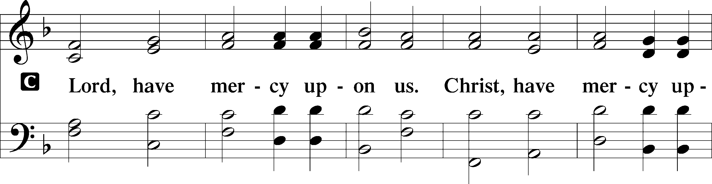

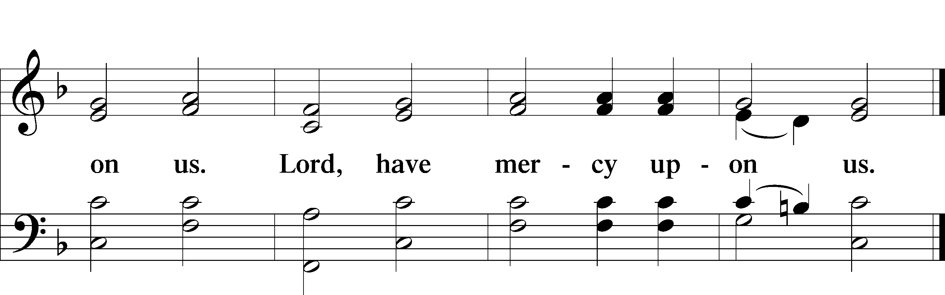

Gloria in Excelsis LSB 187

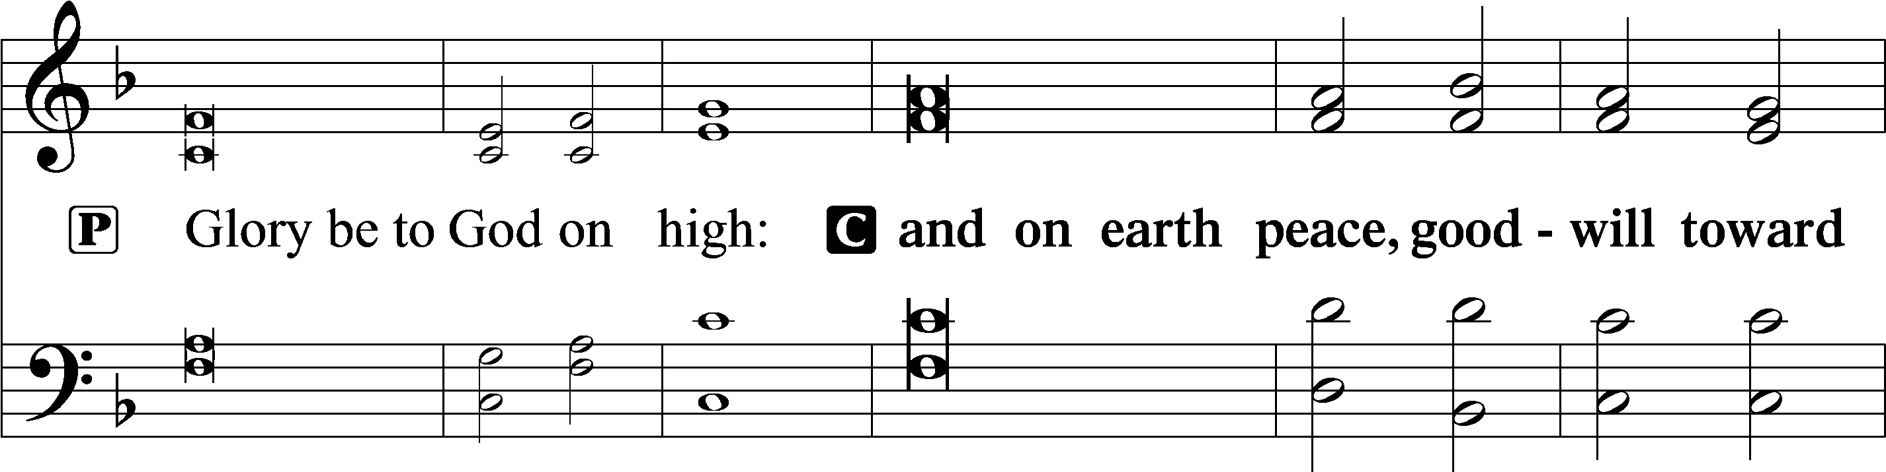

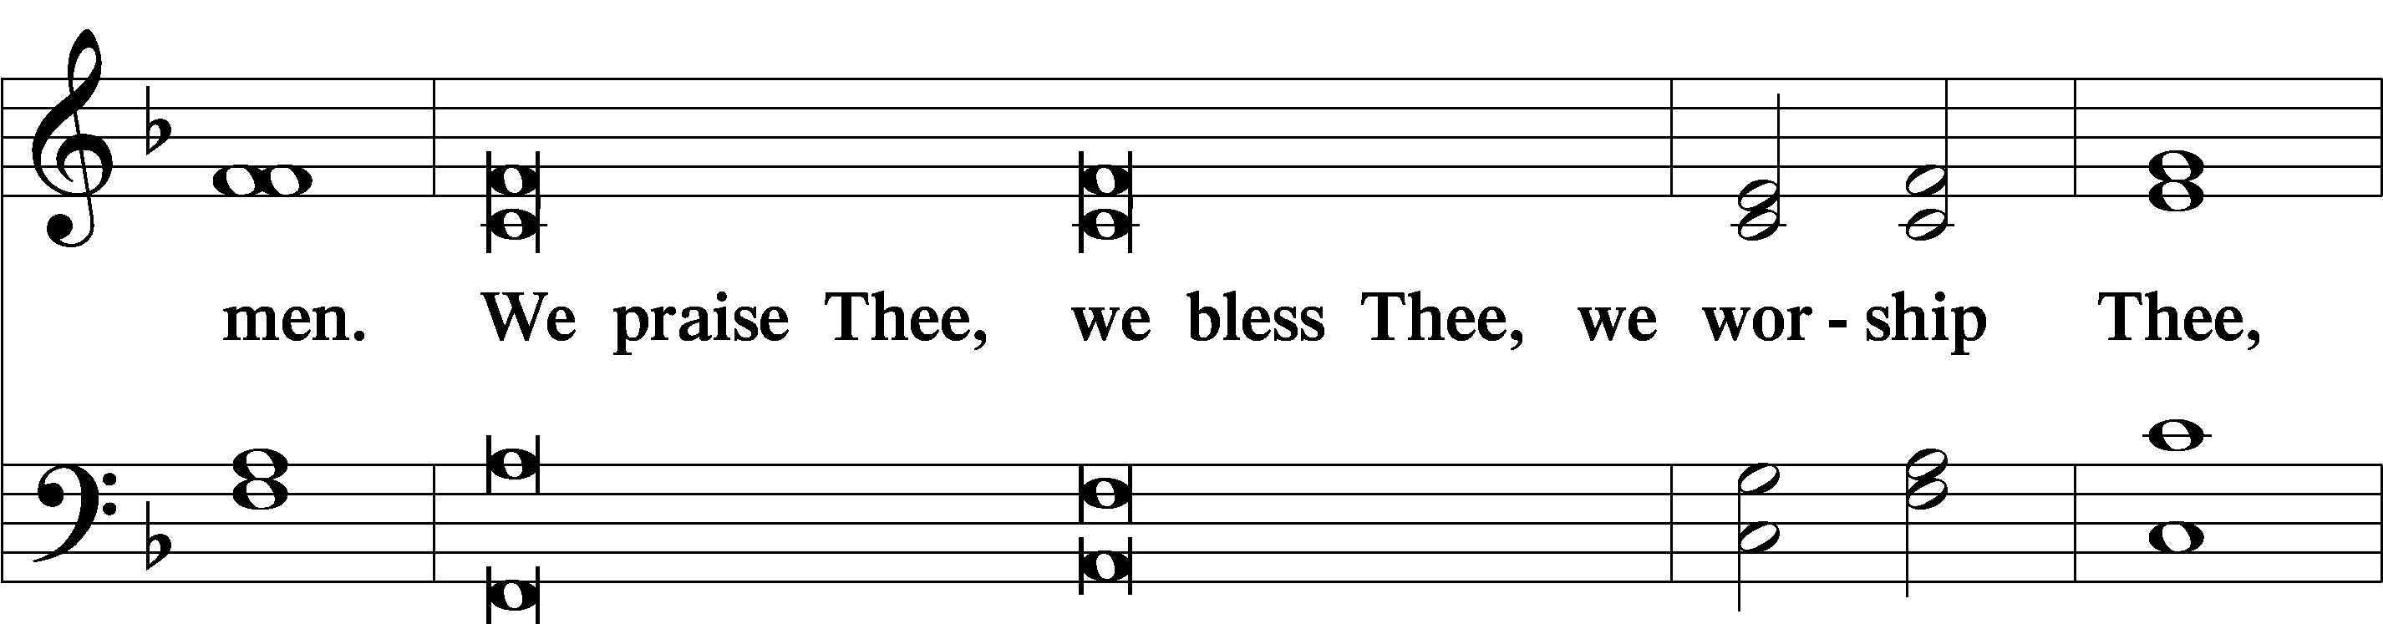

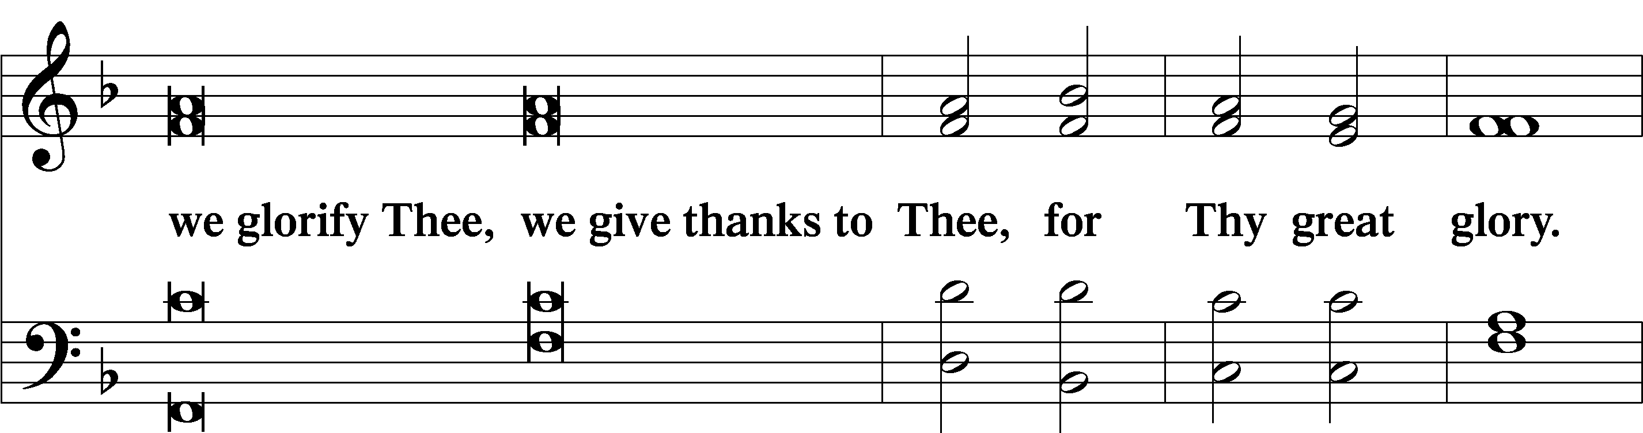

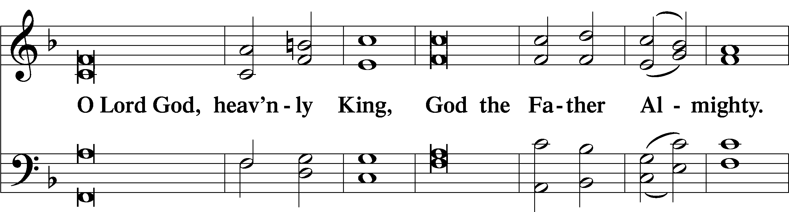

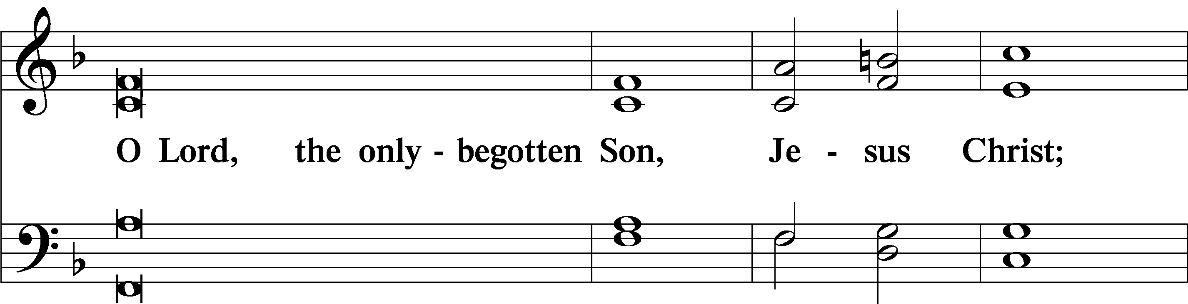

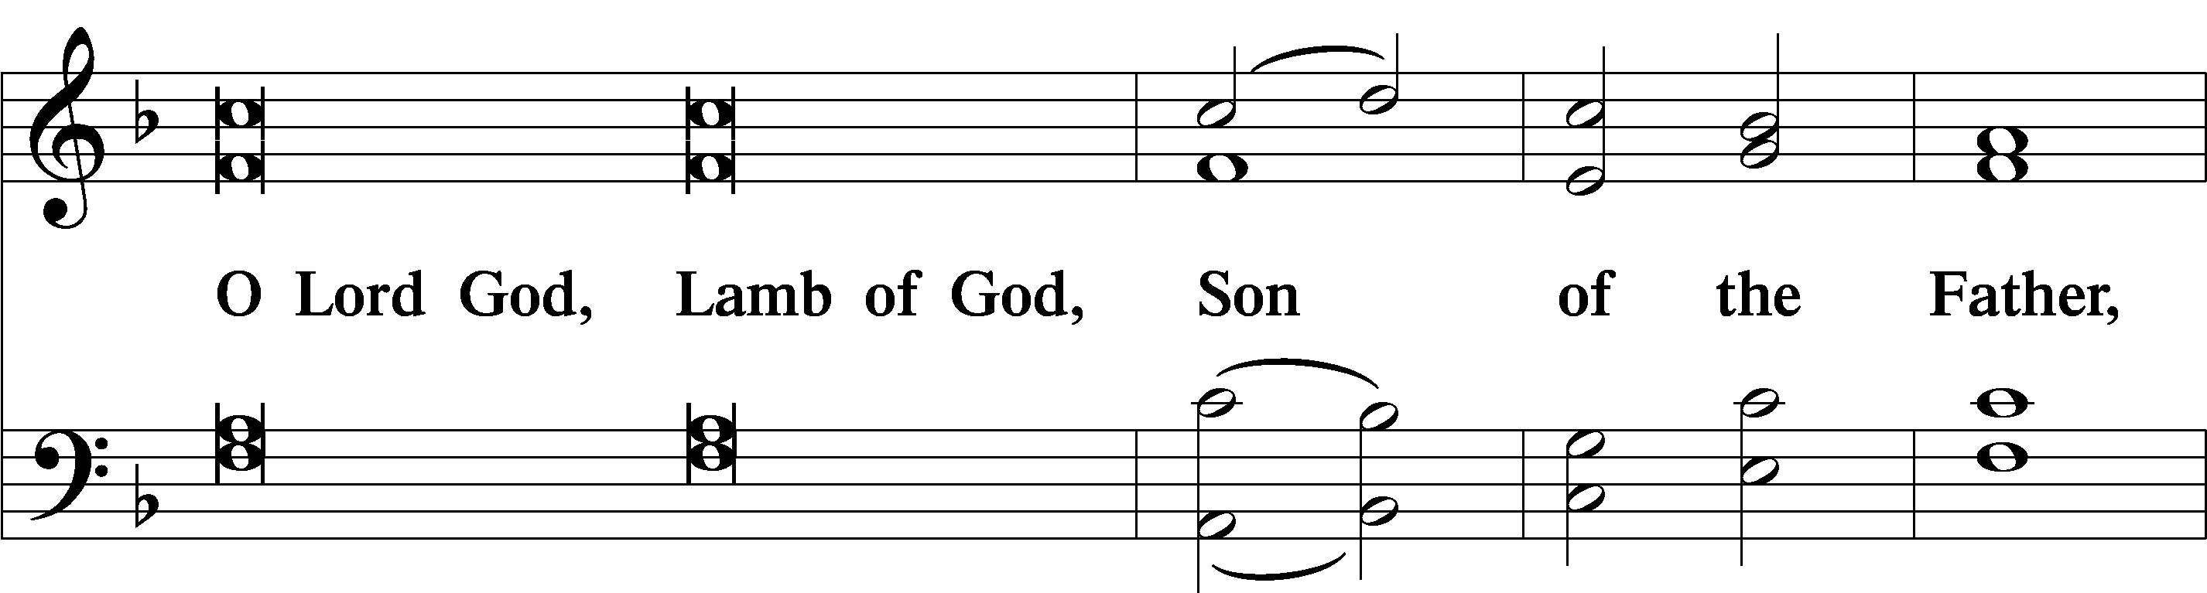

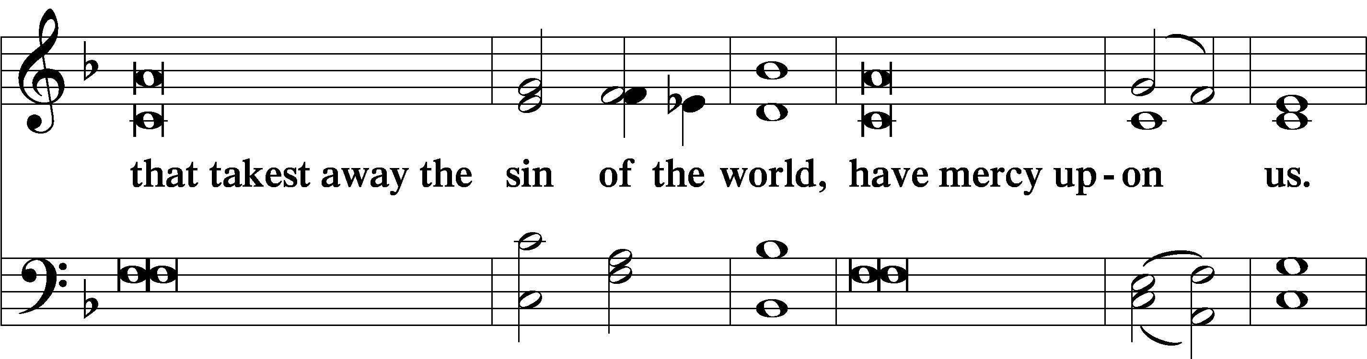

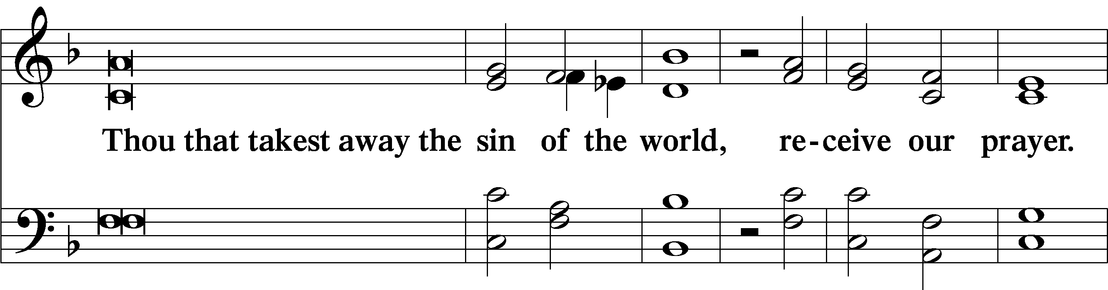

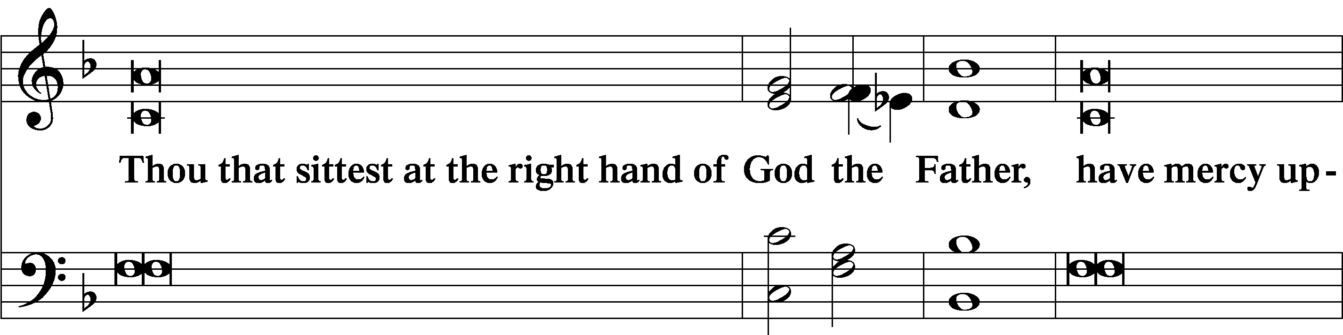

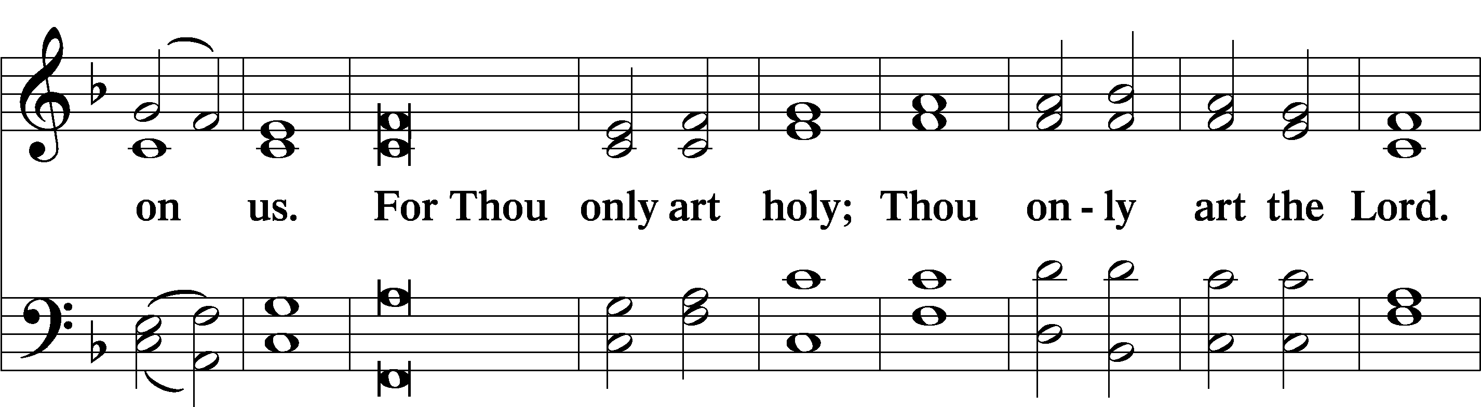

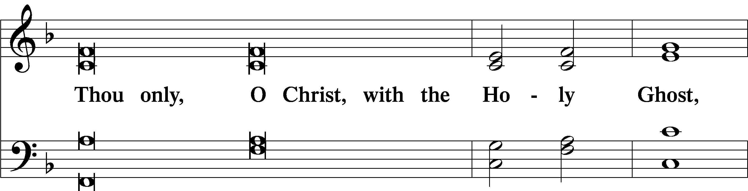

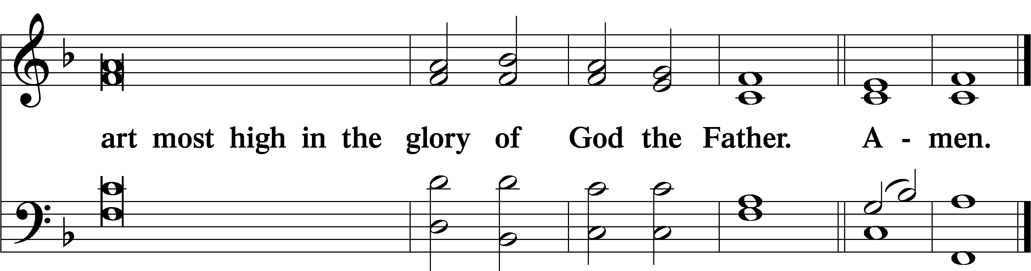

Salutation and Collect of the Day



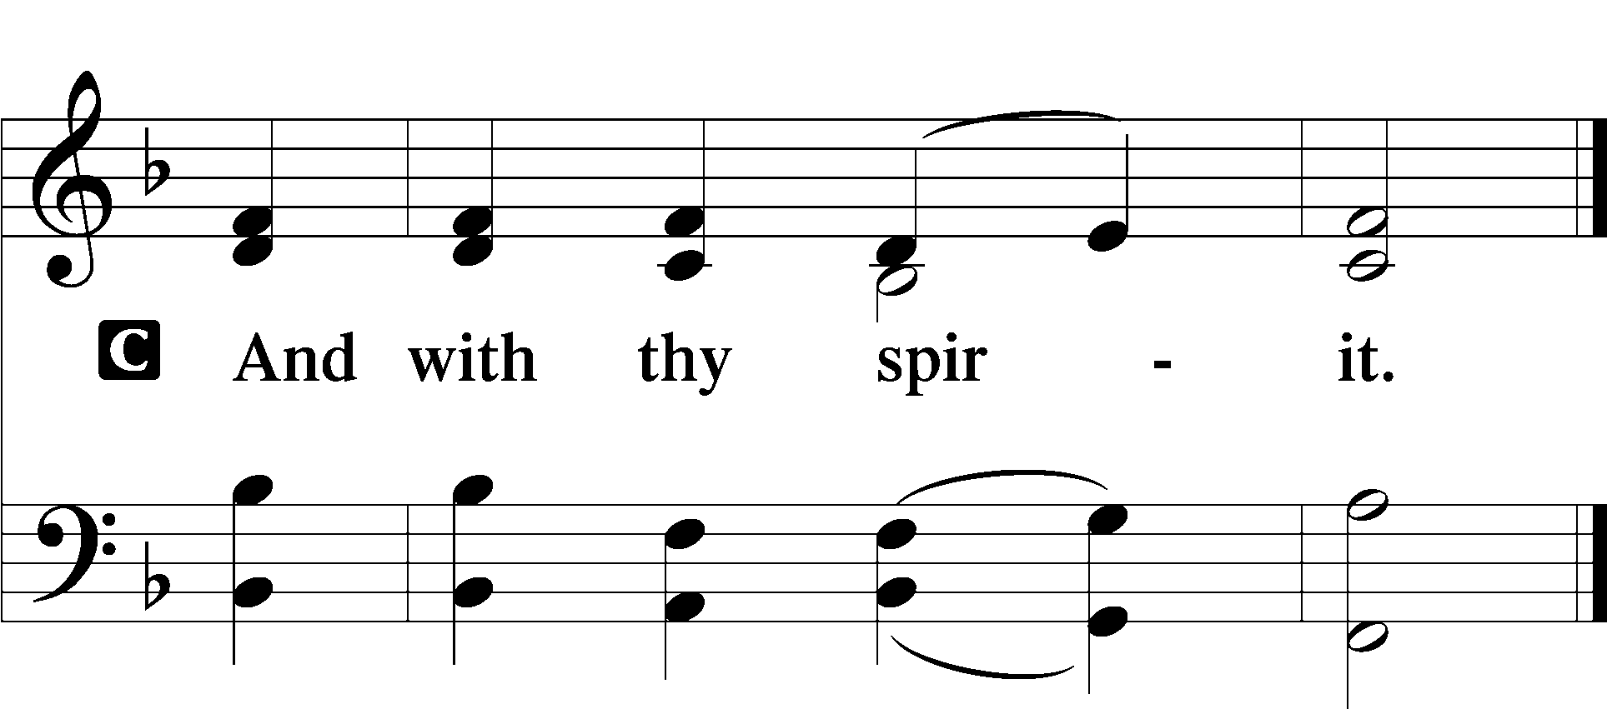

P Let us pray.

P O Lord, grant us wisdom to recognize the treasures You have stored up for us in heaven, that we may never despair but always rejoice and be thankful for the riches of Your grace; through Jesus Christ, Your Son, our Lord, who lives and reigns with You and the Holy Spirit, one God, now and forever.

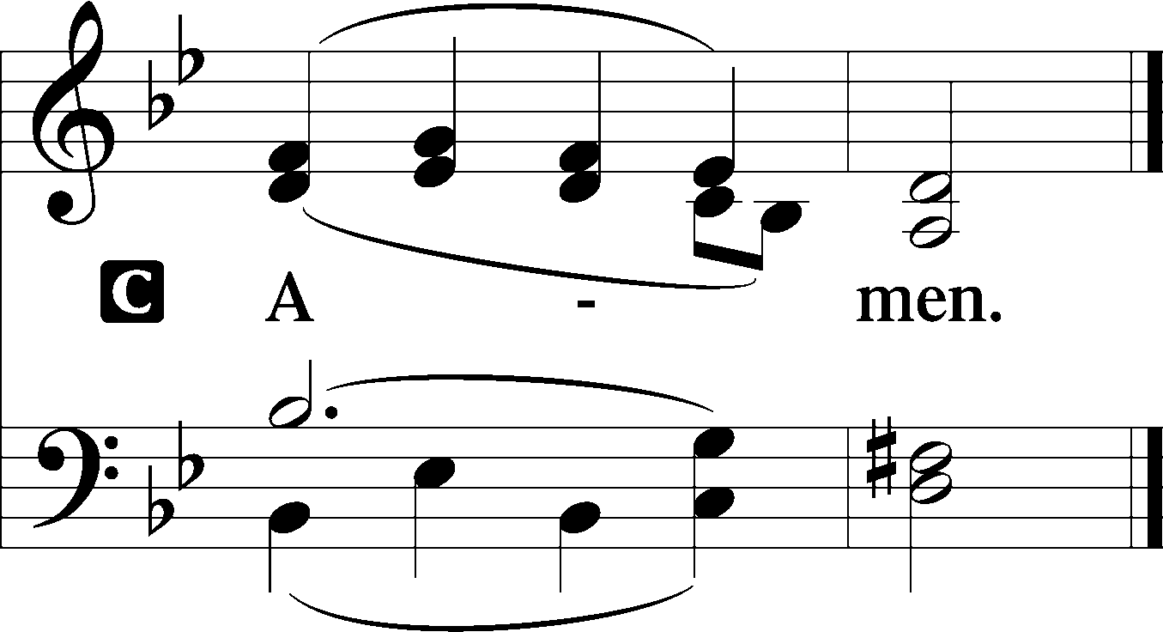

Sit

Old Testament Reading Ecclesiastes 1:2, 12–14; 2:18–26

Vanity of vanities, says the Preacher,  
 vanity of vanities! All is vanity. . . .

I the Preacher have been king over Israel in Jerusalem. And I applied my heart to seek and to search out by wisdom all that is done under heaven. It is an unhappy business that God has given to the children of man to be busy with. I have seen everything that is done under the sun, and behold, all is vanity and a striving after wind. . . .

I hated all my toil in which I toil under the sun, seeing that I must leave it to the man who will come after me, and who knows whether he will be wise or a fool? Yet he will be master of all for which I toiled and used my wisdom under the sun. This also is vanity. So I turned about and gave my heart up to despair over all the toil of my labors under the sun, because sometimes a person who has toiled with wisdom and knowledge and skill must leave everything to be enjoyed by someone who did not toil for it. This also is vanity and a great evil. What has a man from all the toil and striving of heart with which he toils beneath the sun? For all his days are full of sorrow, and his work is a vexation. Even in the night his heart does not rest. This also is vanity.

There is nothing better for a person than that he should eat and drink and find enjoyment in his toil. This also, I saw, is from the hand of God, for apart from him who can eat or who can have enjoyment? For to the one who pleases him God has given wisdom and knowledge and joy, but to the sinner he has given the business of gathering and collecting, only to give to one who pleases God. This also is vanity and a striving after wind.

A This is the Word of the Lord.

C **Thanks be to God.**

Epistle Colossians 3:1–11

If then you have been raised with Christ, seek the things that are above, where Christ is, seated at the right hand of God. Set your minds on things that are above, not on things that are on earth. For you have died, and your life is hidden with Christ in God. When Christ who is your life appears, then you also will appear with him in glory.

Put to death therefore what is earthly in you: sexual immorality, impurity, passion, evil desire, and covetousness, which is idolatry. On account of these the wrath of God is coming. In these you too once walked, when you were living in them. But now you must put them all away: anger, wrath, malice, slander, and obscene talk from your mouth. Do not lie to one another, seeing that you have put off the old self with its practices and have put on the new self, which is being renewed in knowledge after the image of its creator. Here there is not Greek and Jew, circumcised and uncircumcised, barbarian, Scythian, slave, free; but Christ is all, and in all.

A This is the Word of the Lord.

C **Thanks be to God.**

Stand

Alleluia LSB 190

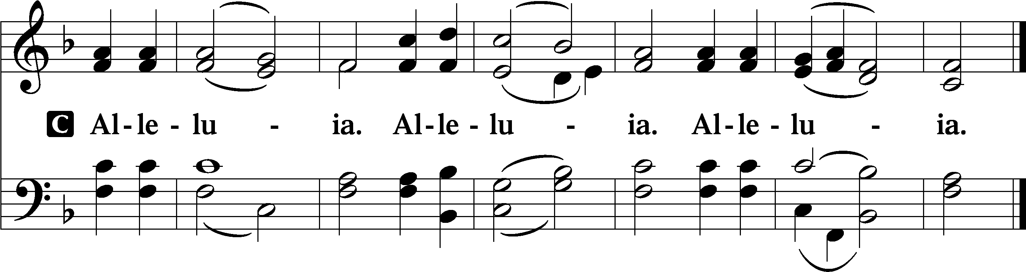

Holy Gospel Luke 12:13–21

P The Holy Gospel according to St. Luke, the twelfth chapter.

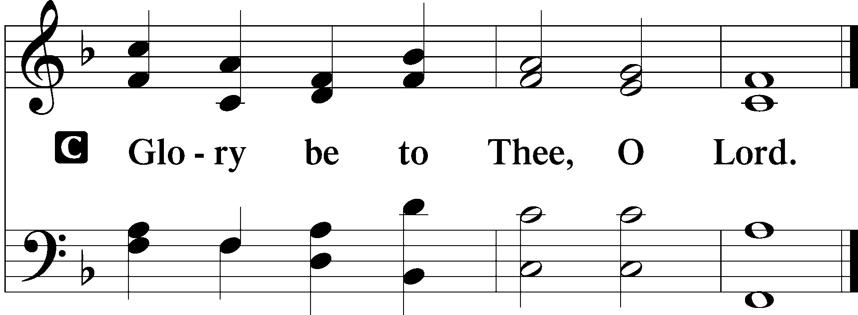

Someone in the crowd said to [Jesus], “Teacher, tell my brother to divide the inheritance with me.” But he said to him, “Man, who made me a judge or arbitrator over you?” And he said to them, “Take care, and be on your guard against all covetousness, for one’s life does not consist in the abundance of his possessions.” And he told them a parable, saying, “The land of a rich man produced plentifully, and he thought to himself, ‘What shall I do, for I have nowhere to store my crops?’ And he said, ‘I will do this: I will tear down my barns and build larger ones, and there I will store all my grain and my goods. And I will say to my soul, Soul, you have ample goods laid up for many years; relax, eat, drink, be merry.’ But God said to him, ‘Fool! This night your soul is required of you, and the things you have prepared, whose will they be?’ So is the one who lays up treasure for himself and is not rich toward God.”

P This is the Gospel of the Lord.

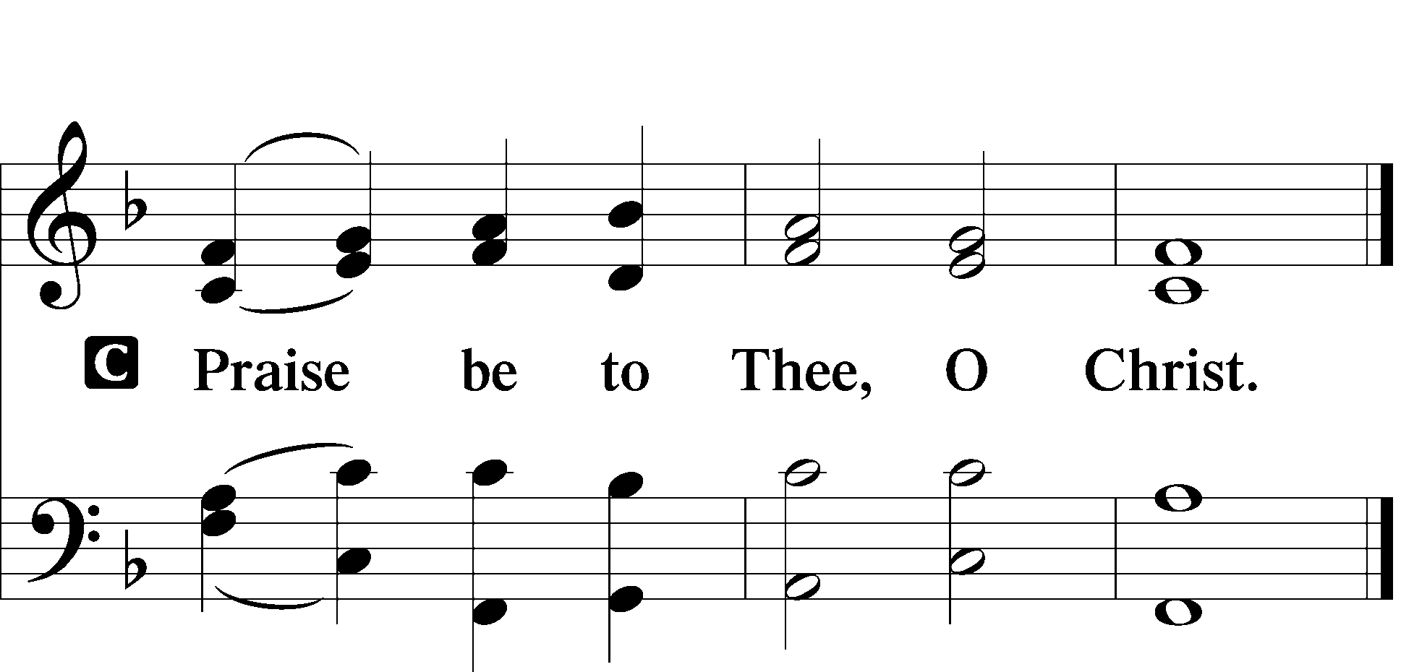

Nicene Creed

C **I believe in one God,**

**the Father Almighty,**

**maker of heaven and earth**

**and of all things visible and invisible.**

**And in one Lord Jesus Christ,**

**the only-begotten Son of God,**

**begotten of His Father before all worlds,**

**God of God, Light of Light,**

**very God of very God,**

**begotten, not made,**

**being of one substance with the Father,**

**by whom all things were made;**

**who for us men and for our salvation came down from heaven**

**and was incarnate by the Holy Spirit of the virgin Mary**

**and was made man;**

**and was crucified also for us under Pontius Pilate.**

**He suffered and was buried.**

**And the third day He rose again according to the Scriptures**

**and ascended into heaven**

**and sits at the right hand of the Father.**

**And He will come again with glory to judge both the living and the dead,**

**whose kingdom will have no end.**

**And I believe in the Holy Spirit,**

**the Lord and giver of life,**

**who proceeds from the Father and the Son,**

**who with the Father and the Son together is worshiped and glorified,**

**who spoke by the prophets.**

**And I believe in one holy Christian and apostolic Church,**

**I acknowledge one Baptism for the remission of sins,**

**and I look for the resurrection of the dead**

**and the life** T **of the world to come. Amen.**

Sit

782 Gracious God, You Send Great Blessings

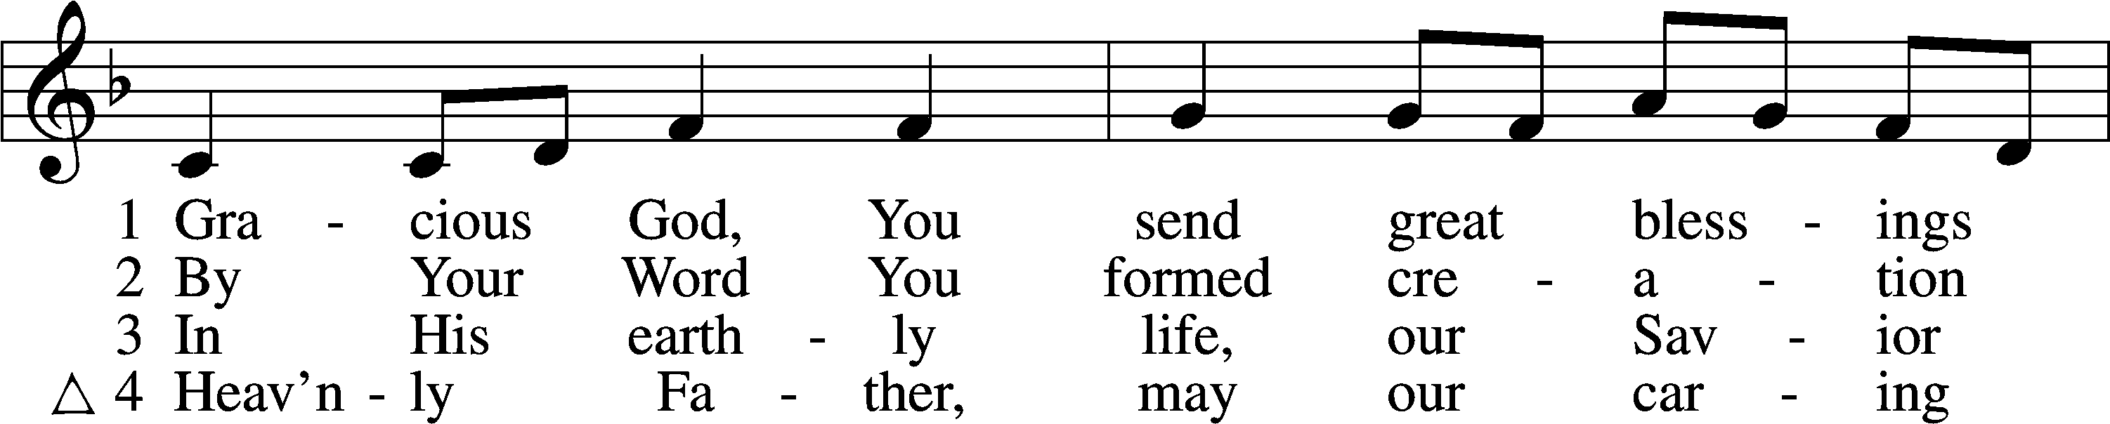

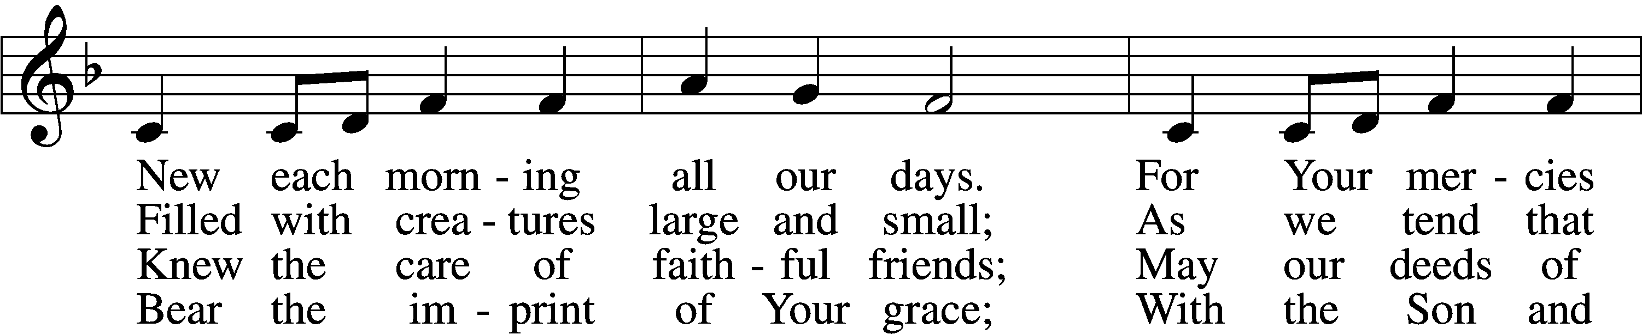

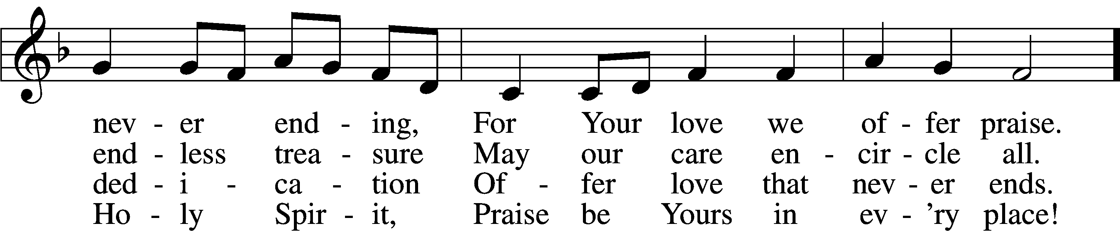

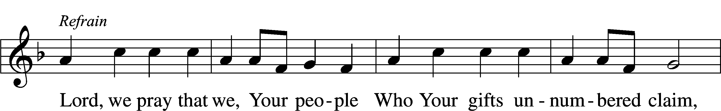

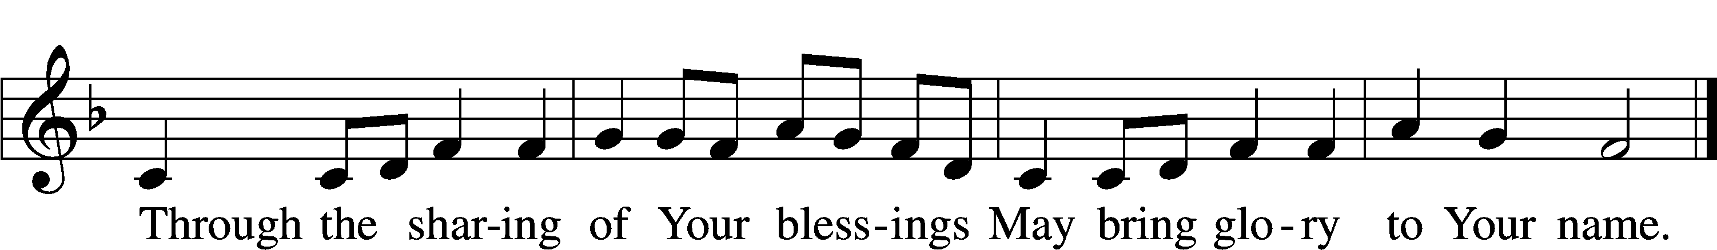

Δ – *Stand for last verse*

Sermon

Offering

Psalm for Meditation Psalm 100; antiphon: v. 3

Make a joyful noise to the Lord, all the earth!  
 Serve the Lord with gladness!  
 Come into his presence with singing!

Know that the Lord, he is God!  
 It is he who made us, and we are his;  
 we are his people, and the sheep of his pasture.

Enter his gates with thanksgiving,  
 and his courts with praise!  
 Give thanks to him; bless his name!

For the Lord is good;  
 his steadfast love endures forever,  
 and his faithfulness to all generations.

Stand

781 We Give Thee But Thine Own sts. 1–2

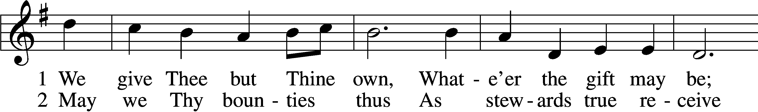

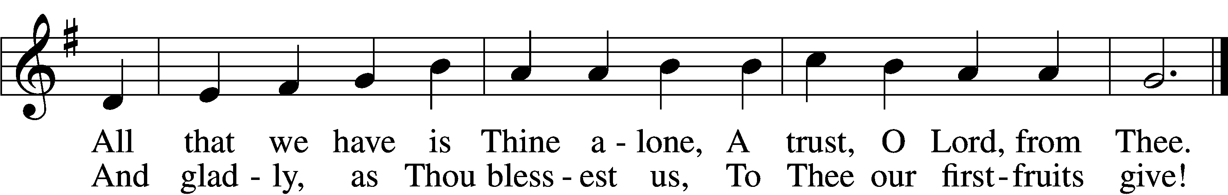

Prayer of the Church

*After “let us pray to the Lord:” respond with “Lord, have mercy.”*

# Service of the Sacrament

Preface LSB 194



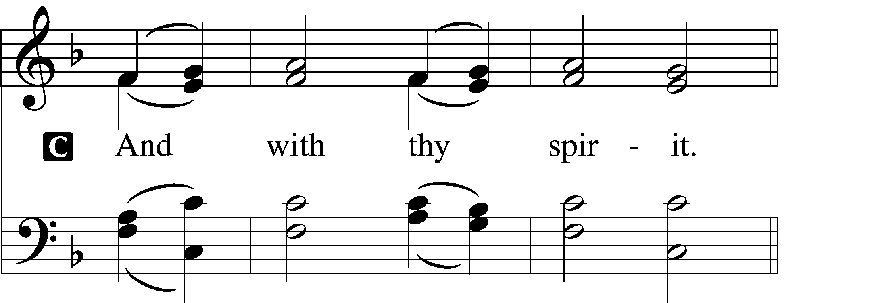



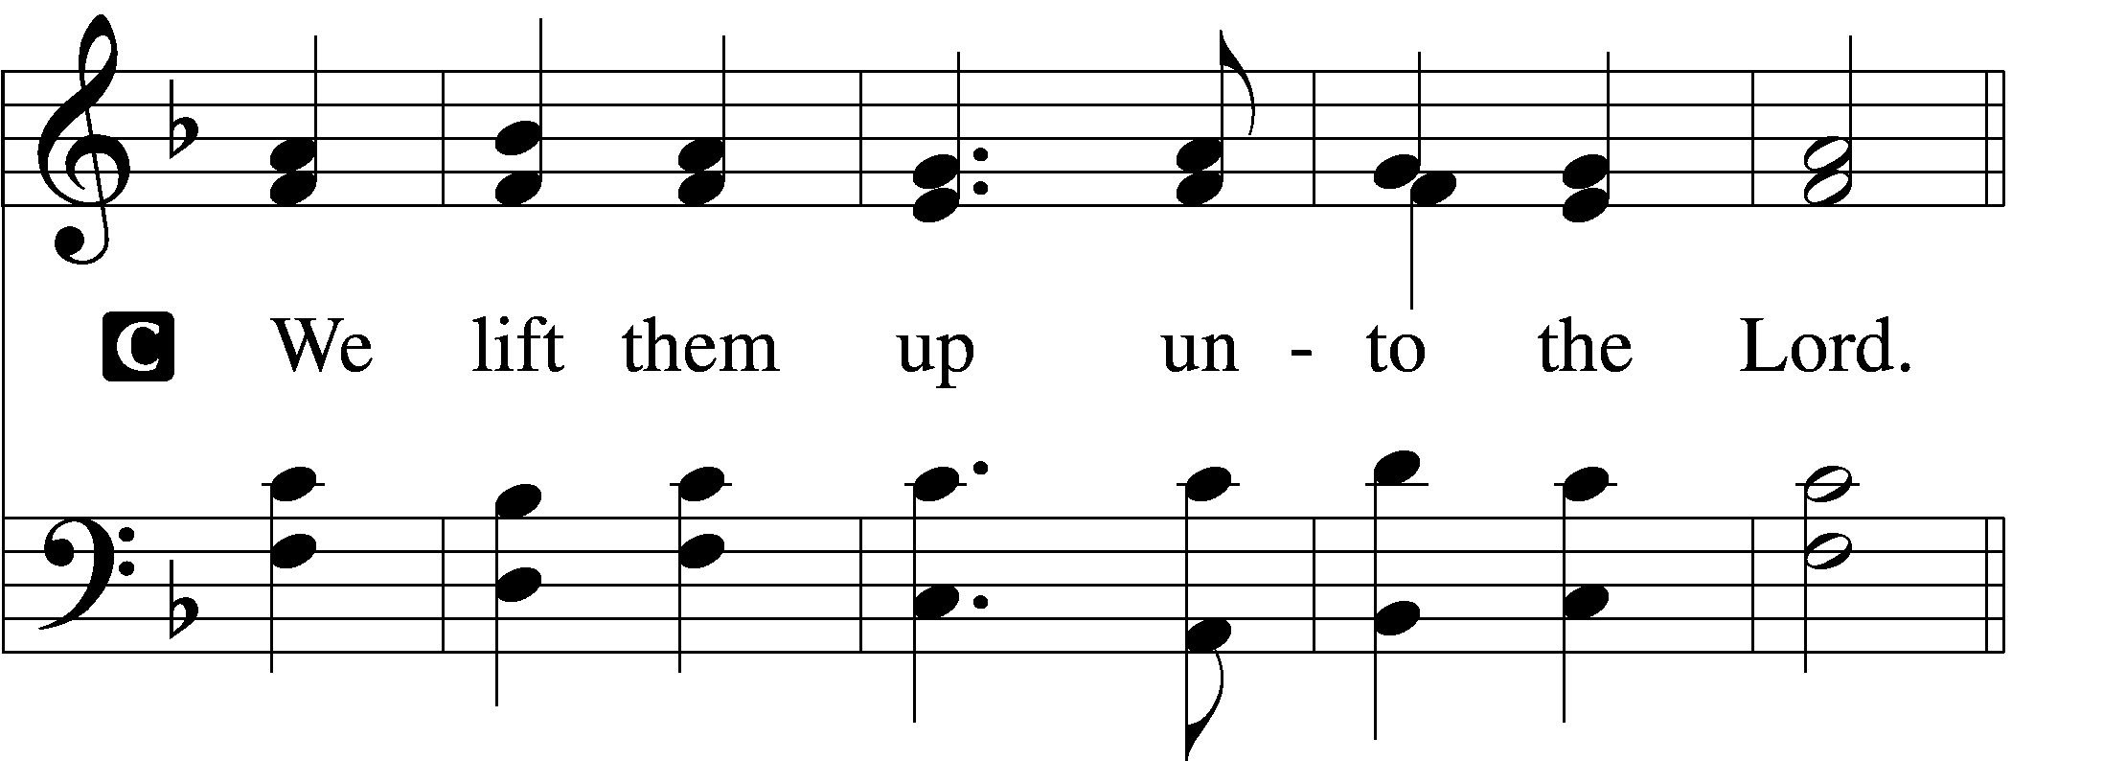

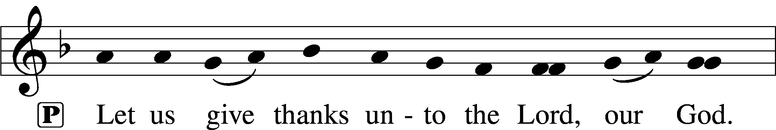

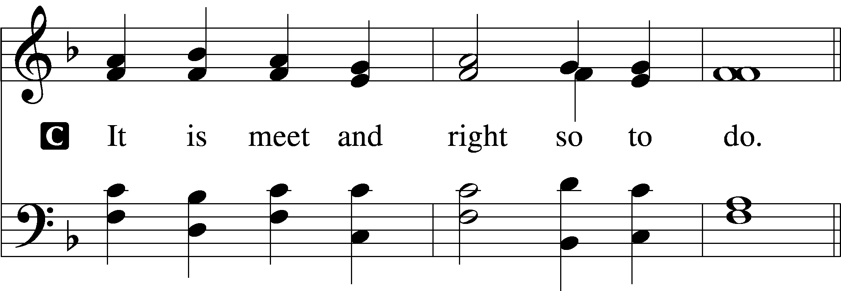

Proper Preface (Full)

P It is truly meet, right, and salutary that we should at all times and in all places give thanks to You, holy Lord, almighty Father, everlasting God, through Jesus Christ, our Lord, who, out of love for His fallen creation, humbled Himself by taking on the form of a servant, becoming obedient unto death, even death upon a cross. Risen from the dead, He has freed us from eternal death and given us life everlasting. Therefore with angels and archangels and with all the company of heaven we laud and magnify Your glorious name, evermore praising You and saying:

Sanctus 195

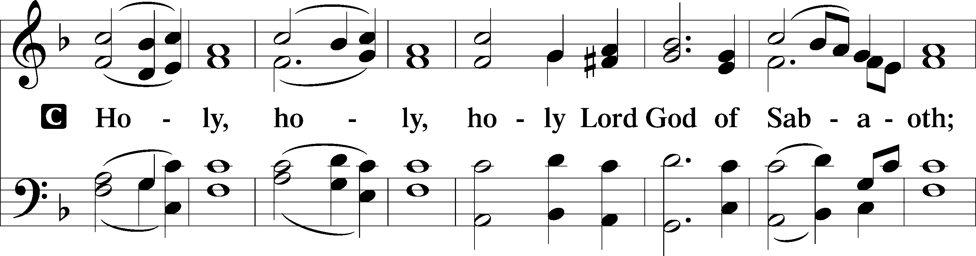

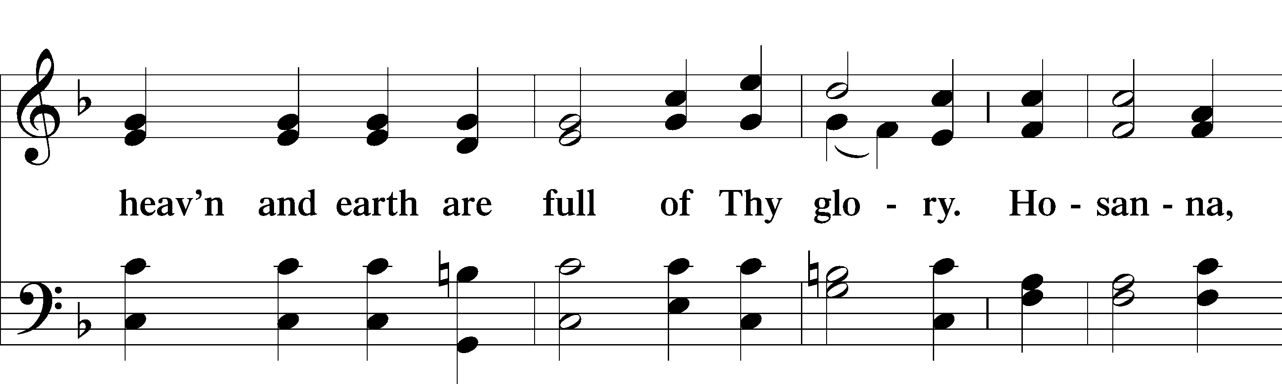

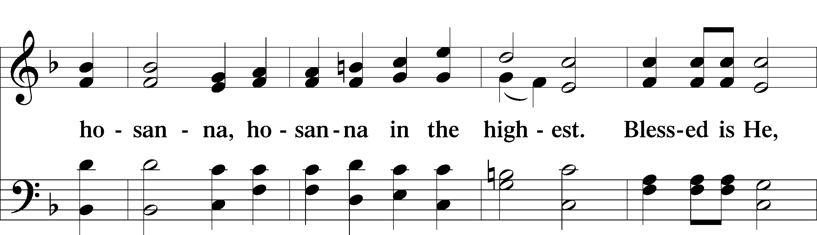

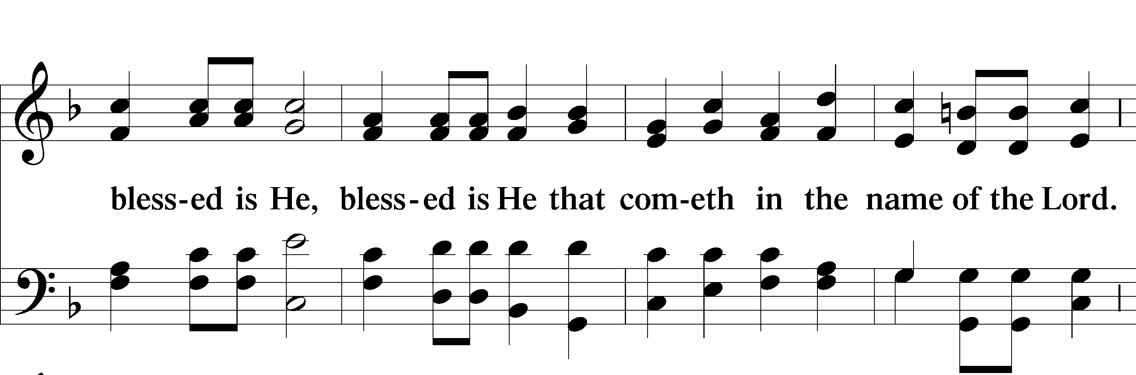

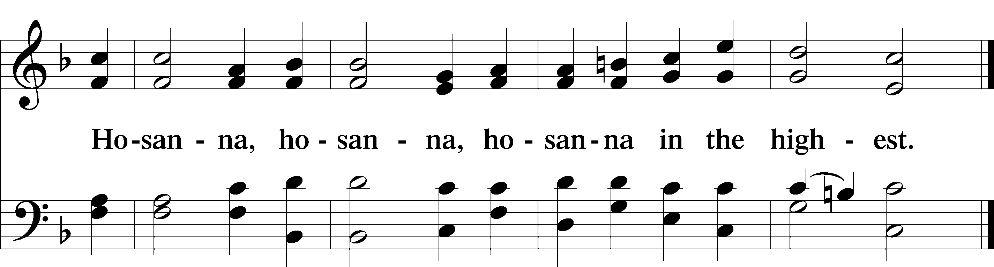

Lord’s Prayer LSB 196

C **Our Father who art in heaven,**

**hallowed be Thy name,**

**Thy kingdom come,**

**Thy will be done on earth as it is in heaven;**

**give us this day our daily bread;**

**and forgive us our trespasses as we forgive those who trespass against us;**

**and lead us not into temptation,**

**but deliver us from evil.**

**For Thine is the kingdom and the power and the glory forever and ever. Amen.**

The Words of Our Lord 197

P Our Lord Jesus Christ, on the night when He was betrayed, took bread, and when He had given thanks, He broke it and gave it to the disciples and said: “Take, eat; this is My T body, which is given for you. This do in remembrance of Me.”

In the same way also He took the cup after supper, and when He had given thanks, He gave it to them, saying: “Drink of it, all of you; this cup is the new testament in My T blood, which is shed for you for the forgiveness of sins. This do, as often as you drink it, in remembrance of Me.”

Pax Domini LSB 197

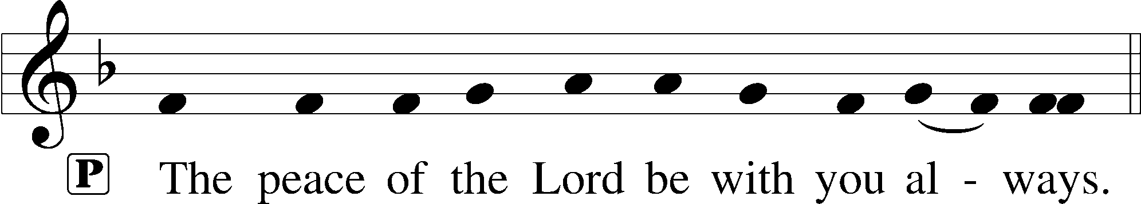

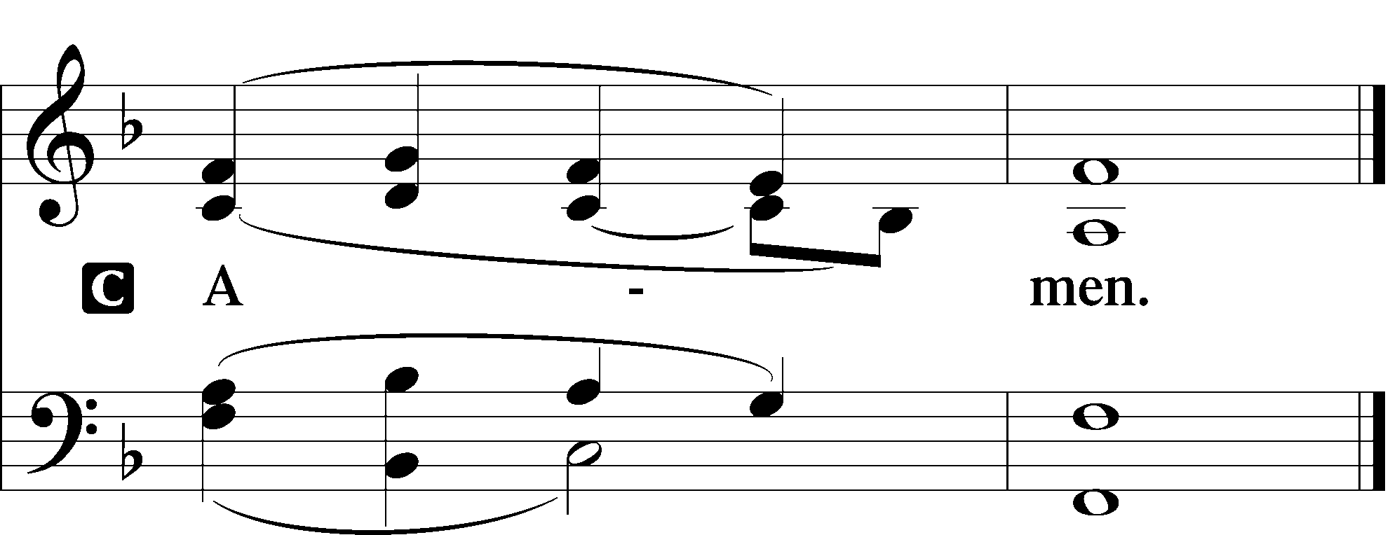

Agnus Dei LSB 198

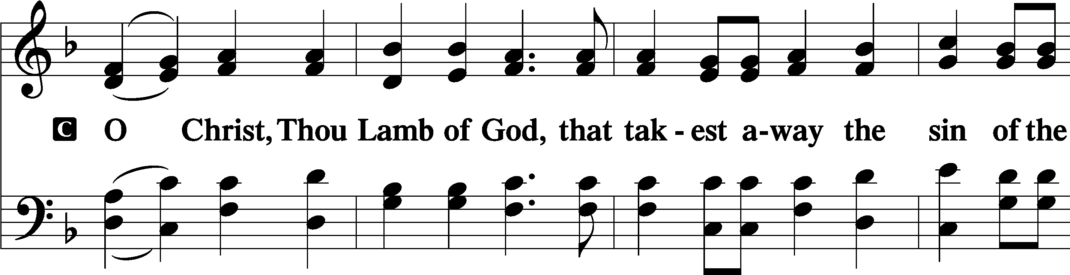

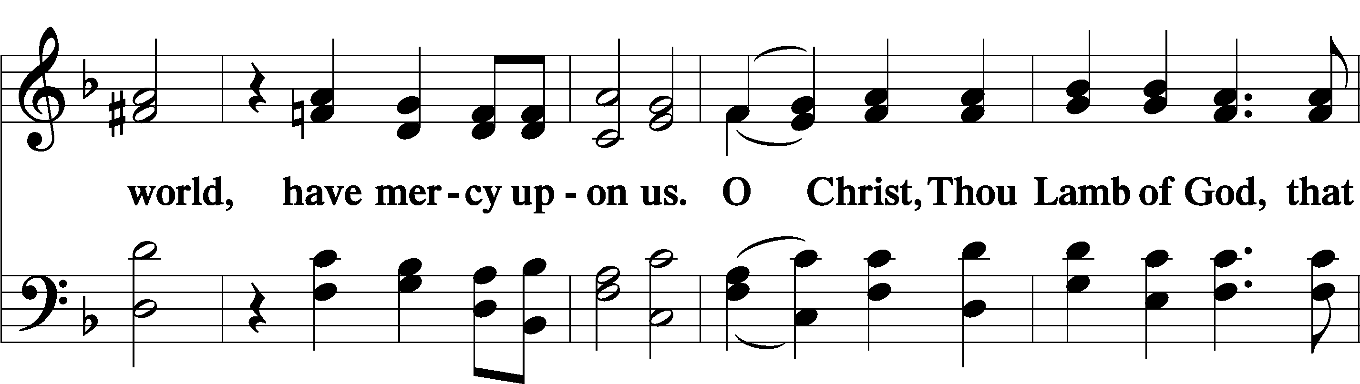

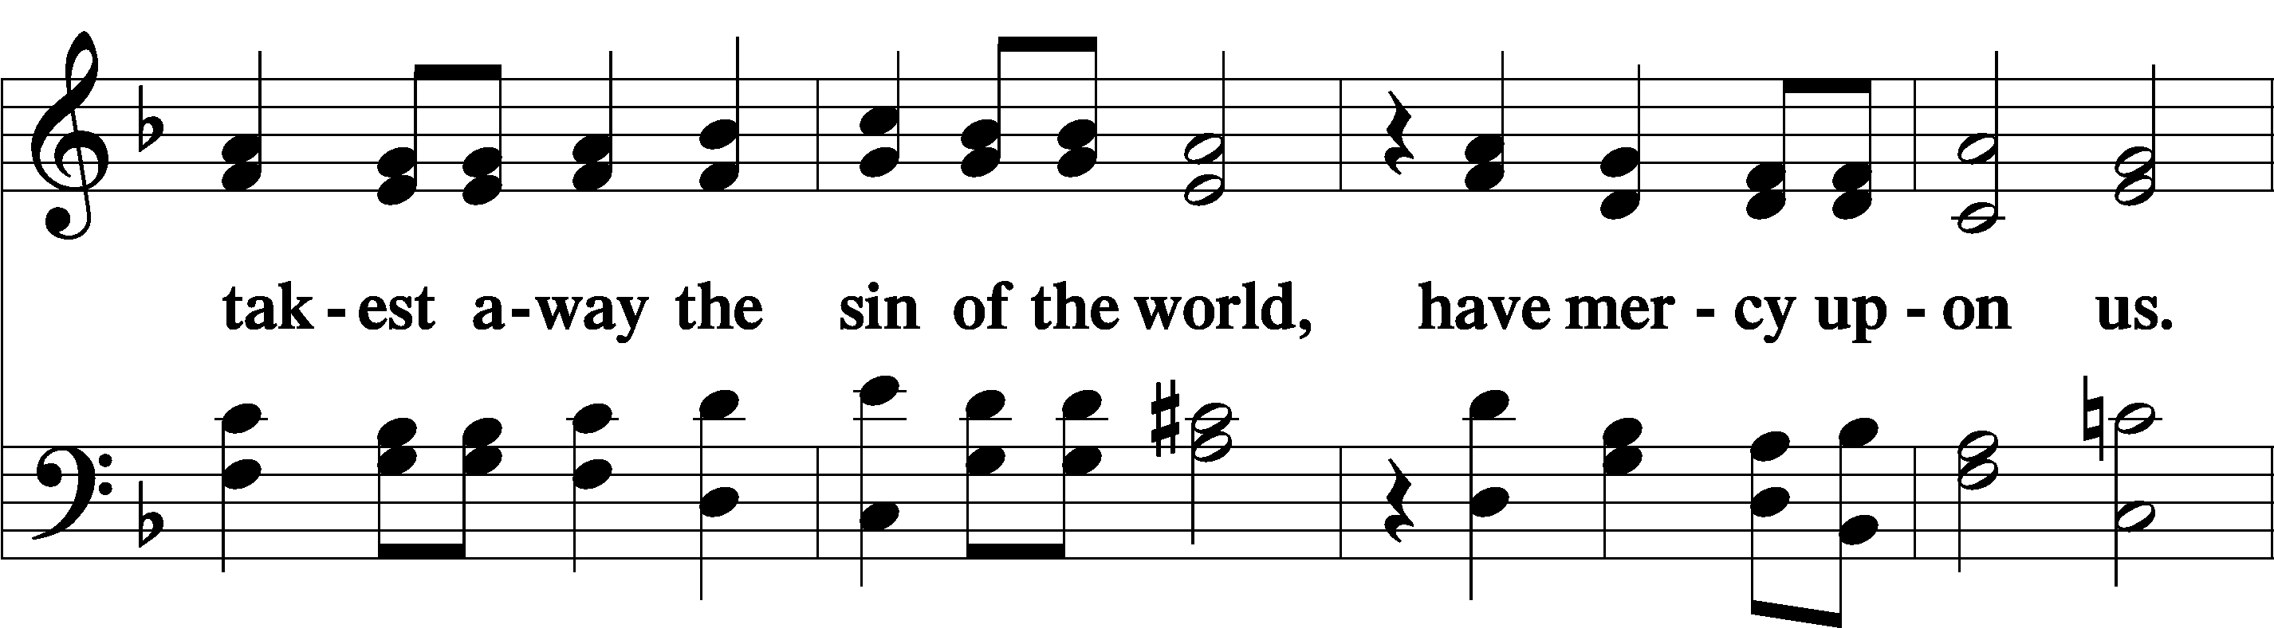

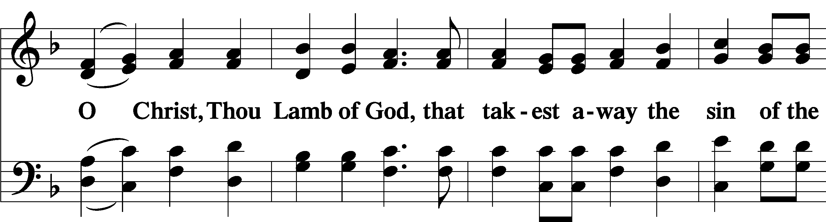

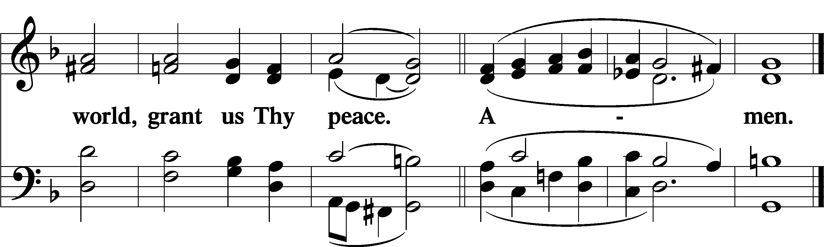

Sit

Distribution & Distribution Hymn

622 Lord Jesus Christ, You Have Prepared sts. 1–4

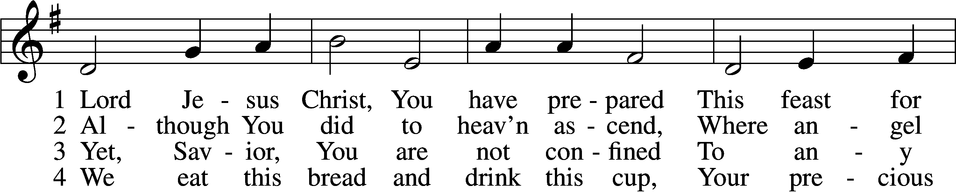

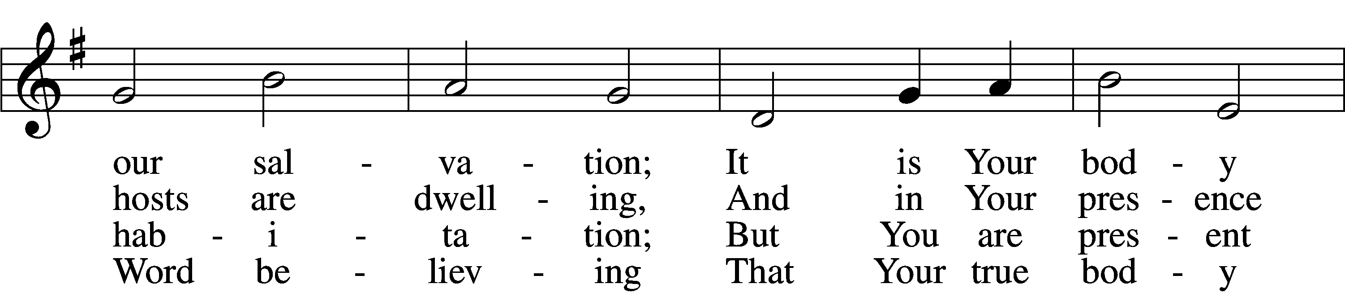

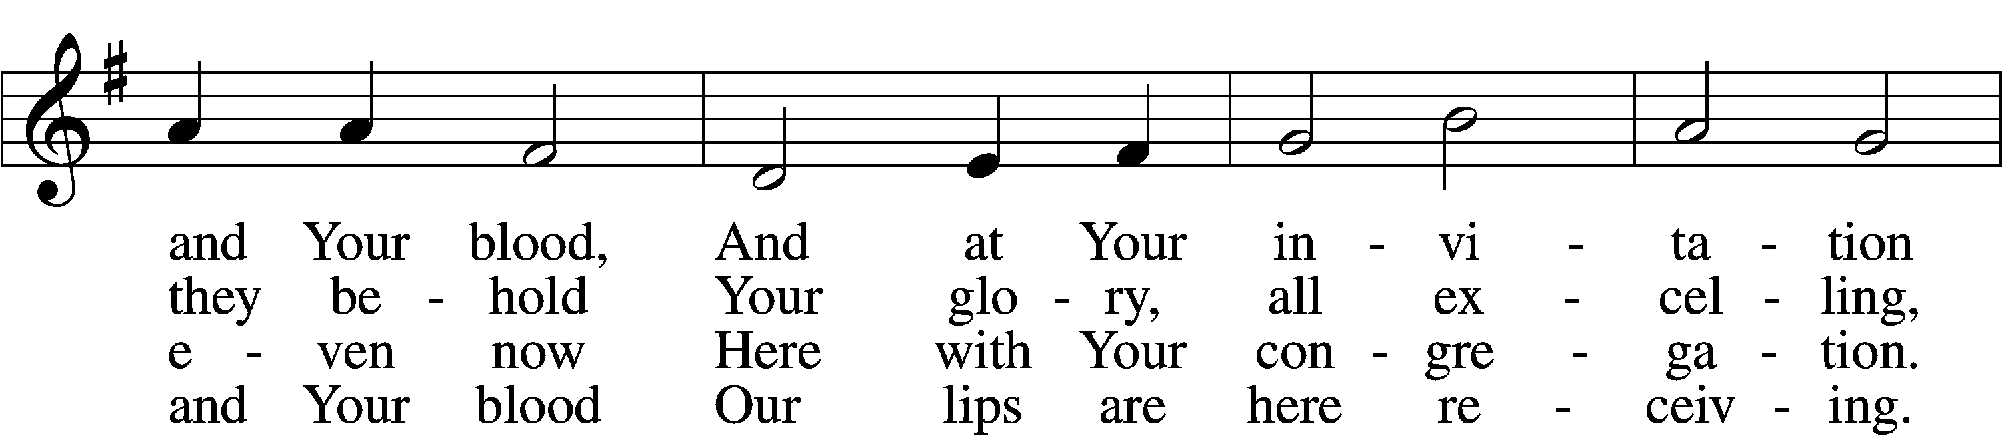

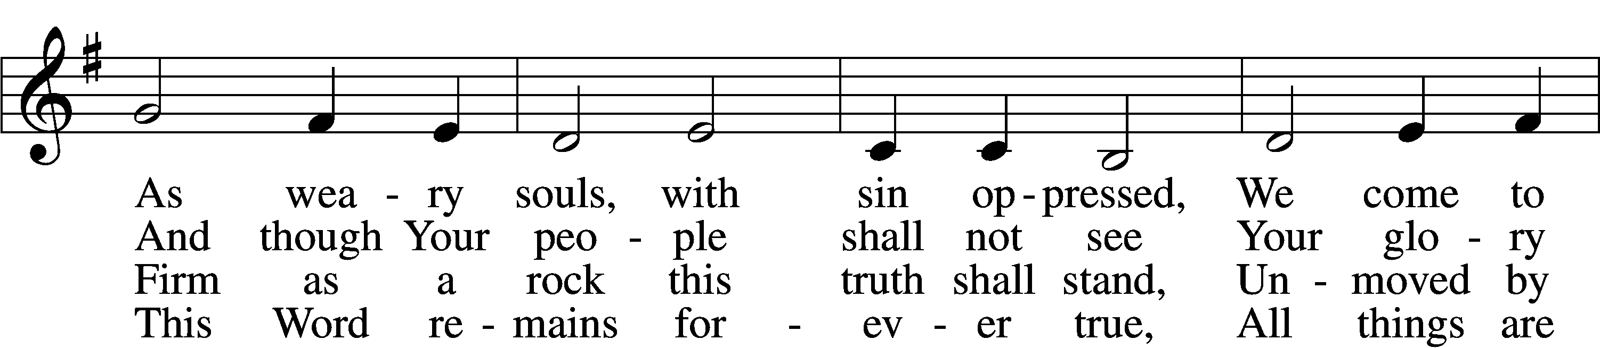

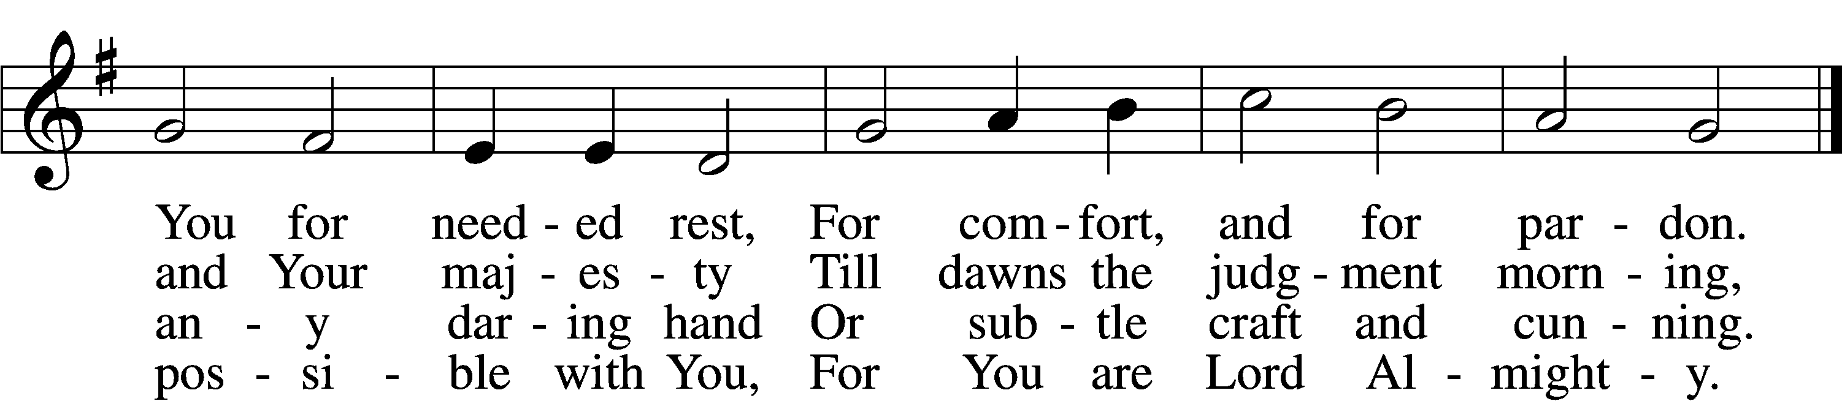

Stand

Nunc Dimittis LSB 199

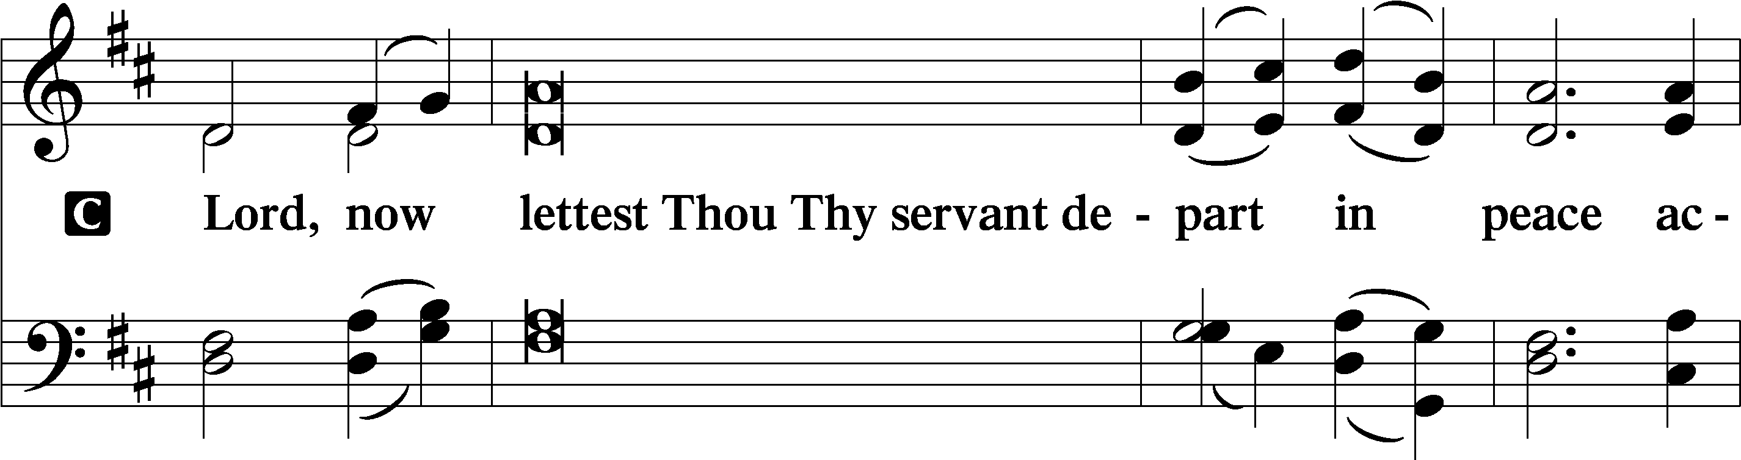

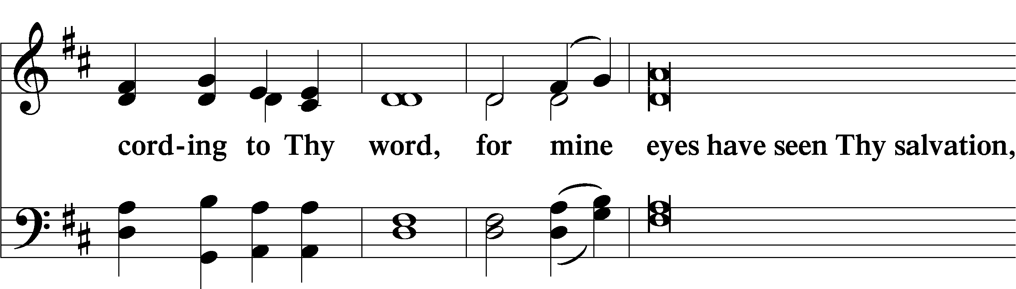

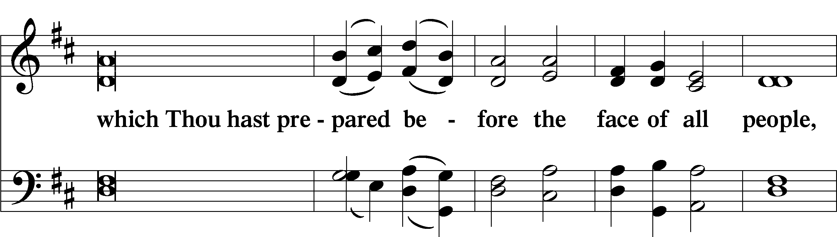

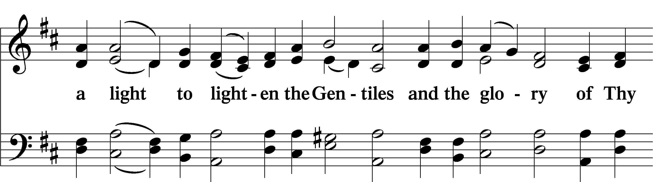

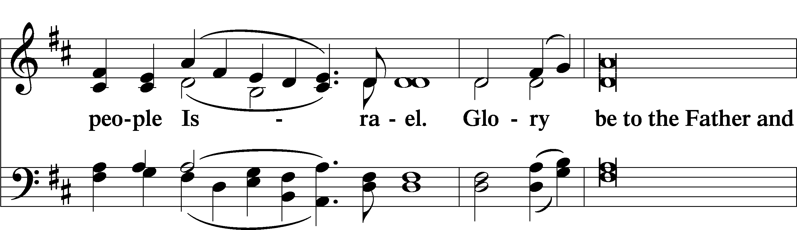

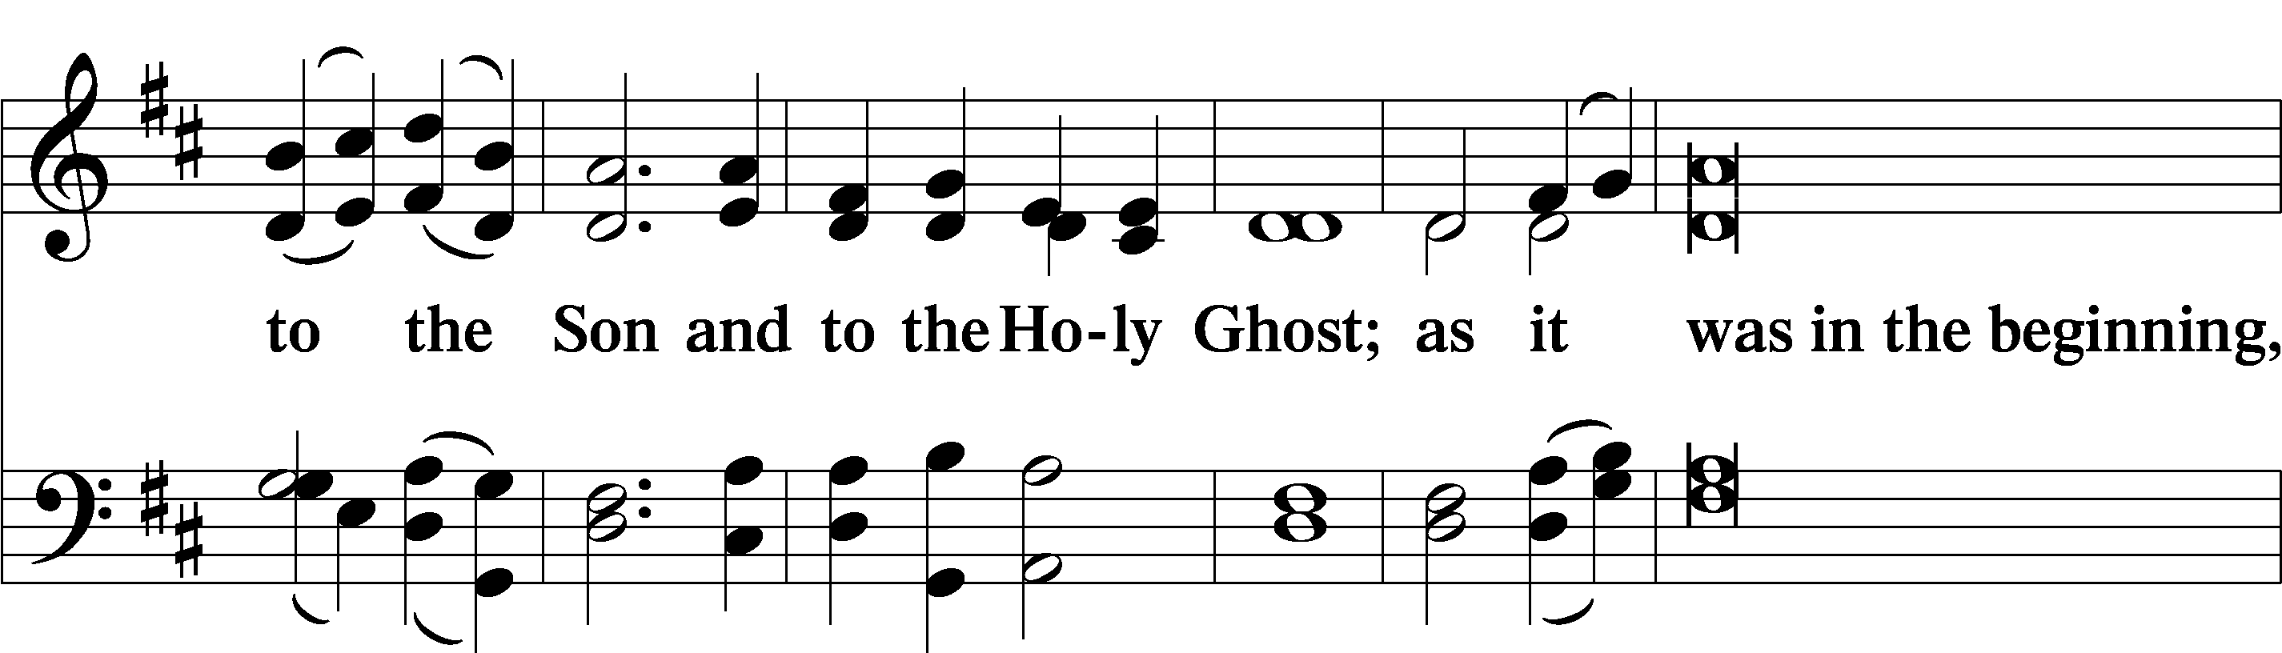

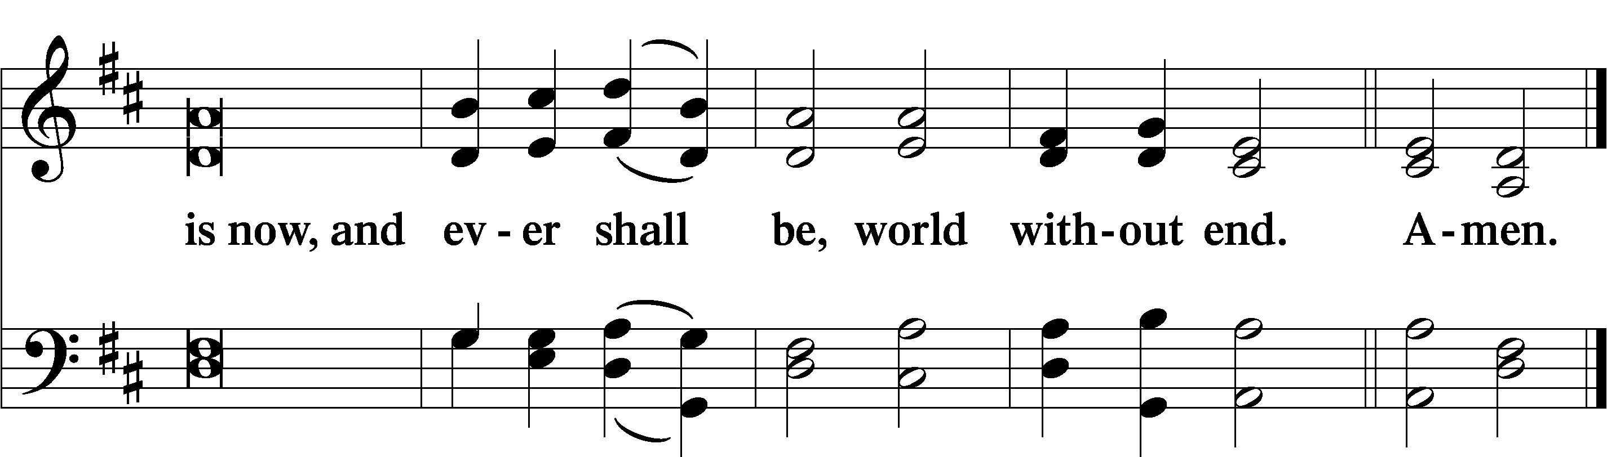

Thanksgiving LSB 200

A O give thanks unto the Lord, for He is good,

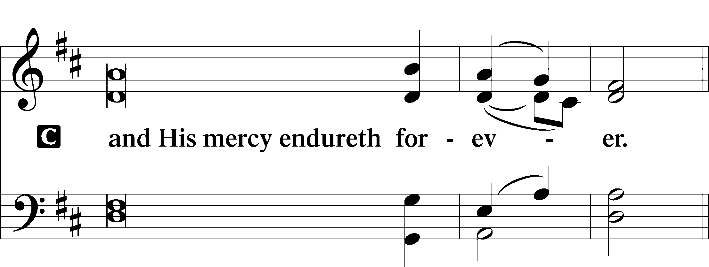

Post-Communion Collect

A Let us pray.

We give thanks to You, almighty God, that You have refreshed us through this salutary gift, and we implore You that of Your mercy You would strengthen us through the same in faith toward You and in fervent love toward one another; through Jesus Christ, Your Son, our Lord, who lives and reigns with You and the Holy Spirit, one God, now and forever.

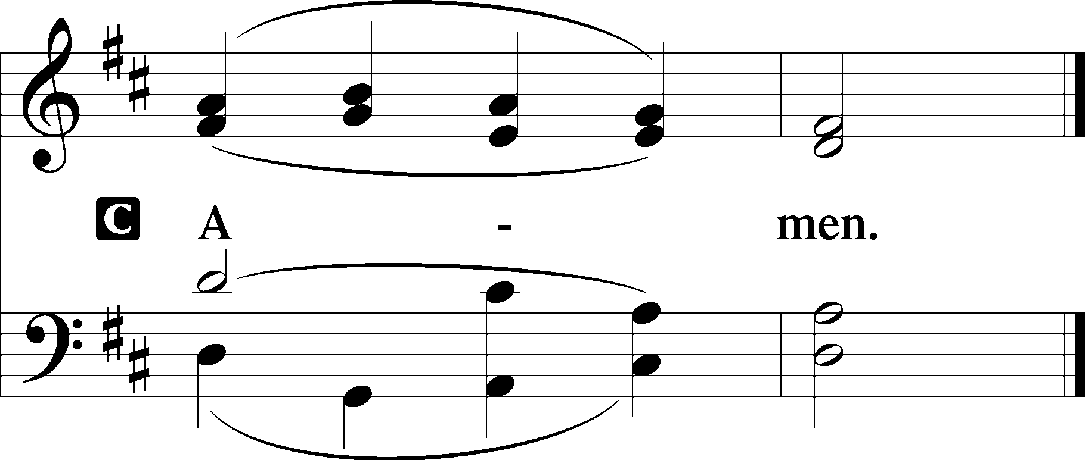

Salutation LSB 201

P The Lord be with you.

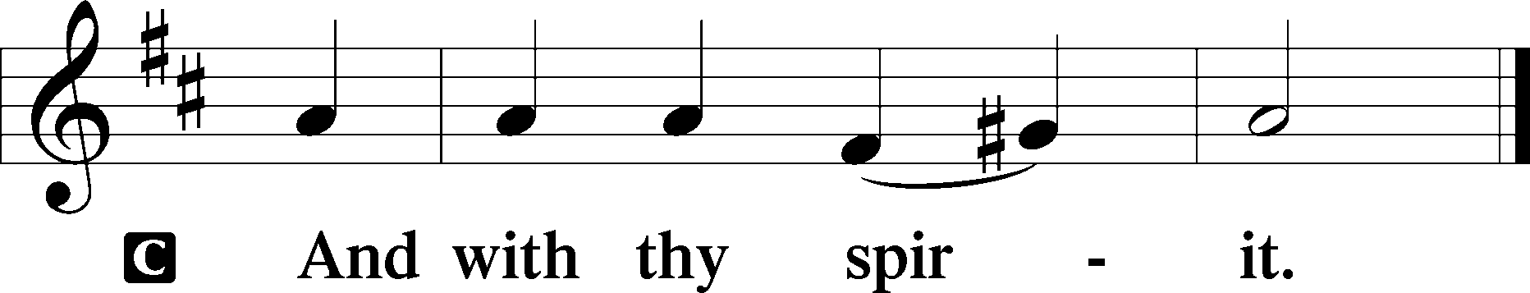

Benedicamus LSB 202

A Bless we the Lord.

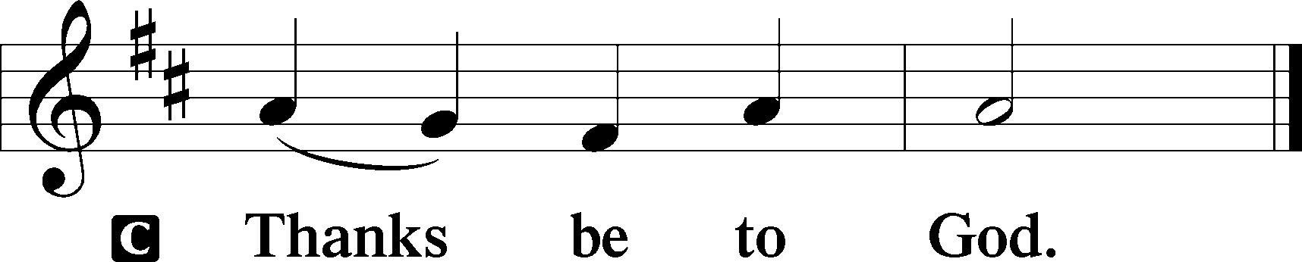

Benediction LSB 202

P The Lord bless you and keep you.

The Lord make His face shine upon you and be gracious unto you.

The Lord lift up His countenance upon you and T give you peace.

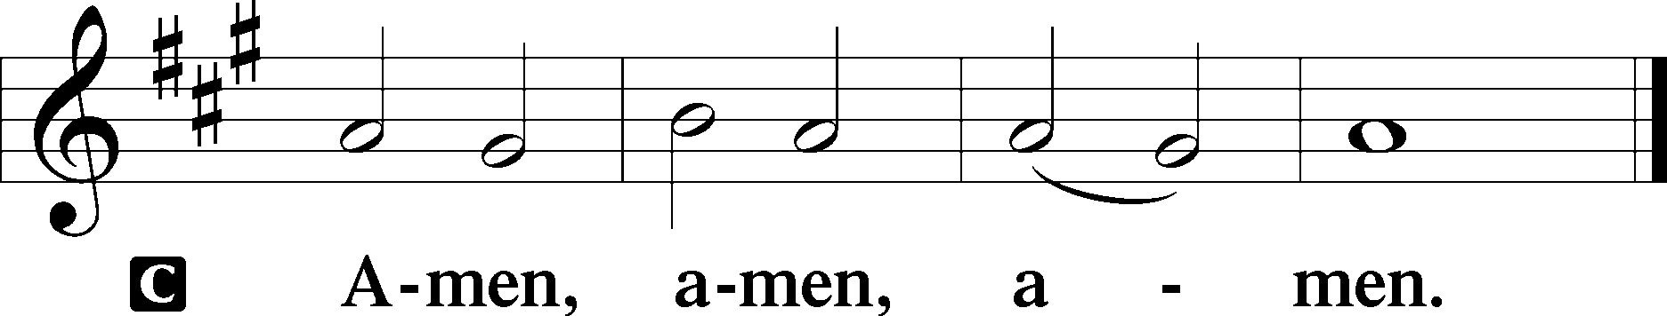

918 Guide Me, O Thou Great Redeemer

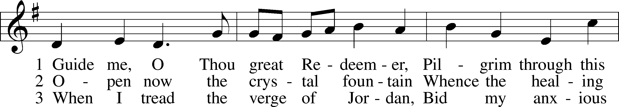

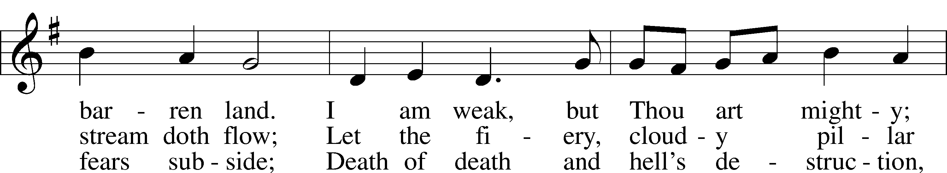

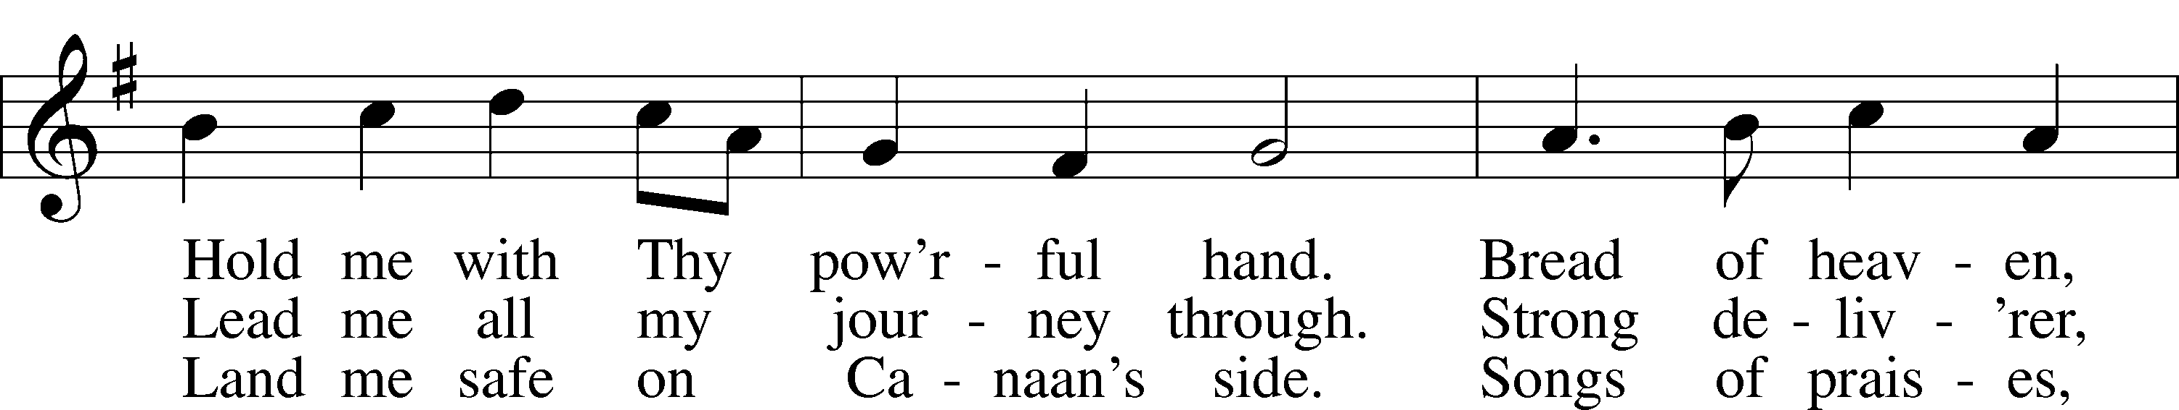

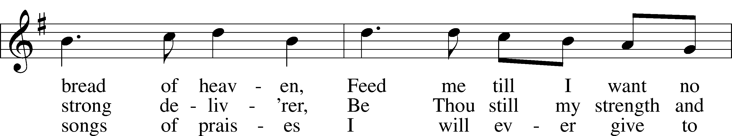

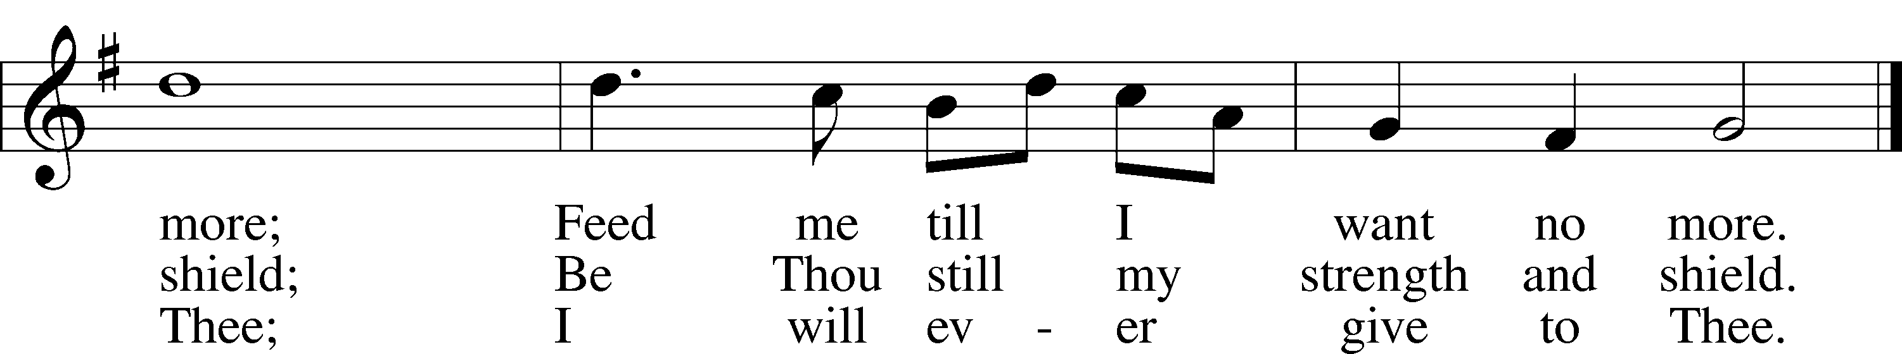

Announcements

**Join us** after the service in the fellowship hall for refreshments.

**Pastor Vogel** will conduct service on August 10th; and every Sunday in September.

We will be having our annual **Yard Sale** on Saturday, September 20th and Saturday September 27th. See flyer on narthex table. **Pre-priced** **items can be brought in and placed on the stage.**

**St. John’s Lutheran Church**

810 Broad St., Clifton, NJ 07013

StJohnsClifton.Org

PrayingHands810@gmail.com

Office: 973-778-1412