Fourth Sunday after Pentecost July 6, 2025 – Lectionary Series

St. John’s Lutheran Church



Order of Worship

by

Lutheran Service Builder

649 Blest Be the Tie That Binds

Stand for last verse

# Confession and Absolution

The sign of the cross may be made by all in remembrance of their Baptism.

Invocation

Exhortation LSB 151

Silence for reflection on God’s Word and for self-examination.

Confession of Sins LSB 151

Declaration LSB 151

# Service of the Word

Introit Psalm 19:2, 4–6; antiphon: v. 1

The heavens declare the glory of God,  
 **and the sky above proclaims his handiwork.**  
Day to day pours out speech,  
 **and night to night reveals knowledge.**  
Their measuring line goes out through all the earth, and their words to the end of the world.  
 **In them he has set a tent for the sun,**  
which comes out like a bridegroom leaving his chamber,  
 **and, like a strong man, runs its course with joy.**  
Its rising is from the end of the heavens, and its circuit to the end of them,  
 and there is nothing hidden from its heat.  
**Glory be to the Father and to the Son**  
 **and to the Holy Spirit;**  
**as it was in the beginning,**  
 **is now, and will be forever. Amen.**  
The heavens declare the glory of God,  
 **and the sky above proclaims his handiwork.**

Kyrie LSB 152

Gloria in Excelsis LSB 154

Salutation and Collect of the Day

P The Lord be with you.

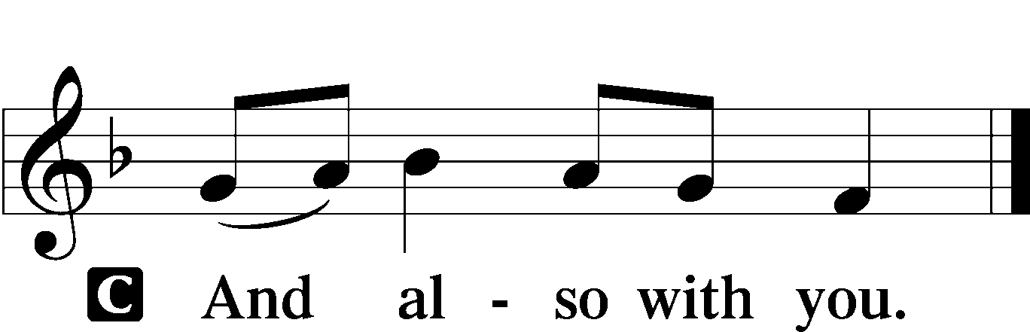

P Let us pray.

Almighty God, You have built Your Church on the foundation of the apostles and prophets with Christ Jesus Himself as the cornerstone. Continue to send Your messengers to preserve Your people in true peace that, by the preaching of Your Word, Your Church may be kept free from all harm and danger; through Jesus Christ, Your Son, our Lord, who lives and reigns with You and the Holy Spirit, one God, now and forever.



Sit

Old Testament Reading Isaiah 66:10–14

“Rejoice with Jerusalem, and be glad for her,  
 all you who love her;  
rejoice with her in joy,  
 all you who mourn over her;  
that you may nurse and be satisfied  
 from her consoling breast;  
that you may drink deeply with delight  
 from her glorious abundance.”  
For thus says the Lord:  
“Behold, I will extend peace to her like a river,  
 and the glory of the nations like an overflowing stream;  
and you shall nurse, you shall be carried upon her hip,  
 and bounced upon her knees.  
As one whom his mother comforts,  
 so I will comfort you;  
 you shall be comforted in Jerusalem.  
You shall see, and your heart shall rejoice;  
 your bones shall flourish like the grass;  
and the hand of the Lord shall be known to his servants,  
 and he shall show his indignation against his enemies.”

A This is the Word of the Lord.

C **Thanks be to God.**

Epistle Galatians 6:1–10, 14–18

Brothers, if anyone is caught in any transgression, you who are spiritual should restore him in a spirit of gentleness. Keep watch on yourself, lest you too be tempted. Bear one another’s burdens, and so fulfill the law of Christ. For if anyone thinks he is something, when he is nothing, he deceives himself. But let each one test his own work, and then his reason to boast will be in himself alone and not in his neighbor. For each will have to bear his own load.

One who is taught the word must share all good things with the one who teaches. Do not be deceived: God is not mocked, for whatever one sows, that will he also reap. For the one who sows to his own flesh will from the flesh reap corruption, but the one who sows to the Spirit will from the Spirit reap eternal life. And let us not grow weary of doing good, for in due season we will reap, if we do not give up. So then, as we have opportunity, let us do good to everyone, and especially to those who are of the household of faith. . . .

But far be it from me to boast except in the cross of our Lord Jesus Christ, by which the world has been crucified to me, and I to the world. For neither circumcision counts for anything, nor uncircumcision, but a new creation. And as for all who walk by this rule, peace and mercy be upon them, and upon the Israel of God.

From now on let no one cause me trouble, for I bear on my body the marks of Jesus.

The grace of our Lord Jesus Christ be with your spirit, brothers. Amen.

A This is the Word of the Lord.

C **Thanks be to God.**

Stand

Alleluia and Verse LSB 156

Holy Gospel Luke 10:1–20

P The Holy Gospel according to St. Luke, the tenth chapter.

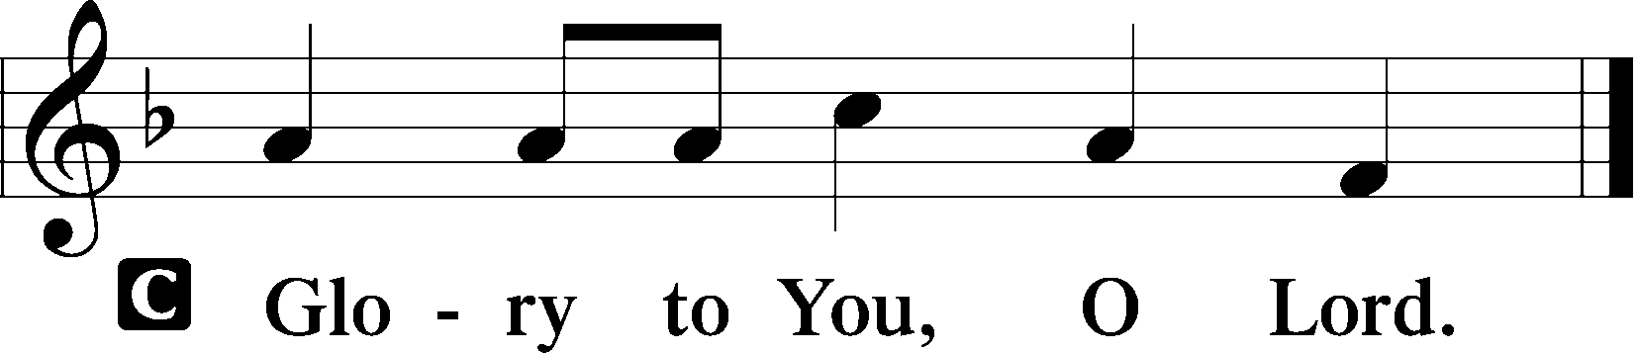

After this the Lord appointed seventy-two others and sent them on ahead of him, two by two, into every town and place where he himself was about to go. And he said to them, “The harvest is plentiful, but the laborers are few. Therefore pray earnestly to the Lord of the harvest to send out laborers into his harvest. Go your way; behold, I am sending you out as lambs in the midst of wolves. Carry no moneybag, no knapsack, no sandals, and greet no one on the road. Whatever house you enter, first say, ‘Peace be to this house!’ And if a son of peace is there, your peace will rest upon him. But if not, it will return to you. And remain in the same house, eating and drinking what they provide, for the laborer deserves his wages. Do not go from house to house. Whenever you enter a town and they receive you, eat what is set before you. Heal the sick in it and say to them, ‘The kingdom of God has come near to you.’ But whenever you enter a town and they do not receive you, go into its streets and say, ‘Even the dust of your town that clings to our feet we wipe off against you. Nevertheless know this, that the kingdom of God has come near.’ I tell you, it will be more bearable on that day for Sodom than for that town.

“Woe to you, Chorazin! Woe to you, Bethsaida! For if the mighty works done in you had been done in Tyre and Sidon, they would have repented long ago, sitting in sackcloth and ashes. But it will be more bearable in the judgment for Tyre and Sidon than for you. And you, Capernaum, will you be exalted to heaven? You shall be brought down to Hades.

“The one who hears you hears me, and the one who rejects you rejects me, and the one who rejects me rejects him who sent me.”

The seventy-two returned with joy, saying, “Lord, even the demons are subject to us in your name!” And he said to them, “I saw Satan fall like lightning from heaven. Behold, I have given you authority to tread on serpents and scorpions, and over all the power of the enemy, and nothing shall hurt you. Nevertheless, do not rejoice in this, that the spirits are subject to you, but rejoice that your names are written in heaven.”

P This is the Gospel of the Lord.

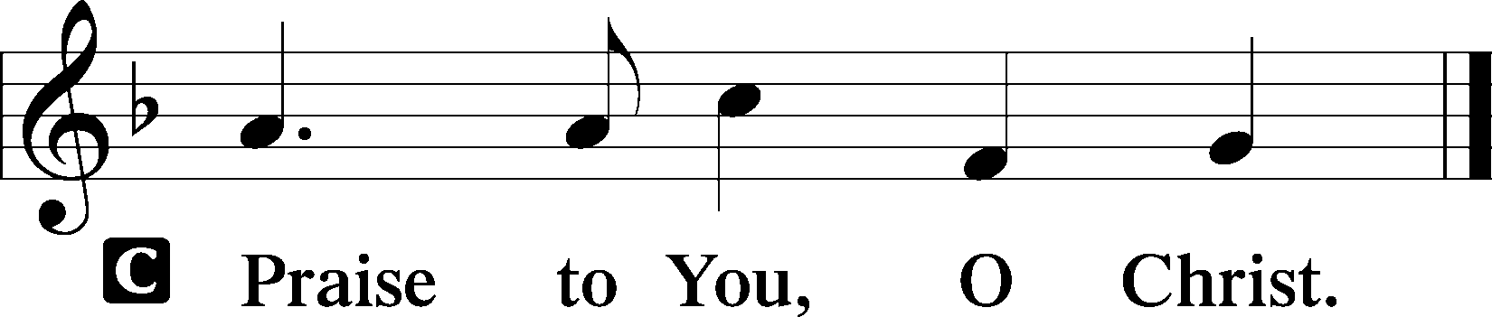

Apostles’ Creed

Sit

528 Oh, for a Thousand Tongues to Sing sts. 1–4

Sermon

Offering

Psalm for Meditation Psalm 66:1–7; antiphon: vv. 8–9

Shout for joy to God, all the earth;  
 sing the glory of his name;  
 give to him glorious praise!  
Say to God, “How awesome are your deeds!  
 So great is your power that your enemies come cringing to you.  
All the earth worships you  
 and sings praises to you;  
 they sing praises to your name.”

Come and see what God has done:  
 he is awesome in his deeds toward the children of man.  
He turned the sea into dry land;  
 they passed through the river on foot.  
There did we rejoice in him,  
 who rules by his might forever,  
whose eyes keep watch on the nations—  
 let not the rebellious exalt themselves.

Stand

781 We Give Thee But Thine Own sts. 1–2

Prayer of the Church

Lord’s Prayer

Benediction LSB 166

524 How Sweet the Name of Jesus Sounds sts. 1–4

Announcements

**Join us** after the service in the fellowship hall for refreshments.

**Pastor Vogel** will conduct service on July 13th & 27th; August 3rd and 10th; and every Sunday in September.

**Thank you** to the volunteers who read the lessons and those who conduct the service.

We will be having our annual **Yard Sale** on Saturday, September 20th and Saturday September 27th. See flyer on narthex table.

**St. John’s Lutheran Church**

810 Broad St., Clifton, NJ 07013

StJohnsClifton.Org

PrayingHands810@gmail.com

Office: 973-778-1412