Seventh Sunday after Pentecost July 27, 2025 – Lectionary Series

St. John’s Lutheran Church



Order of Worship

by

Lutheran Service Builder

901 Open Now Thy Gates of Beauty sts. 1–4

Stand for last verse

# Confession and Absolution

The sign of the cross may be made by all in remembrance of their Baptism.

Invocation

Exhortation LSB 151

Confession of Sins LSB 151

Absolution LSB 151

# Service of the Word

Introit Psalm 119:145–149; antiphon: Psalm 50:15

Call upon me in the day of trouble;  
 **I will deliver you, and you shall glorify me.**  
With my whole heart I cry; answer me, O Lord!  
 **I will keep your statutes.**  
I call to you; save me,  
 **that I may observe your testimonies.**  
I rise before dawn and cry for help;  
 **I hope in your words.**  
My eyes are awake before the watches of the night,  
 **that I may meditate on your promise.**  
Hear my voice according to your steadfast love;  
 **O Lord, according to your justice give me life.**  
**Glory be to the Father and to the Son**  
 **and to the Holy Spirit;**  
**as it was in the beginning,**  
 **is now, and will be forever. Amen.**  
Call upon me in the day of trouble;  
 **I will deliver you, and you shall glorify me.**

Kyrie LSB 152

This Is the Feast LSB 155

Salutation and Collect of the Day

Sit

Old Testament Reading Genesis 18:20–33

Then the Lord said, “Because the outcry against Sodom and Gomorrah is great and their sin is very grave, I will go down to see whether they have done altogether according to the outcry that has come to me. And if not, I will know.”

So the men turned from there and went toward Sodom, but Abraham still stood before the Lord. Then Abraham drew near and said, “Will you indeed sweep away the righteous with the wicked? Suppose there are fifty righteous within the city. Will you then sweep away the place and not spare it for the fifty righteous who are in it? Far be it from you to do such a thing, to put the righteous to death with the wicked, so that the righteous fare as the wicked! Far be that from you! Shall not the Judge of all the earth do what is just?” And the Lord said, “If I find at Sodom fifty righteous in the city, I will spare the whole place for their sake.”

Abraham answered and said, “Behold, I have undertaken to speak to the Lord, I who am but dust and ashes. Suppose five of the fifty righteous are lacking. Will you destroy the whole city for lack of five?” And he said, “I will not destroy it if I find forty-five there.” Again he spoke to him and said, “Suppose forty are found there.” He answered, “For the sake of forty I will not do it.” Then he said, “Oh let not the Lord be angry, and I will speak. Suppose thirty are found there.” He answered, “I will not do it, if I find thirty there.” He said, “Behold, I have undertaken to speak to the Lord. Suppose twenty are found there.” He answered, “For the sake of twenty I will not destroy it.” Then he said, “Oh let not the Lord be angry, and I will speak again but this once. Suppose ten are found there.” He answered, “For the sake of ten I will not destroy it.” And the Lord went his way, when he had finished speaking to Abraham, and Abraham returned to his place.

A This is the Word of the Lord.

C **Thanks be to God.**

Epistle Colossians 2:6–19

Therefore, as you received Christ Jesus the Lord, so walk in him, rooted and built up in him and established in the faith, just as you were taught, abounding in thanksgiving.

See to it that no one takes you captive by philosophy and empty deceit, according to human tradition, according to the elemental spirits of the world, and not according to Christ. For in him the whole fullness of deity dwells bodily, and you have been filled in him, who is the head of all rule and authority. In him also you were circumcised with a circumcision made without hands, by putting off the body of the flesh, by the circumcision of Christ, having been buried with him in baptism, in which you were also raised with him through faith in the powerful working of God, who raised him from the dead. And you, who were dead in your trespasses and the uncircumcision of your flesh, God made alive together with him, having forgiven us all our trespasses, by canceling the record of debt that stood against us with its legal demands. This he set aside, nailing it to the cross. He disarmed the rulers and authorities and put them to open shame, by triumphing over them in him.

Therefore let no one pass judgment on you in questions of food and drink, or with regard to a festival or a new moon or a Sabbath. These are a shadow of the things to come, but the substance belongs to Christ. Let no one disqualify you, insisting on asceticism and worship of angels, going on in detail about visions, puffed up without reason by his sensuous mind, and not holding fast to the Head, from whom the whole body, nourished and knit together through its joints and ligaments, grows with a growth that is from God.

A This is the Word of the Lord.

C **Thanks be to God.**

Stand

Alleluia and Verse LSB 156

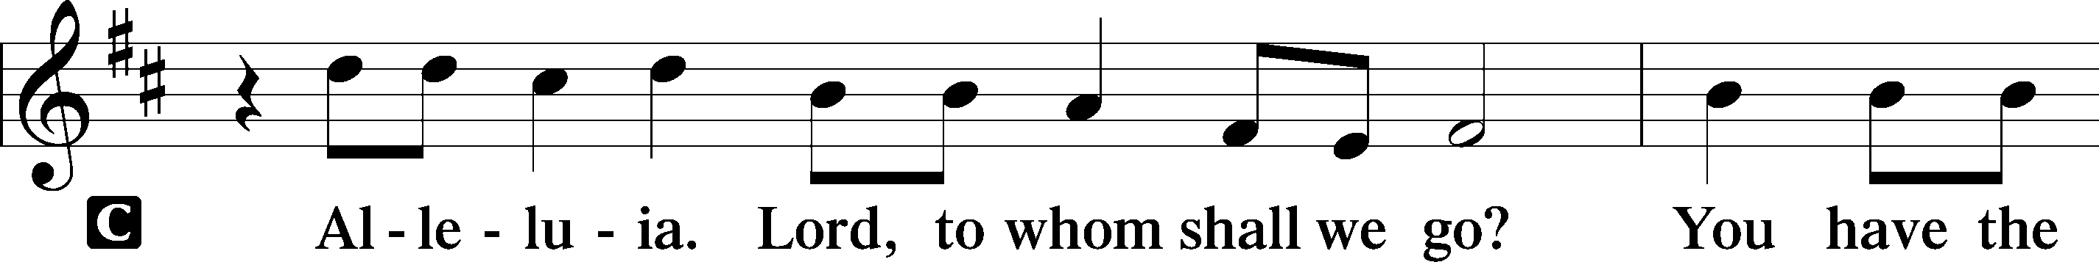

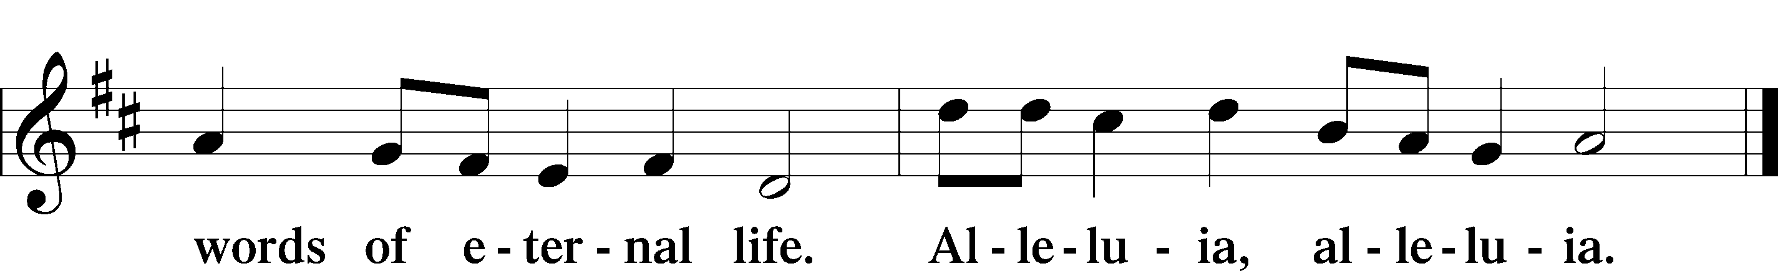

Holy Gospel Luke 11:1–13

P The Holy Gospel according to St. Luke, the eleventh chapter.

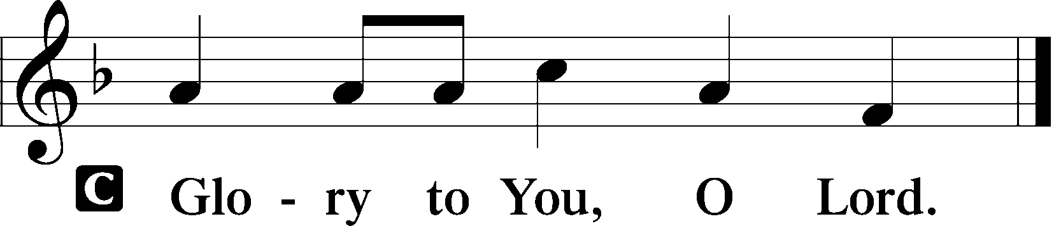

Now Jesus was praying in a certain place, and when he finished, one of his disciples said to him, “Lord, teach us to pray, as John taught his disciples.” And he said to them, “When you pray, say:

“Father, hallowed be your name.  
 Your kingdom come.  
 Give us each day our daily bread,  
 and forgive us our sins,  
 for we ourselves forgive everyone who is indebted to us.  
 And lead us not into temptation.”

And he said to them, “Which of you who has a friend will go to him at midnight and say to him, ‘Friend, lend me three loaves, for a friend of mine has arrived on a journey, and I have nothing to set before him’; and he will answer from within, ‘Do not bother me; the door is now shut, and my children are with me in bed. I cannot get up and give you anything’? I tell you, though he will not get up and give him anything because he is his friend, yet because of his impudence he will rise and give him whatever he needs. And I tell you, ask, and it will be given to you; seek, and you will find; knock, and it will be opened to you. For everyone who asks receives, and the one who seeks finds, and to the one who knocks it will be opened. What father among you, if his son asks for a fish, will instead of a fish give him a serpent; or if he asks for an egg, will give him a scorpion? If you then, who are evil, know how to give good gifts to your children, how much more will the heavenly Father give the Holy Spirit to those who ask him!”

P This is the Gospel of the Lord.

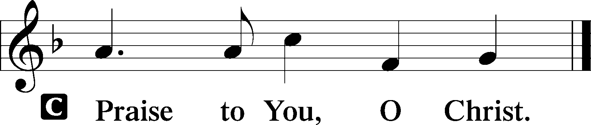

Nicene Creed

Sit

766 Our Father, Who from Heaven Above sts. 1–4

Sermon

Offering

Psalm for Meditation Psalm 138; antiphon: v. 3

I give you thanks, O Lord, with my whole heart;  
 before the gods I sing your praise;  
I bow down toward your holy temple  
 and give thanks to your name for your steadfast love and your faithfulness,  
 for you have exalted above all things  
 your name and your word.  
On the day I called, you answered me;  
 my strength of soul you increased.

All the kings of the earth shall give you thanks, O Lord,  
 for they have heard the words of your mouth,  
and they shall sing of the ways of the Lord,  
 for great is the glory of the Lord.  
For though the Lord is high, he regards the lowly,  
 but the haughty he knows from afar.

Though I walk in the midst of trouble,  
 you preserve my life;  
you stretch out your hand against the wrath of my enemies,  
 and your right hand delivers me.  
The Lord will fulfill his purpose for me;  
 your steadfast love, O Lord, endures forever.  
 Do not forsake the work of your hands.

Stand

781 We Give Thee But Thine Own sts. 1–2

Prayer of the Church

*After “Lord, in Your mercy” respond with “hear our prayer.”*

# Service of the Sacrament

Preface LSB 160

Proper Preface (Full)

Sanctus LSB 161

Prayer of Thanksgiving LSB 161

The Words of Our Lord

Proclamation of Christ

Lord’s Prayer

Pax Domini LSB 163

Agnus Dei LSB 163

Sit

Distribution & Distribution Hymn

620 Jesus Comes Today with Healing sts. 1–4

Stand

Thank the Lord LSB 164

Post-Communion Collect

Benediction LSB 166

549 All Hail the Power of Jesus’ Name sts. 1–4

Announcements

**Join us** after the service in the fellowship hall for refreshments.

**Pastor Vogel** will conduct service on August 3rd and 10th; and every Sunday in September.

We will be having our annual **Yard Sale** on Saturday, September 20th and Saturday September 27th. See flyer on narthex table.

**Pre-priced items may be brought in and placed on the stage.**

**St. John’s Lutheran Church**

810 Broad St., Clifton, NJ 07013

StJohnsClifton.Org

PrayingHands810@gmail.com

Office: 973-778-1412