Sixth Sunday after Pentecost July 20, 2025 – Lectionary Series

St. John’s Lutheran Church



Order of Worship

by

Lutheran Service Builder

728 How Firm a Foundation sts. 1–4

Stand for last verse

# Confession and Absolution.

Invocation

Exhortation LSB 151

Silence for reflection on God’s Word and for self-examination.

Confession of Sins LSB 151

Declaration LSB 151

# Service of the Word

Introit Psalm 119:57–60, 64; antiphon: v. 105

Your word is a lamp to my feet  
 **and a light to my path.**  
The Lord is my portion;  
 **I promise to keep your words.**  
I entreat your favor with all my heart;  
 **be gracious to me according to your promise.**  
When I think on my ways,  
 **I turn my feet to your testimonies;**  
I hasten and do not delay  
 **to keep your commandments.**  
The earth, O Lord, is full of your steadfast love;  
 **teach me your statutes!**  
**Glory be to the Father and to the Son**  
 **and to the Holy Spirit;**  
**as it was in the beginning,**  
 **is now, and will be forever. Amen.**  
Your word is a lamp to my feet  
 **and a light to my path.**

Kyrie LSB 152

Gloria in Excelsis LSB 154

Salutation and Collect of the Day

Sit

Old Testament Reading Genesis 18:1–14

The Lord appeared to [Abraham] by the oaks of Mamre, as he sat at the door of his tent in the heat of the day. He lifted up his eyes and looked, and behold, three men were standing in front of him. When he saw them, he ran from the tent door to meet them and bowed himself to the earth and said, “O Lord, if I have found favor in your sight, do not pass by your servant. Let a little water be brought, and wash your feet, and rest yourselves under the tree, while I bring a morsel of bread, that you may refresh yourselves, and after that you may pass on—since you have come to your servant.” So they said, “Do as you have said.” And Abraham went quickly into the tent to Sarah and said, “Quick! Three seahs of fine flour! Knead it, and make cakes.” And Abraham ran to the herd and took a calf, tender and good, and gave it to a young man, who prepared it quickly. Then he took curds and milk and the calf that he had prepared, and set it before them. And he stood by them under the tree while they ate.

They said to him, “Where is Sarah your wife?” And he said, “She is in the tent.” The Lord said, “I will surely return to you about this time next year, and Sarah your wife shall have a son.” And Sarah was listening at the tent door behind him. Now Abraham and Sarah were old, advanced in years. The way of women had ceased to be with Sarah. So Sarah laughed to herself, saying, “After I am worn out, and my lord is old, shall I have pleasure?” The Lord said to Abraham, “Why did Sarah laugh and say, ‘Shall I indeed bear a child, now that I am old?’ Is anything too hard for the Lord? At the appointed time I will return to you about this time next year, and Sarah shall have a son.”

A This is the Word of the Lord.

C **Thanks be to God.**

Epistle Colossians 1:21–29

You, who once were alienated and hostile in mind, doing evil deeds, he has now reconciled in his body of flesh by his death, in order to present you holy and blameless and above reproach before him, if indeed you continue in the faith, stable and steadfast, not shifting from the hope of the gospel that you heard, which has been proclaimed in all creation under heaven, and of which I, Paul, became a minister.

Now I rejoice in my sufferings for your sake, and in my flesh I am filling up what is lacking in Christ’s afflictions for the sake of his body, that is, the church, of which I became a minister according to the stewardship from God that was given to me for you, to make the word of God fully known, the mystery hidden for ages and generations but now revealed to his saints. To them God chose to make known how great among the Gentiles are the riches of the glory of this mystery, which is Christ in you, the hope of glory. Him we proclaim, warning everyone and teaching everyone with all wisdom, that we may present everyone mature in Christ. For this I toil, struggling with all his energy that he powerfully works within me.

A This is the Word of the Lord.

C **Thanks be to God.**

Stand

Alleluia and Verse LSB 156

Holy Gospel Luke 10:38–42

P The Holy Gospel according to St. Luke, the tenth chapter.

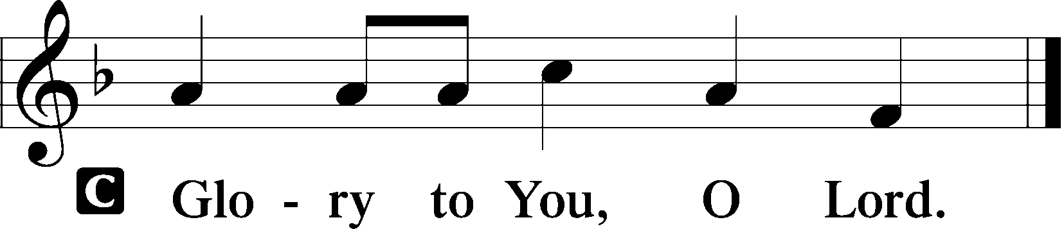

Now as they went on their way, Jesus entered a village. And a woman named Martha welcomed him into her house. And she had a sister called Mary, who sat at the Lord’s feet and listened to his teaching. But Martha was distracted with much serving. And she went up to him and said, “Lord, do you not care that my sister has left me to serve alone? Tell her then to help me.” But the Lord answered her, “Martha, Martha, you are anxious and troubled about many things, but one thing is necessary. Mary has chosen the good portion, which will not be taken away from her.”

P This is the Gospel of the Lord.

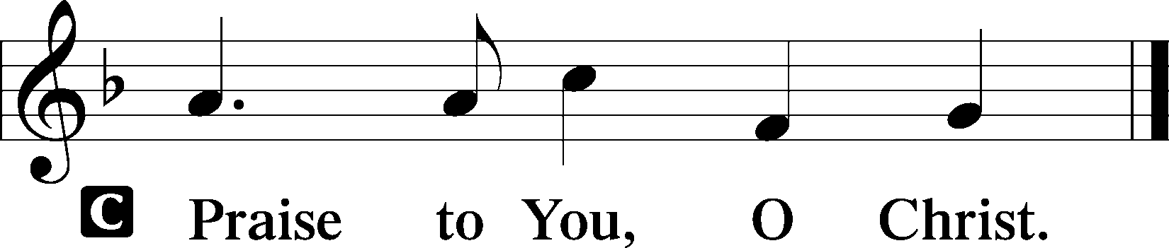

Apostles’ Creed

Sit

862 Oh, Blest the House

Sermon

Offering

Psalm for Meditation Psalm 27; antiphon: v. 4

The Lord is my light and my salvation;  
 whom shall I fear?  
The Lord is the stronghold of my life;  
 of whom shall I be afraid?

When evildoers assail me  
 to eat up my flesh,  
my adversaries and foes,  
 it is they who stumble and fall.

Though an army encamp against me,  
 my heart shall not fear;  
though war arise against me,  
 yet I will be confident.

One thing have I asked of the Lord,  
 that will I seek after:  
that I may dwell in the house of the Lord  
 all the days of my life,  
to gaze upon the beauty of the Lord  
 and to inquire in his temple.

For he will hide me in his shelter  
 in the day of trouble;

he will conceal me under the cover of his tent;  
 he will lift me high upon a rock.

And now my head shall be lifted up  
 above my enemies all around me,  
 and I will offer in his tent  
 sacrifices with shouts of joy;  
I will sing and make melody to the Lord.

Hear, O Lord, when I cry aloud;  
 be gracious to me and answer me!  
You have said, “Seek my face.”  
My heart says to you,  
 “Your face, Lord, do I seek.”  
 Hide not your face from me.  
Turn not your servant away in anger,  
 O you who have been my help.  
Cast me not off; forsake me not,  
 O God of my salvation!  
For my father and my mother have forsaken me,  
 but the Lord will take me in.

Teach me your way, O Lord,  
 and lead me on a level path  
 because of my enemies.  
Give me not up to the will of my adversaries;  
 for false witnesses have risen against me,  
 and they breathe out violence.

I believe that I shall look upon the goodness of the Lord  
 in the land of the living!  
Wait for the Lord;  
 be strong, and let your heart take courage;  
 wait for the Lord!

Stand

781 We Give Thee But Thine Own sts. 1–2

Prayer of the Church

*After “let us pray to the Lord:” respond with “Lord, have mercy.”*

Lord’s Prayer

Benediction LSB 166

537 Beautiful Savior

Announcements

**Join us** after the service in the fellowship hall for refreshments lovingly set out by Ellen.

**Pastor Vogel** will conduct service on July 27th; August 3rd and 10th; and every Sunday in September.

We will be having our annual **Yard Sale** on Saturday, September 20th and Saturday September 27th. See flyer on narthex table.

**St. John’s Lutheran Church**

810 Broad St., Clifton, NJ 07013

StJohnsClifton.Org

PrayingHands810@gmail.com

Office: 973-778-1412