Fifth Sunday after Pentecost July 13, 2025 – Lectionary Series

St. John’s Lutheran Church



Order of Worship

by

Lutheran Service Builder

526 You Are the Way; through You Alone

Stand for last verse

# Confession and Absolution

Invocation

Exhortation LSB 184

Confession of Sins LSB 184

Absolution LSB 185

# Service of the Word

Introit Psalm 136:23–26; antiphon: v. 1

Give thanks to the Lord, for he is good,  
 **for his steadfast love endures forever.**  
It is he who remembered us in our low estate,  
 **for his steadfast love endures forever;**  
and rescued us from our foes,  
 **for his steadfast love endures forever;**  
he who gives food to all flesh,  
 **for his steadfast love endures forever.**  
Give thanks to the God of heaven,  
 **for his steadfast love endures forever.**  
**Glory be to the Father and to the Son**  
 **and to the Holy Spirit;**  
**as it was in the beginning,**  
 **is now, and will be forever. Amen.**  
Give thanks to the Lord, for he is good,  
 **for his steadfast love endures forever.**

Kyrie LSB 186

Gloria in Excelsis LSB 187

Salutation and Collect of the Day

Sit

Old Testament Reading Leviticus 18:1–5; 19:9–18

The Lord spoke to Moses, saying, “Speak to the people of Israel and say to them, I am the Lord your God. You shall not do as they do in the land of Egypt, where you lived, and you shall not do as they do in the land of Canaan, to which I am bringing you. You shall not walk in their statutes. You shall follow my rules and keep my statutes and walk in them. I am the Lord your God. You shall therefore keep my statutes and my rules; if a person does them, he shall live by them: I am the Lord. . . .

“When you reap the harvest of your land, you shall not reap your field right up to its edge, neither shall you gather the gleanings after your harvest. And you shall not strip your vineyard bare, neither shall you gather the fallen grapes of your vineyard. You shall leave them for the poor and for the sojourner: I am the Lord your God.

“You shall not steal; you shall not deal falsely; you shall not lie to one another. You shall not swear by my name falsely, and so profane the name of your God: I am the Lord.

“You shall not oppress your neighbor or rob him. The wages of a hired servant shall not remain with you all night until the morning. You shall not curse the deaf or put a stumbling block before the blind, but you shall fear your God: I am the Lord.

“You shall do no injustice in court. You shall not be partial to the poor or defer to the great, but in righteousness shall you judge your neighbor. You shall not go around as a slanderer among your people, and you shall not stand up against the life of your neighbor: I am the Lord.

“You shall not hate your brother in your heart, but you shall reason frankly with your neighbor, lest you incur sin because of him. You shall not take vengeance or bear a grudge against the sons of your own people, but you shall love your neighbor as yourself: I am the Lord.”

A This is the Word of the Lord.

C **Thanks be to God.**

Epistle Colossians 1:1–14

Paul, an apostle of Christ Jesus by the will of God, and Timothy our brother,

To the saints and faithful brothers in Christ at Colossae:

Grace to you and peace from God our Father.

We always thank God, the Father of our Lord Jesus Christ, when we pray for you, since we heard of your faith in Christ Jesus and of the love that you have for all the saints, because of the hope laid up for you in heaven. Of this you have heard before in the word of the truth, the gospel, which has come to you, as indeed in the whole world it is bearing fruit and growing—as it also does among you, since the day you heard it and understood the grace of God in truth, just as you learned it from Epaphras our beloved fellow servant. He is a faithful minister of Christ on your behalf and has made known to us your love in the Spirit.

And so, from the day we heard, we have not ceased to pray for you, asking that you may be filled with the knowledge of his will in all spiritual wisdom and understanding, so as to walk in a manner worthy of the Lord, fully pleasing to him, bearing fruit in every good work and increasing in the knowledge of God. May you be strengthened with all power, according to his glorious might, for all endurance and patience with joy, giving thanks to the Father, who has qualified you to share in the inheritance of the saints in light. He has delivered us from the domain of darkness and transferred us to the kingdom of his beloved Son, in whom we have redemption, the forgiveness of sins.

A This is the Word of the Lord.

C **Thanks be to God.**

Stand

Alleluia LSB 190

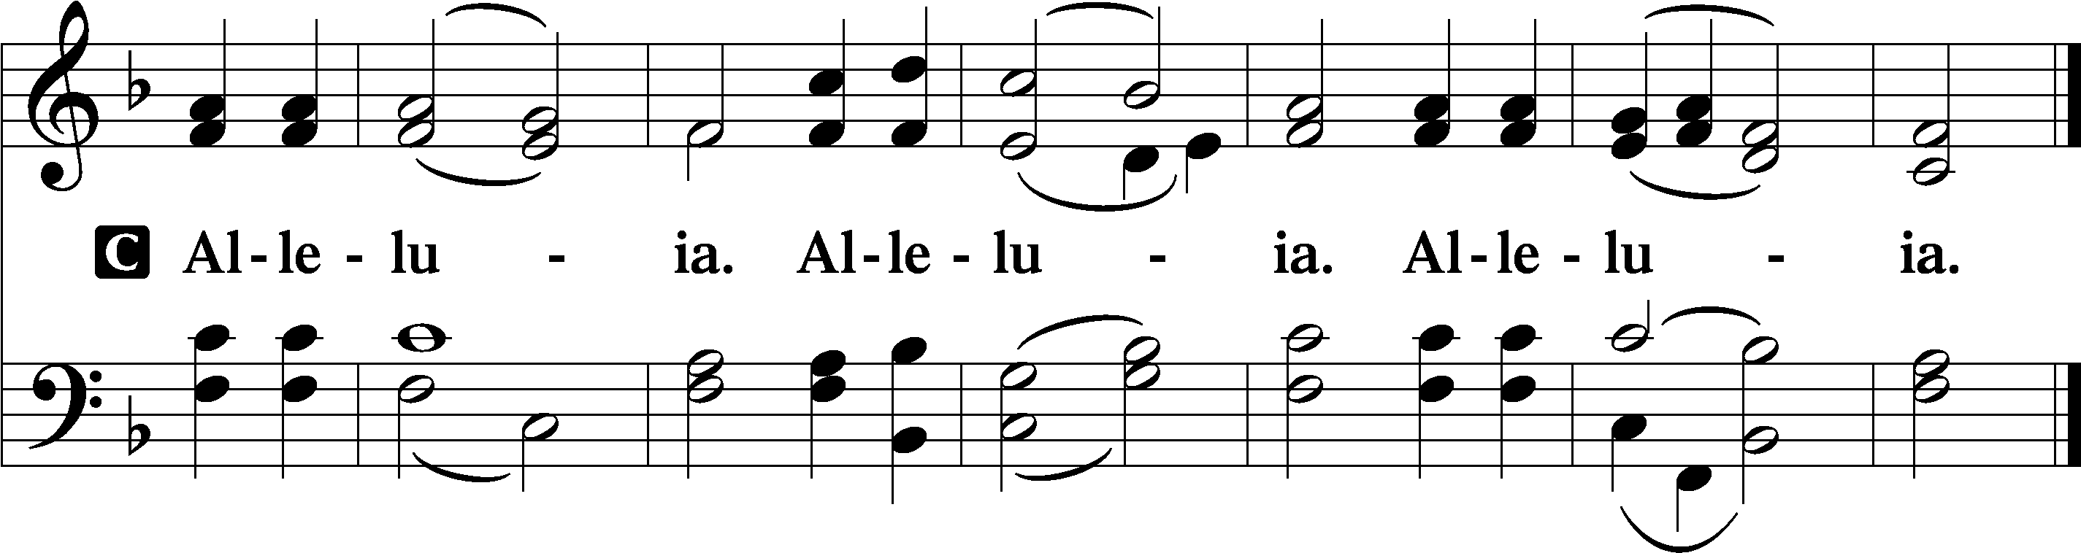

Holy Gospel Luke 10:25–37

P The Holy Gospel according to St. Luke, the tenth chapter.

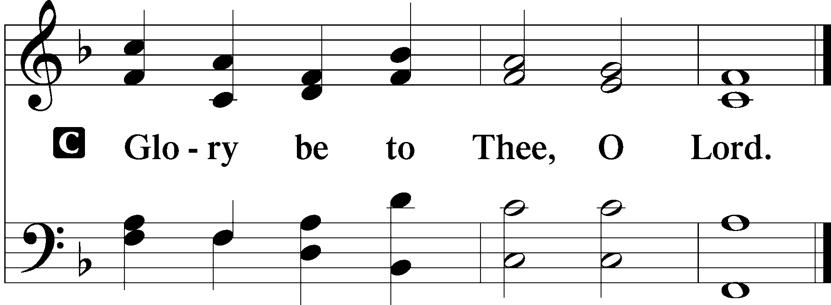

Behold, a lawyer stood up to put [Jesus] to the test, saying, “Teacher, what shall I do to inherit eternal life?” He said to him, “What is written in the Law? How do you read it?” And he answered, “You shall love the Lord your God with all your heart and with all your soul and with all your strength and with all your mind, and your neighbor as yourself.” And he said to him, “You have answered correctly; do this, and you will live.”

But he, desiring to justify himself, said to Jesus, “And who is my neighbor?” Jesus replied, “A man was going down from Jerusalem to Jericho, and he fell among robbers, who stripped him and beat him and departed, leaving him half dead. Now by chance a priest was going down that road, and when he saw him he passed by on the other side. So likewise a Levite, when he came to the place and saw him, passed by on the other side. But a Samaritan, as he journeyed, came to where he was, and when he saw him, he had compassion. He went to him and bound up his wounds, pouring on oil and wine. Then he set him on his own animal and brought him to an inn and took care of him. And the next day he took out two denarii and gave them to the innkeeper, saying, ‘Take care of him, and whatever more you spend, I will repay you when I come back.’ Which of these three, do you think, proved to be a neighbor to the man who fell among the robbers?” He said, “The one who showed him mercy.” And Jesus said to him, “You go, and do likewise.”

P This is the Gospel of the Lord.

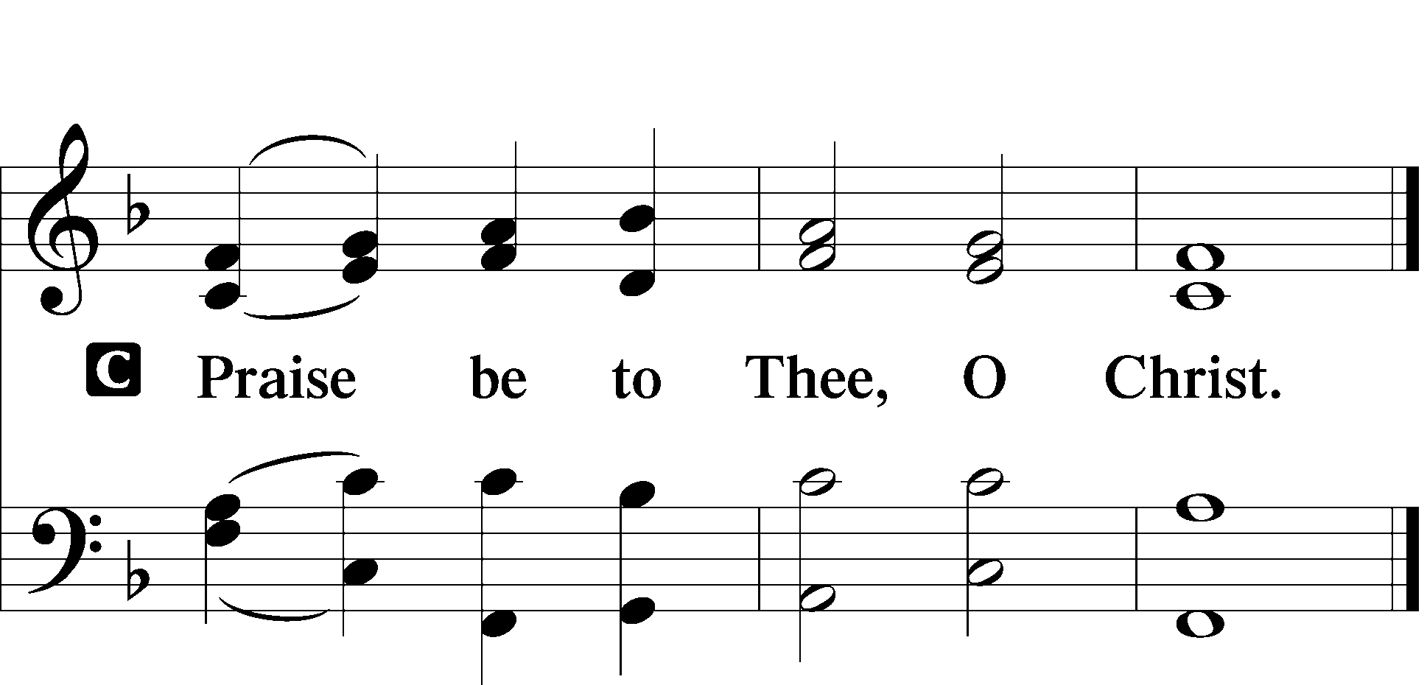

Nicene Creed

Sit

845 Where Charity and Love Prevail sts. 1–4

Sermon

Offering

Psalm for Meditation Psalm 41; antiphon: v. 1

Blessèd is the one who considers the poor!  
 In the day of trouble the Lord delivers him;  
the Lord protects him and keeps him alive;  
 he is called blessèd in the land;  
 you do not give him up to the will of his enemies.  
The Lord sustains him on his sickbed;  
 in his illness you restore him to full health.

As for me, I said, “O Lord, be gracious to me;  
 heal me, for I have sinned against you!”  
My enemies say of me in malice,  
 “When will he die and his name perish?”  
And when one comes to see me, he utters empty words,  
 while his heart gathers iniquity;  
 when he goes out, he tells it abroad.  
All who hate me whisper together about me;  
 they imagine the worst for me.

They say, “A deadly thing is poured out on him;  
 he will not rise again from where he lies.”  
Even my close friend in whom I trusted,  
 who ate my bread, has lifted his heel against me.  
But you, O Lord, be gracious to me,  
 and raise me up, that I may repay them!

By this I know that you delight in me:  
 my enemy will not shout in triumph over me.  
But you have upheld me because of my integrity,  
 and set me in your presence forever.

Blessèd be the Lord, the God of Israel,  
 from everlasting to everlasting!  
 Amen and Amen.

Stand

781 We Give Thee But Thine Own sts. 1–2

Prayer of the Church

*After “Lord, in Your mercy” respond with “hear our prayer.”*

# Service of the Sacrament

Preface LSB 194

Proper Preface (Full)

Sanctus 195

Lord’s Prayer LSB 196

The Words of Our Lord 197

Pax Domini LSB 197

Agnus Dei LSB 198

Sit

Distribution & Distribution Hymn

637 Draw Near and Take the Body of the Lord

Stand

Nunc Dimittis LSB 199

Thanksgiving LSB 200

Post-Communion Collect

Salutation LSB 201

Benedicamus LSB 202

Benediction LSB 202

803 Joyful, Joyful We Adore Thee

Announcements

**Join us** after the service in the fellowship hall for refreshments.

**Pastor Vogel** will conduct service on July 27th; August 3rd and 10th; and every Sunday in September.

**Thank you** to the volunteers who read the lessons and those who conduct the service.

We will be having our annual **Yard Sale** on Saturday, September 20th and Saturday September 27th. See flyer on narthex table.