Third Sunday after Pentecost June 29, 2025 – Lectionary Series

St. John’s Lutheran Church



Order of Worship

by

Lutheran Service Builder

411 I Want to Walk as a Child of the Light

Stand for last verse

# Confession and Absolution

Invocation

Exhortation LSB 184

Silence for reflection on God’s Word and for self-examination.

Confession of Sins LSB 184

Declaration LSB 185

# Service of the Word

Introit Psalm 85:8–10, 13; antiphon: v. 7

Show us your steadfast love, O Lord,  
 **and grant us your salvation.**  
Let me hear what God the Lord will speak,  
 **for he will speak peace to his people, to his saints; but let them not turn back to folly.**  
Surely his salvation is near to those who fear him,  
 **that glory may dwell in our land.**  
Steadfast love and faithfulness meet;  
 **righteousness and peace kiss each other.**  
Righteousness will go before him  
 **and make his footsteps a way.**  
**Glory be to the Father and to the Son**  
 **and to the Holy Spirit;**  
**as it was in the beginning,**  
 **is now, and will be forever. Amen.**  
Show us your steadfast love, O Lord,  
 **and grant us your salvation.**

Kyrie LSB 186

Gloria in Excelsis LSB 187

Salutation and Collect of the Day

Sit

Old Testament Reading 1 Kings 19:9b–21

Behold, the word of the Lord came to [Elijah], and he said to him, “What are you doing here, Elijah?” He said, “I have been very jealous for the Lord, the God of hosts. For the people of Israel have forsaken your covenant, thrown down your altars, and killed your prophets with the sword, and I, even I only, am left, and they seek my life, to take it away.” And he said, “Go out and stand on the mount before the Lord.” And behold, the Lord passed by, and a great and strong wind tore the mountains and broke in pieces the rocks before the Lord, but the Lord was not in the wind. And after the wind an earthquake, but the Lord was not in the earthquake. And after the earthquake a fire, but the Lord was not in the fire. And after the fire the sound of a low whisper. And when Elijah heard it, he wrapped his face in his cloak and went out and stood at the entrance of the cave. And behold, there came a voice to him and said, “What are you doing here, Elijah?” He said, “I have been very jealous for the Lord, the God of hosts. For the people of Israel have forsaken your covenant, thrown down your altars, and killed your prophets with the sword, and I, even I only, am left, and they seek my life, to take it away.” And the Lord said to him, “Go, return on your way to the wilderness of Damascus. And when you arrive, you shall anoint Hazael to be king over Syria. And Jehu the son of Nimshi you shall anoint to be king over Israel, and Elisha the son of Shaphat of Abel-meholah you shall anoint to be prophet in your place. And the one who escapes from the sword of Hazael shall Jehu put to death, and the one who escapes from the sword of Jehu shall Elisha put to death. Yet I will leave seven thousand in Israel, all the knees that have not bowed to Baal, and every mouth that has not kissed him.”

So he departed from there and found Elisha the son of Shaphat, who was plowing with twelve yoke of oxen in front of him, and he was with the twelfth. Elijah passed by him and cast his cloak upon him. And he left the oxen and ran after Elijah and said, “Let me kiss my father and my mother, and then I will follow you.” And he said to him, “Go back again, for what have I done to you?” And he returned from following him and took the yoke of oxen and sacrificed them and boiled their flesh with the yokes of the oxen and gave it to the people, and they ate. Then he arose and went after Elijah and assisted him.

A This is the Word of the Lord.

C **Thanks be to God.**

Epistle Galatians 5:1, 13–25

For freedom Christ has set us free; stand firm therefore, and do not submit again to a yoke of slavery. . . .

For you were called to freedom, brothers. Only do not use your freedom as an opportunity for the flesh, but through love serve one another. For the whole law is fulfilled in one word: “You shall love your neighbor as yourself.” But if you bite and devour one another, watch out that you are not consumed by one another.

But I say, walk by the Spirit, and you will not gratify the desires of the flesh. For the desires of the flesh are against the Spirit, and the desires of the Spirit are against the flesh, for these are opposed to each other, to keep you from doing the things you want to do. But if you are led by the Spirit, you are not under the law. Now the works of the flesh are evident: sexual immorality, impurity, sensuality, idolatry, sorcery, enmity, strife, jealousy, fits of anger, rivalries, dissensions, divisions, envy, drunkenness, orgies, and things like these. I warn you, as I warned you before, that those who do such things will not inherit the kingdom of God. But the fruit of the Spirit is love, joy, peace, patience, kindness, goodness, faithfulness, gentleness, self-control; against such things there is no law. And those who belong to Christ Jesus have crucified the flesh with its passions and desires.

If we live by the Spirit, let us also walk by the Spirit.

A This is the Word of the Lord.

C **Thanks be to God.**

Stand

Alleluia LSB 190

Holy Gospel Luke 9:51–62

P The Holy Gospel according to St. Luke, the ninth chapter.

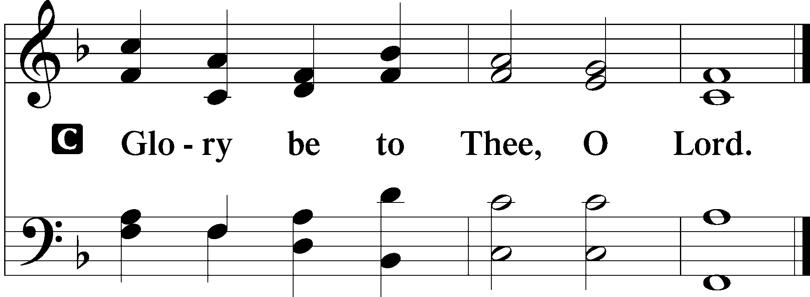

When the days drew near for [Jesus] to be taken up, he set his face to go to Jerusalem. And he sent messengers ahead of him, who went and entered a village of the Samaritans, to make preparations for him. But the people did not receive him, because his face was set toward Jerusalem. And when his disciples James and John saw it, they said, “Lord, do you want us to tell fire to come down from heaven and consume them?” But he turned and rebuked them. And they went on to another village.

As they were going along the road, someone said to him, “I will follow you wherever you go.” And Jesus said to him, “Foxes have holes, and birds of the air have nests, but the Son of Man has nowhere to lay his head.” To another he said, “Follow me.” But he said, “Lord, let me first go and bury my father.” And Jesus said to him, “Leave the dead to bury their own dead. But as for you, go and proclaim the kingdom of God.” Yet another said, “I will follow you, Lord, but let me first say farewell to those at my home.” Jesus said to him, “No one who puts his hand to the plow and looks back is fit for the kingdom of God.”

P This is the Gospel of the Lord.

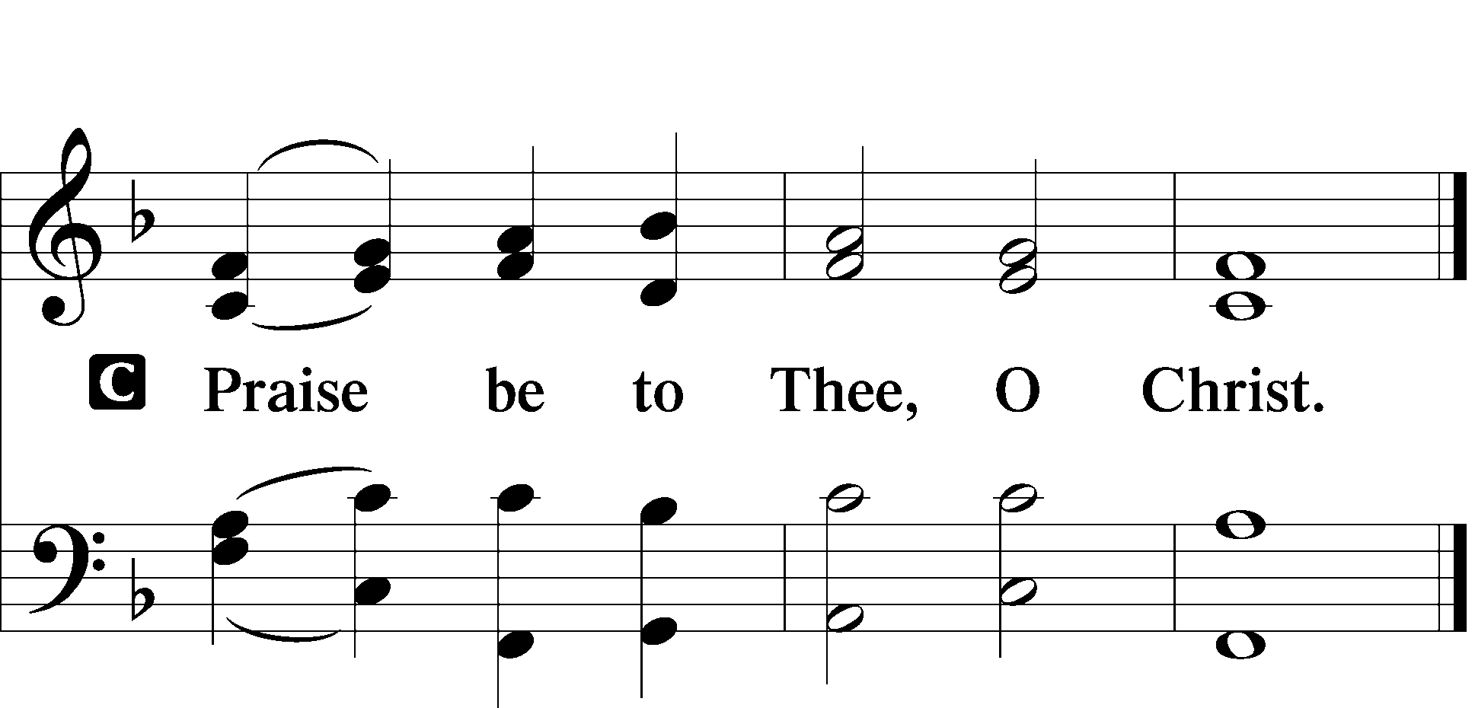

Apostles’ Creed

Sit

685 Let Us Ever Walk with Jesus

Sermon

Offering

Psalm for Meditation Psalm 16; antiphon: v. 11

Preserve me, O God,  
 for in you I take refuge.  
I say to the Lord, “You are my Lord;  
 I have no good apart from you.”

As for the saints in the land,  
 they are the excellent ones,  
 in whom is all my delight.

The sorrows of those who run after another god shall multiply;  
 their drink offerings of blood I will not pour out  
 or take their names on my lips.

The Lord is my chosen portion and my cup;  
 you hold my lot.  
The lines have fallen for me in pleasant places;  
 indeed, I have a beautiful inheritance.

I bless the Lord who gives me counsel;  
 in the night also my heart instructs me.  
I have set the Lord always before me;  
 because he is at my right hand, I shall not be shaken.

Therefore my heart is glad, and my whole being rejoices;  
 my flesh also dwells secure.  
For you will not abandon my soul to Sheol,  
 or let your holy one see corruption.

You make known to me the path of life;  
 in your presence there is fullness of joy;  
 at your right hand are pleasures forevermore.

Stand

781 We Give Thee But Thine Own sts. 1–2

Prayer of the Church

*After “Lord, in Your mercy” respond with “hear our prayer.”*

Lord’s Prayer LSB 196

Salutation LSB 201

Benedicamus LSB 202

Benediction LSB 202

395 O Morning Star, How Fair and Bright sts. 1–4

Announcements

**Join us** after the service in the fellowship hall for refreshments.

**Pastor Vogel** will conduct service on July 13th & 27th.

**Thank you** to the volunteers who read the lessons and those who conduct the service.

We will be having our annual **Yard Sale** on Saturday, September 20th and Saturday September 27th. See flyer on narthex table.

**St. John’s Lutheran Church**

810 Broad St., Clifton, NJ 07013

StJohnsClifton.Org

PrayingHands810@gmail.com

Office: 973-778-1412