Second Sunday after Pentecost June 22, 2025 – Lectionary Series

St. John’s Lutheran Church



Order of Worship

by

Lutheran Service Builder

903 This Is the Day the Lord Has Made

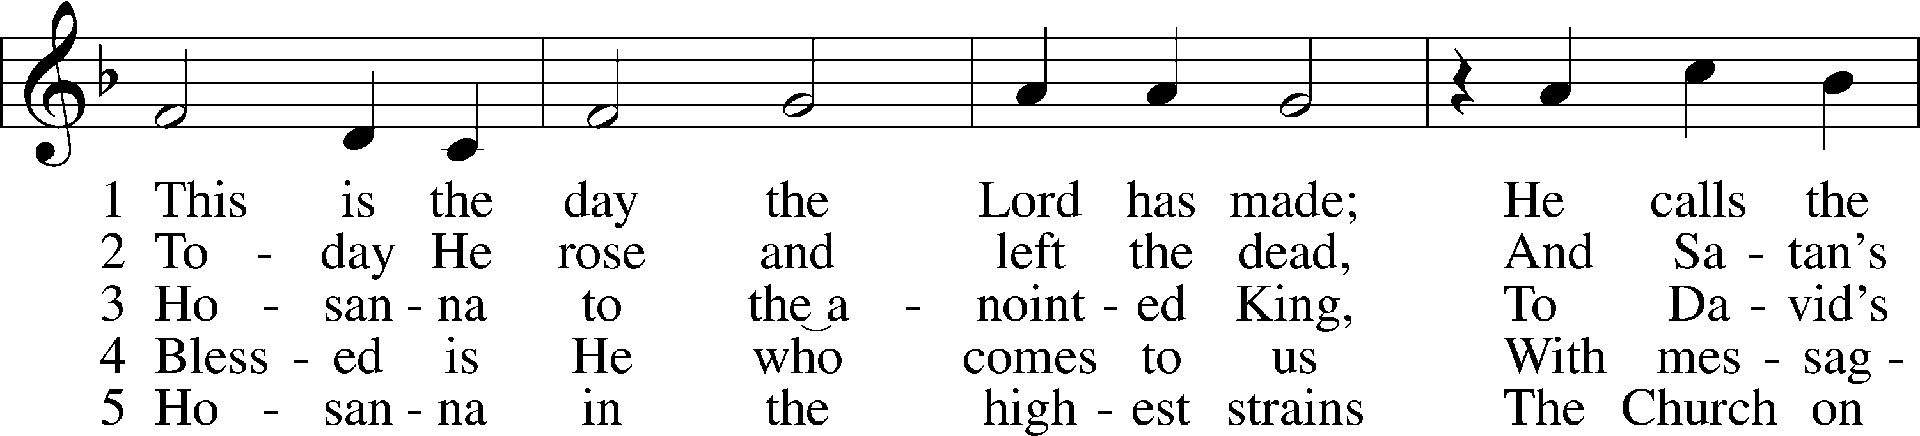

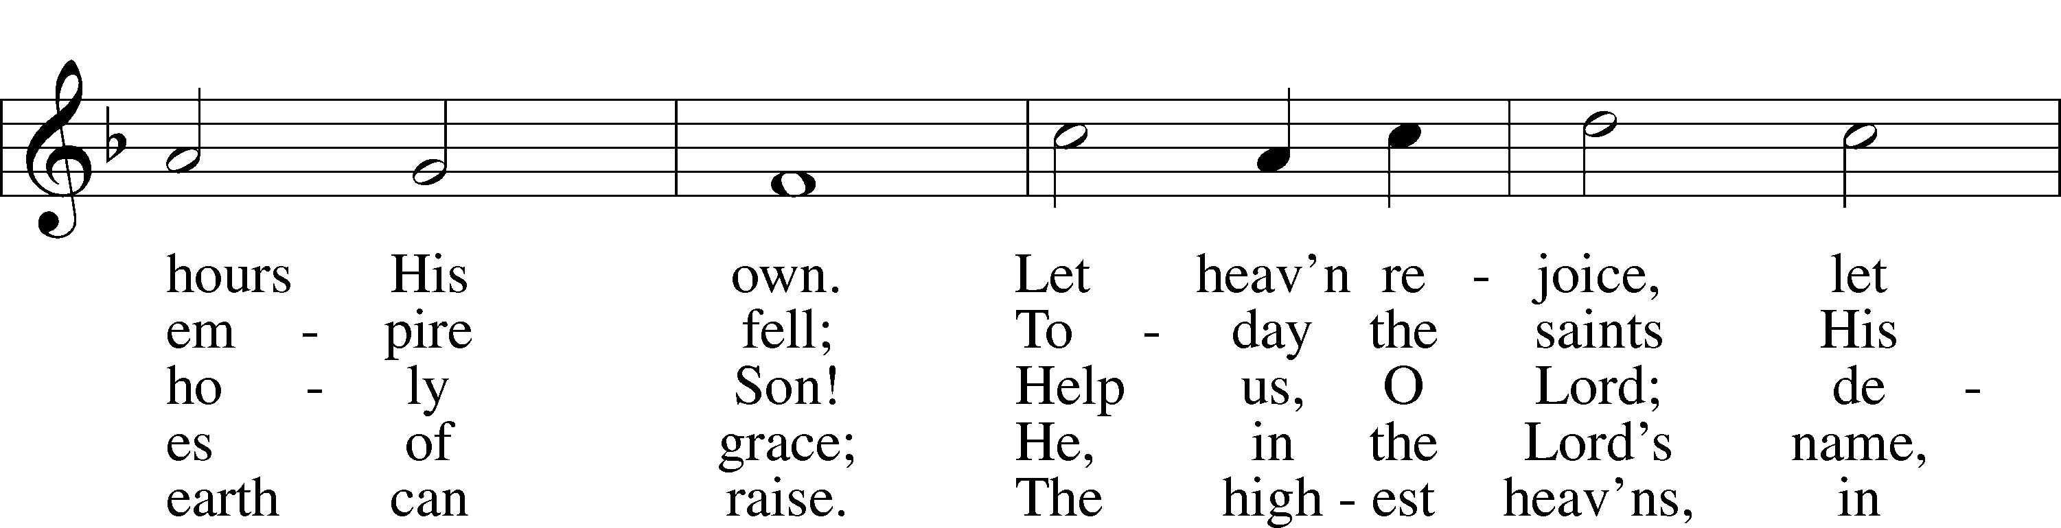

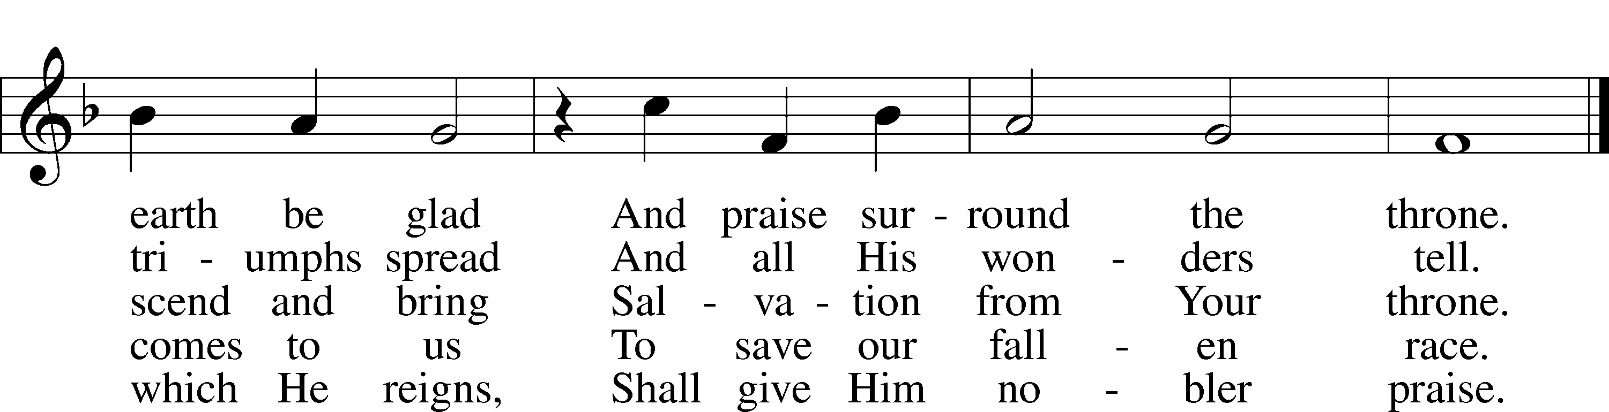

Stand for last verse

# Confession and Absolution

The sign of the cross may be made by all in remembrance of their Baptism.

Invocation

P In the name of the Father and of the T Son and of the Holy Spirit.

C **Amen.**

Exhortation LSB 151

P If we say we have no sin, we deceive ourselves, and the truth is not in us.

C **But if we confess our sins, God, who is faithful and just, will forgive our sins and cleanse us from all unrighteousness.**

Silence for reflection on God’s Word and for self-examination.

Confession of Sins LSB 151

P Let us then confess our sins to God our Father.

C **Most merciful God, we confess that we are by nature sinful and unclean. We have sinned against You in thought, word, and deed, by what we have done and by what we have left undone. We have not loved You with our whole heart; we have not loved our neighbors as ourselves. We justly deserve Your present and eternal punishment. For the sake of Your Son, Jesus Christ, have mercy on us. Forgive us, renew us, and lead us, so that we may delight in Your will and walk in Your ways to the glory of Your holy name. Amen.**

**Declaration**

P In the mercy of almighty God, Jesus Christ was given to die for us, and for his sake God forgives us all our sins. To those who believe in Jesus Christ He gives the power to become the children of God and bestows on them the Holy Spirit. May the Lord, who has begun this good work in us, bring it to completion in the day of our Lord Jesus Christ.

C **Amen.**

# Service of the Word

Introit Psalm 71:20–24; antiphon: v. 3

Be to me a rock of refuge, to which I may continually come;  
 **you have given the command to save me, for you are my rock and my fortress.**  
You who have made me see many troubles and calamities will revive me again;  
 **from the depths of the earth you will bring me up again.**You will increase my greatness  
 **and comfort me again.**  
I will also praise you with the harp for your faithfulness, O my God;  
 **I will sing praises to you with the lyre, O Holy One of Israel.**  
My lips will shout for joy, when I sing praises to you;  
 **my soul also, which you have redeemed.**  
And my tongue will talk of your righteous help all the day long,  
 **for they have been put to shame and disappointed who sought to do me hurt.**  
**Glory be to the Father and to the Son**  
 **and to the Holy Spirit;**  
**as it was in the beginning,**  
 **is now, and will be forever. Amen.**  
Be to me a rock of refuge, to which I may continually come;  
 **you have given the command to save me, for you are my rock and my fortress.**

Kyrie LSB 152



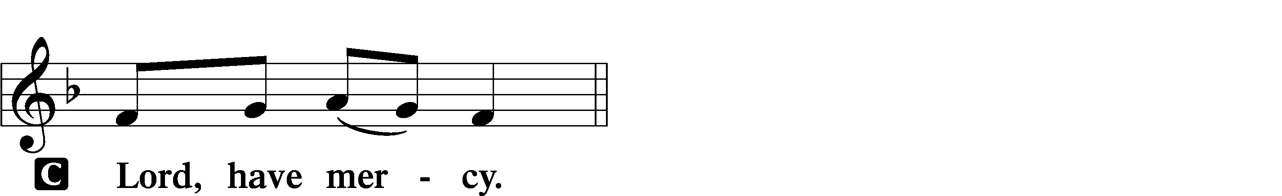

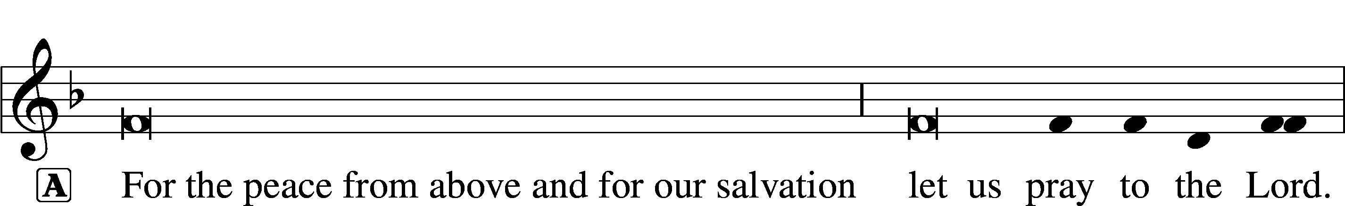

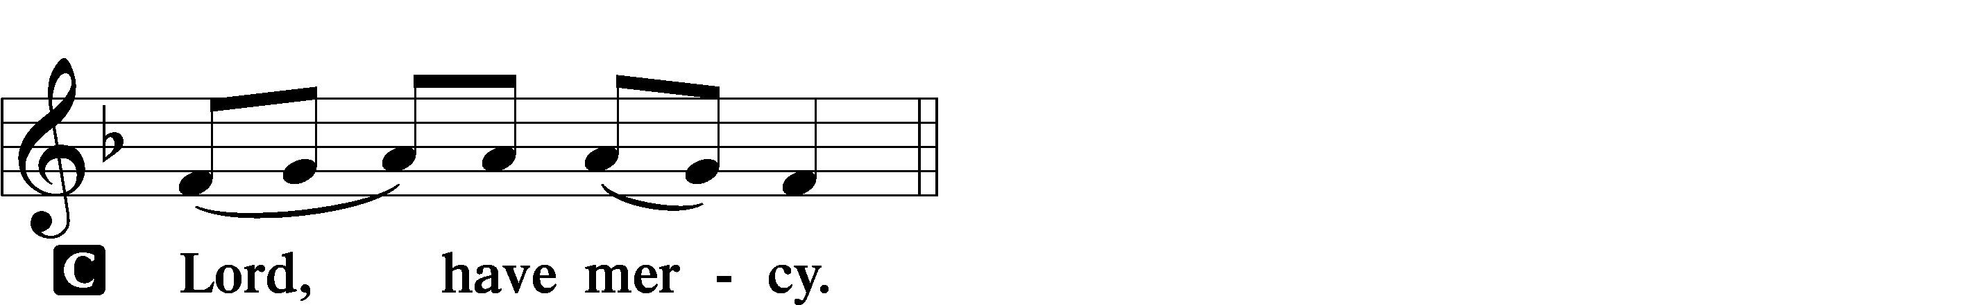

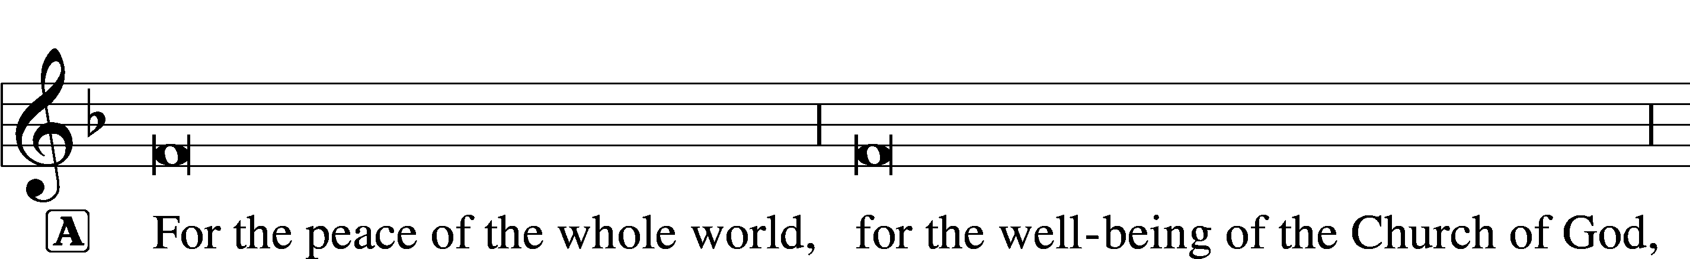

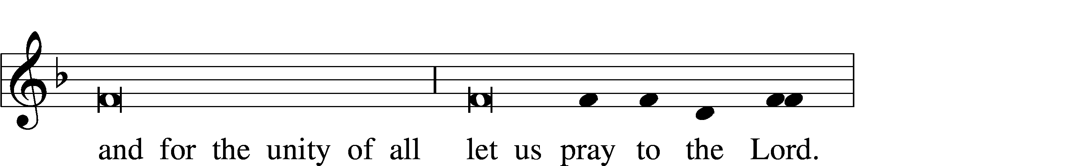

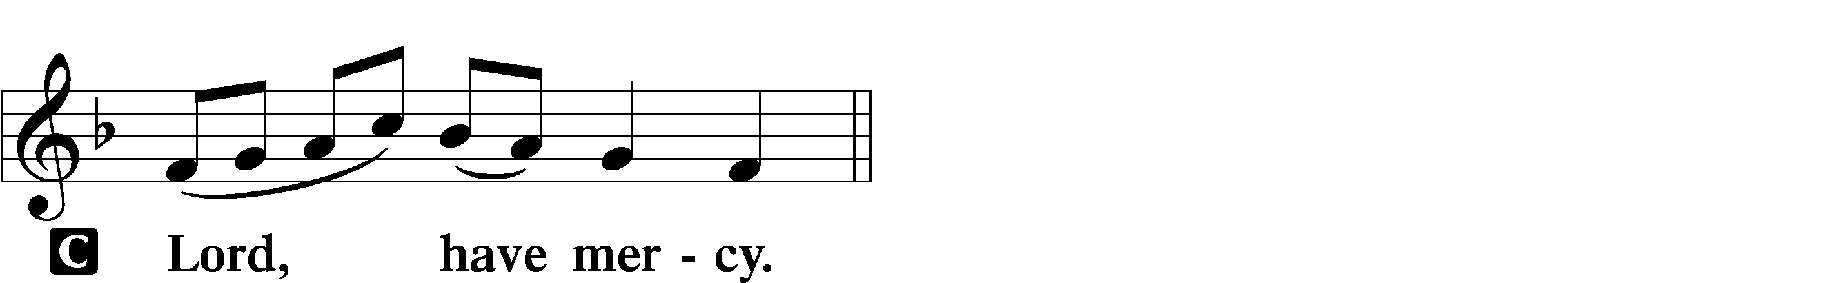

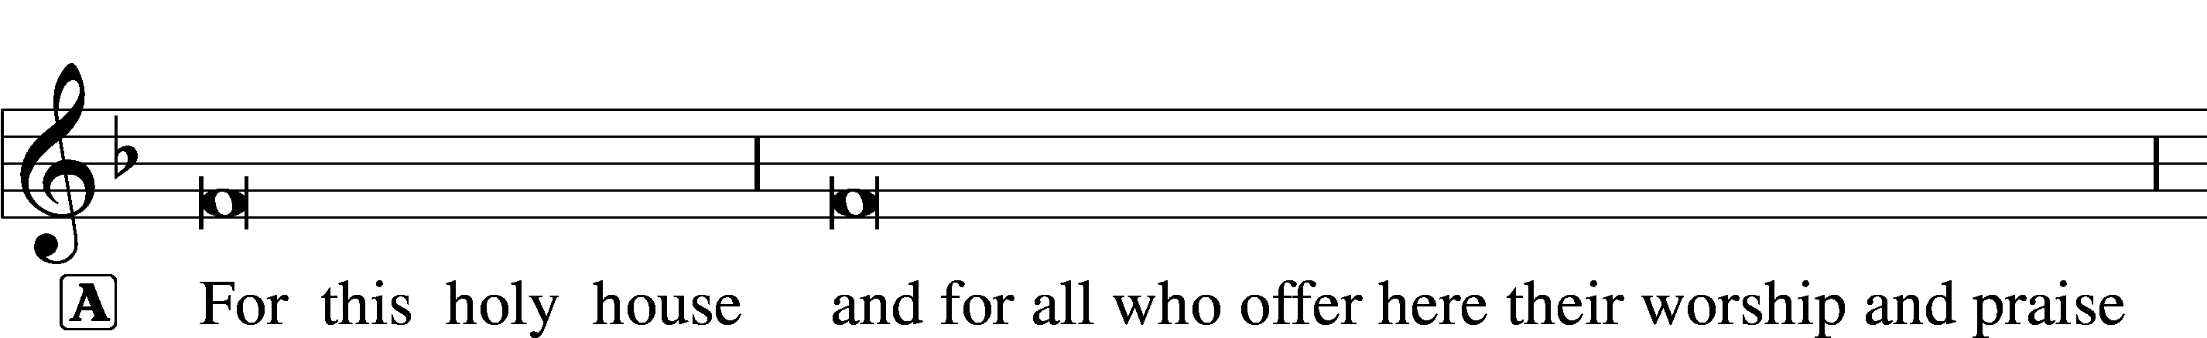



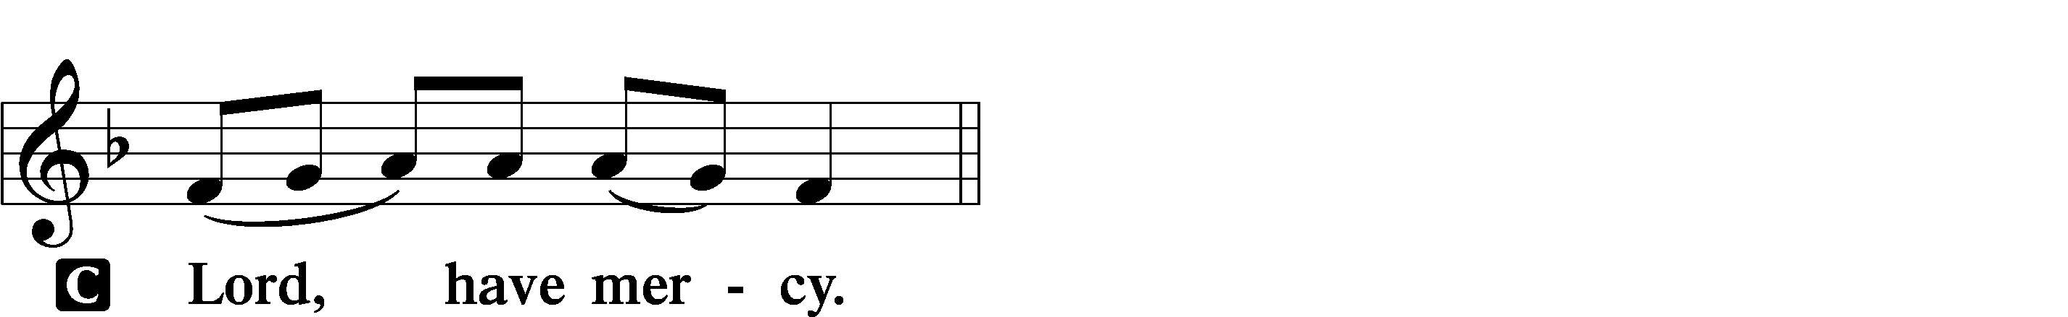

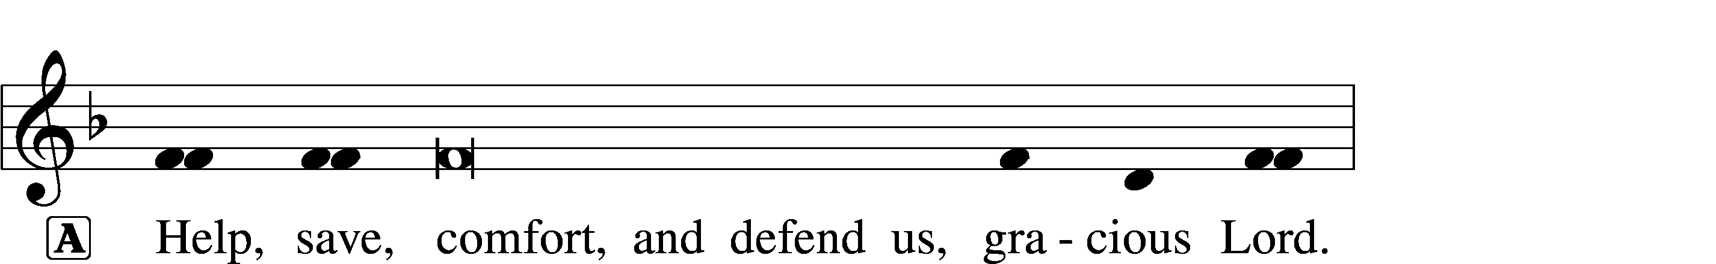



Gloria in Excelsis LSB 154

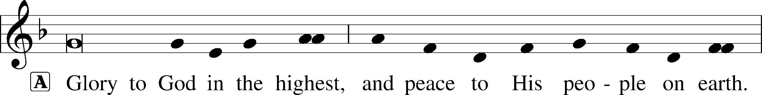

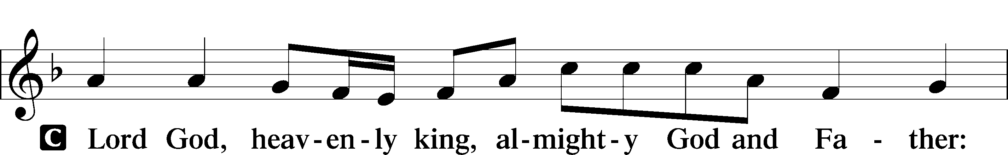

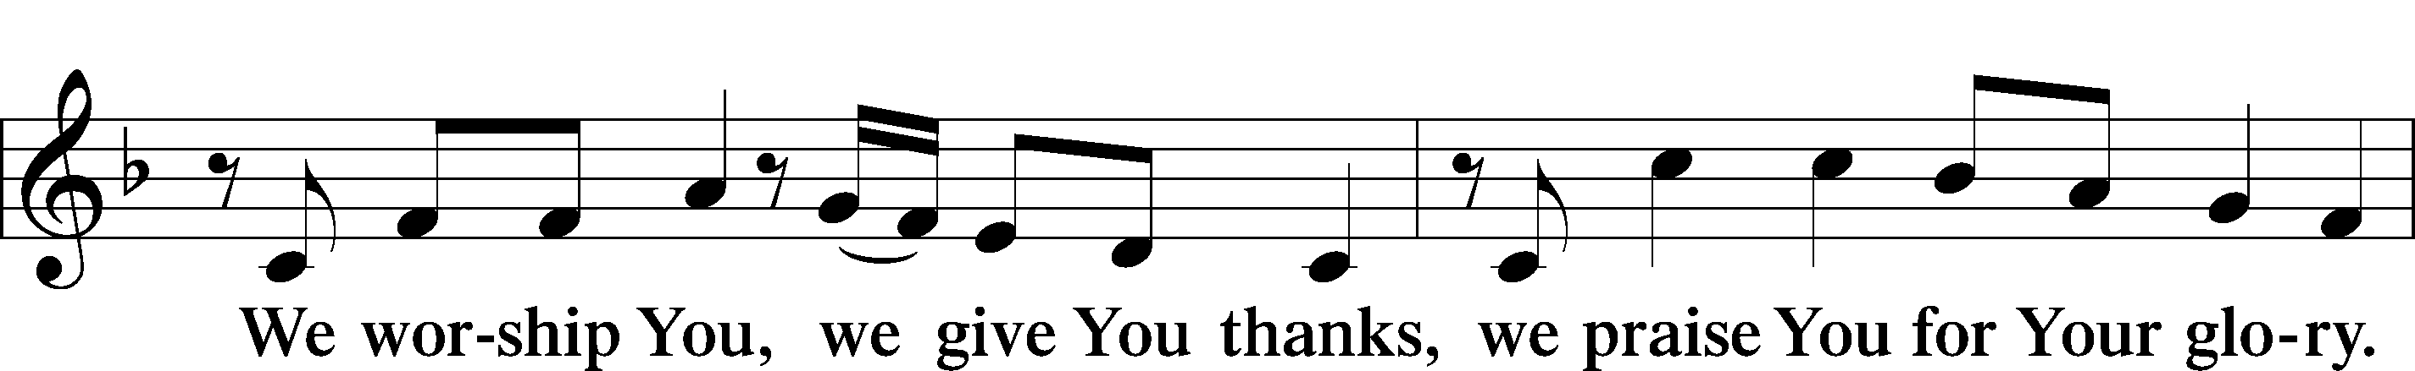

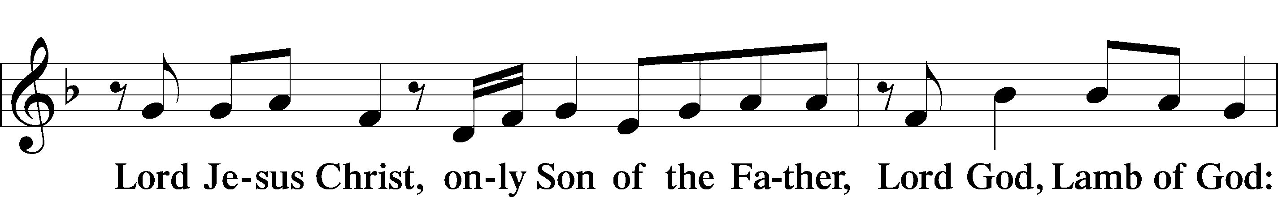

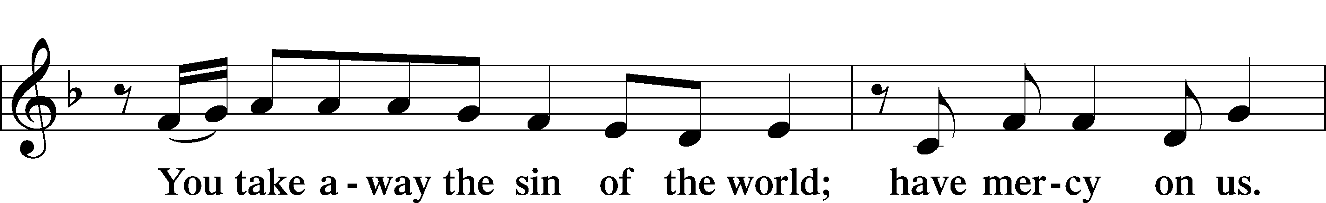

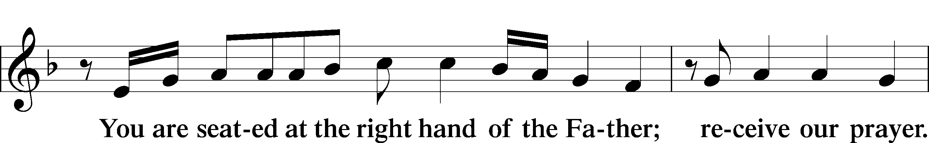

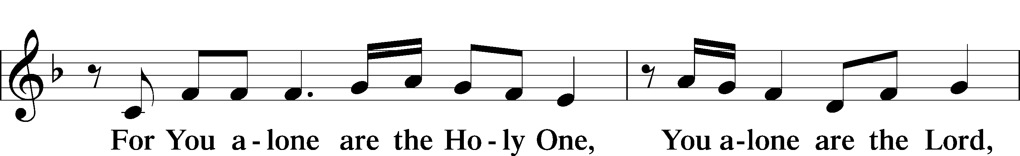

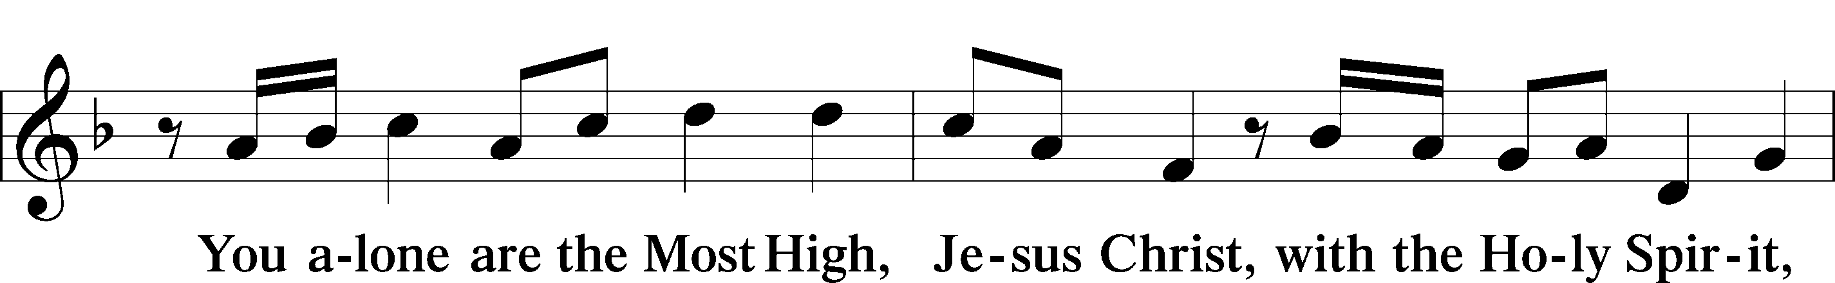

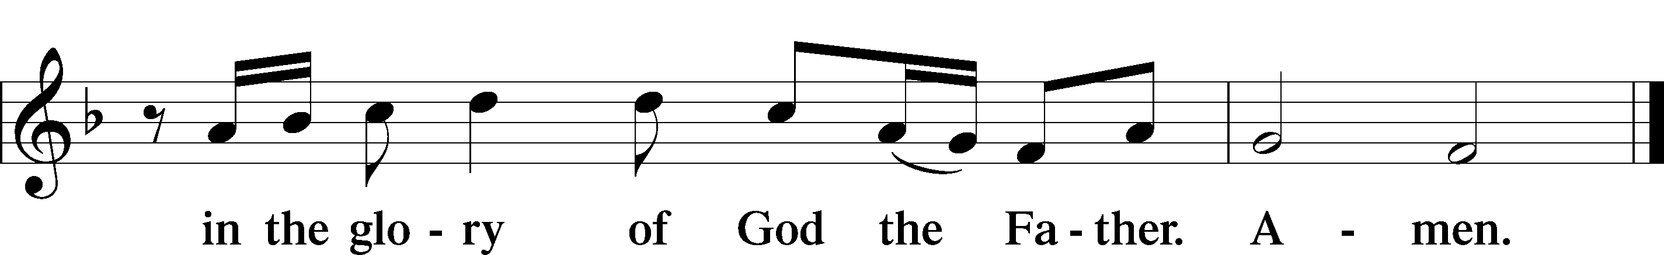

Salutation and Collect of the Day

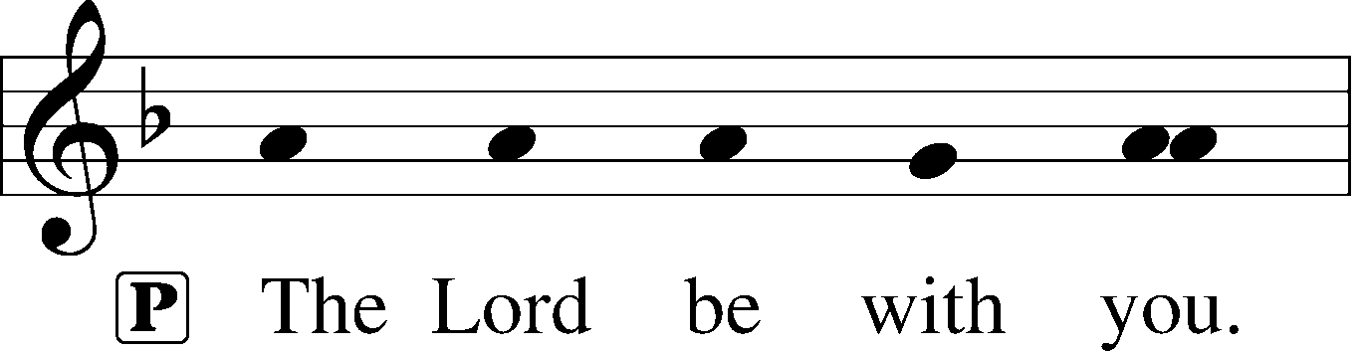

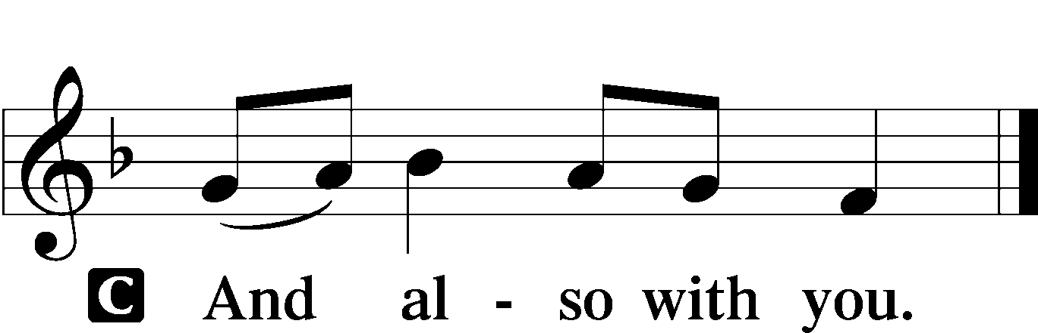

P Let us pray.

O God, You have prepared for those who love You such good things as surpass our understanding. Cast out all sins and evil desires from us, and pour into our hearts Your Holy Spirit to guide us into all blessedness; through Jesus Christ, Your Son, our Lord, who lives and reigns with You and the Holy Spirit, one God, now and forever.

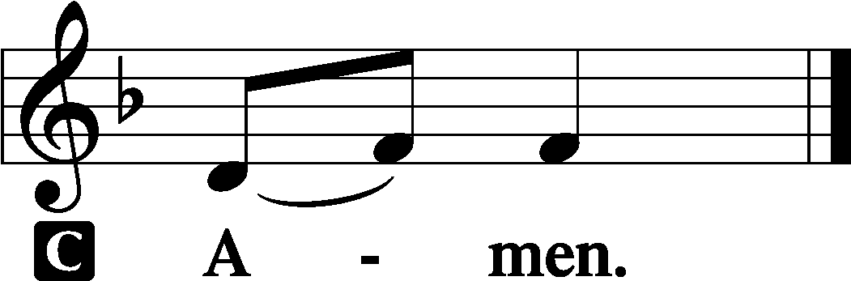

Sit

Old Testament Reading Isaiah 65:1–9

I was ready to be sought by those who did not ask for me;  
 I was ready to be found by those who did not seek me.  
I said, “Here am I, here am I,”  
 to a nation that was not called by my name.  
I spread out my hands all the day  
 to a rebellious people,  
who walk in a way that is not good,  
 following their own devices;  
a people who provoke me  
 to my face continually,  
sacrificing in gardens  
 and making offerings on bricks;  
who sit in tombs,  
 and spend the night in secret places;  
who eat pig’s flesh,  
 and broth of tainted meat is in their vessels;  
who say, “Keep to yourself,  
 do not come near me, for I am too holy for you.”  
These are a smoke in my nostrils,  
 a fire that burns all the day.  
Behold, it is written before me:  
 “I will not keep silent, but I will repay;  
I will indeed repay into their bosom  
 both your iniquities and your fathers’ iniquities together,  
says the Lord;  
because they made offerings on the mountains  
 and insulted me on the hills,  
I will measure into their bosom  
 payment for their former deeds.”

Thus says the Lord:  
“As the new wine is found in the cluster,  
 and they say, ‘Do not destroy it,  
 for there is a blessing in it,’  
so I will do for my servants’ sake,  
 and not destroy them all.  
I will bring forth offspring from Jacob,  
 and from Judah possessors of my mountains;  
my chosen shall possess it,  
 and my servants shall dwell there.”

A This is the Word of the Lord.

C **Thanks be to God.**

Epistle Galatians 3:23—4:7

Now before faith came, we were held captive under the law, imprisoned until the coming faith would be revealed. So then, the law was our guardian until Christ came, in order that we might be justified by faith. But now that faith has come, we are no longer under a guardian, for in Christ Jesus you are all sons of God, through faith. For as many of you as were baptized into Christ have put on Christ. There is neither Jew nor Greek, there is neither slave nor free, there is neither male nor female, for you are all one in Christ Jesus. And if you are Christ’s, then you are Abraham’s offspring, heirs according to promise.

I mean that the heir, as long as he is a child, is no different from a slave, though he is the owner of everything, but he is under guardians and managers until the date set by his father. In the same way we also, when we were children, were enslaved to the elementary principles of the world. But when the fullness of time had come, God sent forth his Son, born of woman, born under the law, to redeem those who were under the law, so that we might receive adoption as sons. And because you are sons, God has sent the Spirit of his Son into our hearts, crying, “Abba! Father!” So you are no longer a slave, but a son, and if a son, then an heir through God.

A This is the Word of the Lord.

C **Thanks be to God.**

Stand

Alleluia and Verse LSB 156

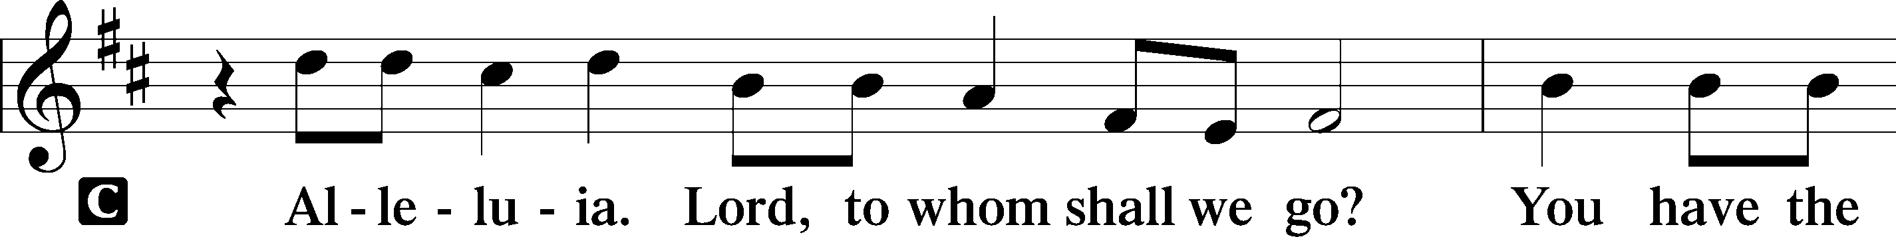

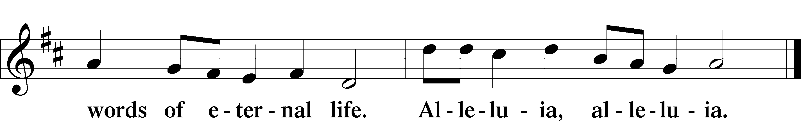

Holy Gospel Luke 8:26–39

P The Holy Gospel according to St. Luke, the eighth chapter.

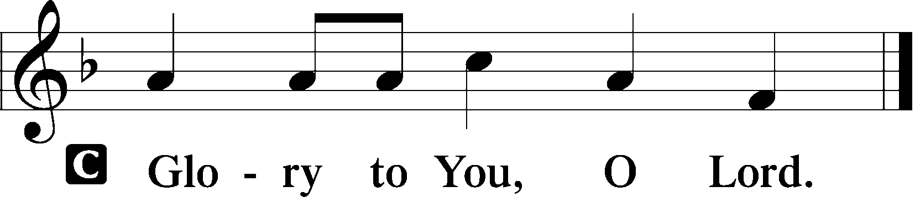

Then they sailed to the country of the Gerasenes, which is opposite Galilee. When Jesus had stepped out on land, there met him a man from the city who had demons. For a long time he had worn no clothes, and he had not lived in a house but among the tombs. When he saw Jesus, he cried out and fell down before him and said with a loud voice, “What have you to do with me, Jesus, Son of the Most High God? I beg you, do not torment me.” For he had commanded the unclean spirit to come out of the man. (For many a time it had seized him. He was kept under guard and bound with chains and shackles, but he would break the bonds and be driven by the demon into the desert.) Jesus then asked him, “What is your name?” And he said, “Legion,” for many demons had entered him. And they begged him not to command them to depart into the abyss. Now a large herd of pigs was feeding there on the hillside, and they begged him to let them enter these. So he gave them permission. Then the demons came out of the man and entered the pigs, and the herd rushed down the steep bank into the lake and were drowned.

When the herdsmen saw what had happened, they fled and told it in the city and in the country. Then people went out to see what had happened, and they came to Jesus and found the man from whom the demons had gone, sitting at the feet of Jesus, clothed and in his right mind, and they were afraid. And those who had seen it told them how the demon-possessed man had been healed. Then all the people of the surrounding country of the Gerasenes asked him to depart from them, for they were seized with great fear. So he got into the boat and returned. The man from whom the demons had gone begged that he might be with him, but Jesus sent him away, saying, “Return to your home, and declare how much God has done for you.” And he went away, proclaiming throughout the whole city how much Jesus had done for him.

P This is the Gospel of the Lord.

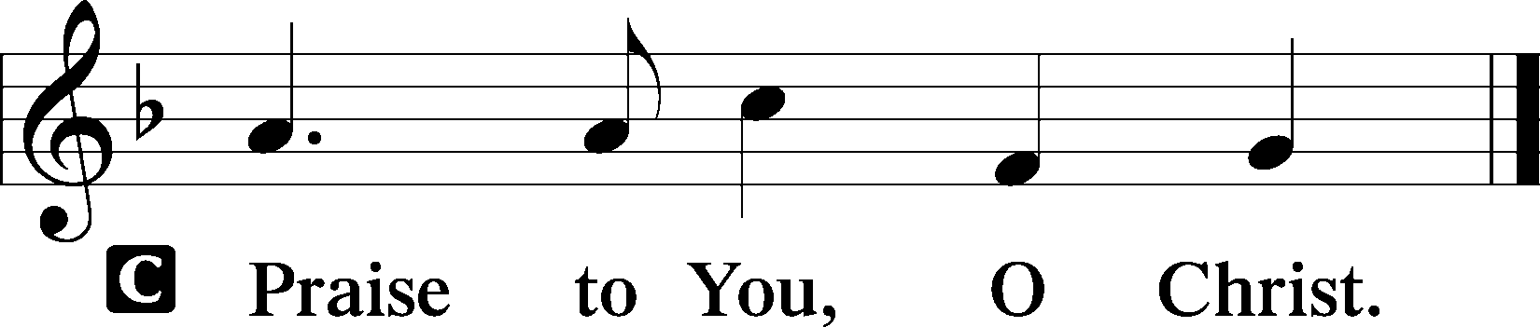

Apostles’ Creed

C **I believe in God, the Father Almighty,**

**maker of heaven and earth.**

**And in Jesus Christ, His only Son, our Lord,**

**who was conceived by the Holy Spirit,**

**born of the virgin Mary,**

**suffered under Pontius Pilate,**

**was crucified, died and was buried.**

**He descended into hell.**

**The third day He rose again from the dead.**

**He ascended into heaven**

**and sits at the right hand of God the Father Almighty.**

**From thence He will come to judge the living and the dead.**

**I believe in the Holy Spirit,**

**the holy Christian Church,**

**the communion of saints,**

**the forgiveness of sins,**

**the resurrection of the body,**

**and the life** T **everlasting. Amen.**

Sit

844 Lord of All Nations, Grant Me Grace

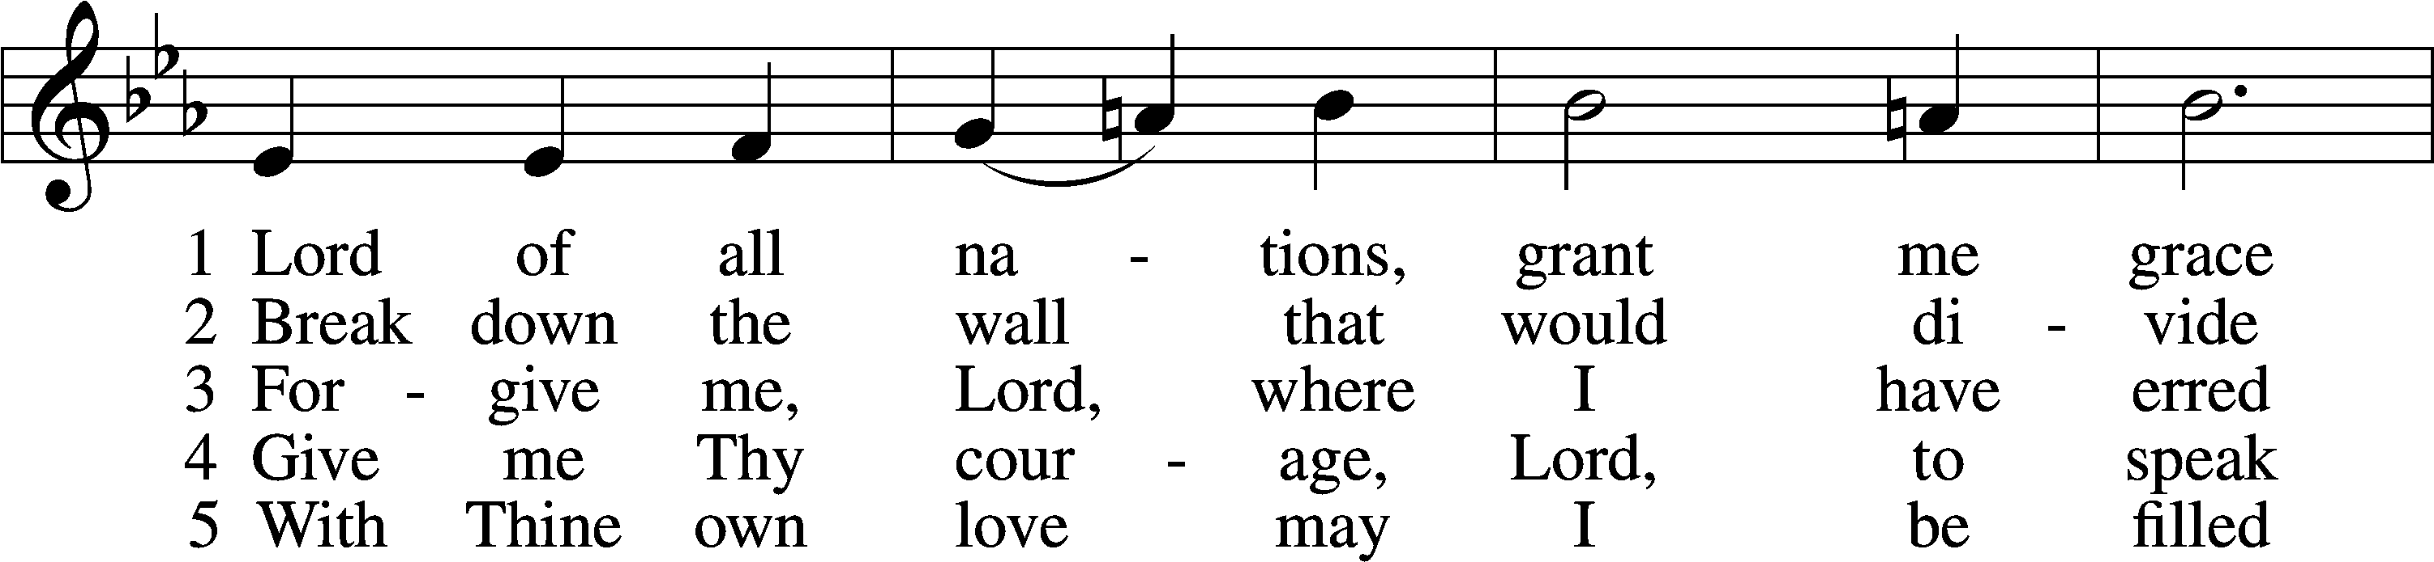

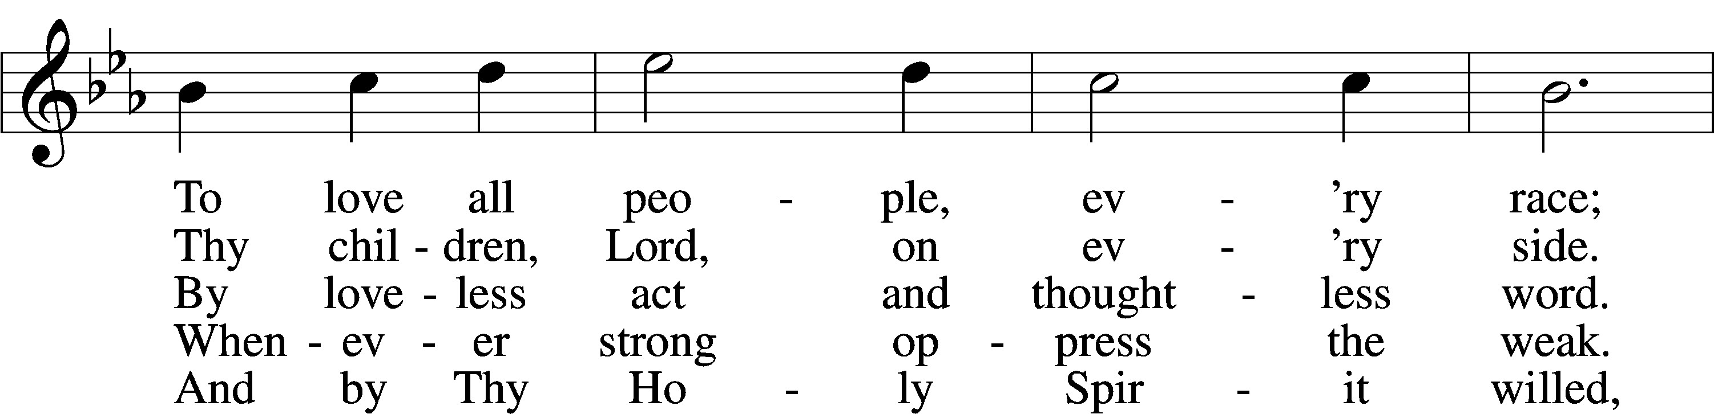

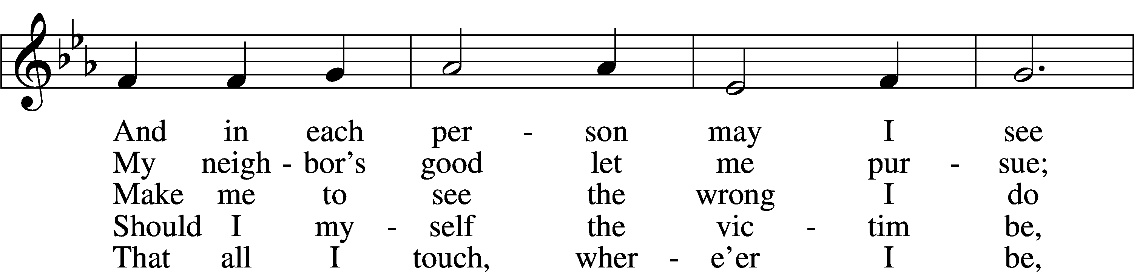

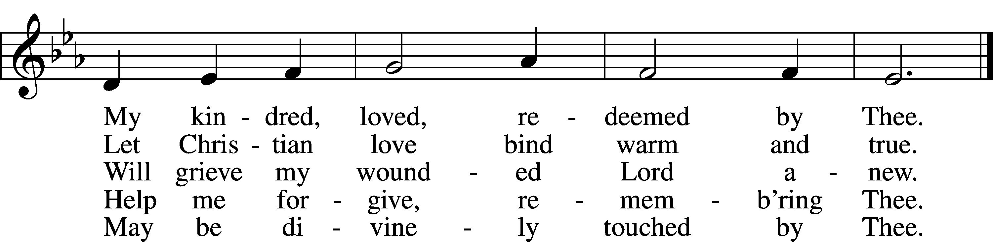

Sermon

Offering

Psalm for Meditation Psalm 3; antiphon: v. 8

O Lord, how many are my foes!  
 Many are rising against me;  
many are saying of my soul,  
 there is no salvation for him in God.

But you, O Lord, are a shield about me,  
 my glory, and the lifter of my head.  
I cried aloud to the Lord,  
 and he answered me from his holy hill.

I lay down and slept;  
 I woke again, for the Lord sustained me.  
I will not be afraid of many thousands of people  
 who have set themselves against me all around.

Arise, O Lord!  
 Save me, O my God!  
For you strike all my enemies on the cheek;  
 you break the teeth of the wicked.

Salvation belongs to the Lord;  
 your blessing be on your people!

Stand

781 We Give Thee But Thine Own sts. 1–2

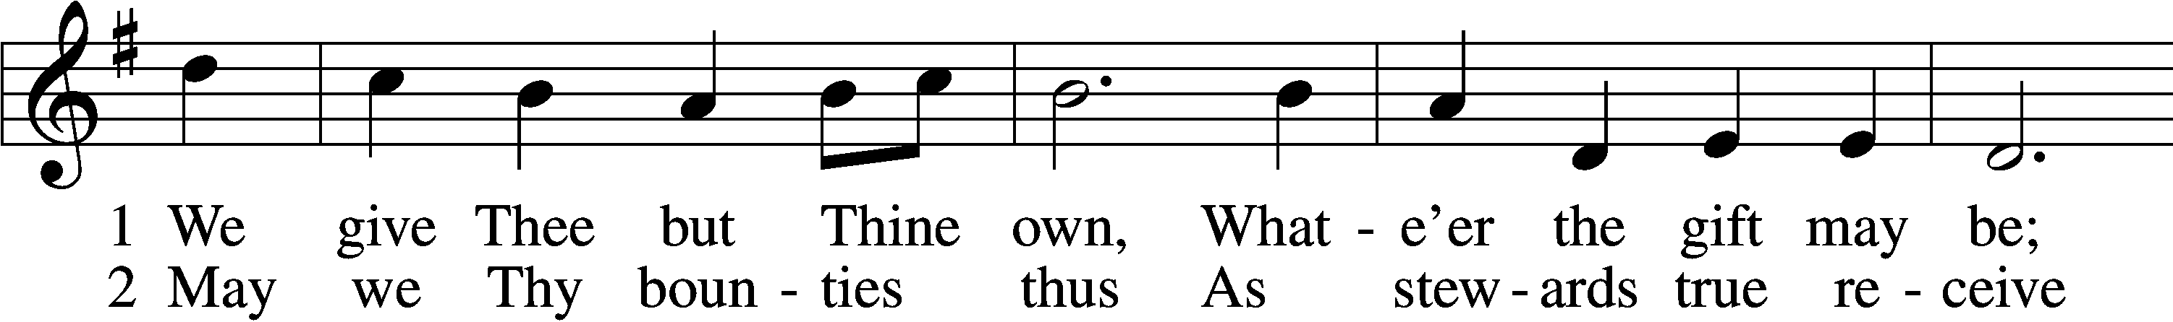

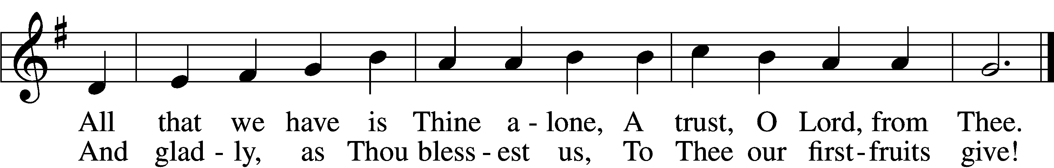

Prayer of the Church

P Let us pray for the whole people of God in Christ Jesus and for all people according to their needs.

P For the faithful proclamation of Christ’s saving name, that God’s people may be strengthened in the true faith and His kingdom extended, let us pray to the Lord:

C **Lord, have mercy.**

P For the holy Christian Church throughout the world and for all who confess the name of Christ, that God would guard and defend us from the temptations of the devil, the world, and our sinful nature, let us pray to the Lord:

C **Lord, have mercy.**

P For those who have wandered from the faith, that the Holy Spirit would use us to call them home to the Father, let us pray to the Lord:

C **Lord, have mercy.**

P For the government and all who have been set into positions of leadership, that they may use the authority entrusted to them honorably and for the good of the people, let us pray to the Lord:

C **Lord, have mercy.**

P For those who suffer from hunger, homelessness, poverty, or unemployment, that God’s great mercy and love would preserve and relieve them, let us pray to the Lord:

C **Lord, have mercy.**

P For those who are sick especially Marge, Tony, Karen, Bill M., Patricia, Braydon, Phil, Pat, Lidia, Michele, Giuseppe, Alfred, and Nancy that God would grant healing to their bodies and strength to bear their infirmities with patience and grace, let us pray to the Lord:

C **Lord, have mercy.**

P For those who rejoice in the rich blessings of God, that they may always remember the Giver of every gift and give Him heartfelt thanks, let us pray to the Lord:

C **Lord, have mercy.**

P O Lord, heavenly Father, we gratefully remember the sufferings and death of Your dear Son, Jesus Christ, for our salvation. Rejoicing in His victorious resurrection from the dead, we draw strength from His ascension before You, where He ever stands for us as our own High Priest. Gather us together from the ends of the earth to celebrate with all the faithful the marriage feast of the Lamb in His kingdom, which has no end. Graciously receive our prayers, deliver and preserve us, for to You alone we give all glory, honor, and worship, Father, Son, and Holy Spirit, one God, now and forever.

C **Amen.**

Lord’s Prayer

C **Our Father who art in heaven,**

**hallowed be Thy name,**

**Thy kingdom come,**

**Thy will be done on earth**

**as it is in heaven;**

**give us this day our daily bread;**

**and forgive us our trespasses**

**as we forgive those**

**who trespass against us;**

**and lead us not into temptation,**

**but deliver us from evil.**

**For Thine is the kingdom**

**and the power and the glory**

**forever and ever. Amen.**

Benediction LSB 166

P The Lord bless you and keep you.

The Lord make His face shine on you and be gracious to you.

The Lord look upon you with favor and T give you peace.



570 Just as I Am, without One Plea sts. 1–4

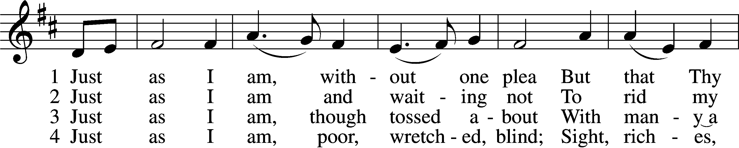

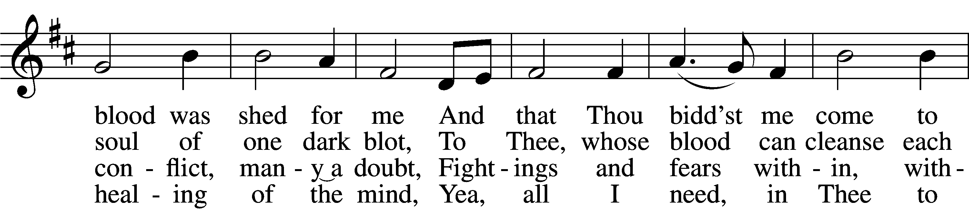

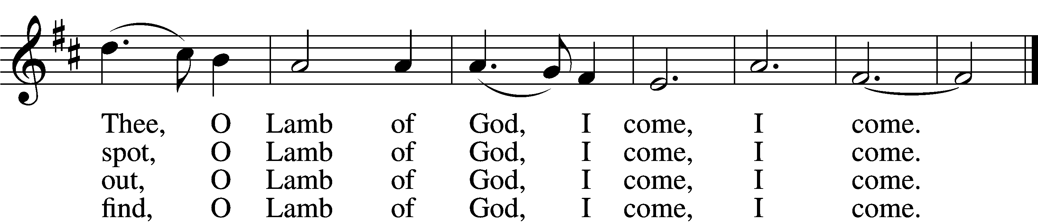

Announcements

**Join us** after the service in the fellowship hall for refreshments.

**Pastor Vogel** will conduct service on July 27th.

**Thank you** to the volunteers who read the lessons and those who conduct the service.

We will be having our annual **Yard Sale** on Saturday, September 20th and Saturday September 27th. See flyer on narthex table.