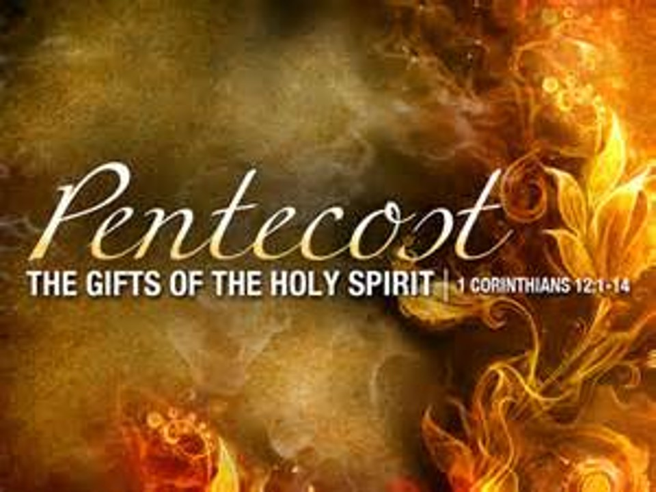

Saint John’s Lutheran Church
810 Broad Street
Clifton, New Jersey
Office: 973-778-1412
www.StJohnsClifton.org

Pentecost 12
Sunday, August 16, 2026
9:00 AM

Officiant: Pastor Dennis Rockett

The church of the praying hands

Hymn of Invocation

662 Onward, Christian Soldiers

Stand

Confession and Absolution

The sign of the cross may be made by all in remembrance of their Baptism.

Invocation

Silence for reflection on God’s Word and for self-examination.

Exhortation LSB 167

Confession of Sins LSB 167

Absolution LSB 167

Service of the Word

Introit Psalm 28:1–2, 6–7; antiphon: v. 8

The Lord is the strength of his people;
he is the saving refuge of his anointed.
To you, O Lord, I call; my rock, be not deaf to me,
lest, if you be silent to me, I become like those who go down to the pit.
Hear the voice of my pleas for mercy, when I cry to you for help,
when I lift up my hands toward your most holy sanctuary.
Blessèd be the Lord!
For he has heard the voice of my pleas for mercy.
The Lord is my strength and my shield; in him my heart trusts, and I am helped;
my heart exults, and with my song I give thanks to him.
Glory be to the Father and to the Son and to the Holy Spirit; as it was in the beginning, is now, and will be forever. Amen.
The Lord is the strength of his people;
he is the saving refuge of his anointed.

Kyrie LSB 168

This Is the Feast LSB 171

Salutation and Collect of the Day

Sit

Old Testament Reading Isaiah 56:1, 6–8

Thus says the Lord:
“Keep justice, and do righteousness, for soon my salvation will come, and my deliverance be revealed. . . .
“And the foreigners who join themselves to the Lord, to minister to him, to love the name of the Lord, and to be his servants, everyone who keeps the Sabbath and does not profane it, and holds fast my covenant— these I will bring to my holy mountain, and make them joyful in my house of prayer; their burnt offerings and their sacrifices will be accepted on my altar; for my house shall be called a house of prayer for all peoples.”
The Lord God, who gathers the outcasts of Israel, declares, “I will gather yet others to him besides those already gathered.”

A This is the Word of the Lord.
C Thanks be to God.

Epistle Romans 11:1–2a, 13–15, 28–32

I ask, then, has God rejected his people? By no means! For I myself am an Israelite, a descendant of Abraham, a member of the tribe of Benjamin. God has not rejected his people whom he foreknew. . . .

Now I am speaking to you Gentiles. Inasmuch then as I am an apostle to the Gentiles, I magnify my ministry in order somehow to make my fellow Jews jealous, and thus save some of them. For if their rejection means the reconciliation of the world, what will their acceptance mean but life from the dead? . . .

As regards the gospel, they are enemies of God for your sake. But as regards election, they are beloved for the sake of their forefathers. For the gifts and the calling of God are irrevocable. Just as you were at one time disobedient to God but now have received mercy because of their disobedience, so they too have now been disobedient in order that by the mercy shown to you they also may now receive mercy. For God has consigned all to disobedience, that he may have mercy on all.

A This is the Word of the Lord.
C Thanks be to God.

Stand

Alleluia and Verse LSB 173

Holy Gospel Matthew 15:21–28

P The Holy Gospel according to St. Matthew, the fifteenth chapter.

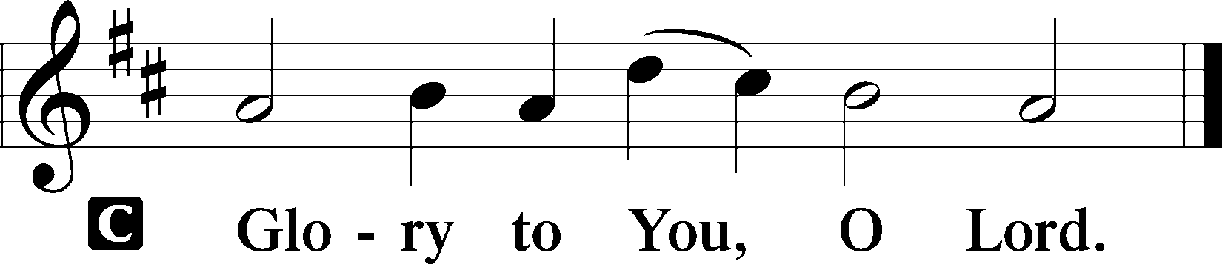

Jesus went away from there and withdrew to the district of Tyre and Sidon. And behold, a Canaanite woman from that region came out and was crying, “Have mercy on me, O Lord, Son of David; my daughter is severely oppressed by a demon.” But he did not answer her a word. And his disciples came and begged him, saying, “Send her away, for she is crying out after us.” He answered, “I was sent only to the lost sheep of the house of Israel.” But she came and knelt before him, saying, “Lord, help me.” And he answered, “It is not right to take the children’s bread and throw it to the dogs.” She said, “Yes, Lord, yet even the dogs eat the crumbs that fall from their masters’ table.” Then Jesus answered her, “O woman, great is your faith! Be it done for you as you desire.” And her daughter was healed instantly.
P This is the Gospel of the Lord.

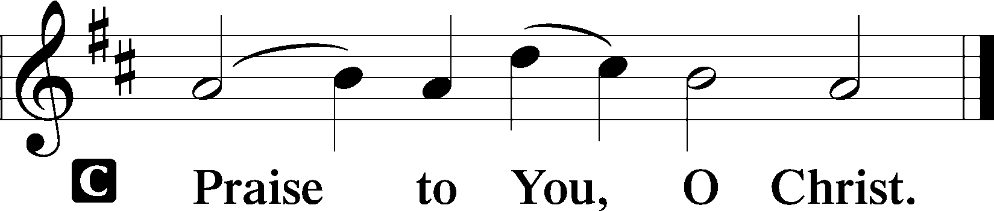

Nicene Creed LSB Back Cover

Sit

Hymn of the Day

803 Joyful, Joyful We Adore Thee

Sermon

Offering & Offertory

Create In Me LSB 192

Psalm Psalm 67; antiphon: v. 5

May God be gracious to us and bless us and make his face to shine upon us, that your way may be known on earth, your saving power among all nations.
Let the peoples praise you, O God; let all the peoples praise you! Let the nations be glad and sing for joy, for you judge the peoples with equity and guide the nations upon earth.
Let the peoples praise you, O God; let all the peoples praise you! The earth has yielded its increase; God, our God, shall bless us. God shall bless us; let all the ends of the earth fear him!

Stand

Prayer of the Church
After “Lord, in Your mercy” respond with “hear our prayer.”

Service of the Sacrament

Preface LSB 177

Proper Preface

Sanctus LSB 178

Prayer of Thanksgiving LSB 178

The Words of Our Lord

Proclamation of Christ

Lord’s Prayer LSB Back Cover

Pax Domini LSB 180

Agnus Dei LSB 180

Distribution & Hymn

680 Thine the Amen, Thine the Praise

Stand

Thank the Lord LSB 181

Post-Communion Collect

Benediction LSB 183

Closing Hymn

507 Holy, Holy, Holy sts. 1–4

Announcements

All Church Members

Please bring pictures of your Clifton church life. They will be hung in the Fellowship Hall to commemorate our anniversary.

Rally Day/Church Picnic is Sunday September 13th. Please sign up if you plan to attend and/or bring a dish. The sign-up sheet is on the table outside of the sanctuary.

Acknowledgments

Unless otherwise indicated, Scripture quotations are from the ESV® Bible (The Holy Bible, English Standard Version®), copyright © 2001 by Crossway, a publishing ministry of Good News Publishers. Used by permission. All rights reserved.
Created by Lutheran Service Builder © 2026 Concordia Publishing House.

