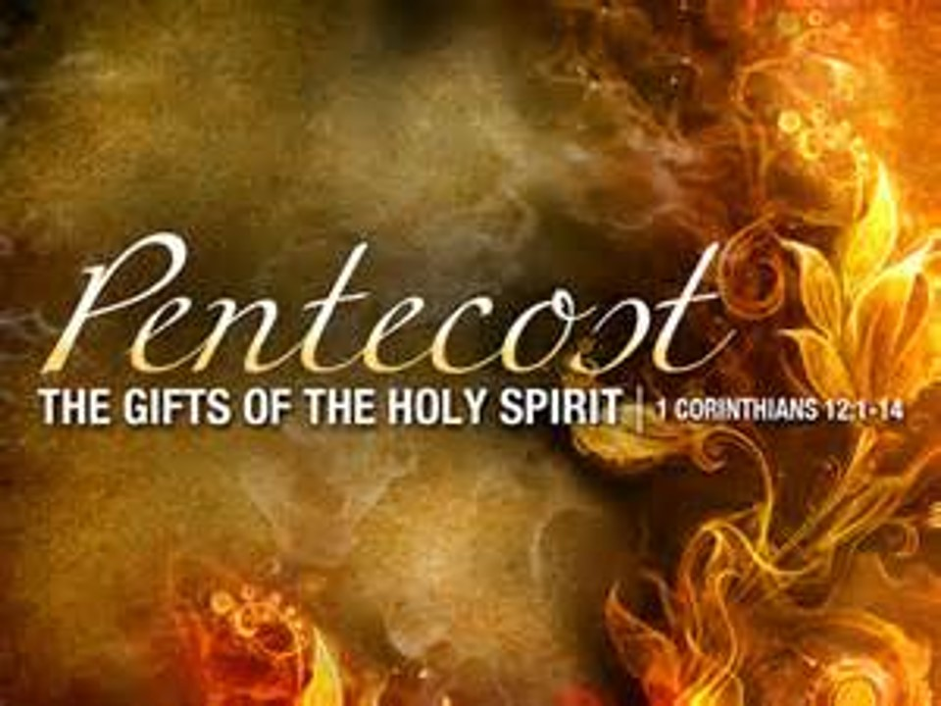

Saint John’s Lutheran Church
810 Broad Street
Clifton, New Jersey
Office: 973-778-1412
www.StJohnsClifton.org

Pentecost 10
Sunday, August 3, 2026
9:00 AM

Officiant: Pastor Dennis Rockett

The church of the praying hands

Hymn of Invocation

493 A Hymn of Glory Let Us Sing sts. 1, 3–4, 6

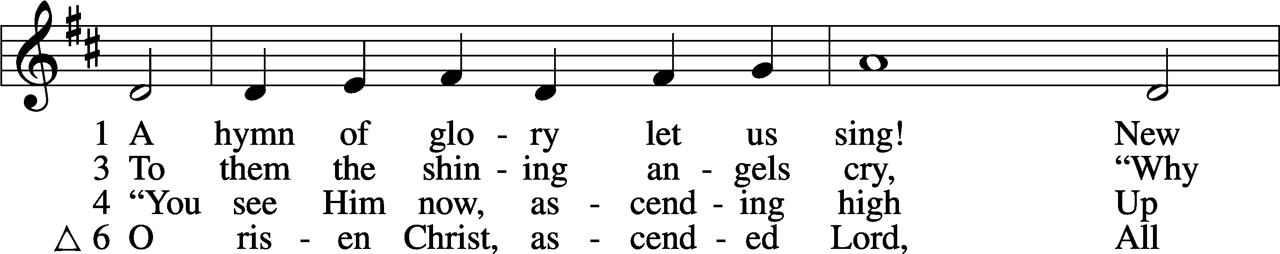
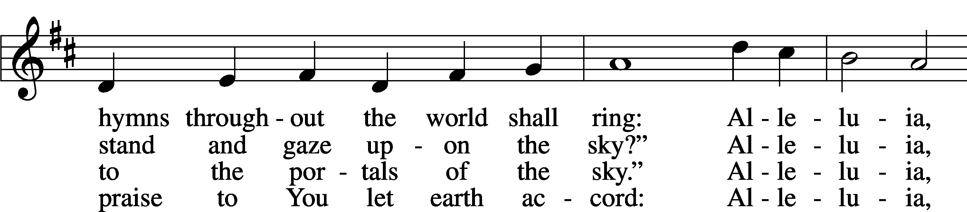
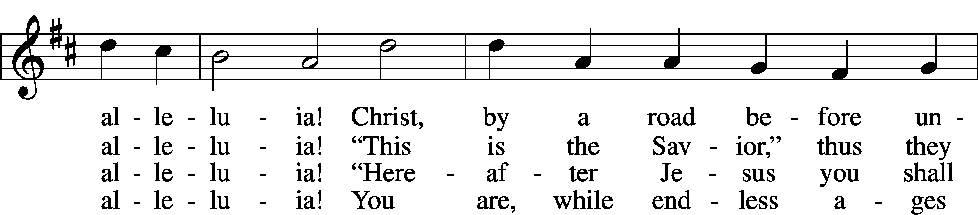
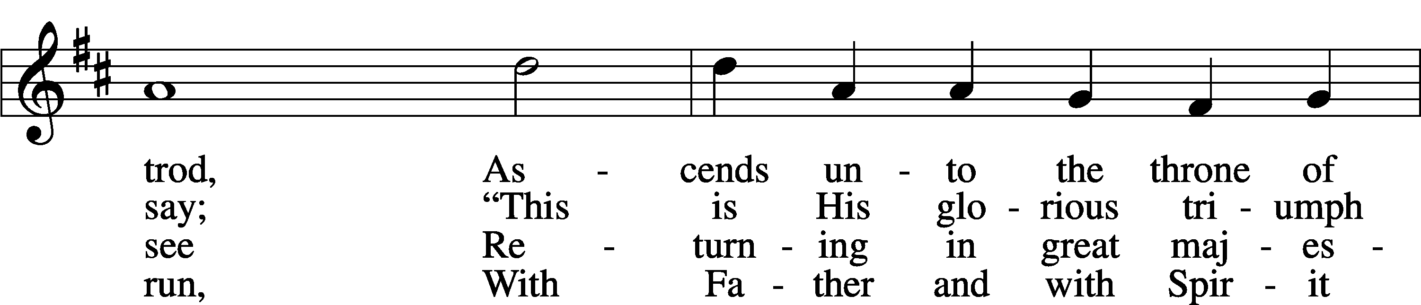
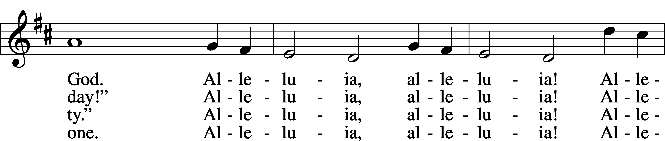
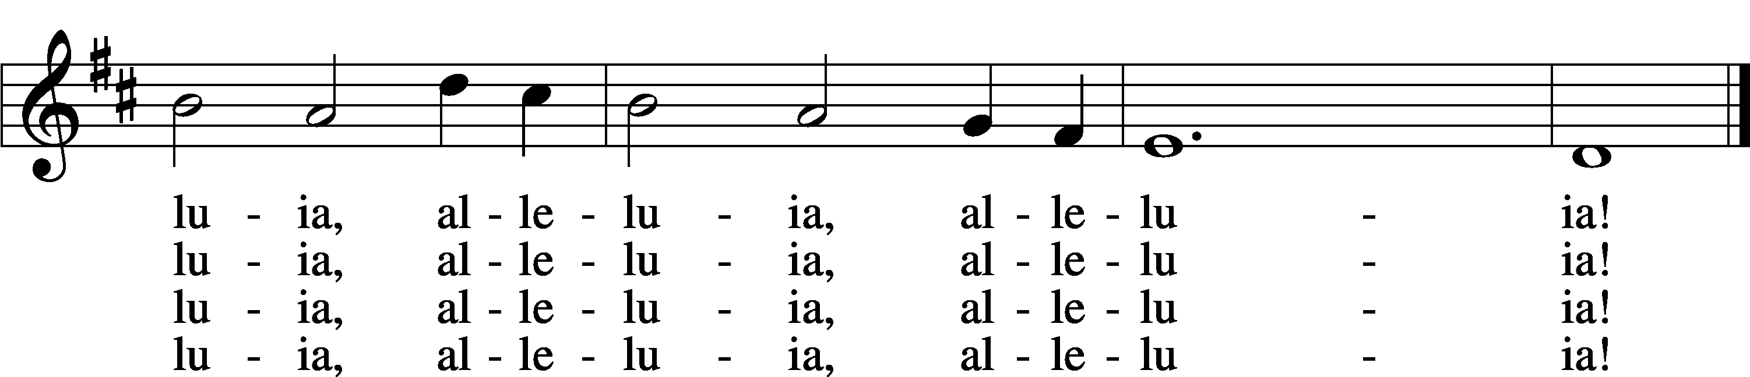
Text: Bede, 673–735; tr. Lutheran Book of Worship, 1978, alt.
Tune: Geistliche Kirchengesäng, 1623, Köln
Text: © 1978 Lutheran Book of Worship. Used by permission: LSB Hymn License no. 110003925
Tune: Public domain
Stand

Confession and Absolution

The sign of the cross may be made by all in remembrance of their Baptism.

Invocation

P In the name of the Father and of the T Son and of the Holy Spirit.
C Amen.

Silence for reflection on God’s Word and for self-examination.

Exhortation LSB 167

P If we say we have no sin, we deceive ourselves, and the truth is not in us.
C But if we confess our sins, God, who is faithful and just, will forgive our sins and cleanse us from all unrighteousness.

Confession of Sins LSB 167

P Let us then confess our sins to God our Father.
C Most merciful God, we confess that we are by nature sinful and unclean. We have sinned against You in thought, word, and deed, by what we have done and by what we have left undone. We have not loved You with our whole heart; we have not loved our neighbors as ourselves. We justly deserve Your present and eternal punishment. For the sake of Your Son, Jesus Christ, have mercy on us. Forgive us, renew us, and lead us, so that we may delight in Your will and walk in Your ways to the glory of Your holy name. Amen.

Absolution LSB 167

P Almighty God in His mercy has given His Son to die for you and for His sake forgives you all your sins. As a called and ordained servant of Christ, and by His authority, I therefore forgive you all your sins in the name of the Father and of the T Son and of the Holy Spirit.
C Amen.

Service of the Word

Introit Psalm 105:39–43; antiphon: v. 1

Oh give thanks to the Lord; call upon his name;
make known his deeds among the peoples!
He spread a cloud for a covering,
and fire to give light by night.
They asked, and he brought quail,
and gave them bread from heaven in abundance.
He opened the rock, and water gushed out;
it flowed through the desert like a river.
For he remembered his holy promise,
and Abraham, his servant.
So he brought his people out with joy,
his chosen ones with singing.
Glory be to the Father and to the Son and to the Holy Spirit; as it was in the beginning, is now, and will be forever. Amen.
Oh give thanks to the Lord; call upon his name;
make known his deeds among the peoples!
Kyrie LSB 168


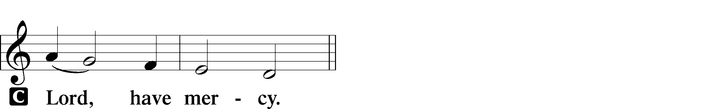

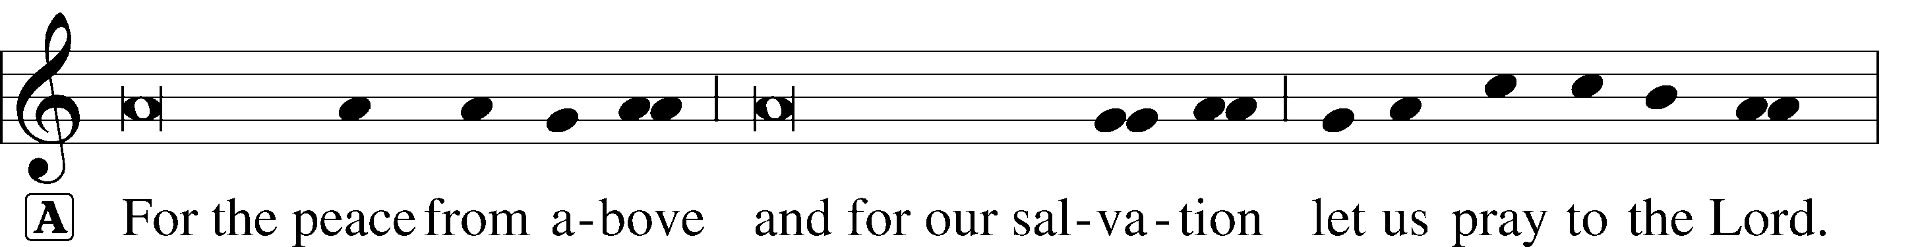
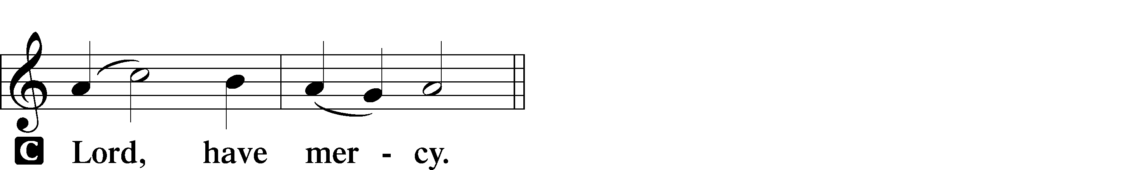

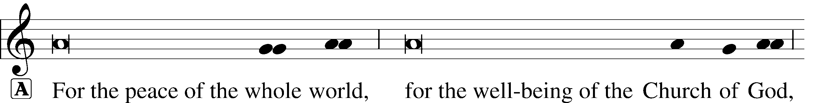

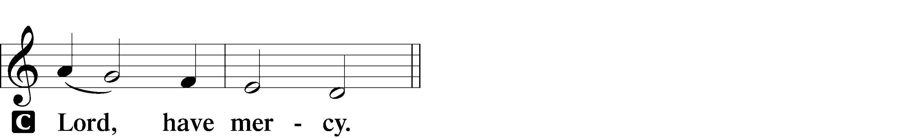

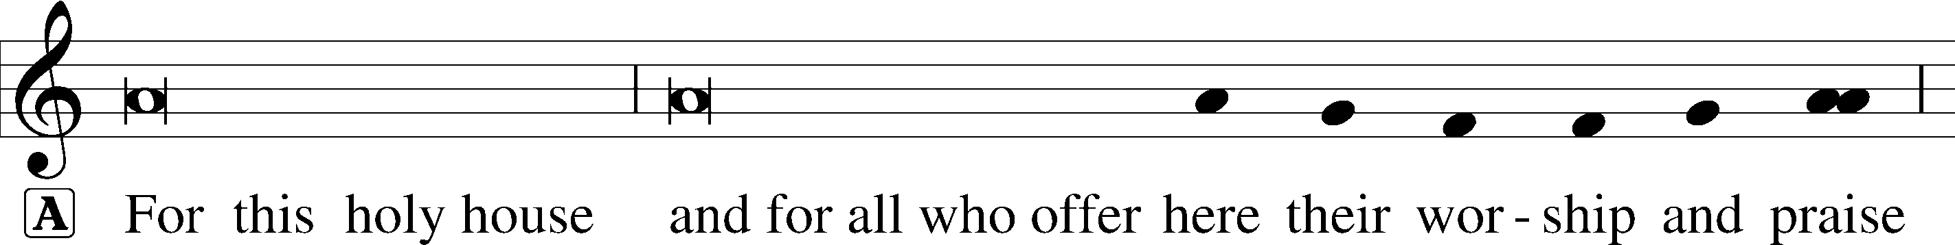

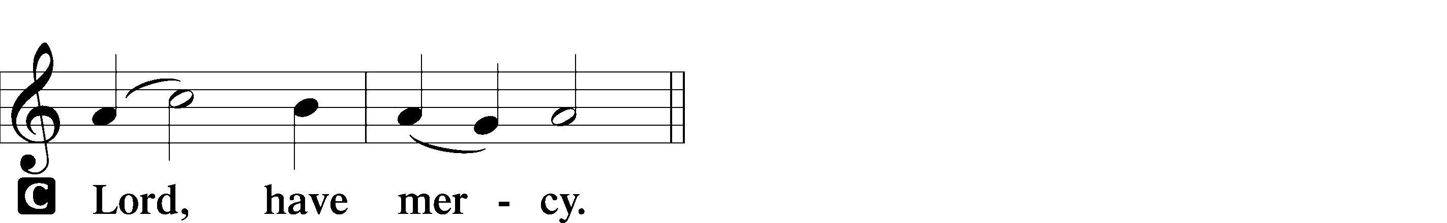




This Is the Feast LSB 171

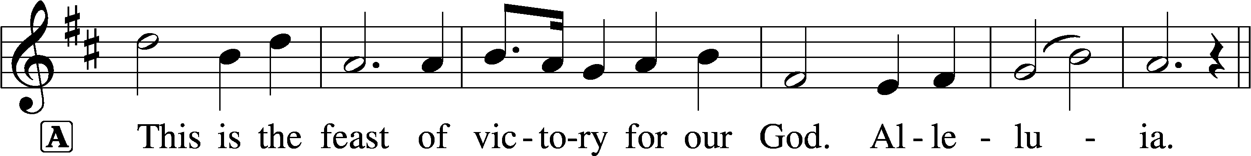
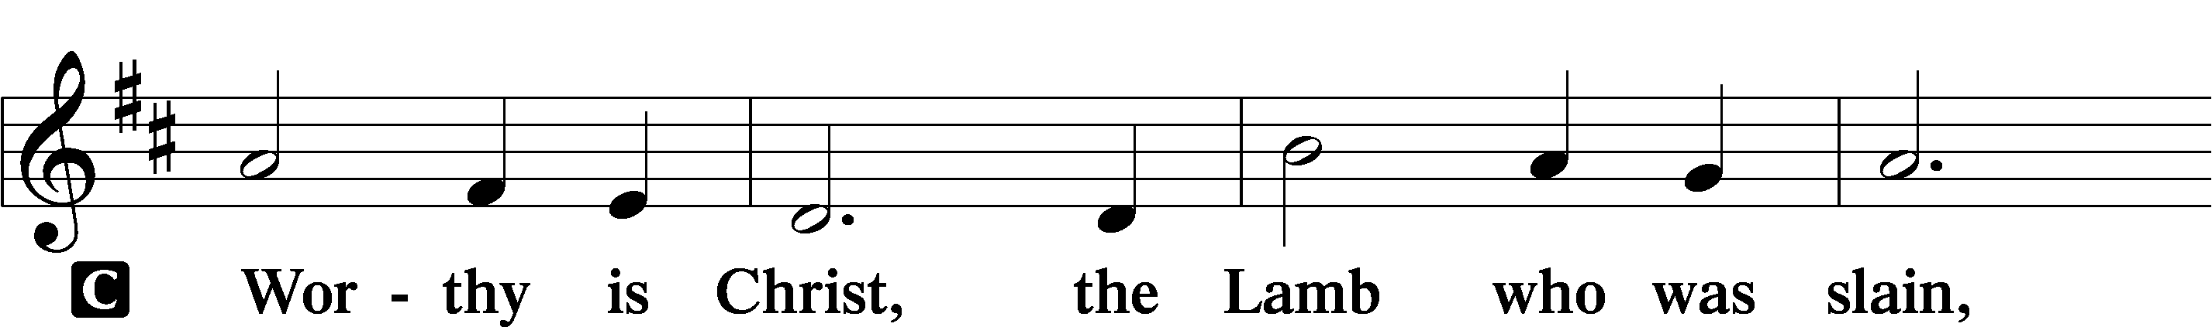
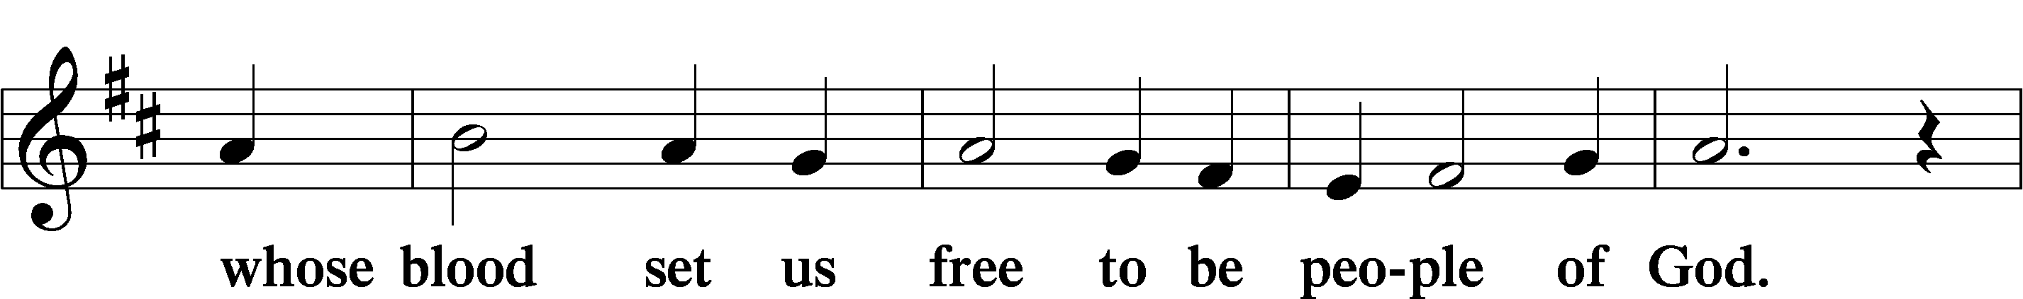
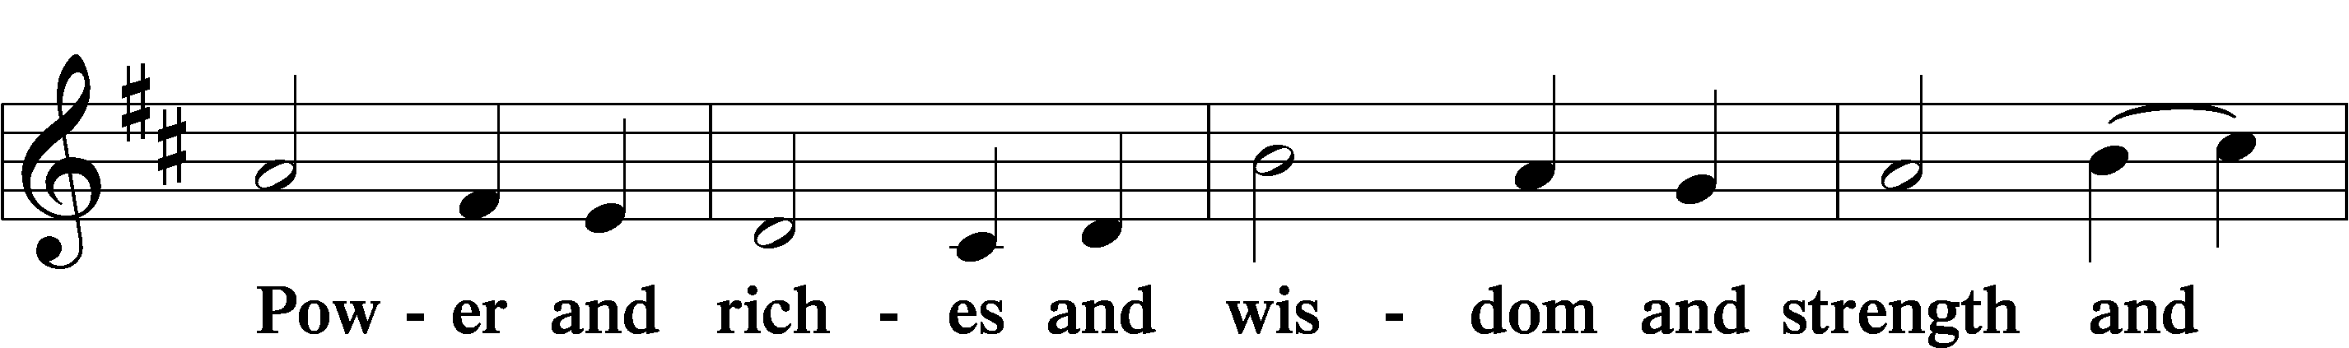
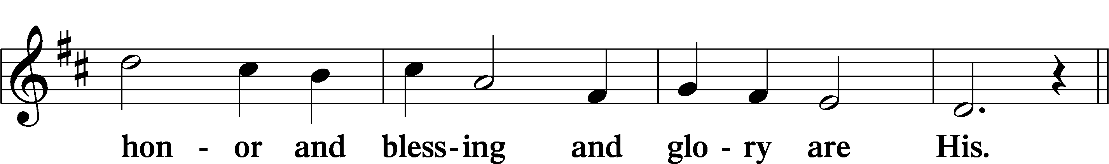
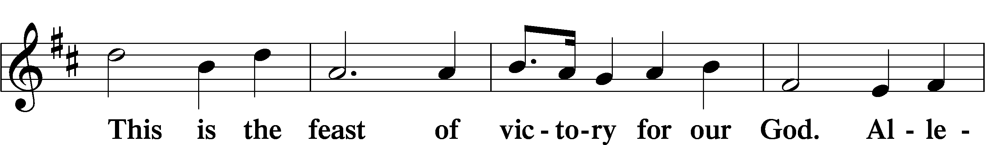
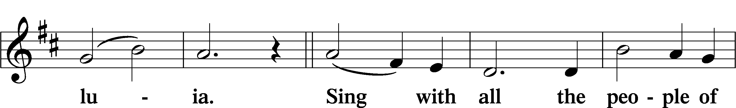
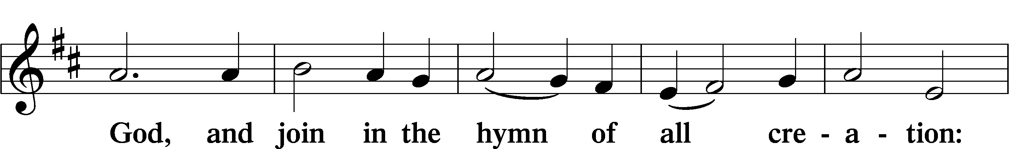
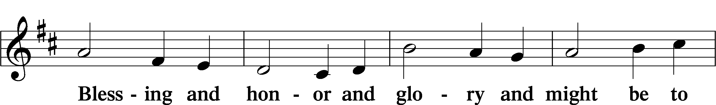
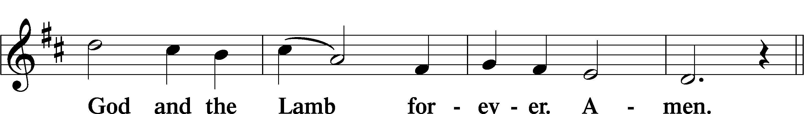
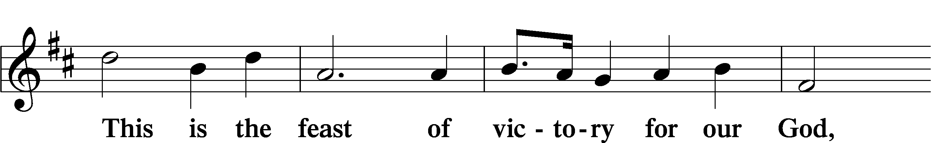
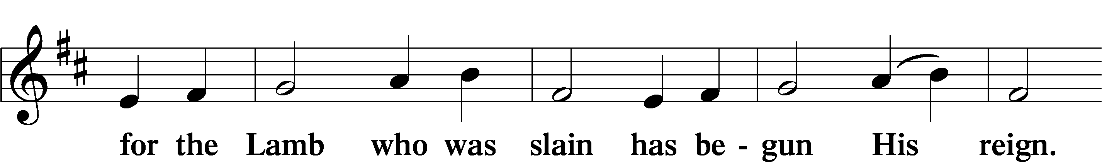
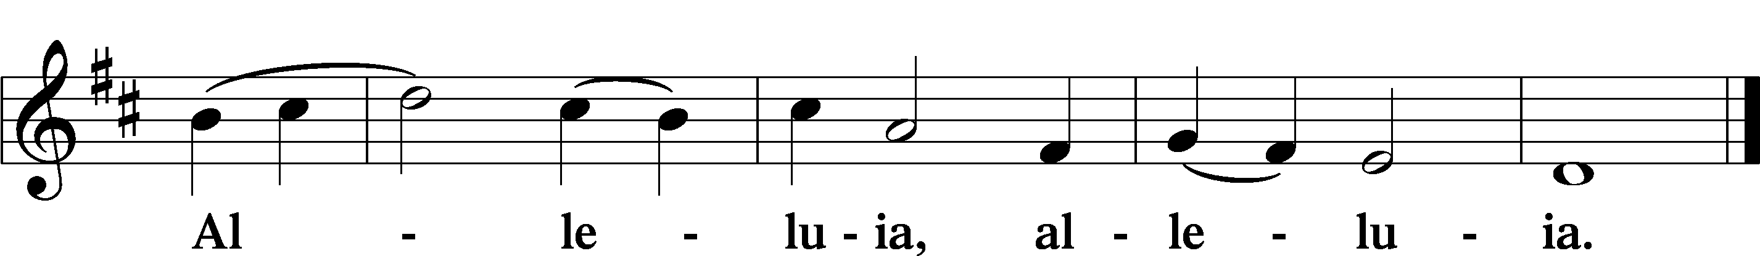

Salutation and Collect of the Day

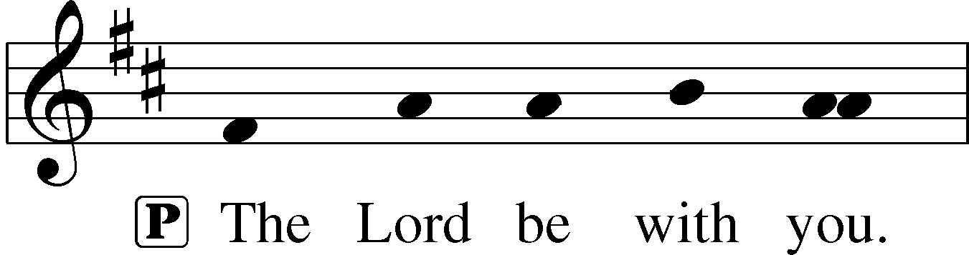
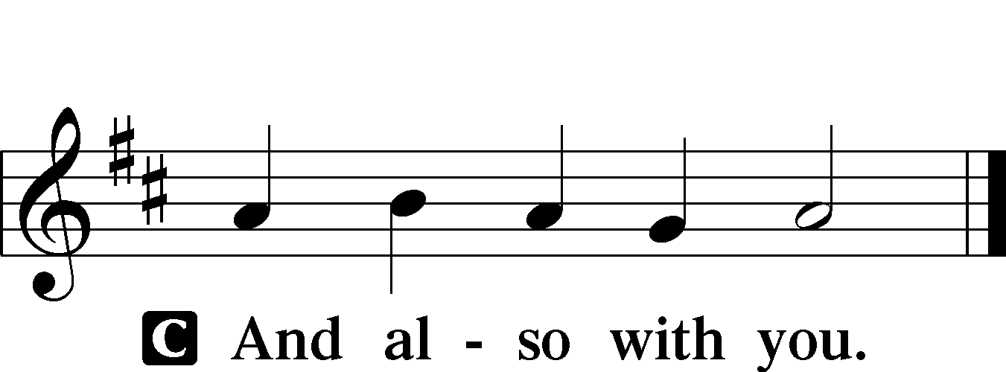

P Let us pray.
Heavenly Father, though we do not deserve Your goodness, still You provide for all our needs of body and soul. Grant us Your Holy Spirit that we may acknowledge Your gifts, give thanks for all Your benefits, and serve You in willing obedience; through Jesus Christ, Your Son, our Lord, who lives and reigns with You and the Holy Spirit, one God, now and forever.

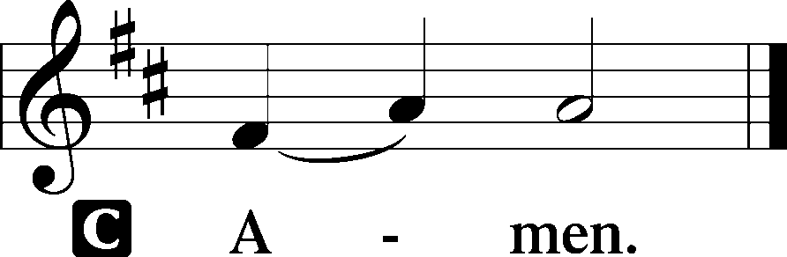

Sit

Old Testament Reading Isaiah 55:1–5

“Come, everyone who thirsts, come to the waters; and he who has no money, come, buy and eat! Come, buy wine and milk without money and without price.
Why do you spend your money for that which is not bread, and your labor for that which does not satisfy? Listen diligently to me, and eat what is good, and delight yourselves in rich food. Incline your ear, and come to me; hear, that your soul may live; and I will make with you an everlasting covenant, my steadfast, sure love for David.
Behold, I made him a witness to the peoples, a leader and commander for the peoples. Behold, you shall call a nation that you do not know, and a nation that did not know you shall run to you, because of the Lord your God, and of the Holy One of Israel, for he has glorified you.”

A This is the Word of the Lord.
C Thanks be to God.

Epistle Romans 9:1–13

I am speaking the truth in Christ—I am not lying; my conscience bears me witness in the Holy Spirit— that I have great sorrow and unceasing anguish in my heart. For I could wish that I myself were accursed and cut off from Christ for the sake of my brothers, my kinsmen according to the flesh. They are Israelites, and to them belong the adoption, the glory, the covenants, the giving of the law, the worship, and the promises. To them belong the patriarchs, and from their race, according to the flesh, is the Christ who is God over all, blessed forever. Amen.

But it is not as though the word of God has failed. For not all who are descended from Israel belong to Israel, and not all are children of Abraham because they are his offspring, but “Through Isaac shall your offspring be named.” This means that it is not the children of the flesh who are the children of God, but the children of the promise are counted as offspring. For this is what the promise said: “About this time next year I will return and Sarah shall have a son.” And not only so, but also when Rebecca had conceived children by one man, our forefather Isaac, though they were not yet born and had done nothing either good or bad—in order that God’s purpose of election might continue, not because of works but because of his call— she was told, “The older will serve the younger.” As it is written, “Jacob I loved, but Esau I hated.”

A This is the Word of the Lord.
C Thanks be to God.
Stand

Alleluia and Verse LSB 173

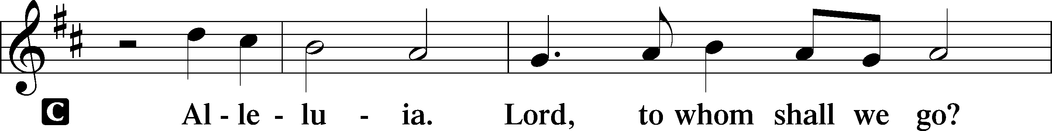
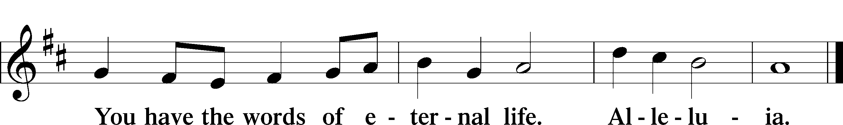

Holy Gospel Matthew 14:13–21

P The Holy Gospel according to St. Matthew, the fourteenth chapter.

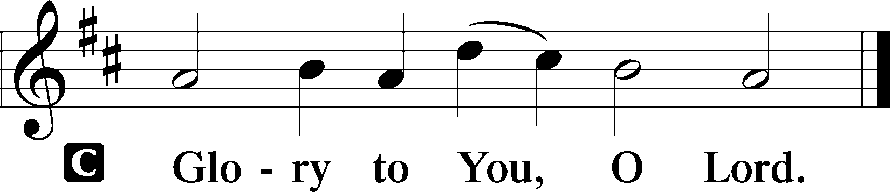

Now when Jesus heard [about the death of John], he withdrew from there in a boat to a desolate place by himself. But when the crowds heard it, they followed him on foot from the towns. When he went ashore he saw a great crowd, and he had compassion on them and healed their sick. Now when it was evening, the disciples came to him and said, “This is a desolate place, and the day is now over; send the crowds away to go into the villages and buy food for themselves.” But Jesus said, “They need not go away; you give them something to eat.” They said to him, “We have only five loaves here and two fish.” And he said, “Bring them here to me.” Then he ordered the crowds to sit down on the grass, and taking the five loaves and the two fish, he looked up to heaven and said a blessing. Then he broke the loaves and gave them to the disciples, and the disciples gave them to the crowds. And they all ate and were satisfied. And they took up twelve baskets full of the broken pieces left over. And those who ate were about five thousand men, besides women and children.

P This is the Gospel of the Lord.

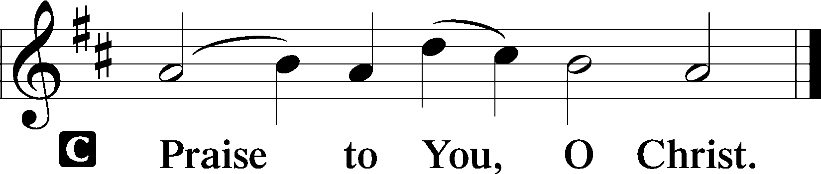

Nicene Creed

C I believe in one God, the Father Almighty, maker of heaven and earth and of all things visible and invisible.

And in one Lord Jesus Christ, the only-begotten Son of God, begotten of His Father before all worlds, God of God, Light of Light, very God of very God, begotten, not made, being of one substance with the Father, by whom all things were made; who for us men and for our salvation came down from heaven and was incarnate by the Holy Spirit of the virgin Mary and was made man; and was crucified also for us under Pontius Pilate. He suffered and was buried.

And the third day He rose again according to the Scriptures and ascended into heaven and sits at the right hand of the Father.

And He will come again with glory to judge both the living and the dead, whose kingdom will have no end.

And I believe in the Holy Spirit, the Lord and giver of life, who proceeds from the Father and the Son, who with the Father and the Son together is worshiped and glorified, who spoke by the prophets.

And I believe in one holy Christian and apostolic Church, I acknowledge one Baptism for the remission of sins, and I look for the resurrection of the dead and the life T of the world to come. Amen.

Sit

Hymn of the Day

642 O Living Bread from Heaven

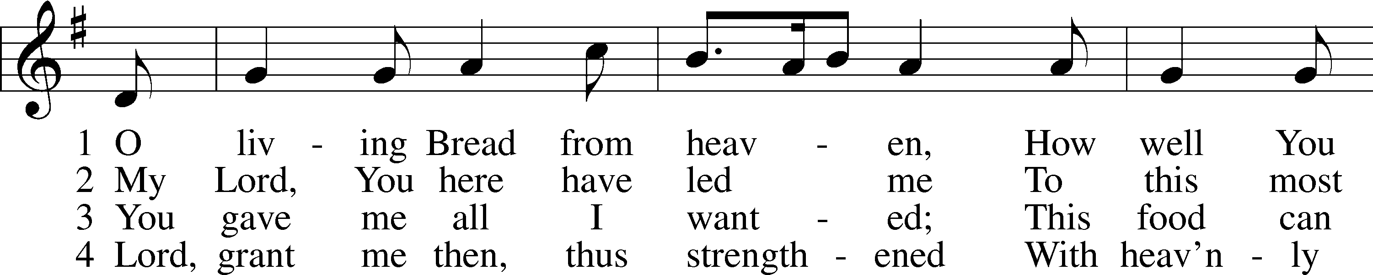
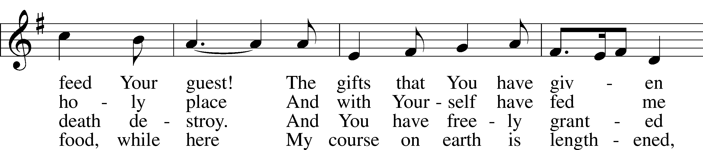
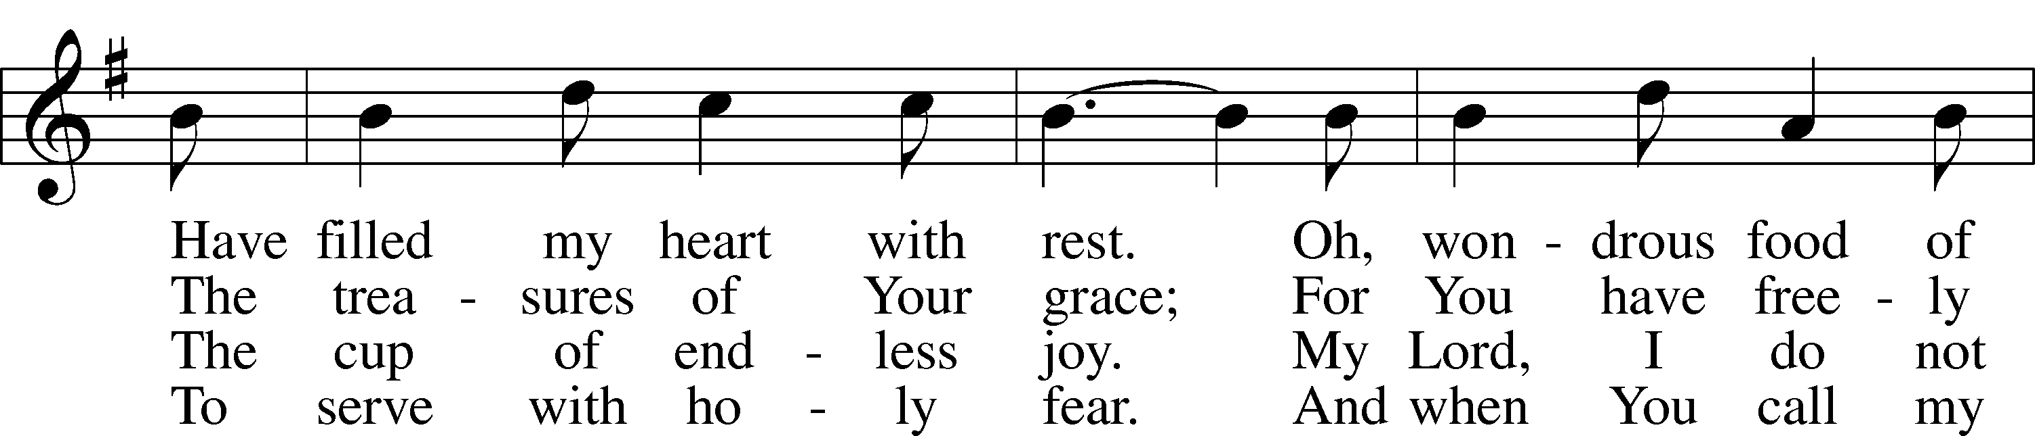
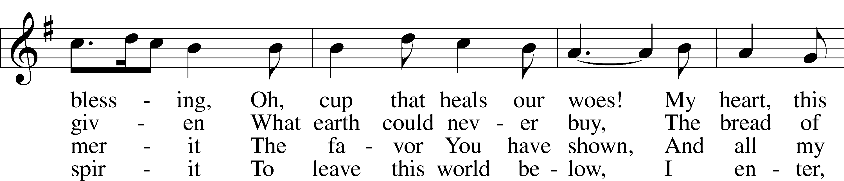
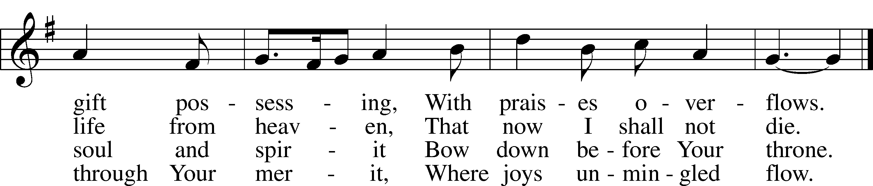
Text: Johann Rist, 1607–67; tr. Catherine Winkworth, 1827–78, alt.
Tune: Musae Sioniae, 1609, vol. 7, Wolfenbüttel, ed. Michael Praetorius
Text and tune: Public domain

Sermon

Offering & Offertory LSB 192

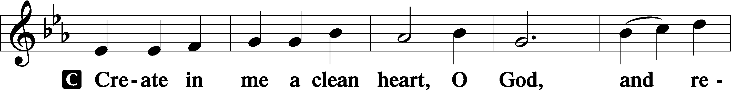
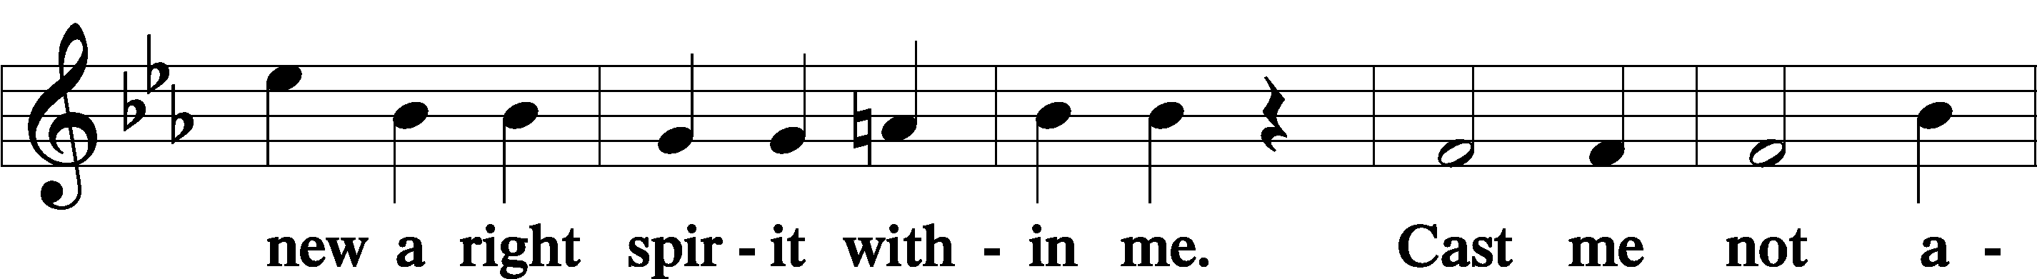
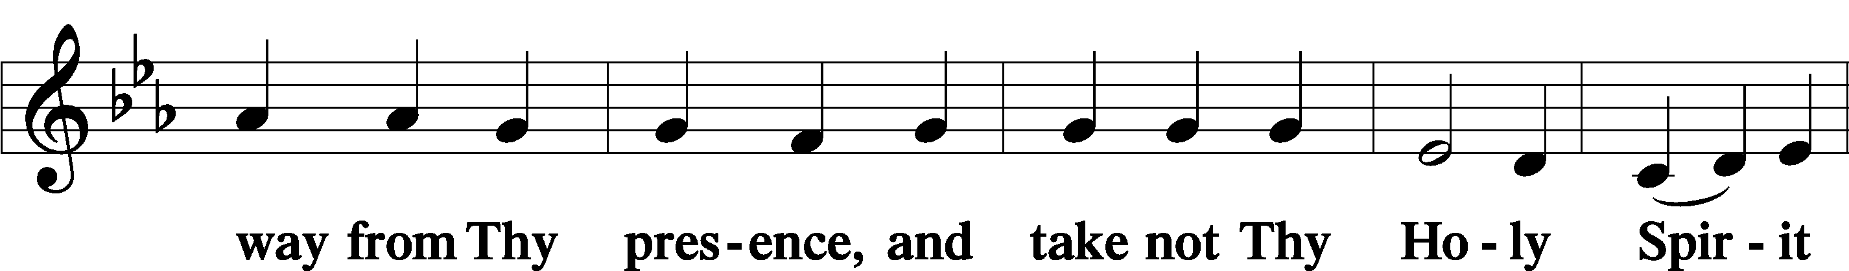
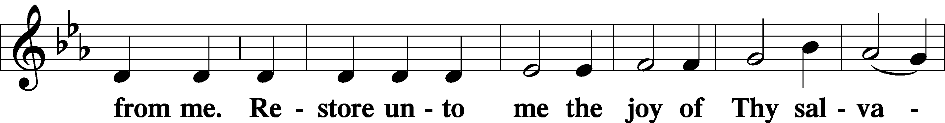
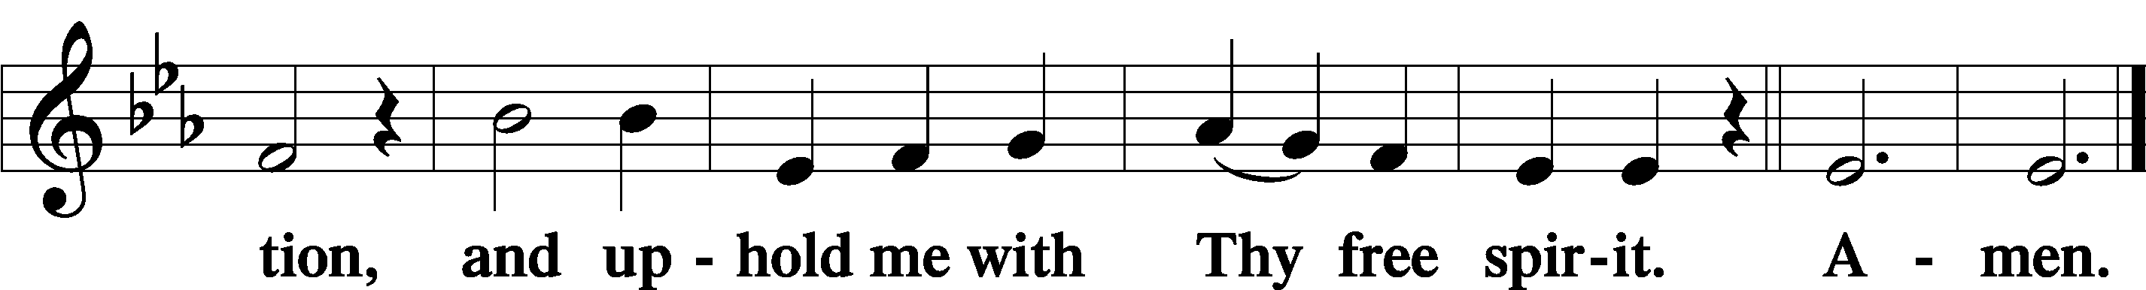

Psalm Psalm 136:1–9; antiphon: v. 26

Give thanks to the Lord, for he is good, for his steadfast love endures forever.
Give thanks to the God of gods, for his steadfast love endures forever.
Give thanks to the Lord of lords, for his steadfast love endures forever; to him who alone does great wonders, for his steadfast love endures forever; to him who by understanding made the heavens, for his steadfast love endures forever; to him who spread out the earth above the waters, for his steadfast love endures forever; to him who made the great lights, for his steadfast love endures forever; the sun to rule over the day, for his steadfast love endures forever; the moon and stars to rule over the night, for his steadfast love endures forever;

Stand

Prayer of the Church
After “Lord, in Your mercy” respond with “hear our prayer.”

P Almighty God, we give thanks for all Your goodness and bless You for the love that sustains us from day to day. We praise You for the gift of Your Son, our Savior, in whom we have redemption, the forgiveness of sins. We thank You for the Holy Spirit, the Comforter; for Your holy Church, for the means of grace, for the lives of all faithful and just people, and for the hope of the life to come. Help us to treasure in our hearts all that You have done for us, and enable us to show our thankfulness in lives that are wholly given to Your service. Lord, in Your mercy,
C hear our prayer.
P Save and defend Your whole Church, purchased with the precious blood of Christ. Strengthen Your faithful people through the Word and the holy Sacraments, making them perfect in love and in all good works, and establishing in them the faith once delivered to the saints. Lord, in Your mercy,
C hear our prayer.
P Grant Your wisdom and heavenly grace to all pastors and to those who hold office in Your Church that, by their devoted service, faith may abound and Your kingdom increase. Lord, in Your mercy,
C hear our prayer.
P Send the light of Your truth into all the earth. Raise up faithful servants of Christ to advance the Gospel both at home and in distant lands. Lord, in Your mercy,
C hear our prayer.
P In Your mercy strengthen newly established congregations, and support them in challenging times. Make them steadfast, abounding in the work of the Lord, and let their faith and zeal for the Gospel refresh and renew the witness of Your people everywhere. Lord, in Your mercy,
C hear our prayer.
P For the government and all who have been set into positions of leadership, that they may use the authority entrusted to them honorably and for the good of the people, according to Your holy will. Lord, in Your mercy,
C hear our prayer.
P Take from us all hatred and prejudice, give us the spirit of love, and order our days in Your peace. Prosper the labor of those who work to bring peace and justice to the nations of the world that mutual understanding and common endeavor may be increased among all peoples. Lord, in Your mercy,
C hear our prayer.
P Bless the schools of the Church and all colleges, universities, and centers of research and those who teach and work in them. Grant Your wisdom in such measure that people may serve You honorably in Church and state, and that our common life may be conformed to the ways of Your truth. Lord, in Your mercy,
C hear our prayer.
P Sanctify our homes with Your presence, and bless them with joy. Keep our children in the covenant of their Baptism, and enable their parents to bring them up in lives of faith and devotion. Unite the members of all families in a spirit of affection and service that they may show Your praise in our land and in all the world. Lord, in Your mercy,
C hear our prayer.
P Let Your blessing remain upon the seedtime and harvest, the commerce and industry, the leisure and rest, the arts and culture of our people. Take under Your special protection those whose work is difficult or dangerous, and be with all who put their hands to any useful task. Give them the just rewards for their labor and the knowledge that their work is a blessing in Your sight. Lord, in Your mercy,
C hear our prayer.
P For those who are sick …..<pastor will read the names on the sheet given to him> Lord, in Your mercy,
C hear our prayer.
P All these things and whatever else You know that we need, grant us, Father, for the sake of Him who died and rose again and now lives and reigns with You and the Holy Spirit, one God forever.
C Amen.

Service of the Sacrament

Preface LSB 177




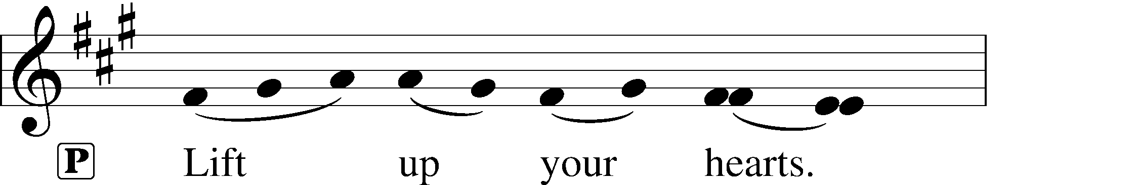
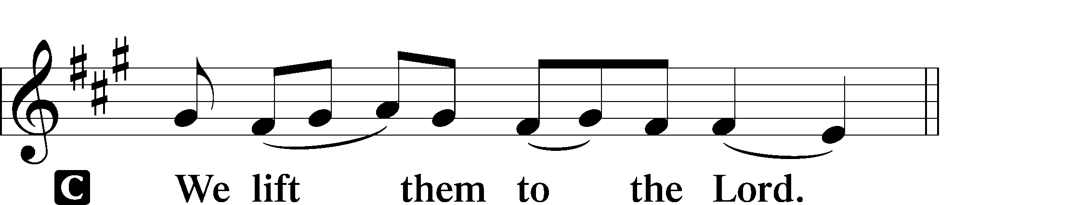

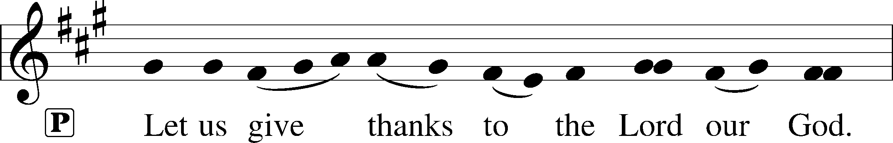
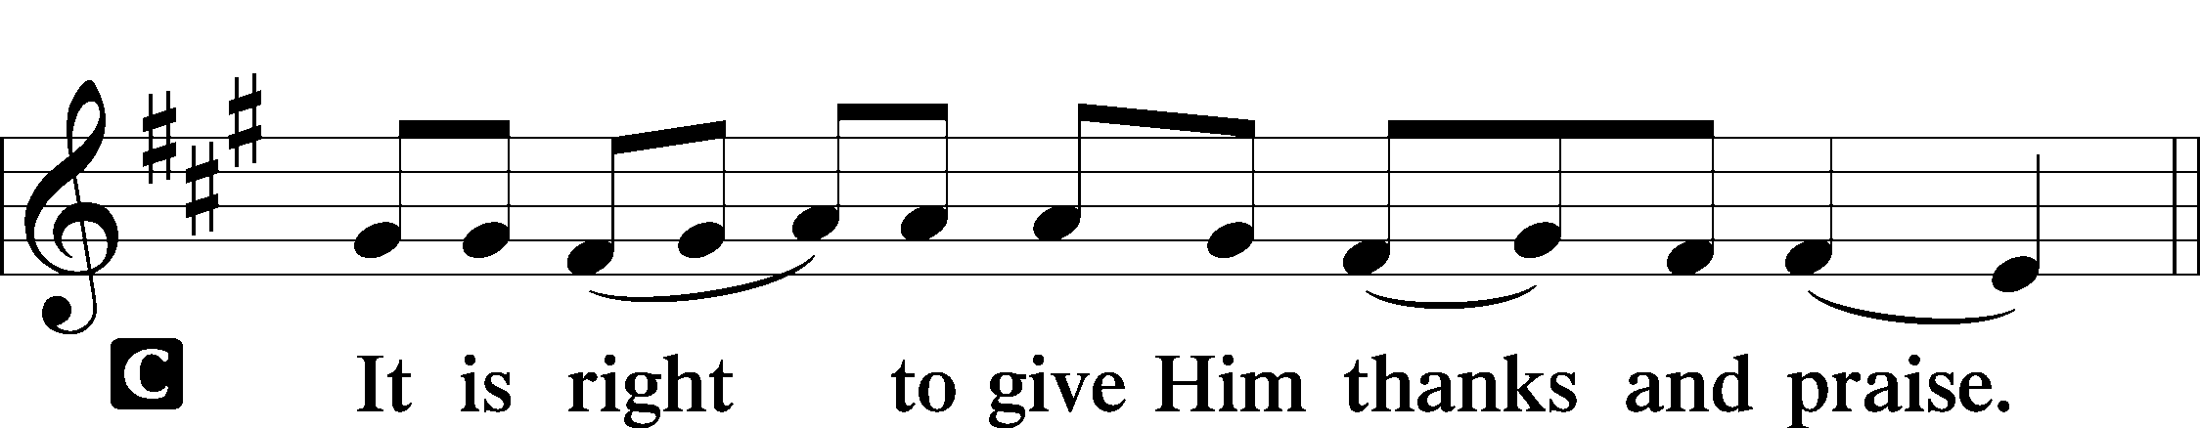

Proper Preface

P It is truly good, right, and salutary that we should at all times and in all places give thanks to You, holy Lord, almighty Father, everlasting God, through Jesus Christ, our Lord. Therefore with angels and archangels and with all the company of heaven we laud and magnify Your glorious name, evermore praising You and saying:

Sanctus LSB 178

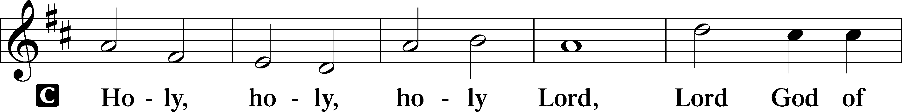
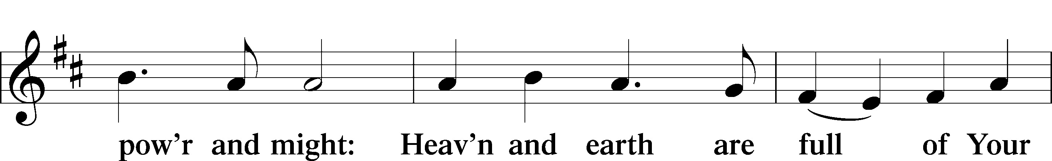
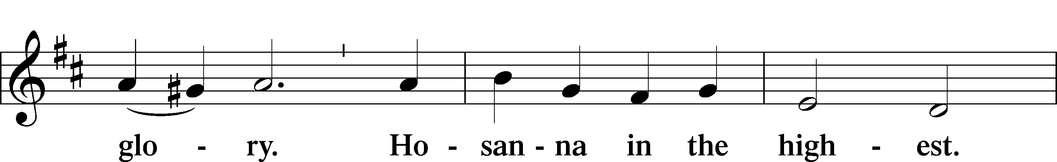
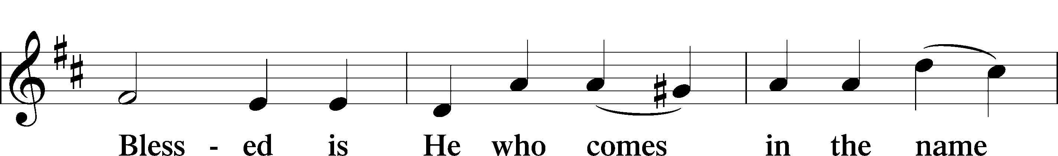
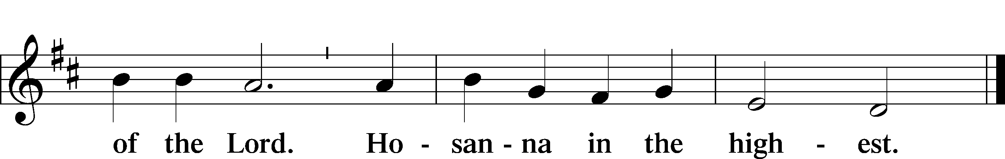

Prayer of Thanksgiving LSB 178

P Blessed are You, Lord of heaven and earth, for You have had mercy on those whom You created and sent Your only-begotten Son into our flesh to bear our sin and be our Savior. With repentant joy we receive the salvation accomplished for us by the all-availing sacrifice of His body and His blood on the cross.

Gathered in the name and the remembrance of Jesus, we beg You, O Lord, to forgive, renew, and strengthen us with Your Word and Spirit. Grant us faithfully to eat His body and drink His blood as He bids us do in His own testament. Gather us together, we pray, from the ends of the earth to celebrate with all the faithful the marriage feast of the Lamb in His kingdom, which has no end. Graciously receive our prayers; deliver and preserve us. To You alone, O Father, be all glory, honor, and worship, with the Son and the Holy Spirit, one God, now and forever.
C Amen.

The Words of Our Lord

P Our Lord Jesus Christ, on the night when He was betrayed, took bread, and when He had given thanks, He broke it and gave it to the disciples and said: “Take, eat; this is My T body, which is given for you. This do in remembrance of Me.”

In the same way also He took the cup after supper, and when He had given thanks, He gave it to them, saying: “Drink of it, all of you; this cup is the new testament in My T blood, which is shed for you for the forgiveness of sins. This do, as often as you drink it, in remembrance of Me.”

Proclamation of Christ

P As often as we eat this bread and drink this cup, we proclaim the Lord’s death until He comes.
C Amen. Come, Lord Jesus.

P O Lord Jesus Christ, only Son of the Father, in giving us Your body and blood to eat and to drink, You lead us to remember and confess Your holy cross and passion, Your blessed death, Your rest in the tomb, Your resurrection from the dead, Your ascension into heaven, and Your coming for the final judgment. So remember us in Your kingdom and teach us to pray:

Lord’s Prayer

Our Father who art in heaven, hallowed be Thy name, Thy kingdom come, Thy will be done on earth as it is in heaven.

Give us this day our daily bread; and forgive us our trespasses as we forgive those who trespass against us; and lead us not into temptation but deliver us from evil.
For Thine is the kingdom and the power and the glory forever and ever. Amen.

Pax Domini LSB 180

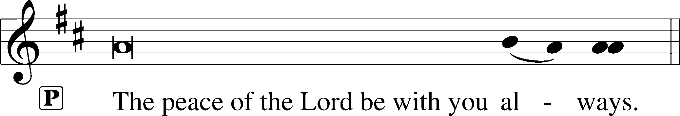


Agnus Dei LSB 180

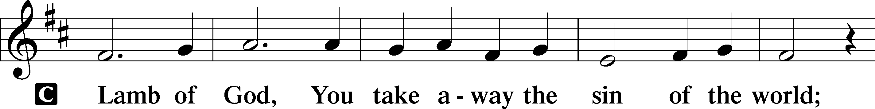
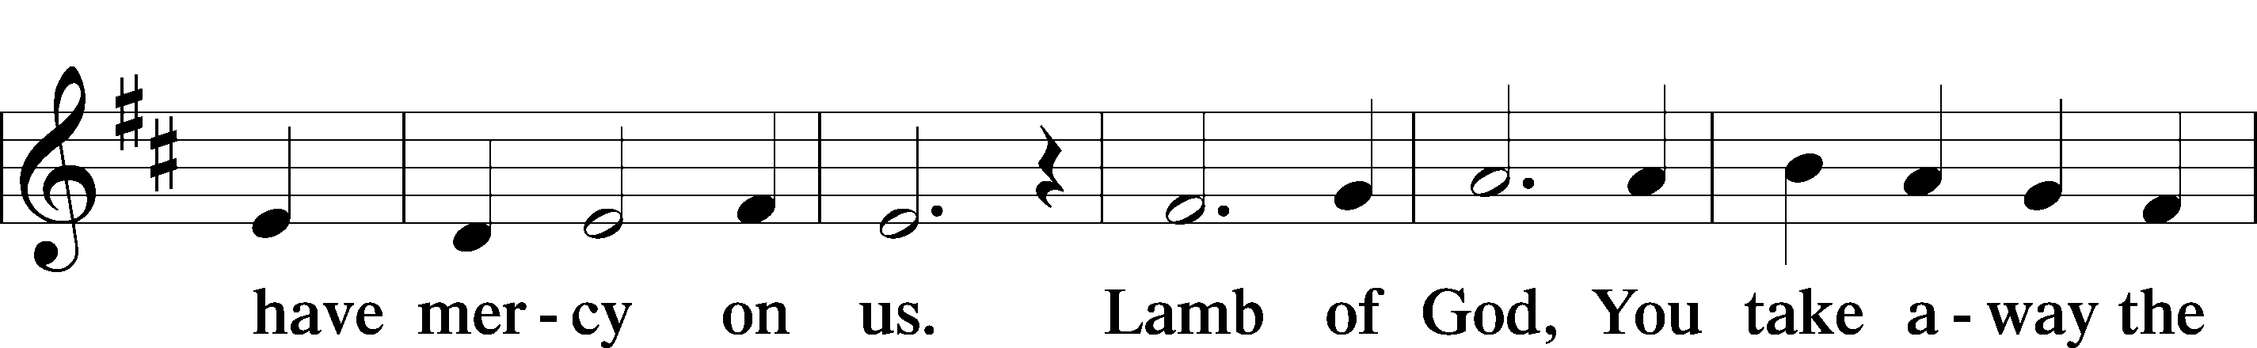
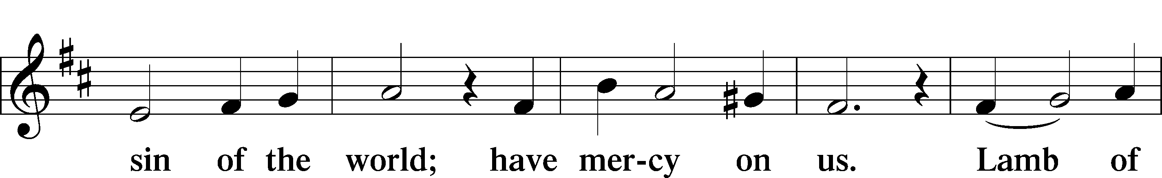
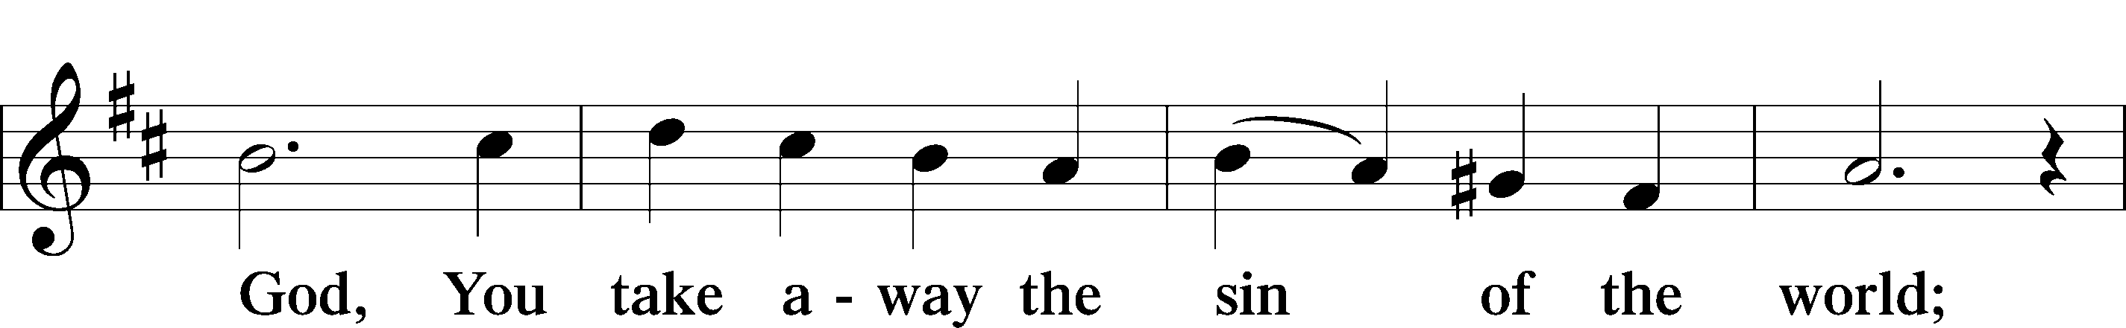
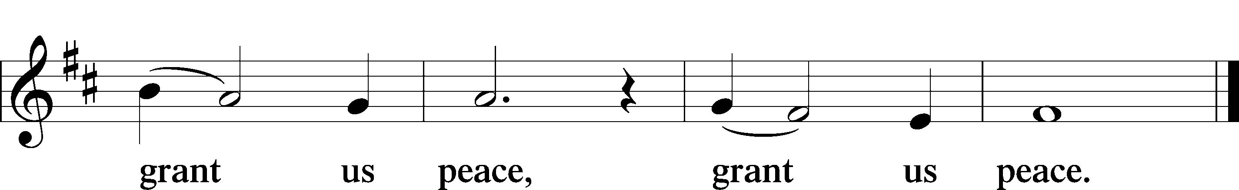

Distribution & Hymn

628 Your Table I Approach sts. 1–4, 6

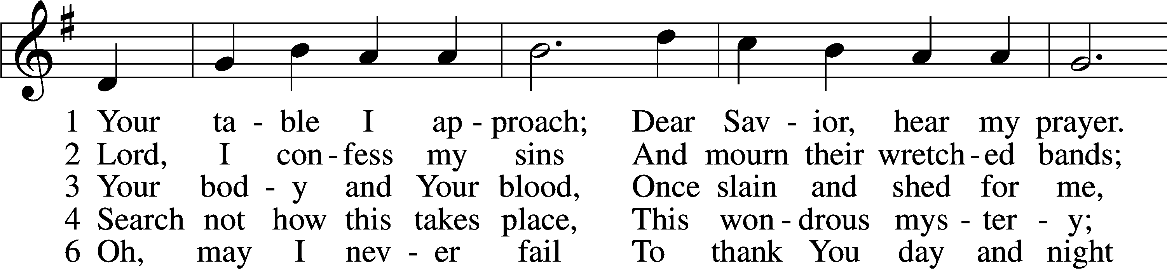
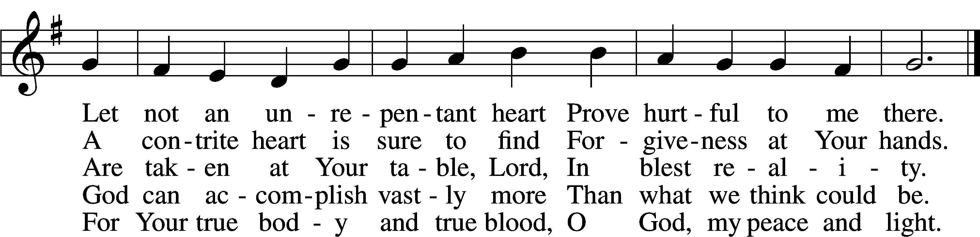
Text: Gerhard Wolter Molanus, 1633–1722; tr. Matthias Loy, 1828–1915, alt.
Tune: Trente quatre Pseaumes de David, 1551, Geneva, ed. Louis Bourgeois
Text and tune: Public domain

Stand

Thank the Lord LSB 181

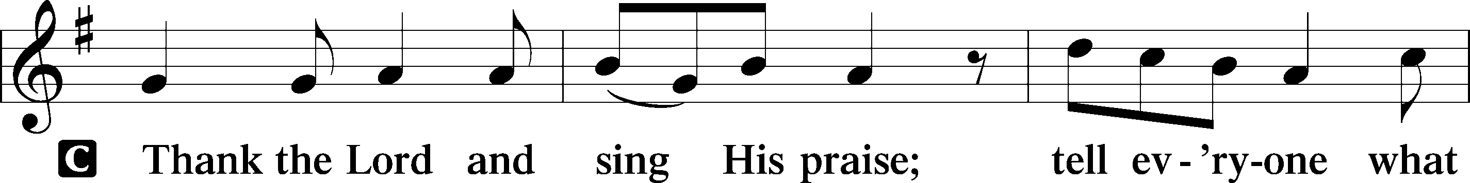
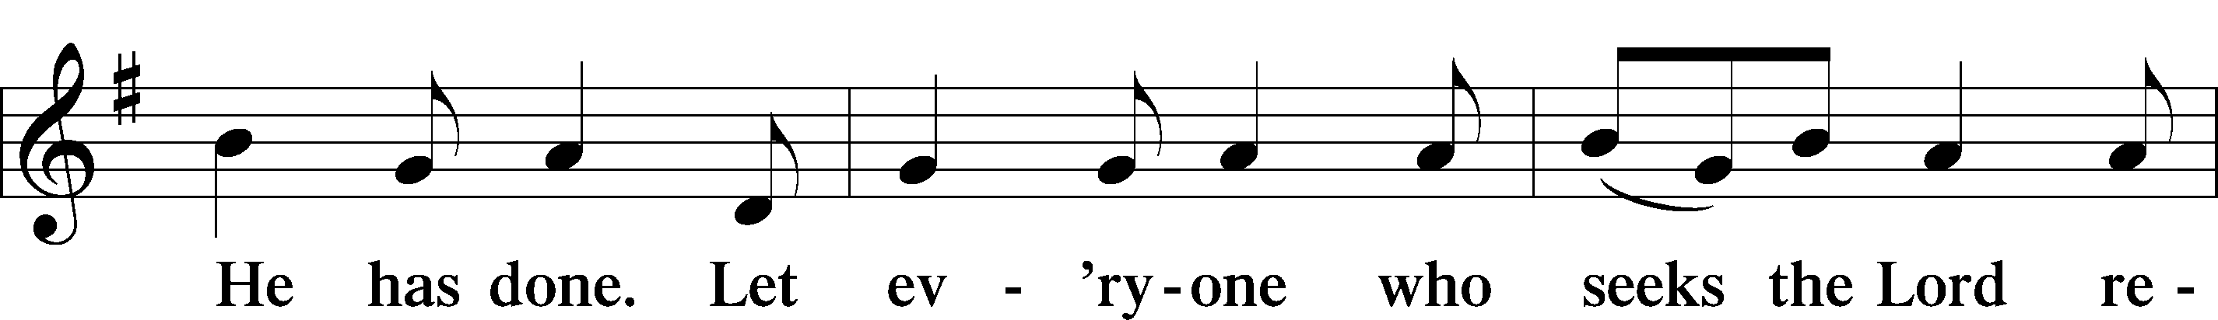
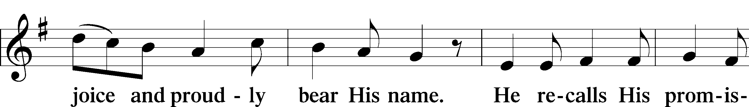
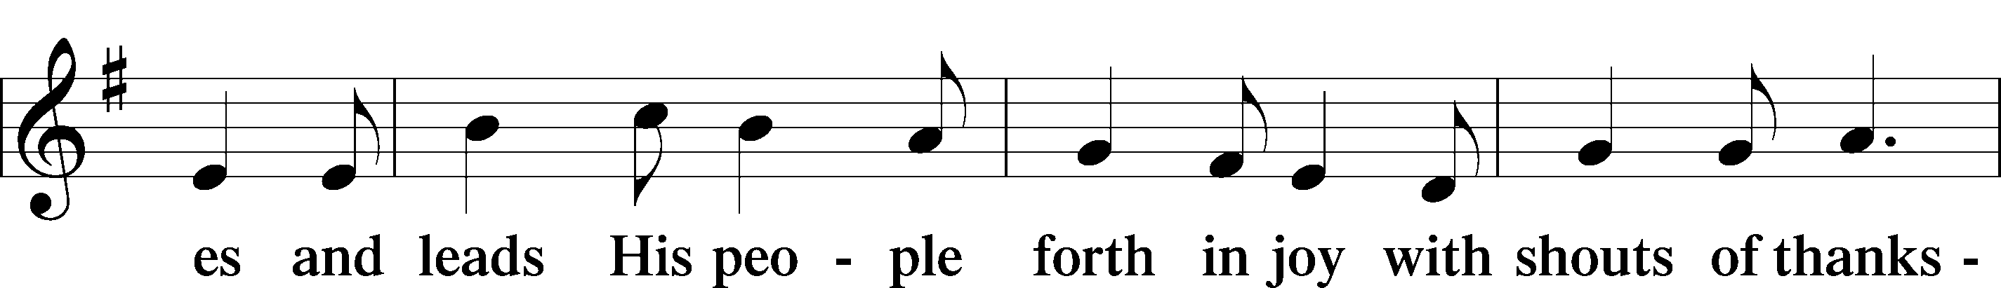
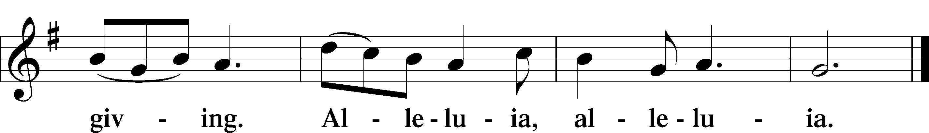

Post-Communion Collect

A Let us pray.
We give thanks to You, almighty God, that You have refreshed us through this salutary gift, and we implore You that of Your mercy You would strengthen us through the same in faith toward You and in fervent love toward one another; through Jesus Christ, Your Son, our Lord, who lives and reigns with You and the Holy Spirit, one God, now and forever.
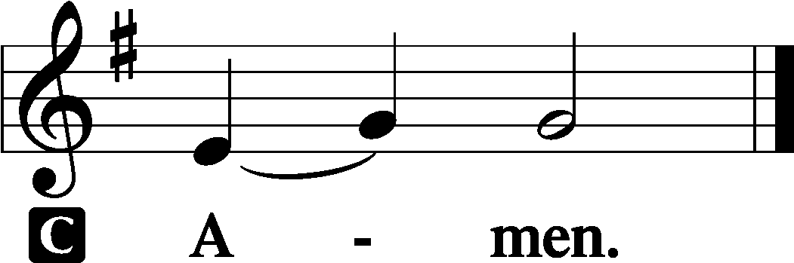

Benediction LSB 183

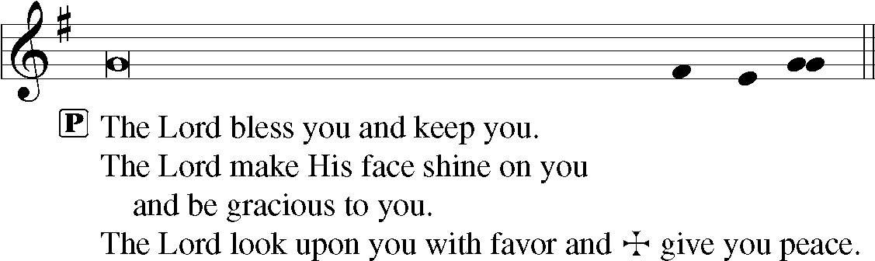

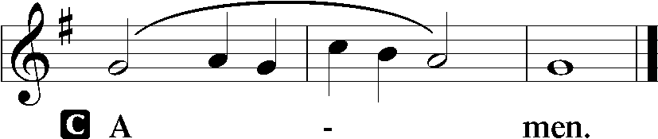

Closing Hymn

918 Guide Me, O Thou Great Redeemer

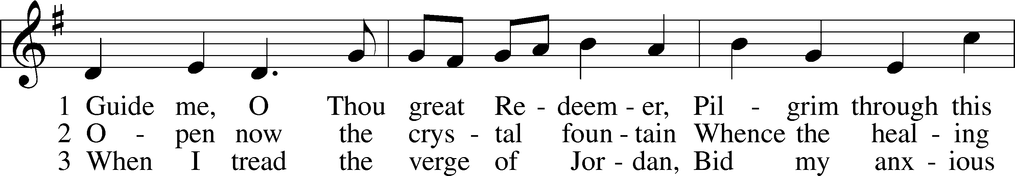
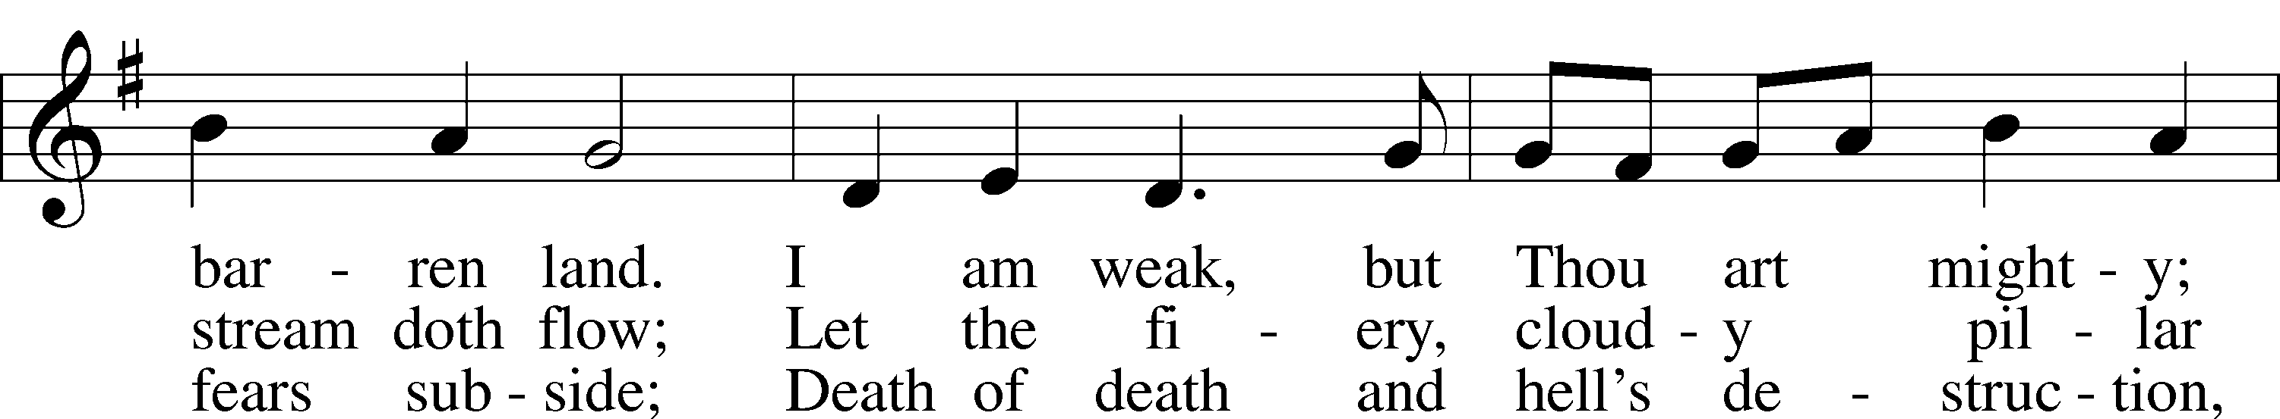
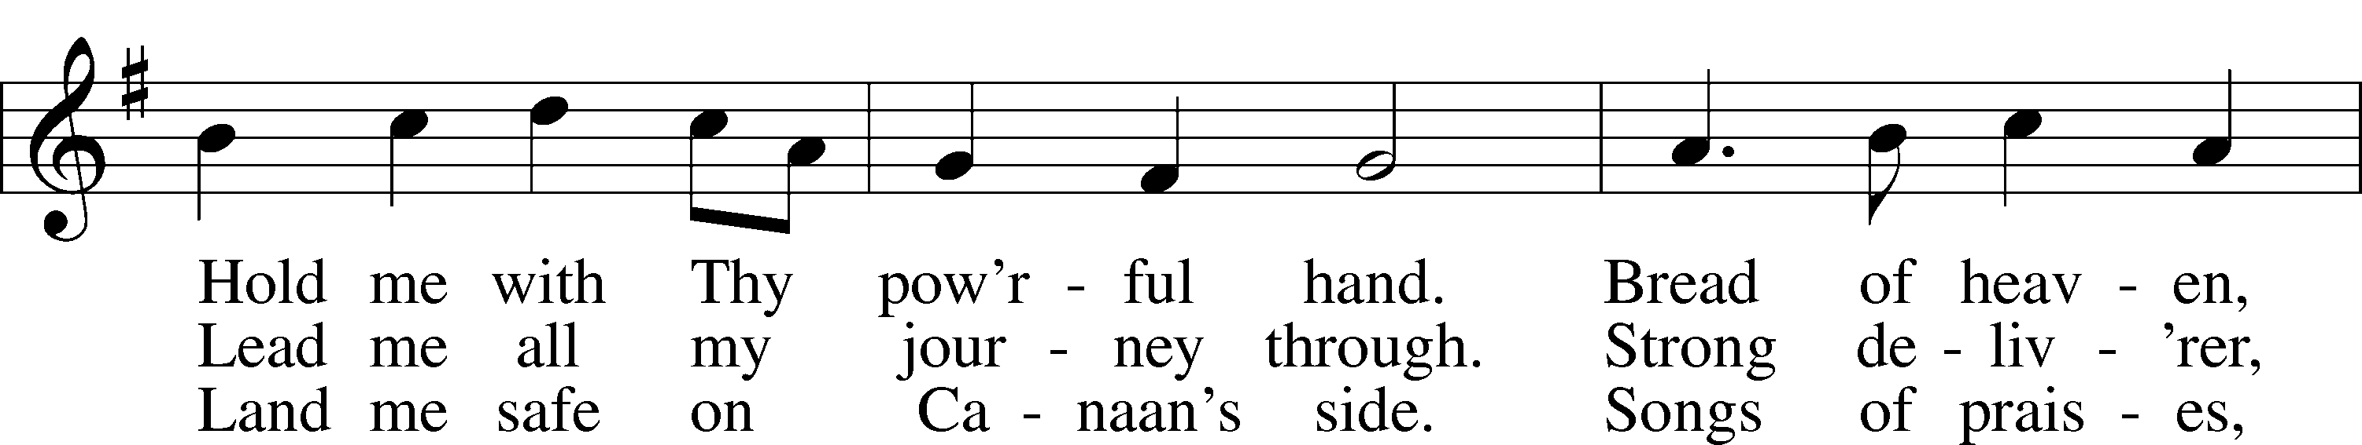
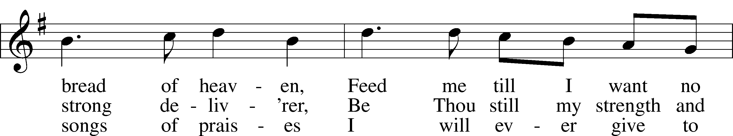
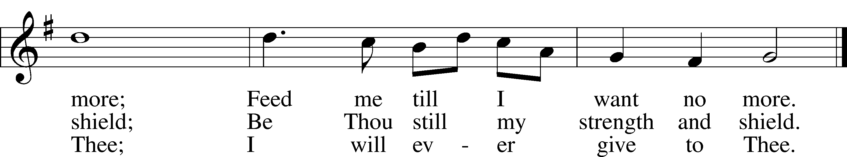
Text: William Williams, 1717–91, abr.; (st. 1): tr. Peter Williams, 1722–96, alt.; (sts. 2–3): tr. William Williams, 1717–91
Tune: John Hughes, 1873–1932
Text and tune: Public domain

Announcements

All Church Members

Please bring pictures of your Clifton church life. They will be hung in the Fellowship Hall to commemorate our anniversary.

Acknowledgments

Unless otherwise indicated, Scripture quotations are from the ESV® Bible (The Holy Bible, English Standard Version®), copyright © 2001 by Crossway, a publishing ministry of Good News Publishers. Used by permission. All rights reserved.
Created by Lutheran Service Builder © 2026 Concordia Publishing House.

