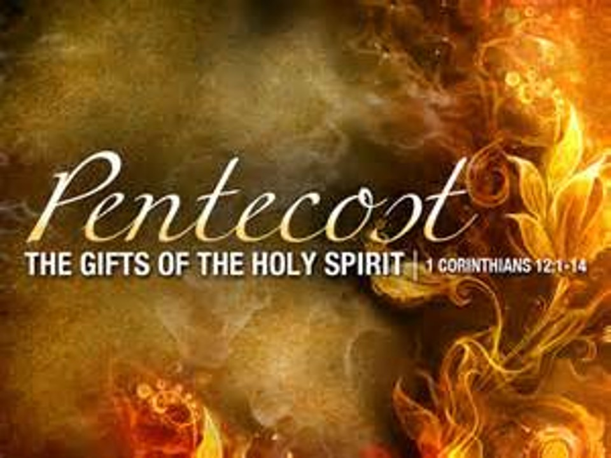

Saint John’s Lutheran Church
810 Broad Street
Clifton, New Jersey
Office: 973-778-141
www.StJohnsClifton.org

Pentecost 5
Sunday, June 28, 2026
9:00 AM

Leader: Ralph Unkert

The church of the praying hands

Hymn of Invocation

868 Awake, My Soul, and with the Sun sts. 1–2, 5–6

Stand

Confession and Absolution

The sign of the cross may be made by all in remembrance of their Baptism.

Invocation

Exhortation LSB 184

Silence for reflection on God’s Word and for self-examination.

Confession of Sins LSB 184

Declaration of Grace LSB 185

Service of the Word

Introit Psalm 89:15–18; antiphon: v. 1

I will sing of the steadfast love of the Lord, forever;
with my mouth I will make known your faithfulness to all generations.
Blessèd are the people who know the festal shout,
who walk, O Lord, in the light of your face,
who exult in your name all the day
and in your righteousness are exalted.
For you are the glory of their strength;
by your favor our horn is exalted.
For our shield belongs to the Lord,
our king to the Holy One of Israel.
Glory be to the Father and to the Son and to the Holy Spirit; as it was in the beginning, is now, and will be forever. Amen.
I will sing of the steadfast love of the Lord, forever;
with my mouth I will make known your faithfulness to all generations.

Kyrie LSB 186

Gloria in Excelsis LSB 187

Salutation and Collect of the Day

Sit

Old Testament Reading Jeremiah 28:5–9

Then the prophet Jeremiah spoke to Hananiah the prophet in the presence of the priests and all the people who were standing in the house of the Lord, and the prophet Jeremiah said, “Amen! May the Lord do so; may the Lord make the words that you have prophesied come true, and bring back to this place from Babylon the vessels of the house of the Lord, and all the exiles. Yet hear now this word that I speak in your hearing and in the hearing of all the people. The prophets who preceded you and me from ancient times prophesied war, famine, and pestilence against many countries and great kingdoms. As for the prophet who prophesies peace, when the word of that prophet comes to pass, then it will be known that the Lord has truly sent the prophet.”

A This is the Word of the Lord.
C Thanks be to God.

Epistle Romans 7:1–13

Or do you not know, brothers—for I am speaking to those who know the law—that the law is binding on a person only as long as he lives? Thus a married woman is bound by law to her husband while he lives, but if her husband dies she is released from the law of marriage. Accordingly, she will be called an adulteress if she lives with another man while her husband is alive. But if her husband dies, she is free from that law, and if she marries another man she is not an adulteress.

Likewise, my brothers, you also have died to the law through the body of Christ, so that you may belong to another, to him who has been raised from the dead, in order that we may bear fruit for God. For while we were living in the flesh, our sinful passions, aroused by the law, were at work in our members to bear fruit for death. But now we are released from the law, having died to that which held us captive, so that we serve not under the old written code but in the new life of the Spirit.

What then shall we say? That the law is sin? By no means! Yet if it had not been for the law, I would not have known sin. I would not have known what it is to covet if the law had not said, “You shall not covet.” But sin, seizing an opportunity through the commandment, produced in me all kinds of covetousness. Apart from the law, sin lies dead. I was once alive apart from the law, but when the commandment came, sin came alive and I died. The very commandment that promised life proved to be death to me. For sin, seizing an opportunity through the commandment, deceived me and through it killed me. So the law is holy, and the commandment is holy and righteous and good.

Did that which is good, then, bring death to me? By no means! It was sin, producing death in me through what is good, in order that sin might be shown to be sin, and through the commandment might become sinful beyond measure.

A This is the Word of the Lord.
C Thanks be to God.

Stand

Alleluia LSB 190

Holy Gospel Matthew 10:34–42

P The Holy Gospel according to St. Matthew, the tenth chapter.

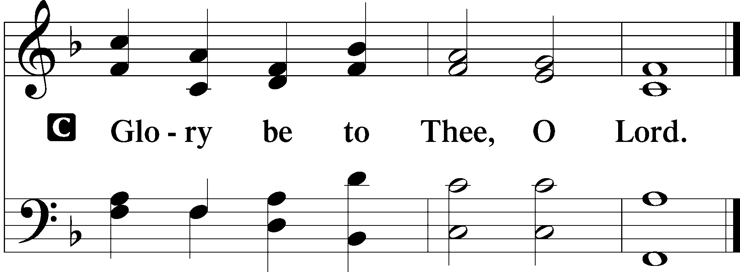

[Jesus said:] “Do not think that I have come to bring peace to the earth. I have not come to bring peace, but a sword. For I have come to set a man against his father, and a daughter against her mother, and a daughter-in-law against her mother-in-law. And a person’s enemies will be those of his own household. Whoever loves father or mother more than me is not worthy of me, and whoever loves son or daughter more than me is not worthy of me. And whoever does not take his cross and follow me is not worthy of me. Whoever finds his life will lose it, and whoever loses his life for my sake will find it.
“Whoever receives you receives me, and whoever receives me receives him who sent me. The one who receives a prophet because he is a prophet will receive a prophet’s reward, and the one who receives a righteous person because he is a righteous person will receive a righteous person’s reward. And whoever gives one of these little ones even a cup of cold water because he is a disciple, truly, I say to you, he will by no means lose his reward.”

P This is the Gospel of the Lord.
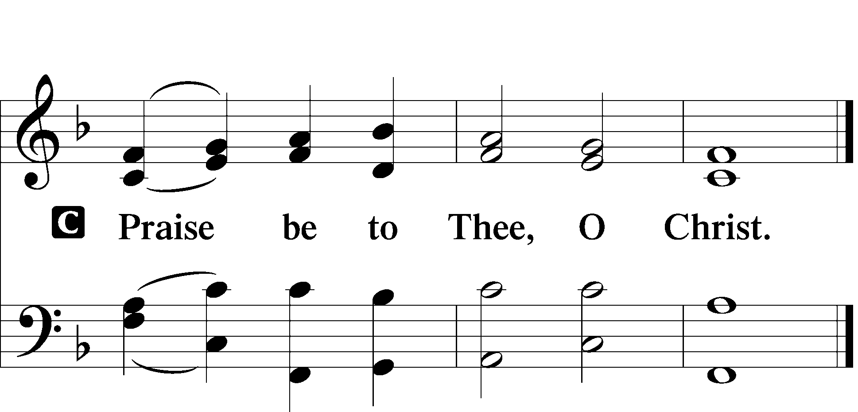

Apostles’ Creed LSB Back Cover

Sit

Hymn of the Day

425 When I Survey the Wondrous Cross

Sermon

Offering

Psalm Psalm 119:153–160; antiphon: v. 154

Look on my affliction and deliver me, for I do not forget your law. Plead my cause and redeem me; give me life according to your promise! Salvation is far from the wicked, for they do not seek your statutes.
Great is your mercy, O Lord; give me life according to your just decrees. Many are my persecutors and my adversaries, but I do not swerve from your testimonies.
I look at the faithless with disgust, because they do not keep your commands.
Consider how I love your precepts! Give me life according to your steadfast love. The sum of your word is truth, and every one of your just and righteous decrees endures forever.

Stand

781 We Give Thee But Thine Own sts. 1–2

Prayer of the Church
After “Lord, in Your mercy” respond with “hear our prayer.”

Lord’s Prayer LSB Back Cover

Benediction LSB 202

Hymn to Depart

656 A Mighty Fortress Is Our God

Acknowledgments
Divine Service, Setting One from Lutheran Service Book
Unless otherwise indicated, Scripture quotations are from the ESV® Bible (The Holy Bible, English Standard Version®), copyright © 2001 by Crossway, a publishing ministry of Good News Publishers. Used by permission. All rights reserved.
Created by Lutheran Service Builder © 2026 Concordia Publishing House

