

Saint John’s Lutheran Church
810 Broad Street
Clifton, New Jersey
Office: 973-778-141
www.StJohnsClifton.org

Pentecost 3
Sunday, June 14, 2026
9:00 AM

Leader: Matthew Martinique

The church of the praying hands

Opening Hymn

869 With the Lord Begin Your Task sts. 1–3, 5

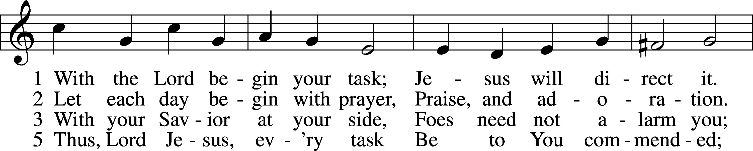
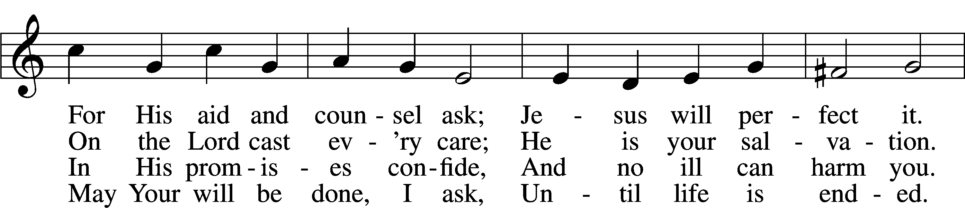
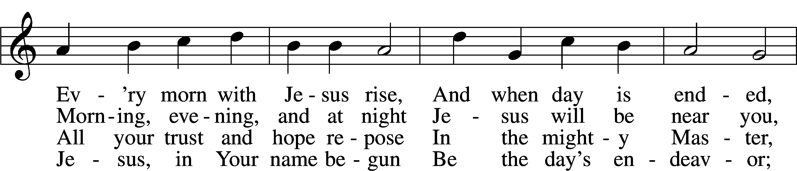
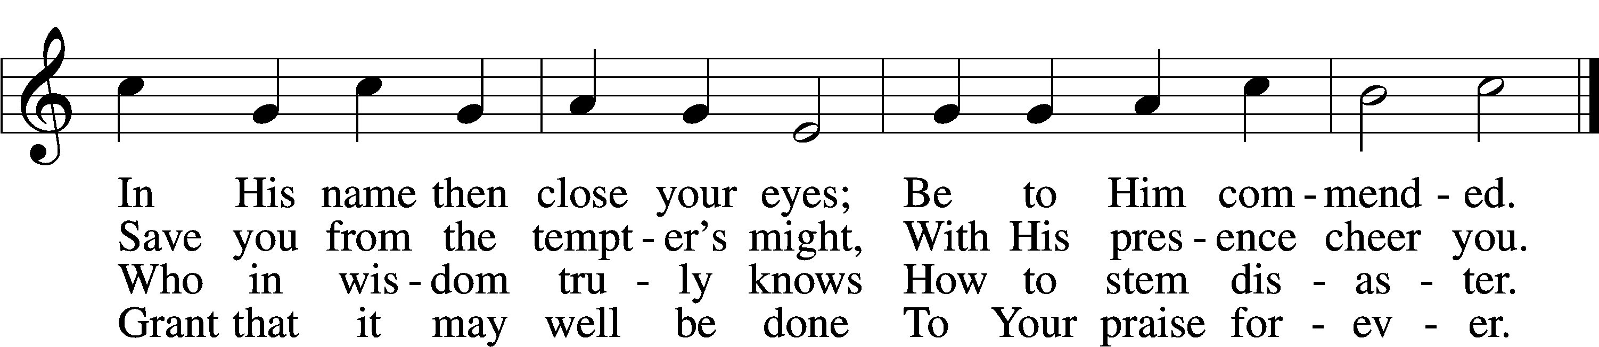
Text: Morgen- und Abend-segen, 1734, Waldenburg; tr. W. Gustave Polack, 1890–1950, alt.
Tune: Peter Frank, 1616–75
Text: © 1941 Concordia Publishing House. Used by permission: LSB Hymn License no. 110003925
Tune: Public domain

Stand

Confession and Absolution

The sign of the cross may be made by all in remembrance of their Baptism.

Invocation

P In the name of the Father and of the T Son and of the Holy Spirit.
C Amen.

Exhortation LSB 151

P If we say we have no sin, we deceive ourselves, and the truth is not in us.
C But if we confess our sins, God, who is faithful and just, will forgive our sins and cleanse us from all unrighteousness.

Kneel/Stand

Silence for reflection on God’s Word and for self-examination.

Confession of Sins LSB 151

P Let us then confess our sins to God our Father.
C Most merciful God, we confess that we are by nature sinful and unclean. We have sinned against You in thought, word, and deed, by what we have done and by what we have left undone. We have not loved You with our whole heart; we have not loved our neighbors as ourselves. We justly deserve Your present and eternal punishment. For the sake of Your Son, Jesus Christ, have mercy on us. Forgive us, renew us, and lead us, so that we may delight in Your will and walk in Your ways to the glory of Your holy name. Amen.
Declaration of Grace LSB 151

P In the mercy of almighty God, Jesus Christ was given to die for us, and for His sake God forgives us all our sins. To those who believe in Jesus Christ He gives the power to become the children of God and bestows on them the Holy Spirit. May the Lord, who has begun this good work in us, bring it to completion in the day of our Lord Jesus Christ.
C Amen.

Stand

Service of the Word

Introit Psalm 67:4–7; antiphon: v. 3

Let the peoples praise you, O God;
let all the peoples praise you!
Let the nations be glad and sing for joy,
for you judge the peoples with equity and guide the nations upon earth.
Let the peoples praise you, O God;
let all the peoples praise you!
The earth has yielded its increase;
God, our God, shall bless us.
God shall bless us;
let all the ends of the earth fear him!
Glory be to the Father and to the Son and to the Holy Spirit; as it was in the beginning, is now, and will be forever. Amen.
Let the peoples praise you, O God;
let all the peoples praise you!

Kyrie LSB 152

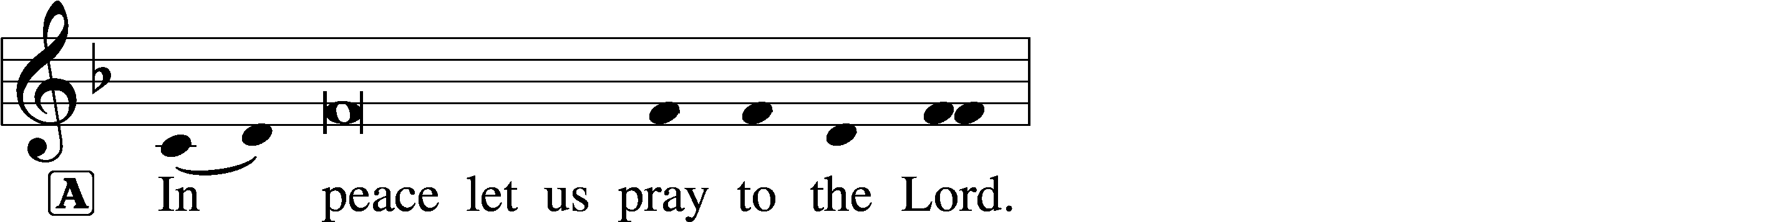
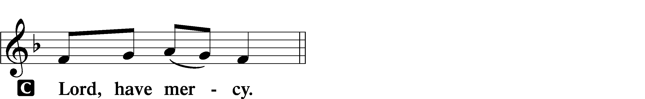

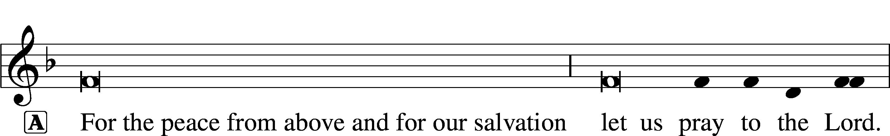
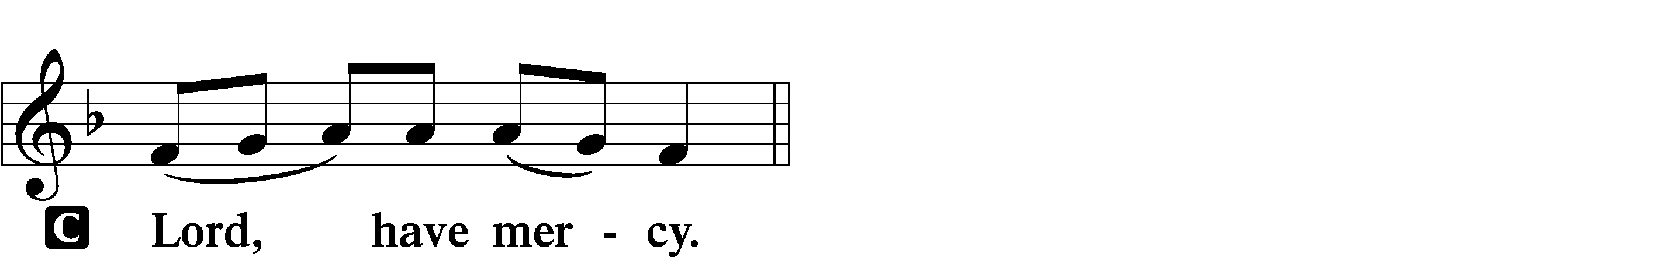

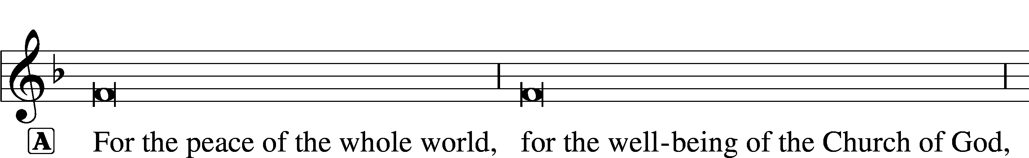
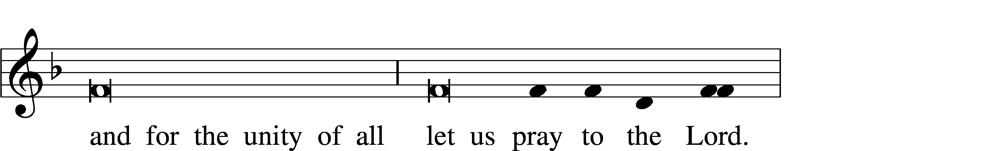
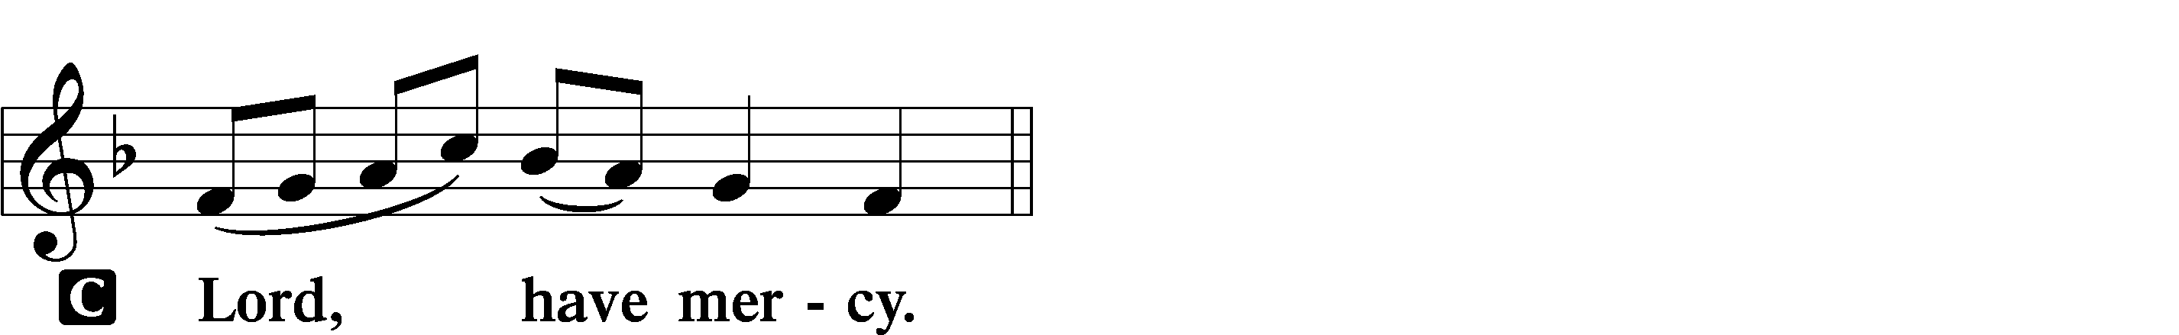

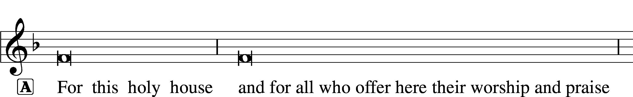
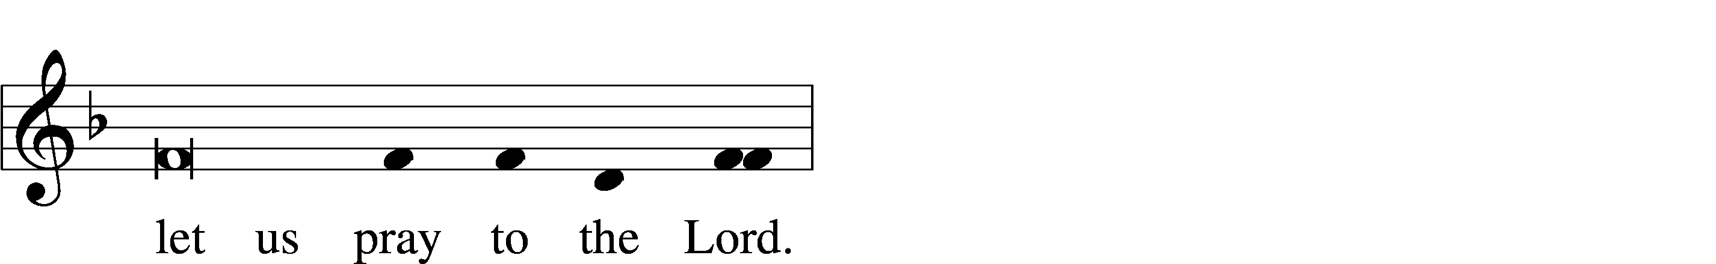
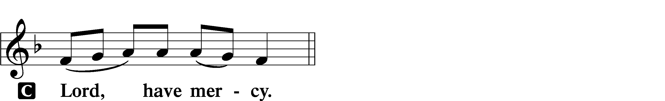

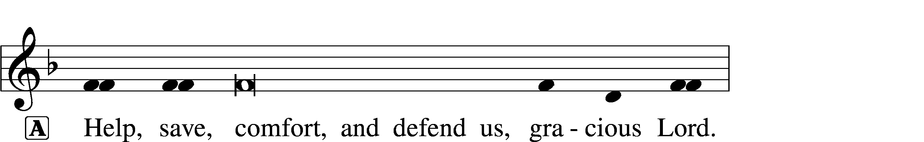


Gloria in Excelsis LSB 154

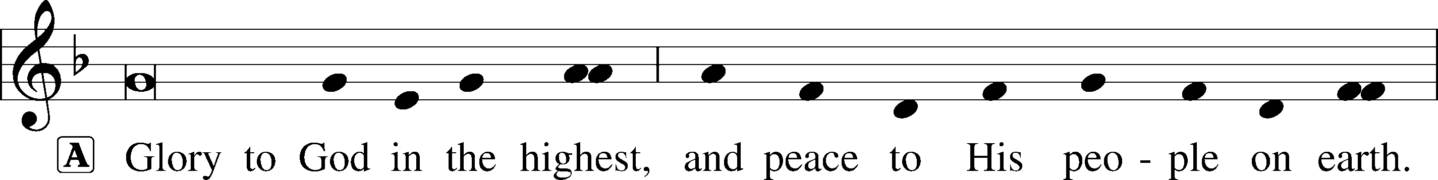
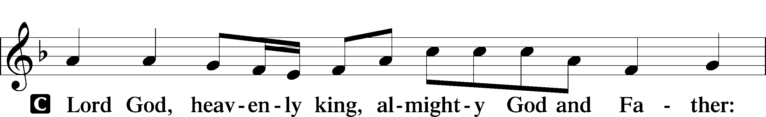
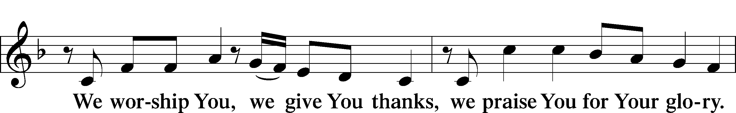
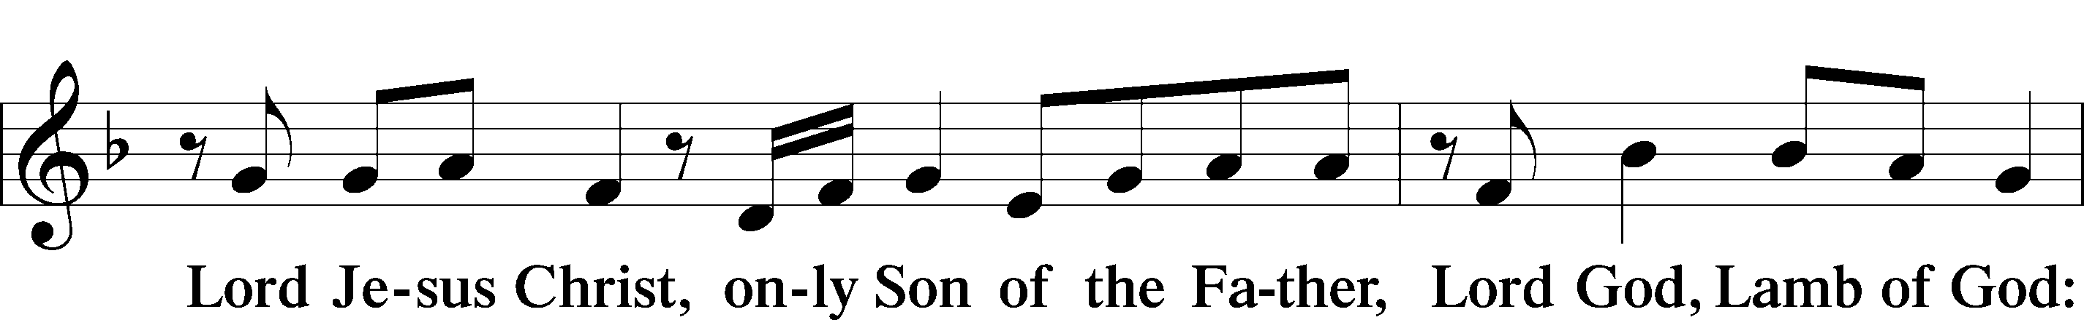
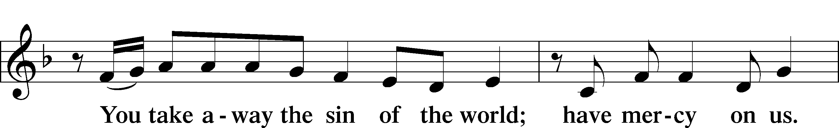
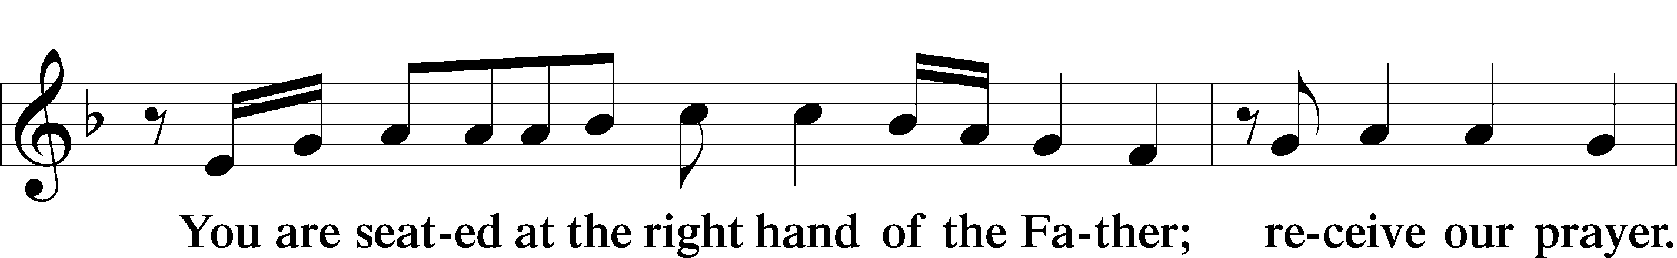
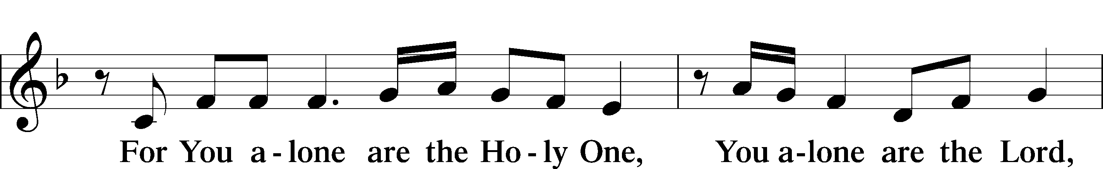
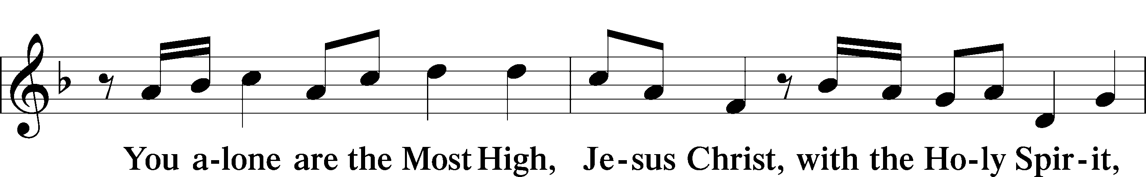
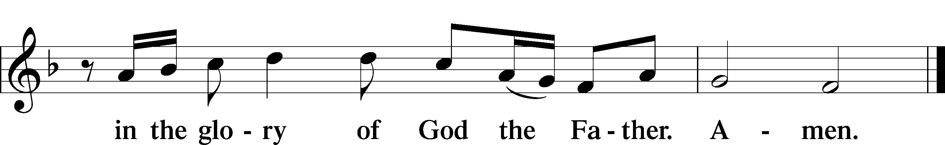

Salutation and Collect of the Day

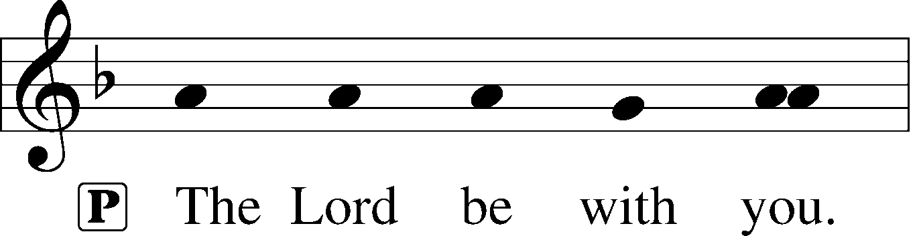
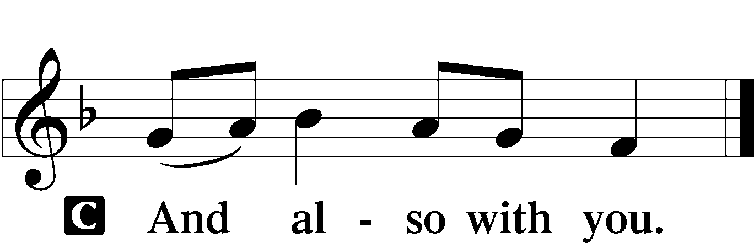

P Let us pray.
Almighty, eternal God, in the Word of Your apostles and prophets You have proclaimed to us Your saving will. Grant us faith to believe Your promises that we may receive eternal salvation; through Jesus Christ, our Lord, who lives and reigns with You and the Holy Spirit, one God, now and forever.

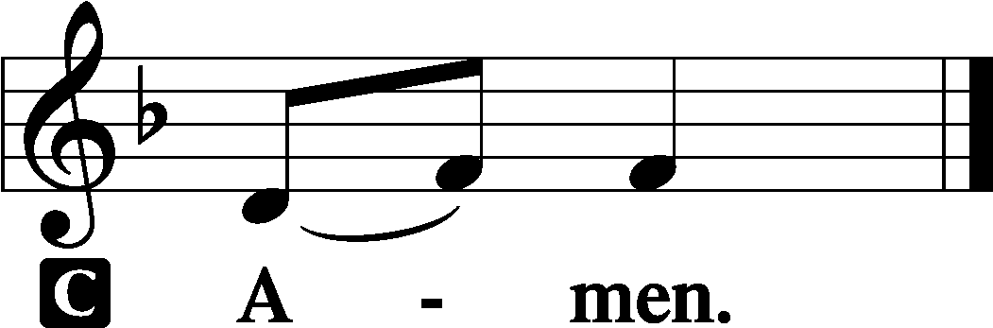

Sit

Old Testament Reading Exodus 19:2–8

[The people of Israel] set out from Rephidim and came into the wilderness of Sinai, and they encamped in the wilderness. There Israel encamped before the mountain, while Moses went up to God. The Lord called to him out of the mountain, saying, “Thus you shall say to the house of Jacob, and tell the people of Israel: You yourselves have seen what I did to the Egyptians, and how I bore you on eagles’ wings and brought you to myself. Now therefore, if you will indeed obey my voice and keep my covenant, you shall be my treasured possession among all peoples, for all the earth is mine; and you shall be to me a kingdom of priests and a holy nation. These are the words that you shall speak to the people of Israel.”
So Moses came and called the elders of the people and set before them all these words that the Lord had commanded him. All the people answered together and said, “All that the Lord has spoken we will do.” And Moses reported the words of the people to the Lord.

A This is the Word of the Lord.
C Thanks be to God.

Epistle Romans 5:6–15

For while we were still weak, at the right time Christ died for the ungodly. For one will scarcely die for a righteous person—though perhaps for a good person one would dare even to die— but God shows his love for us in that while we were still sinners, Christ died for us. Since, therefore, we have now been justified by his blood, much more shall we be saved by him from the wrath of God. For if while we were enemies we were reconciled to God by the death of his Son, much more, now that we are reconciled, shall we be saved by his life. More than that, we also rejoice in God through our Lord Jesus Christ, through whom we have now received reconciliation.
Therefore, just as sin came into the world through one man, and death through sin, and so death spread to all men because all sinned— for sin indeed was in the world before the law was given, but sin is not counted where there is no law. Yet death reigned from Adam to Moses, even over those whose sinning was not like the transgression of Adam, who was a type of the one who was to come.
But the free gift is not like the trespass. For if many died through one man’s trespass, much more have the grace of God and the free gift by the grace of that one man Jesus Christ abounded for many.

A This is the Word of the Lord.
C Thanks be to God.

Stand

Alleluia and Verse LSB 156

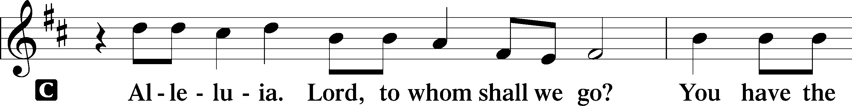
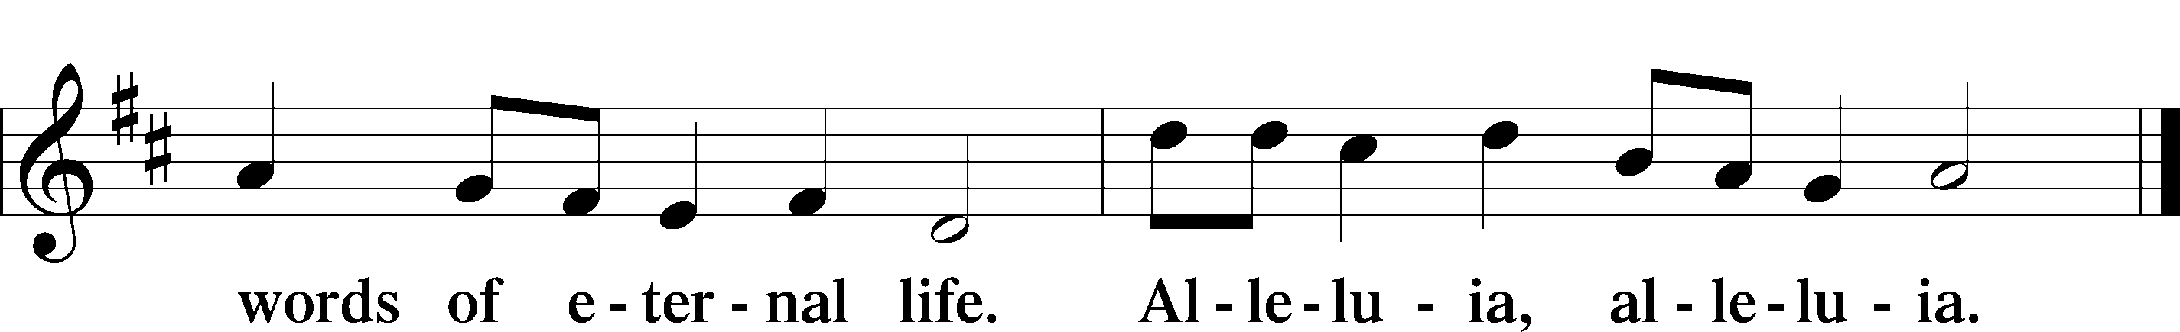
Holy Gospel Matthew 9:35—10:20

P The Holy Gospel according to St. Matthew, the ninth chapter.

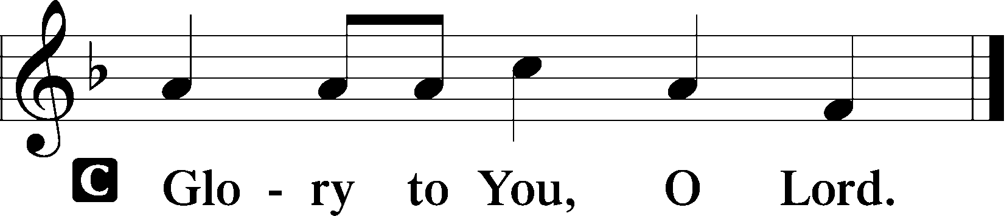

Jesus went throughout all the cities and villages, teaching in their synagogues and proclaiming the gospel of the kingdom and healing every disease and every affliction. When he saw the crowds, he had compassion for them, because they were harassed and helpless, like sheep without a shepherd. Then he said to his disciples, “The harvest is plentiful, but the laborers are few; therefore pray earnestly to the Lord of the harvest to send out laborers into his harvest.”
And he called to him his twelve disciples and gave them authority over unclean spirits, to cast them out, and to heal every disease and every affliction. The names of the twelve apostles are these: first, Simon, who is called Peter, and Andrew his brother; James the son of Zebedee, and John his brother; Philip and Bartholomew; Thomas and Matthew the tax collector; James the son of Alphaeus, and Thaddaeus; Simon the Cananaean, and Judas Iscariot, who betrayed him.
These twelve Jesus sent out, instructing them, “Go nowhere among the Gentiles and enter no town of the Samaritans, but go rather to the lost sheep of the house of Israel. And proclaim as you go, saying, ‘The kingdom of heaven is at hand.’ Heal the sick, raise the dead, cleanse lepers, cast out demons. You received without paying; give without pay. Acquire no gold nor silver nor copper for your belts, no bag for your journey, nor two tunics nor sandals nor a staff, for the laborer deserves his food. And whatever town or village you enter, find out who is worthy in it and stay there until you depart. As you enter the house, greet it. And if the house is worthy, let your peace come upon it, but if it is not worthy, let your peace return to you. And if anyone will not receive you or listen to your words, shake off the dust from your feet when you leave that house or town. Truly, I say to you, it will be more bearable on the day of judgment for the land of Sodom and Gomorrah than for that town.
“Behold, I am sending you out as sheep in the midst of wolves, so be wise as serpents and innocent as doves. Beware of men, for they will deliver you over to courts and flog you in their synagogues, and you will be dragged before governors and kings for my sake, to bear witness before them and the Gentiles. When they deliver you over, do not be anxious how you are to speak or what you are to say, for what you are to say will be given to you in that hour. For it is not you who speak, but the Spirit of your Father speaking through you.”

P This is the Gospel of the Lord.

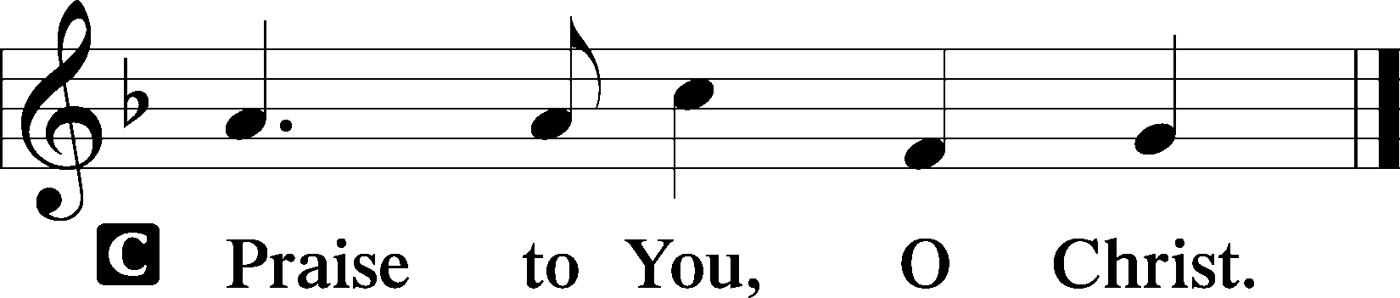

Sit

Hymn of the Day

571 God Loved the World So That He Gave sts. 1–2,
5–6

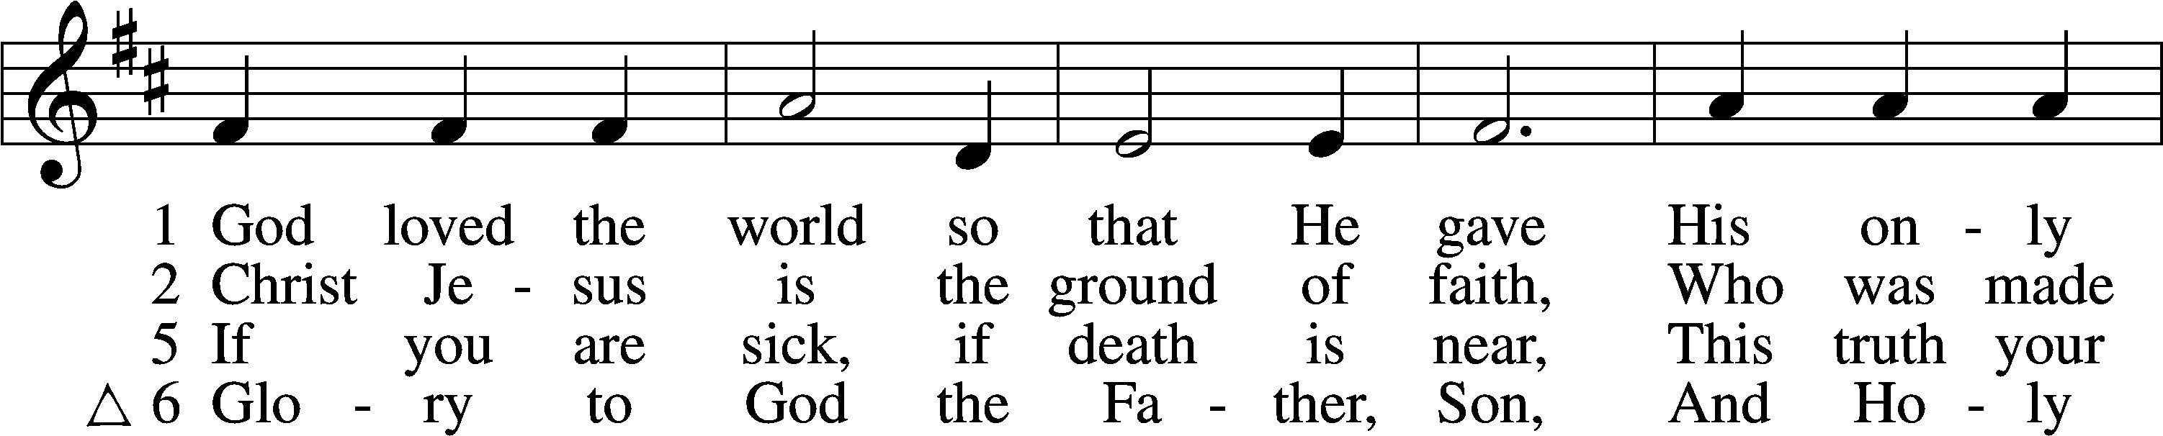
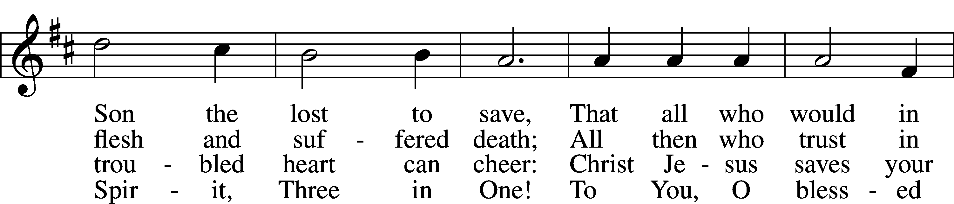
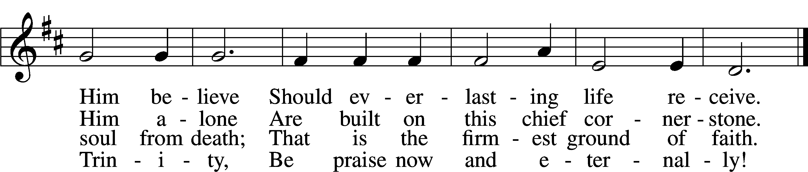
Text: Heiliges Lippen- und Hertzens-Opffer, c. 1778, Stettin; tr. August Crull, 1845–1923, alt.
Tune: George J. Elvey, 1816–93
Text and tune: Public domain

Sermon

Apostles’ Creed

I believe in God, the Father Almighty, maker of
heaven and earth.

And in Jesus Christ, His only Son, our Lord, who was conceived by the Holy Spirit, born of the virgin Mary, suffered under Pontius Pilate, was crucified, died and was buried.

He descended into hell. The third day He rose again from the dead. He ascended into heaven and sits at the right hand of God the Father Almighty. From thence He will come to judge the living and the dead.

I believe in the Holy Spirit, the holy Christian Church, the communion of saints, the forgiveness of sins, the resurrection of the body, and the life T everlasting. Amen.

Offering

Psalm Psalm 100; antiphon: v. 5

Make a joyful noise to the Lord, all the earth!
Serve the Lord with gladness!
Come into his presence with singing!
Know that the Lord, he is God!
It is he who made us, and we are his;
we are his people, and the sheep of his pasture.

Enter his gates with thanksgiving, and his courts with praise!
Give thanks to him; bless his name!
For the Lord is good; his steadfast love endures forever, and his faithfulness to all generations.

Stand

781 We Give Thee But Thine Own sts. 1–2

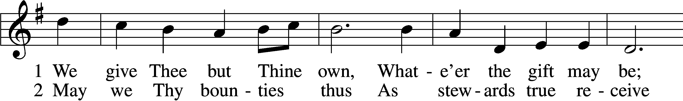
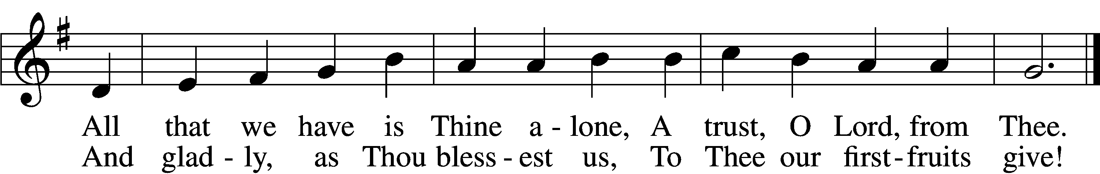
Text: William W. How, 1823–97
Tune: William H. Monk, 1823–89
Text and tune: Public domain

Prayer of the Church
After “Lord, in Your mercy” respond with “hear our prayer.”

P Let us pray for the whole people of God in Christ Jesus and for all people according to their needs.
P For the faithful proclamation of Christ’s saving name, that God’s people may be strengthened in the true faith and His kingdom extended, let us pray to the Lord:
C Lord, have mercy.
P For the holy Christian Church throughout the world and for all who confess the name of Christ, that God would guard and defend us from the temptations of the devil, the world, and our sinful nature, let us pray to the Lord:
C Lord, have mercy.
P For the government and all who have been set into positions of leadership, that they may use the authority entrusted to them honorably and for the good of the people, let us pray to the Lord:
C Lord, have mercy.
P For those who are sick especially Kristine, Joshua, Hunter, Jimmy, Dorothy, Marge, Tony, Bill M., Phil, Lidia, Liz, Michele, Giuseppe, Alfred, Ray and Nancy that God would grant healing to their bodies and strength to bear their infirmities with patience and grace, let us pray to the Lord:
C Lord, have mercy.
P O Lord, heavenly Father, we gratefully remember the sufferings and death of Your dear Son, Jesus Christ, for our salvation. Rejoicing in His victorious resurrection from the dead, we draw strength from His ascension before You, where He ever stands for us as our own High Priest. Gather us together from the ends of the earth to celebrate with all the faithful the marriage feast of the Lamb in His kingdom, which has no end. Graciously receive our prayers, deliver and preserve us, for to You alone we give all glory, honor, and worship, Father, Son, and Holy Spirit, one God, now and forever.
C Amen.

Stand

Lord’s Prayer

Our Father who art in heaven, hallowed be Thy name, Thy kingdom come, Thy will be done on earth as it is in heaven;
Give us this day our daily bread; and forgive us our trespasses as we forgive those who trespass against us; and lead us not into temptation, but deliver us from evil.
For Thine is the kingdom and the power and the glory forever and ever. Amen.
Benediction LSB 166

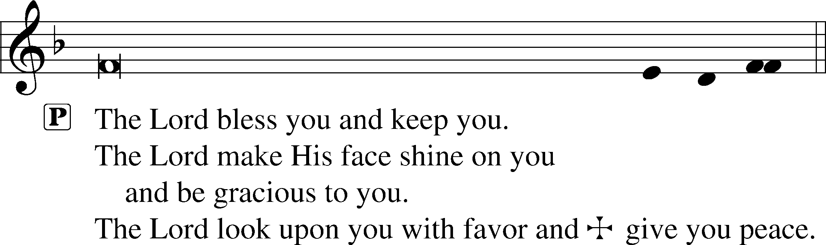


Closing Hymn

791 All People That on Earth Do Dwell sts. 1, 3, 5

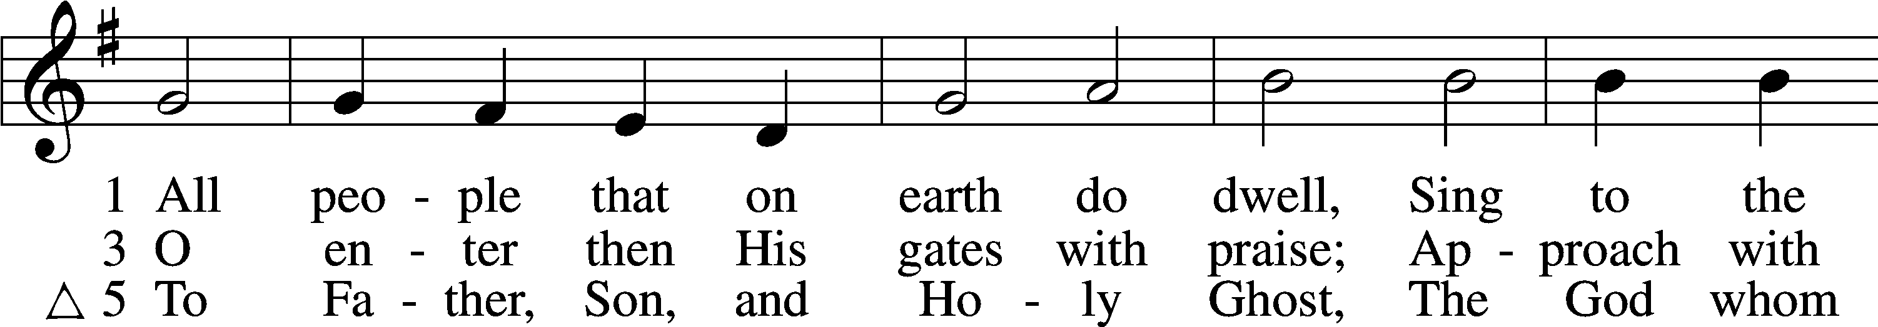
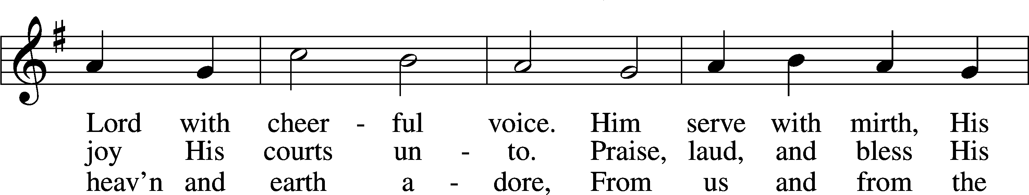
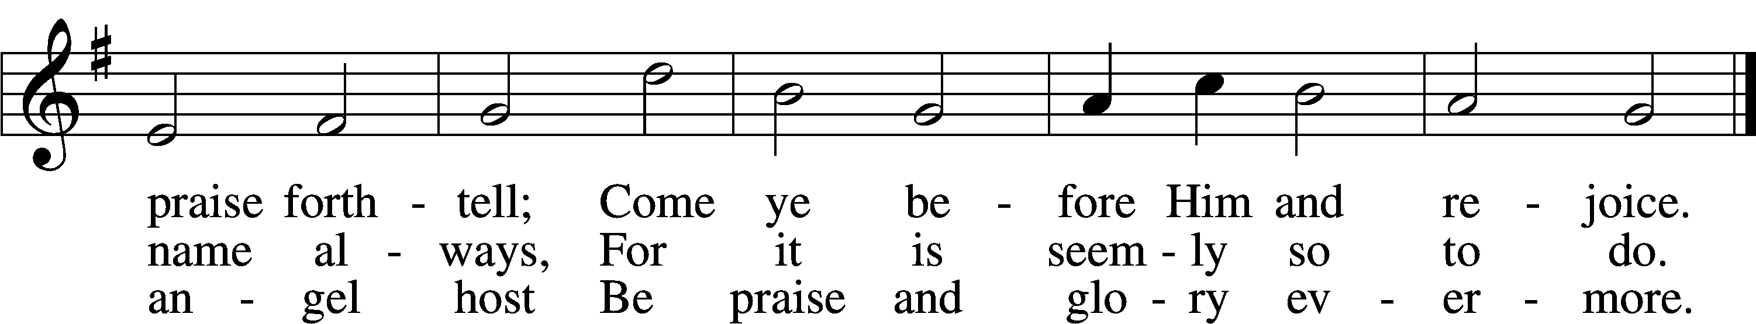
Text: William Kethe, d. c. 1593, alt.
Tune: Trente quatre Pseaumes de David, 1551, Geneva, ed. Louis Bourgeois
Text and tune: Public domain

Acknowledgments

Unless otherwise indicated, Scripture quotations are from the ESV® Bible (The Holy Bible, English Standard Version®), copyright © 2001 by Crossway, a publishing ministry of Good News Publishers. Used by permission. All rights reserved.
Created by Lutheran Service Builder © 2026 Concordia Publishing House.

