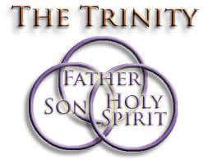

Saint John’s Lutheran Church
810 Broad Street
Clifton, New Jersey
Office: 973-778-141
www.StJohnsClifton.org

Holy Trinity Sunday
Sunday, May 31, 2026
9:00 AM

The church of the praying hands

Hymn of Invocation

905 Come, Thou Almighty King sts. 1-4

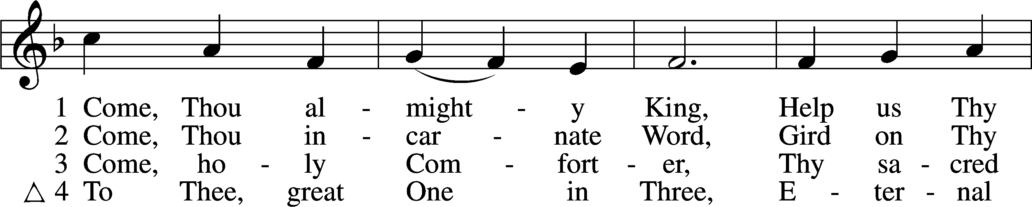
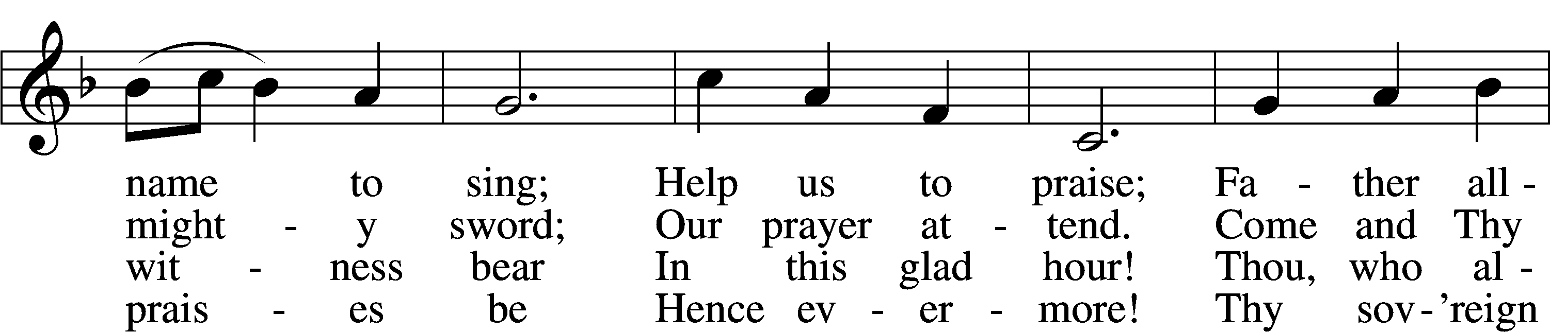
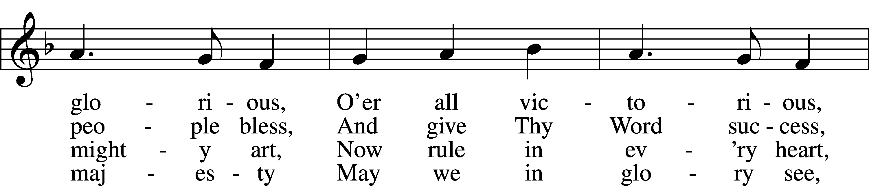
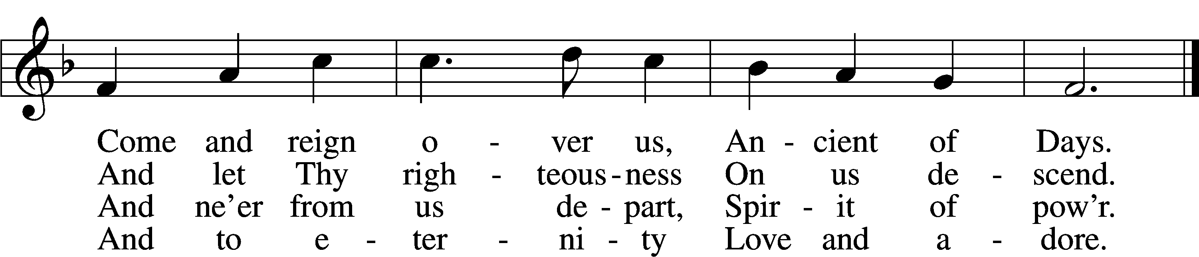
Text: English, before 1760, alt.
Tune: Felice de Giardini, 1716–96
Text and tune: Public domain

Stand

Confession and Absolution

The sign of the cross may be made by all in remembrance of their Baptism.

Invocation

P In the name of the Father and of the T Son and of the Holy Spirit.
C Amen.

Exhortation LSB 184

P Beloved in the Lord! Let us draw near with a true heart and confess our sins unto God our Father, beseeching Him in the name of our Lord Jesus Christ to grant us forgiveness.

P Our help is in the name of the Lord,
C who made heaven and earth.
P I said, I will confess my transgressions unto the Lord,
C and You forgave the iniquity of my sin.

Silence for reflection on God’s Word and for self-examination.

Confession of Sins LSB 184

P O almighty God, merciful Father,
C I, a poor, miserable sinner, confess unto You all my sins and iniquities with which I have ever offended You and justly deserved Your temporal and eternal punishment. But I am heartily sorry for them and sincerely repent of them, and I pray You of Your boundless mercy and for the sake of the holy, innocent, bitter sufferings and death of Your beloved Son, Jesus Christ, to be gracious and merciful to me, a poor, sinful being.

Declaration of Grace LSB 185

P Almighty God, our heavenly Father, has had mercy upon us and has given His only Son to die for us and for His sake forgives us all our sins. To those who believe on His name He gives power to become the children of God and has promised them His Holy Spirit. He that believes and is baptized shall be saved.
Grant this, Lord, unto us all.
C Amen.

Service of the Word

Introit Psalm 16:8–11; antiphon: Liturgical Text

Blessèd be the Holy Trinity and the undivided Unity.
Let us give glory to him because he has shown his mercy to us.
I have set the Lord always before me;
because he is at my right hand, I shall not be shaken.
Therefore my heart is glad, and my whole being rejoices;
my flesh also dwells secure.
For you will not abandon my soul to Sheol,
or let your holy one see corruption.
You make known to me the path of life;
in your presence there is fullness of joy; at your right hand are pleasures forevermore.
Glory be to the Father and to the Son and to the Holy Spirit; as it was in the beginning, is now, and will be forever. Amen.
Blessèd be the Holy Trinity and the undivided Unity.
Let us give glory to him because he has shown his mercy to us.

Kyrie LSB 186

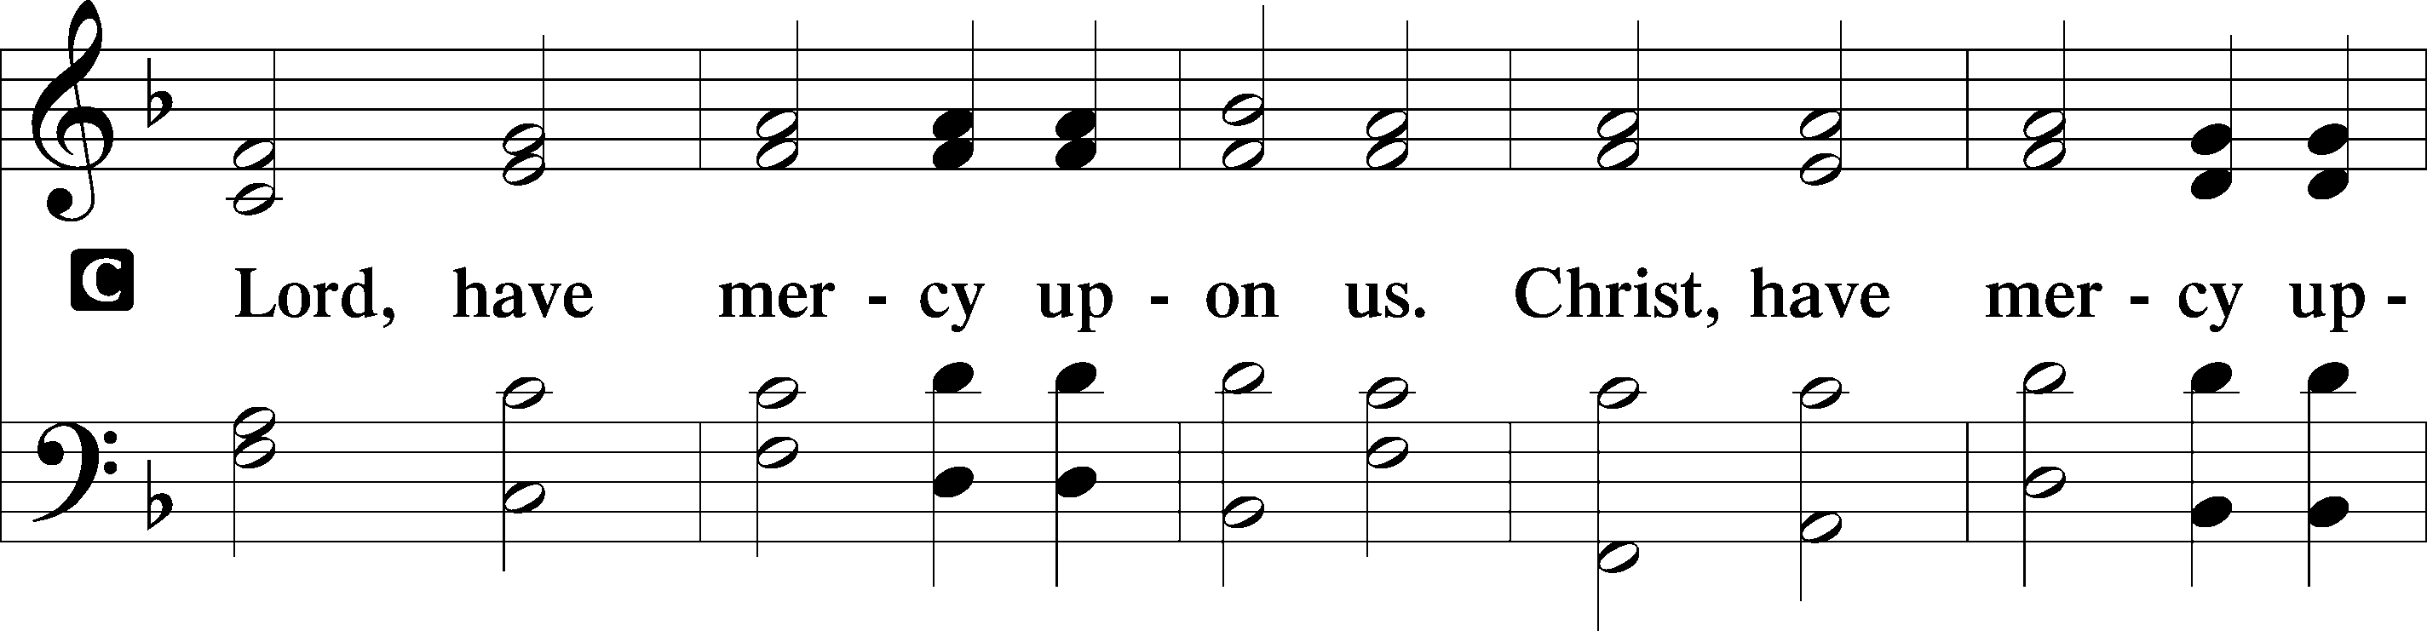
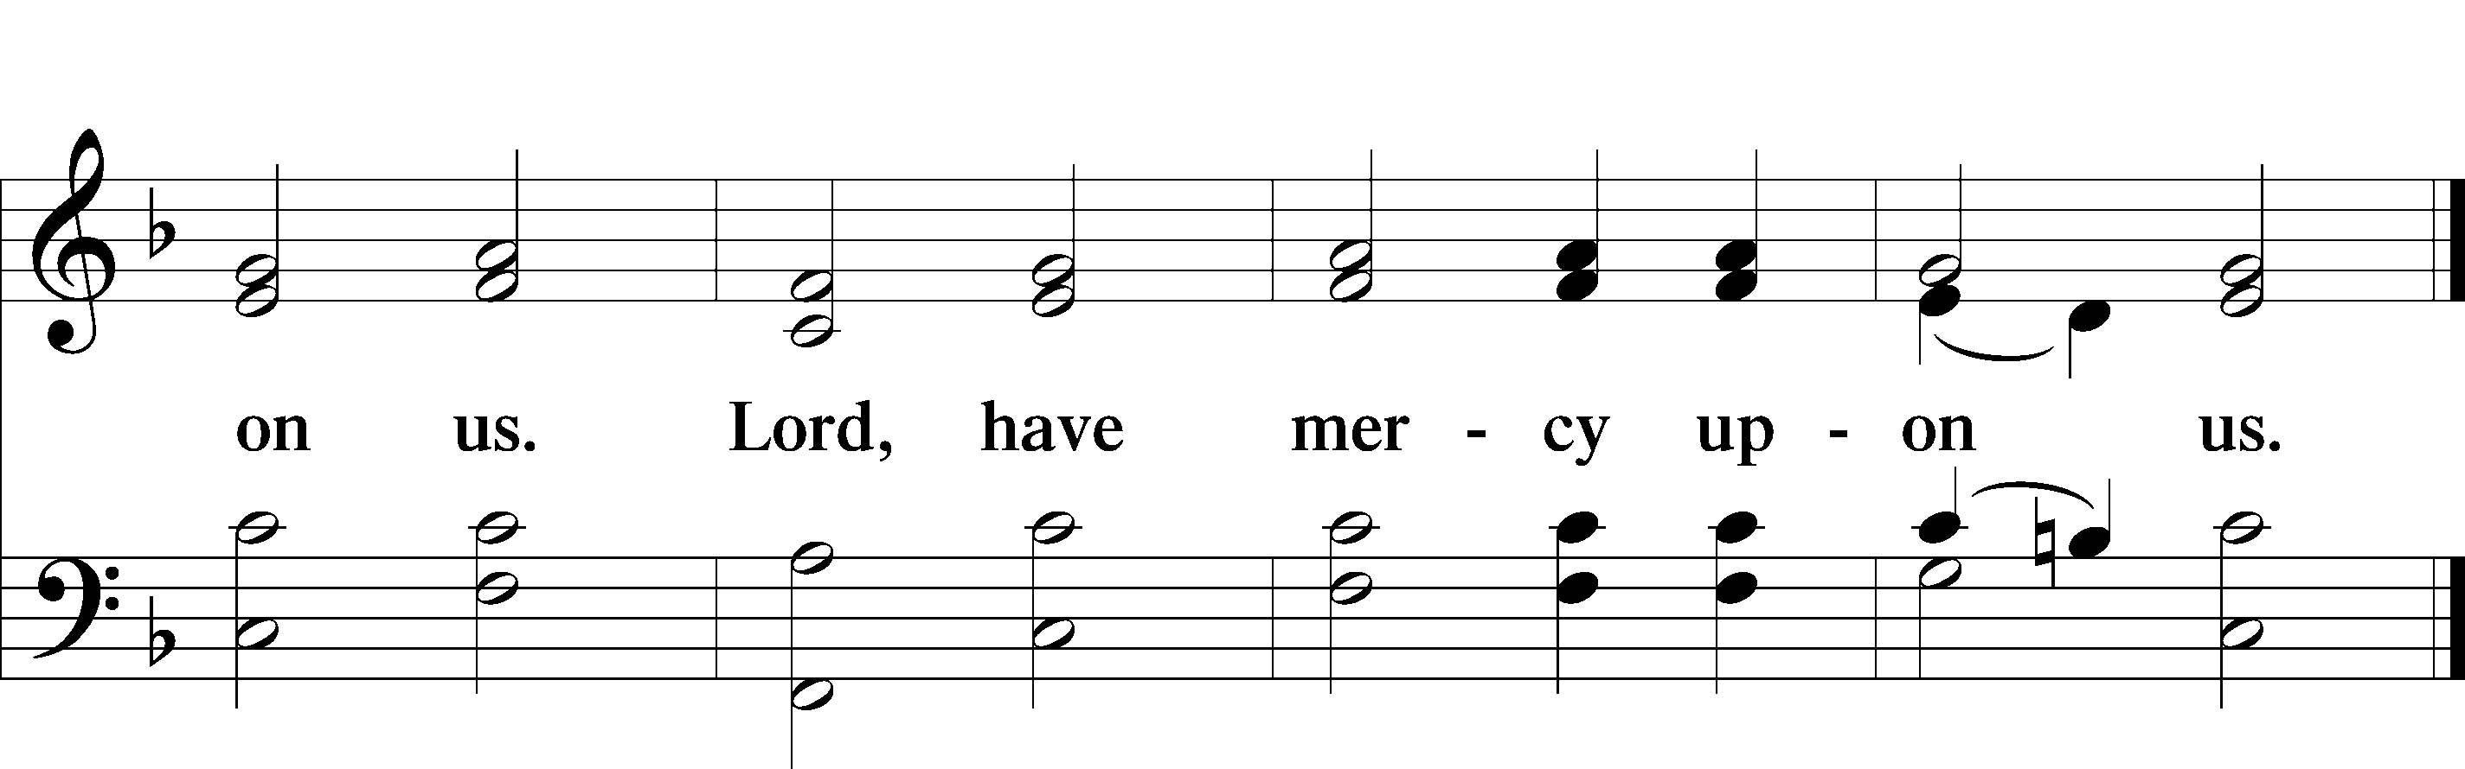

Gloria in Excelsis LSB 187

P Glory be to God on high:
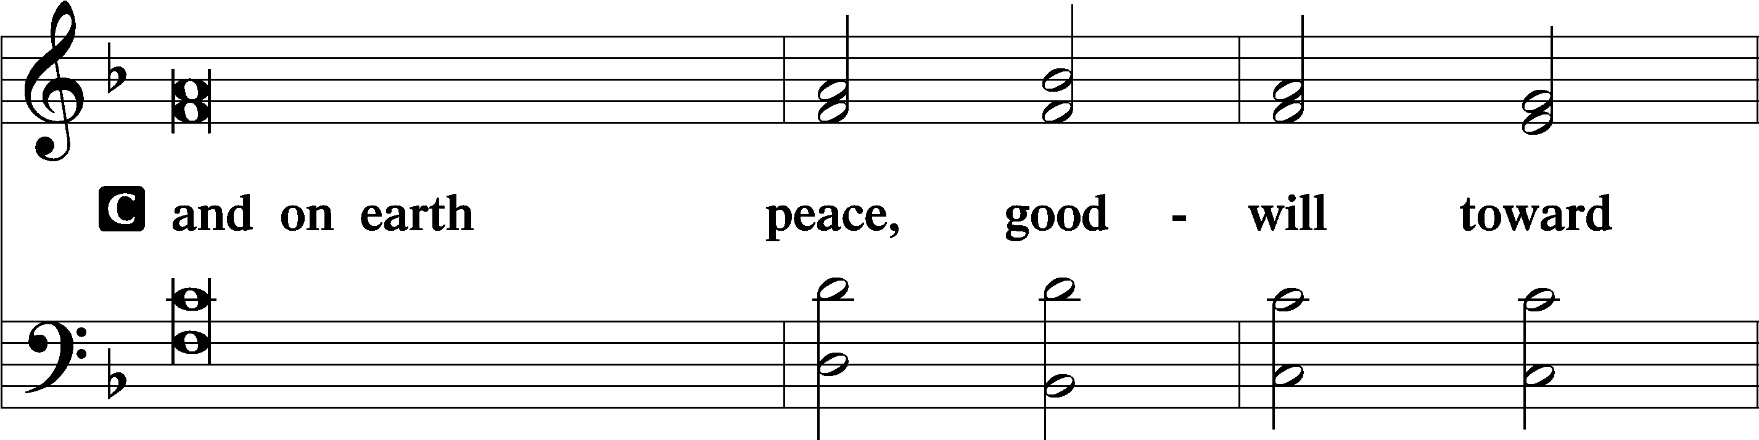
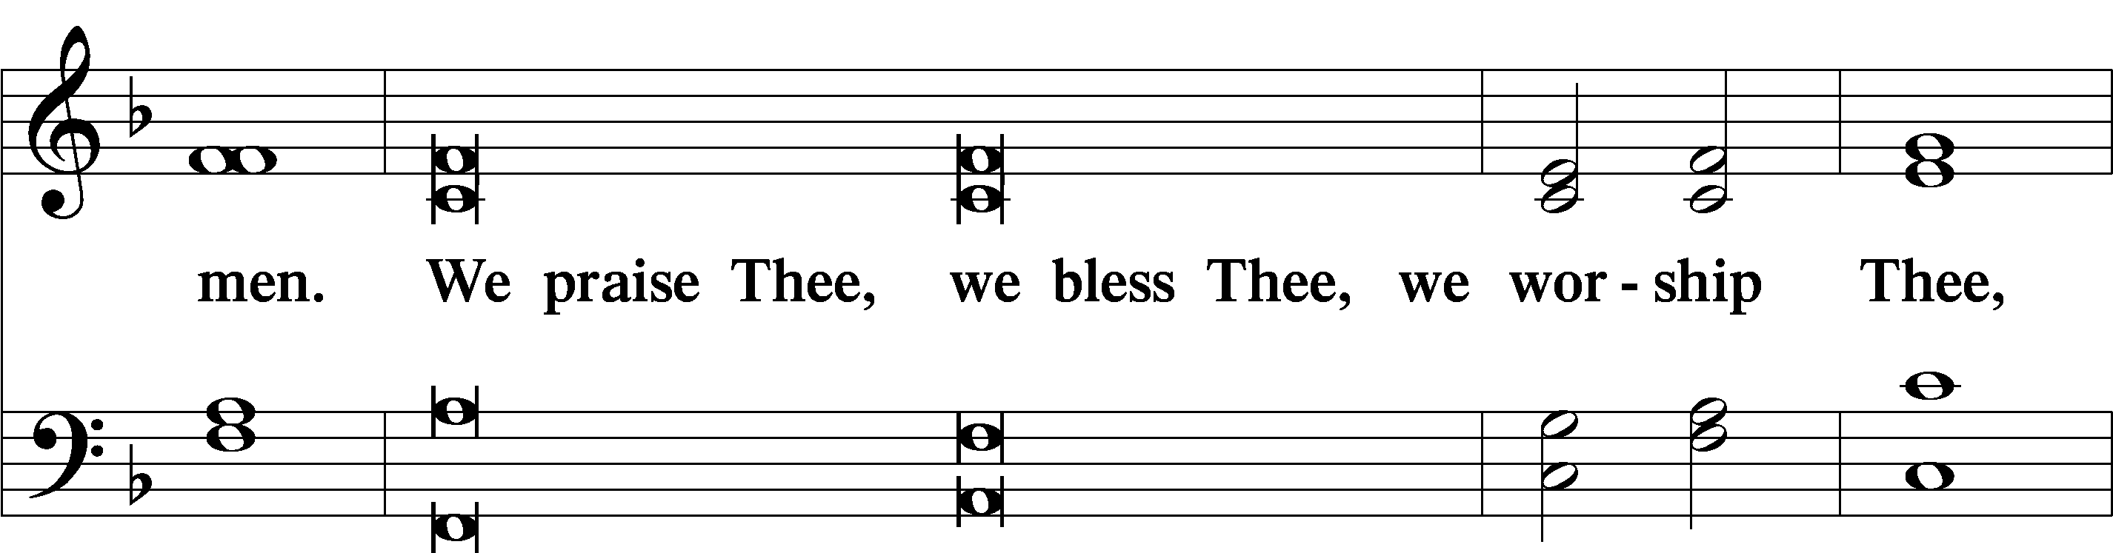
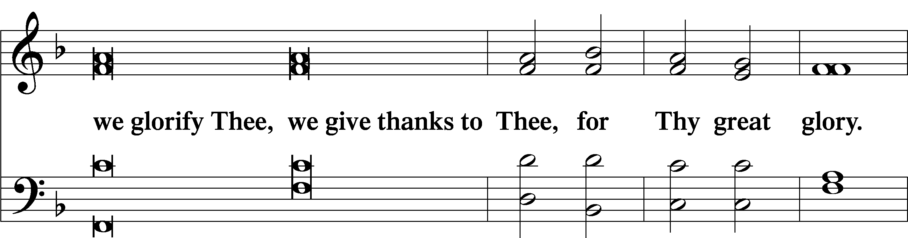
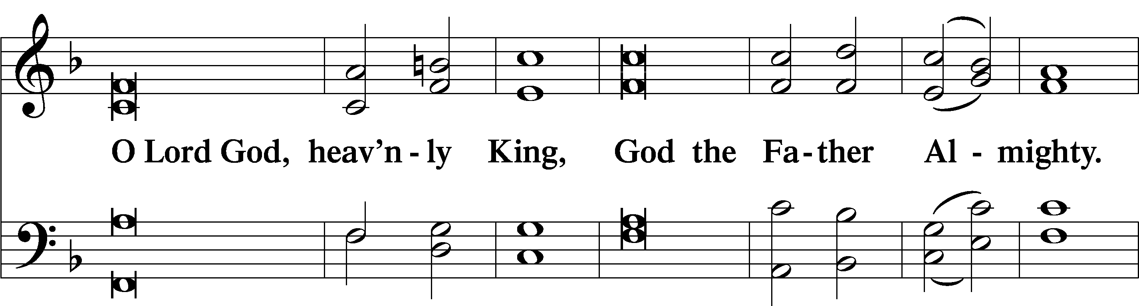
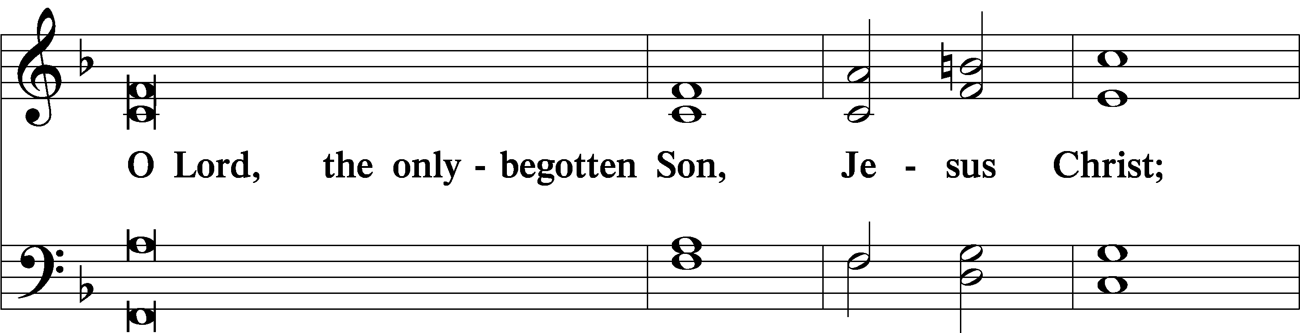
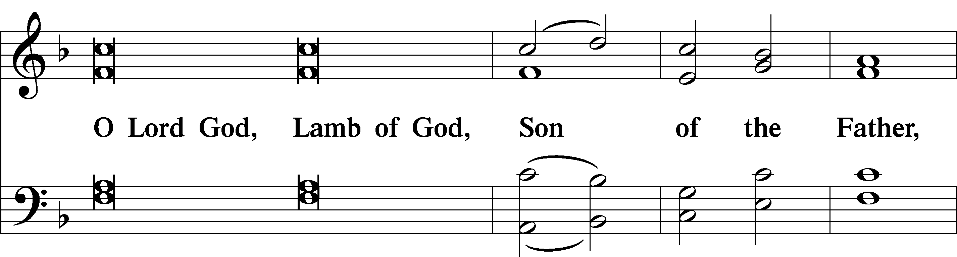
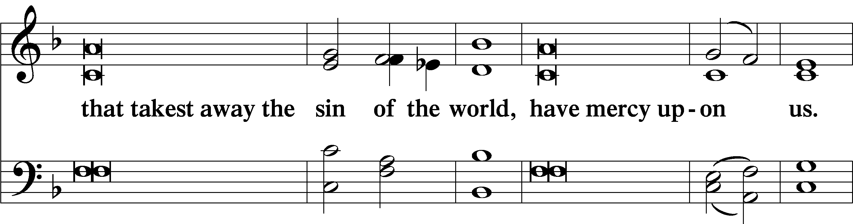
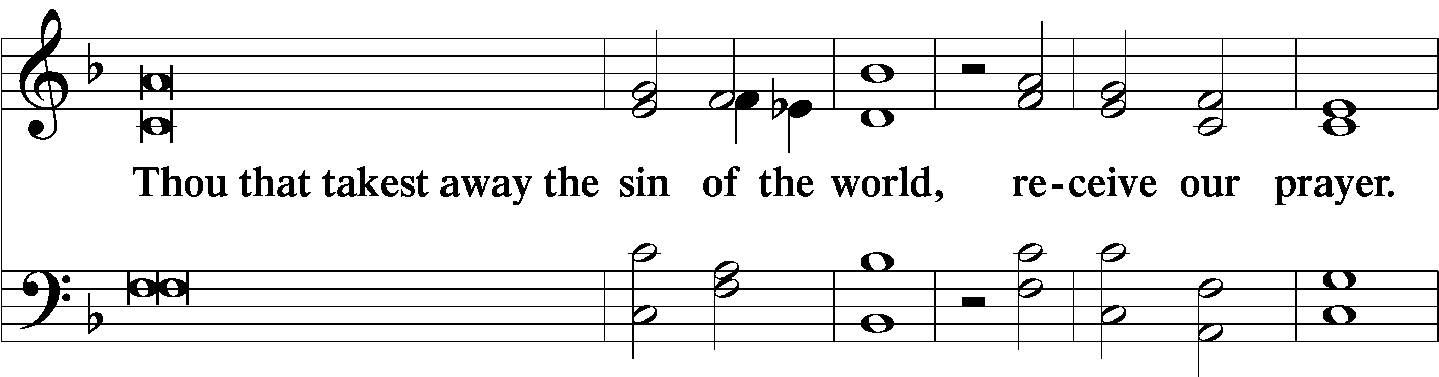
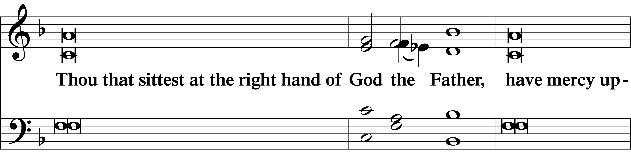
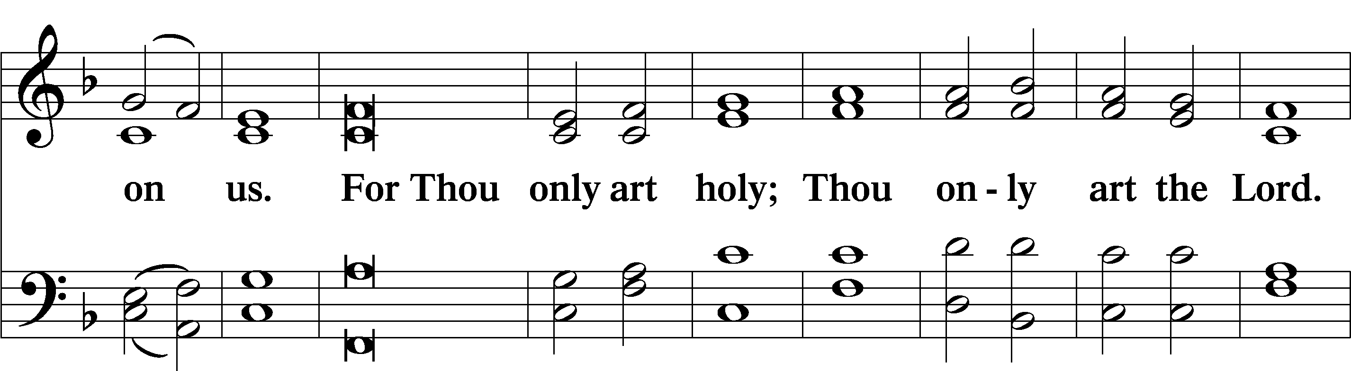
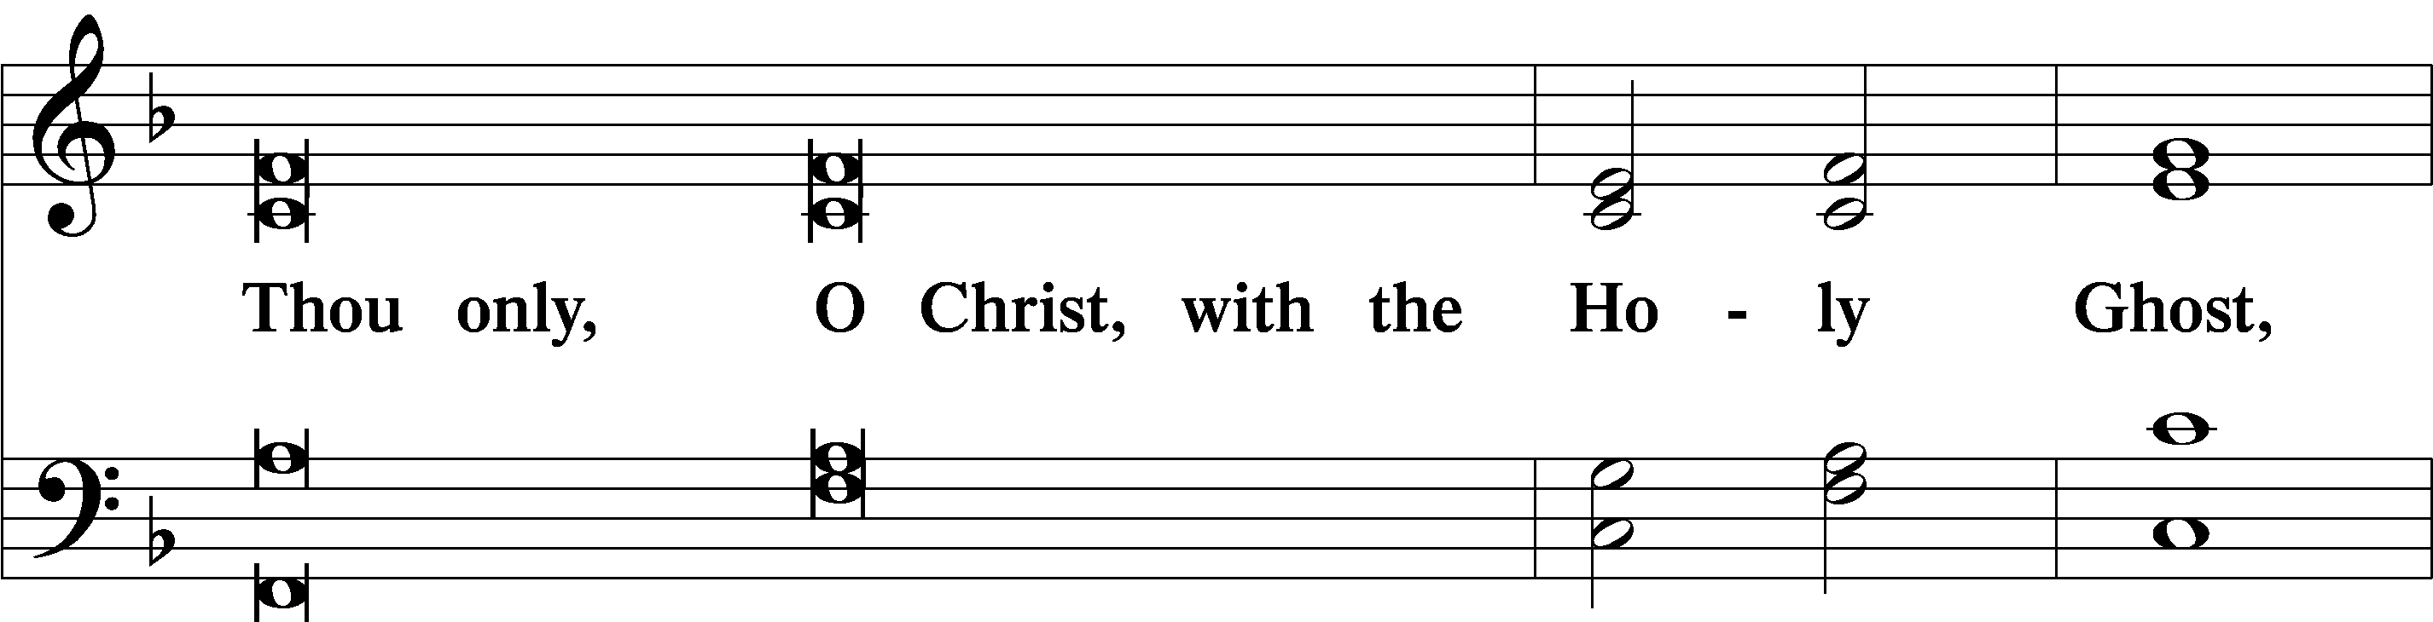
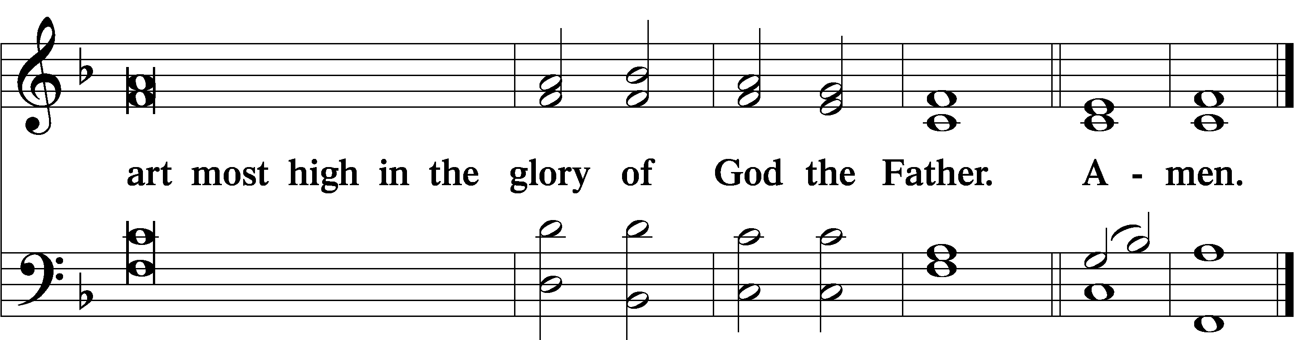

Salutation and Collect of the Day

P The Lord be with you.
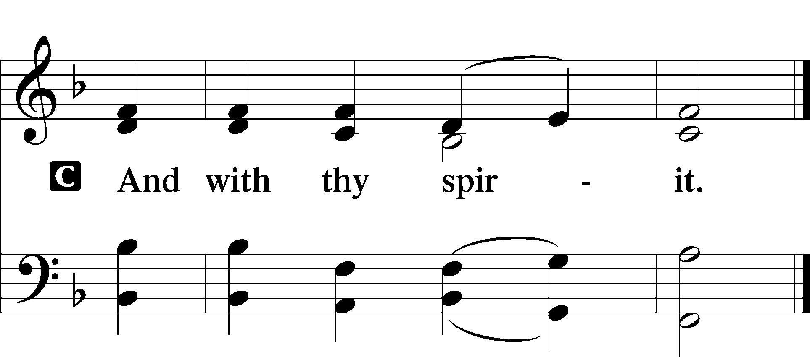
P Let us pray.
Almighty and everlasting God, You have given us grace to acknowledge the glory of the eternal Trinity by the confession of a true faith and to worship the Unity in the power of the Divine Majesty. Keep us steadfast in this faith and defend us from all adversities; for You, O Father, Son, and Holy Spirit, live and reign, one God, now and forever.

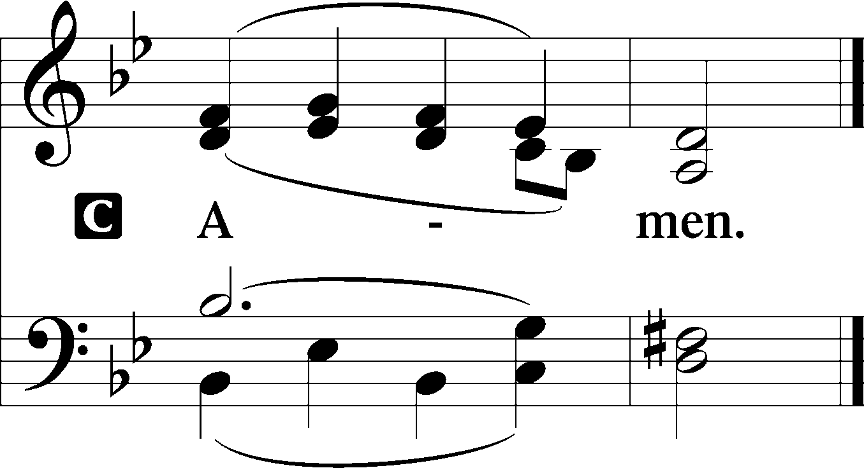

Sit

Old Testament Reading Genesis 1:1—2:4a

In the beginning, God created the heavens and the earth. The earth was without form and void, and darkness was over the face of the deep. And the Spirit of God was hovering over the face of the waters.

And God said, “Let there be light,” and there was light. And God saw that the light was good. And God separated the light from the darkness. God called the light Day, and the darkness he called Night. And there was evening and there was morning, the first day.

And God said, “Let there be an expanse in the midst of the waters, and let it separate the waters from the waters.” And God made the expanse and separated the waters that were under the expanse from the waters that were above the expanse. And it was so. And God called the expanse Heaven. And there was evening and there was morning, the second day.

And God said, “Let the waters under the heavens be gathered together into one place, and let the dry land appear.” And it was so. God called the dry land Earth, and the waters that were gathered together he called Seas. And God saw that it was good.

And God said, “Let the earth sprout vegetation, plants yielding seed, and fruit trees bearing fruit in which is their seed, each according to its kind, on the earth.” And it was so. The earth brought forth vegetation, plants yielding seed according to their own kinds, and trees bearing fruit in which is their seed, each according to its kind. And God saw that it was good. And there was evening and there was morning, the third day.

And God said, “Let there be lights in the expanse of the heavens to separate the day from the night. And let them be for signs and for seasons, and for days and years, and let them be lights in the expanse of the heavens to give light upon the earth.” And it was so. And God made the two great lights—the greater light to rule the day and the lesser light to rule the night—and the stars. And God set them in the expanse of the heavens to give light on the earth, to rule over the day and over the night, and to separate the light from the darkness. And God saw that it was good. And there was evening and there was morning, the fourth day.

And God said, “Let the waters swarm with swarms of living creatures, and let birds fly above the earth across the expanse of the heavens.” So God created the great sea creatures and every living creature that moves, with which the waters swarm, according to their kinds, and every winged bird according to its kind. And God saw that it was good. And God blessed them, saying, “Be fruitful and multiply and fill the waters in the seas, and let birds multiply on the earth.” And there was evening and there was morning, the fifth day.

And God said, “Let the earth bring forth living creatures according to their kinds—livestock and creeping things and beasts of the earth according to their kinds.” And it was so. And God made the beasts of the earth according to their kinds and the livestock according to their kinds, and everything that creeps on the ground according to its kind. And God saw that it was good.

Then God said, “Let us make man in our image, after our likeness. And let them have dominion over the fish of the sea and over the birds of the heavens and over the livestock and over all the earth and over every creeping thing that creeps on the earth.”
So God created man in his own image, in the image of God he created him; male and female he created them.
And God blessed them. And God said to them, “Be fruitful and multiply and fill the earth and subdue it and have dominion over the fish of the sea and over the birds of the heavens and over every living thing that moves on the earth.” And God said, “Behold, I have given you every plant yielding seed that is on the face of all the earth, and every tree with seed in its fruit. You shall have them for food. And to every beast of the earth and to every bird of the heavens and to everything that creeps on the earth, everything that has the breath of life, I have given every green plant for food.” And it was so. And God saw everything that he had made, and behold, it was very good. And there was evening and there was morning, the sixth day.

Thus, the heavens and the earth were finished, and all the host of them. And on the seventh day God finished his work that he had done, and he rested on the seventh day from all his work that he had done. So God blessed the seventh day and made it holy, because on it God rested from all his work that he had done in creation.
These are the generations of the heavens and the earth when they were created.
A This is the Word of the Lord.
C Thanks be to God.

Second Reading Acts 2:14a, 22–36

Peter, standing with the eleven, lifted up his voice and addressed them, . . .

“Men of Israel, hear these words: Jesus of Nazareth, a man attested to you by God with mighty works and wonders and signs that God did through him in your midst, as you yourselves know— this Jesus, delivered up according to the definite plan and foreknowledge of God, you crucified and killed by the hands of lawless men. God raised him up, loosing the pangs of death, because it was not possible for him to be held by it. For David says concerning him,

“‘I saw the Lord always before me, for he is at my right hand that I may not be shaken; therefore my heart was glad, and my tongue rejoiced; my flesh also will dwell in hope. For you will not abandon my soul to Hades, or let your Holy One see corruption. You have made known to me the paths of life; you will make me full of gladness with your presence.’

“Brothers, I may say to you with confidence about the patriarch David that he both died and was buried, and his tomb is with us to this day. Being therefore a prophet, and knowing that God had sworn with an oath to him that he would set one of his descendants on his throne, he foresaw and spoke about the resurrection of the Christ, that he was not abandoned to Hades, nor did his flesh see corruption. This Jesus God raised up, and of that we all are witnesses. Being therefore exalted at the right hand of God, and having received from the Father the promise of the Holy Spirit, he has poured out this that you yourselves are seeing and hearing. For David did not ascend into the heavens, but he himself says,

“‘The Lord said to my Lord, Sit at my right hand, until I make your enemies your footstool.’

Let all the house of Israel therefore know for certain that God has made him both Lord and Christ, this Jesus whom you crucified.”

A This is the Word of the Lord.
C Thanks be to God.

Stand

Alleluia LSB 190

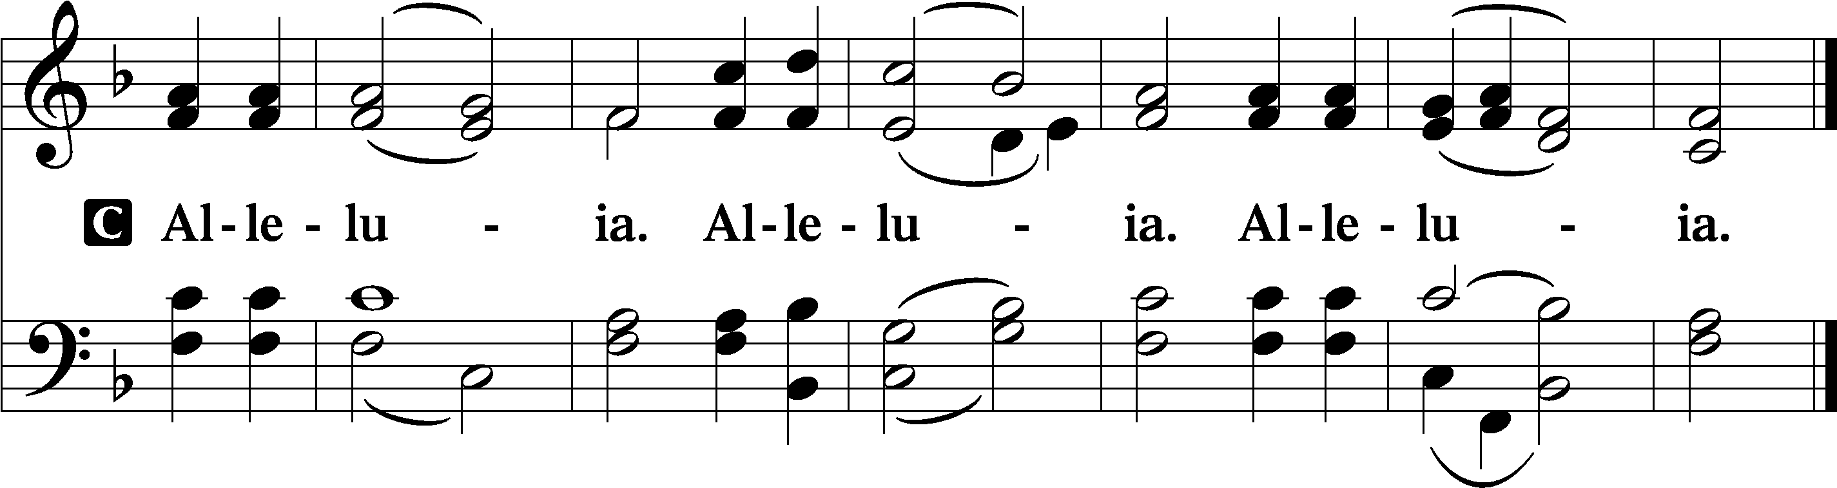

Holy Gospel Matthew 28:16–20

P The Holy Gospel according to St. Matthew, the twenty-eighth chapter.

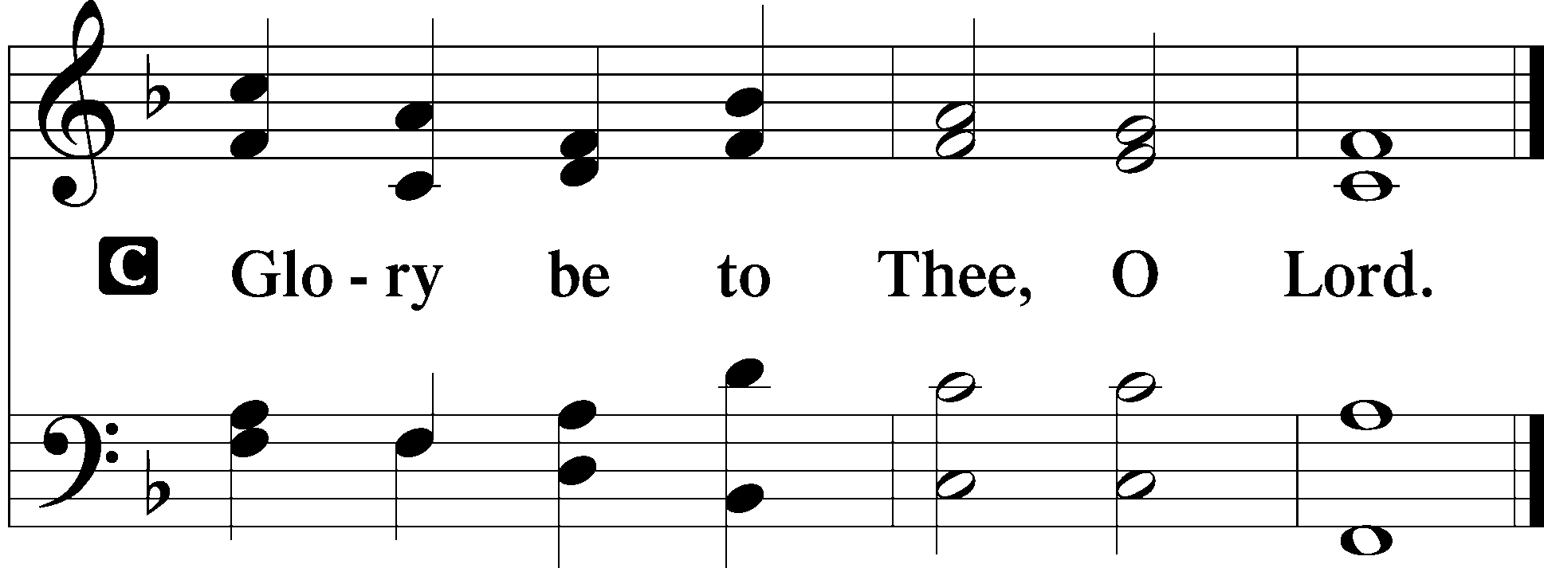

Now the eleven disciples went to Galilee, to the mountain to which Jesus had directed them. And when they saw him, they worshiped him, but some doubted.

And Jesus came and said to them, “All authority in heaven and on earth has been given to me. Go therefore and make disciples of all nations, baptizing them in the name of the Father and of the Son and of the Holy Spirit, teaching them to observe all that I have commanded you. And behold, I am with you always, to the end of the age.”

P This is the Gospel of the Lord.
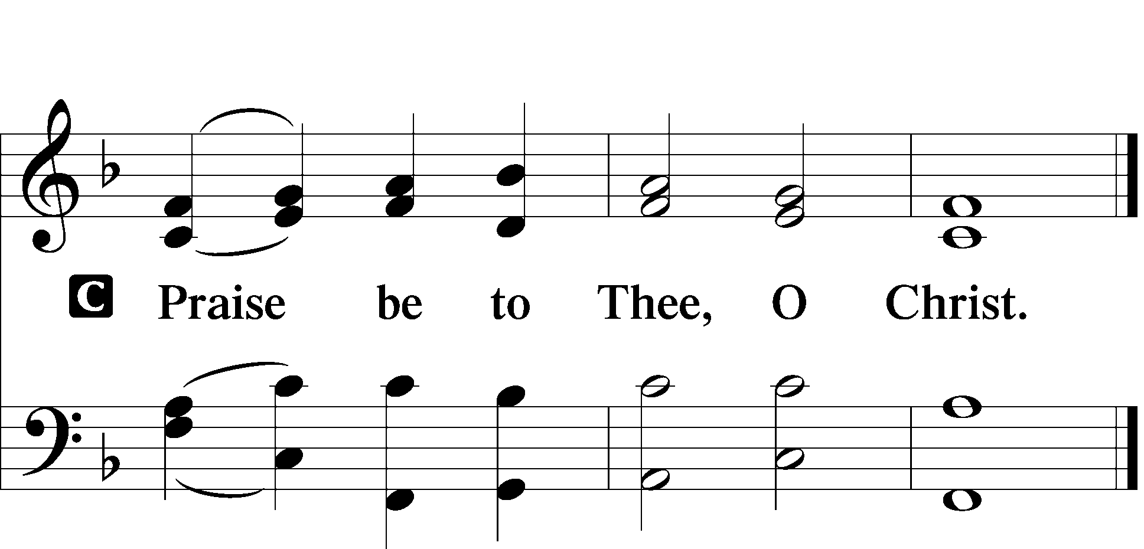

Apostles’ Creed

I believe in God, the Father Almighty, maker of
heaven and earth. And in Jesus Christ, His only Son,
our Lord, who was conceived by the Holy Spirit, born
of the virgin Mary, suffered under Pontius Pilate, was
crucified, died and was buried.

He descended into hell. The third day He rose again from the dead. He ascended into heaven and sits at the right hand of God the Father Almighty. From thence He will come to judge the living and the dead.

I believe in the Holy Spirit, the holy Christian Church, the communion of saints, the forgiveness of sins, the resurrection of the body, and the life T everlasting. Amen.

Sit

Hymn of the Day

504 Father Most Holy sts. 1–4

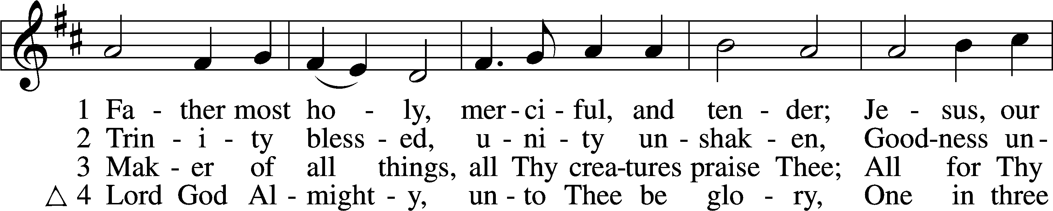
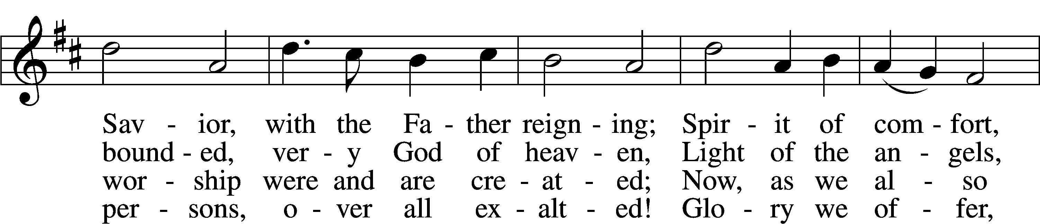
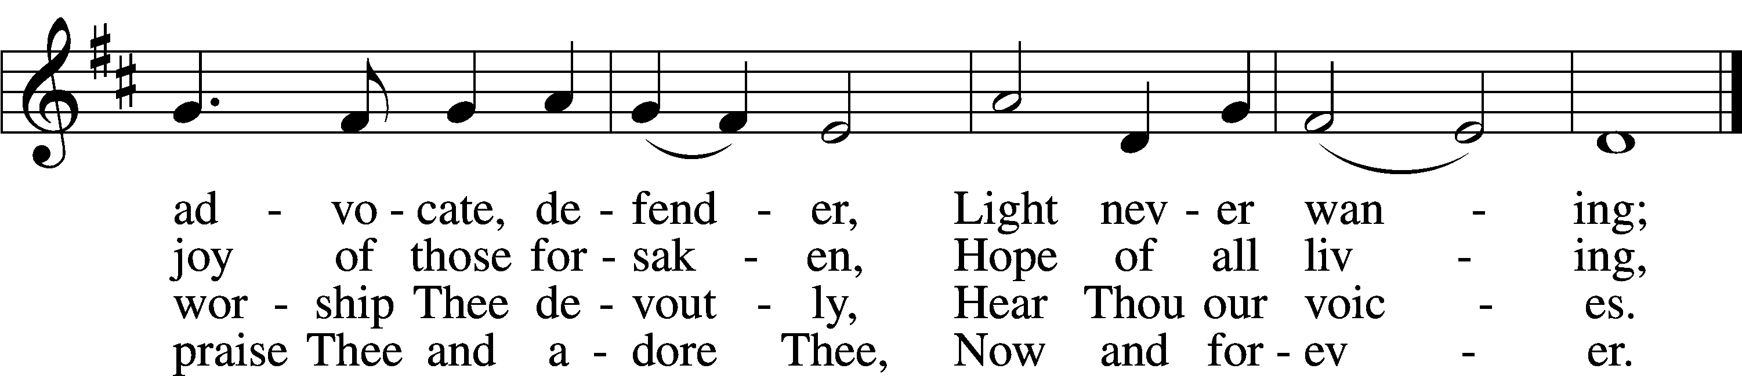
Text: Latin, c. 10th cent.; tr. Percy Dearmer, 1867–1936, alt.
Tune: Antiphoner, 1681, Paris
Text and tune: Public domain

Sermon

Offering

Psalm for Meditation Psalm 8; antiphon: v. 9

O Lord, our Lord, how majestic is your name in all the earth! You have set your glory above the heavens.
Out of the mouth of babes and infants, you have established strength because of your foes, to still the enemy and the avenger.

When I look at your heavens, the work of your fingers, the moon and the stars, which you have set in place,
what is man that you are mindful of him, and the son of man that you care for him?

Yet you have made him a little lower than the heavenly beings and crowned him with glory and honor. You have given him dominion over the works of your hands; you have put all things under his feet, all sheep and oxen, and also the beasts of the field, the birds of the heavens, and the fish of the sea, whatever passes along the paths of the seas.

O Lord, our Lord, how majestic is your name in all the earth!

Stand

781 We Give Thee But Thine Own sts. 1–2

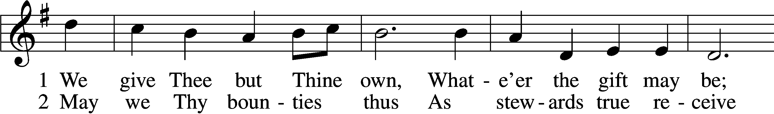
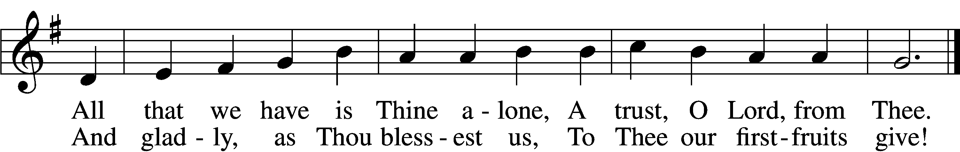
Text: William W. How, 1823–97
Tune: William H. Monk, 1823–89
Text and tune: Public domain

Prayer of the Church

P Let us pray for the whole people of God in Christ Jesus and for all people according to their needs.
P For the faithful proclamation of Christ’s saving name, that God’s people may be strengthened in the true faith and His kingdom extended, let us pray to the Lord:
C Lord, have mercy.
P For the holy Christian Church throughout the world and for all who confess the name of Christ, that God would guard and defend us from the temptations of the devil, the world, and our sinful nature, let us pray to the Lord:
C Lord, have mercy.
P For the government and all who have been set into positions of leadership, that they may use the authority entrusted to them honorably and for the good of the people, let us pray to the Lord:
C Lord, have mercy.
P For those who suffer from hunger, homelessness, poverty, or unemployment, that God’s great mercy and love would preserve and relieve them, let us pray to the Lord:
C Lord, have mercy.
P For those who are sick especially Kristine, Joshua, Hunter, Jimmy, Dorothy, Marge, Tony, Bill M., Phil, Lidia, Michele, Giuseppe, Alfred, and Nancy that God would grant healing to their bodies and strength to bear their infirmities with patience and grace, let us pray to the Lord:
C Lord, have mercy.
P O Lord, heavenly Father, we gratefully remember the sufferings and death of Your dear Son, Jesus Christ, for our salvation. Rejoicing in His victorious resurrection from the dead, we draw strength from His ascension before You, where He ever stands for us as our own High Priest. Gather us together from the ends of the earth to celebrate with all the faithful the marriage feast of the Lamb in His kingdom, which has no end. Graciously receive our prayers, deliver and preserve us, for to You alone we give all glory, honor, and worship, Father, Son, and Holy Spirit, one God, now and forever.
C Amen.

Lord’s Prayer

Our Father who art in heaven, hallowed be Thy name, Thy kingdom come, Thy will be done on earth as it is in heaven. Give us this day our daily bread; and forgive us our trespasses as we forgive those who trespass against us; and lead us not into temptation but deliver us from evil.
For Thine is the kingdom and the power and the glory forever and ever. Amen.

Benediction LSB 202

P The Lord bless you and keep you.
The Lord make His face shine upon you and be gracious unto you.
The Lord lift up His countenance upon you and T give you peace.

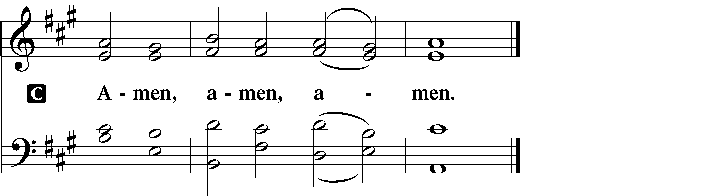

Hymn to Depart

507 Holy, Holy, Holy sts. 1–4

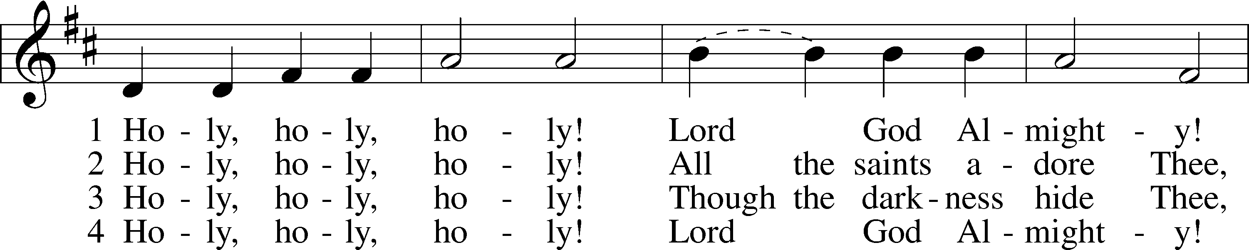
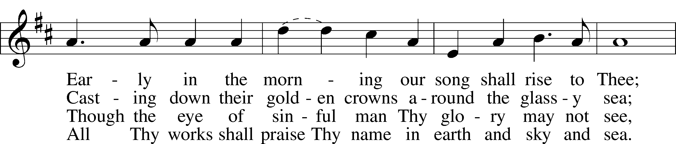
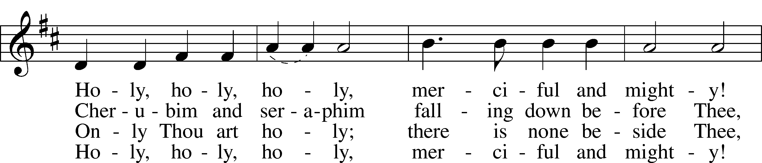
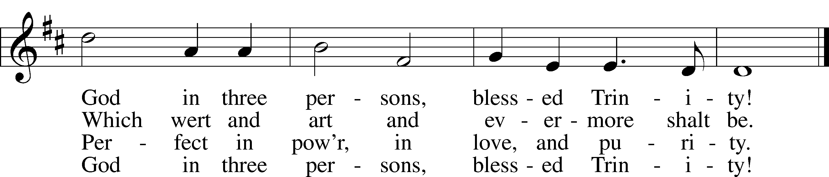
Text: Reginald Heber, 1783–1826
Tune: John B. Dykes, 1823–76
Text and tune: Public domain

Acknowledgments
Divine Service, Setting One from Lutheran Service Book
Unless otherwise indicated, Scripture quotations are from the ESV® Bible (The Holy Bible, English Standard Version®), copyright © 2001 by Crossway, a publishing ministry of Good News Publishers. Used by permission. All rights reserved.
Created by Lutheran Service Builder © 2026 Concordia Publishing House

