

Saint John’s Lutheran Church
810 Broad Street
Clifton, New Jersey
Office: 973-778-141
www.StJohnsClifton.org

The Third Sunday of Easter
Sunday, April 26, 2026
9:00 AM

The church of the praying hands

P: Alleluia! Christ is Risen!
C: He is Risen Indeed! Alleluia!

Hymn of Invocation

474 Alleluia! Jesus Is Risen sts. 1, ref, 2–4

Stand

Confession and Absolution

The sign of the cross may be made by all in remembrance of their Baptism.

Invocation

Exhortation LSB 184

Silence for reflection on God’s Word and for self-examination.

Confession of Sins LSB 184

Declaration of Grace LSB 185

Service of the Word

Introit Psalm 95:1–3, 6–7a; antiphon: John 10:14, 15b

I am the good shepherd.
I know my own and my own know me, and I lay down my life for the sheep.
Oh come, let us sing to the Lord;
let us make a joyful noise to the rock of our salvation!
Let us come into his presence with thanksgiving;
let us make a joyful noise to him with songs of praise!
For the Lord is a great God,
and a great King above all gods.
Oh come, let us worship and bow down;
let us kneel before the Lord, our Maker!
For he is our God,
and we are the people of his pasture, and the sheep of his hand.
Glory be to the Father and to the Son and to the Holy Spirit; as it was in the beginning, is now, and will be forever. Amen.
I am the good shepherd.
I know my own and my own know me, and I lay down my life for the sheep.

Kyrie LSB 186

Gloria in Excelsis LSB 187

Salutation and Collect of the Day

Sit

First Reading Acts 2:42–47

They devoted themselves to the apostles’ teaching and fellowship, to the breaking of bread and the prayers. And awe came upon every soul, and many wonders and signs were being done through the apostles. And all who believed were together and had all things in common. And they were selling their possessions and belongings and distributing the proceeds to all, as any had need. And day by day, attending the temple together and breaking bread in their homes, they received their food with glad and generous hearts, praising God and having favor with all the people. And the Lord added to their number day by day those who were being saved.

A This is the Word of the Lord.
C Thanks be to God.

Epistle 1 Peter 2:19–25

This is a gracious thing, when, mindful of God, one endures sorrows while suffering unjustly. For what credit is it if, when you sin and are beaten for it, you endure? But if when you do good and suffer for it you endure, this is a gracious thing in the sight of God. For to this you have been called, because Christ also suffered for you, leaving you an example, so that you might follow in his steps. He committed no sin, neither was deceit found in his mouth. When he was reviled, he did not revile in return; when he suffered, he did not threaten, but continued entrusting himself to him who judges justly. He himself bore our sins in his body on the tree, that we might die to sin and live to righteousness. By his wounds you have been healed. For you were straying like sheep, but have now returned to the Shepherd and Overseer of your souls.

A This is the Word of the Lord.
C Thanks be to God.

Stand

Alleluia LSB 190

Holy Gospel John 10:1–10

P The Holy Gospel according to St. John, the tenth chapter.

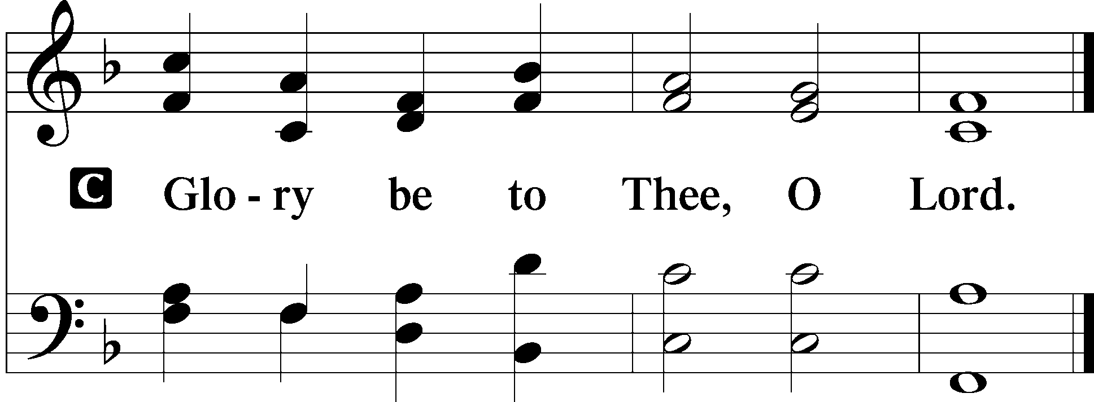

[Jesus said:] “Truly, truly, I say to you, he who does not enter the sheepfold by the door but climbs in by another way, that man is a thief and a robber. But he who enters by the door is the shepherd of the sheep. To him the gatekeeper opens. The sheep hear his voice, and he calls his own sheep by name and leads them out. When he has brought out all his own, he goes before them, and the sheep follow him, for they know his voice. A stranger they will not follow, but they will flee from him, for they do not know the voice of strangers.” This figure of speech Jesus used with them, but they did not understand what he was saying to them.

So Jesus again said to them, “Truly, truly, I say to you, I am the door of the sheep. All who came before me are thieves and robbers, but the sheep did not listen to them. I am the door. If anyone enters by me, he will be saved and will go in and out and find pasture. The thief comes only to steal and kill and destroy. I came that they may have life and have it abundantly.”

P This is the Gospel of the Lord.
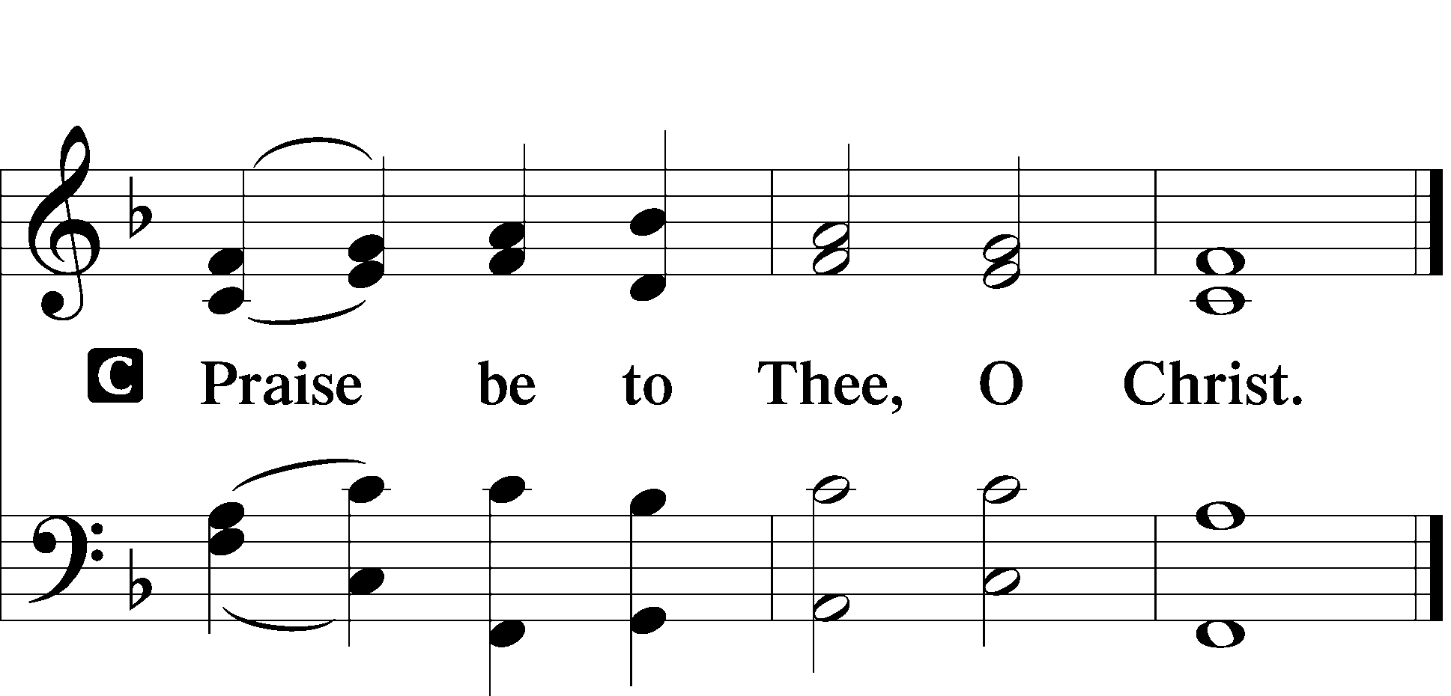

Apostles’ Creed LSB Back Cover

Sit

Hymn of the Day

692 Praise to You and Adoration sts. 1–2

Sermon

Offering

Psalm for Meditation Psalm 23; antiphon: v. 1

The Lord is my shepherd; I shall not want.
He makes me lie down in green pastures.
He leads me beside still waters. He restores my soul.
He leads me in paths of righteousness for his name’s sake.
Even though I walk through the valley of the shadow of death, I will fear no evil, for you are with me; your rod and your staff, they comfort me.
You prepare a table before me in the presence of my enemies; you anoint my head with oil; my cup overflows.
Surely goodness and mercy shall follow me all the days of my life, and I shall dwell in the house of the Lord forever.

Stand

781 We Give Thee But Thine Own sts. 1–2

Prayer of the Church
After “Lord, in Your mercy” respond with “hear our prayer.”

Lord’s Prayer LSB Back Cover

Benediction LSB 202

Hymn to Depart

770 What a Friend We Have in Jesus sts. 1–3

Acknowledgments

Divine Service, Setting One from Lutheran Service Book
Unless otherwise indicated, Scripture quotations are from the ESV® Bible (The Holy Bible, English Standard Version®), copyright © 2001 by Crossway, a publishing ministry of Good News Publishers. Used by permission. All rights reserved.
Created by Lutheran Service Builder © 2026 Concordia Publishing House

