

Saint John’s Lutheran Church
810 Broad Street
Clifton, New Jersey
Office: 973-778-141
www.StJohnsClifton.org

Resurrection (Easter) Sunday
Sunday, April 5, 2026
9:00 AM

The church of the praying hands

Hymn of Invocation

457 Jesus Christ Is Risen Today sts. 1–4

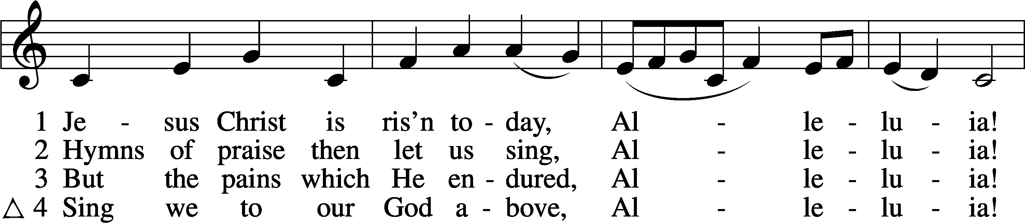
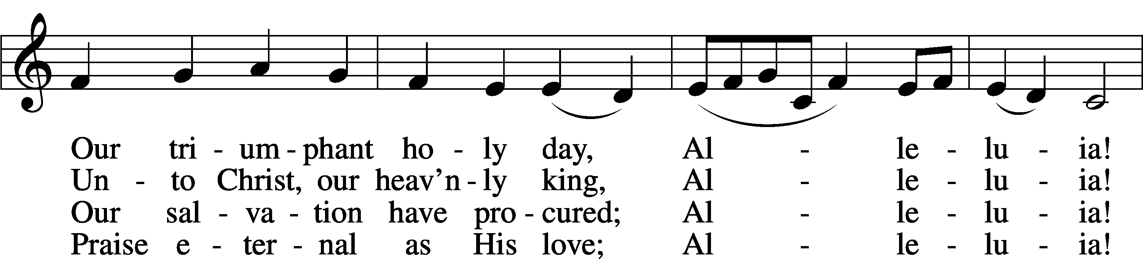
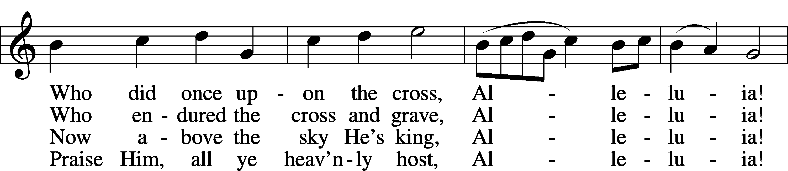
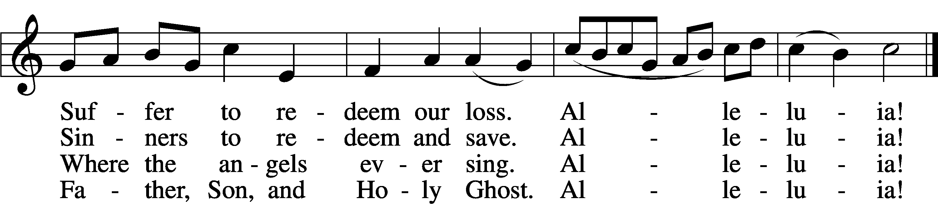
Text: tr. Lyra Davidica, 1708, London, alt.; (sts. 1–3): Latin, 14th cent.; (st. 4): Charles Wesley, 1707–88
Tune: Lyra Davidica, 1708, London
Text and tune: Public domain

Stand

Confession and Absolution

The sign of the cross may be made by all in remembrance of their Baptism.

Invocation

P In the name of the Father and of the T Son and of the Holy Spirit.
C Amen.

Exhortation LSB 151

P If we say we have no sin, we deceive ourselves, and the truth is not in us.
C But if we confess our sins, God, who is faithful and just, will forgive our sins and cleanse us from all unrighteousness.

Silence for reflection on God’s Word and for self-examination.

Confession of Sins LSB 151

P Let us then confess our sins to God our Father.
C Most merciful God, we confess that we are by nature sinful and unclean. We have sinned against You in thought, word, and deed, by what we have done and by what we have left undone. We have not loved You with our whole heart; we have not loved our neighbors as ourselves. We justly deserve Your present and eternal punishment. For the sake of Your Son, Jesus Christ, have mercy on us. Forgive us, renew us, and lead us, so that we may delight in Your will and walk in Your ways to the glory of Your holy name. Amen.

Declaration

P In the mercy of almighty God, Jesus Christ was given to die for us, and for his sake God forgives us all our sins. To those who believe in Jesus Christ He gives the power to become the children of God and bestows on them the Holy Spirit. May the Lord, who has begun this good work in us, bring it to completion in the day of our Lord Jesus Christ.
C Amen.

Service of the Word

Introit Exodus 15:2a, 6, 13, 17–18; antiphon: v. 1b

I will sing to the Lord, for he has triumphed gloriously;
the horse and his rider he has thrown into the sea.
The Lord is my strength and my song,
and he has become my salvation.
Your right hand, O Lord, glorious in power,
your right hand, O Lord, shatters the enemy.
You have led in your steadfast love the people whom you have redeemed;
you have guided them by your strength to your holy abode.
You will bring them in and plant them on your own mountain,
the place, O Lord, which you have made for your abode, the sanctuary,
O Lord, which your hands have established.
The Lord will reign forever and ever.
Glory be to the Father and to the Son and to the Holy Spirit; as it was in the beginning, is now, and will be forever. Amen.
I will sing to the Lord, for he has triumphed gloriously;
the horse and his rider he has thrown into the sea.

Kyrie LSB 186

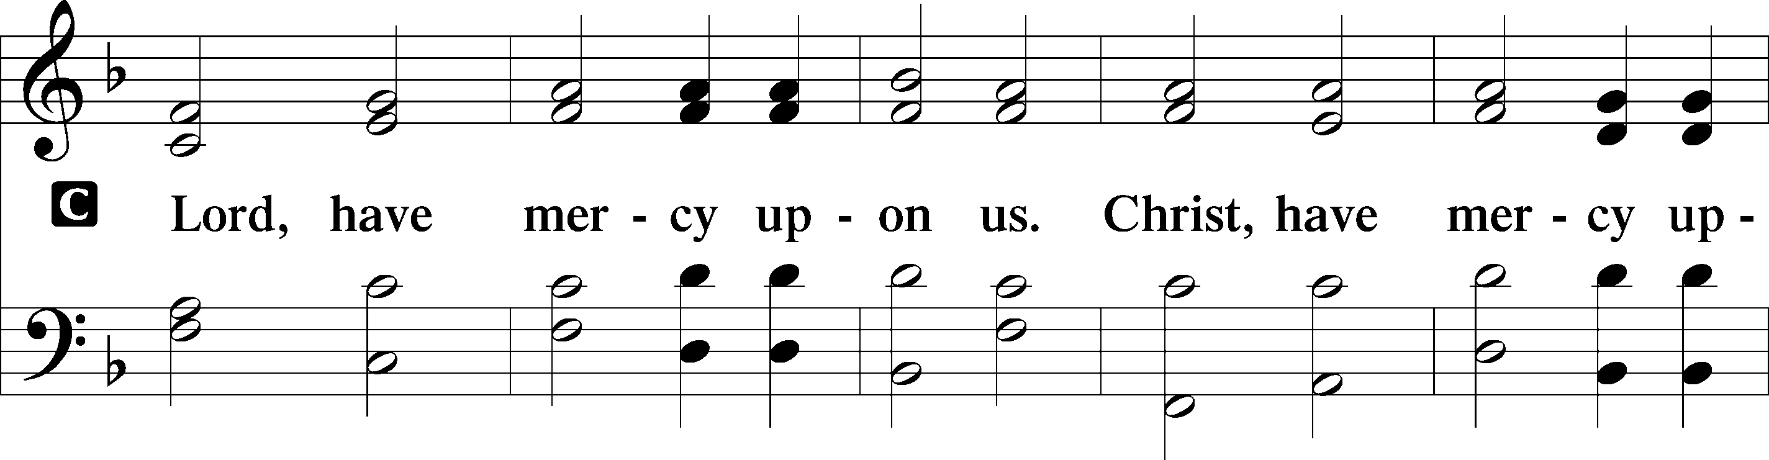
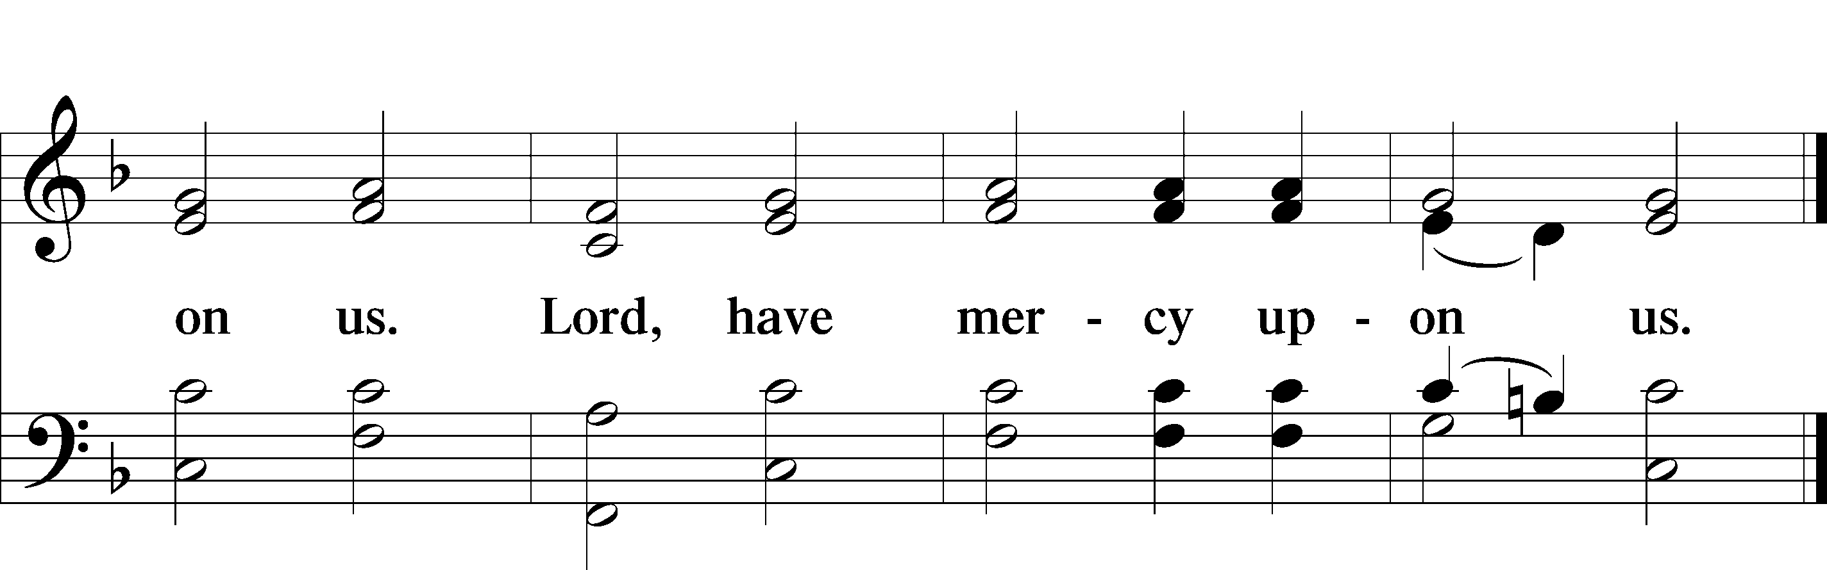

Gloria in Excelsis LSB 187

P Glory be to God on high:
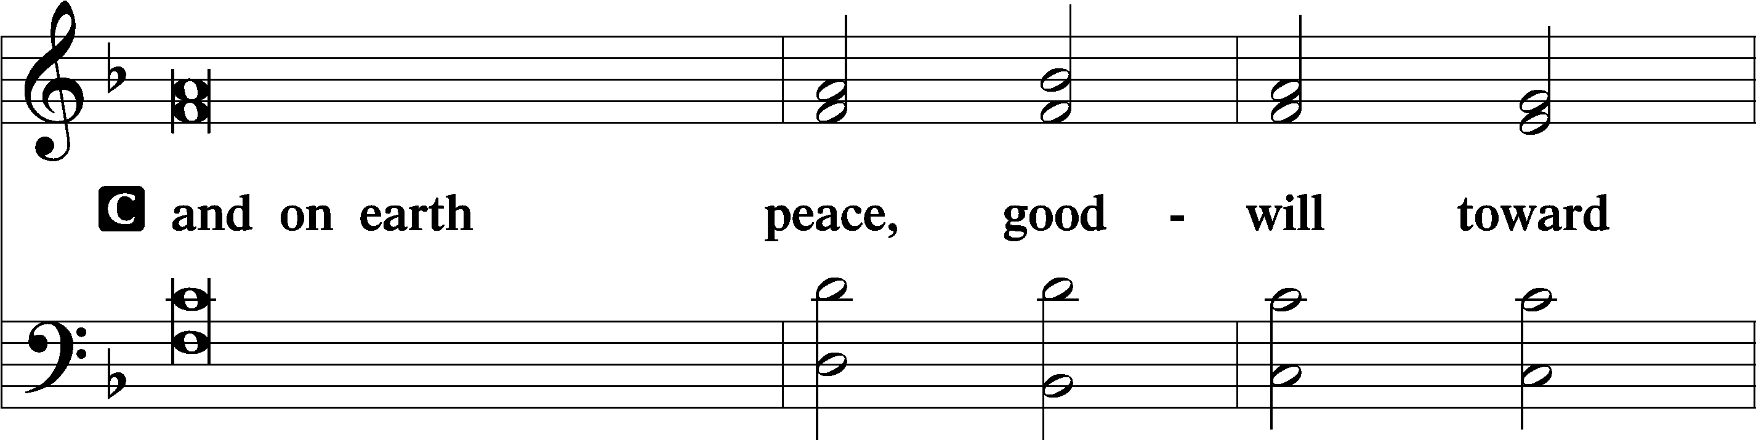
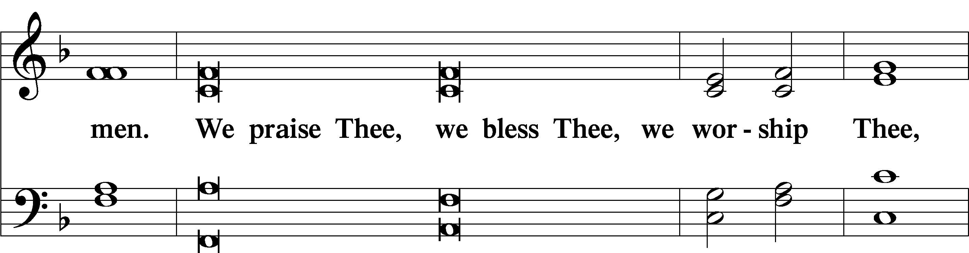
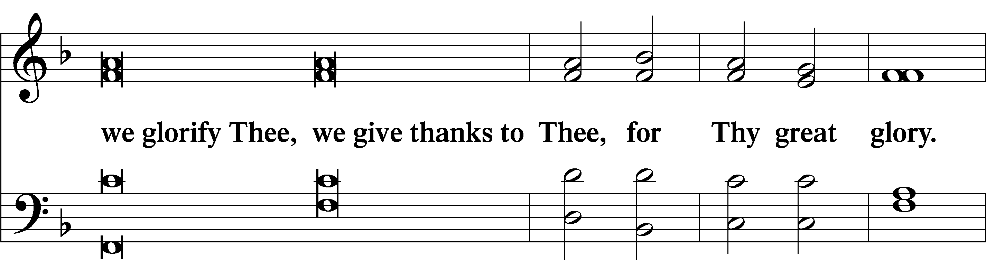
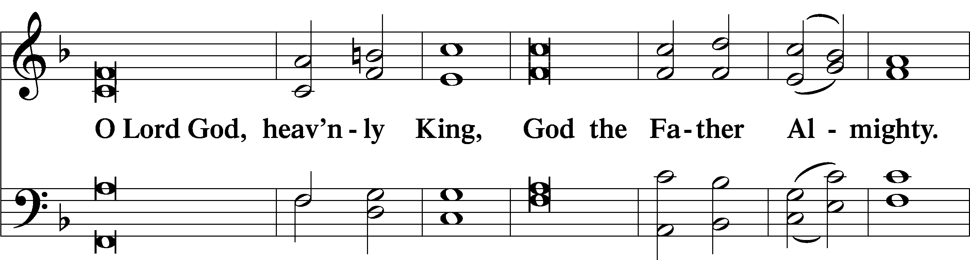
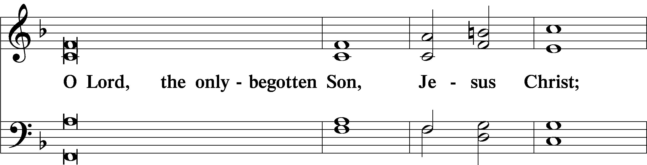
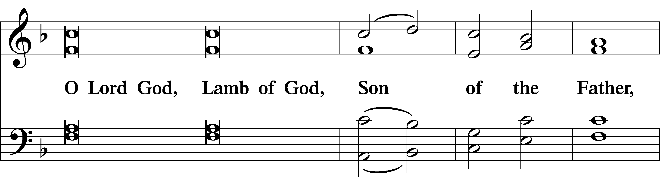
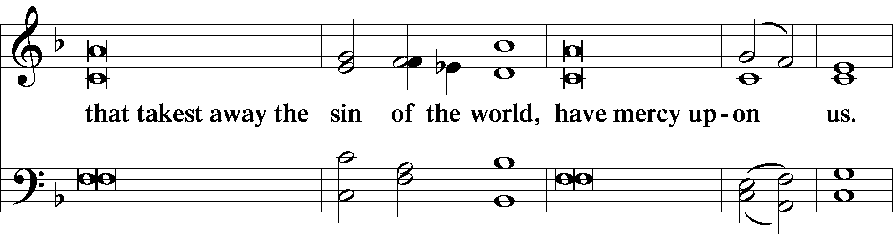
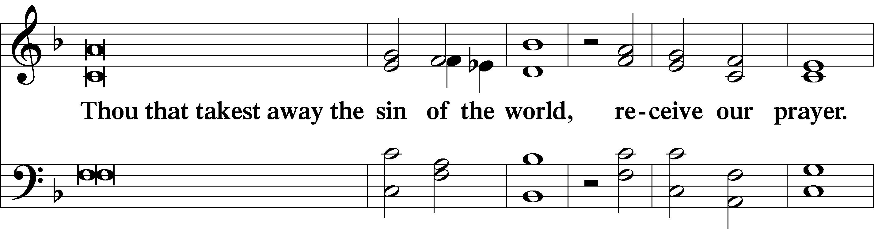
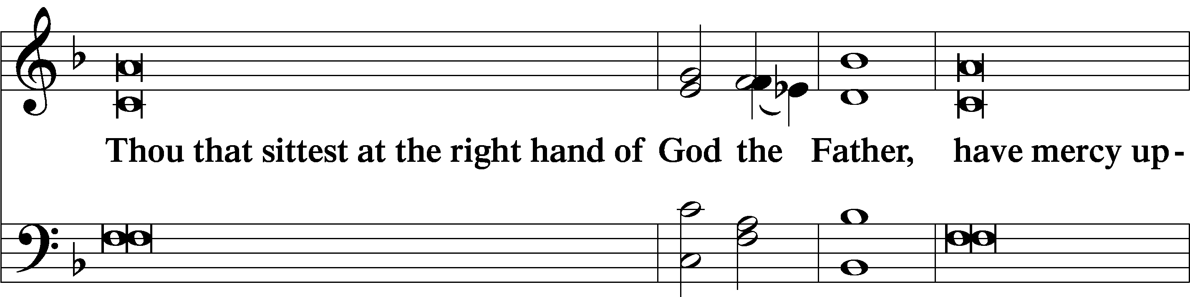
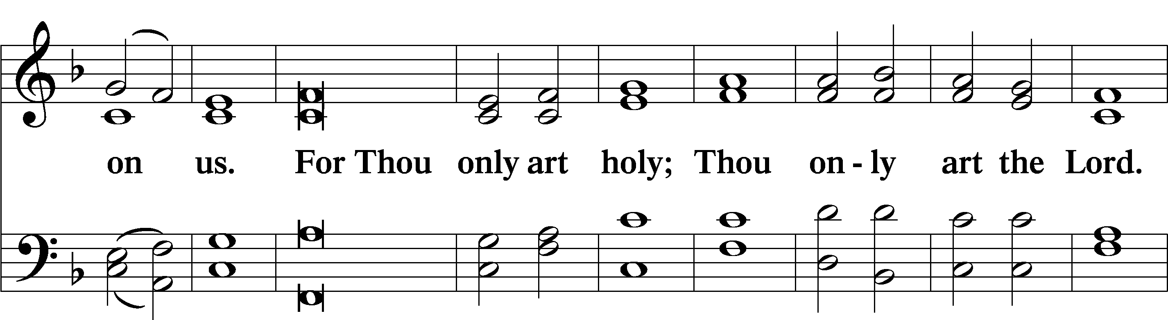
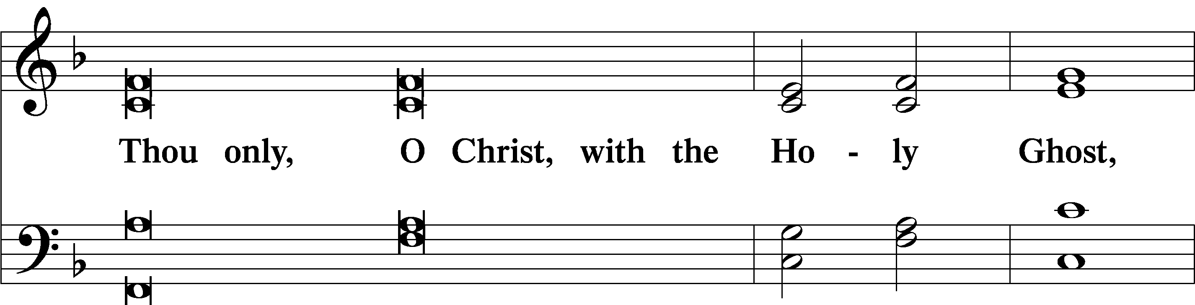
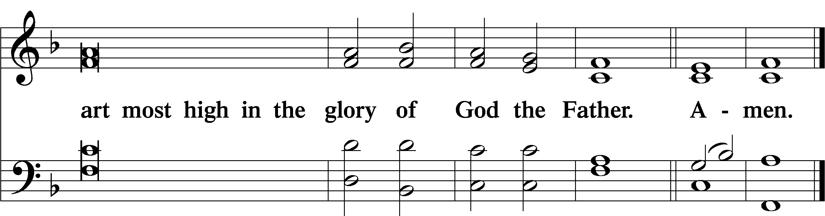

Salutation and Collect of the Day

P The Lord be with you.
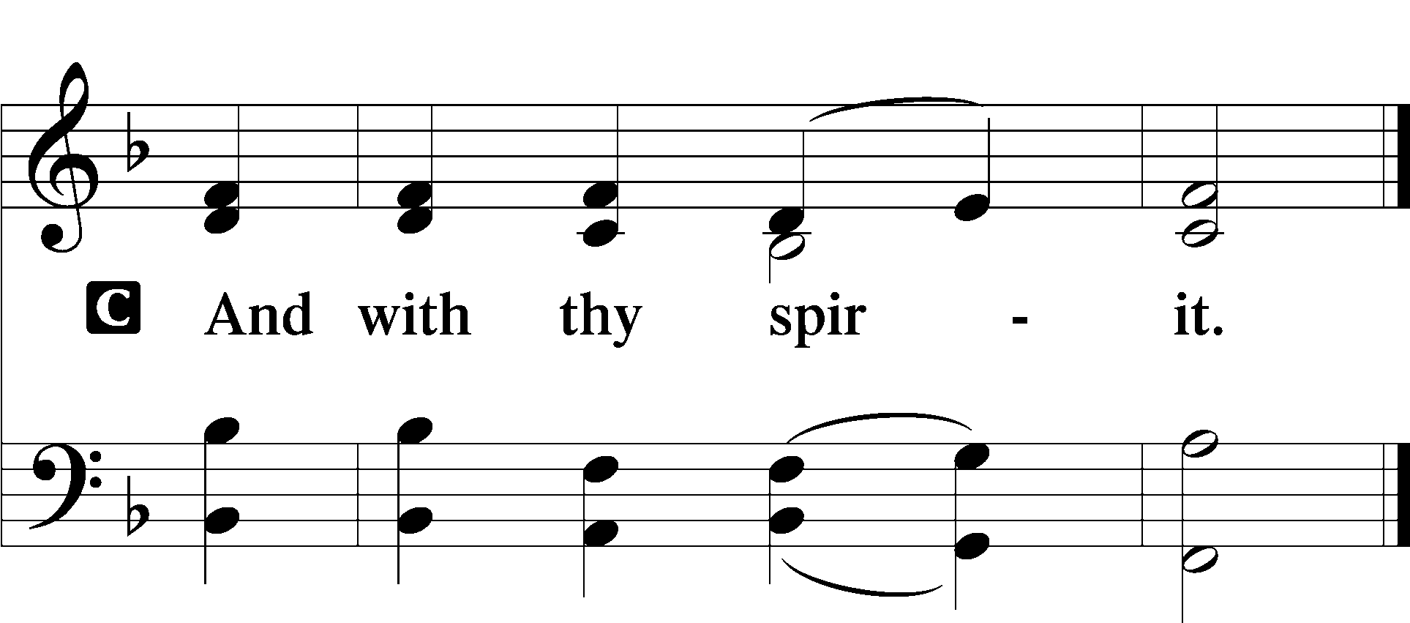
P Let us pray.
Almighty God the Father, through Your only-begotten Son, Jesus Christ, You have overcome death and opened the gate of everlasting life to us. Grant that we, who celebrate with joy the day of our Lord’s resurrection, may be raised from the death of sin by Your life-giving Spirit; through Jesus Christ, our Lord, who lives and reigns with You and the Holy Spirit, one God, now and forever.

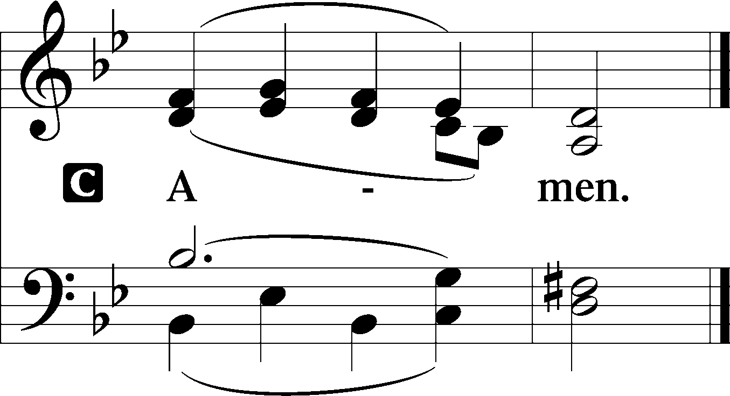

Sit

Old Testament Reading Jeremiah 31:1–6

“At that time, declares the Lord, I will be the God of all the clans of Israel, and they shall be my people.”

Thus says the Lord:
“The people who survived the sword found grace in the wilderness; when Israel sought for rest, the Lord appeared to him from far away. I have loved you with an everlasting love; therefore, I have continued my faithfulness to you.

Again I will build you, and you shall be built, O virgin Israel! Again you shall adorn yourself with tambourines and shall go forth in the dance of the merrymakers.
Again you shall plant vineyards on the mountains of Samaria; the planters shall plant and shall enjoy the fruit.
For there shall be a day when watchmen will call in the hill country of Ephraim: ‘Arise, and let us go up to Zion, to the Lord our God.’”

A This is the Word of the Lord.
C Thanks be to God.

Epistle Colossians 3:1–4

If then you have been raised with Christ, seek the things that are above, where Christ is, seated at the right hand of God. Set your minds on things that are above, not on things that are on earth. For you have died, and your life is hidden with Christ in God. When Christ who is your life appears, then you also will appear with him in glory.

A This is the Word of the Lord.
C Thanks be to God.

Stand

Holy Gospel Matthew 28:1–10

P The Holy Gospel according to St. Matthew, the twenty-eighth chapter.

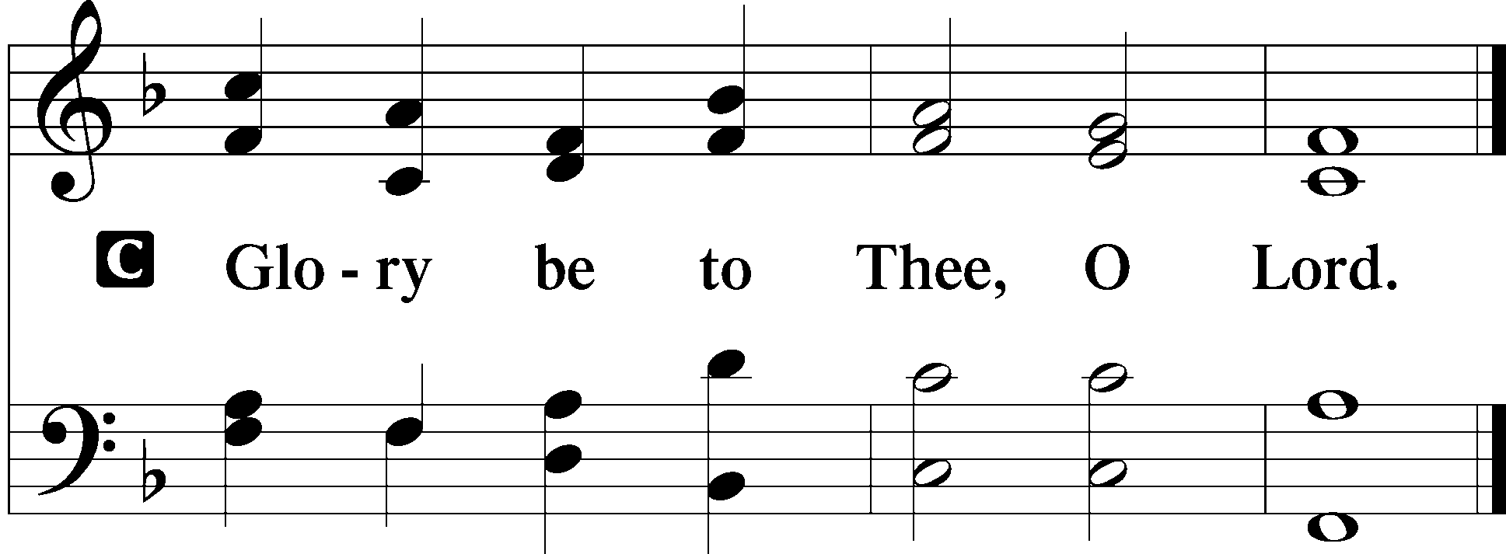

Now after the Sabbath, toward the dawn of the first day of the week, Mary Magdalene and the other Mary went to see the tomb. And behold, there was a great earthquake, for an angel of the Lord descended from heaven and came and rolled back the stone and sat on it. His appearance was like lightning, and his clothing white as snow. And for fear of him the guards trembled and became like dead men. But the angel said to the women, “Do not be afraid, for I know that you seek Jesus who was crucified. He is not here, for he has risen, as he said. Come, see the place where he lay. Then go quickly and tell his disciples that he has risen from the dead, and behold, he is going before you to Galilee; there you will see him. See, I have told you.” So they departed quickly from the tomb with fear and great joy, and ran to tell his disciples. And behold, Jesus met them and said, “Greetings!” And they came up and took hold of his feet and worshiped him. Then Jesus said to them, “Do not be afraid; go and tell my brothers to go to Galilee, and there they will see me.”

P This is the Gospel of the Lord.
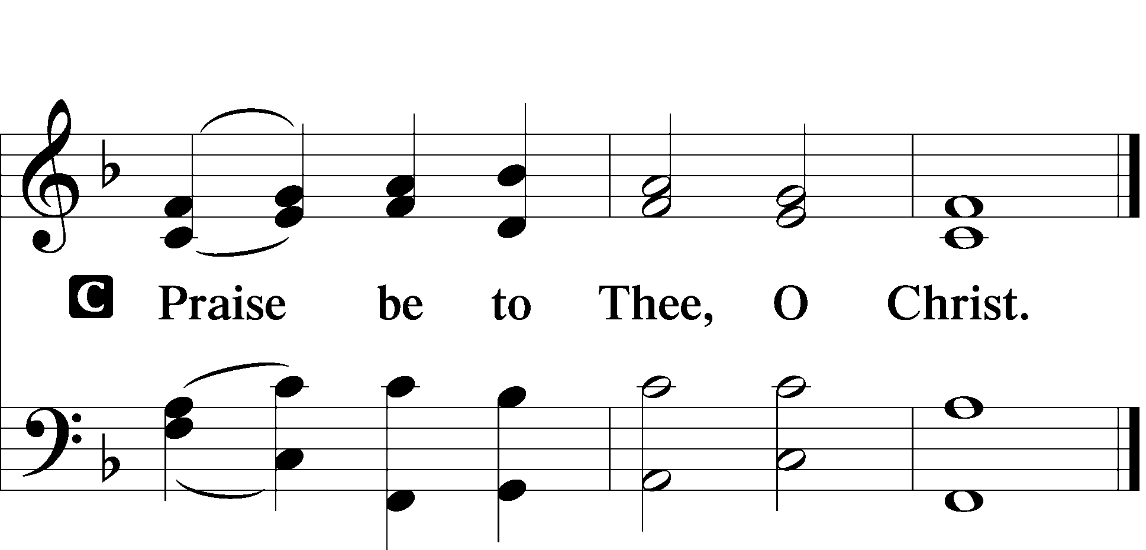

Apostles’ Creed

I believe in God, the Father Almighty, maker of
heaven and earth.
And in Jesus Christ, His only Son, our Lord, who was conceived by the Holy Spirit, born of the virgin Mary, suffered under Pontius Pilate, was crucified, died and was buried.

He descended into hell. The third day He rose again from the dead. He ascended into heaven and sits at the right hand of God the Father Almighty. From thence He will come to judge the living and the dead.

I believe in the Holy Spirit, the holy Christian Church, the communion of saints, the forgiveness of sins, the resurrection of the body, and the life T everlasting. Amen.

Sit

Hymn of the Day

459 Christ Is Arisen

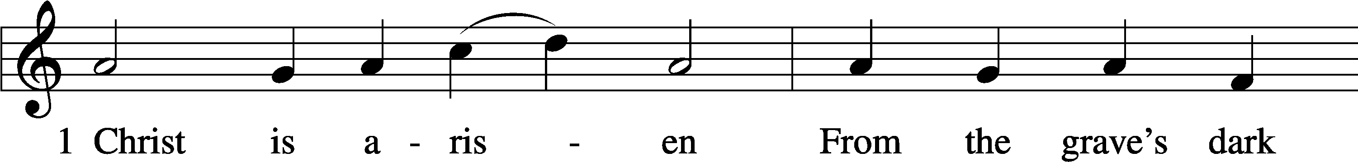
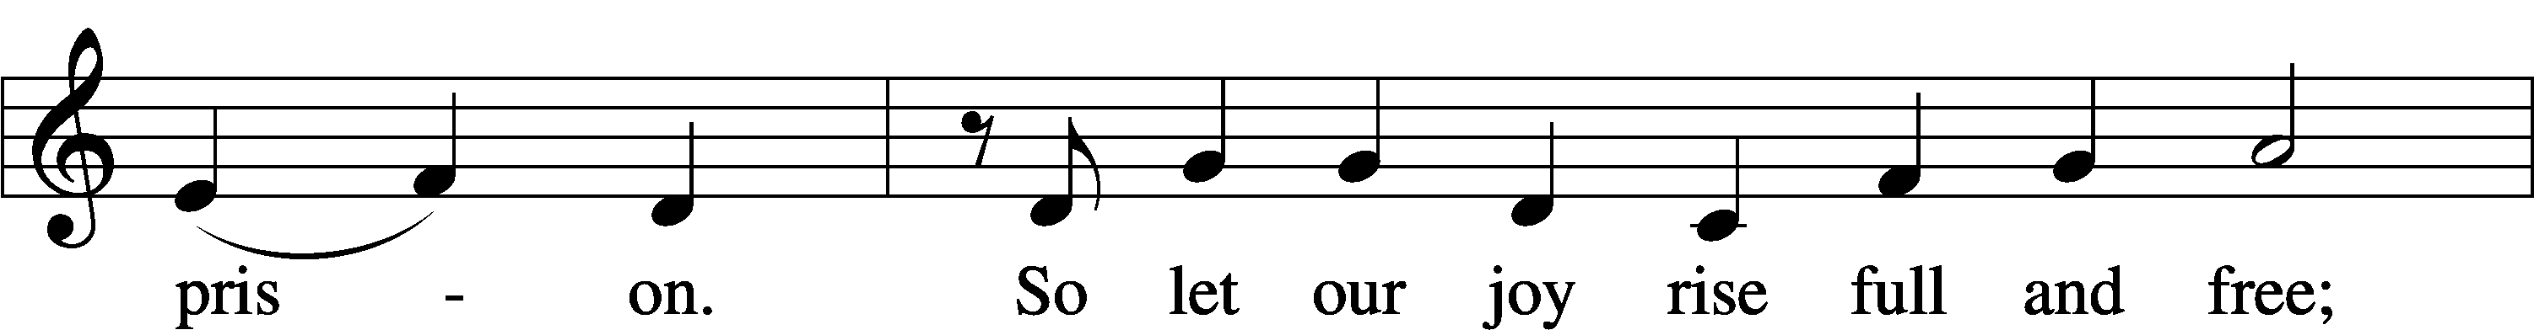
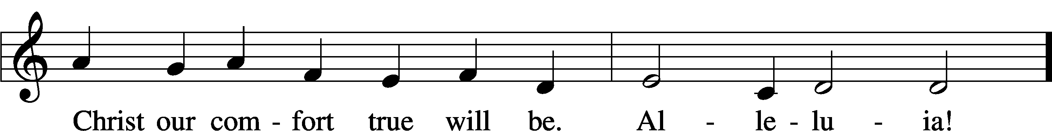
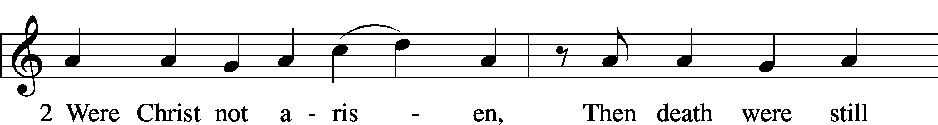
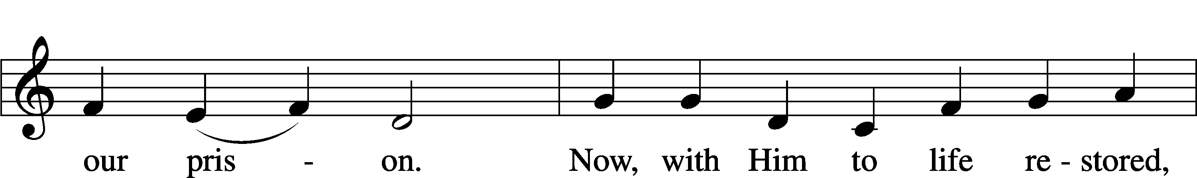
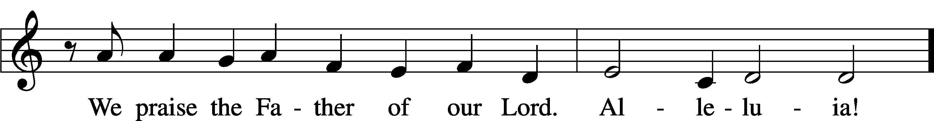
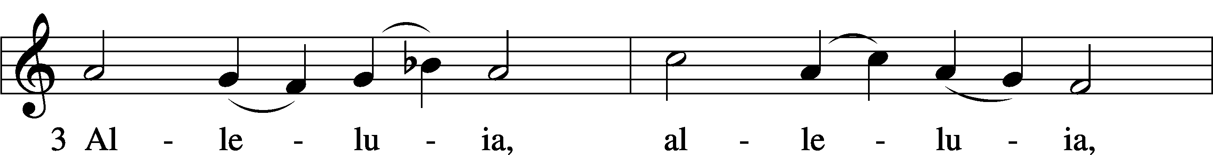
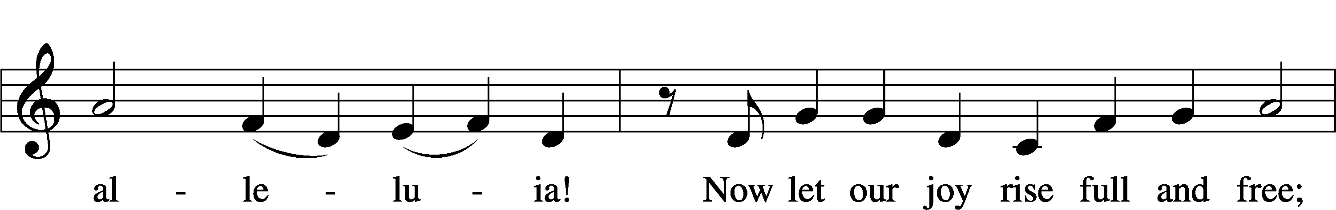
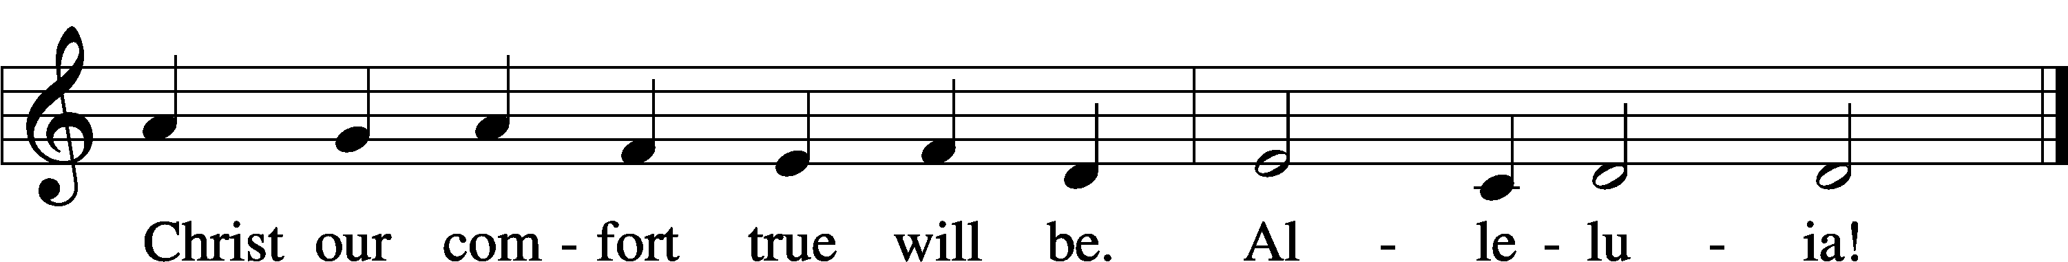
Text: German, 12th–15th cent.; tr. Martin L. Seltz, 1909–67, alt.
Tune: Latin, c. 1100; Geistliche Lieder auffs new gebessert, 1533, Wittenberg, ed. Joseph Klug
Text: © 1969 Concordia Publishing House. Used by permission: LSB Hymn License no. 110003925
Tune: Public domain

Sermon

Offering

Psalm for Meditation Psalm 16; antiphon: v. 10

Preserve me, O God, for in you I take refuge.
I say to the Lord, “You are my Lord; I have no good apart from you.” As for the saints in the land, they are the excellent ones, in whom is all my delight.

The sorrows of those who run after another god shall multiply; their drink offerings of blood I will not pour out or take their names on my lips.
The Lord is my chosen portion and my cup; you hold my lot. The lines have fallen for me in pleasant places; indeed, I have a beautiful inheritance.

I bless the Lord who gives me counsel; in the night also my heart instructs me. I have set the Lord always before me; because he is at my right hand, I shall not be shaken.

Therefore my heart is glad, and my whole being rejoices; my flesh also dwells secure. For you will not abandon my soul to Sheol, or let your holy one see corruption.
You make known to me the path of life; in your presence there is fullness of joy; at your right hand are pleasures forevermore.

Stand

781 We Give Thee But Thine Own sts. 1–2

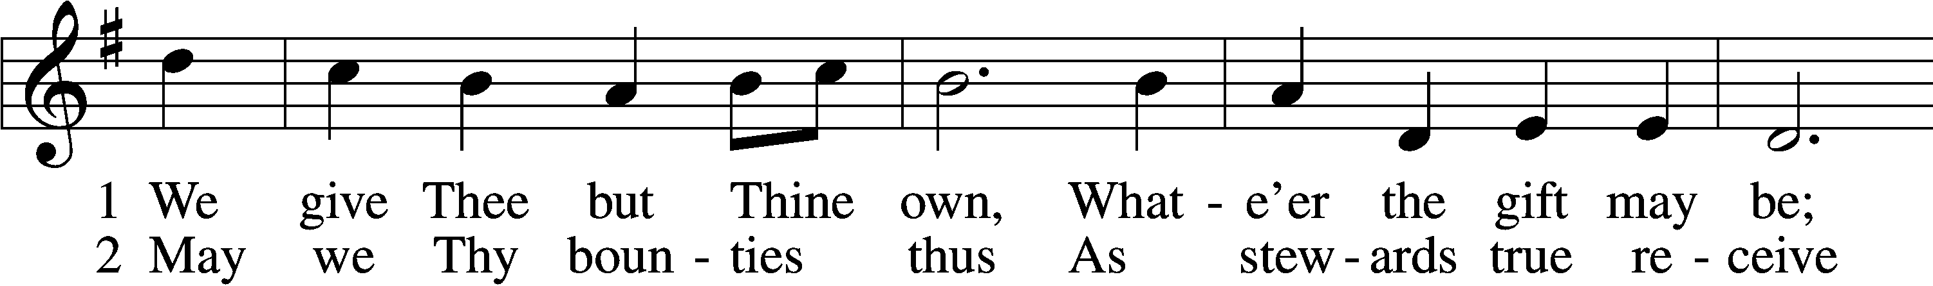
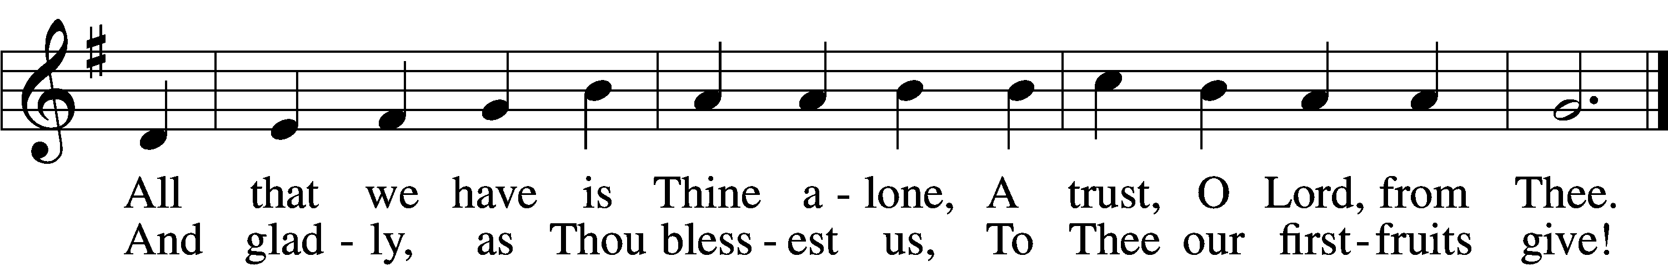
Text: William W. How, 1823–97
Tune: William H. Monk, 1823–89
Text and tune: Public domain

Prayer of the Church

P Let us pray for the whole people of God in Christ Jesus and for all people according to their needs.
P For the faithful proclamation of Christ’s saving name, that God’s people may be strengthened in the true faith and His kingdom extended, let us pray to the Lord:
C Lord, have mercy.
P For the holy Christian Church throughout the world and for all who confess the name of Christ, that God would guard and defend us from the temptations of the devil, the world, and our sinful nature, let us pray to the Lord:
C Lord, have mercy.
P For those who have wandered from the faith, that the Holy Spirit would use us to call them home to the Father, let us pray to the Lord:
C Lord, have mercy.
P For the government and all who have been set into positions of leadership, that they may use the authority entrusted to them honorably and for the good of the people, let us pray to the Lord:
C Lord, have mercy.
P For those who suffer from hunger, homelessness, poverty, or unemployment, that God’s great mercy and love would preserve and relieve them, let us pray to the Lord:
C Lord, have mercy.
P For those who are sick especially Kristine, Joshua, Hunter, Lorraine, Dorothy, Marge, Tony, Bill M., Patricia, Phil, Lidia, Michele, Giuseppe, Alfred, and Nancy that God would grant healing to their bodies and strength to bear their infirmities with patience and grace, let us pray to the Lord:
C Lord, have mercy.
P For those who rejoice in the rich blessings of God, that they may always remember the Giver of every gift and give Him heartfelt thanks, let us pray to the Lord:
C Lord, have mercy.
P O Lord, heavenly Father, we gratefully remember the sufferings and death of Your dear Son, Jesus Christ, for our salvation. Rejoicing in His victorious resurrection from the dead, we draw strength from His ascension before You, where He ever stands for us as our own High Priest. Gather us together from the ends of the earth to celebrate with all the faithful the marriage feast of the Lamb in His kingdom, which has no end. Graciously receive our prayers, deliver and preserve us, for to You alone we give all glory, honor, and worship, Father, Son, and Holy Spirit, one God, now and forever.
C Amen.

Lord’s Prayer

Our Father who art in heaven, hallowed be Thy name, Thy kingdom come, Thy will be done on earth as it is in heaven.

Give us this day our daily bread; and forgive us our trespasses as we forgive those who trespass against us; and lead us not into temptation but deliver us from evil.
For Thine is the kingdom and the power and the glory forever and ever. Amen.

Benediction LSB 166

P The Lord bless you and keep you.
The Lord make His face shine on you and be gracious to you.
The Lord look upon you with favor and T give you peace.


Hymn to Depart

463 Christ the Lord Is Risen Today; Alleluia sts. 1–4

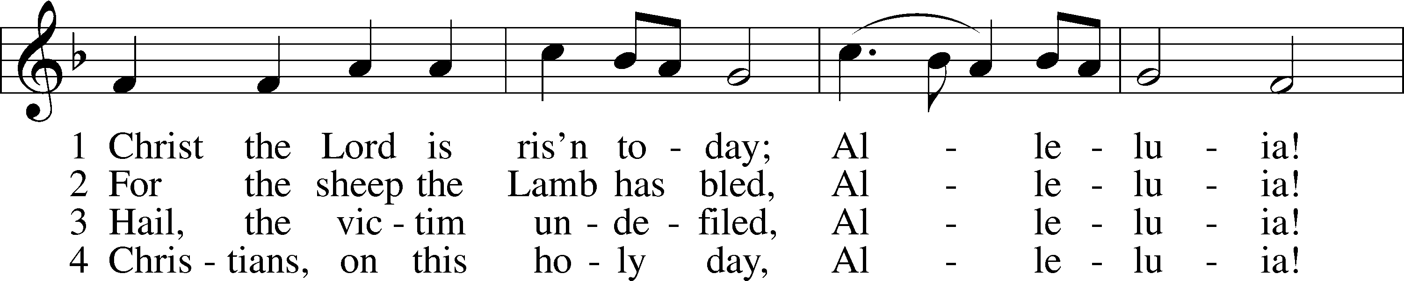
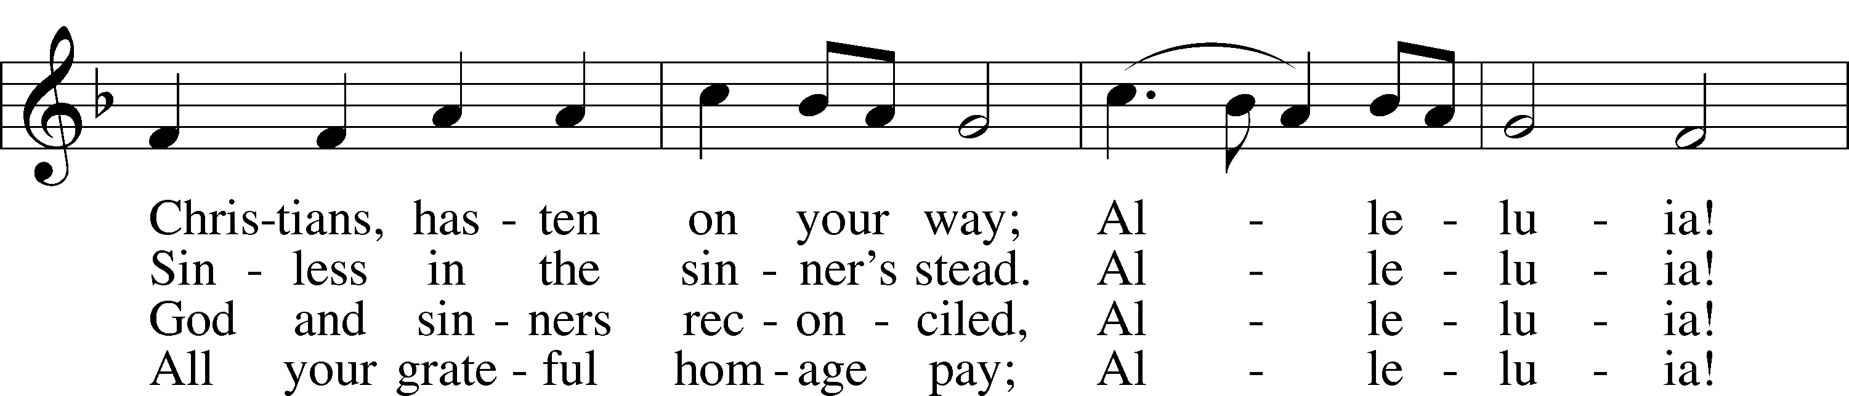
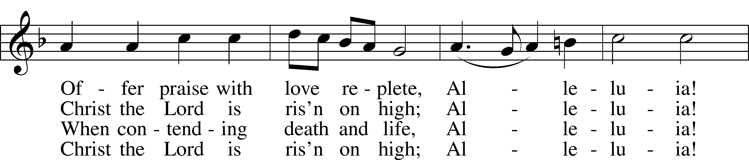
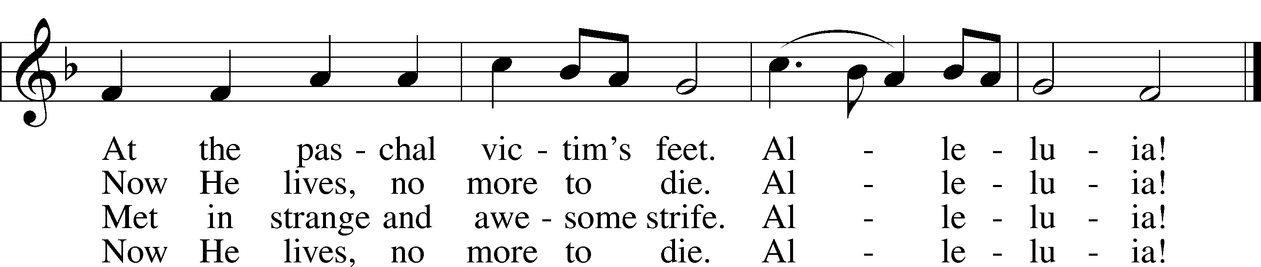
Text: attr. Wipo of Burgundy, d. c. 1050; tr. Jane E. Leeson, 1809–81, alt.
Tune: Robert Williams, c. 1781–1821
Text and tune: Public domain


Easter Lilies
IN LOVING MEMORY OF | GIVEN BY
Aunt & Uncle: Edythe & Amos Weglowski | Jayne, Liz, Laurie, Tyler & Sarah
Brother & Sister In-Law: Richard & Lee Trenery | Joe Torelli
Brother: Donald Torelli | Joe Torelli
Brother: John Hayes | Patricia Hayes
Brother: Paul Pennisi | Barbara Penisi
Brother: Phil | Kristine Hohmann & Andrew Dworetzky
Grandparents: Emma & Roy Gildart | Kristine Hohmann
Husband: Andrew Malatesta, Jr. | Dorothy Malatesta
Husband: George Klink | Janet Klink
Husband: Ron Buchchio | Barbaralee Berte’
Loved Ones | Ralph & Susan Unkert
Loved Ones | Matt & Sandy Martinique
Loved Ones: Elbert, Mona, Violet, Lucille & Duchess | Yvette Rock
Loving Wife: Pat Torelli | Joe Torelli
Niece: Adele Ulrich | Janet Klink
Parents/Grandparents: Robert & Jayne Sachtleben | Jayne, Liz, Laurie, Tyler & Sarah
Parents: Corinne & George Bender | Bob & Carol Bender
Parents: Emma & John Hohmann | Kristine Hohmann
Parents: Evelyn & Fred Pfefferle | Bob & Carol Bender
Parents: James & Mary Anna Gallarelli | Donald Galarelli
Parents: Kippy & Bill Dworetzky | Kristine Hohmann & Andrew Dworetzky
Parents: Matthew & Marie Berghorn | Janet Klink
Parents: Paul & Jean Pennisi | Barbara Pennisi
Parents: Richard & Leah Trenery | Joe Torelli
Parents: Stephen & Bertha Micklus | Dorothy Malatesta
Parents: Viola & Frank Berte’ | Barbaralee Berte’
Parents: Walter & Cecilia Torelli | Joe Torelli
Parents: William & Margaret Kleeman | The Kleeman, Herman & Lainson Families
Sister & Brother In-Law: Edna & Louis Ulrich | Janet Klink
Sister: Joan | Kristine Hohmann & Andrew Dworetzky

Easter Lilies

To the Glory of God & Blessings Received
Carol & Bob Bender
Debbie Brunette
Ellen Koromhas
The Martinique Family
Lorraine & Bill Montesano
Beverly & Tom Smith
The Johnson Family

Announcements

Upcoming events at St. John’s Clifton

Sun | 4/12 | Divine Service w/Comm | 9:00 AM
 |  | Pastor Vogel
 | After | Coffee Hour & Bible Study
Sat | 4/18 | LWML Spring Rally | 1:00 PM
 |  | Hosted by the Ladies Guild
 |  | Refreshments | 1:00 PM
 |  | Rally begins | 1:30 PM

All ladies of St. John’s are encouraged to attend the LWML Spring Rally .

Pierogi sale: $7.50 per dozen

Choice of flavors: potato, potato & cheese, potato & sauerkraut, just sauerkraut. All one kind or mixed. They will be pre-boiled. Just boil and fry. Pick up is Sunday, April 12th.

Help is needed April 9th, 10th and 11th to cook and assemble. Thank you. See Kristine.

Acknowledgments
Divine Service, Setting One from Lutheran Service Book
Unless otherwise indicated, Scripture quotations are from the ESV® Bible (The Holy Bible, English Standard Version®), copyright © 2001 by Crossway, a publishing ministry of Good News Publishers. Used by permission. All rights reserved.
Created by Lutheran Service Builder © 2026 Concordia Publishing House
Announcements

Upcoming events at St. John’s Clifton

Sun | 4/12 | Divine Service w/Comm | 9:00 AM
 |  | Pastor Vogel
 | After | Coffee Hour & Bible Study
Sat | 4/18 | LWML Spring Rally | 1:00 PM
 |  | Hosted by the Ladies Guild
 |  | Refreshments | 1:00 PM
 |  | Rally begins | 1:30 PM

All ladies of St. John’s are encouraged to attend the LWML Spring Rally .

Pierogi sale: $7.50 per dozen

Choice of flavors: potato, potato & cheese, potato & sauerkraut, just sauerkraut. All one kind or mixed. They will be pre-boiled. Just boil and fry. Pick up is Sunday, April 12th.

Help is needed April 9th, 10th and 11th to cook and assemble. Thank you. See Kristine.

Acknowledgments
Divine Service, Setting One from Lutheran Service Book
Unless otherwise indicated, Scripture quotations are from the ESV® Bible (The Holy Bible, English Standard Version®), copyright © 2001 by Crossway, a publishing ministry of Good News Publishers. Used by permission. All rights reserved.
Created by Lutheran Service Builder © 2026 Concordia Publishing House

