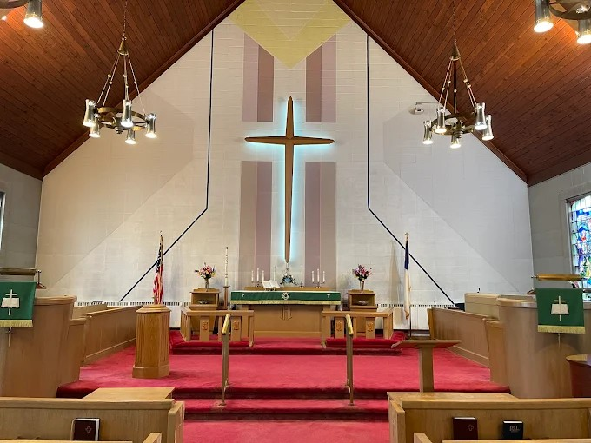

Saint John’s Lutheran Church
810 Broad Street
Clifton, New Jersey
Office: 973-778-141
www.StJohnsClifton.org

Good Friday
Friday, April 3, 2026
2:00 PM

The church of the praying hands

Service of the Word

The congregation and pastor(s) enter in silence.

Kneel/Stand

Collect of the Day

P Almighty God, graciously behold this Your family for whom our Lord Jesus Christ was willing to be betrayed and delivered into the hands of sinful men to suffer death upon the cross; through the same Jesus Christ, Your Son, our Lord, who lives and reigns with You and the Holy Spirit, one God, now and forever.
C Amen.

Sit

Old Testament Reading Isaiah 52:13—53:12

The Old Testament Reading for Good Friday is from Isaiah, chapters 52 and 53.

Behold, my servant shall act wisely; he shall be high and lifted up and shall be exalted. As many were astonished at you— his appearance was so marred, beyond human semblance, and his form beyond that of the children of mankind— so shall he sprinkle many nations; kings shall shut their mouths because of him; for that which has not been told them they see, and that which they have not heard they understand.
Who believed what they heard from us? And to whom has the arm of the Lord been revealed? For he grew up before him like a young plant, and like a root out of dry ground; he had no form or majesty that we should look at him, and no beauty that we should desire him.
He was despised and rejected by men; a man of sorrows, and acquainted with grief; and as one from whom men hide their faces he was despised, and we esteemed him not. Surely he has borne our griefs and carried our sorrows; yet we esteemed him stricken, smitten by God, and afflicted. But he was wounded for our transgressions; he was crushed for our iniquities; upon him was the chastisement that brought us peace, and with his stripes we are healed.
All we like sheep have gone astray; we have turned every one to his own way; and the Lord has laid on him the iniquity of us all. He was oppressed, and he was afflicted, yet he opened not his mouth; like a lamb that is led to the slaughter, and like a sheep that before its shearers is silent, so he opened not his mouth.
By oppression and judgment, he was taken away; and as for his generation, who considered that he was cut off out of the land of the living, stricken for the transgression of my people? And they made his grave with the wicked and with a rich man in his death, although he had done no violence, and there was no deceit in his mouth.
Yet it was the will of the Lord to crush him; he has put him to grief; when his soul makes an offering for sin, he shall see his offspring; he shall prolong his days; the will of the Lord shall prosper in his hand.
Out of the anguish of his soul, he shall see and be satisfied; by his knowledge shall the righteous one, my servant, make many to be accounted righteous, and he shall bear their iniquities.
Therefore, I will divide him a portion with the many, and he shall divide the spoil with the strong, because he poured out his soul to death and was numbered with the transgressors; yet he bore the sin of many and makes intercession for the transgressors.

A This is the Word of the Lord.
C Thanks be to God.

Silence

Kneel/Stand

P Let us pray.
Merciful and everlasting God, You did not spare Your only Son but delivered Him up for us all to bear our sins on the cross. Grant that our hearts may be so fixed with steadfast faith in Him that we fear not the power of sin, death, and the devil; through the same Jesus Christ, our Lord.
C Amen.

Sit

Epistle Hebrews 4:14–16; 5:7–9

The Epistle is from Hebrews, chapters four and five.

Since then we have a great high priest who has passed through the heavens, Jesus, the Son of God, let us hold fast our confession. For we do not have a high priest who is unable to sympathize with our weaknesses, but one who in every respect has been tempted as we are, yet without sin. Let us then with confidence draw near to the throne of grace, that we may receive mercy and find grace to help in time of need. . . .

In the days of his flesh, Jesus offered up prayers and supplications, with loud cries and tears, to him who was able to save him from death, and he was heard because of his reverence. Although he was a son, he learned obedience through what he suffered. And being made perfect, he became the source of eternal salvation to all who obey him.

A This is the Word of the Lord.
C Thanks be to God.

Silence

Kneel/Stand

P Let us pray.
Almighty and everlasting God, You willed that Your Son should bear for us the pains of the cross and so remove from us the power of the adversary. Help us so to remember and give thanks for our Lord’s passion that we may receive forgiveness of sin and redemption from everlasting death; through Jesus Christ, our Lord.
C Amen.

Sit

The Passion of Our Lord Jesus Christ

451 Stricken, Smitten, and Afflicted st 1

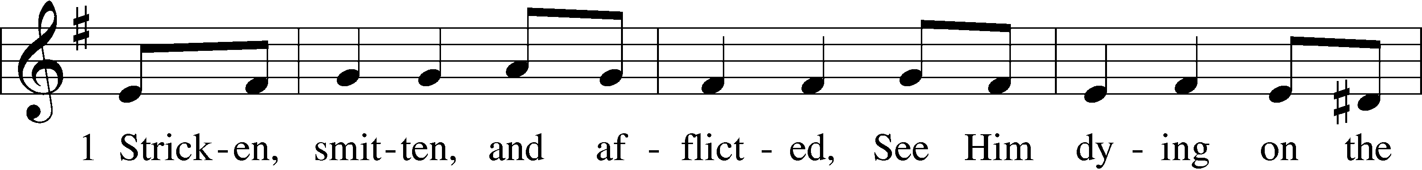
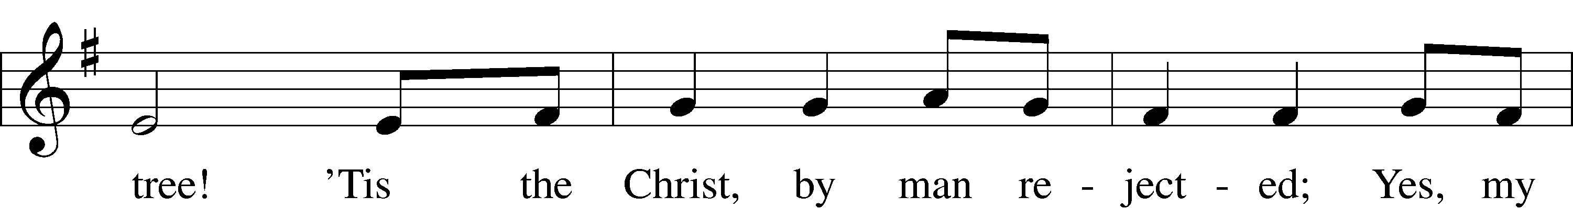
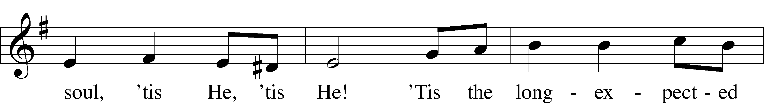
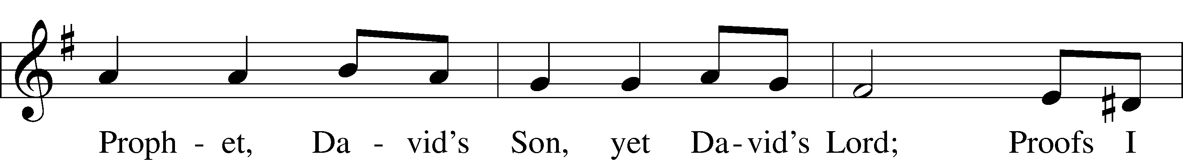
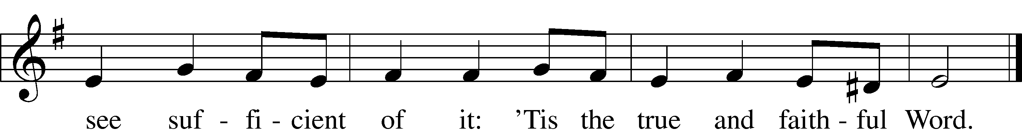
Text: Thomas Kelly, 1769–1855, alt.
Tune: Geistliche Volkslieder, 1850, Paderborn
Text and tune: Public domain

P The Passion of Our Lord Jesus Christ according to St. John.

The Betrayal and Arrest of Jesus John 18:1–11

When Jesus had spoken these words, he went out with his disciples across the Kidron Valley, where there was a garden, which he and his disciples entered. Now Judas, who betrayed him, also knew the place, for Jesus often met there with his disciples. So, Judas, having procured a band of soldiers and some officers from the chief priests and the Pharisees, went there with lanterns and torches and weapons. Then Jesus, knowing all that would happen to him, came forward and said to them, “Whom do you seek?” They answered him, “Jesus of Nazareth.” Jesus said to them, “I am he.” Judas, who betrayed him, was standing with them. When Jesus said to them, “I am he,” they drew back and fell to the ground. So he asked them again, “Whom do you seek?” And they said, “Jesus of Nazareth.” Jesus answered, “I told you that I am he. So, if you seek me, let these men go.” This was to fulfill the word that he had spoken: “Of those whom you gave me I have lost not one.” Then Simon Peter, having a sword, drew it and struck the high priest’s servant and cut off his right ear. (The servant’s name was Malchus.) So Jesus said to Peter, “Put your sword into its sheath; shall I not drink the cup that the Father has given me?”

450 O Sacred Head, Now Wounded st. 1

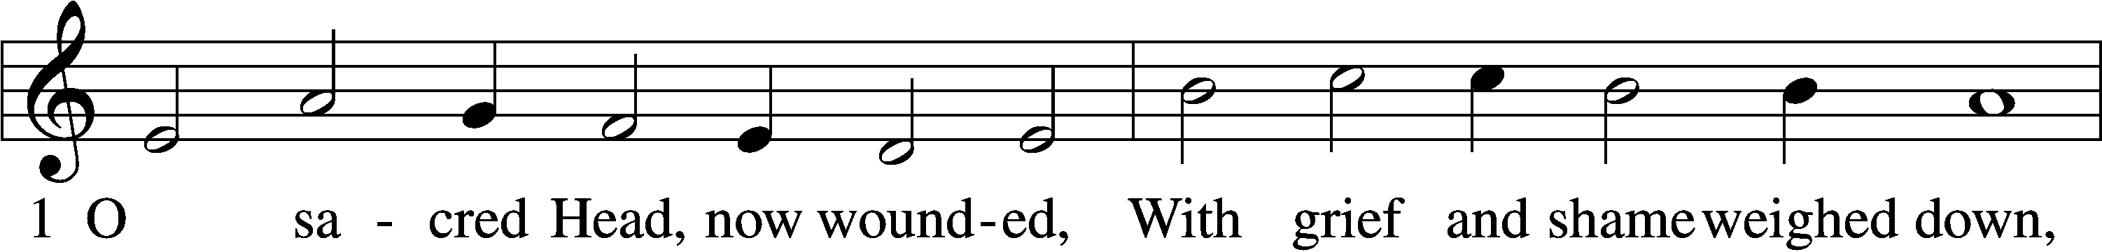
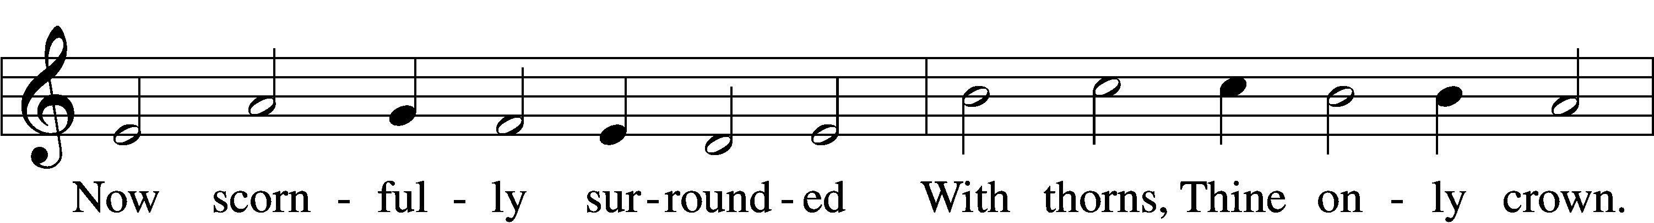
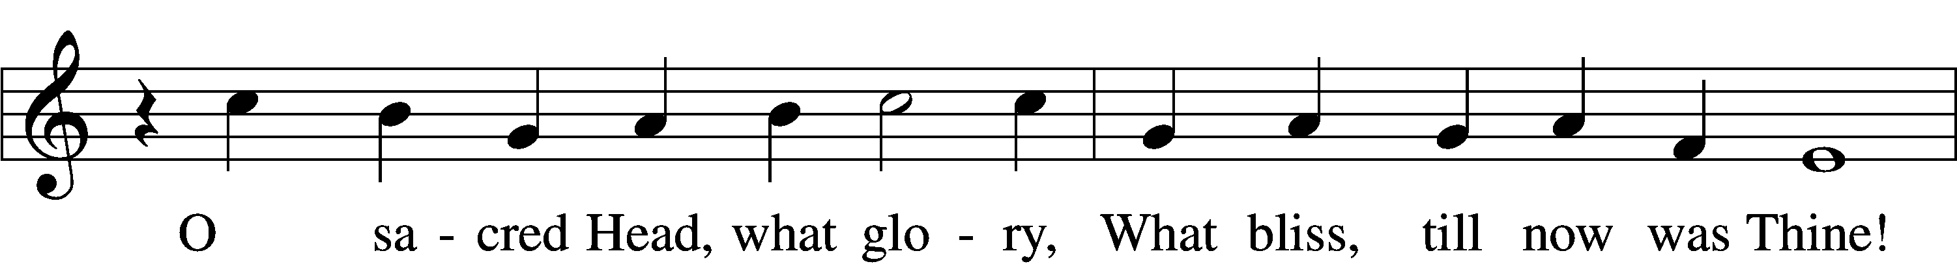
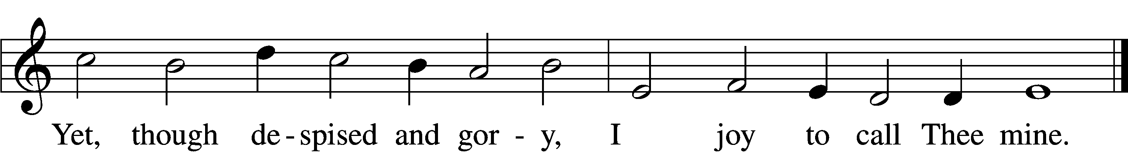
Text: attr. Bernard of Clairvaux, 1091–1153; German version, Paul Gerhardt, 1607–76; tr. The Lutheran Hymnal, 1941, alt.
Tune: Hans Leo Hassler, 1564–1612
Text: © 1941 Concordia Publishing House. Used by permission: LSB Hymn License no. 110003925
Tune: Public domain

Jesus Before the High Priest and the Denial of Peter John 18:12–27

So, the band of soldiers and their captain and the officers of the Jews arrested Jesus and bound him. First, they led him to Annas, for he was the father-in-law of Caiaphas, who was high priest that year. It was Caiaphas who had advised the Jews that it would be expedient that one man should die for the people.

Simon Peter followed Jesus, and so did another disciple. Since that disciple was known to the high priest, he entered with Jesus into the court of the high priest, but Peter stood outside at the door. So the other disciple, who was known to the high priest, went out and spoke to the servant girl who kept watch at the door, and brought Peter in. The servant girl at the door said to Peter, “You also are not one of this man’s disciples, are you?” He said, “I am not.” Now the servants and officers had made a charcoal fire, because it was cold, and they were standing and warming themselves. Peter also was with them, standing and warming himself.

The high priest then questioned Jesus about his disciples and his teaching. Jesus answered him, “I have spoken openly to the world. I have always taught in synagogues and in the temple, where all Jews come together. I have said nothing in secret. Why do you ask me? Ask those who have heard me what I said to them; they know what I said.” When he had said these things, one of the officers standing by struck Jesus with his hand, saying, “Is that how you answer the high priest?” Jesus answered him, “If what I said is wrong, bear witness about the wrong; but if what I said is right, why do you strike me?” Annas then sent him bound to Caiaphas the high priest.

Now Simon Peter was standing and warming himself. So they said to him, “You also are not one of his disciples, are you?” He denied it and said, “I am not.” One of the servants of the high priest, a relative of the man whose ear Peter had cut off, asked, “Did I not see you in the garden with him?” Peter again denied it, and at once a rooster crowed.

450 O Sacred Head, Now Wounded st. 2

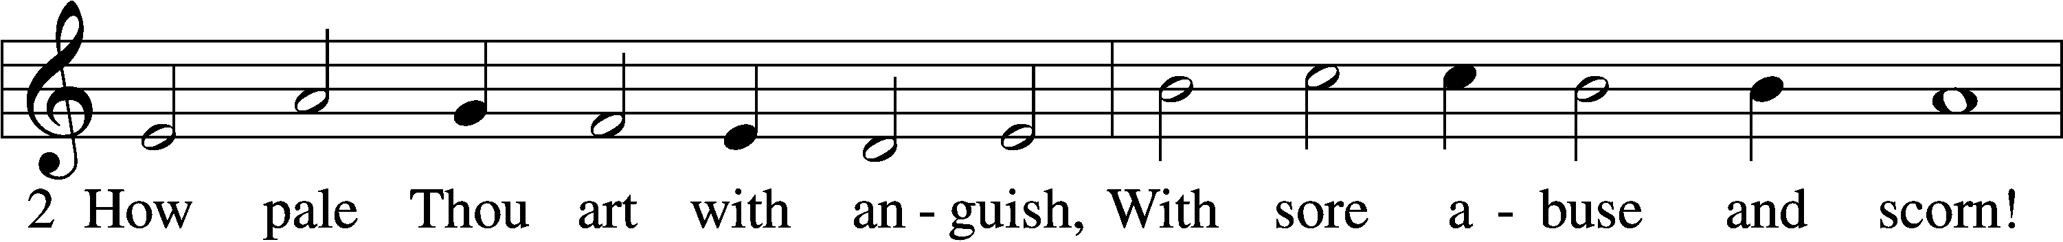
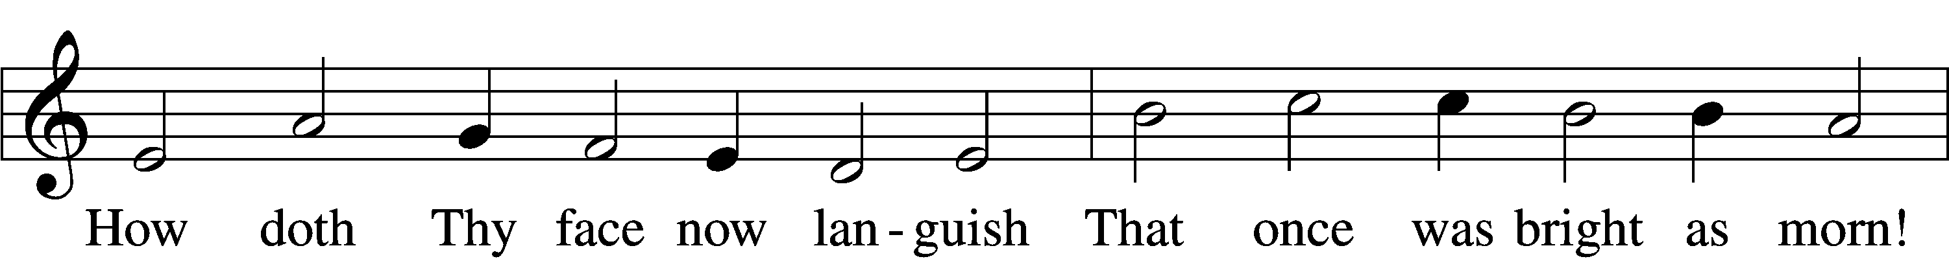
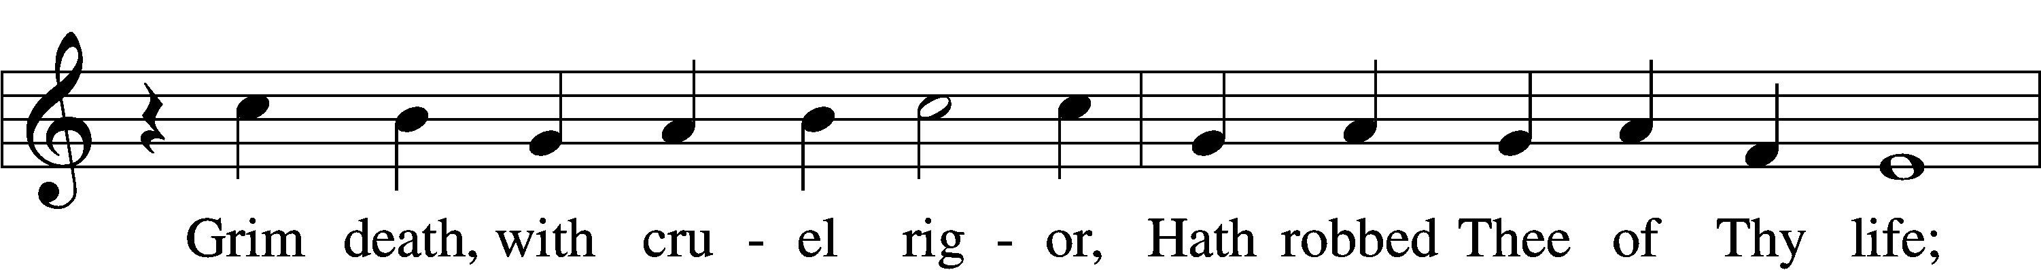
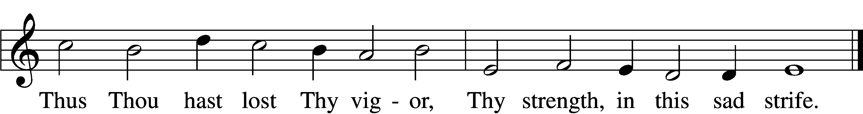

Jesus Before Pilate John 18:28–40

Then they led Jesus from the house of Caiaphas to the governor’s headquarters. It was early morning. They themselves did not enter the governor’s headquarters, so that they would not be defiled, but could eat the Passover. So Pilate went outside to them and said, “What accusation do you bring against this man?” They answered him, “If this man were not doing evil, we would not have delivered him over to you.” Pilate said to them, “Take him yourselves and judge him by your own law.” The Jews said to him, “It is not lawful for us to put anyone to death.” This was to fulfill the word that Jesus had spoken to show by what kind of death he was going to die.

So, Pilate entered his headquarters again and called Jesus and said to him, “Are you the King of the Jews?” Jesus answered, “Do you say this of your own accord, or did others say it to you about me?” Pilate answered, “Am I a Jew? Your own nation and the chief priests have delivered you over to me. What have you done?” Jesus answered, “My kingdom is not of this world. If my kingdom were of this world, my servants would have been fighting, that I might not be delivered over to the Jews. But my kingdom is not from the world.” Then Pilate said to him, “So you are a king?” Jesus answered, “You say that I am a king. For this purpose I was born and for this purpose I have come into the world—to bear witness to the truth. Everyone who is of the truth listens to my voice.” Pilate said to him, “What is truth?”

After he had said this, he went back outside to the Jews and told them, “I find no guilt in him. But you have a custom that I should release one man for you at the Passover. So do you want me to release to you the King of the Jews?” They cried out again, “Not this man, but Barabbas!” Now Barabbas was a robber.

450 O Sacred Head, Now Wounded st. 3

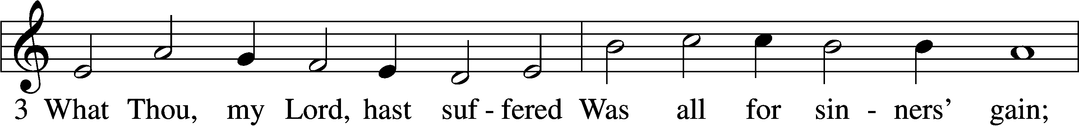
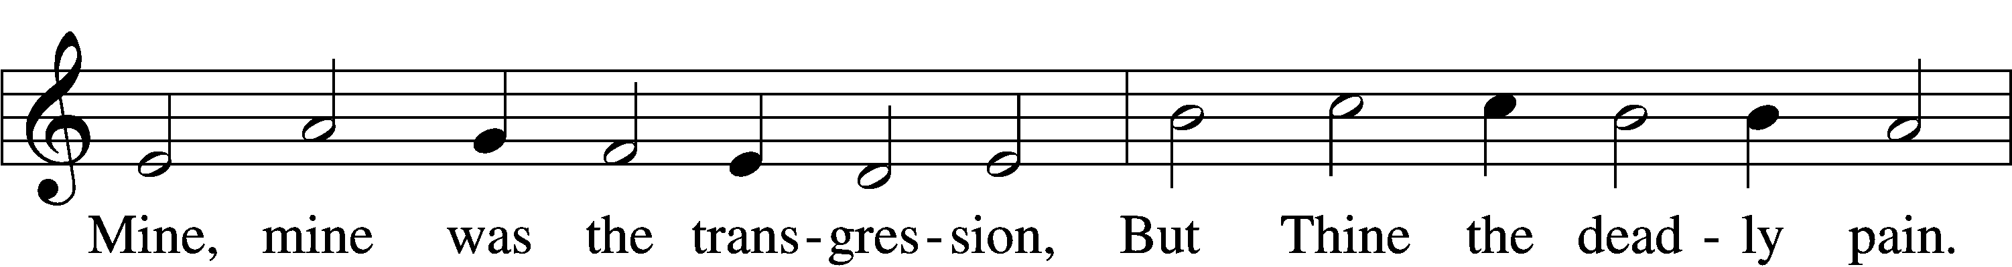
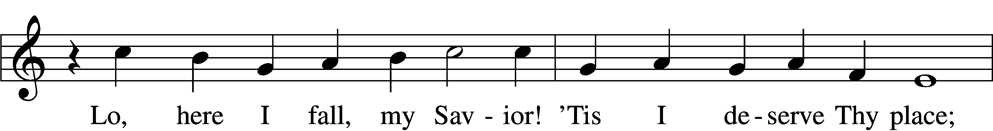
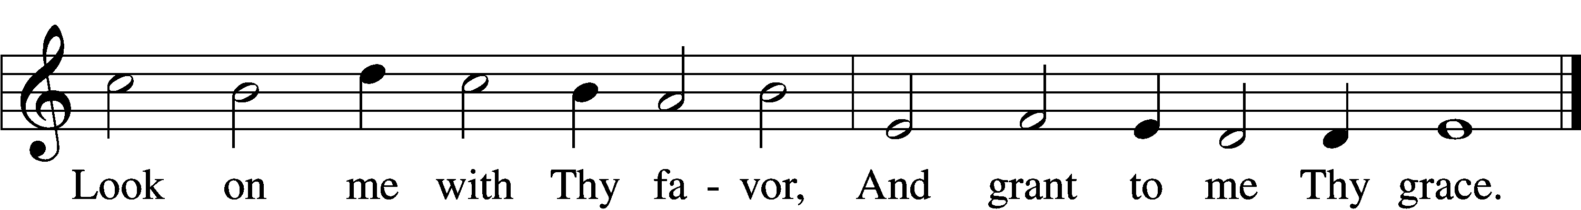

Jesus Prepared for Crucifixion John 19:1–16a

Then Pilate took Jesus and flogged him. And the soldiers twisted together a crown of thorns and put it on his head and arrayed him in a purple robe. They came up to him, saying, “Hail, King of the Jews!” and struck him with their hands. Pilate went out again and said to them, “See, I am bringing him out to you that you may know that I find no guilt in him.” So Jesus came out, wearing the crown of thorns and the purple robe. Pilate said to them, “Behold the man!” When the chief priests and the officers saw him, they cried out, “Crucify him, crucify him!” Pilate said to them, “Take him yourselves and crucify him, for I find no guilt in him.” The Jews answered him, “We have a law, and according to that law he ought to die because he has made himself the Son of God.” When Pilate heard this statement, he was even more afraid. He entered his headquarters again and said to Jesus, “Where are you from?” But Jesus gave him no answer. So Pilate said to him, “You will not speak to me? Do you not know that I have authority to release you and authority to crucify you?” Jesus answered him, “You would have no authority over me at all unless it had been given you from above. Therefore he who delivered me over to you has the greater sin.”
From then on Pilate sought to release him, but the Jews cried out, “If you release this man, you are not Caesar’s friend. Everyone who makes himself a king opposes Caesar.” So when Pilate heard these words, he brought Jesus out and sat down on the judgment seat at a place called The Stone Pavement, and in Aramaic Gabbatha. Now it was the day of Preparation of the Passover. It was about the sixth hour. He said to the Jews, “Behold your King!” They cried out, “Away with him, away with him, crucify him!” Pilate said to them, “Shall I crucify your King?” The chief priests answered, “We have no king but Caesar.” So he delivered him over to them to be crucified.

450 O Sacred Head, Now Wounded st. 4

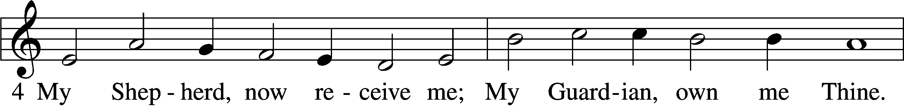
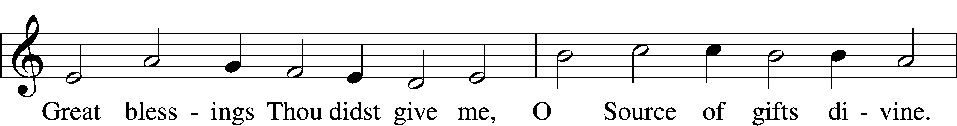
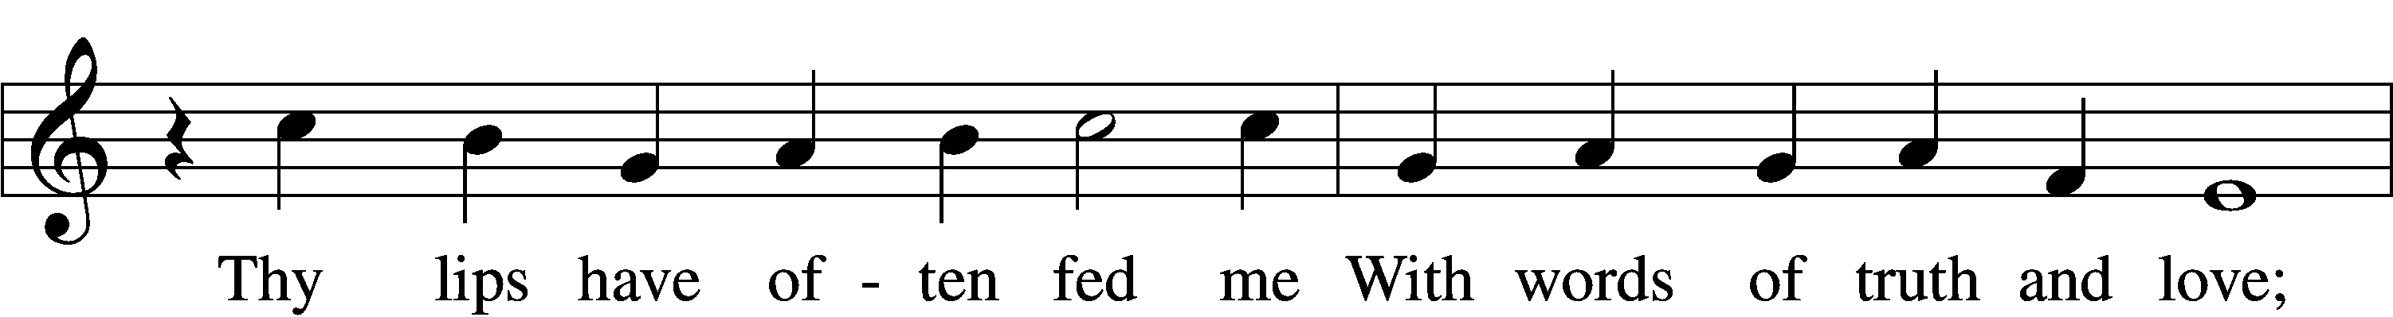
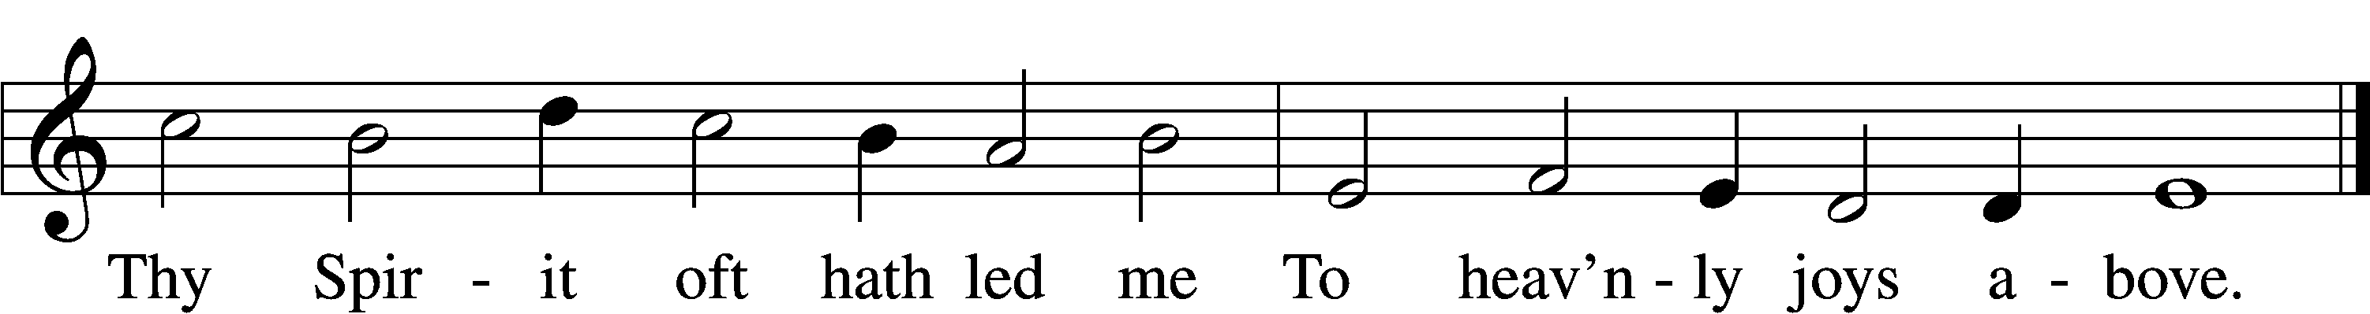

Stand

The Crucifixion of Jesus John 19:16b–24

So they took Jesus, and he went out, bearing his own cross, to the place called the place of a skull, which in Aramaic is called Golgotha. There they crucified him, and with him two others, one on either side, and Jesus between them. Pilate also wrote an inscription and put it on the cross. It read, “Jesus of Nazareth, the King of the Jews.” Many of the Jews read this inscription, for the place where Jesus was crucified was near the city, and it was written in Aramaic, in Latin, and in Greek. So the chief priests of the Jews said to Pilate, “Do not write, ‘The King of the Jews,’ but rather, ‘This man said, I am King of the Jews.’” Pilate answered, “What I have written I have written.”

When the soldiers had crucified Jesus, they took his garments and divided them into four parts, one part for each soldier; also his tunic. But the tunic was seamless, woven in one piece from top to bottom, so they said to one another, “Let us not tear it, but cast lots for it to see whose it shall be.” This was to fulfill the Scripture which says,
“They divided my garments among them, and for my clothing they cast lots.”
So the soldiers did these things.

450 O Sacred Head, Now Wounded st. 5

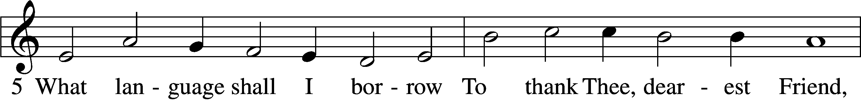
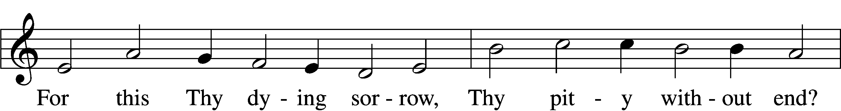
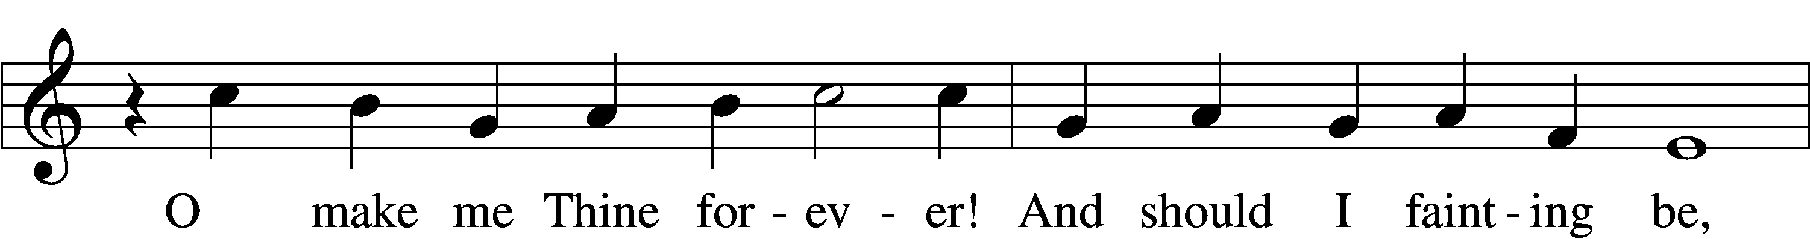
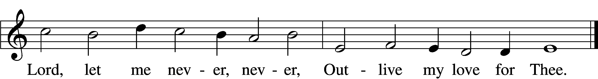

Jesus’ Mother and His Death John 19:25–30

Standing by the cross of Jesus were his mother and his mother’s sister, Mary the wife of Clopas, and Mary Magdalene. When Jesus saw his mother and the disciple whom he loved standing nearby, he said to his mother, “Woman, behold, your son!” Then he said to the disciple, “Behold, your mother!” And from that hour the disciple took her to his own home.

After this, Jesus, knowing that all was now finished, said (to fulfill the Scripture), “I thirst.” A jar full of sour wine stood there, so they put a sponge full of the sour wine on a hyssop branch and held it to his mouth. When Jesus had received the sour wine, he said, “It is finished,” and he bowed his head and gave up his spirit.

Silence

Jesus’ Side is Pierced John 19:31–42

Since it was the day of Preparation, and so that the bodies would not remain on the cross on the Sabbath (for that Sabbath was a high day), the Jews asked Pilate that their legs might be broken and that they might be taken away. So the soldiers came and broke the legs of the first, and of the other who had been crucified with him. But when they came to Jesus and saw that he was already dead, they did not break his legs. But one of the soldiers pierced his side with a spear, and at once there came out blood and water. He who saw it has borne witness—his testimony is true, and he knows that he is telling the truth—that you also may believe. For these things took place that the Scripture might be fulfilled: “Not one of his bones will be broken.” And again another Scripture says, “They will look on him whom they have pierced.”
After these things Joseph of Arimathea, who was a disciple of Jesus, but secretly for fear of the Jews, asked Pilate that he might take away the body of Jesus, and Pilate gave him permission. So he came and took away his body. Nicodemus also, who earlier had come to Jesus by night, came bringing a mixture of myrrh and aloes, about seventy-five pounds in weight. So they took the body of Jesus and bound it in linen cloths with the spices, as is the burial custom of the Jews. Now in the place where he was crucified there was a garden, and in the garden a new tomb in which no one had yet been laid. So because of the Jewish day of Preparation, since the tomb was close at hand, they laid Jesus there.

Silence

Sit

425 When I Survey the Wondrous Cross Sts 1-4

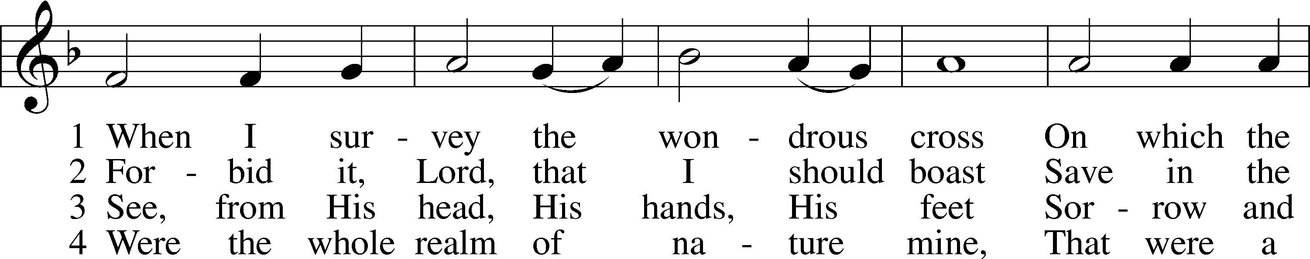
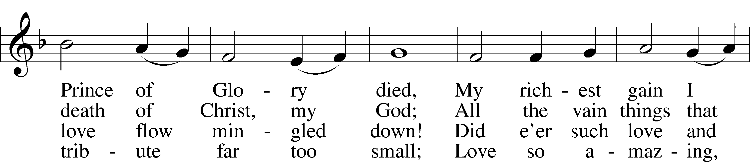
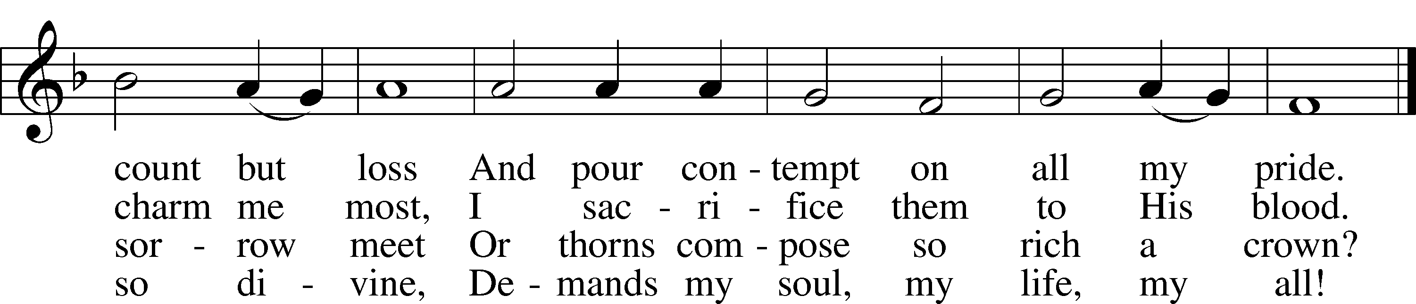
Text: Isaac Watts, 1674–1748
Tune: Lowell Mason, 1792–1872
Text and tune: Public domain

Sermon

Kneel/Stand

Bidding Prayer

A Let us pray for the whole Christian Church, that our Lord God would defend her against all the assaults and temptations of the adversary and keep her perpetually on the true foundation, Jesus Christ:
P Almighty and everlasting God, since You have revealed Your glory to all nations in Jesus Christ and in the Word of His truth, keep, we ask You, in safety the works of Your mercy so that Your Church, spread throughout all the nations, may be defended against the adversary and may serve You in true faith and persevere in the confession of Your name; through Jesus Christ, our Lord.
C Amen.

A Let us pray for all the ministers of the Word, for all vocations in the Church, and for all the people of God:
P Almighty and everlasting God, by whose Spirit the whole body of the Church is governed and sanctified, receive the supplications and prayers which we offer before You for all Your servants in Your holy Church that every member of the same may truly serve You according to Your calling; through Jesus Christ, our Lord.
C Amen.

A Let us pray for our catechumens, that our Lord God would open their hearts and the door of His mercy that, having received the remission of all their sins by the washing of regeneration, they may be mindful of their Baptism and evermore be found in Christ Jesus, our Lord:
P Almighty God and Father, because You always grant growth to Your Church, increase the faith and understanding of our catechumens that, rejoicing in their new birth by the water of Holy Baptism, they may forever continue in the family of those whom You adopt as Your sons and daughters; through Jesus Christ, our Lord.
C Amen.

A Let us pray for all in authority that we may lead a quiet and peaceable life in all godliness and honesty:
P O merciful Father in heaven, because You hold in Your hand all the might of man and because You have ordained, for the punishment of evildoers and for the praise of those who do well, all the powers that exist in all the nations of the world, we humbly pray You graciously to regard Your servants, especially [name], our President; the Congress of the United States; [name], our Governor; and all those who make, administer, and judge our laws; that all who receive the sword as Your ministers may bear it according to Your Word; through Jesus Christ, our Lord.
C Amen.

A Let us pray our Lord God Almighty that He would deliver the world from all error, take away disease, ward off famine, set free those in bondage, and grant health to the sick and a safe journey to all who travel:
P Almighty and everlasting God, the consolation of the sorrowful and the strength of the weak, may the prayers of those who in any tribulation or distress cry to You graciously come before You, so that in all their necessities they may rejoice in Your manifold help and comfort; through Jesus Christ, our Lord.
C Amen.

A Let us pray for all who are outside the Church, that our Lord God would be pleased to deliver them from their error, call them to faith in the true and living God and His only Son, Jesus Christ, our Lord, and gather them into His family, the Church:
P Almighty and everlasting God, because You seek not the death but the life of all, hear our prayers for all who have no right knowledge of You, free them from their error, and for the glory of Your name bring them into the fellowship of Your holy Church; through Jesus Christ, our Lord.
C Amen.

A Let us pray for peace, that we may come to the knowledge of God’s holy Word and walk before Him as is fitting for Christians:
P Almighty and everlasting God, King of Glory, and Lord of heaven and earth, by whose Spirit all things are governed, by whose providence all things are ordered, the God of peace and the author of all concord, grant us, we implore You, Your heavenly peace and concord that we may serve You in true fear, to the praise and glory of Your name; through Jesus Christ, our Lord.
C Amen.

A Let us pray for our enemies, that God would remember them in mercy and graciously grant them such things as are both needful for them and profitable for their salvation:
P O almighty, everlasting God, through Your only Son, our blessed Lord, You have commanded us to love our enemies, to do good to those who hate us, and to pray for those who persecute us. We therefore earnestly implore You that by Your gracious visitation all our enemies may be led to true repentance and may have the same love and be of one accord and one mind and heart with us and with Your whole Christian Church; through Jesus Christ, our Lord.
C Amen.

A Let us pray for the fruits of the earth, that God would send down His blessing upon them and graciously dispose our hearts to enjoy them according to His own good will:
P O Lord, Father Almighty, by Your Word You created and You continue to bless and uphold all things. We pray You so to reveal to us Your Word, our Lord Jesus Christ that, through His dwelling in our hearts, we may by Your grace be made ready to receive Your blessing on all the fruits of the earth and whatsoever pertains to our bodily need; through Jesus Christ, our Lord.
C Amen.

Stand

A Holy Lord God, holy and mighty God, holy and most merciful Redeemer; God eternal, keep us steadfast in the true faith. O Lord, have mercy.

434 Lamb of God, Pure and Holy st. 3

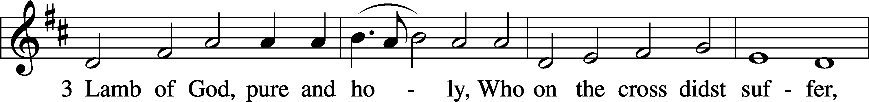
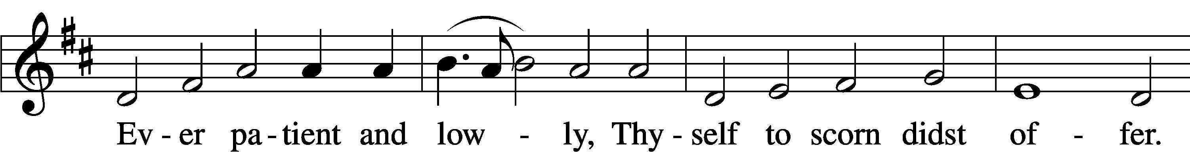
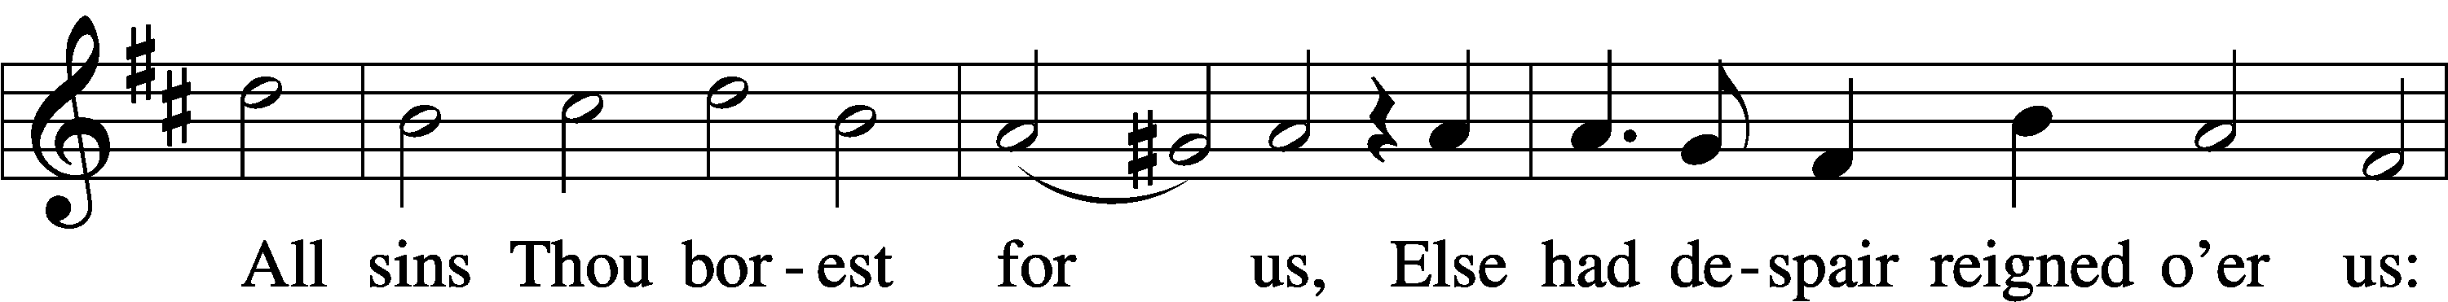
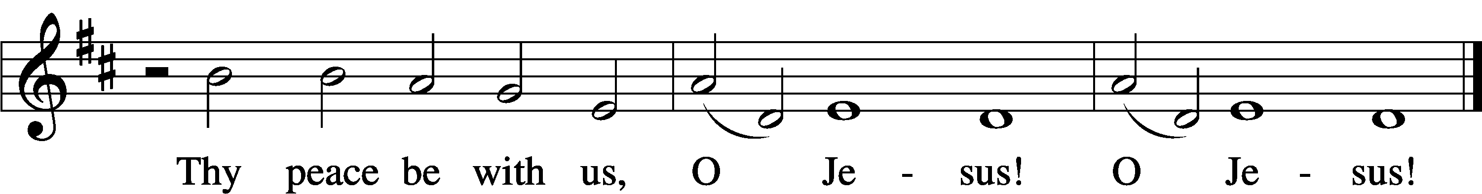
Text: tr. The Lutheran Hymnal, 1941
Text and tune: Nicolaus Decius, c. 1485–after 1546
Text and tune: Public domain
Kneel/Stand

C We adore You, O Lord, and we praise and glorify Your holy resurrection. For behold, by the wood of Your cross joy has come into all the world.

God be merciful to us and bless us, and cause His face to shine upon us, and have mercy upon us.
We adore You, O Lord, and we praise and glorify Your holy resurrection.

For behold, by the wood of Your cross joy has come into all the world.

Stand

The Lord’s prayer is spoken softly.

Lord’s Prayer

Our Father who art in heaven, hallowed be Thy name, Thy kingdom come, Thy will be done on earth as it is in heaven; give us this day our daily bread; and forgive us our trespasses as we forgive those who trespass against us; and lead us not into temptation, but deliver us from evil. For Thine is the kingdom and the power and the glory forever and ever. Amen.

Strepitus
The pastor and congregation leave in silence

Announcements

Upcoming events at St. John’s Clifton

Day | Date |  | Event |  | Time
Sun | 4/5 |  | Easter Divine Service |  | 9:00 AM
 | After |  | Breakfast |  | 10:00 AM
Sun |  | 4/12 |  | Divine Service w/Comm | 9:00 AM
 |  |  |  | Pastor Vogel
 |  | After |  | Coffee Hour & Bible Study
Sat |  | 4/18 |  | LWML Spring Rally | 1:00 PM
 |  |  |  | Hosted by the Ladies Guild
 |  |  |  | Refreshments | 1:00 PM
 |  |  |  | Rally begins | 1:30 PM

Easter breakfast sign-up sheets will be on the Narthex table for those who wish to bring something to the breakfast. Any questions, please see Ellen.

All ladies of St. John’s are encouraged to attend the LWML Spring Rally .

Pierogi sale: $7.50 per dozen

Choice of flavors: potato, potato & cheese, potato & sauerkraut, just sauerkraut. All one kind or mixed. They will be pre-boiled. Just boil and fry. Pick up is Sunday, April 12th.

Help is needed April 9th, 10th and 11th to cook and assemble. Thank you. See Kristine.

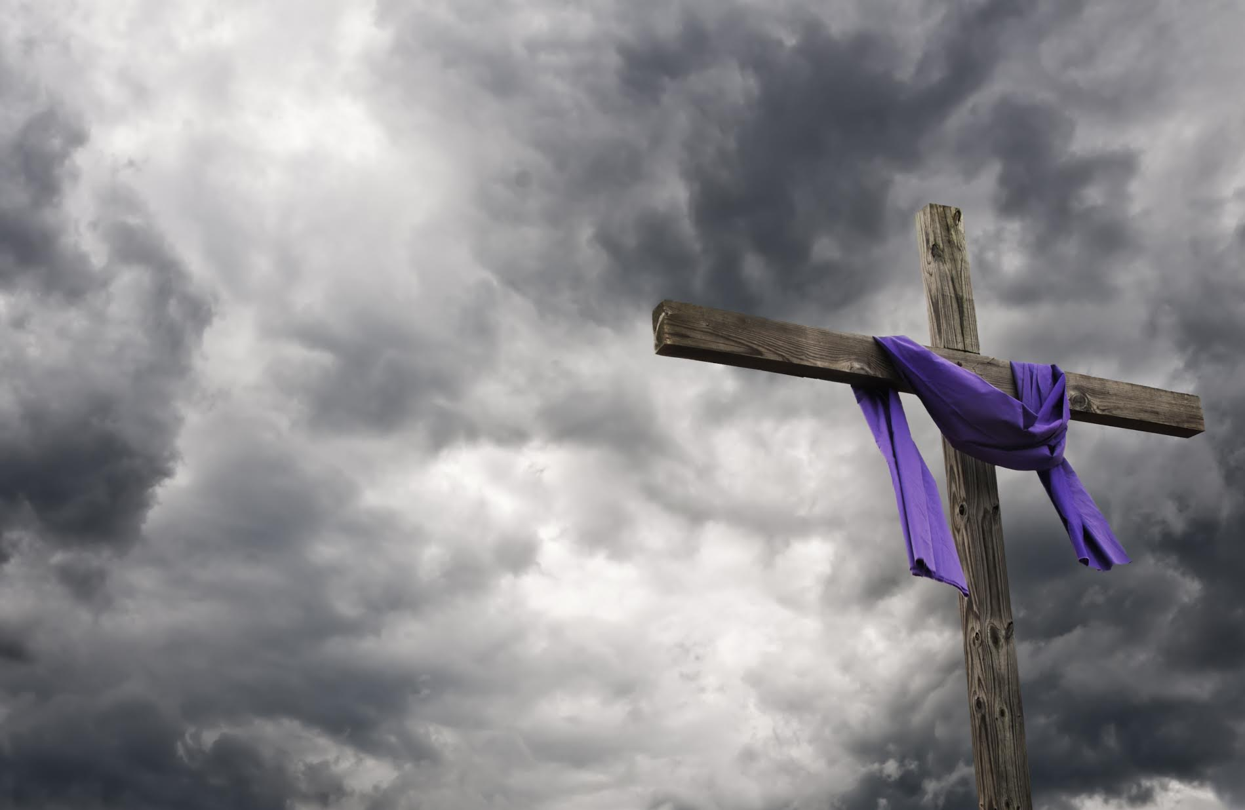
Good Friday (April 3rd) commemorates the day when our Lord gave his life to save us from our sins. It is a very humbling service, as we contemplate the cost that Jesus paid for our redemption. This is the one day out of the church year when it is not appropriate to celebrate Holy Communion. On this day the body of our Lord is broken on the cross—not at the altar; and on this day no celebrations are appropriate. In this Service we will ponder how Jesus mercifully removed the sentence of death against us by going to the cross to declare us not guilty


Easter Sunday (April 5th) is the day of the resurrection. In this Service we will celebrate that Jesus rose from the dead, so that we might have a new beginning that mirrors the mercy of our Lord and Savior.

Acknowledgments
Good Friday, Chief Service from Lutheran Service Book
Unless otherwise indicated, Scripture quotations are from the ESV® Bible (The Holy Bible, English Standard Version®), copyright © 2001 by Crossway, a publishing ministry of Good News Publishers. Used by permission. All rights reserved.
Created by Lutheran Service Builder © 2026 Concordia Publishing House.

