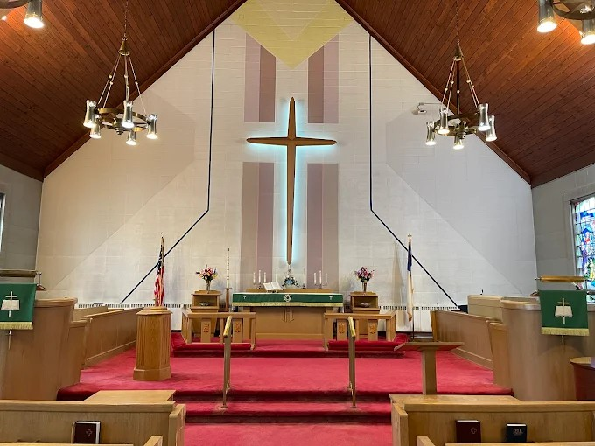

Saint John’s Lutheran Church
810 Broad Street
Clifton, New Jersey
Office: 973-778-141
www.StJohnsClifton.org

Passion (Palm) Sunday
Sunday, March 29, 2026
9:00 AM

The church of the praying hands

Hymn of Invocation

442 All Glory, Laud, and Honor sts. ref–4

Stand

Confession and Absolution

The sign of the cross may be made by all in remembrance of their Baptism.

Invocation

P In the name of the Father and of the T Son and of the Holy Spirit.
C Amen.

Exhortation LSB 151

P If we say we have no sin, we deceive ourselves, and the truth is not in us.
C But if we confess our sins, God, who is faithful and just, will forgive our sins and cleanse us from all unrighteousness.

Silence for reflection on God’s Word and for self-examination.

Confession of Sins LSB 151

P Let us then confess our sins to God our Father.
C Most merciful God, we confess that we are by nature sinful and unclean. We have sinned against You in thought, word, and deed, by what we have done and by what we have left undone. We have not loved You with our whole heart; we have not loved our neighbors as ourselves. We justly deserve Your present and eternal punishment. For the sake of Your Son, Jesus Christ, have mercy on us. Forgive us, renew us, and lead us, so that we may delight in Your will and walk in Your ways to the glory of Your holy name. Amen.

Declaration

P In the mercy of almighty God, Jesus Christ was given to die for us, and for his sake God forgives us all our sins. To those who believe in Jesus Christ He gives the power to become the children of God and bestows on them the Holy Spirit. May the Lord, who has begun this good work in us, bring it to completion in the day of our Lord Jesus Christ.
C Amen.

Service of the Word

Introit Psalm 24:7–10; antiphon: Psalm 118:26

Blessèd is he who comes in the name of the Lord!
We bless you from the house of the Lord.
Lift up your heads, O gates! And be lifted up, O ancient doors,
that the King of glory may come in.
Who is this King of glory?
The Lord, strong and mighty, the Lord, mighty in battle!
Lift up your heads, O gates! And lift them up, O ancient doors,
that the King of glory may come in.
Who is this King of glory?
The Lord of hosts, he is the King of glory!
Blessèd is he who comes in the name of the Lord!
We bless you from the house of the Lord.

Kyrie LSB 152

Sit

Old Testament Reading Isaiah 50:4–9a

The Lord God has given me the tongue of those who are taught, that I may know how to sustain with a word him who is weary. Morning by morning he awakens; he awakens my ear to hear as those who are taught.
The Lord God has opened my ear, and I was not rebellious; I turned not backward. I gave my back to those who strike, and my cheeks to those who pull out the beard; I hid not my face from disgrace and spitting.

But the Lord God helps me; therefore, I have not been disgraced; therefore, I have set my face like a flint, and I know that I shall not be put to shame. He who vindicates me is near.
Who will contend with me? Let us stand up together.
Who is my adversary? Let him come near to me.
Behold, the Lord God helps me; who will declare me guilty?

A This is the Word of the Lord.
C Thanks be to God.

Epistle Philippians 2:5–11

Have this mind among yourselves, which is yours in Christ Jesus, who, though he was in the form of God, did not count equality with God a thing to be grasped, but made himself nothing, taking the form of a servant, being born in the likeness of men. And being found in human form, he humbled himself by becoming obedient to the point of death, even death on a cross. Therefore, God has highly exalted him and bestowed on him the name that is above every name, so that at the name of Jesus every knee should bow, in heaven and on earth and under the earth, and every tongue confess that Jesus Christ is Lord, to the glory of God the Father.

A This is the Word of the Lord.
C Thanks be to God.

Stand
Holy Gospel Matthew 27:11–66

P The Holy Gospel according to St. Matthew, the twenty-seventh chapter.

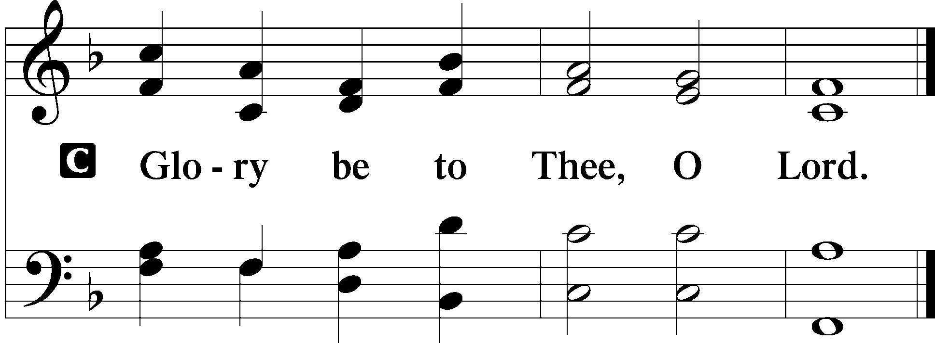

Now Jesus stood before the governor, and the governor asked him, “Are you the King of the Jews?” Jesus said, “You have said so.” But when he was accused by the chief priests and elders, he gave no answer. Then Pilate said to him, “Do you not hear how many things they testify against you?” But he gave him no answer, not even to a single charge, so that the governor was greatly amazed.
Now at the feast the governor was accustomed to release for the crowd any one prisoner whom they wanted. And they had then a notorious prisoner called Barabbas. So when they had gathered, Pilate said to them, “Whom do you want me to release for you: Barabbas, or Jesus who is called Christ?” For he knew that it was out of envy that they had delivered him up. Besides, while he was sitting on the judgment seat, his wife sent word to him, “Have nothing to do with that righteous man, for I have suffered much because of him today in a dream.” Now the chief priests and the elders persuaded the crowd to ask for Barabbas and destroy Jesus. The governor again said to them, “Which of the two do you want me to release for you?” And they said, “Barabbas.” Pilate said to them, “Then what shall I do with Jesus who is called Christ?” They all said, “Let him be crucified!” And he said, “Why, what evil has he done?” But they shouted all the more, “Let him be crucified!”
So, when Pilate saw that he was gaining nothing, but rather that a riot was beginning, he took water and washed his hands before the crowd, saying, “I am innocent of this man’s blood; see to it yourselves.” And all the people answered, “His blood be on us and on our children!” Then he released for them Barabbas, and having scourged Jesus, delivered him to be crucified.
Then the soldiers of the governor took Jesus into the governor’s headquarters, and they gathered the whole battalion before him. And they stripped him and put a scarlet robe on him, and twisting together a crown of thorns, they put it on his head and put a reed in his right hand. And kneeling before him, they mocked him, saying, “Hail, King of the Jews!” And they spit on him and took the reed and struck him on the head. And when they had mocked him, they stripped him of the robe and put his own clothes on him and led him away to crucify him.
As they went out, they found a man of Cyrene, Simon by name. They compelled this man to carry his cross. And when they came to a place called Golgotha (which means Place of a Skull), they offered him wine to drink, mixed with gall, but when he tasted it, he would not drink it. And when they crucified him, they divided his garments among them by casting lots. Then they sat down and watched over him there. And over his head they put the charge against him, which read, “This is Jesus, the King of the Jews.” Then two robbers were crucified with him, one on the right and one on the left. And those who passed by derided him, wagging their heads and saying, “You who would destroy the temple and rebuild it in three days, save yourself! If you are the Son of God, come down from the cross.” So also, the chief priests, with the scribes and elders, mocked him, saying, “He saved others; he cannot save himself. He is the King of Israel; let him come down now from the cross, and we will believe in him. He trusts in God; let God deliver him now, if he desires him. For he said, ‘I am the Son of God.’” And the robbers who were crucified with him also reviled him in the same way.
Now from the sixth hour there was darkness over all the land until the ninth hour. And about the ninth hour Jesus cried out with a loud voice, saying, “Eli, Eli, lema sabachthani?” that is, “My God, my God, why have you forsaken me?” And some of the bystanders, hearing it, said, “This man is calling Elijah.” And one of them at once ran and took a sponge, filled it with sour wine, and put it on a reed and gave it to him to drink. But the others said, “Wait, let us see whether Elijah will come to save him.” And Jesus cried out again with a loud voice and yielded up his spirit.
And behold, the curtain of the temple was torn in two, from top to bottom. And the earth shook, and the rocks were split. The tombs also were opened. And many bodies of the saints who had fallen asleep were raised, and coming out of the tombs after his resurrection they went into the holy city and appeared to many. When the centurion and those who were with him, keeping watch over Jesus, saw the earthquake and what took place, they were filled with awe and said, “Truly this was the Son of God!”
There were also many women there, looking on from a distance, who had followed Jesus from Galilee, ministering to him, among whom were Mary Magdalene and Mary the mother of James and Joseph and the mother of the sons of Zebedee.
When it was evening, there came a rich man from Arimathea, named Joseph, who also was a disciple of Jesus. He went to Pilate and asked for the body of Jesus. Then Pilate ordered it to be given to him. And Joseph took the body and wrapped it in a clean linen shroud and laid it in his own new tomb, which he had cut in the rock. And he rolled a great stone to the entrance of the tomb and went away. Mary Magdalene and the other Mary were there, sitting opposite the tomb.
Next day, that is, after the day of Preparation, the chief priests and the Pharisees gathered before Pilate and said, “Sir, we remember how that impostor said, while he was still alive, ‘After three days I will rise.’ Therefore, order the tomb to be made secure until the third day, lest his disciples go and steal him away and tell the people, ‘He has risen from the dead,’ and the last fraud will be worse than the first.” Pilate said to them, “You have a guard of soldiers. Go, make it as secure as you can.” So, they went and made the tomb secure by sealing the stone and setting a guard.

P This is the Gospel of the Lord.
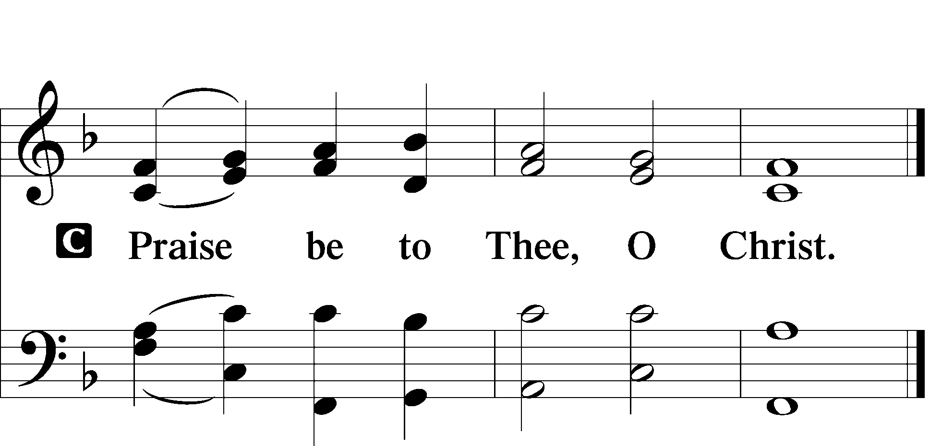

Apostles’ Creed

I believe in God, the Father Almighty, maker of
heaven and earth.
And in Jesus Christ, His only Son, our Lord, who was conceived by the Holy Spirit, born of the virgin Mary, suffered under Pontius Pilate, was crucified, died and was buried.

He descended into hell. The third day He rose again from the dead. He ascended into heaven and sits at the right hand of God the Father Almighty. From thence He will come to judge the living and the dead.

I believe in the Holy Spirit, the holy Christian Church, the communion of saints, the forgiveness of sins, the resurrection of the body, and the life T everlasting. Amen.

Sit

Hymn of the Day

434 Lamb of God, Pure and Holy sts. 1–3

Sermon

Offering

Psalm for Meditation Psalm 118:19–29; antiphon: v. 26

Open to me the gates of righteousness, that I may enter through them and give thanks to the Lord. This is the gate of the Lord; the righteous shall enter through it.
I thank you that you have answered me and have become my salvation.
The stone that the builders rejected has become the cornerstone. This is the Lord’s doing; it is marvelous in our eyes.
This is the day that the Lord has made; let us rejoice and be glad in it. Save us, we pray, O Lord! O Lord, we pray, give us success! Blessèd is he who comes in the name of the Lord! We bless you from the house of the Lord.
The Lord is God, and he has made his light to shine upon us. Bind the festal sacrifice with cords, up to the horns of the altar! You are my God, and I will give thanks to you; you are my God; I will extol you.
Oh give thanks to the Lord, for he is good; for his steadfast love endures forever!

Stand

781 We Give Thee But Thine Own sts. 1–2

Prayer of the Church

P Let us pray for the whole people of God in Christ Jesus and for all people according to their needs.
P For the faithful proclamation of Christ’s saving name, that God’s people may be strengthened in the true faith and His kingdom extended, let us pray to the Lord:
C Lord, have mercy.
P For the holy Christian Church throughout the world and for all who confess the name of Christ, that God would guard and defend us from the temptations of the devil, the world, and our sinful nature, let us pray to the Lord:
C Lord, have mercy.
P For those who have wandered from the faith, that the Holy Spirit would use us to call them home to the Father, let us pray to the Lord:
C Lord, have mercy.
P For the government and all who have been set into positions of leadership, that they may use the authority entrusted to them honorably and for the good of the people, let us pray to the Lord:
C Lord, have mercy.
P For those who suffer from hunger, homelessness, poverty, or unemployment, that God’s great mercy and love would preserve and relieve them, let us pray to the Lord:
C Lord, have mercy.
P For those who are sick especially Kristine, Joshua, Hunter, Lorraine, Dorothy, Marge, Tony, Bill M., Patricia, Phil, Lidia, Michele, Giuseppe, Alfred, and Nancy that God would grant healing to their bodies and strength to bear their infirmities with patience and grace, let us pray to the Lord:
C Lord, have mercy.
P For those who rejoice in the rich blessings of God, that they may always remember the Giver of every gift and give Him heartfelt thanks, let us pray to the Lord:
C Lord, have mercy.
P O Lord, heavenly Father, we gratefully remember the sufferings and death of Your dear Son, Jesus Christ, for our salvation. Rejoicing in His victorious resurrection from the dead, we draw strength from His ascension before You, where He ever stands for us as our own High Priest. Gather us together from the ends of the earth to celebrate with all the faithful the marriage feast of the Lamb in His kingdom, which has no end. Graciously receive our prayers, deliver and preserve us, for to You alone we give all glory, honor, and worship, Father, Son, and Holy Spirit, one God, now and forever.
C Amen.

Lord’s Prayer

Our Father who art in heaven, hallowed be Thy name, Thy kingdom come, Thy will be done on earth as it is in heaven.

Give us this day our daily bread; and forgive us our trespasses as we forgive those who trespass against us; and lead us not into temptation but deliver us from evil.
For Thine is the kingdom and the power and the glory forever and ever. Amen.

Benediction LSB 166
P The Lord bless you and keep you.
The Lord make His face shine on you and be gracious to you.
The Lord look upon you with favor and T give you peace.


Hymn to Depart

441 Ride On, Ride On in Majesty sts. 1–4

Announcements

Upcoming events at St. John’s Clifton

Day | Date | Event | Time
Today | 3/29 | Divine Service NC | 9:00 AM
 | After | Coffee Hour
Fri | 4/3 | Good Friday Service | 2:00 PM
 |  | Pastor Dennis Rockett
Sun | 4/5 | Easter Divine Service | 9:00 AM
 | After | Breakfast | 10:00 AM
Sun | 4/12 | Divine Service w/Comm | 9:00 AM
 |  | Pastor Vogel
 | After | Coffee Hour & Bible Study
Sat | 4/18 | LWML Spring Rally | 1:00 PM
 |  | Hosted by the Ladies Guild
 |  | Refreshments | 1:00 PM
 |  | Rally begins | 1:30 PM

Easter breakfast sign-up sheets will be on the Narthex table for those who wish to bring something to the breakfast. Any questions, please see Ellen.

Easter lilies can now be ordered at $15.00 per plant. Please make your check payable to the “Ladies Guild”. Last day to order is TODAY. See Carol Bender or Ellen to place your order.

All ladies of St. John’s are encouraged to attend the LWML Spring Rally .

Pierogi sale: $7.50 per dozen

Choice of flavors: potato, potato & cheese, potato & sauerkraut, just sauerkraut. All one kind or mixed. They will be pre-boiled. Just boil and fry. Pick up is Sunday, April 12th.

Help is needed April 9th, 10th and 11th to cook and assemble. Thank you. See Kristine.

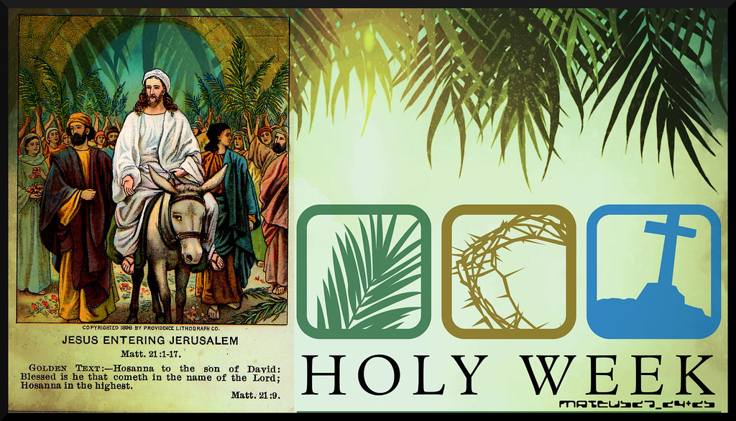

Dear Family,

Holy Week recalls the events of the week that led up to the death and resurrection of Jesus Christ. It has been considered the most important and holy time in the life of the church—especially what is known as the “Triduum” — or Great Three Days — of Maundy Thursday, Good Friday, and Easter morning.



Palm Sunday (March 29th) marks the beginning of Holy Week. We rejoice with the crowds as Jesus enters the city of Jerusalem, waving palms and singing “Hosanna!” We witness Jesus beginning His mission of mercy for all people for the salvation of our souls.

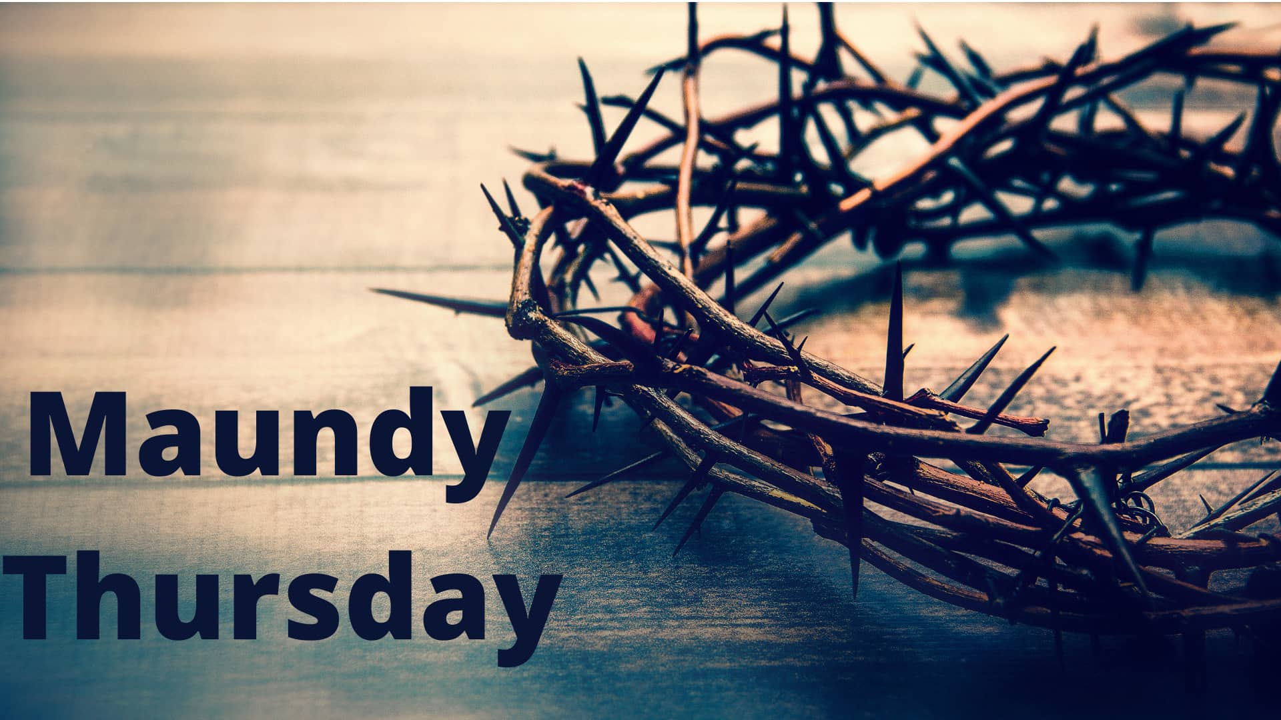

Maundy Thursday (April 2nd) takes its name from the Latin word for “commandment,” as we remember when Jesus told his disciples, “A new commandment I give to you: Love one another.”

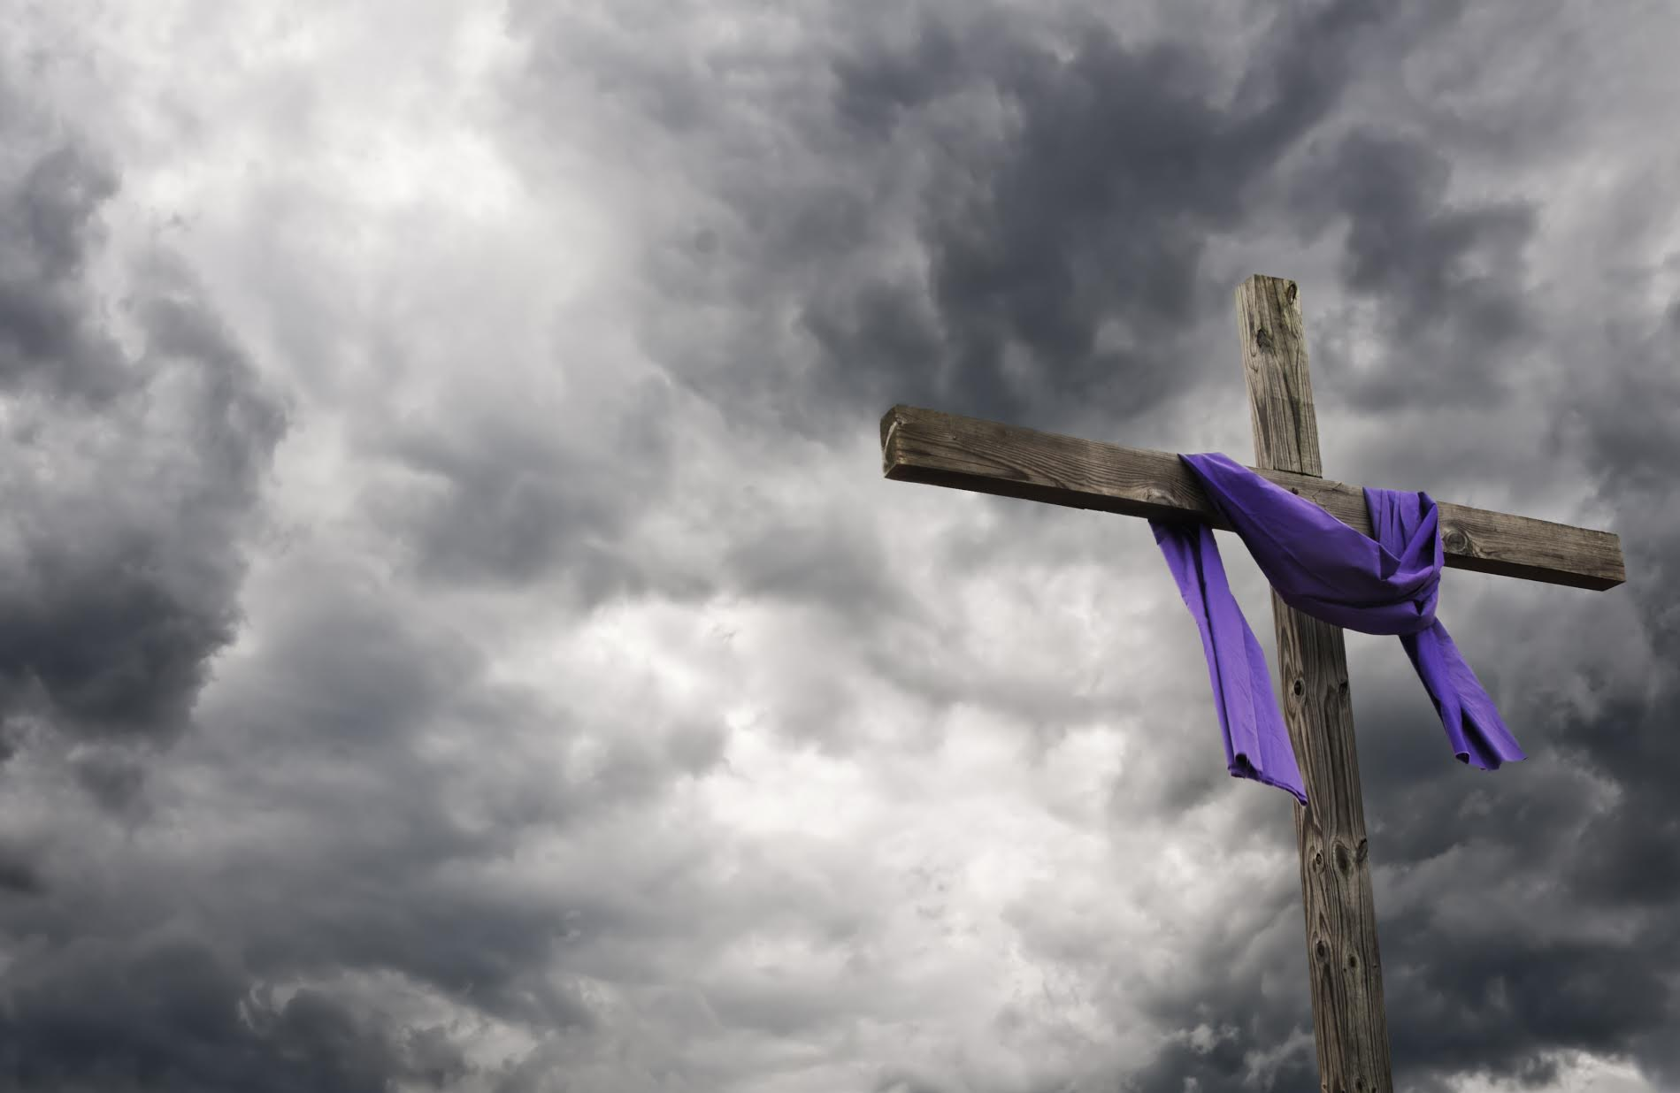

Good Friday (April 3rd) commemorates the day when our Lord gave his life to save us from our sins. It is a very humbling service, as we contemplate the cost that Jesus paid for our redemption. This is the one day out of the church year when it is not appropriate to celebrate Holy Communion. On this day the body of our Lord is broken on the cross—not at the altar; and on this day no celebrations are appropriate. In this Service we will ponder how Jesus mercifully removed the sentence of death against us by going to the cross to declare us not guilty


Easter Sunday (April 5th) is the day of the resurrection. In this Service we will celebrate that Jesus rose from the dead, so that we might have a new beginning that mirrors the mercy of our Lord and Savior.

Acknowledgments
Divine Service, Setting One from Lutheran Service Book
Unless otherwise indicated, Scripture quotations are from the ESV® Bible (The Holy Bible, English Standard Version®), copyright © 2001 by Crossway, a publishing ministry of Good News Publishers. Used by permission. All rights reserved.
Created by Lutheran Service Builder © 2026 Concordia Publishing House

