Nineteenth Sunday after Pentecost October 19, 2025 – Lectionary Series
St. John’s Lutheran Church

Order of Worship
by
Lutheran Service Builder
LWML Lutheran Women, One and All
Tune: Come, Ye Thankful People, Come

- Lutheran women, one and all,
We have heard the Gospel call.
We by faith have seen our Lord
Crucified and then restored.
We have seen Him pay the price,
For our sins a sacrifice.
Him we Lord and Christ acclaim
And unite to praise His name.
- Lutheran women, young and old,
Well we know His challenge bold:
Help to take the Gospel light
To a world in darkest night,
By example in the home,
By inviting those who roam,
By our prayers for sinners lost,
By our gifts for missions’ cost.
- Lutheran women, coast to coast,
In the Lord a mighty host,
Let us all united be
In the Holy Trinity,
One in faith, in hope, and love,
Working for the Lord above,
Till, our earthly labors done,
We in heaven shall all be one.

Stand for last verse

Confession and Absolution

The sign of the cross may be made by all in remembrance of their Baptism.

Invocation
P In the name of the Father and of the T Son and of the Holy Spirit.
C Amen.

Exhortation LSB 151
P If we say we have no sin, we deceive ourselves, and the truth is not in us.
C But if we confess our sins, God, who is faithful and just, will forgive our sins and cleanse us from all unrighteousness.

Silence for reflection on God’s Word and for self-examination.

Confession of Sins LSB 151
P Let us then confess our sins to God our Father.
C Most merciful God, we confess that we are by nature sinful and unclean. We have sinned against You in thought, word, and deed, by what we have done and by what we have left undone. We have not loved You with our whole heart; we have not loved our neighbors as ourselves. We justly deserve Your present and eternal punishment. For the sake of Your Son, Jesus Christ, have mercy on us. Forgive us, renew us, and lead us, so that we may delight in Your will and walk in Your ways to the glory of Your holy name. Amen.

Absolution LSB 151
P Almighty God in His mercy has given His Son to die for you and for His sake forgives you all your sins. As a called and ordained servant of Christ, and by His authority, I therefore forgive you all your sins in the name of the Father and of the T Son and of the Holy Spirit.
C Amen.

Service of the Word
Introit Psalm 74:18–19, 21, 20a, 22a; antiphon: v. 2a
Remember your congregation, which you have purchased of old,
which you have redeemed to be the tribe of your heritage!
Remember this, O Lord, how the enemy scoffs,
and a foolish people reviles your name.
Do not deliver the soul of your dove to the wild beasts;
do not forget the life of your poor forever.
Let not the downtrodden turn back in shame;
let the poor and needy praise your name.
Have regard for the covenant;
arise, O God, defend your cause.
Glory be to the Father and to the Son
and to the Holy Spirit;
as it was in the beginning,
is now, and will be forever. Amen.
Remember your congregation, which you have purchased of old,
which you have redeemed to be the tribe of your heritage!

Kyrie LSB 152
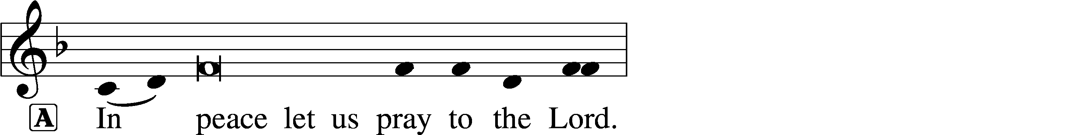
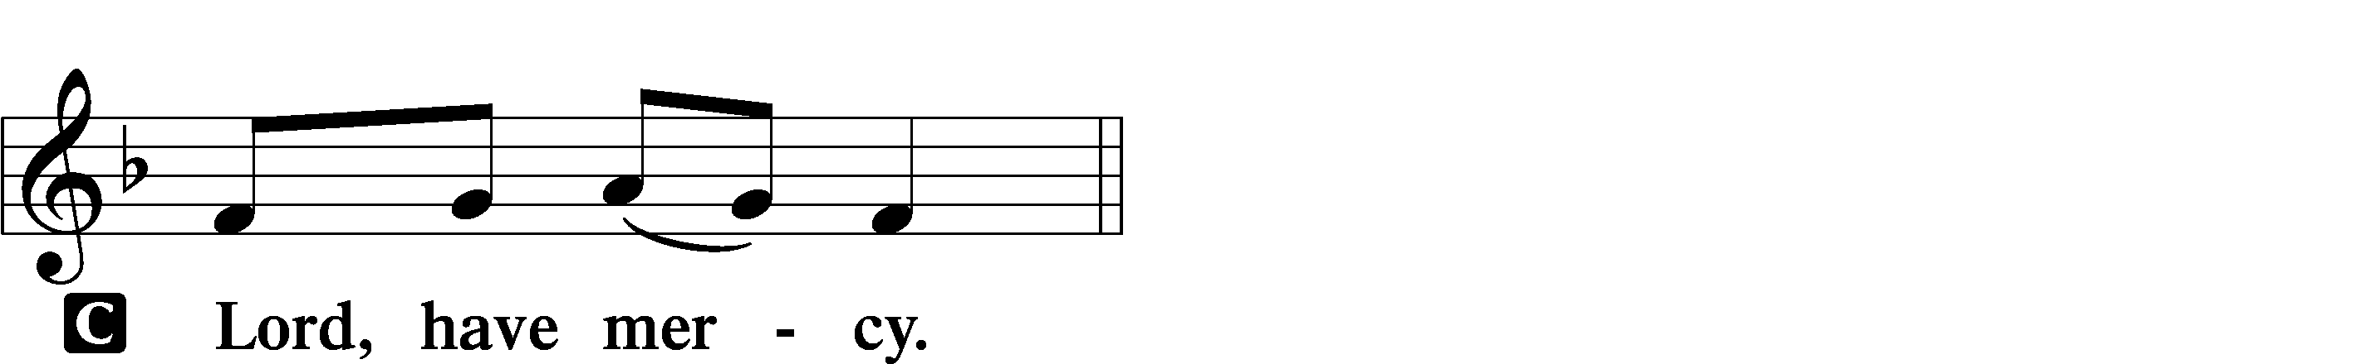

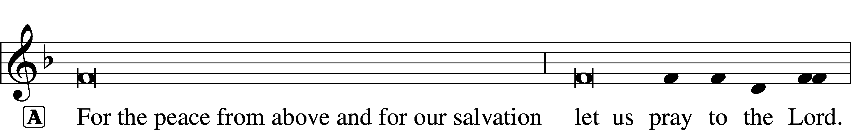
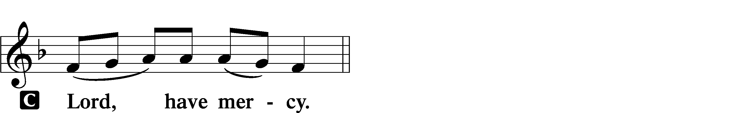

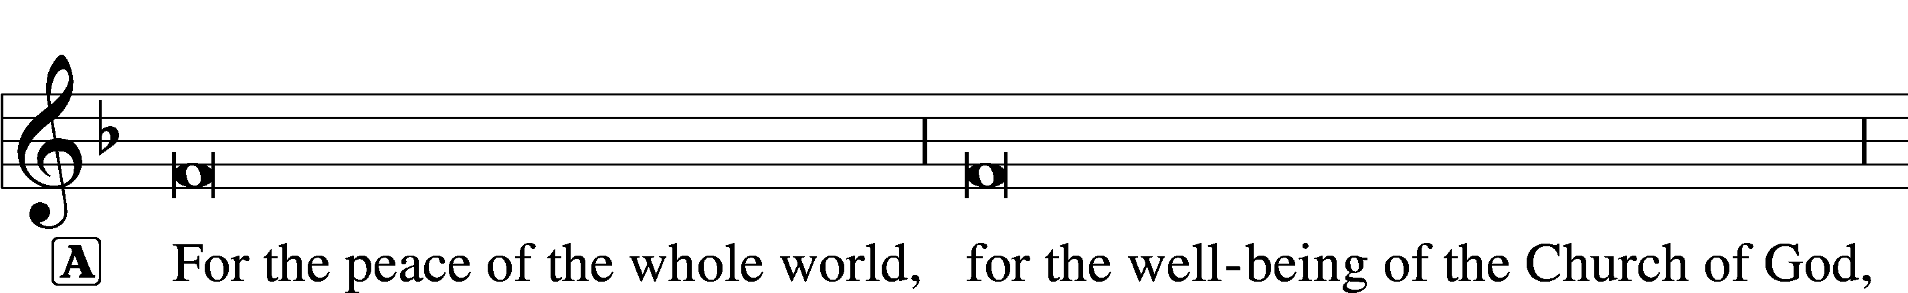
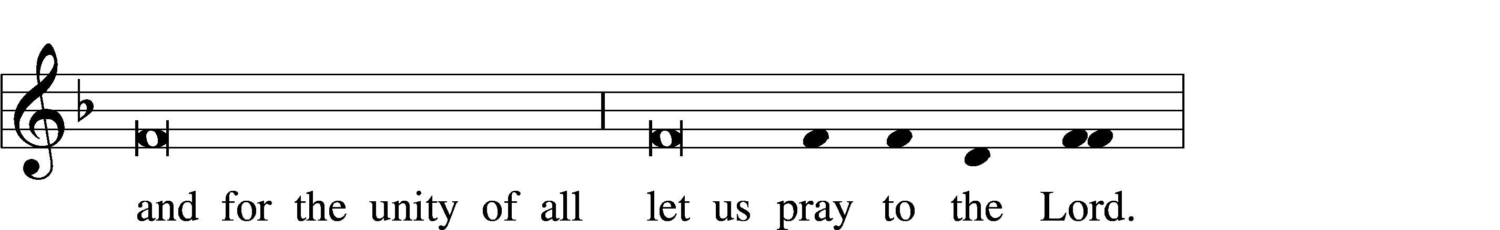
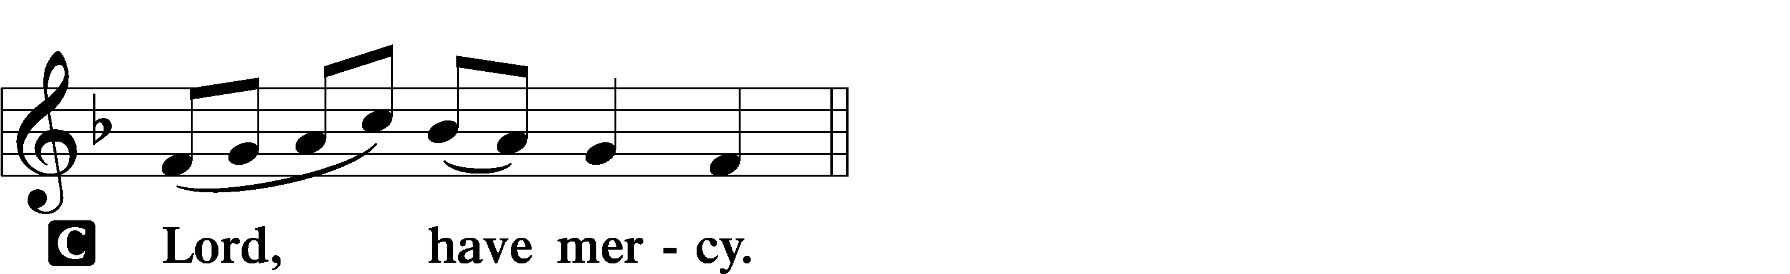

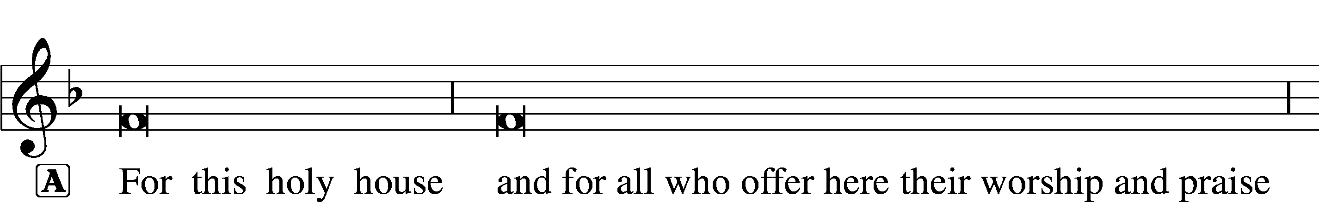
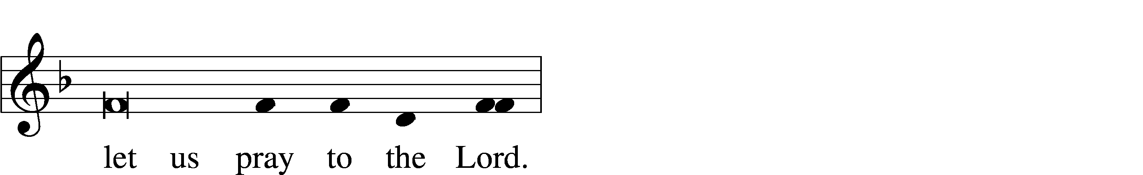
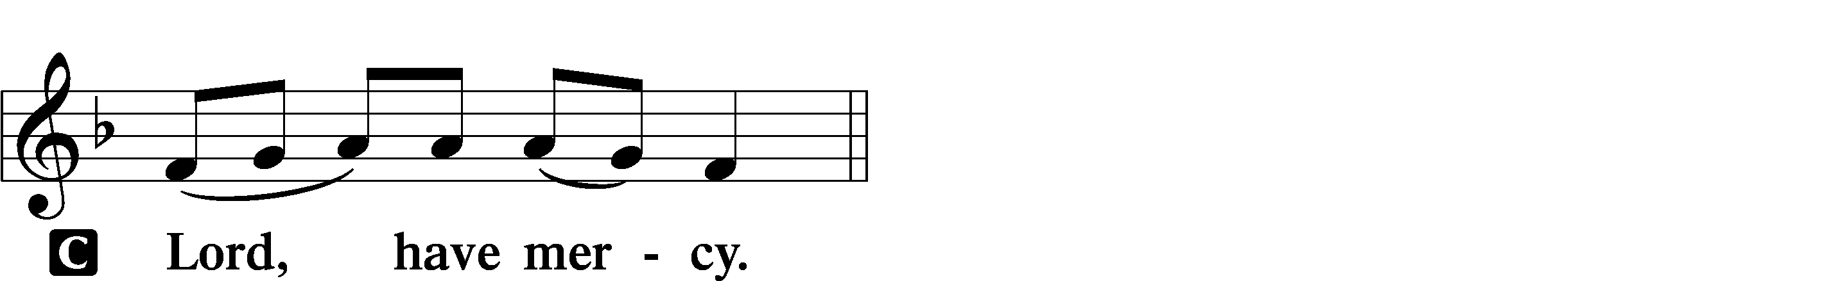

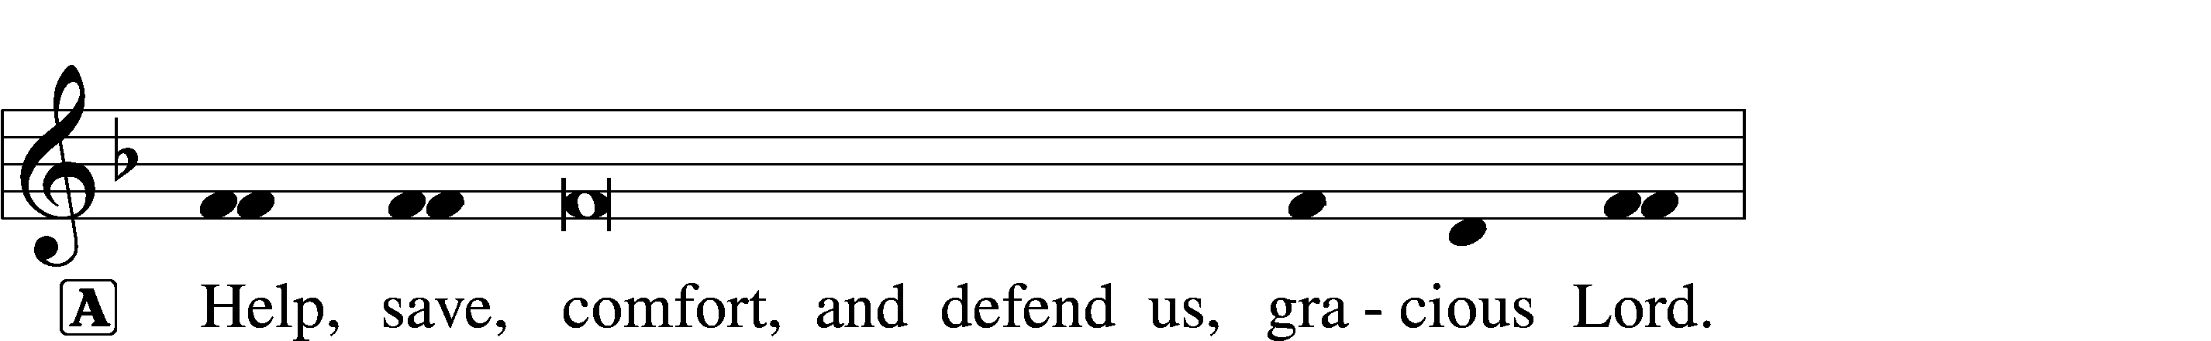
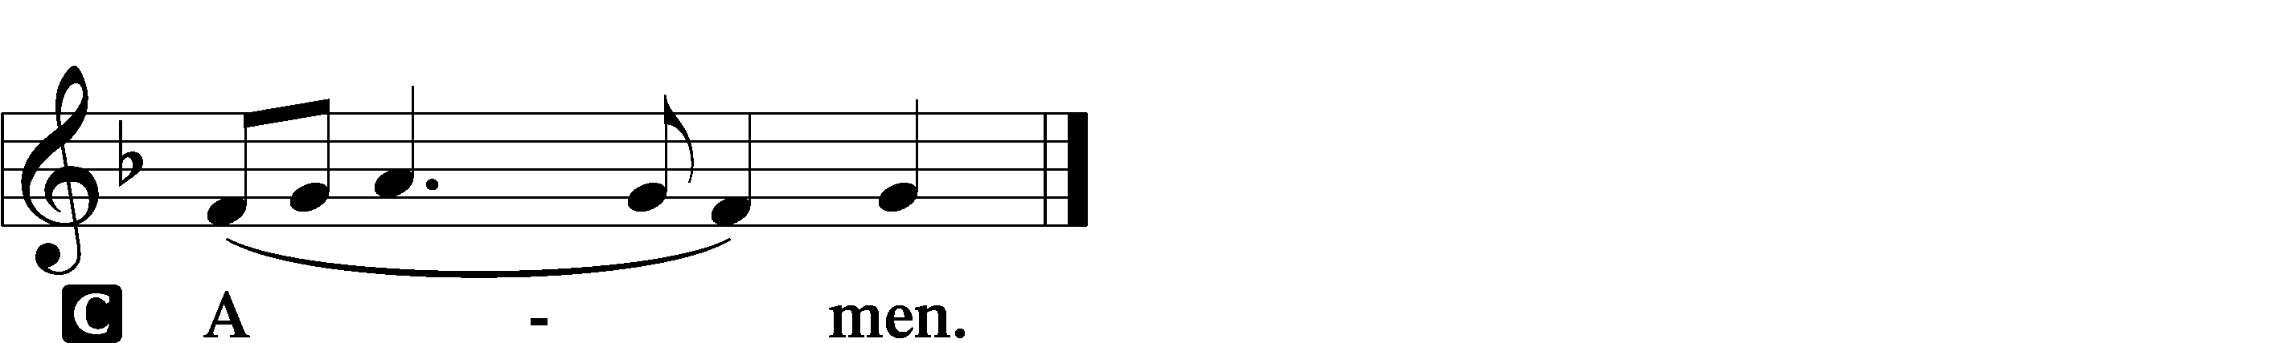

This Is the Feast LSB 155
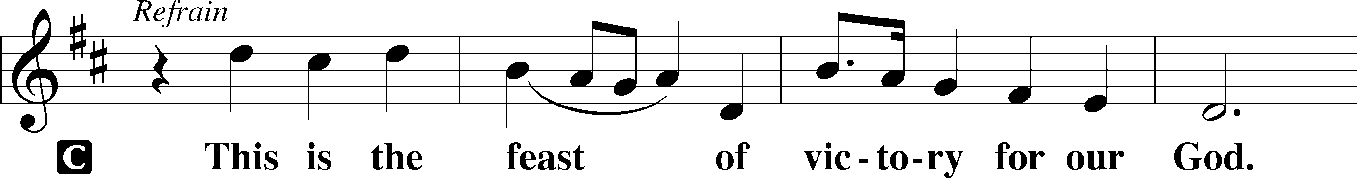
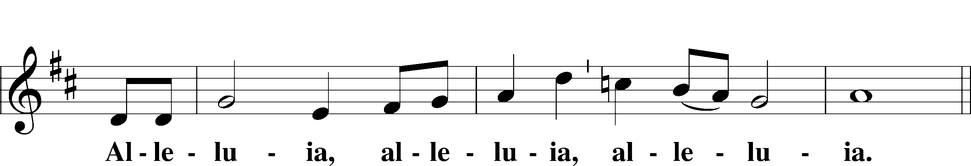
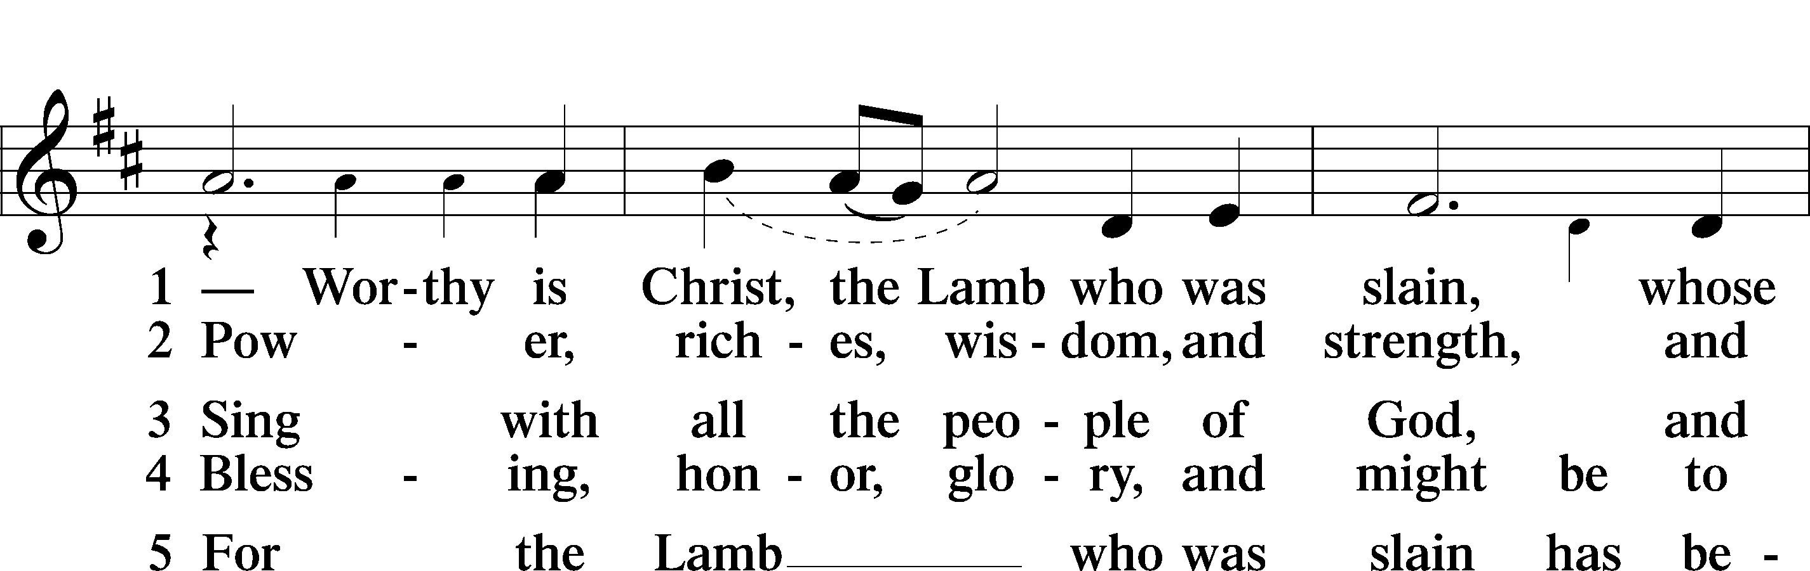
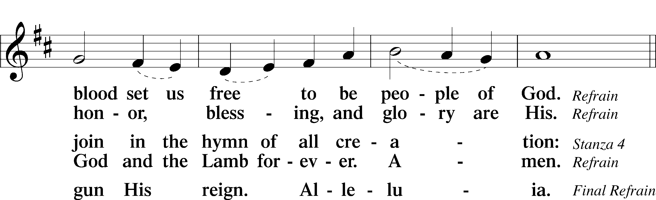
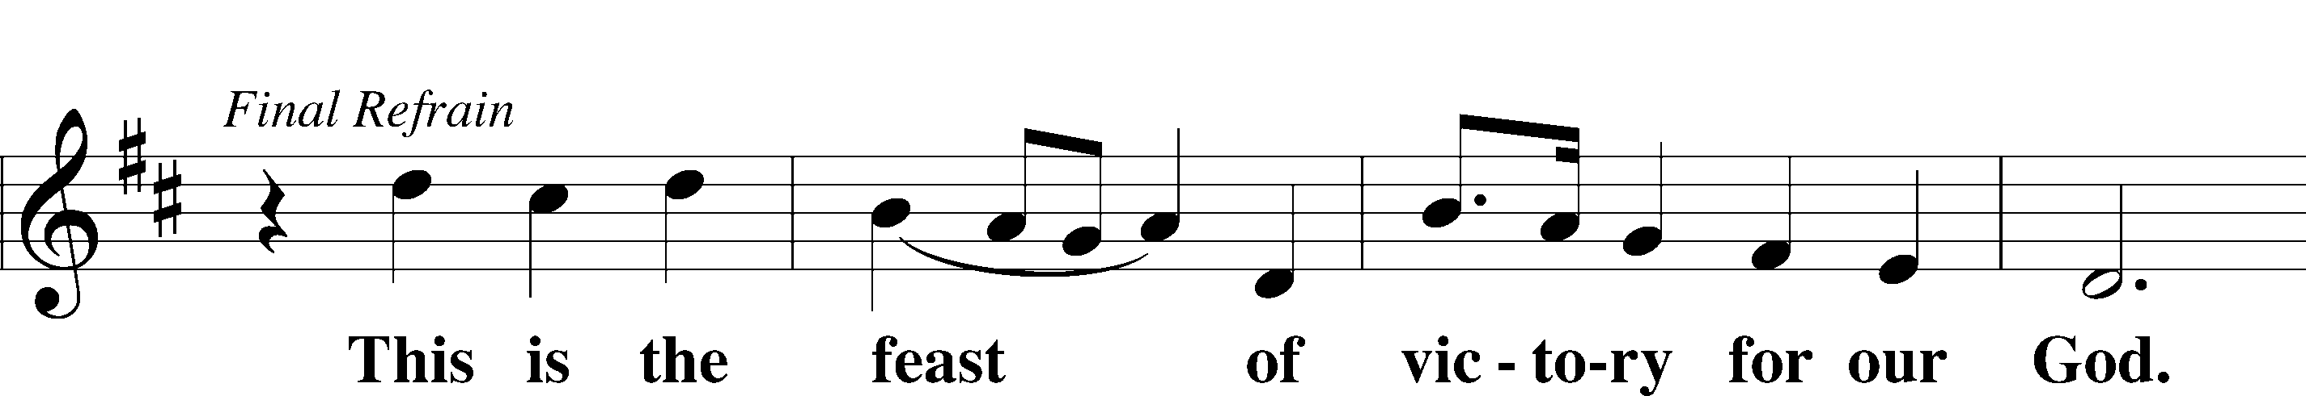
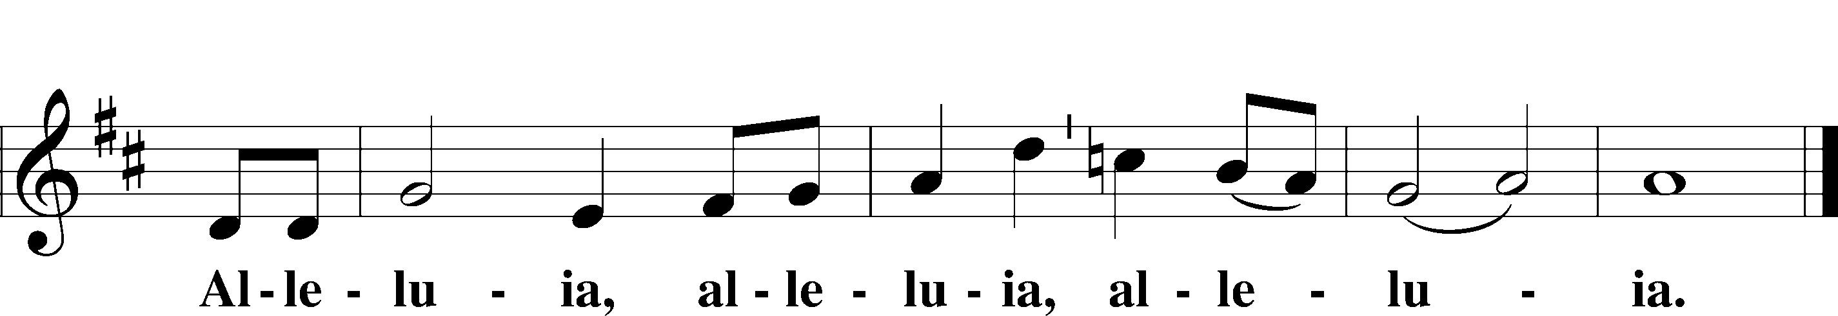

Salutation and Collect of the Day
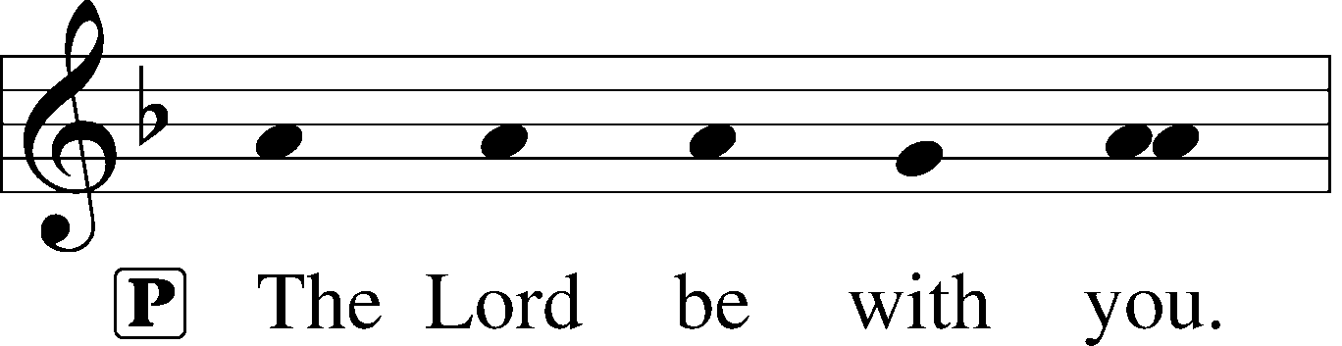
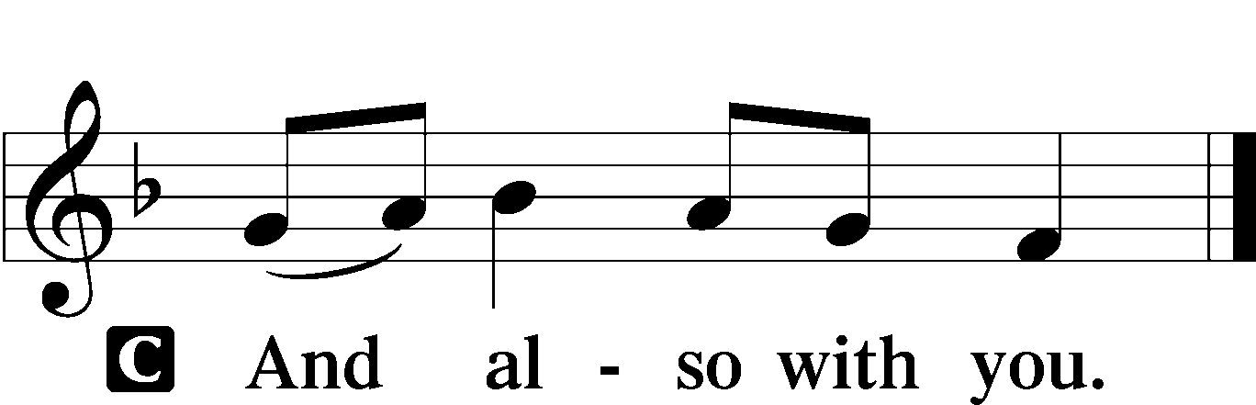

P Let us pray.
O Lord, almighty and everlasting God, You have commanded us to pray and have promised to hear us. Mercifully grant that Your Holy Spirit may direct and govern our hearts in all things that we may persevere with steadfast faith in the confession of Your name; through Jesus Christ, Your Son, our Lord, who lives and reigns with You and the Holy Spirit, one God, now and forever.

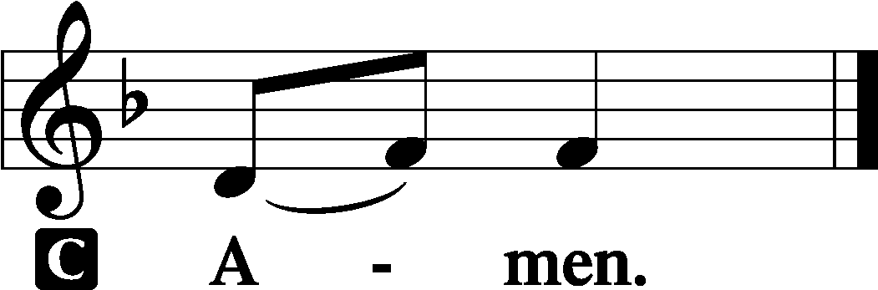

Sit

Old Testament Reading Genesis 32:22–30
The same night [Jacob] arose and took his two wives, his two female servants, and his eleven children, and crossed the ford of the Jabbok. He took them and sent them across the stream, and everything else that he had. And Jacob was left alone. And a man wrestled with him until the breaking of the day. When the man saw that he did not prevail against Jacob, he touched his hip socket, and Jacob’s hip was put out of joint as he wrestled with him. Then he said, “Let me go, for the day has broken.” But Jacob said, “I will not let you go unless you bless me.” And he said to him, “What is your name?” And he said, “Jacob.” Then he said, “Your name shall no longer be called Jacob, but Israel, for you have striven with God and with men, and have prevailed.” Then Jacob asked him, “Please tell me your name.” But he said, “Why is it that you ask my name?” And there he blessed him. So Jacob called the name of the place Peniel, saying, “For I have seen God face to face, and yet my life has been delivered.”

A This is the Word of the Lord.
C Thanks be to God.

Epistle 2 Timothy 3:14—4:5
As for you, continue in what you have learned and have firmly believed, knowing from whom you learned it and how from childhood you have been acquainted with the sacred writings, which are able to make you wise for salvation through faith in Christ Jesus. All Scripture is breathed out by God and profitable for teaching, for reproof, for correction, and for training in righteousness, that the man of God may be competent, equipped for every good work.
I charge you in the presence of God and of Christ Jesus, who is to judge the living and the dead, and by his appearing and his kingdom: preach the word; be ready in season and out of season; reprove, rebuke, and exhort, with complete patience and teaching. For the time is coming when people will not endure sound teaching, but having itching ears they will accumulate for themselves teachers to suit their own passions, and will turn away from listening to the truth and wander off into myths. As for you, always be sober-minded, endure suffering, do the work of an evangelist, fulfill your ministry.

A This is the Word of the Lord.
C Thanks be to God.

Stand

Alleluia and Verse LSB 156
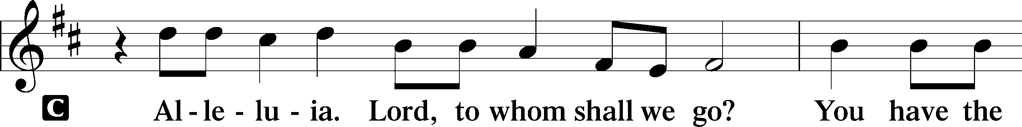
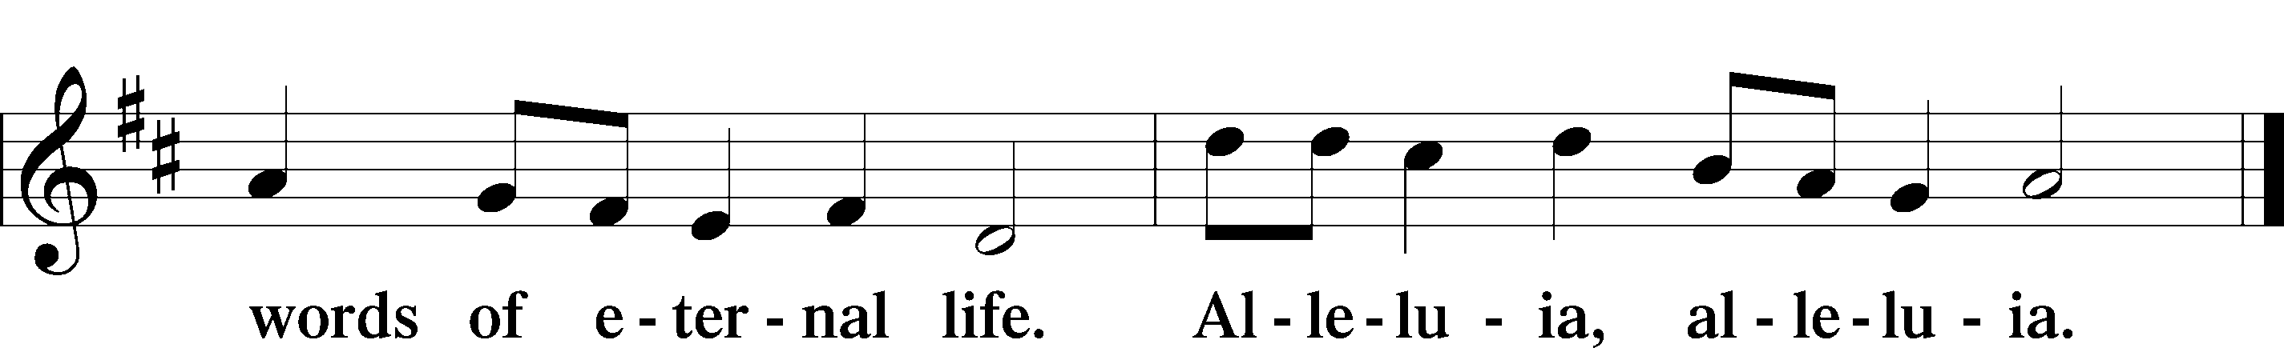

Holy Gospel Luke 18:1–8
P The Holy Gospel according to St. Luke, the eighteenth chapter.

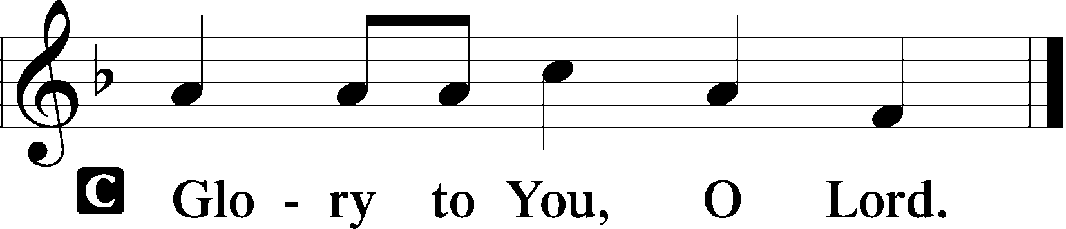

[Jesus] told them a parable to the effect that they ought always to pray and not lose heart. He said, “In a certain city there was a judge who neither feared God nor respected man. And there was a widow in that city who kept coming to him and saying, ‘Give me justice against my adversary.’ For a while he refused, but afterward he said to himself, ‘Though I neither fear God nor respect man, yet because this widow keeps bothering me, I will give her justice, so that she will not beat me down by her continual coming.’” And the Lord said, “Hear what the unrighteous judge says. And will not God give justice to his elect, who cry to him day and night? Will he delay long over them? I tell you, he will give justice to them speedily. Nevertheless, when the Son of Man comes, will he find faith on earth?”

P This is the Gospel of the Lord.

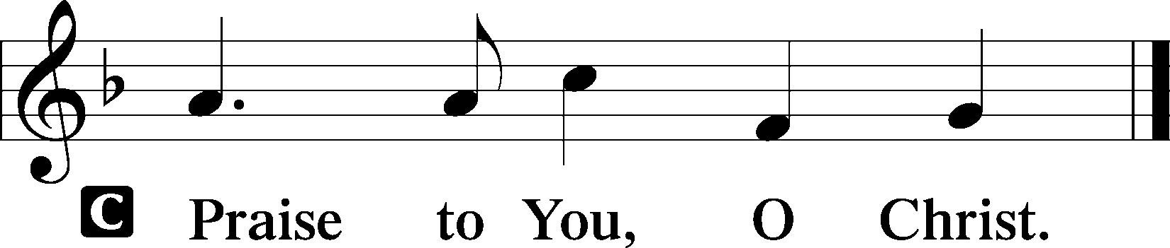

Nicene Creed
C I believe in one God,
the Father Almighty,
maker of heaven and earth
and of all things visible and invisible.

And in one Lord Jesus Christ,
the only-begotten Son of God,
begotten of His Father before all worlds,
God of God, Light of Light,
very God of very God,
begotten, not made,
being of one substance with the Father,
by whom all things were made;
who for us men and for our salvation came down from heaven
and was incarnate by the Holy Spirit of the virgin Mary
and was made man;
and was crucified also for us under Pontius Pilate.
He suffered and was buried.
And the third day He rose again according to the Scriptures
and ascended into heaven
and sits at the right hand of the Father.
And He will come again with glory to judge both the living and the dead,
whose kingdom will have no end.

And I believe in the Holy Spirit,
the Lord and giver of life,
who proceeds from the Father and the Son,
who with the Father and the Son together is worshiped and glorified,
who spoke by the prophets.
And I believe in one holy Christian and apostolic Church,
I acknowledge one Baptism for the remission of sins,
and I look for the resurrection of the dead
and the life T of the world to come. Amen.

Sit
737 Rejoice, My Heart, Be Glad and Sing sts. 1–4
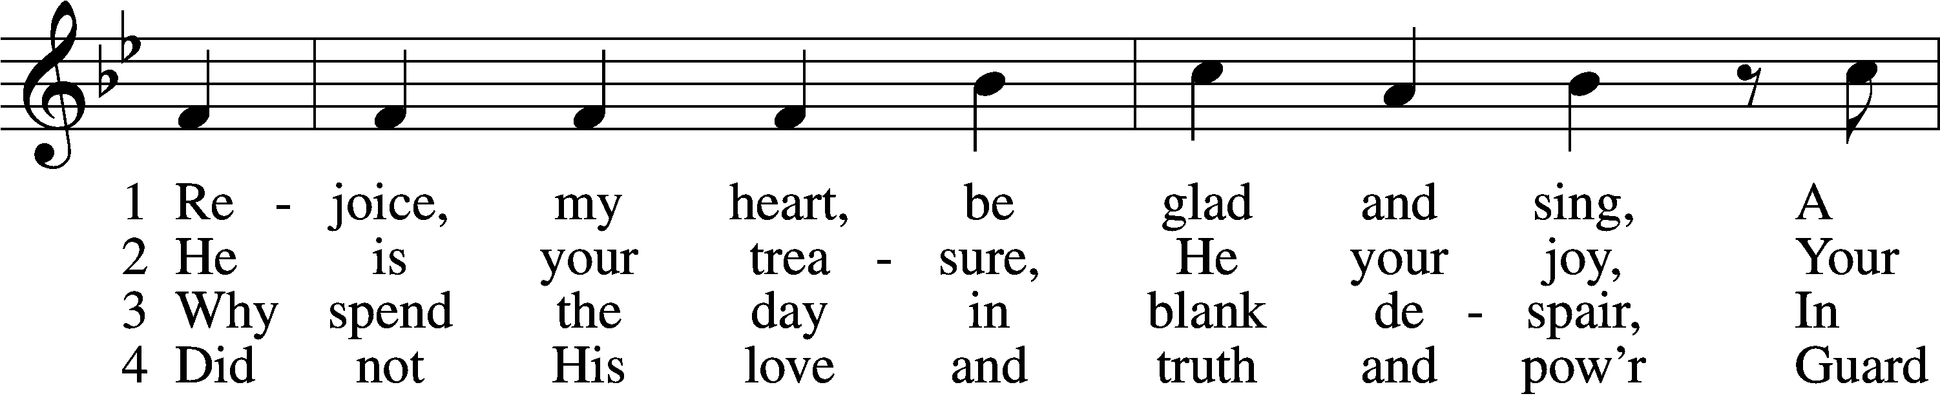
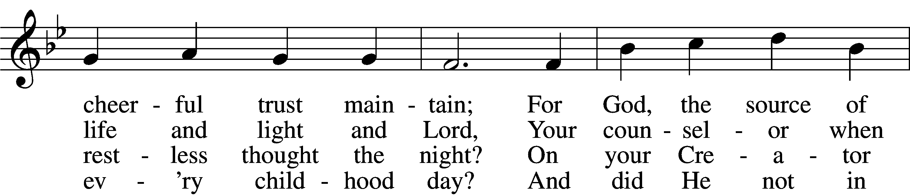
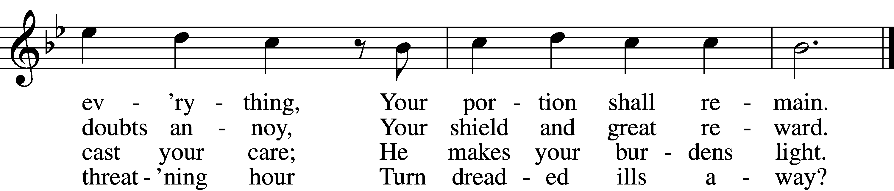

Sermon

Offering

Psalm for Meditation Psalm 121; antiphon: vv. 1–2
I lift up my eyes to the hills.
From where does my help come?
My help comes from the Lord,
who made heaven and earth.
He will not let your foot be moved;
he who keeps you will not slumber.
Behold, he who keeps Israel
will neither slumber nor sleep.
The Lord is your keeper;
the Lord is your shade on your right hand.
The sun shall not strike you by day,
nor the moon by night.
The Lord will keep you from all evil;
he will keep your life.
The Lord will keep
your going out and your coming in
from this time forth and forevermore.

Stand

781 We Give Thee But Thine Own sts. 1–2
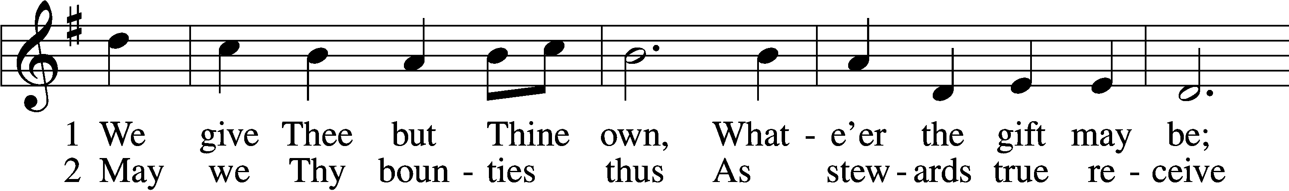
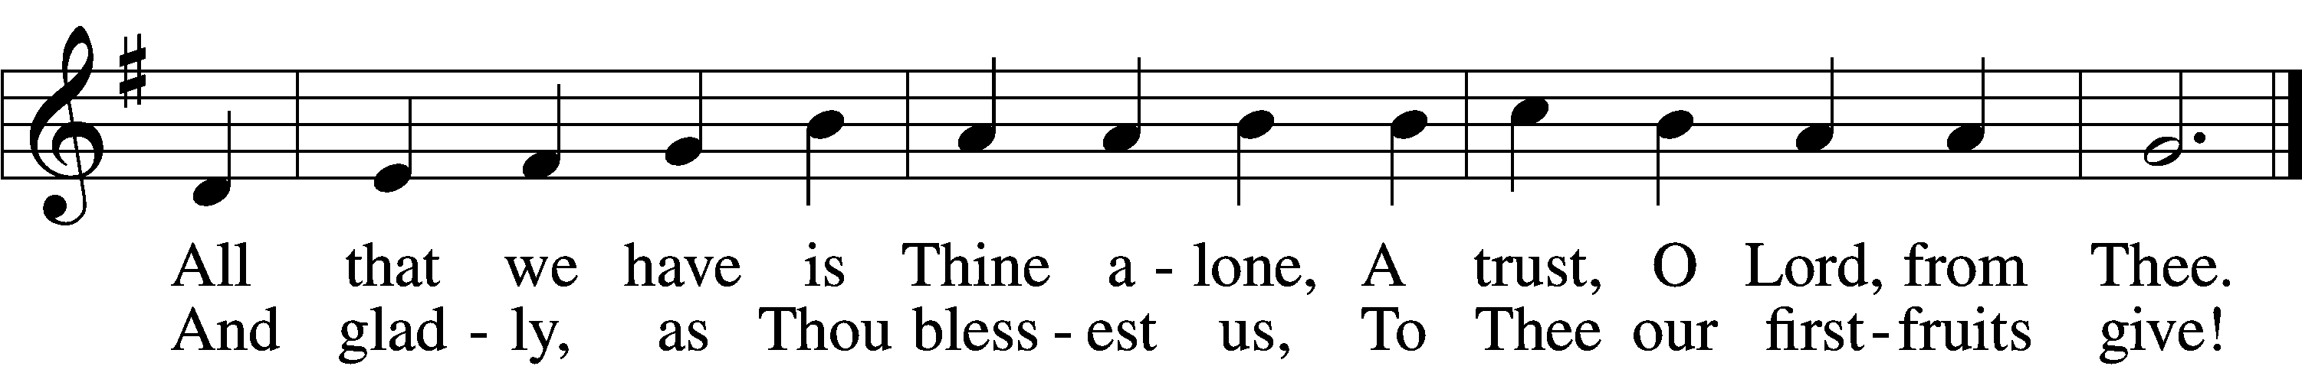

Prayer of the Church
After “let us pray to the Lord:” respond with “Lord, have mercy.”

Service of the Sacrament

Preface LSB 160
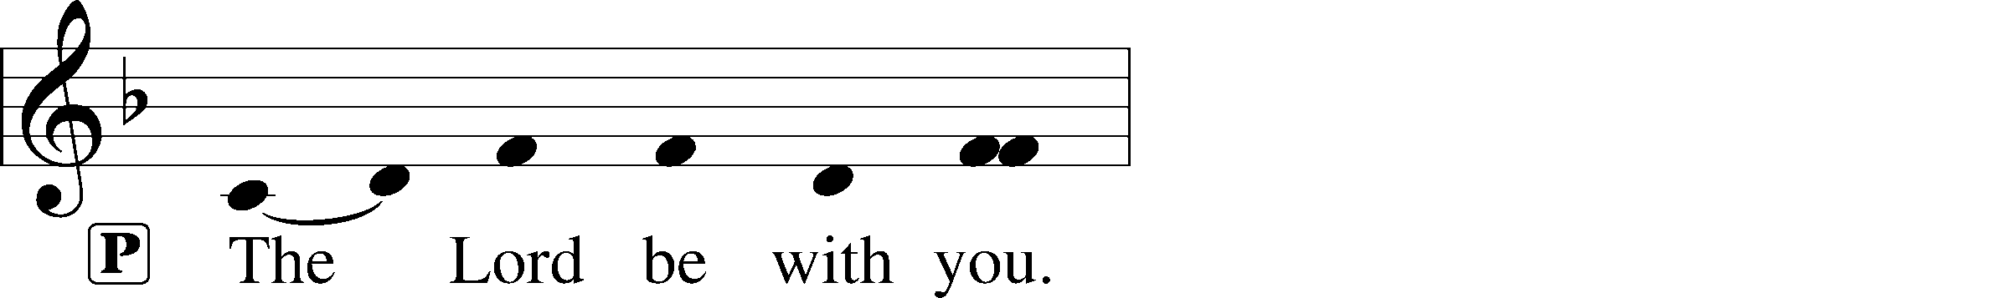
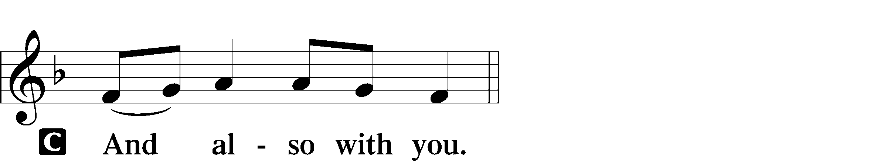
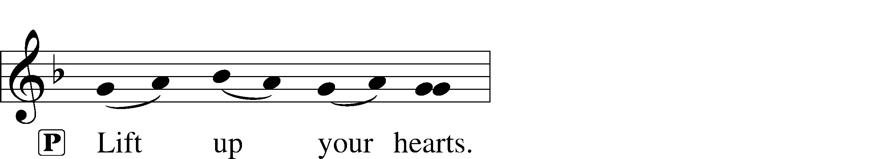

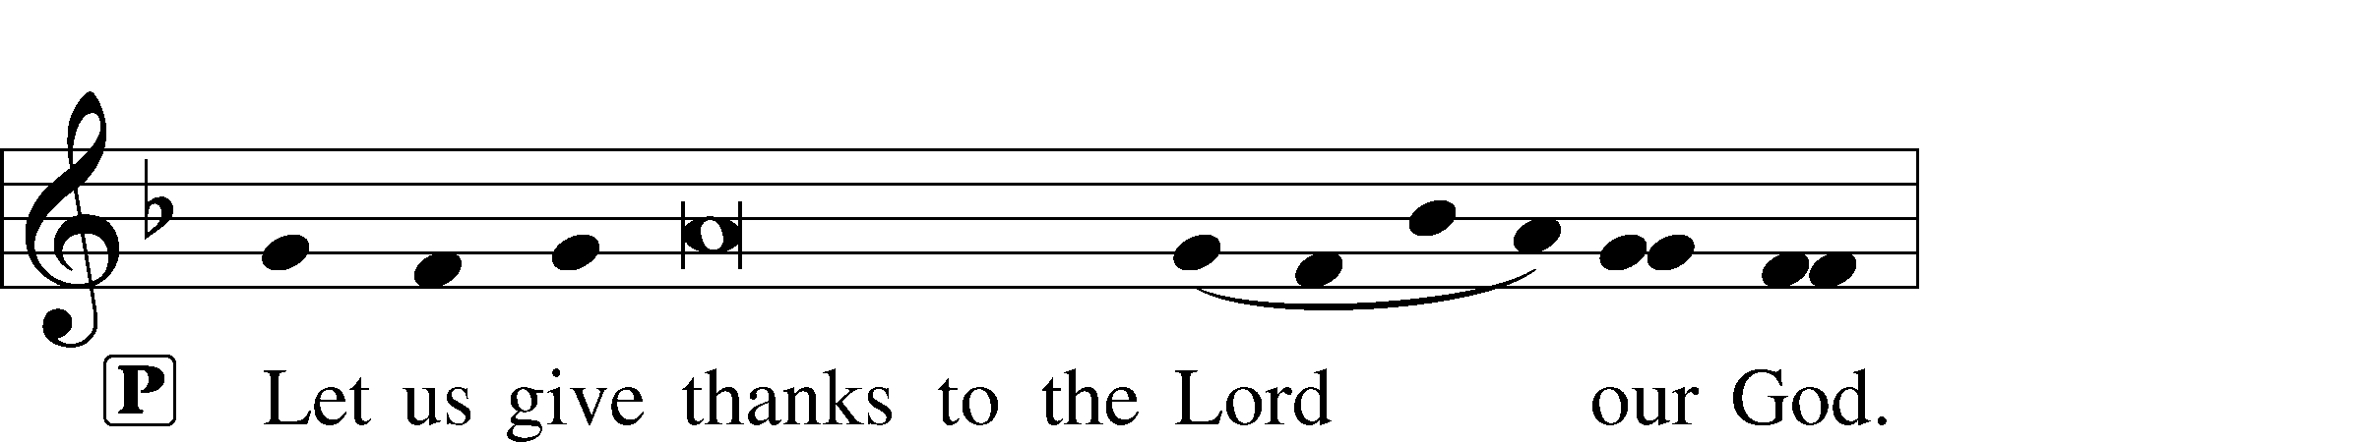
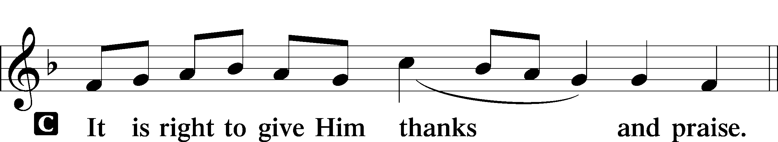

Proper Preface (Full)
P It is truly good, right, and salutary that we should at all times and in all places give thanks to You, holy Lord, almighty Father, everlasting God, through Jesus Christ, our Lord, who on this day overcame death and the grave and by His glorious resurrection opened to us the way of everlasting life. Therefore with angels and archangels and with all the company of heaven we laud and magnify Your glorious name, evermore praising You and saying:

Sanctus LSB 161
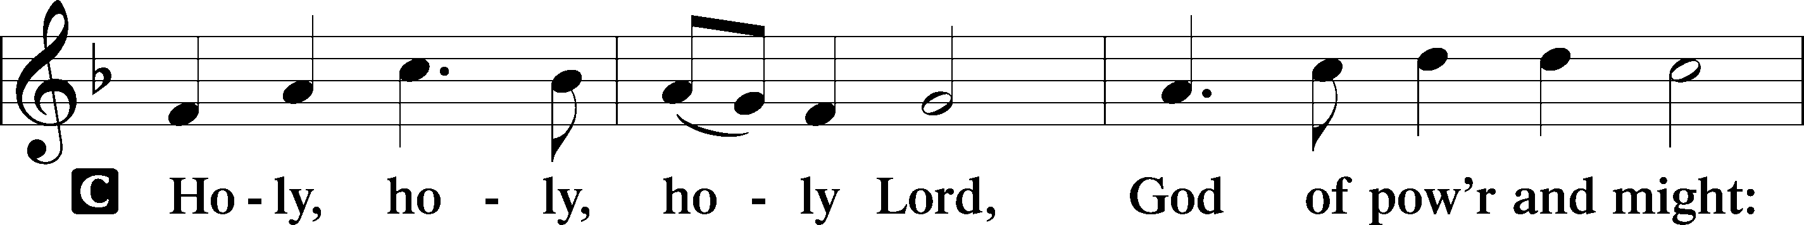
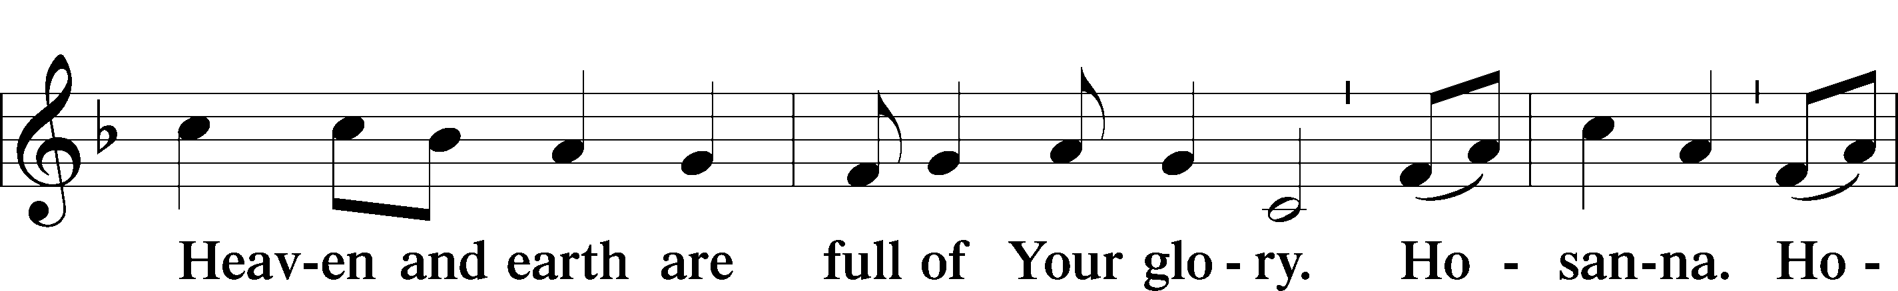
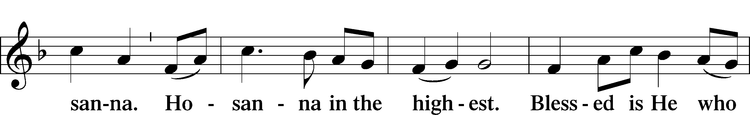
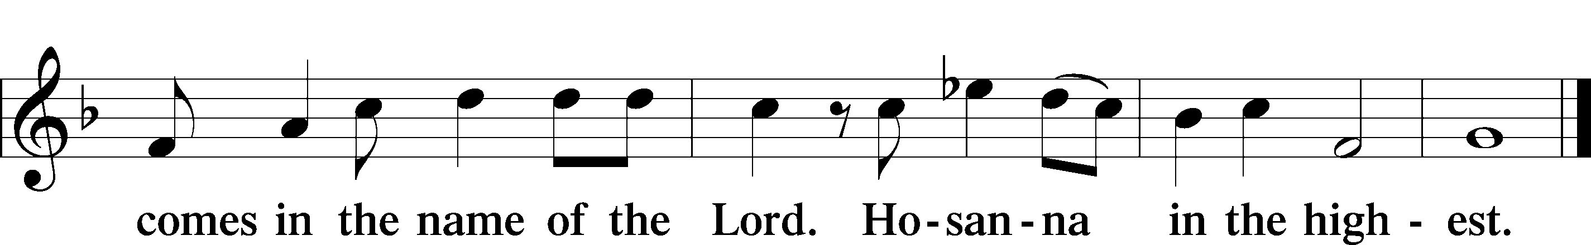

Prayer of Thanksgiving LSB 161
P Blessed are You, Lord of heaven and earth, for You have had mercy on those whom You created and sent Your only-begotten Son into our flesh to bear our sin and be our Savior. With repentant joy we receive the salvation accomplished for us by the all-availing sacrifice of His body and His blood on the cross.

Gathered in the name and the remembrance of Jesus, we beg You, O Lord, to forgive, renew, and strengthen us with Your Word and Spirit. Grant us faithfully to eat His body and drink His blood as He bids us do in His own testament. Gather us together, we pray, from the ends of the earth to celebrate with all the faithful the marriage feast of the Lamb in His kingdom, which has no end. Graciously receive our prayers; deliver and preserve us. To You alone, O Father, be all glory, honor, and worship, with the Son and the Holy Spirit, one God, now and forever.
C Amen.

The Words of Our Lord
P Our Lord Jesus Christ, on the night when He was betrayed, took bread, and when He had given thanks, He broke it and gave it to the disciples and said: “Take, eat; this is My T body, which is given for you. This do in remembrance of Me.”

In the same way also He took the cup after supper, and when He had given thanks, He gave it to them, saying: “Drink of it, all of you; this cup is the new testament in My T blood, which is shed for you for the forgiveness of sins. This do, as often as you drink it, in remembrance of Me.”

Proclamation of Christ
P As often as we eat this bread and drink this cup, we proclaim the Lord’s death until He comes.
C Amen. Come, Lord Jesus.

P O Lord Jesus Christ, only Son of the Father, in giving us Your body and blood to eat and to drink, You lead us to remember and confess Your holy cross and passion, Your blessed death, Your rest in the tomb, Your resurrection from the dead, Your ascension into heaven, and Your coming for the final judgment. So remember us in Your kingdom and teach us to pray:

Lord’s Prayer
C Our Father who art in heaven,
hallowed be Thy name,
Thy kingdom come,
Thy will be done on earth
as it is in heaven;
give us this day our daily bread;
and forgive us our trespasses
as we forgive those
who trespass against us;
and lead us not into temptation,
but deliver us from evil.
For Thine is the kingdom
and the power and the glory
forever and ever. Amen.

Pax Domini LSB 163
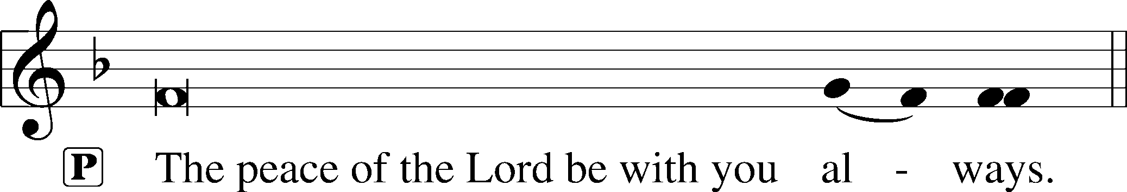
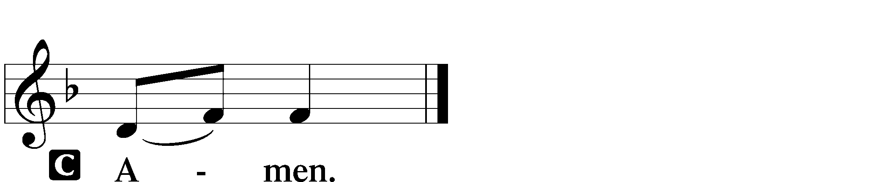

Agnus Dei LSB 163
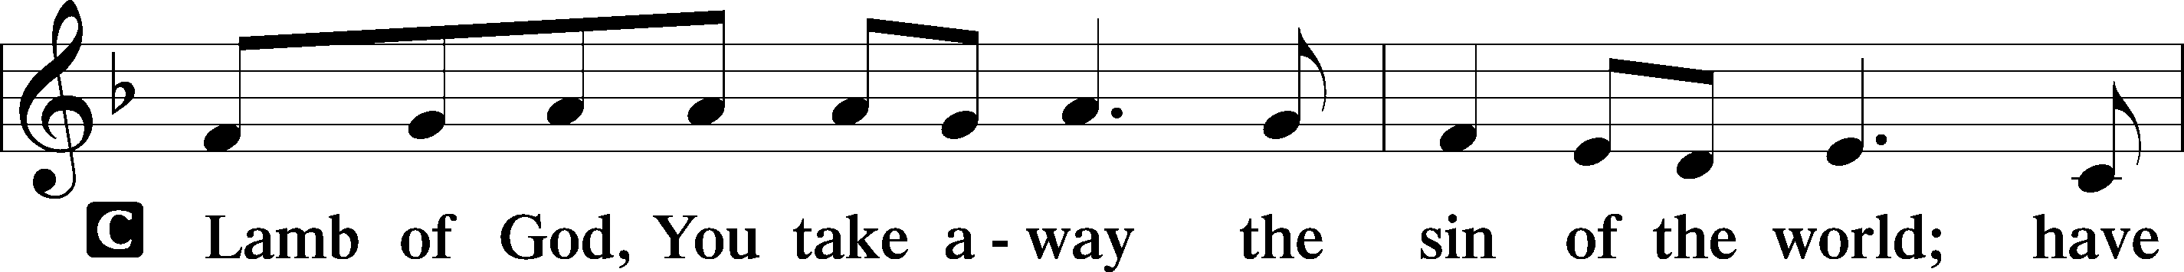
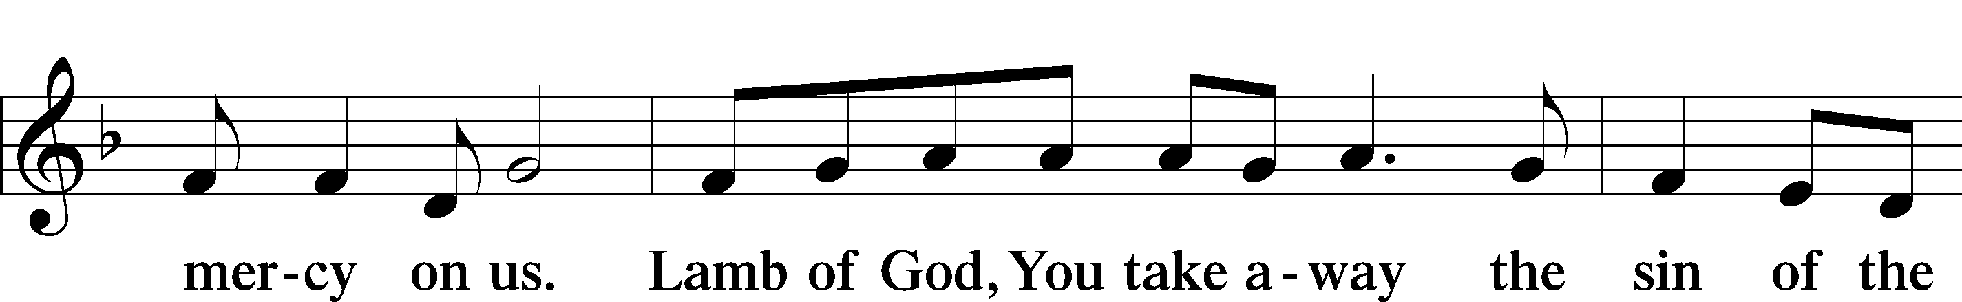
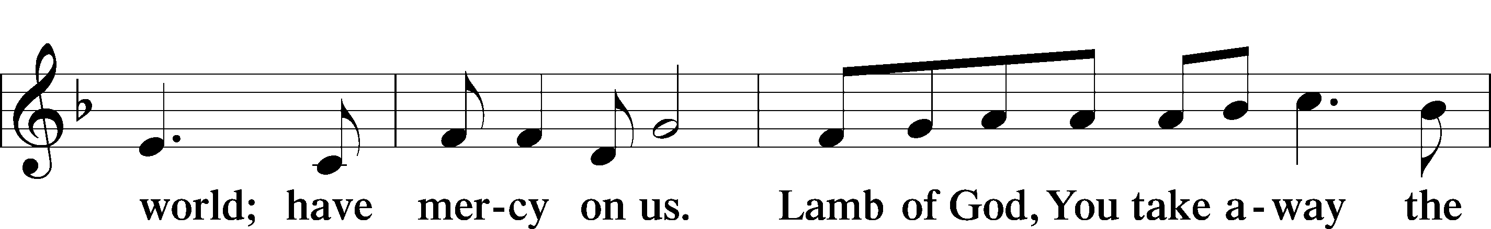
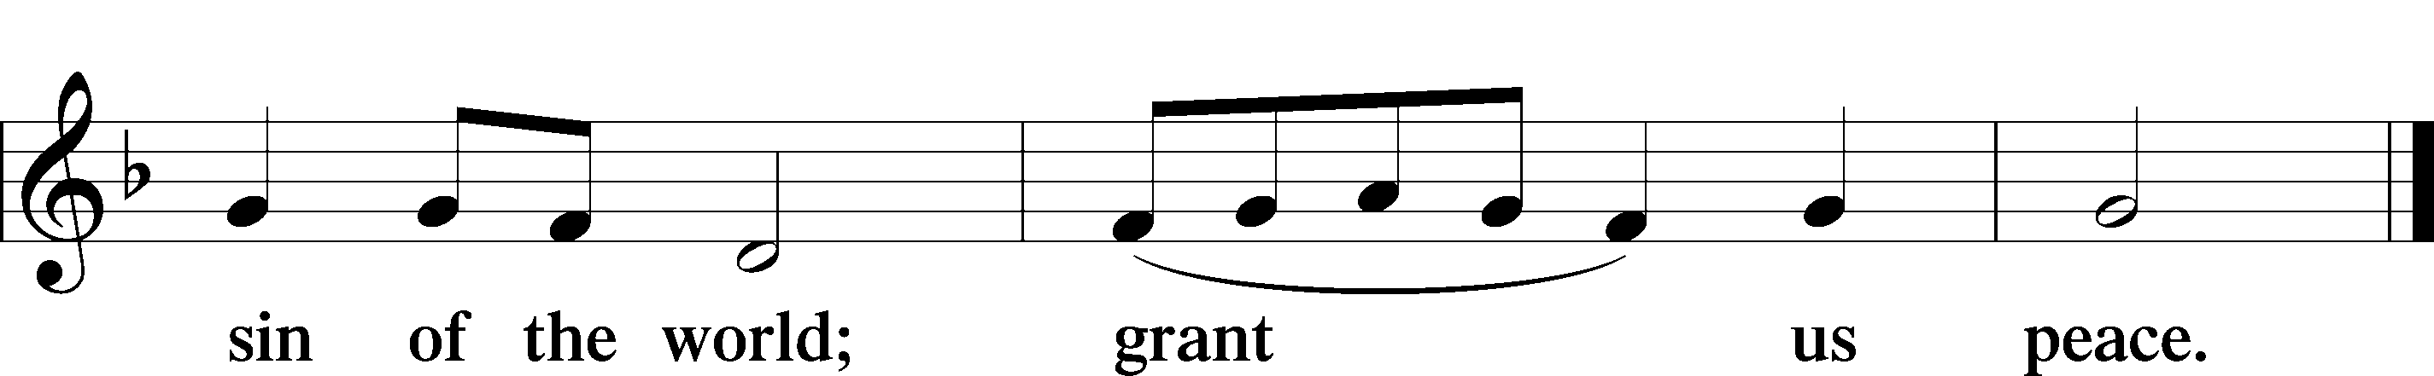
Sit

Distribution & Distribution Hymn

625 Lord Jesus Christ, Life-Giving Bread
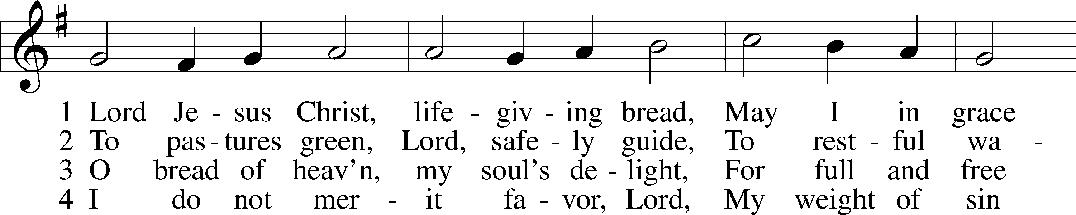
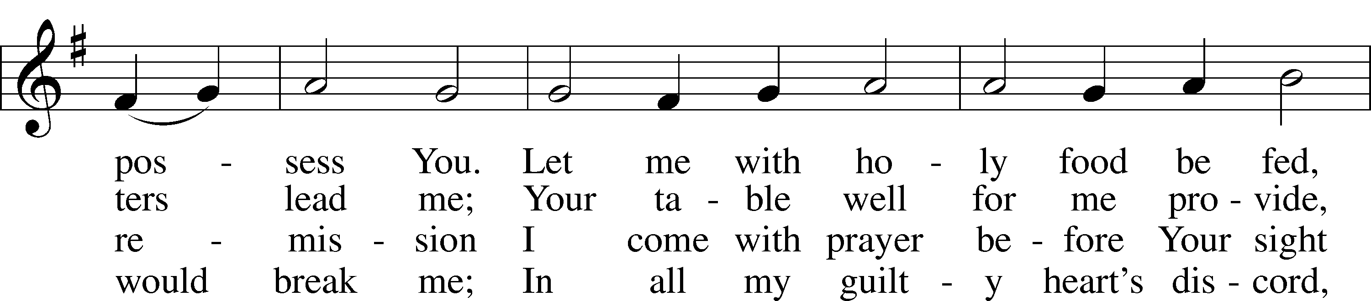
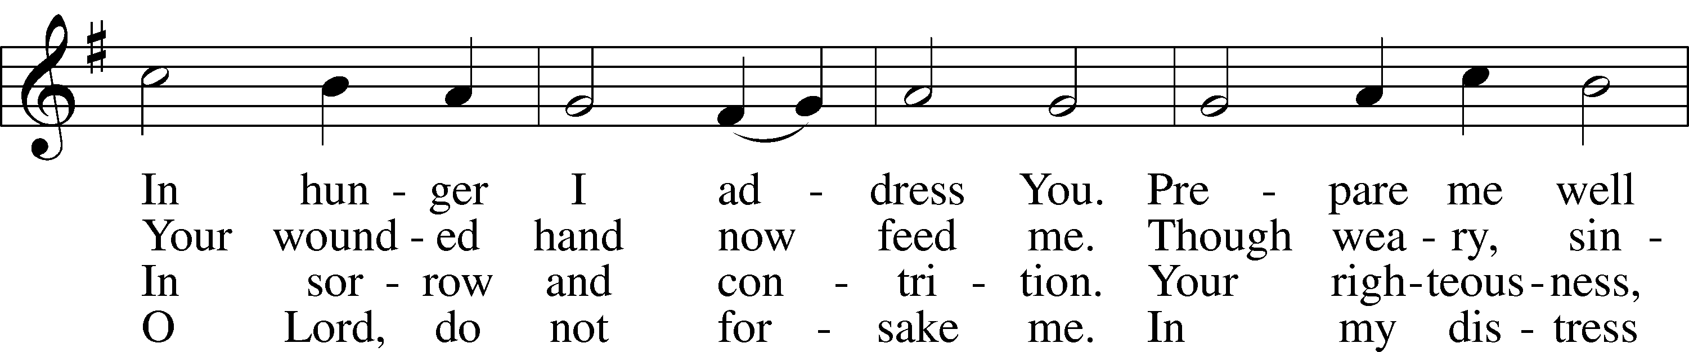
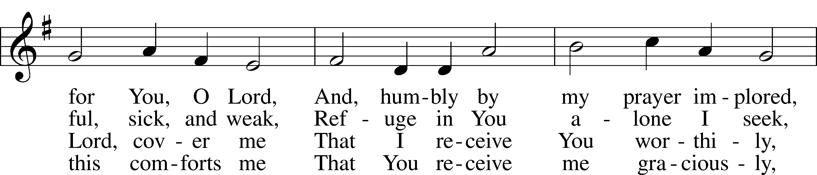
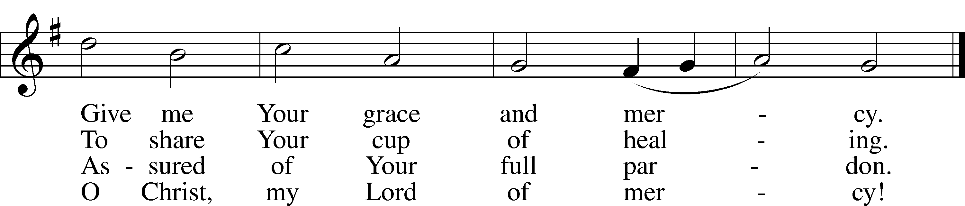

Stand

Thank the Lord LSB 164
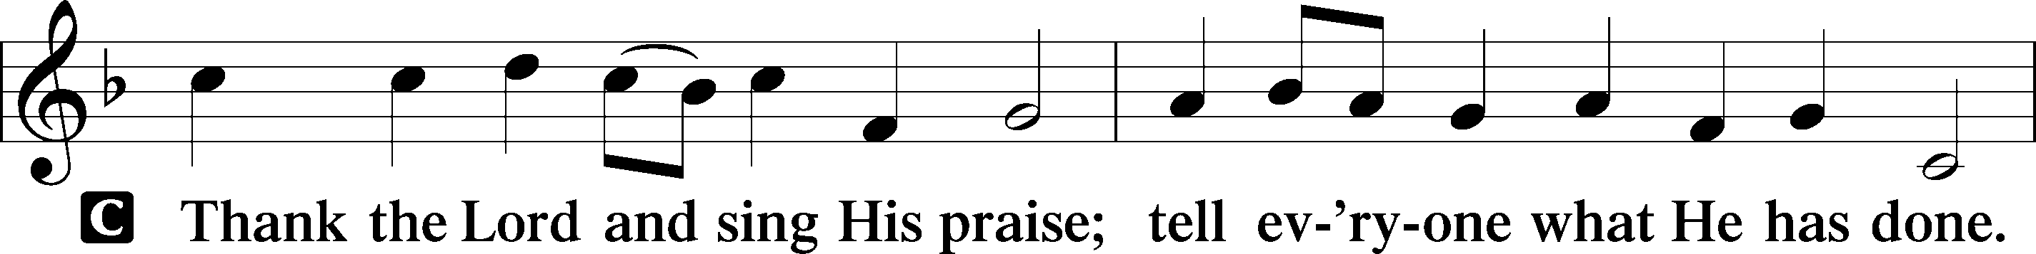
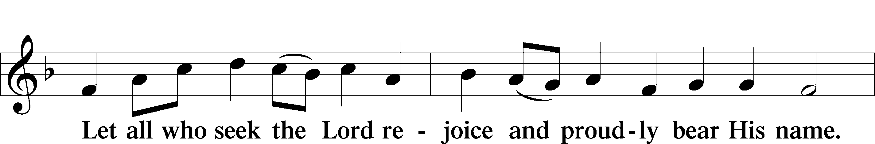
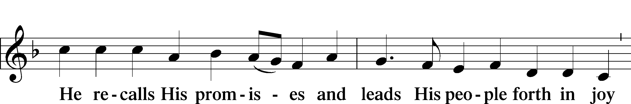
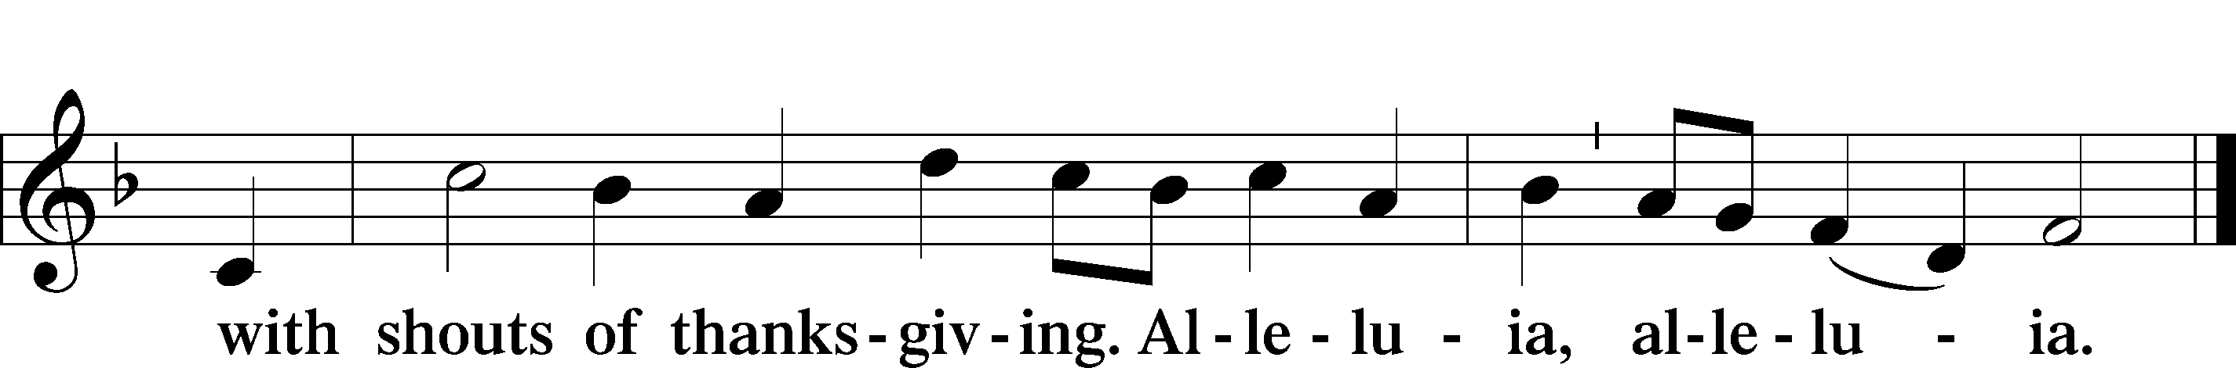

Post-Communion Collect
A Let us pray.
We give thanks to You, almighty God, that You have refreshed us through this salutary gift, and we implore You that of Your mercy You would strengthen us through the same in faith toward You and in fervent love toward one another; through Jesus Christ, Your Son, our Lord, who lives and reigns with You and the Holy Spirit, one God, now and forever.

Benediction LSB 166
P The Lord bless you and keep you.
The Lord make His face shine on you and be gracious to you.
The Lord look upon you with favor and T give you peace.
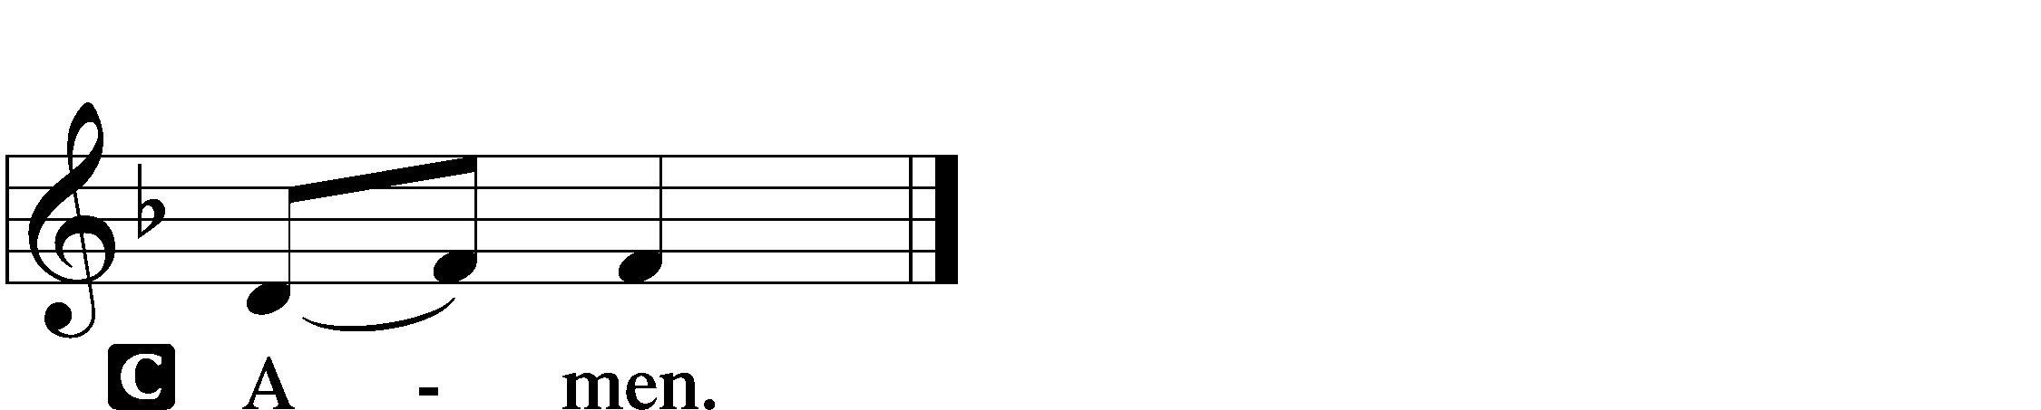

570 Just as I Am, without One Plea sts. 1–4
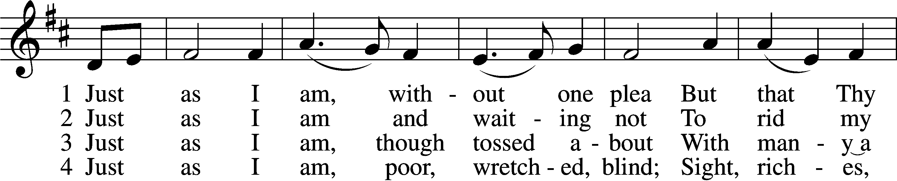
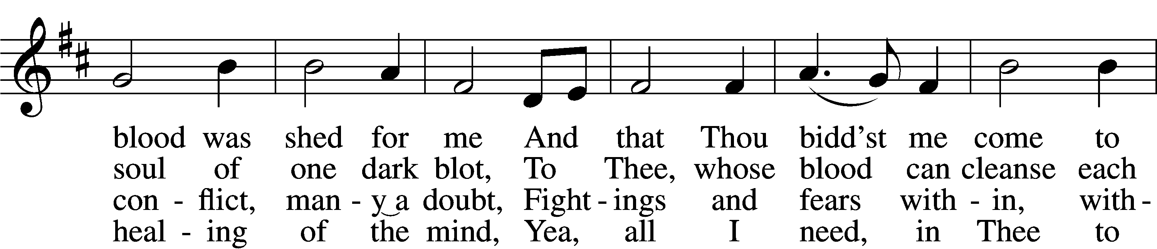
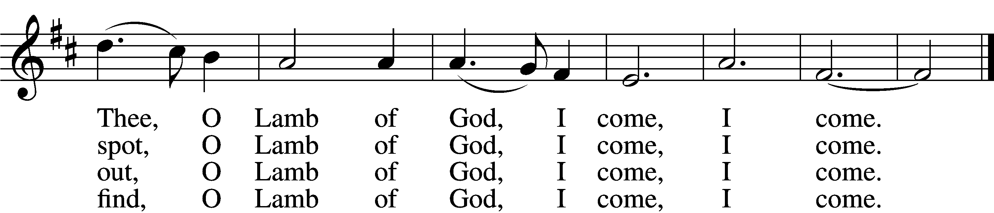

Announcements

Join us after the service in the fellowship hall for refreshments.

A Voters’ meeting is scheduled for today after service. Important items are to be discussed.

Pastor Vogel will be leading services on Oct. 26th and the whole month of November.

If not taking your bulletin home, please leave on table in the narthex when leaving so it can be recycled. Thank you.

St. John’s Lutheran Church
810 Broad St., Clifton, NJ 07013
StJohnsClifton.Org
PrayingHands810@gmail.com

