Sixteenth Sunday after Pentecost September 28, 2025 – Lectionary Series
St. John’s Lutheran Church

Order of Worship
by
Lutheran Service Builder
912 Christ Is Our Cornerstone
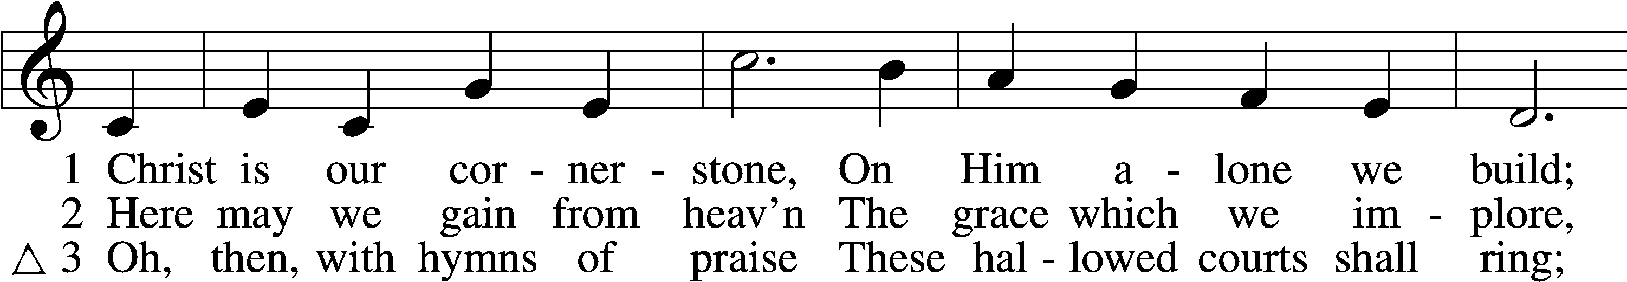
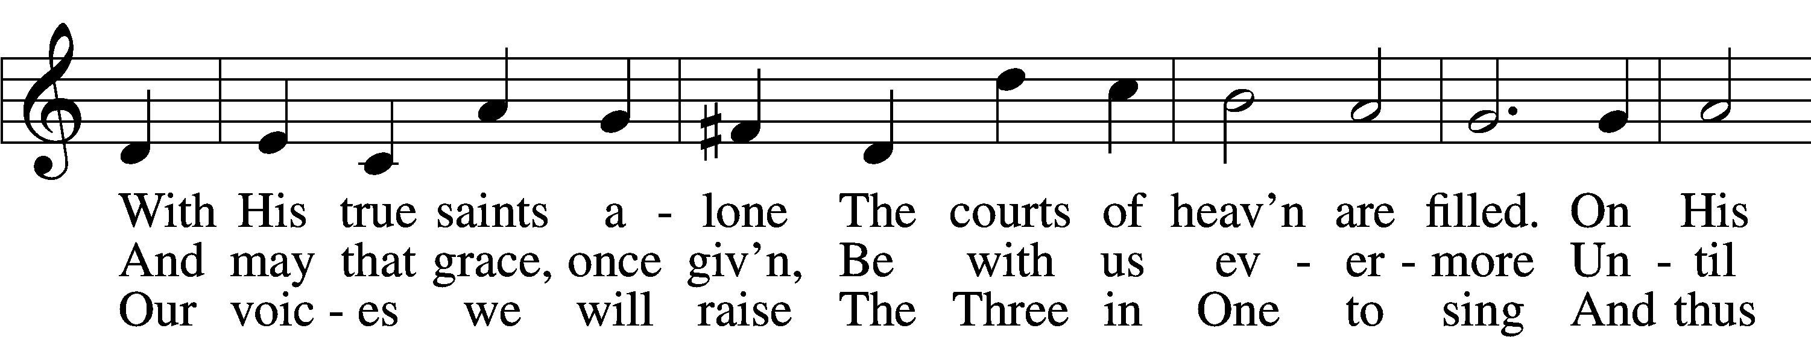
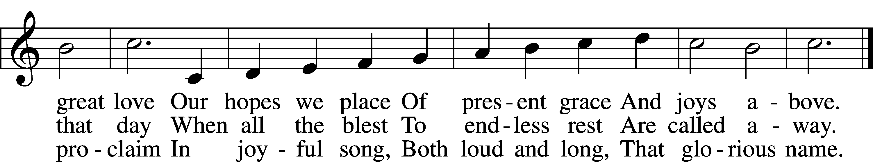

Δ – Stand for last verse

Confession and Absolution

The sign of the cross may be made by all in remembrance of their Baptism.

Invocation
P In the name of the Father and of the T Son and of the Holy Spirit.
C Amen.

Exhortation LSB 151
P If we say we have no sin, we deceive ourselves, and the truth is not in us.
C But if we confess our sins, God, who is faithful and just, will forgive our sins and cleanse us from all unrighteousness.

Silence for reflection on God’s Word and for self-examination.

Confession of Sins LSB 151
P Let us then confess our sins to God our Father.
C Most merciful God, we confess that we are by nature sinful and unclean. We have sinned against You in thought, word, and deed, by what we have done and by what we have left undone. We have not loved You with our whole heart; we have not loved our neighbors as ourselves. We justly deserve Your present and eternal punishment. For the sake of Your Son, Jesus Christ, have mercy on us. Forgive us, renew us, and lead us, so that we may delight in Your will and walk in Your ways to the glory of Your holy name. Amen.

Absolution LSB 151
P Almighty God in His mercy has given His Son to die for you and for His sake forgives you all your sins. As a called and ordained servant of Christ, and by His authority, I therefore forgive you all your sins in the name of the Father and of the T Son and of the Holy Spirit.
C Amen.

Service of the Word

Introit Psalm 119:73–75, 77; antiphon: v. 76
Let your steadfast love comfort me
according to your promise to your servant.
Your hands have made and fashioned me;
give me understanding that I may learn your commandments.
Those who fear you shall see me and rejoice,
because I have hoped in your word.
I know, O Lord, that your just decrees are righteous,
and that in faithfulness you have afflicted me.
Let your mercy come to me, that I may live;
for your law is my delight.
Glory be to the Father and to the Son
and to the Holy Spirit;
as it was in the beginning,
is now, and will be forever. Amen.
Let your steadfast love comfort me
according to your promise to your servant.

Kyrie LSB 152

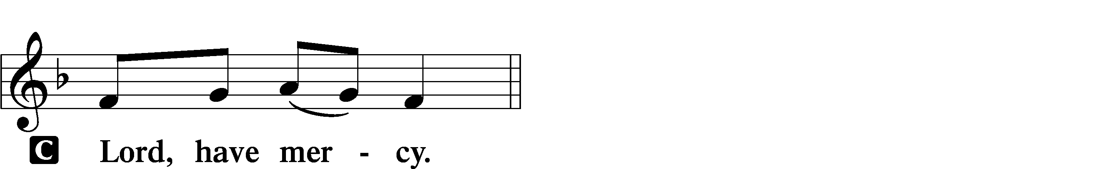

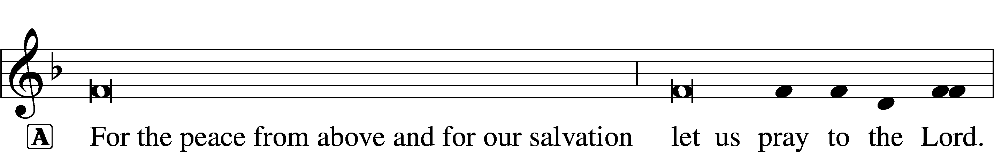
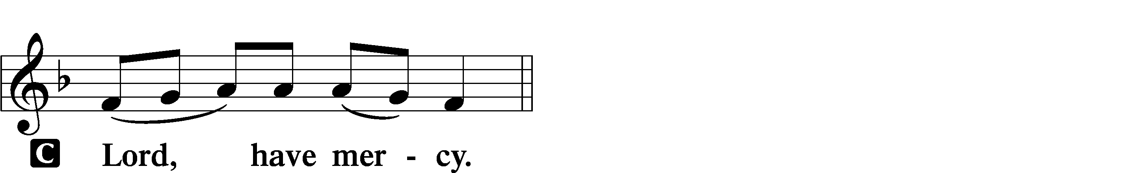

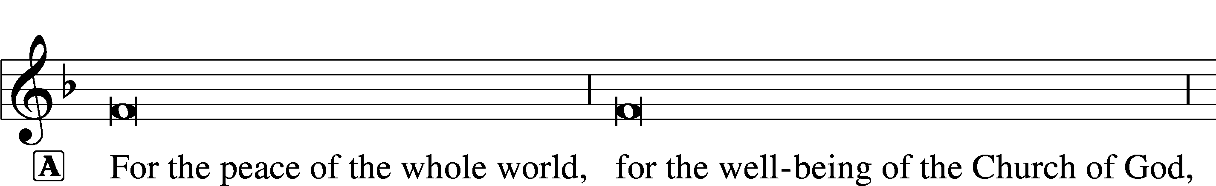

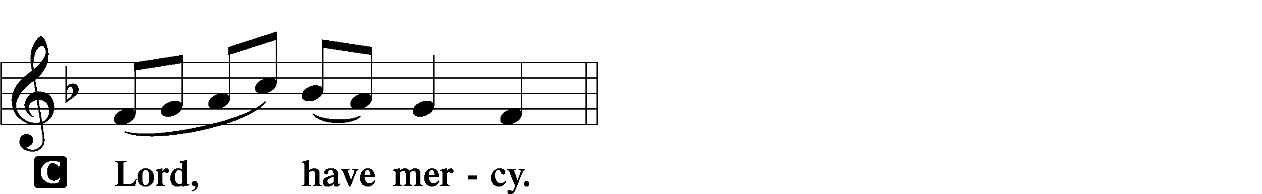

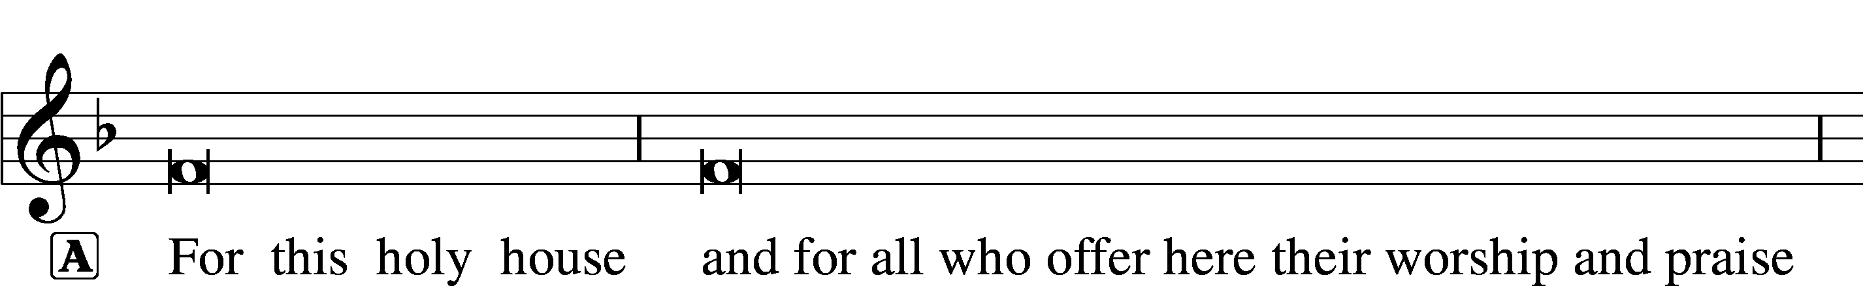

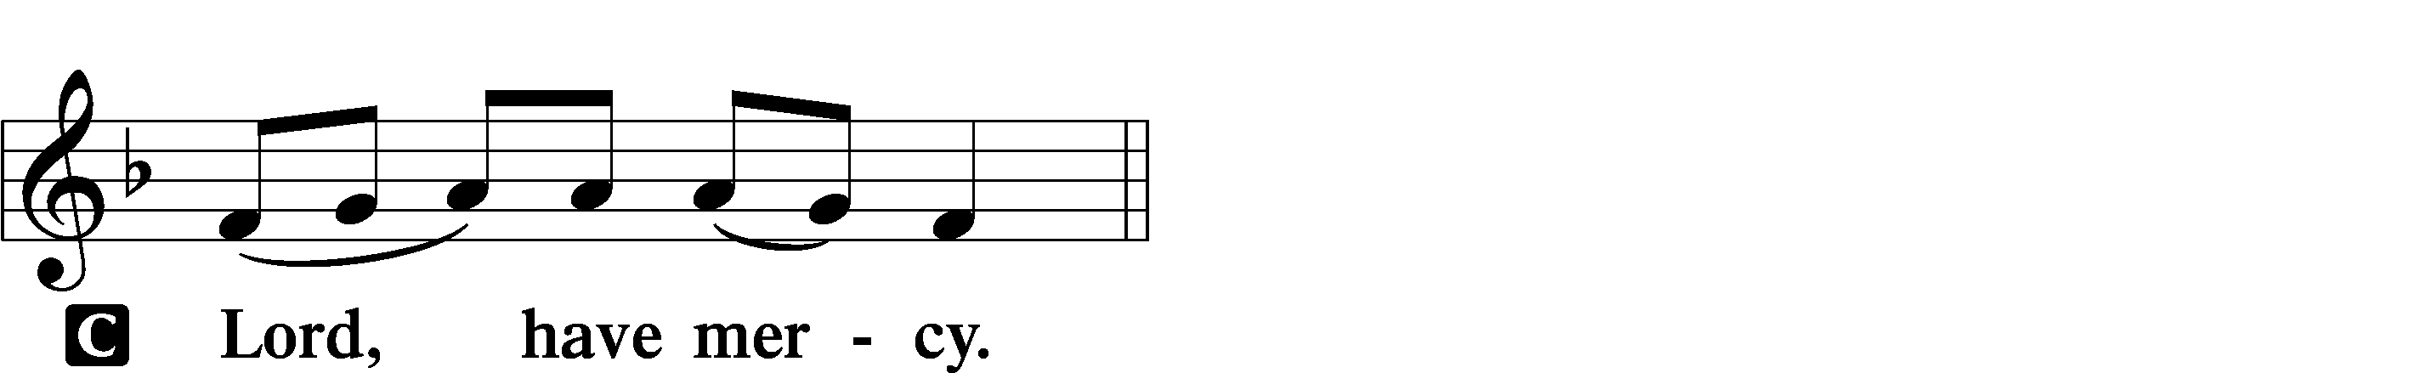




Gloria in Excelsis LSB 154
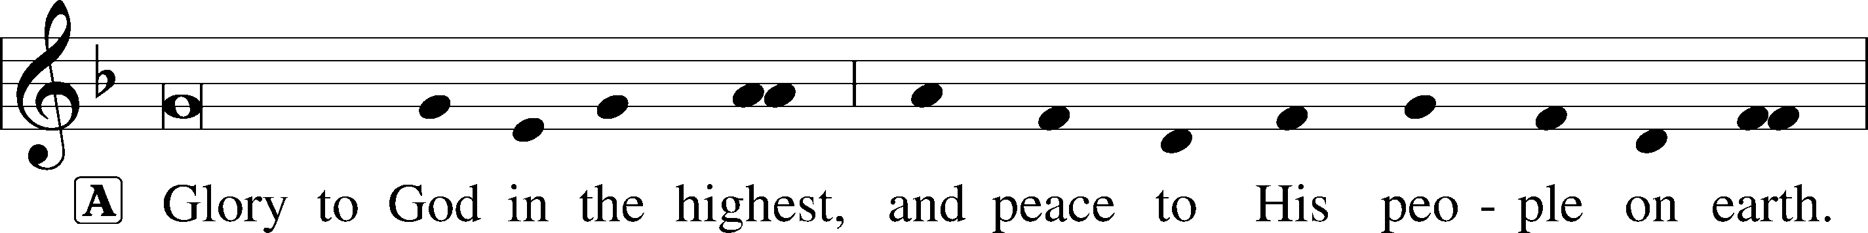
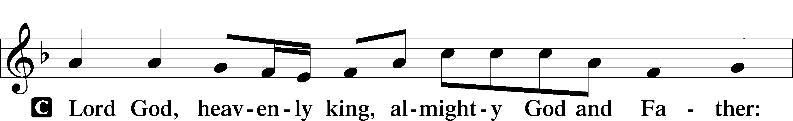
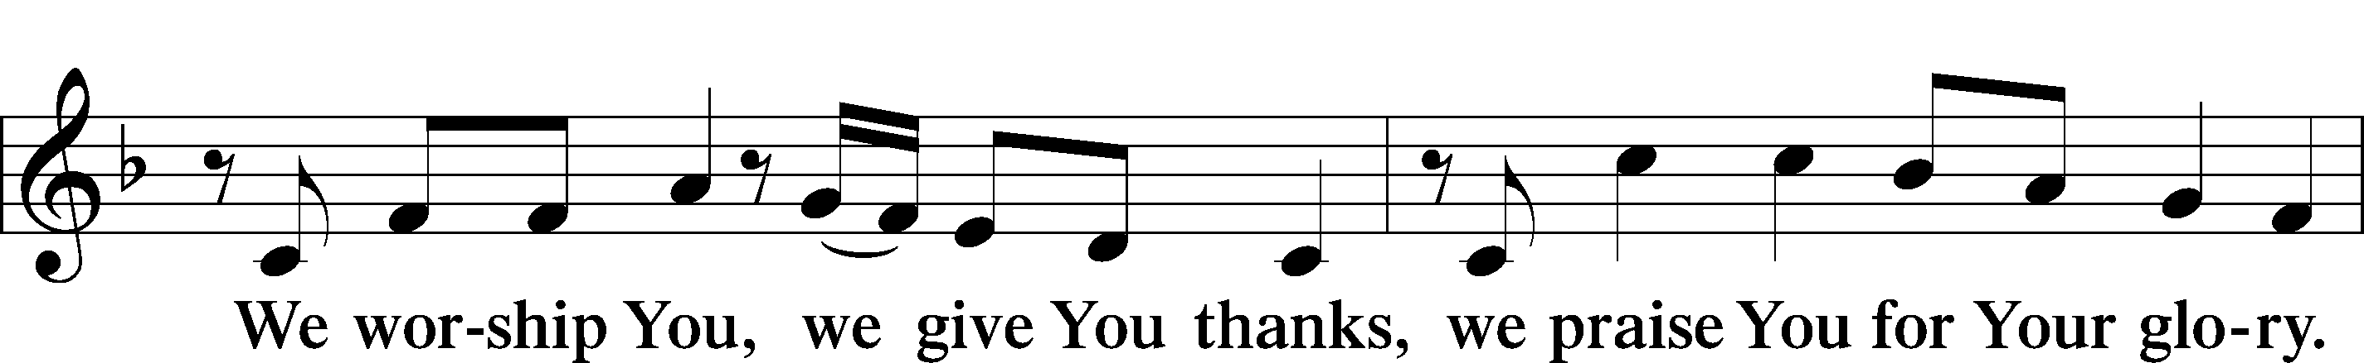
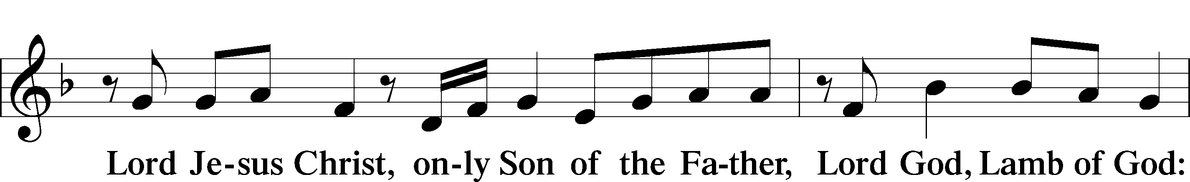
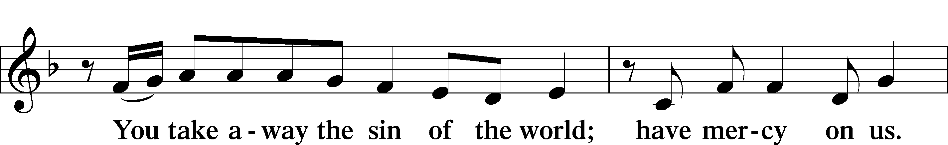
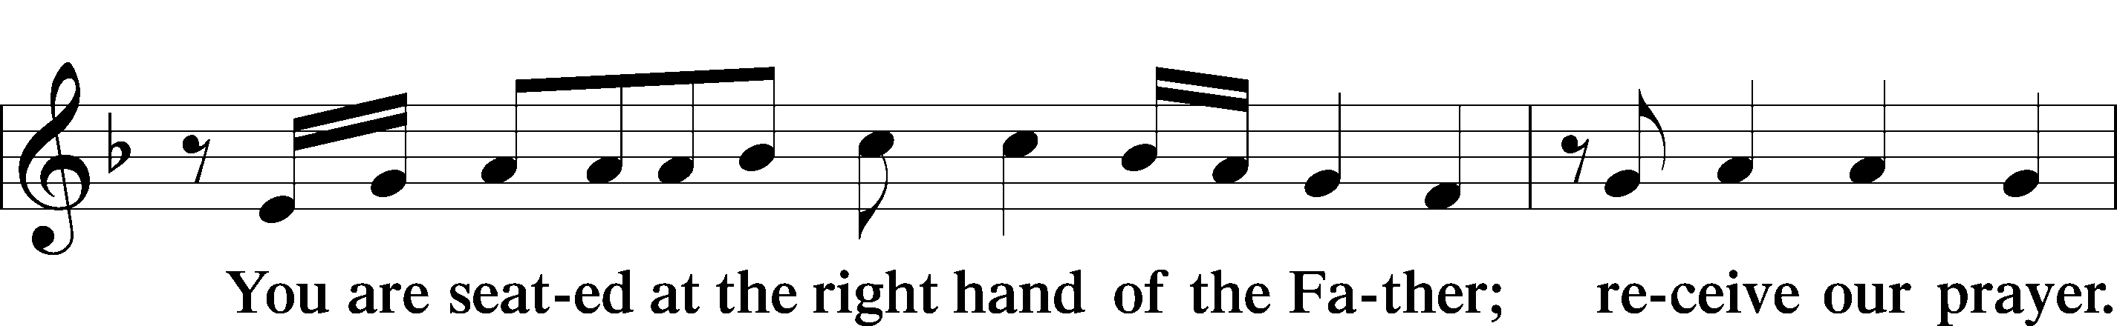
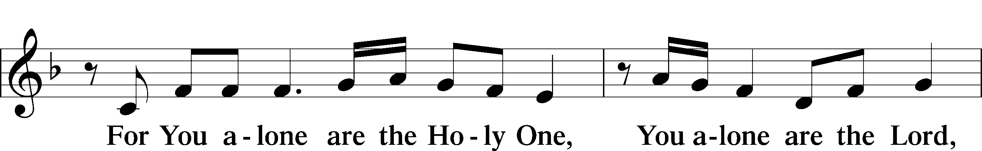
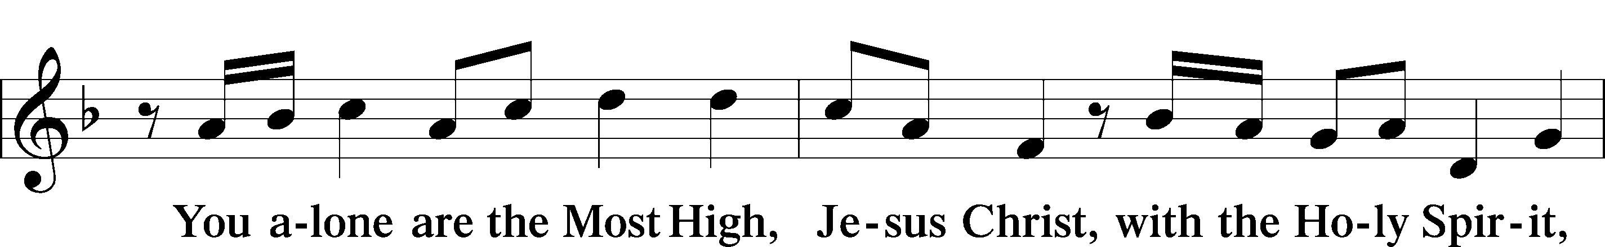
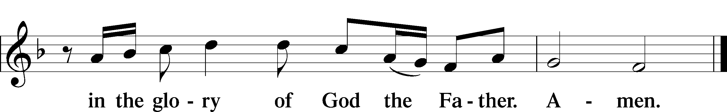

Salutation and Collect of the Day
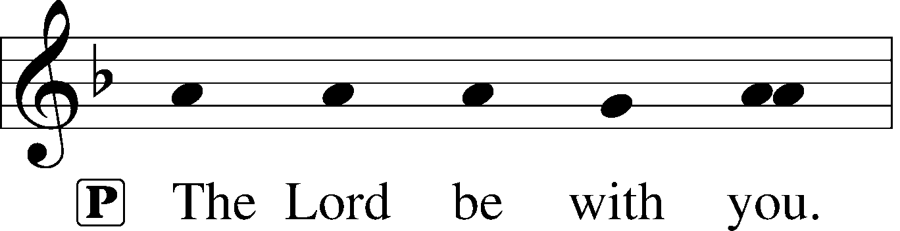
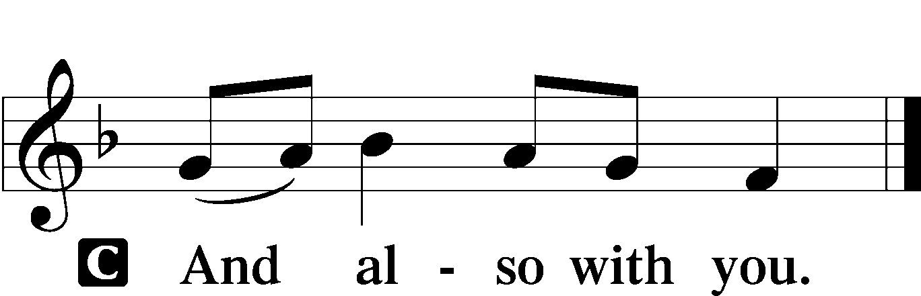

P Let us pray.
O God, You are the strength of all who trust in You, and without Your aid we can do no good thing. Grant us the help of Your grace that we may please You in both will and deed; through Jesus Christ, Your Son, our Lord, who lives and reigns with You and the Holy Spirit, one God, now and forever.

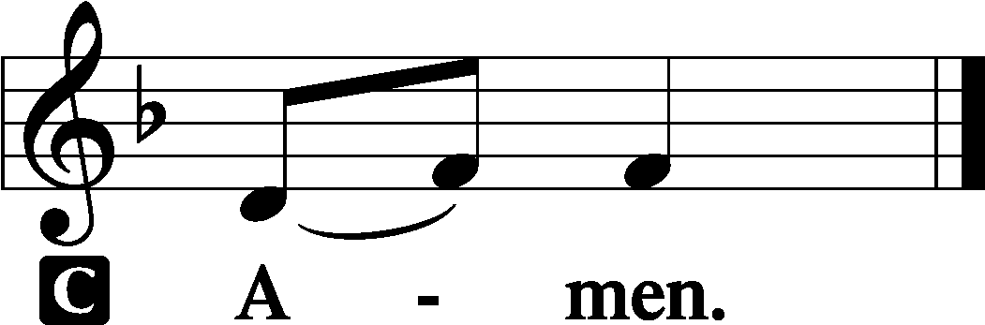

Sit

Old Testament Reading Amos 6:1–7
“Woe to those who are at ease in Zion,
and to those who feel secure on the mountain of Samaria,
the notable men of the first of the nations,
to whom the house of Israel comes!
Pass over to Calneh, and see,
and from there go to Hamath the great;
then go down to Gath of the Philistines.
Are you better than these kingdoms?
Or is their territory greater than your territory,
O you who put far away the day of disaster
and bring near the seat of violence?
“Woe to those who lie on beds of ivory
and stretch themselves out on their couches,
and eat lambs from the flock
and calves from the midst of the stall,
who sing idle songs to the sound of the harp
and like David invent for themselves instruments of music,
who drink wine in bowls
and anoint themselves with the finest oils,
but are not grieved over the ruin of Joseph!
Therefore they shall now be the first of those who go into exile,
and the revelry of those who stretch themselves out shall pass away.”

A This is the Word of the Lord.
C Thanks be to God.

Epistle 1 Timothy 3:1–13
The saying is trustworthy: If anyone aspires to the office of overseer, he desires a noble task. Therefore an overseer must be above reproach, the husband of one wife, sober-minded, self-controlled, respectable, hospitable, able to teach, not a drunkard, not violent but gentle, not quarrelsome, not a lover of money. He must manage his own household well, with all dignity keeping his children submissive, for if someone does not know how to manage his own household, how will he care for God’s church? He must not be a recent convert, or he may become puffed up with conceit and fall into the condemnation of the devil. Moreover, he must be well thought of by outsiders, so that he may not fall into disgrace, into a snare of the devil.
Deacons likewise must be dignified, not double-tongued, not addicted to much wine, not greedy for dishonest gain. They must hold the mystery of the faith with a clear conscience. And let them also be tested first; then let them serve as deacons if they prove themselves blameless. Their wives likewise must be dignified, not slanderers, but sober-minded, faithful in all things. Let deacons each be the husband of one wife, managing their children and their own households well. For those who serve well as deacons gain a good standing for themselves and also great confidence in the faith that is in Christ Jesus.

A This is the Word of the Lord.
C Thanks be to God.

Stand

Alleluia and Verse LSB 156
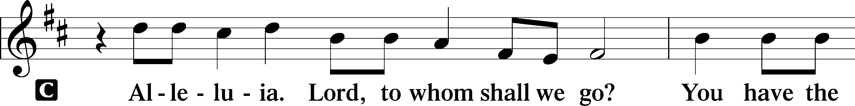
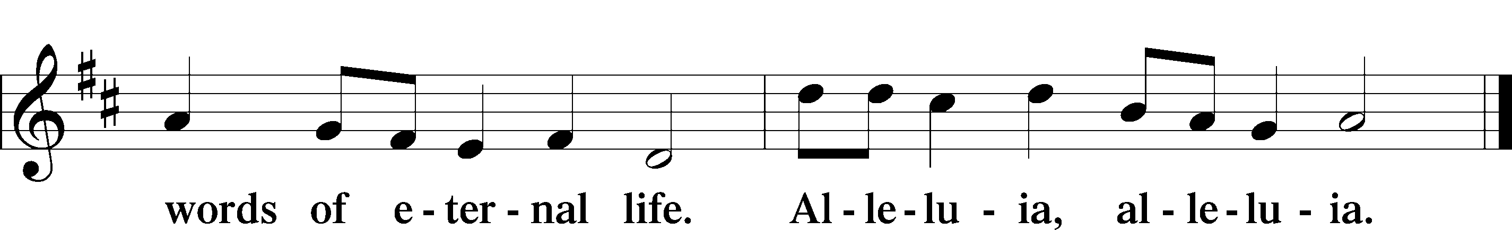

Holy Gospel Luke 16:19–31
P The Holy Gospel according to St. Luke, the sixteenth chapter.

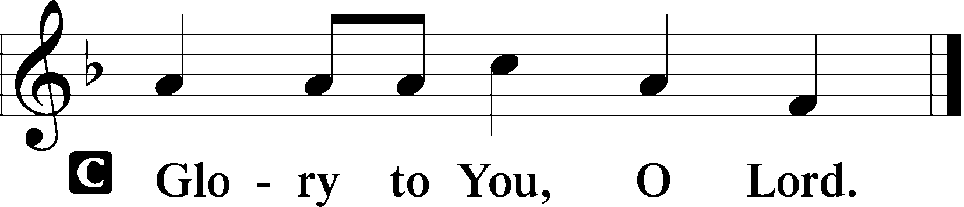

[Jesus said:] “There was a rich man who was clothed in purple and fine linen and who feasted sumptuously every day. And at his gate was laid a poor man named Lazarus, covered with sores, who desired to be fed with what fell from the rich man’s table. Moreover, even the dogs came and licked his sores. The poor man died and was carried by the angels to Abraham’s side. The rich man also died and was buried, and in Hades, being in torment, he lifted up his eyes and saw Abraham far off and Lazarus at his side. And he called out, ‘Father Abraham, have mercy on me, and send Lazarus to dip the end of his finger in water and cool my tongue, for I am in anguish in this flame.’ But Abraham said, ‘Child, remember that you in your lifetime received your good things, and Lazarus in like manner bad things; but now he is comforted here, and you are in anguish. And besides all this, between us and you a great chasm has been fixed, in order that those who would pass from here to you may not be able, and none may cross from there to us.’ And he said, ‘Then I beg you, father, to send him to my father’s house— for I have five brothers—so that he may warn them, lest they also come into this place of torment.’ But Abraham said, ‘They have Moses and the Prophets; let them hear them.’ And he said, ‘No, father Abraham, but if someone goes to them from the dead, they will repent.’ He said to him, ‘If they do not hear Moses and the Prophets, neither will they be convinced if someone should rise from the dead.’”

P This is the Gospel of the Lord.

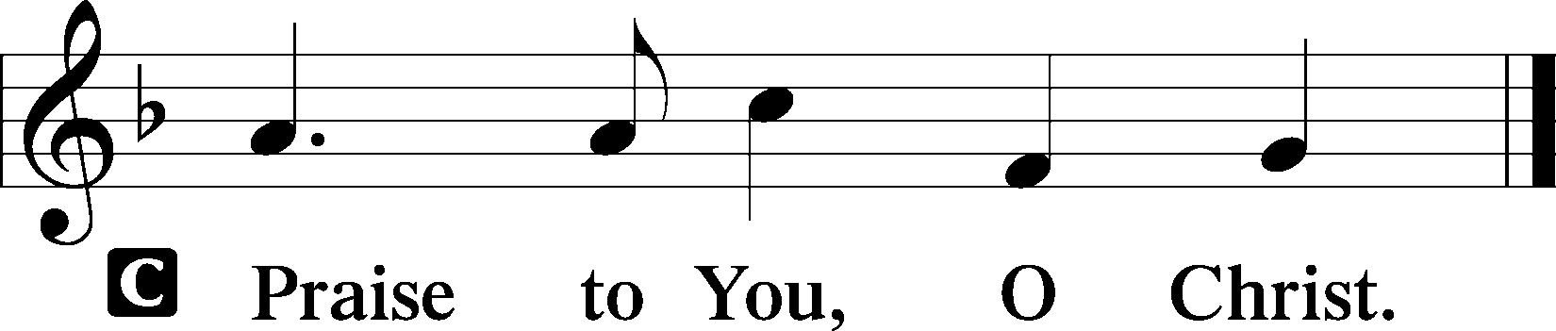

Apostles’ Creed
C I believe in God, the Father Almighty,
maker of heaven and earth.

And in Jesus Christ, His only Son, our Lord,
who was conceived by the Holy Spirit,
born of the virgin Mary,
suffered under Pontius Pilate,
was crucified, died and was buried.
He descended into hell.
The third day He rose again from the dead.
He ascended into heaven
and sits at the right hand of God the Father Almighty.
From thence He will come to judge the living and the dead.

I believe in the Holy Spirit,
the holy Christian Church,
the communion of saints,
the forgiveness of sins,
the resurrection of the body,
and the life T everlasting. Amen.

Si
708 Lord, Thee I Love with All My Heart
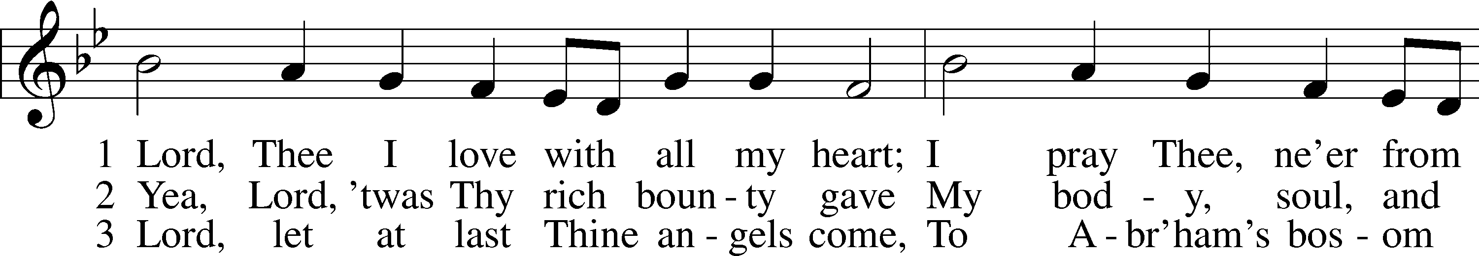
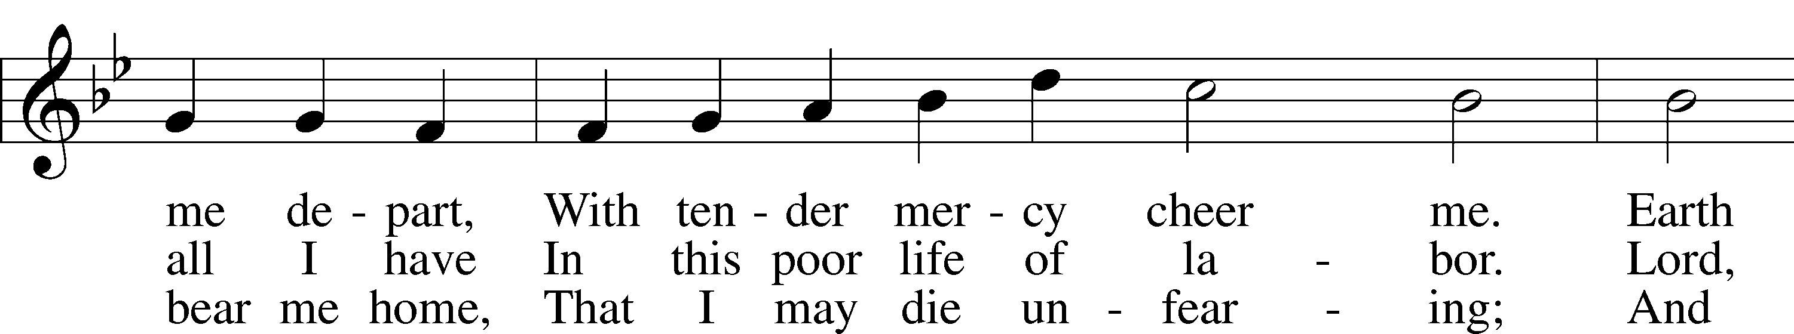
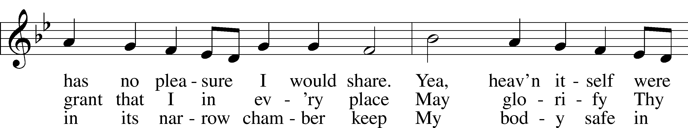
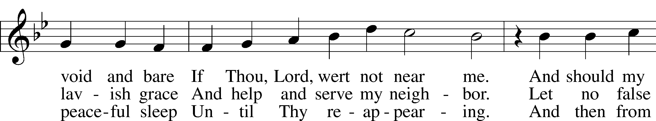
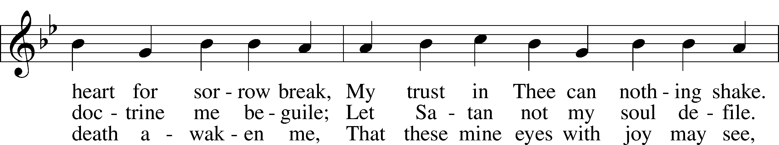
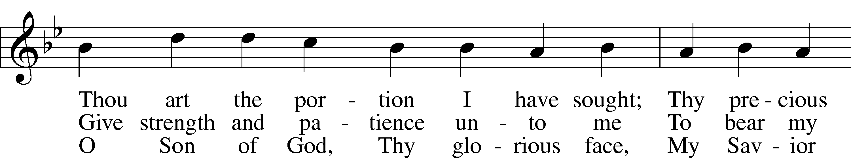
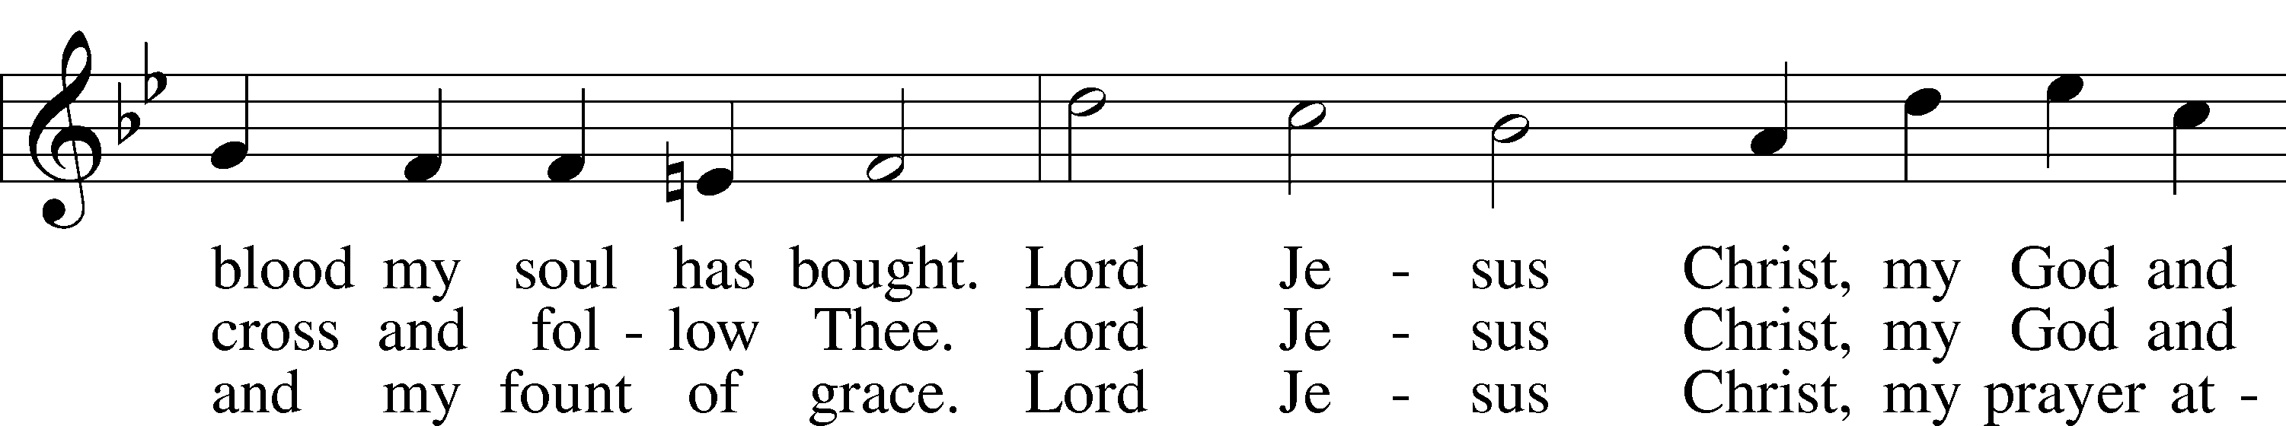
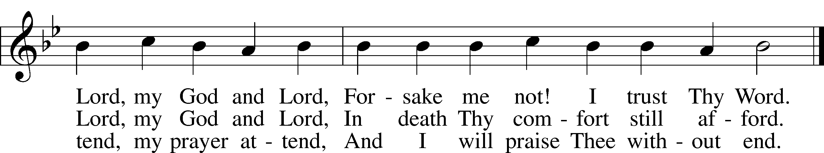

Sermon

Offering

Psalm for Meditation Psalm 146; antiphon: v. 2
Praise the Lord!
Praise the Lord, O my soul!
I will praise the Lord as long as I live;
I will sing praises to my God while I have my being.
Put not your trust in princes,
in a son of man, in whom there is no salvation.
When his breath departs he returns to the earth;
on that very day his plans perish.
Blessèd is he whose help is the God of Jacob,
whose hope is in the Lord his God,
who made heaven and earth,
the sea, and all that is in them,
who keeps faith forever;
who executes justice for the oppressed,
who gives food to the hungry.
The Lord sets the prisoners free;
the Lord opens the eyes of the blind.
The Lord lifts up those who are bowed down;
the Lord loves the righteous.
The Lord watches over the sojourners;
he upholds the widow and the fatherless,
but the way of the wicked he brings to ruin.
The Lord will reign forever,
your God, O Zion, to all generations. Praise the Lord!

Stand

781 We Give Thee But Thine Own sts. 1–2
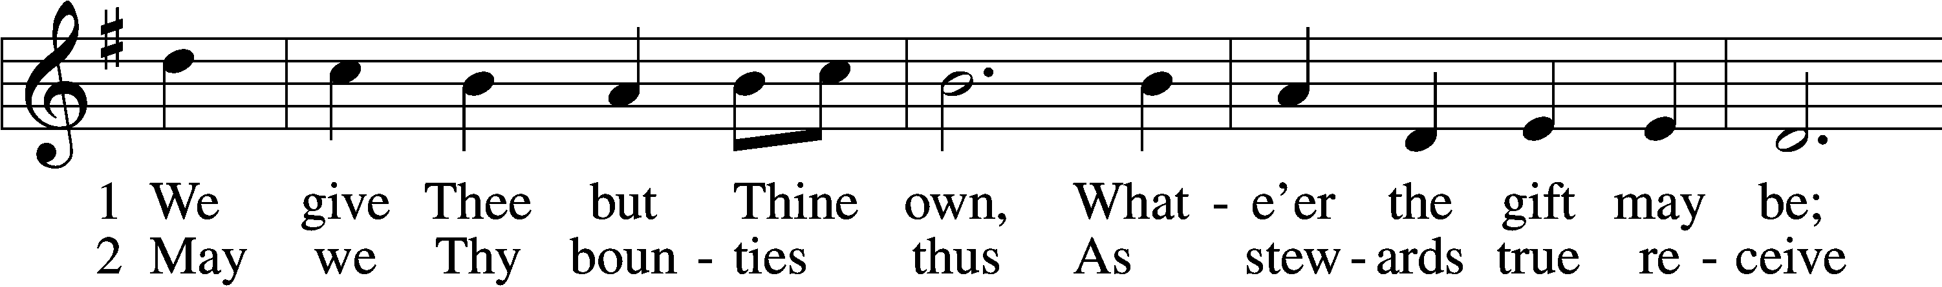
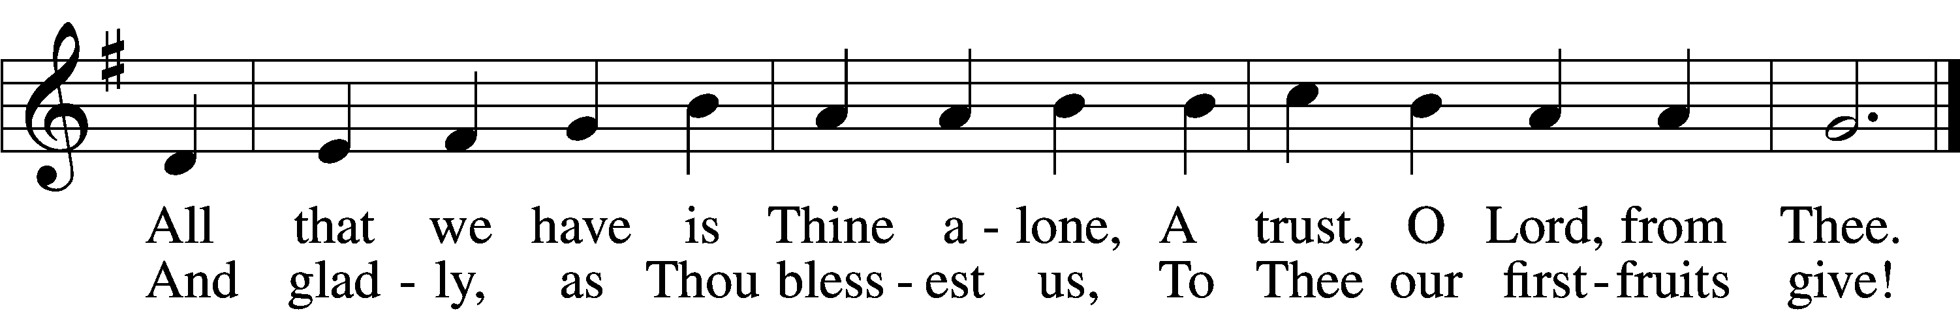

Installation of New Members

Prayer of the Church
After “Lord, in Your mercy” respond with “hear our prayer.”

Lord’s Prayer
C Our Father who art in heaven,
hallowed be Thy name,
Thy kingdom come,
Thy will be done on earth
as it is in heaven;
give us this day our daily bread;
and forgive us our trespasses
as we forgive those
who trespass against us;
and lead us not into temptation,
but deliver us from evil.
For Thine is the kingdom
and the power and the glory
forever and ever. Amen.

Benediction LSB 166
P The Lord bless you and keep you.
The Lord make His face shine on you and be gracious to you.
The Lord look upon you with favor and T give you peace.

575 My Hope Is Built on Nothing Less
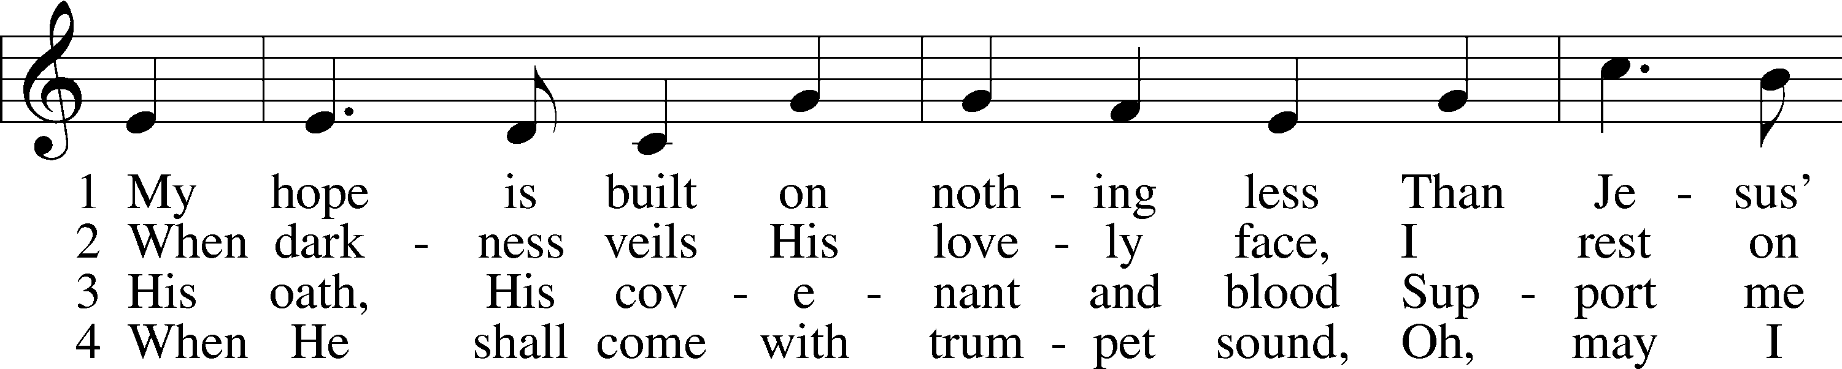
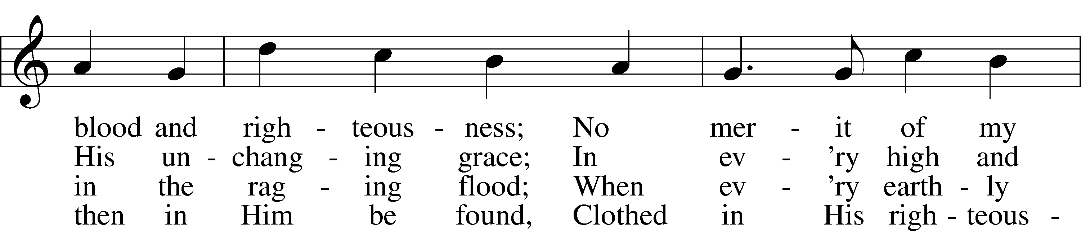
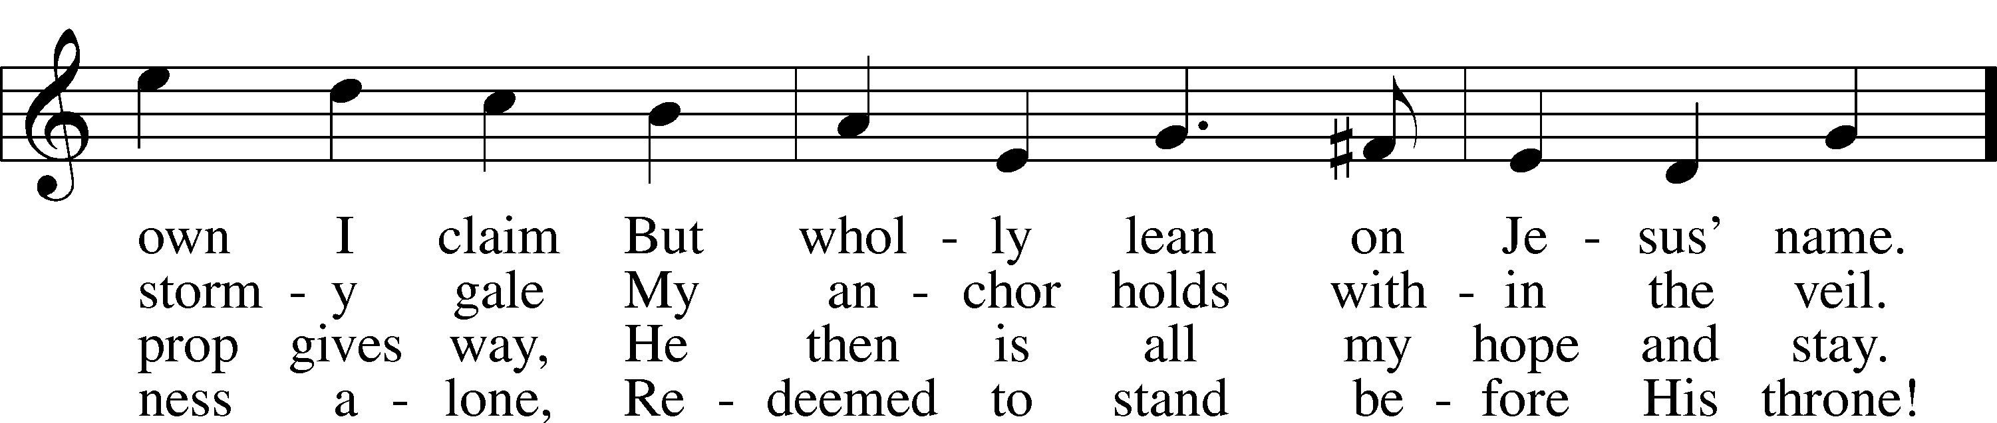
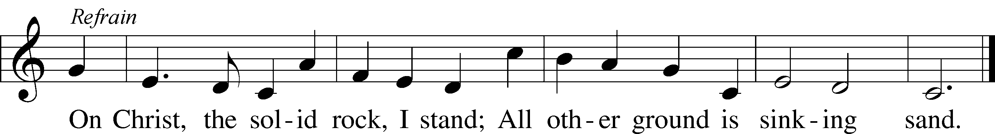

Announcements

Join us after the service in the fellowship hall for refreshments and to welcome our new members: Patricia Hayes, Ralph and Susan Unkert, and Yvette Rock.

THANK YOU! to all who helped donate, bake, set up, clean up and worked the days of the sale. And thank you to Sue Faria for organizing this big project.

Council meeting will be held Friday, October 3rd at 10:00am.

A Voters’ meeting is scheduled for October 12th after service. Important items are to be discussed.

If not taking your bulletin home, please leave on table in the narthex when leaving so it can be recycled. Thank you.

St. John’s Lutheran Church
810 Broad St., Clifton, NJ 07013
StJohnsClifton.Org
PrayingHands810@gmail.com

