Fifteenth Sunday after Pentecost September 21, 2025 – Lectionary Series
St. John’s Lutheran Church

Order of Worship
by
Lutheran Service Builder
909 Christ Is Made the Sure Foundation
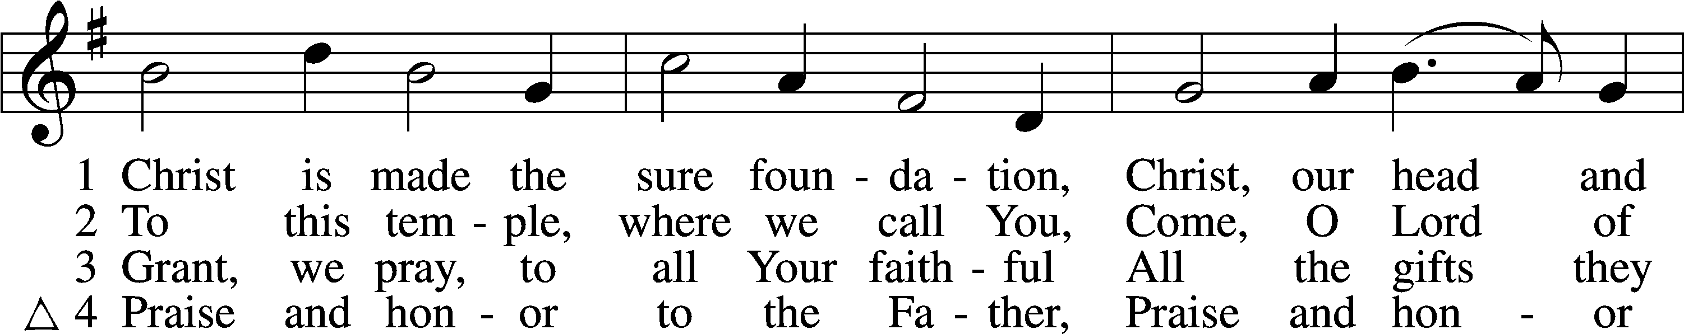
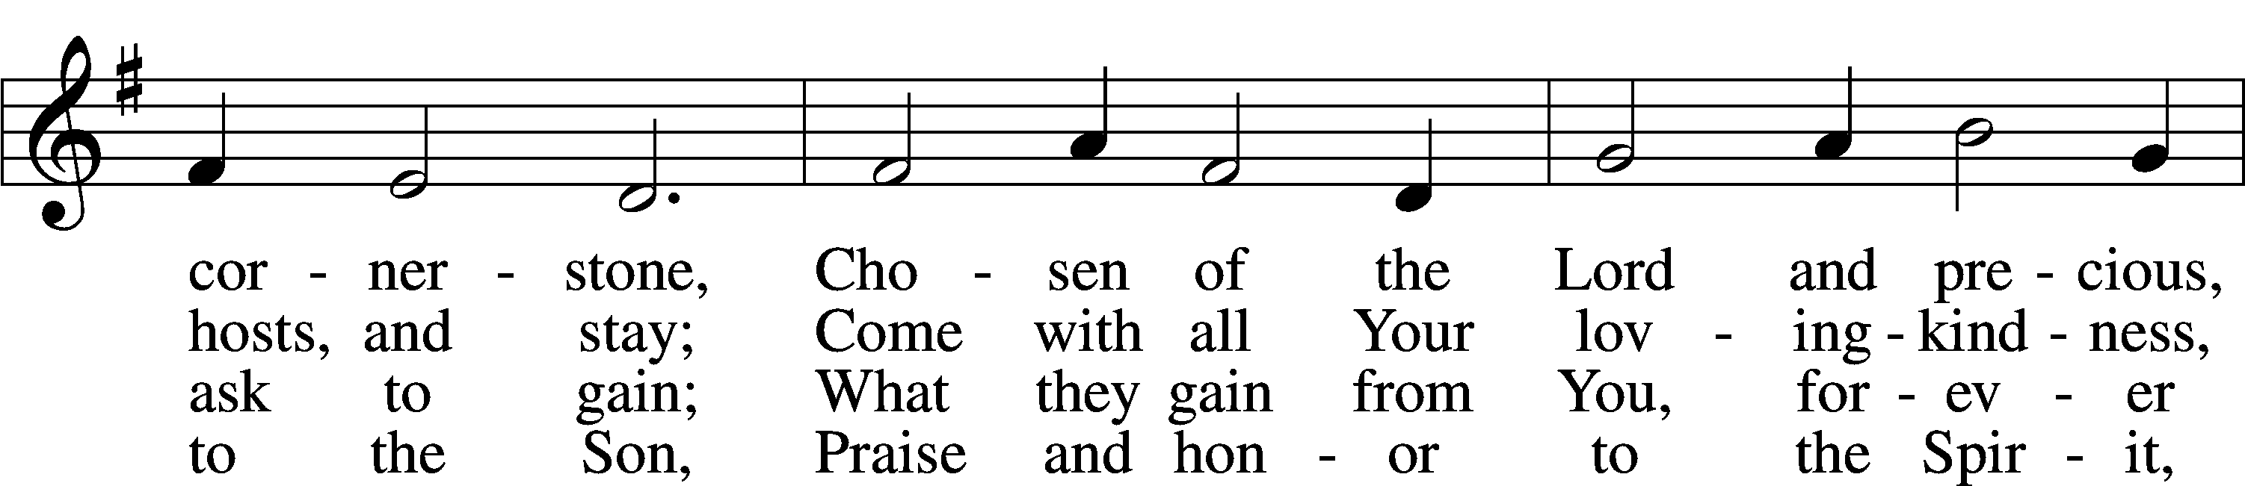
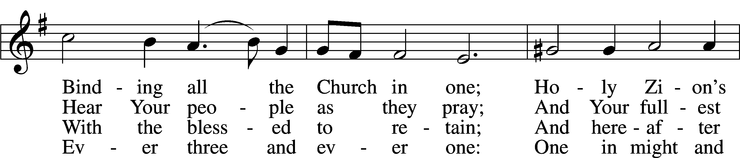
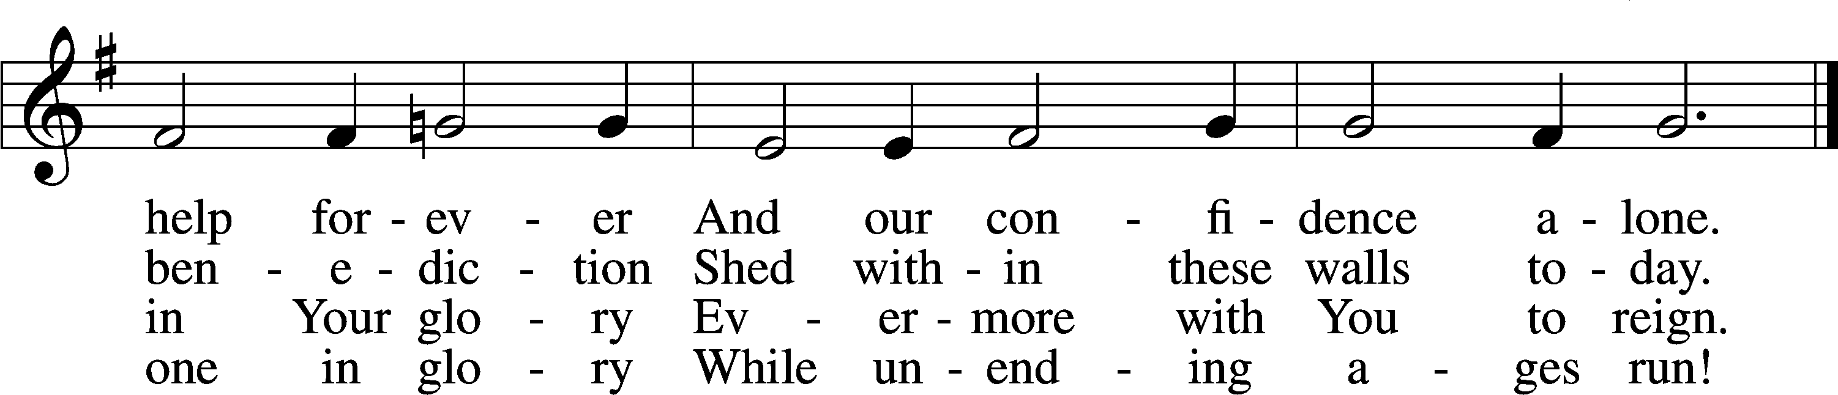

Δ – Stand for last verse

Confession and Absolution

The sign of the cross may be made by all in remembrance of their Baptism.

Invocation
P In the name of the Father and of the T Son and of the Holy Spirit.
C Amen.

Exhortation LSB 184
P Beloved in the Lord! Let us draw near with a true heart and confess our sins unto God our Father, beseeching Him in the name of our Lord Jesus Christ to grant us forgiveness.

P Our help is in the name of the Lord,
C who made heaven and earth.
P I said, I will confess my transgressions unto the Lord,
C and You forgave the iniquity of my sin.

Silence for reflection on God’s Word and for self-examination.

Confession of Sins LSB 184
P O almighty God, merciful Father,
C I, a poor, miserable sinner, confess unto You all my sins and iniquities with which I have ever offended You and justly deserved Your temporal and eternal punishment. But I am heartily sorry for them and sincerely repent of them, and I pray You of Your boundless mercy and for the sake of the holy, innocent, bitter sufferings and death of Your beloved Son, Jesus Christ, to be gracious and merciful to me, a poor, sinful being.

Absolution LSB 185
P Upon this your confession, I, by virtue of my office, as a called and ordained servant of the Word, announce the grace of God unto all of you, and in the stead and by the command of my Lord Jesus Christ I forgive you all your sins in the name of the Father and of the T Son and of the Holy Spirit.
C Amen.

Service of the Word

Introit Psalm 119:137–140, 142; antiphon: v. 144
Your testimonies are righteous forever;
give me understanding that I may live.
Righteous are you, O Lord,
and right are your just decrees.
You have appointed your testimonies in righteousness
and in all faithfulness.
My zeal consumes me,
because my foes forget your words.
Your promise is well tried,
and your servant loves it.
Your righteousness is righteous forever,
and your law is true.
Glory be to the Father and to the Son
and to the Holy Spirit;
as it was in the beginning,
is now, and will be forever. Amen.
Your testimonies are righteous forever;
give me understanding that I may live.

Kyrie LSB 186
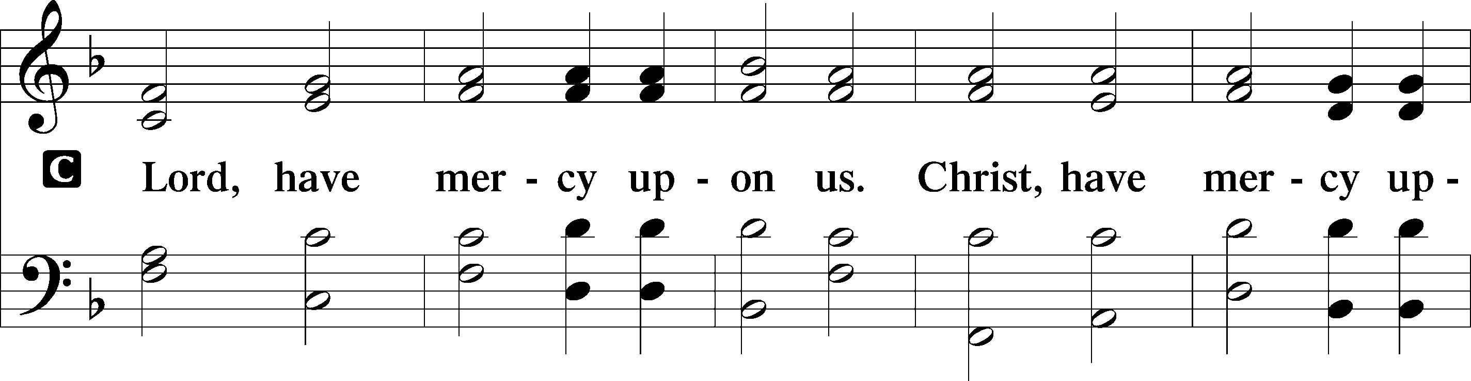
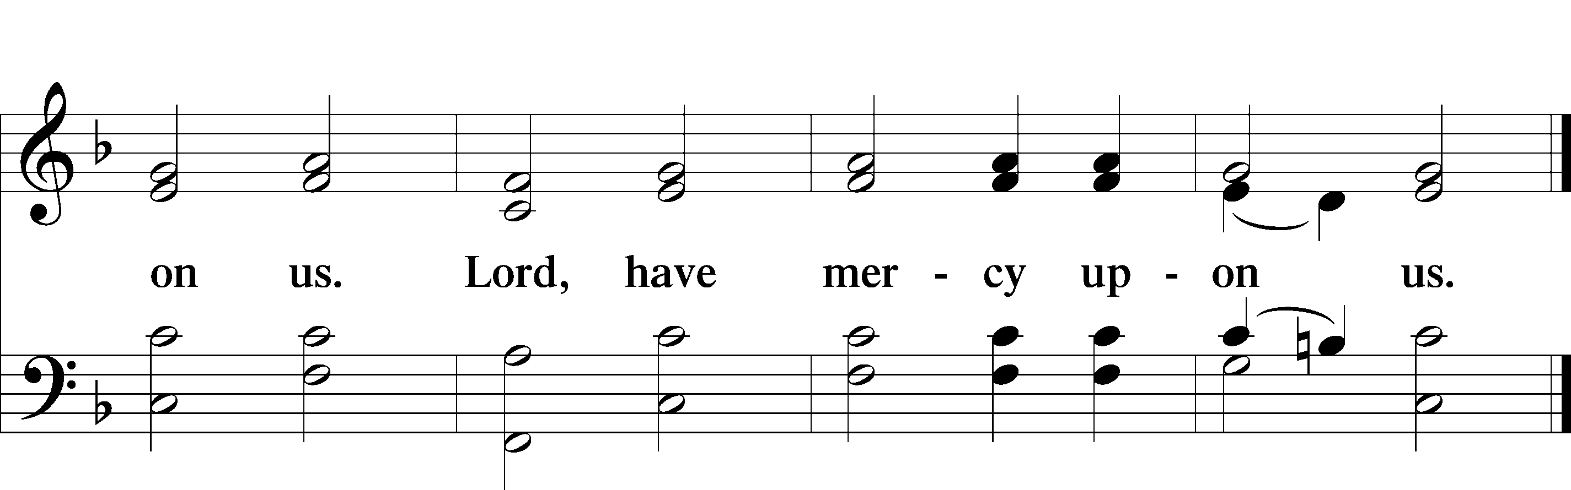

Gloria in Excelsis LSB 187
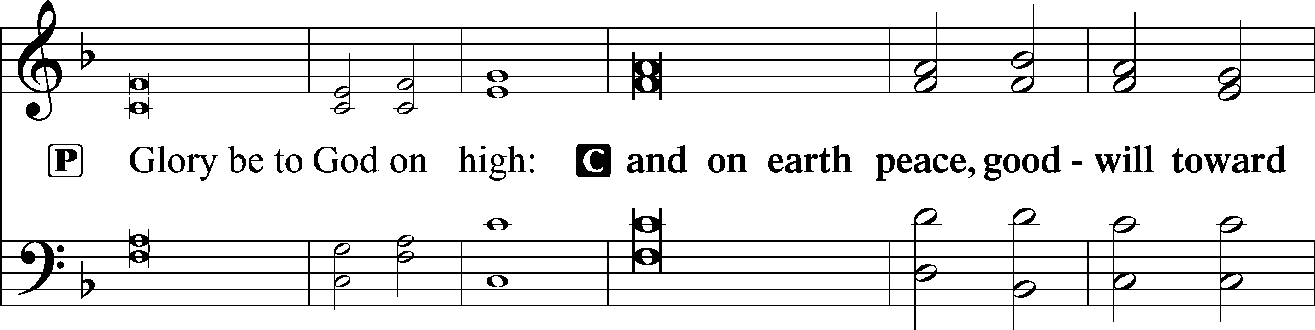
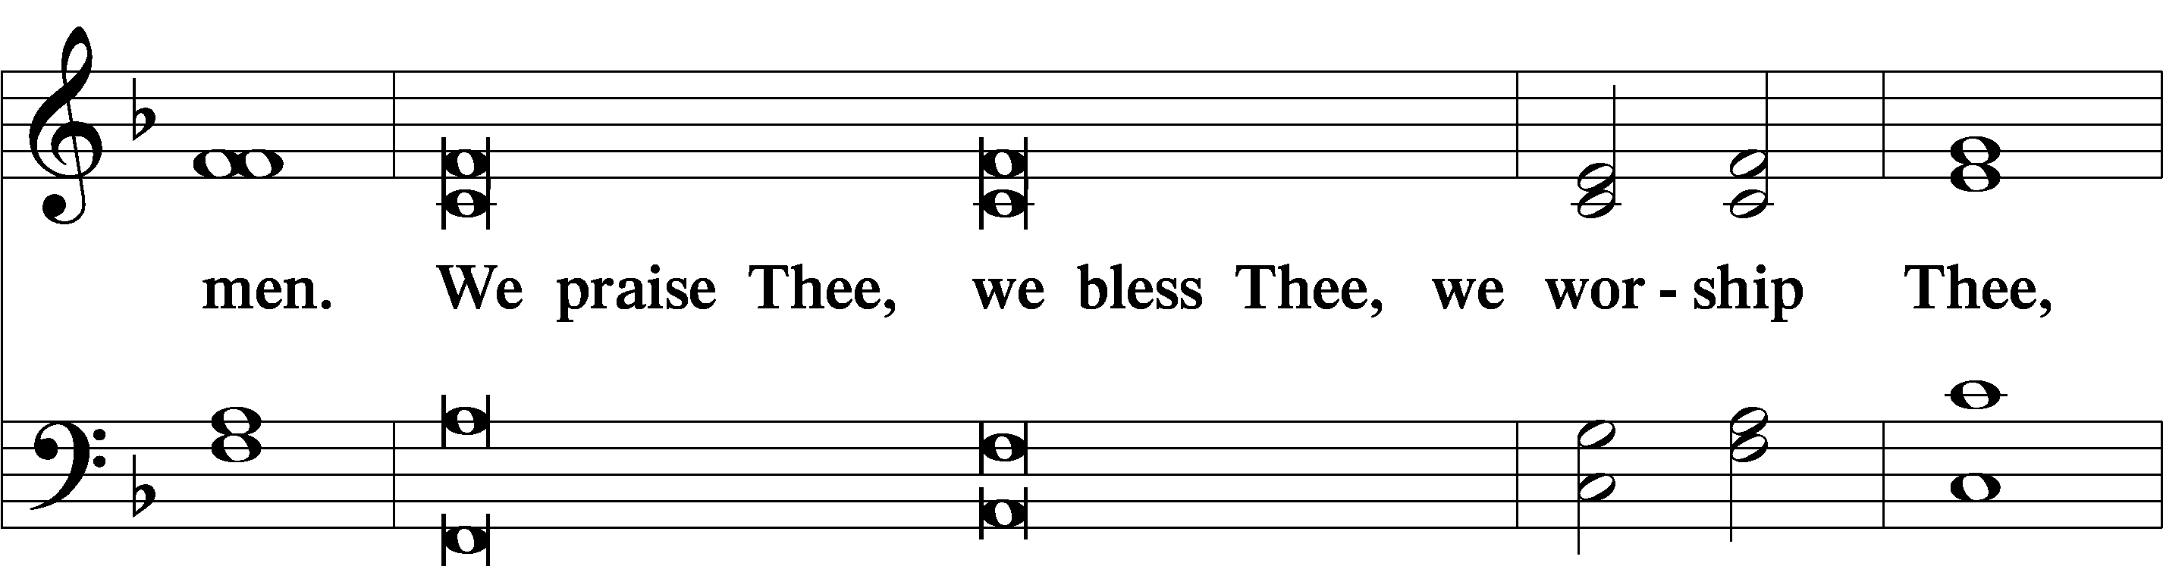
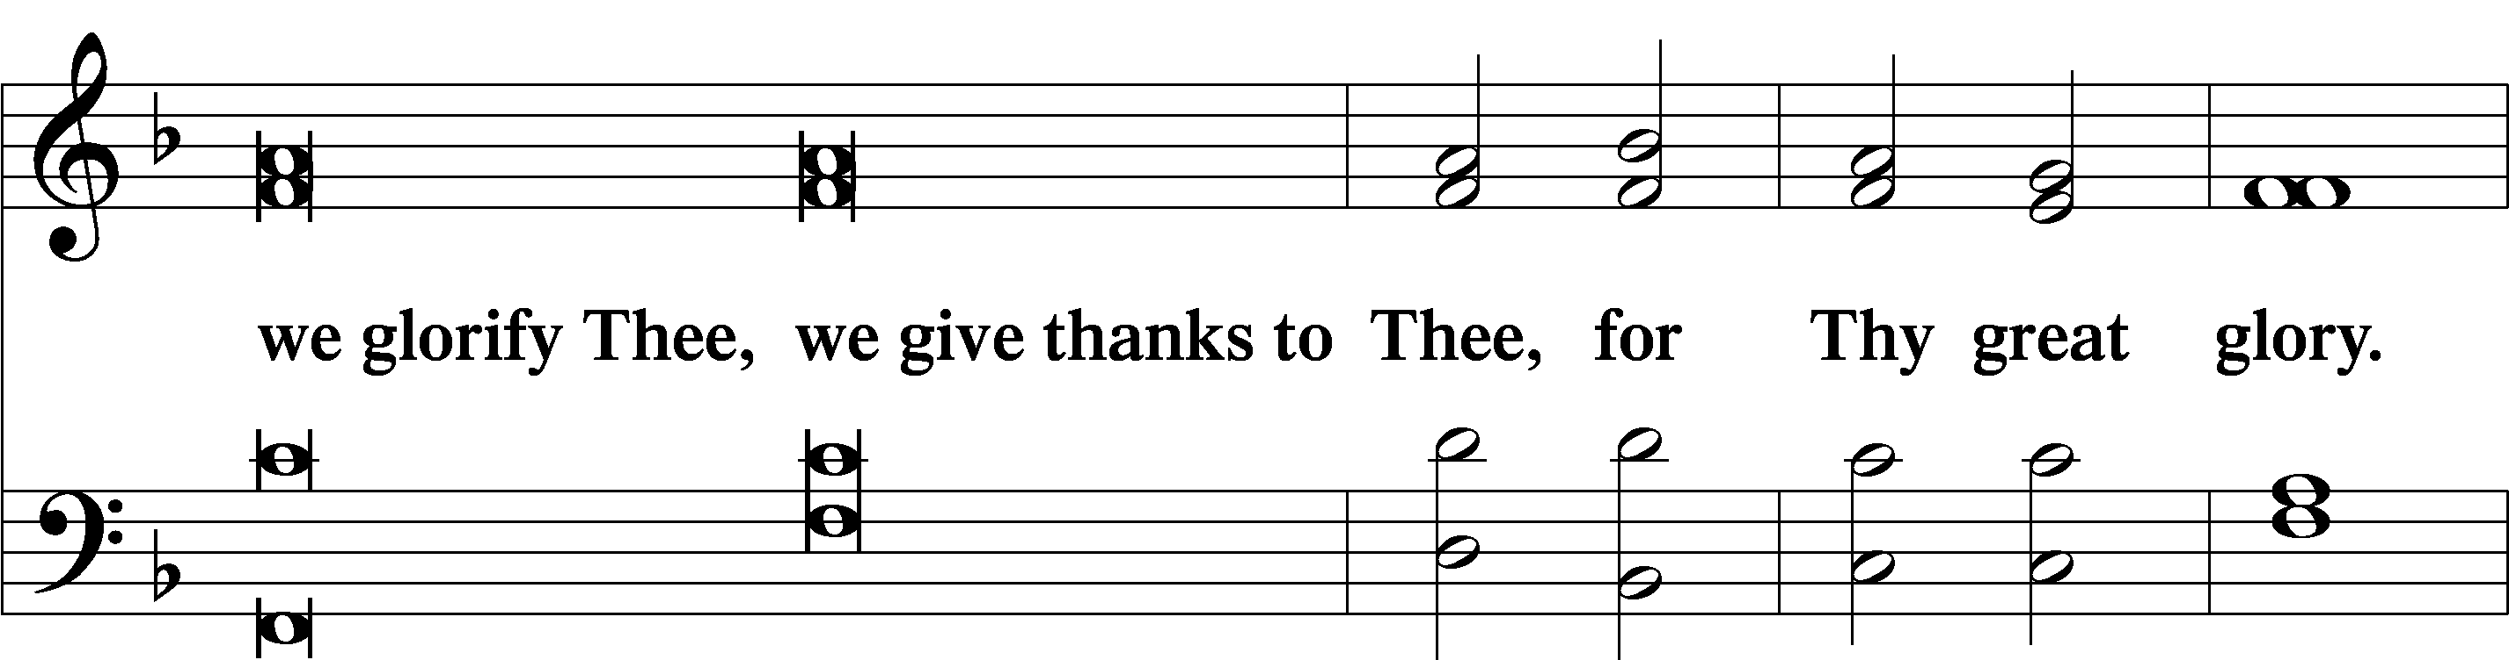
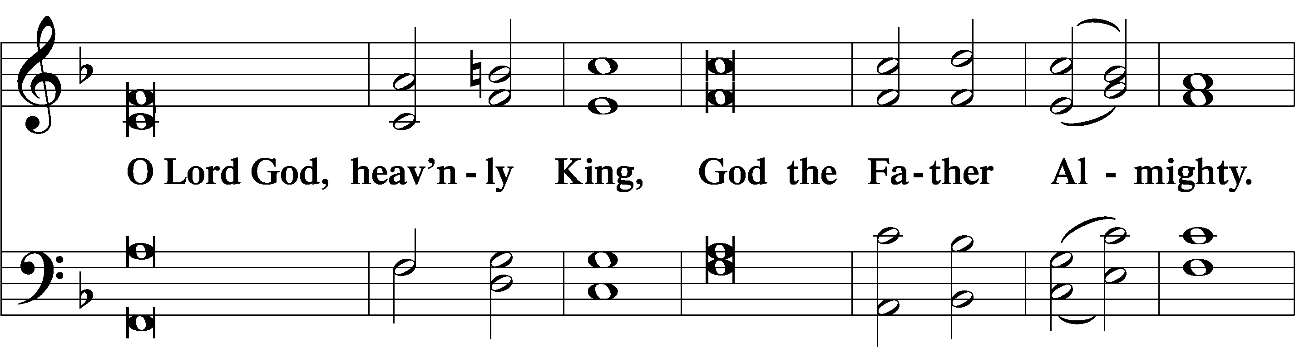
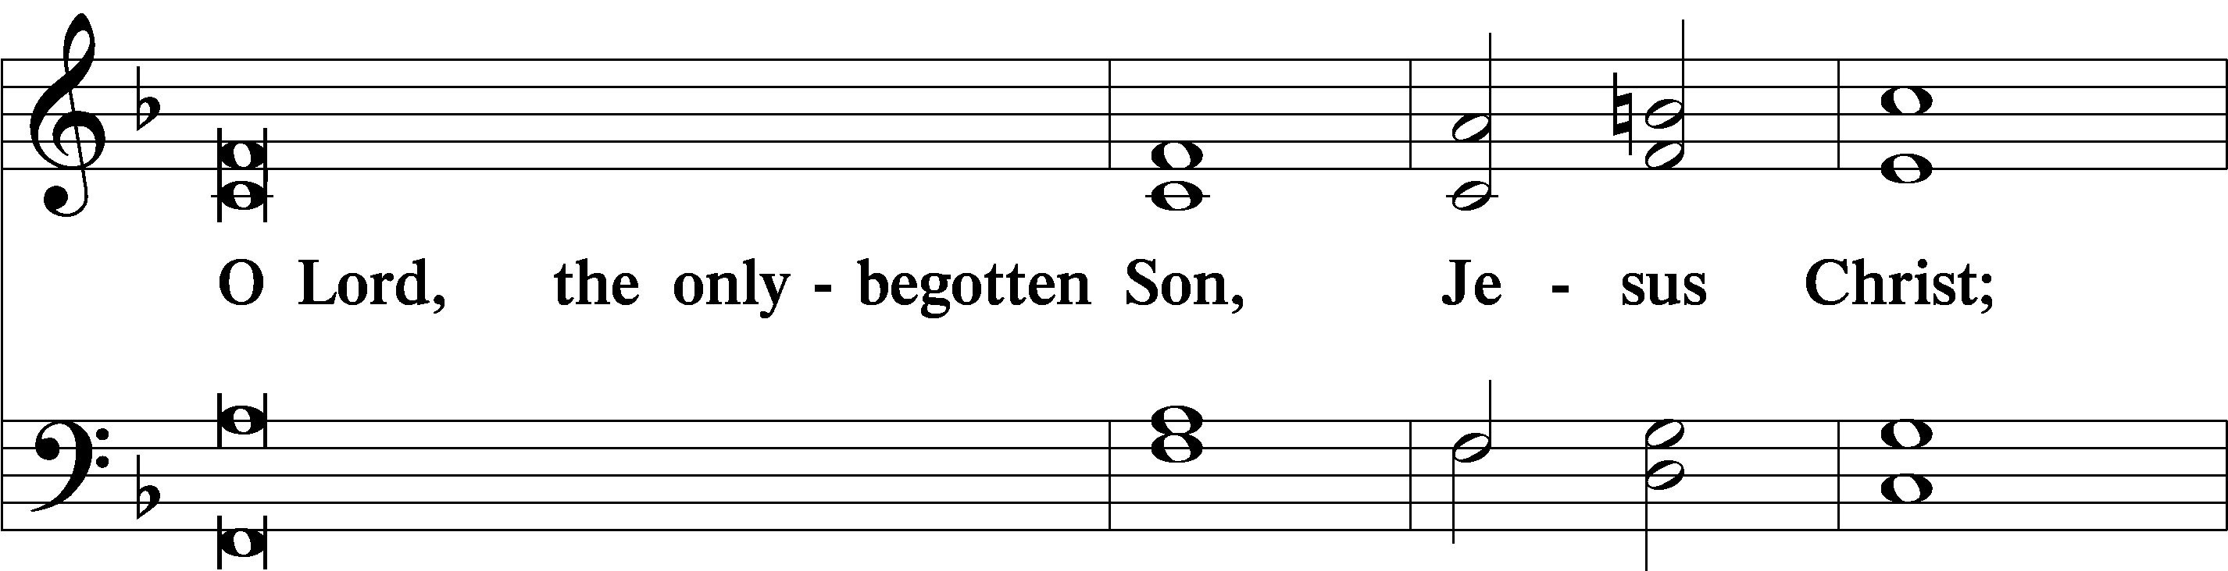
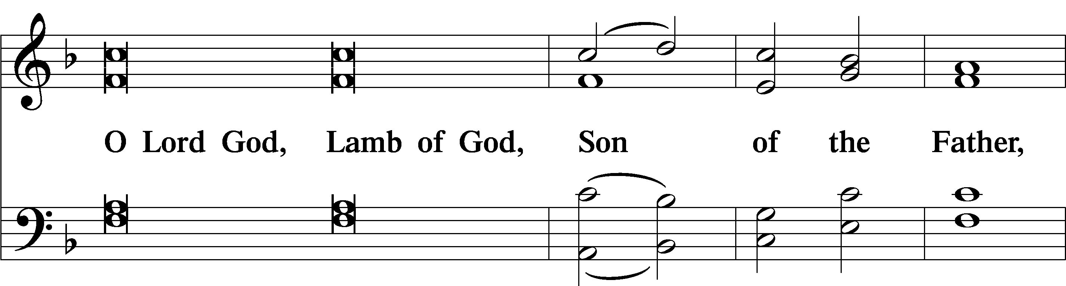
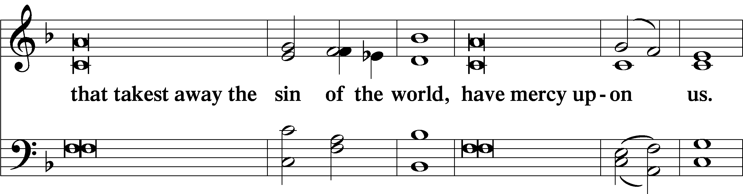
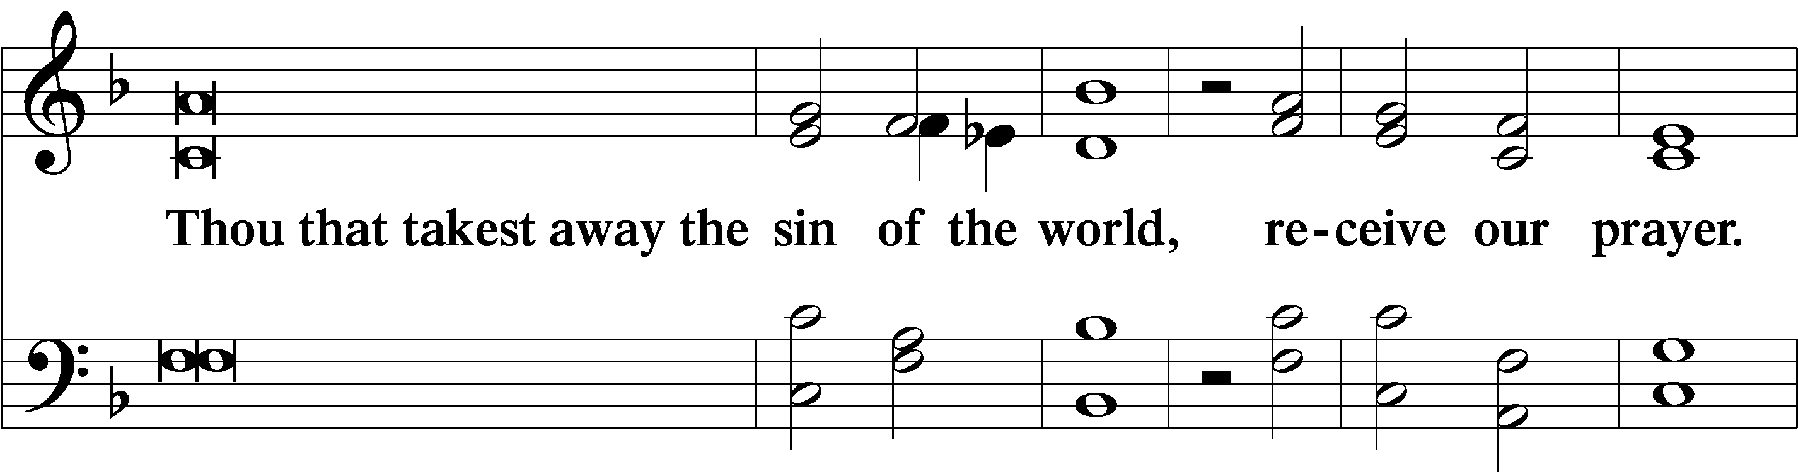
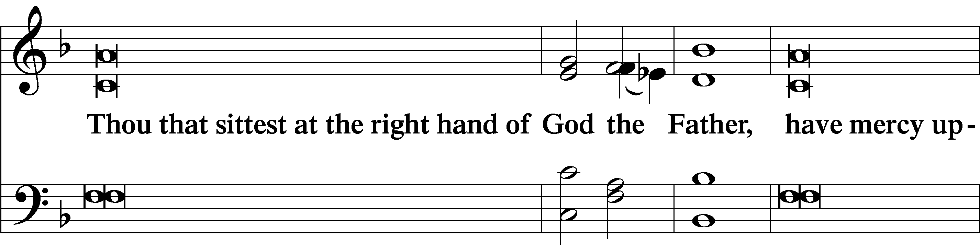
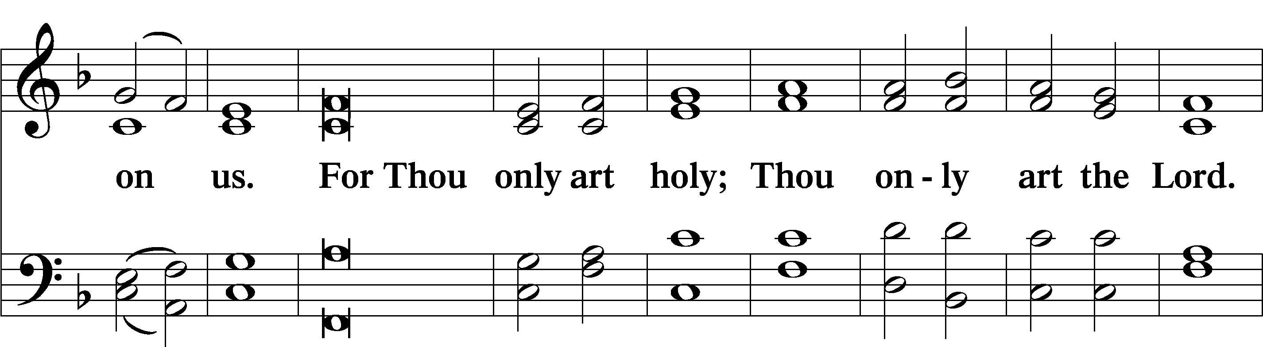
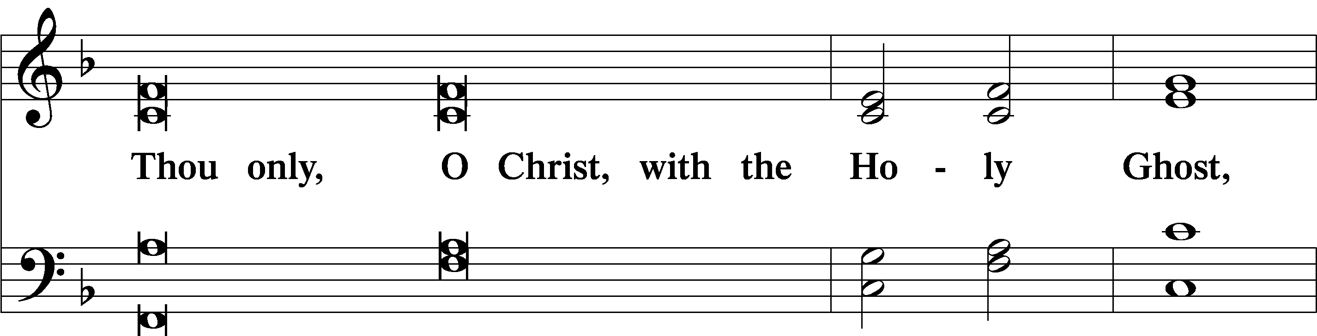
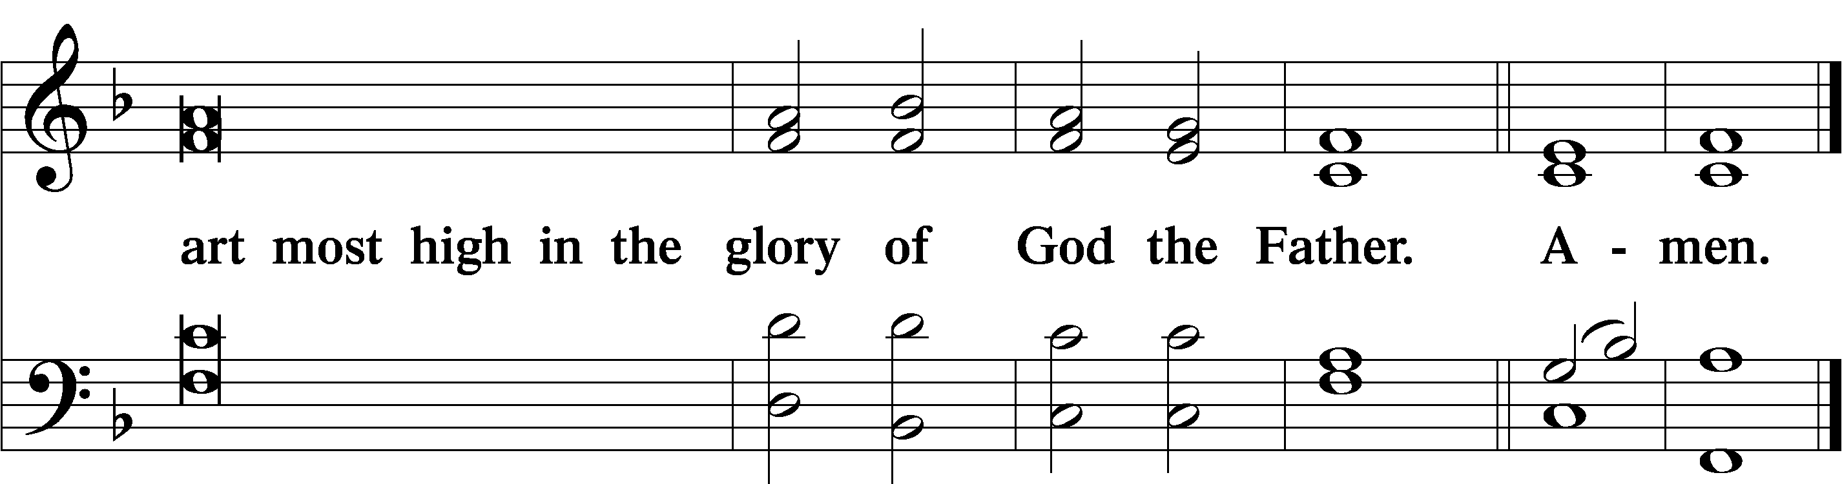

Salutation and Collect of the Day

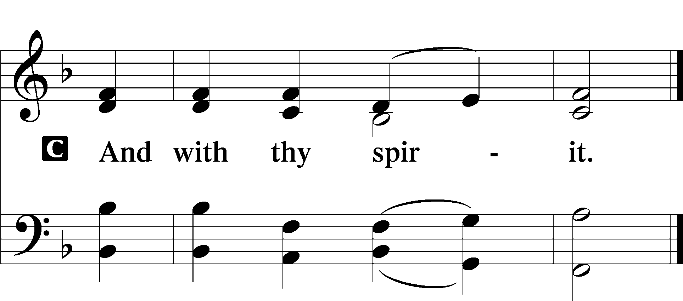
P Let us pray.
P O Lord, keep Your Church in Your perpetual mercy; and because without You we cannot but fall, preserve us from all things hurtful, and lead us to all things profitable to our salvation; through Jesus Christ, Your Son, our Lord, who lives and reigns with You and the Holy Spirit, one God, now and forever.

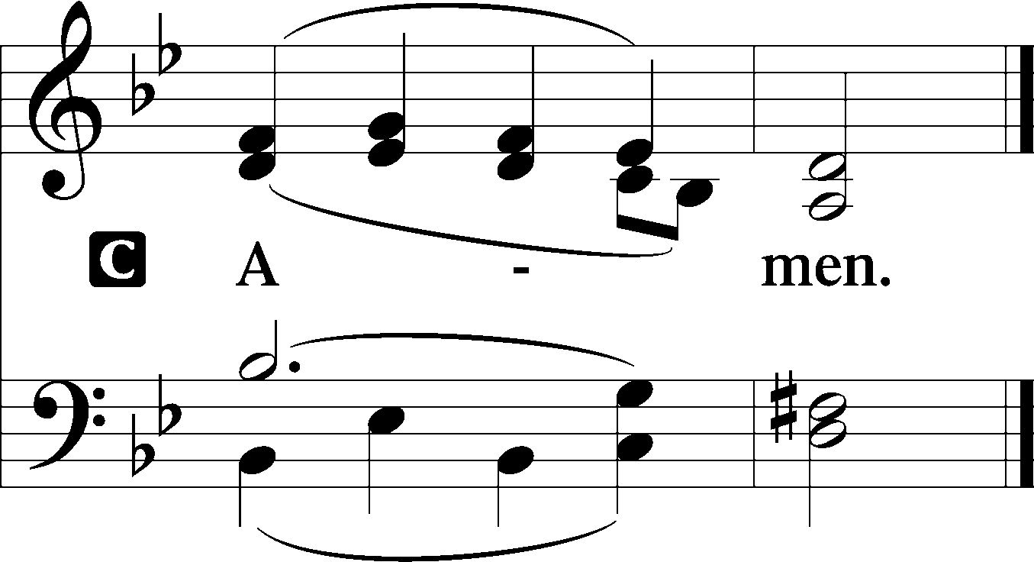

Sit

Old Testament Reading Amos 8:4–7
Hear this, you who trample on the needy
and bring the poor of the land to an end,
saying, “When will the new moon be over,
that we may sell grain?
And the Sabbath,
that we may offer wheat for sale,
that we may make the ephah small and the shekel great
and deal deceitfully with false balances,
that we may buy the poor for silver
and the needy for a pair of sandals
and sell the chaff of the wheat?”
The Lord has sworn by the pride of Jacob:
“Surely I will never forget any of their deeds.”

A This is the Word of the Lord.
C Thanks be to God.

Epistle 1 Timothy 2:1–15
First of all, then, I urge that supplications, prayers, intercessions, and thanksgivings be made for all people, for kings and all who are in high positions, that we may lead a peaceful and quiet life, godly and dignified in every way. This is good, and it is pleasing in the sight of God our Savior, who desires all people to be saved and to come to the knowledge of the truth. For there is one God, and there is one mediator between God and men, the man Christ Jesus, who gave himself as a ransom for all, which is the testimony given at the proper time. For this I was appointed a preacher and an apostle (I am telling the truth, I am not lying), a teacher of the Gentiles in faith and truth.
I desire then that in every place the men should pray, lifting holy hands without anger or quarreling; likewise also that women should adorn themselves in respectable apparel, with modesty and self-control, not with braided hair and gold or pearls or costly attire, but with what is proper for women who profess godliness—with good works. Let a woman learn quietly with all submissiveness. I do not permit a woman to teach or to exercise authority over a man; rather, she is to remain quiet. For Adam was formed first, then Eve; and Adam was not deceived, but the woman was deceived and became a transgressor. Yet she will be saved through childbearing—if they continue in faith and love and holiness, with self-control.

A This is the Word of the Lord.
C Thanks be to God.

Stand

Alleluia LSB 190
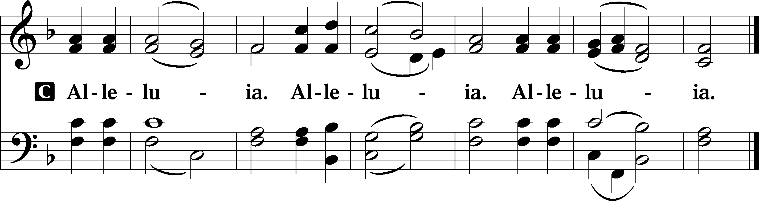

Holy Gospel Luke 16:1–15
P The Holy Gospel according to St. Luke, the sixteenth chapter.
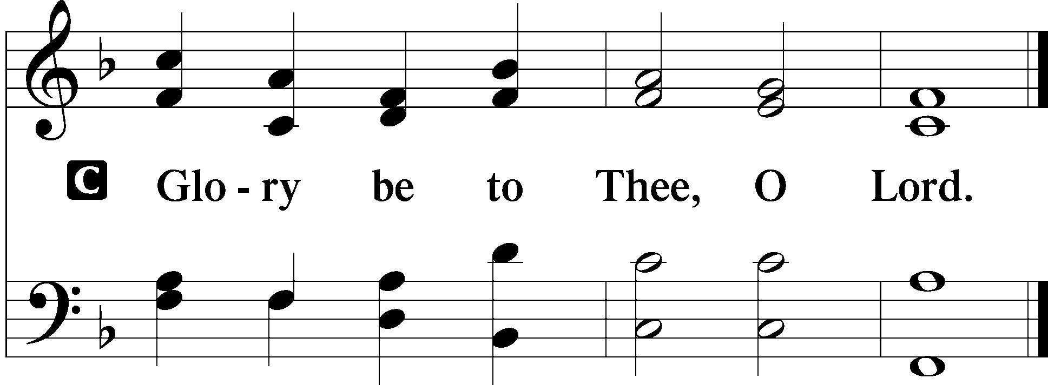

[Jesus] also said to the disciples, “There was a rich man who had a manager, and charges were brought to him that this man was wasting his possessions. And he called him and said to him, ‘What is this that I hear about you? Turn in the account of your management, for you can no longer be manager.’ And the manager said to himself, ‘What shall I do, since my master is taking the management away from me? I am not strong enough to dig, and I am ashamed to beg. I have decided what to do, so that when I am removed from management, people may receive me into their houses.’ So, summoning his master’s debtors one by one, he said to the first, ‘How much do you owe my master?’ He said, ‘A hundred measures of oil.’ He said to him, ‘Take your bill, and sit down quickly and write fifty.’ Then he said to another, ‘And how much do you owe?’ He said, ‘A hundred measures of wheat.’ He said to him, ‘Take your bill, and write eighty.’ The master commended the dishonest manager for his shrewdness. For the sons of this world are more shrewd in dealing with their own generation than the sons of light. And I tell you, make friends for yourselves by means of unrighteous wealth, so that when it fails they may receive you into the eternal dwellings.
“One who is faithful in a very little is also faithful in much, and one who is dishonest in a very little is also dishonest in much. If then you have not been faithful in the unrighteous wealth, who will entrust to you the true riches? And if you have not been faithful in that which is another’s, who will give you that which is your own? No servant can serve two masters, for either he will hate the one and love the other, or he will be devoted to the one and despise the other. You cannot serve God and money.”
The Pharisees, who were lovers of money, heard all these things, and they ridiculed him. And he said to them, “You are those who justify yourselves before men, but God knows your hearts. For what is exalted among men is an abomination in the sight of God.”

P This is the Gospel of the Lord.
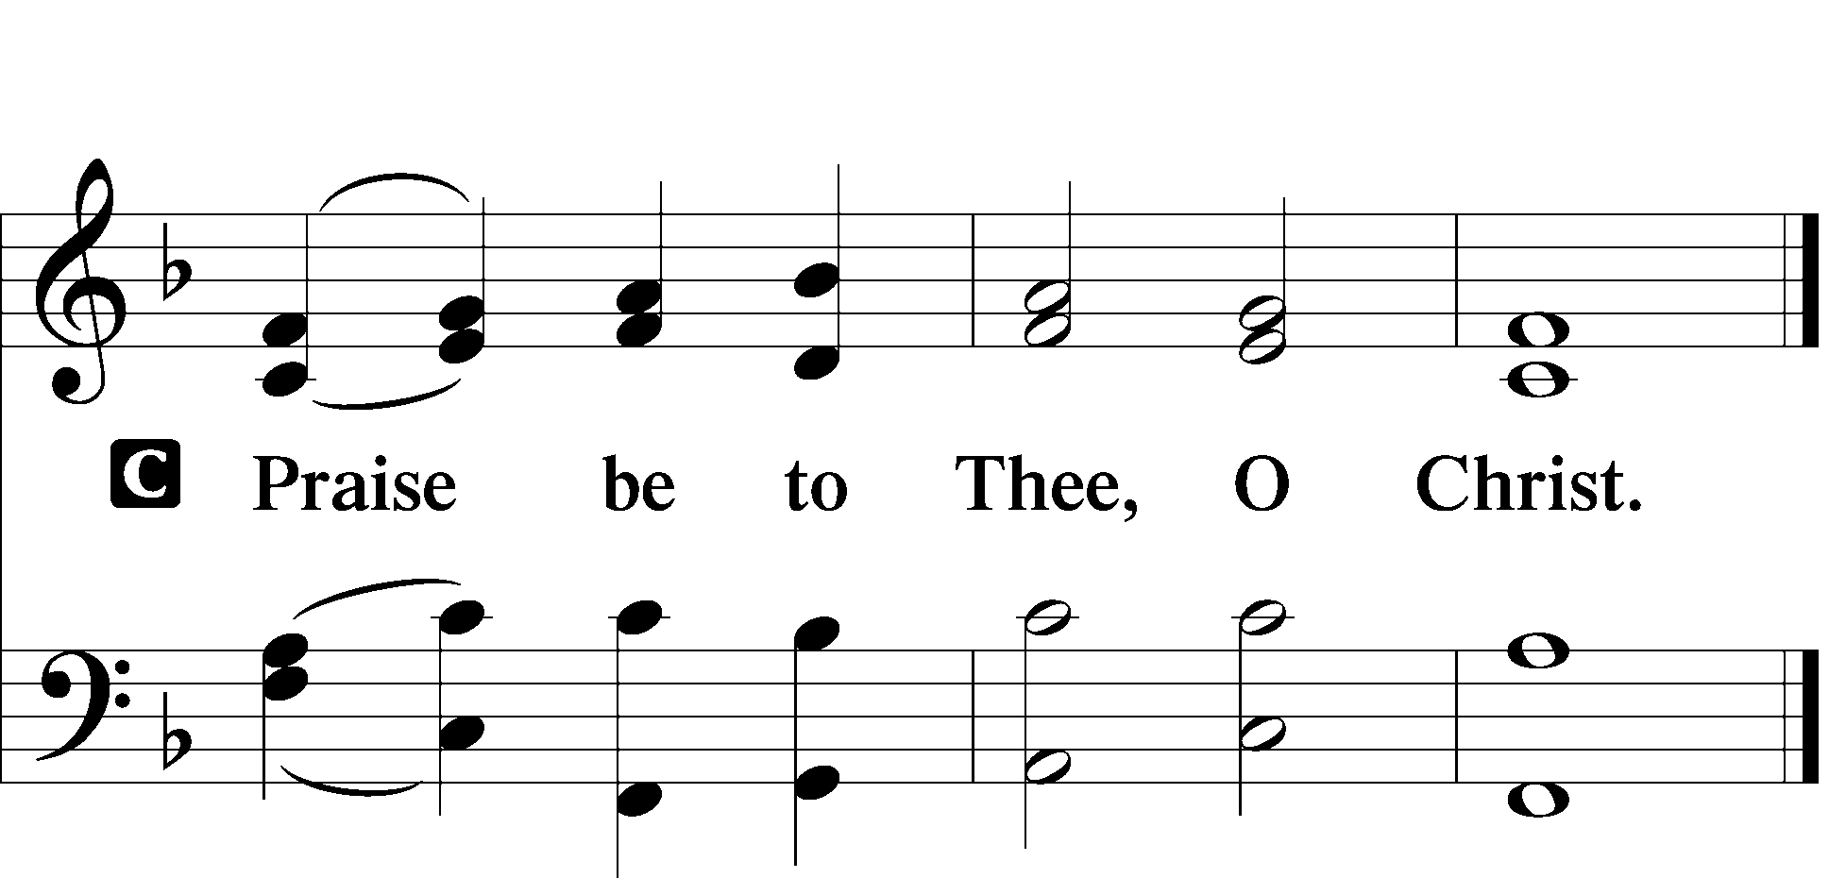

Nicene Creed
C I believe in one God,
the Father Almighty,
maker of heaven and earth
and of all things visible and invisible.

And in one Lord Jesus Christ,
the only-begotten Son of God,
begotten of His Father before all worlds,
God of God, Light of Light,
very God of very God,
begotten, not made,
being of one substance with the Father,
by whom all things were made;
who for us men and for our salvation came down from heaven
and was incarnate by the Holy Spirit of the virgin Mary
and was made man;
and was crucified also for us under Pontius Pilate.
He suffered and was buried.
And the third day He rose again according to the Scriptures
and ascended into heaven
and sits at the right hand of the Father.
And He will come again with glory to judge both the living and the dead,
whose kingdom will have no end.

And I believe in the Holy Spirit,
the Lord and giver of life,
who proceeds from the Father and the Son,
who with the Father and the Son together is worshiped and glorified,
who spoke by the prophets.
And I believe in one holy Christian and apostolic Church,
I acknowledge one Baptism for the remission of sins,
and I look for the resurrection of the dead
and the life T of the world to come. Amen.

Sit

557 Seek Where You May to Find a Way
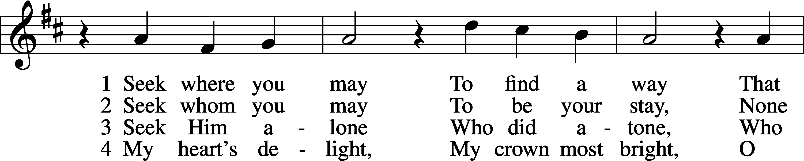
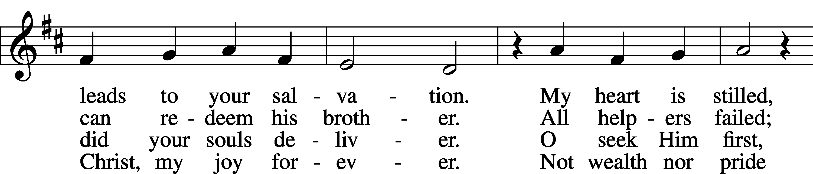
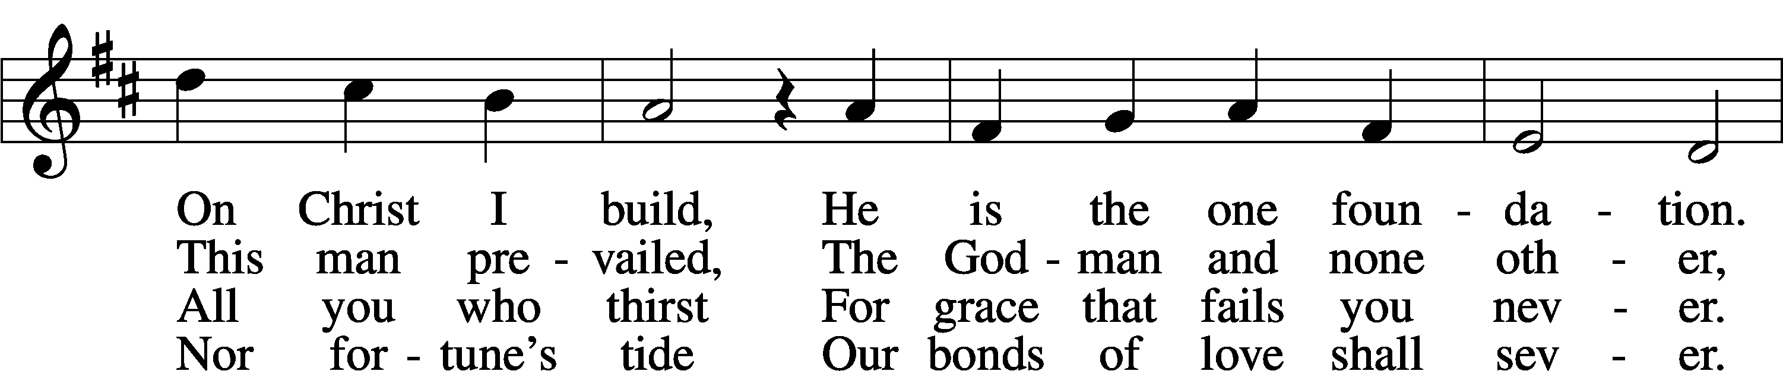
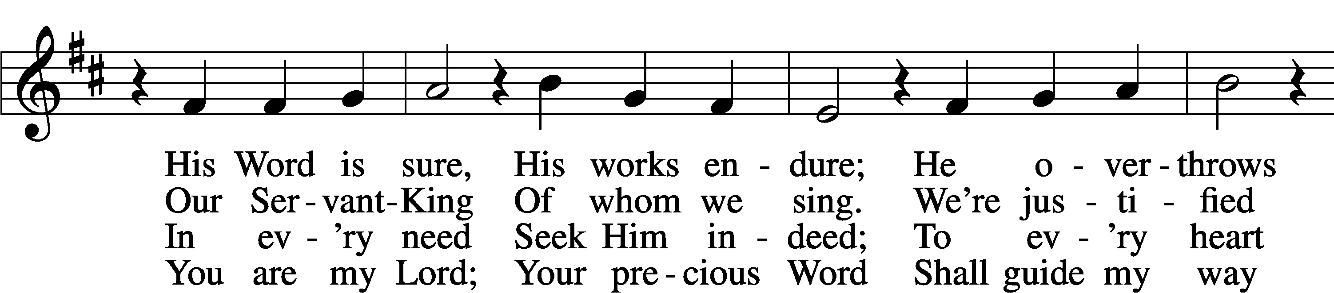
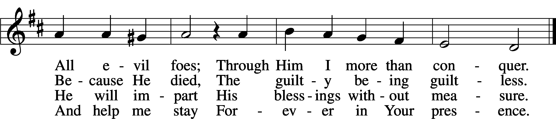

Sermon

Offering

Psalm Psalm 113; antiphon: v. 3
Praise the Lord!
Praise, O servants of the Lord,
praise the name of the Lord!
Blessèd be the name of the Lord
from this time forth and forevermore!
From the rising of the sun to its setting,
the name of the Lord is to be praised!
The Lord is high above all nations,
and his glory above the heavens!
Who is like the Lord our God,
who is seated on high,
who looks far down
on the heavens and the earth?
He raises the poor from the dust
and lifts the needy from the ash heap,
to make them sit with princes,
with the princes of his people.
He gives the barren woman a home,
making her the joyous mother
of children. Praise the Lord!

Stand

781 We Give Thee But Thine Own sts. 1–2
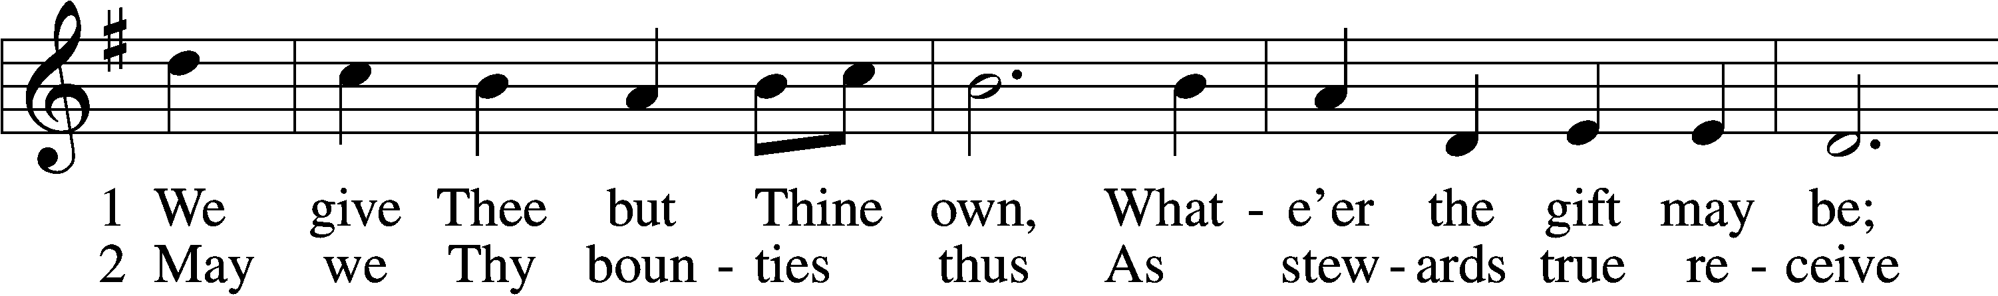
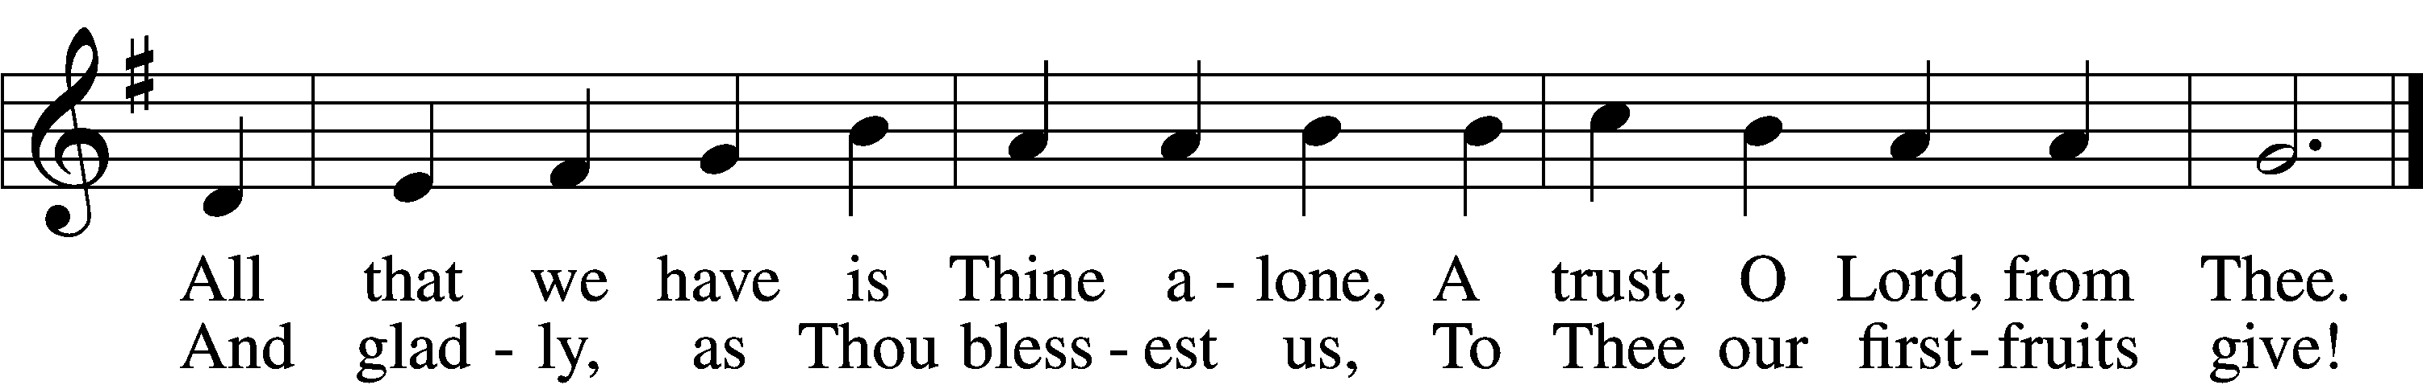

Prayer of the Church
After “let us pray to the Lord:” respond with “Lord, have mercy.”
.

Service of the Sacrament

Preface LSB 194

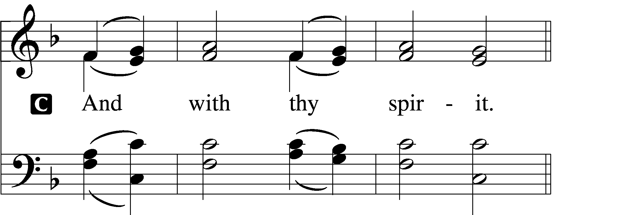


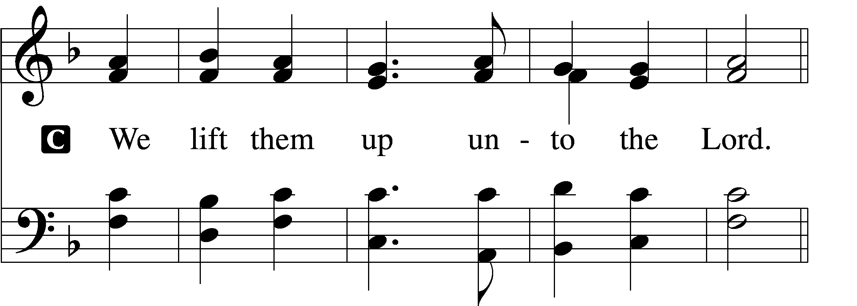

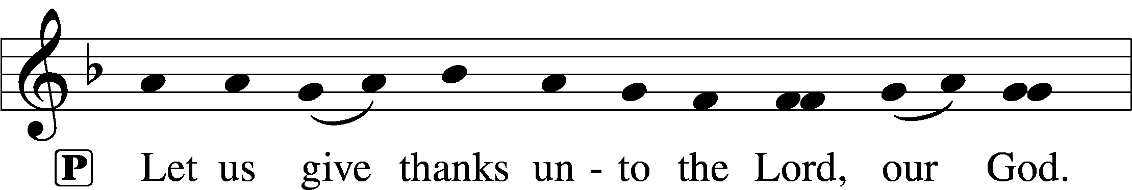
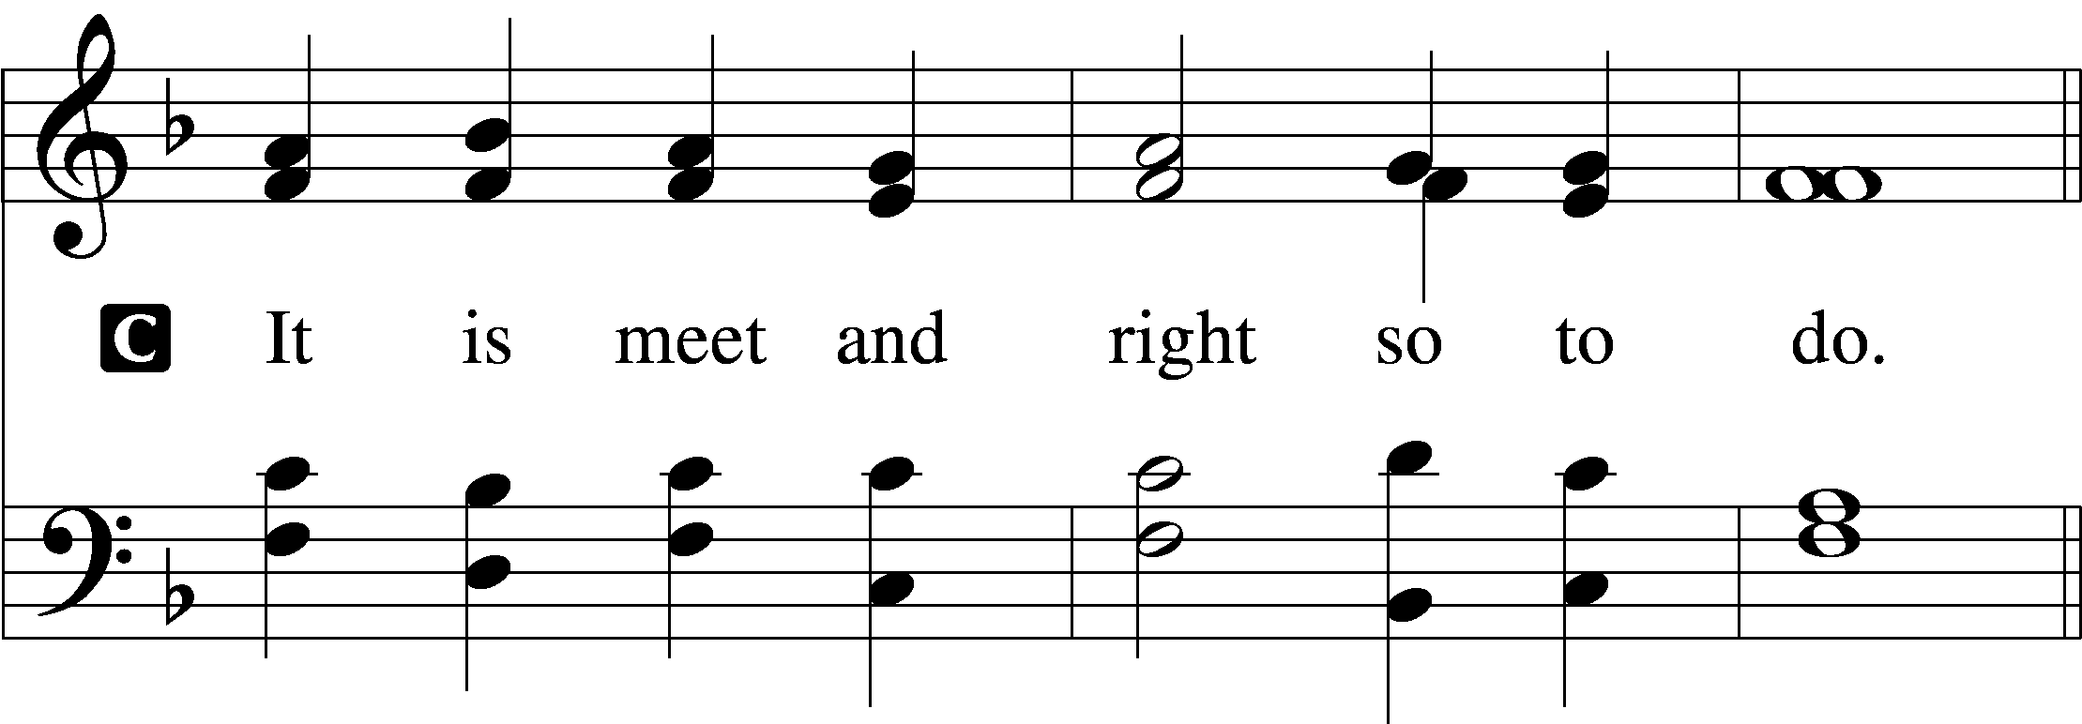

Proper Preface (Full)
P It is truly meet, right, and salutary that we should at all times and in all places give thanks to You, holy Lord, almighty Father, everlasting God, through Jesus Christ, our Lord, who, having created all things, took on human flesh and was born of the virgin Mary. For our sake He died on the cross and rose from the dead to put an end to death, thus fulfilling Your will and gaining for You a holy people. Therefore with angels and archangels and with all the company of heaven we laud and magnify Your glorious name, evermore praising You and saying:

Sanctus 195
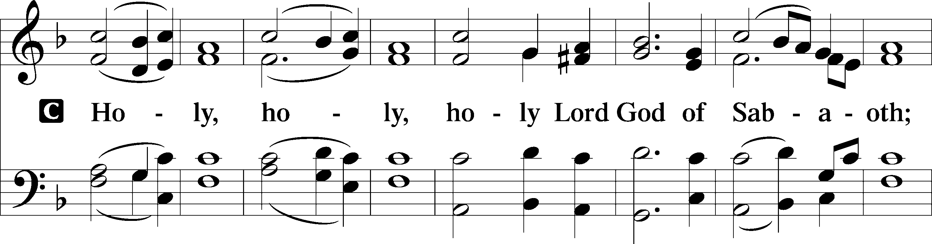
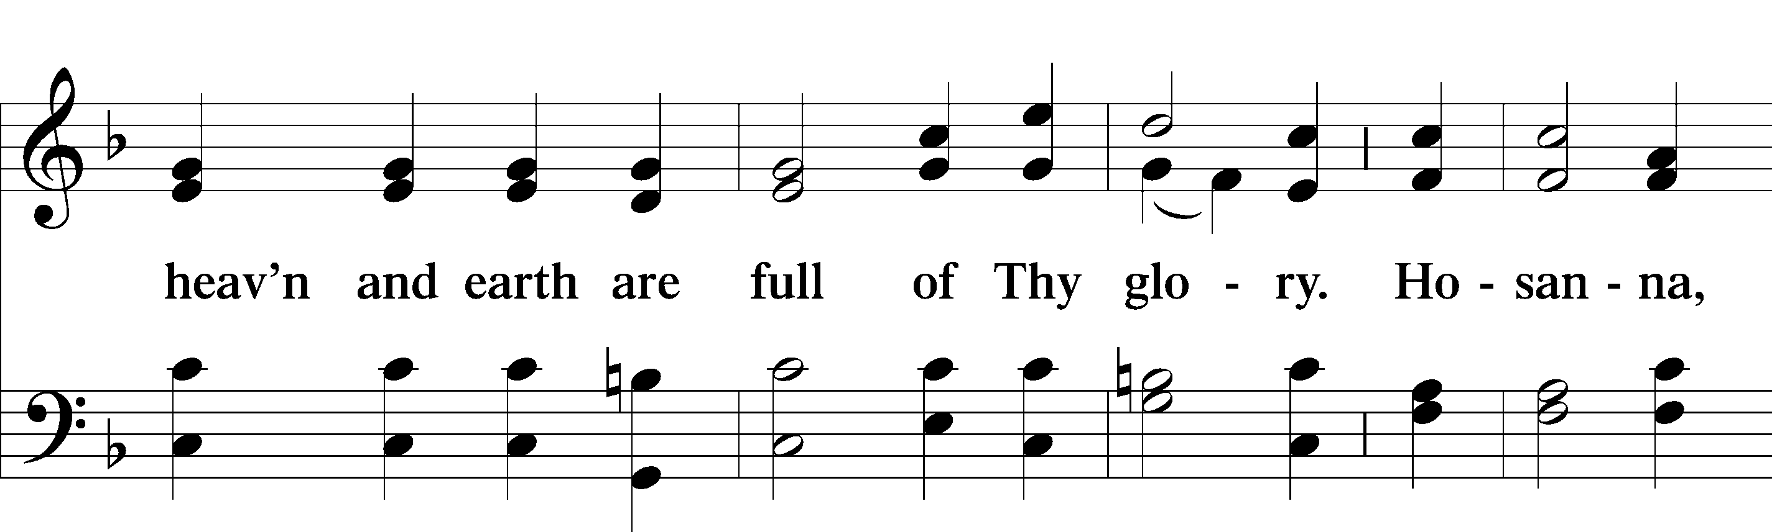
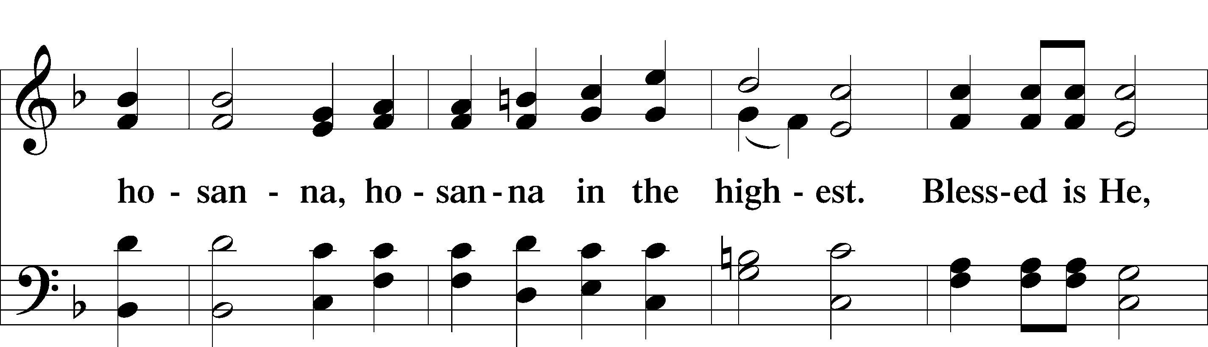
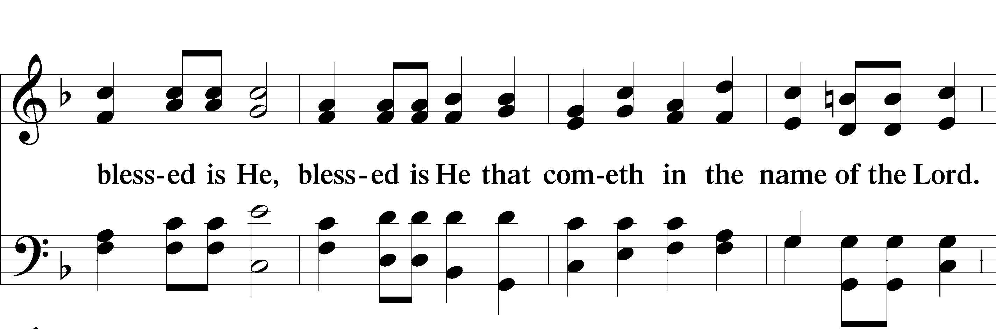
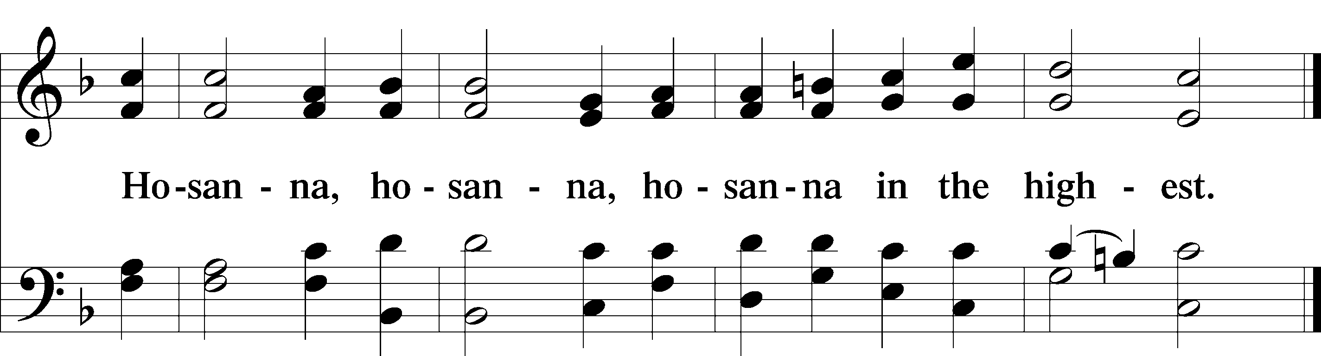

Lord’s Prayer LSB 196
C Our Father who art in heaven,
hallowed be Thy name,
Thy kingdom come,
Thy will be done on earth as it is in heaven;
give us this day our daily bread;
and forgive us our trespasses as we forgive those who trespass against us;
and lead us not into temptation,
but deliver us from evil.
C For Thine is the kingdom and the power and the glory forever and ever. Amen.

The Words of Our Lord 197
P Our Lord Jesus Christ, on the night when He was betrayed, took bread, and when He had given thanks, He broke it and gave it to the disciples and said: “Take, eat; this is My T body, which is given for you. This do in remembrance of Me.”

In the same way also He took the cup after supper, and when He had given thanks, He gave it to them, saying: “Drink of it, all of you; this cup is the new testament in My T blood, which is shed for you for the forgiveness of sins. This do, as often as you drink it, in remembrance of Me.”

Pax Domini LSB 197
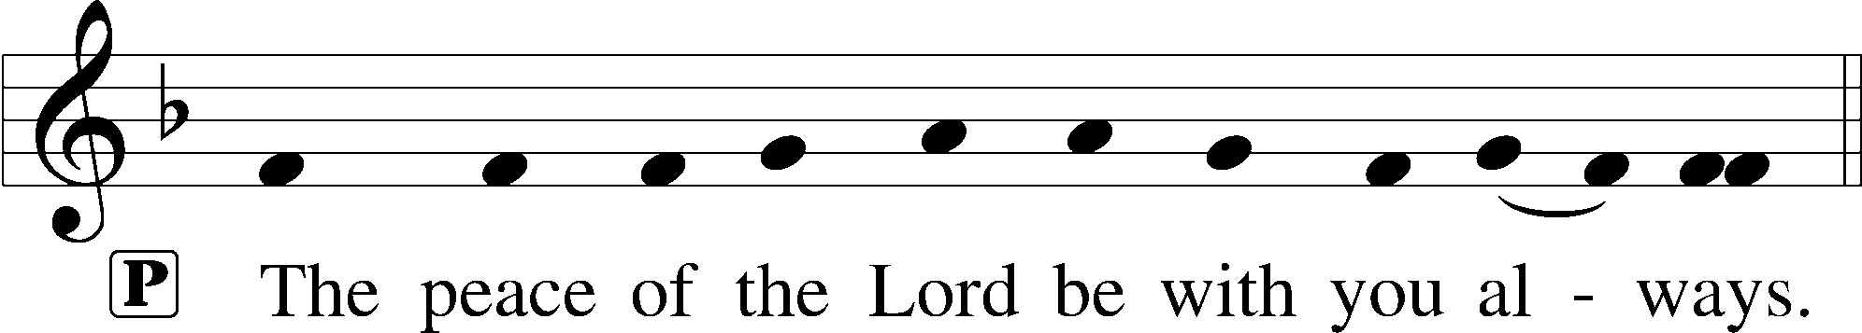
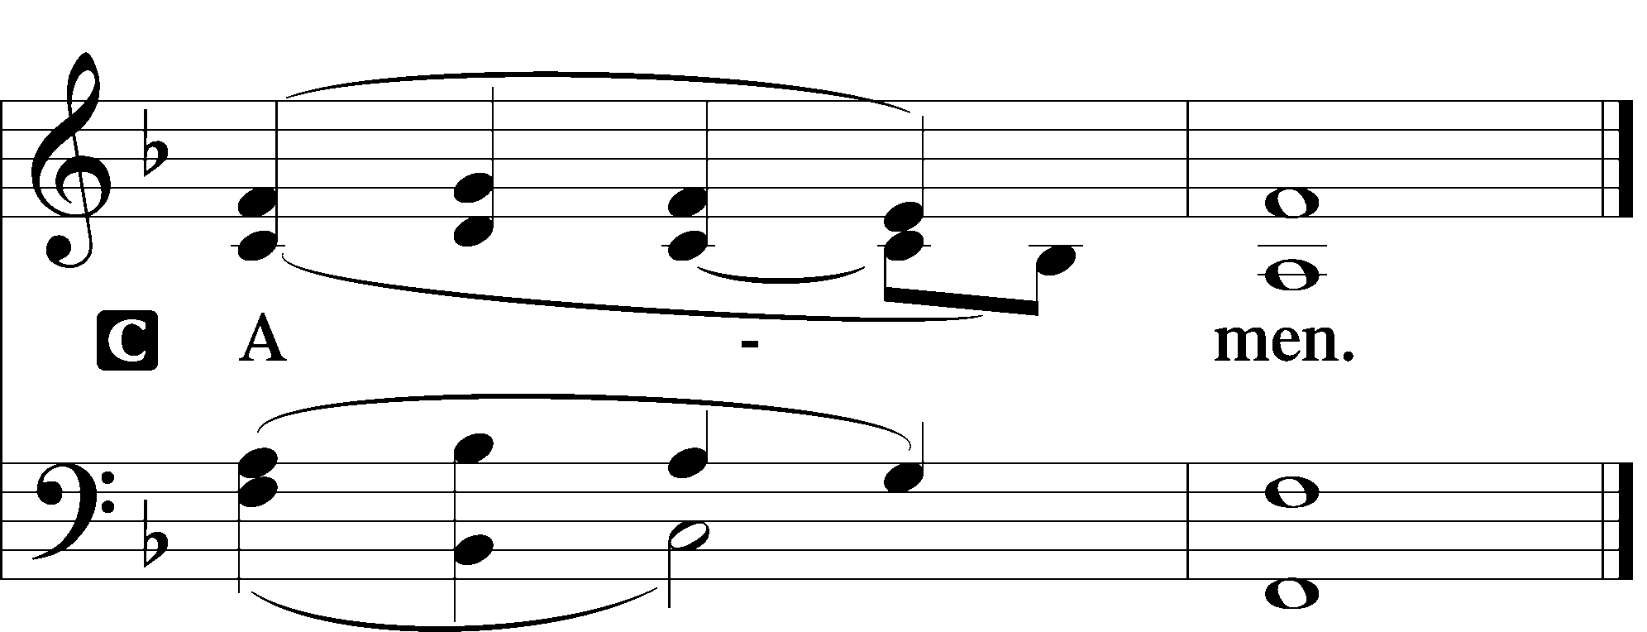

Agnus Dei LSB 198

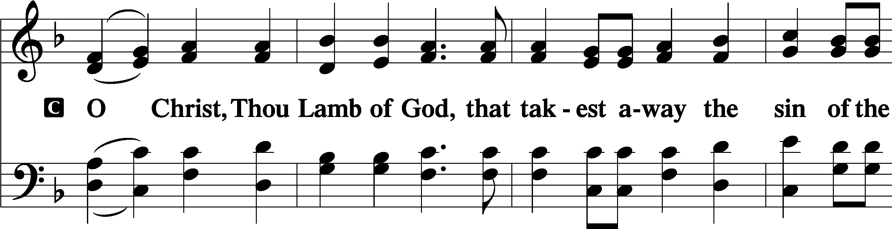
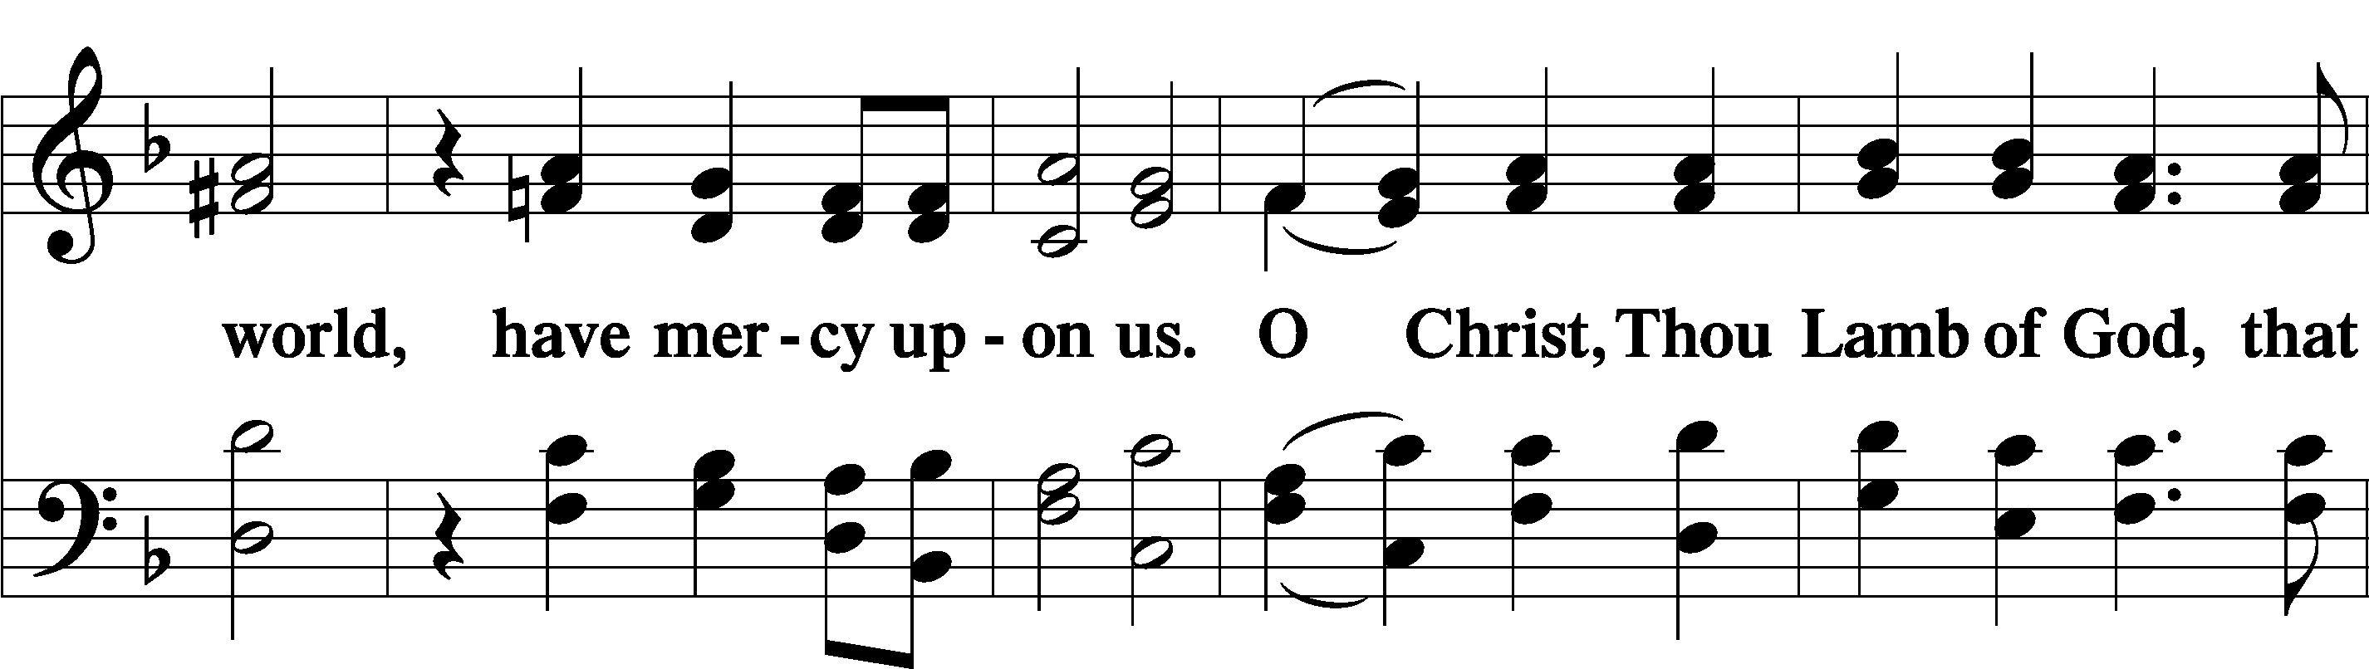
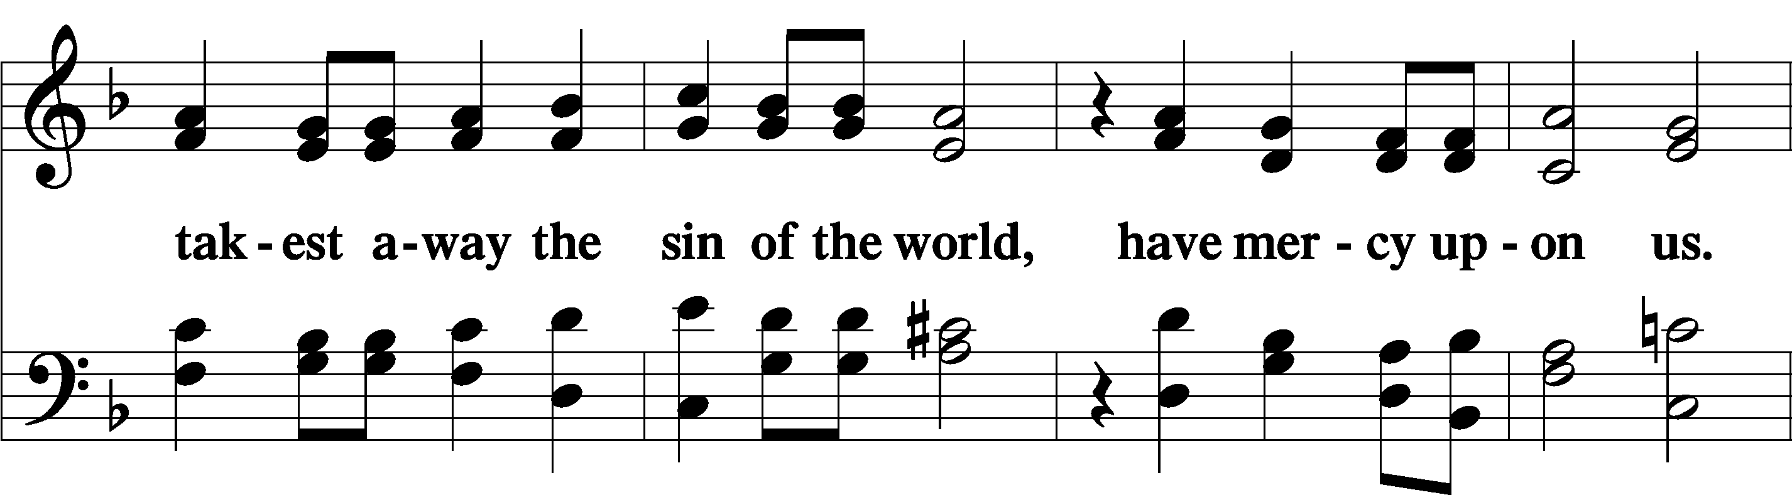
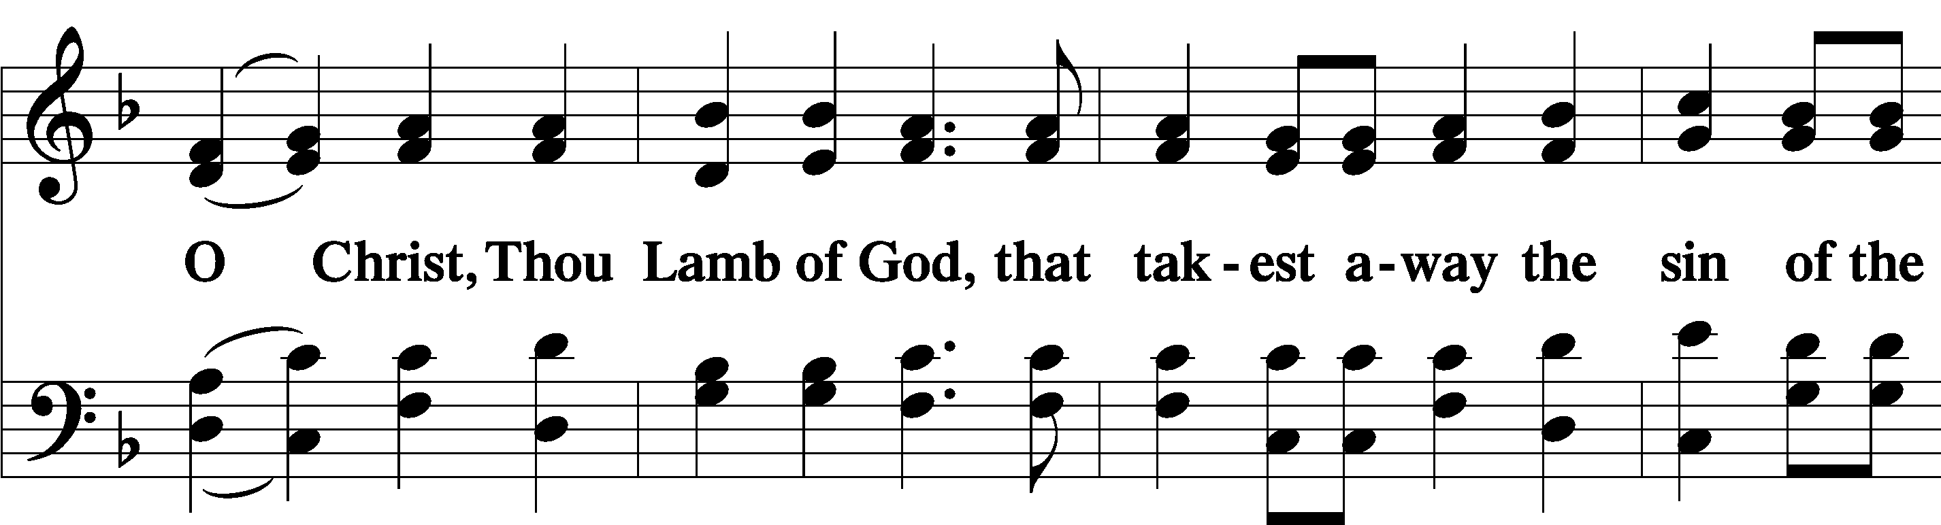
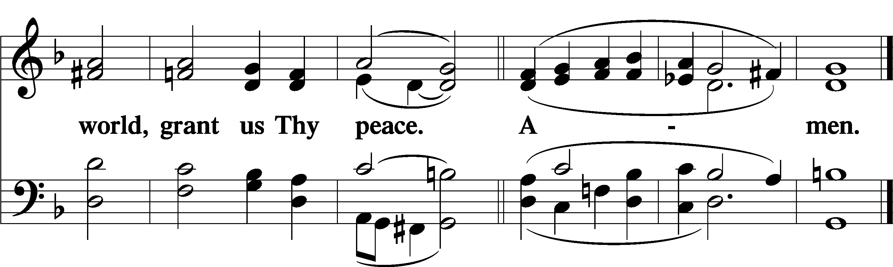

Sit

Distribution & Distribution Hymn

623 Lord Jesus Christ, We Humbly Pray sts. 1–4
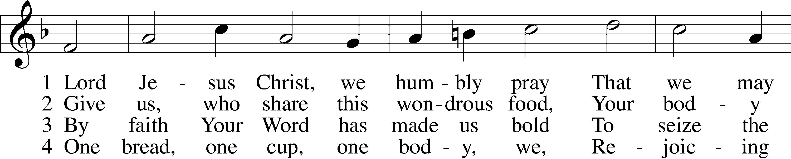
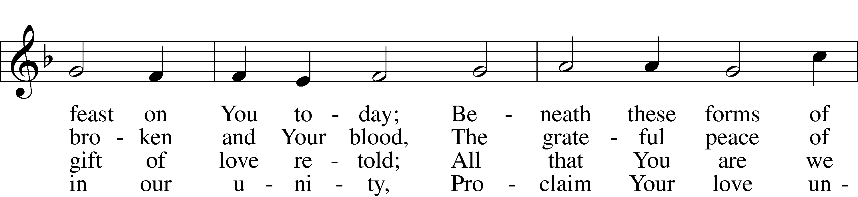
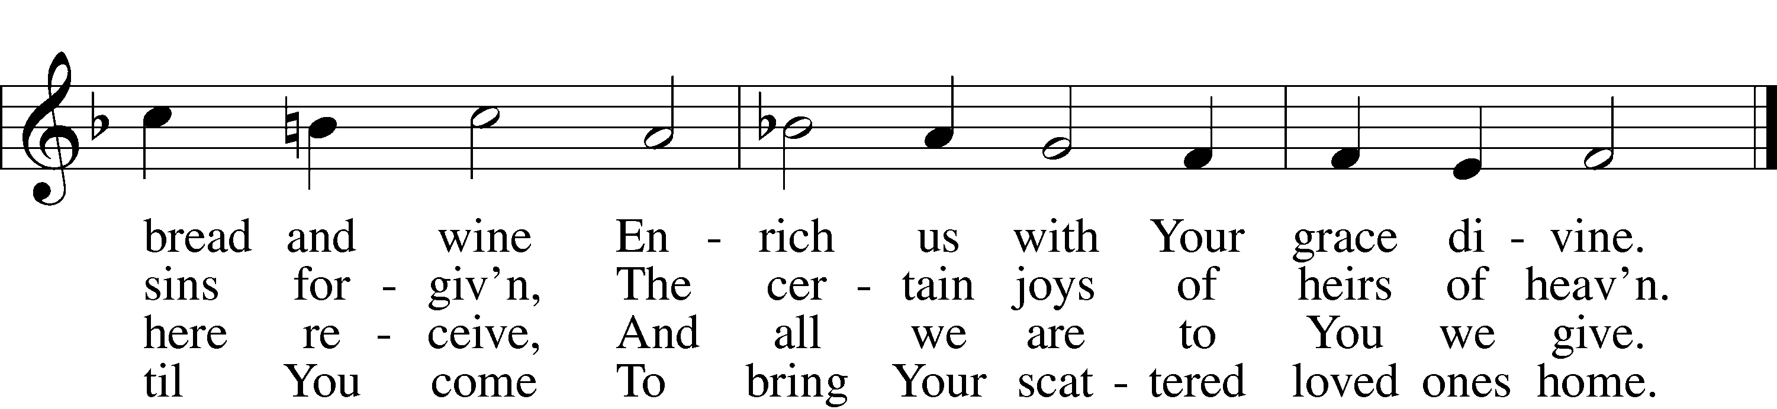

Stand

Nunc Dimittis LSB 199
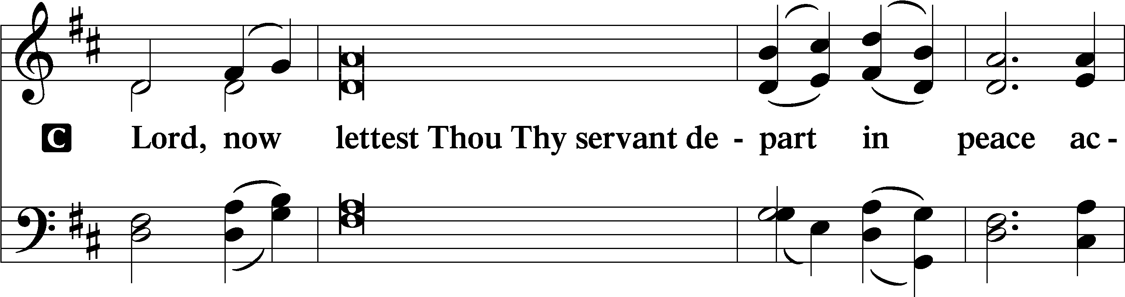
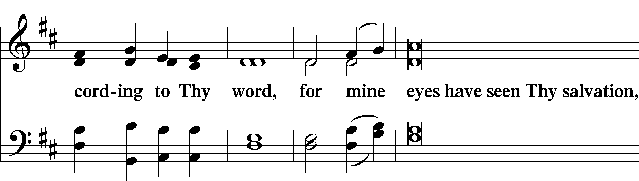
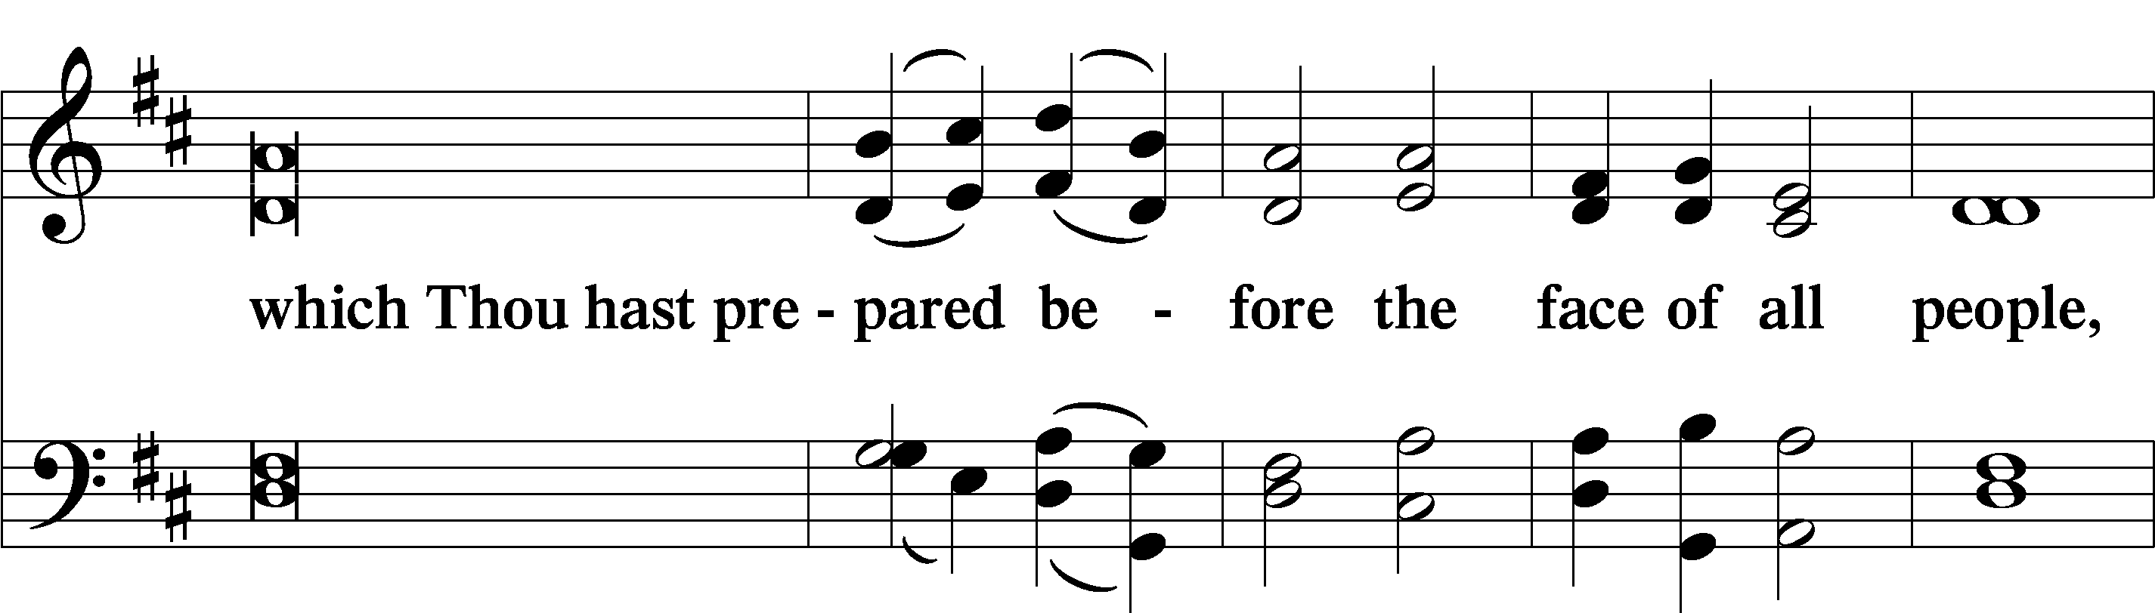
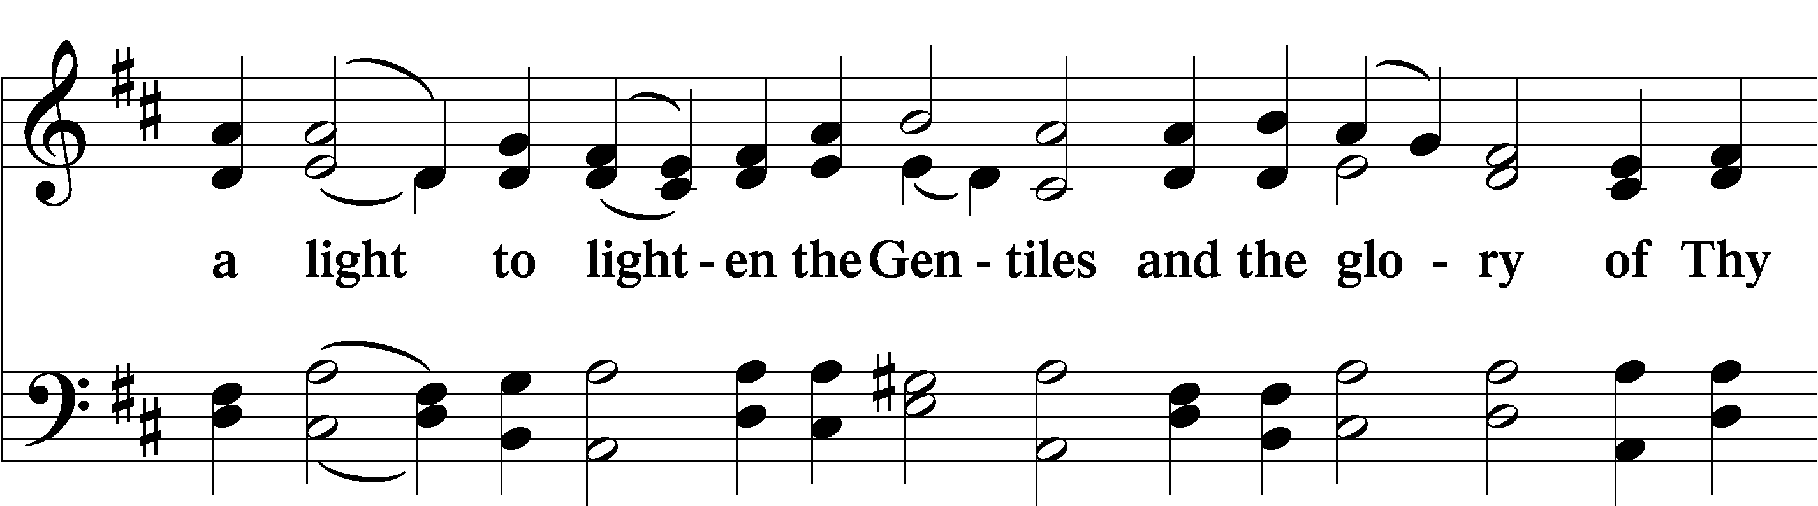
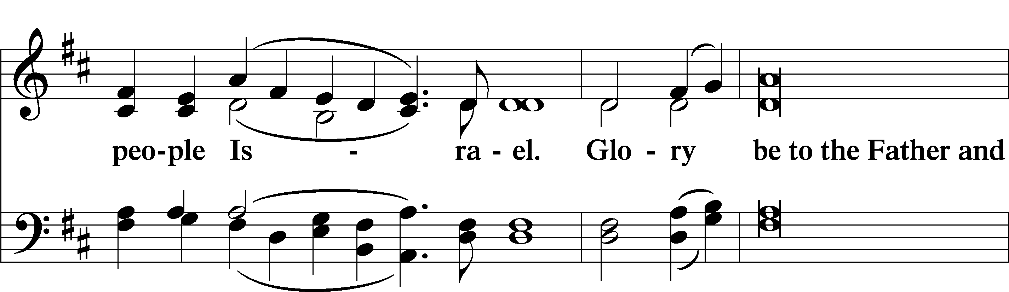
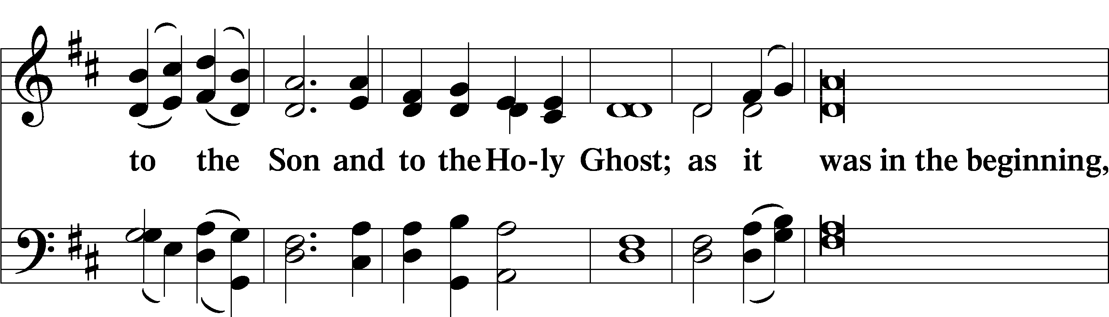
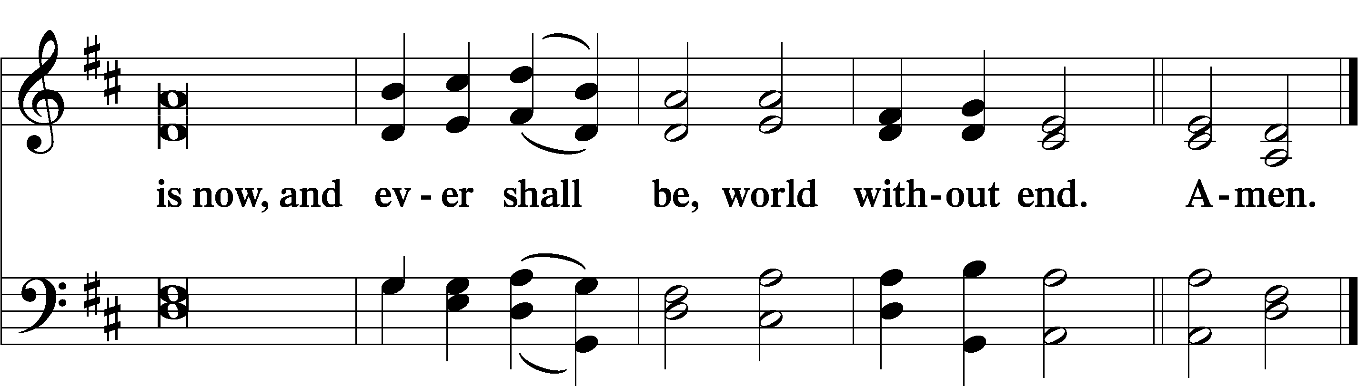

Thanksgiving LSB 200
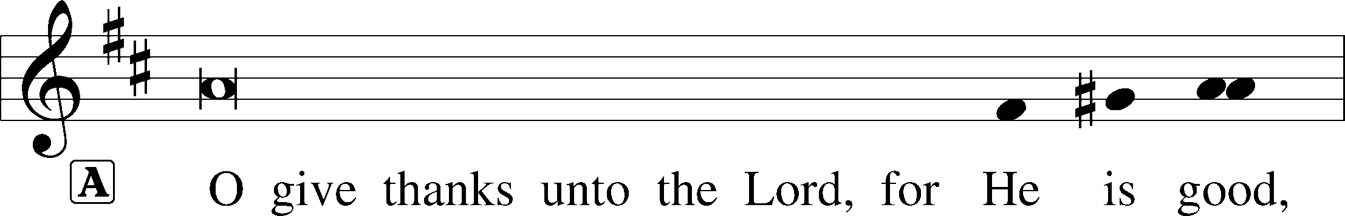
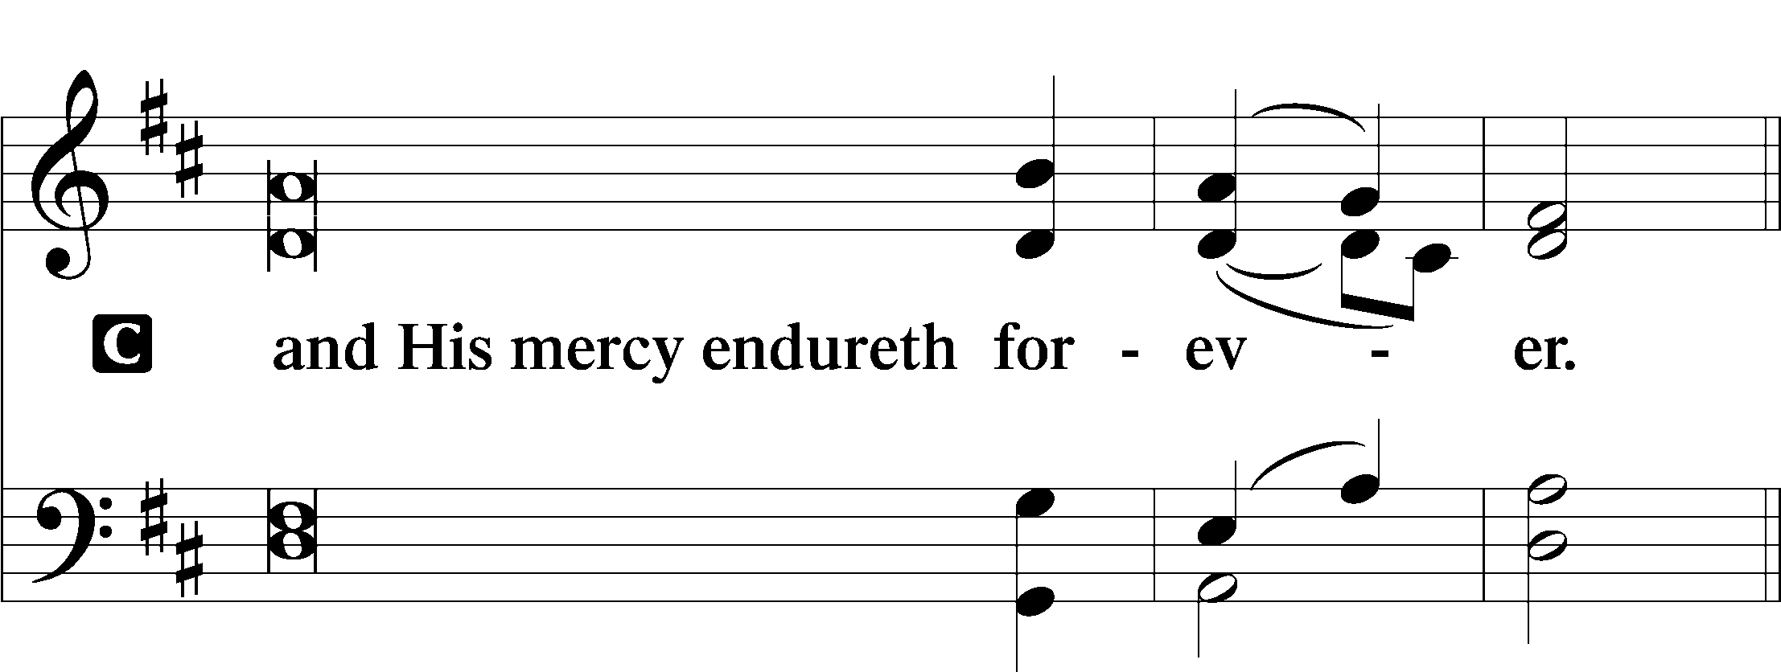

Post-Communion Collect
A Let us pray.
We give thanks to You, almighty God, that You have refreshed us through this salutary gift, and we implore You that of Your mercy You would strengthen us through the same in faith toward You and in fervent love toward one another; through Jesus Christ, Your Son, our Lord, who lives and reigns with You and the Holy Spirit, one God, now and forever.

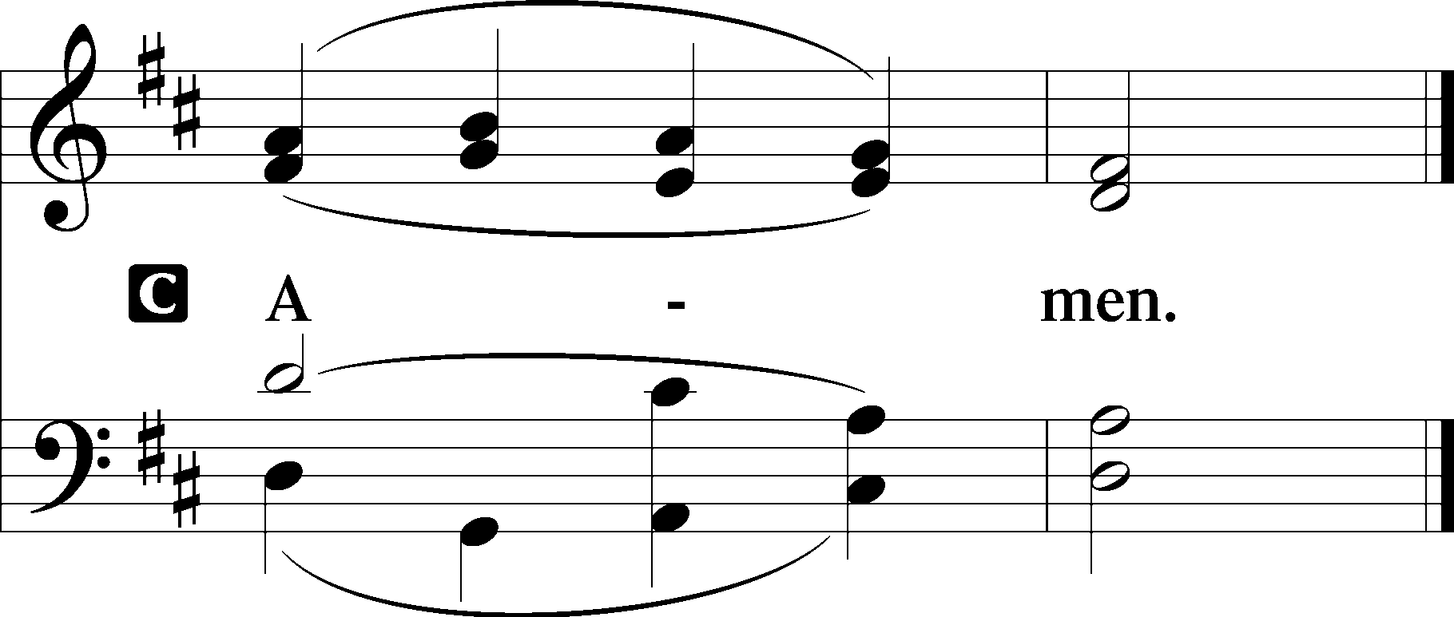

Salutation LSB 201

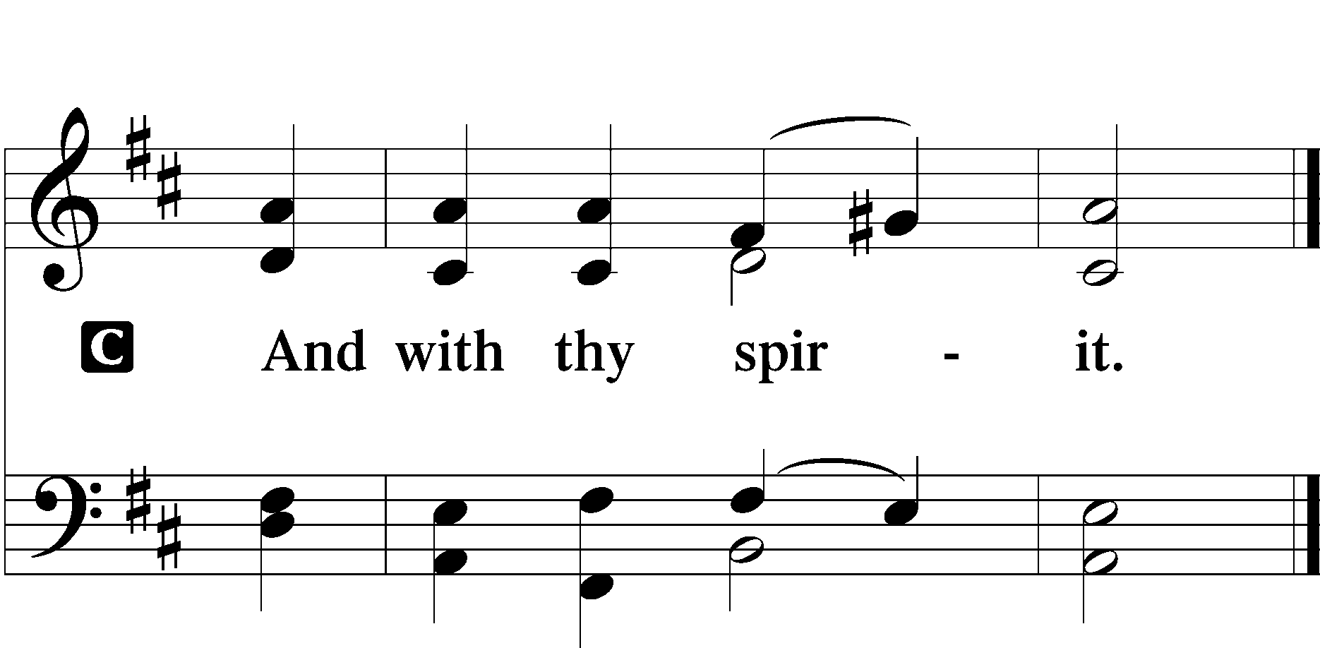

Benedicamus LSB 202

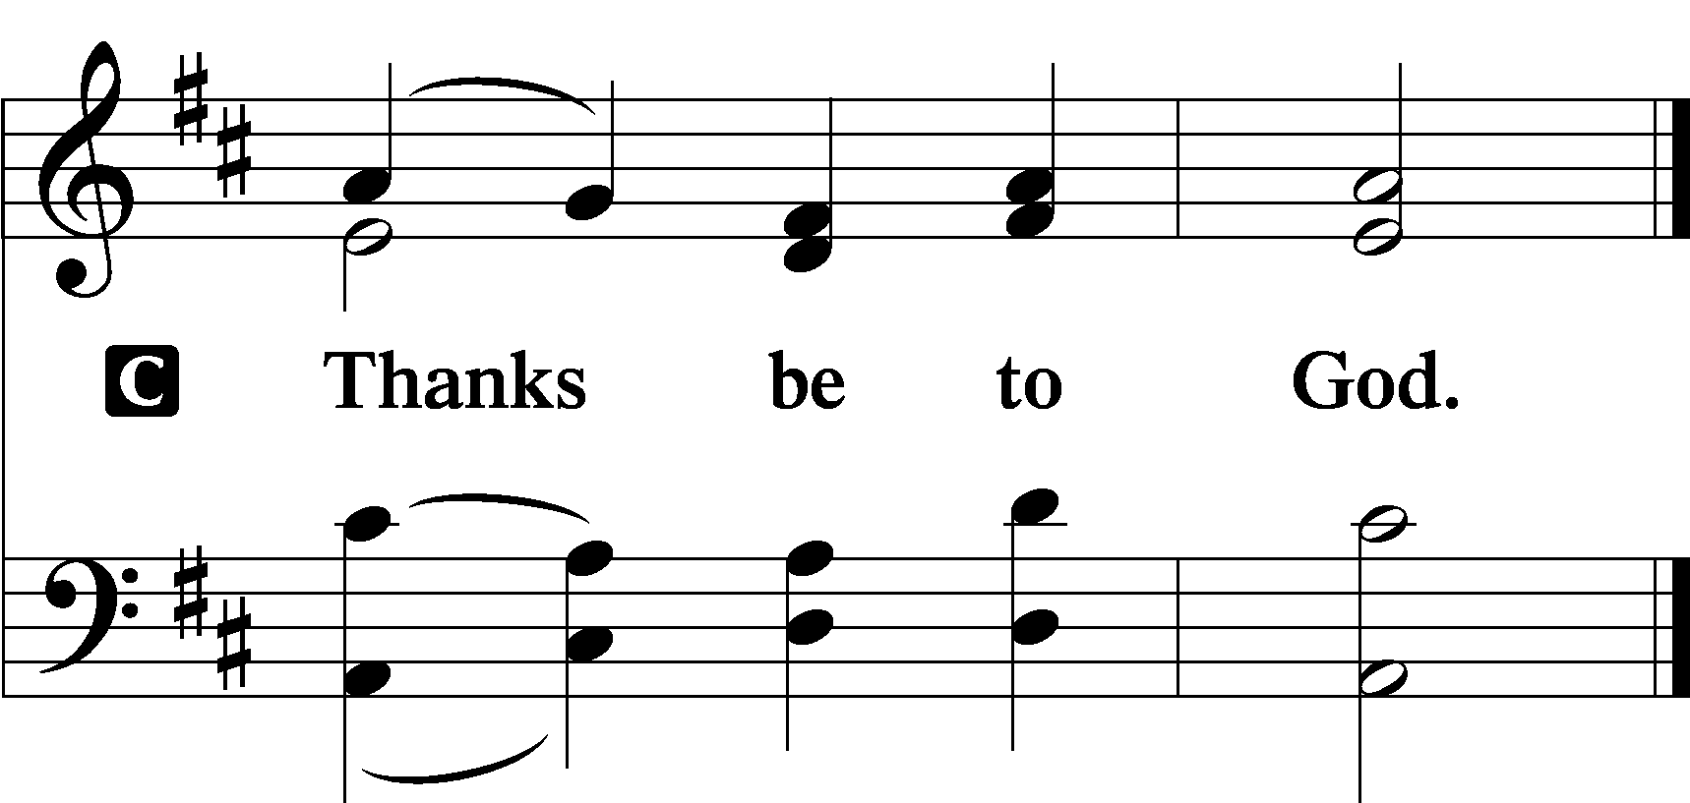

Benediction LSB 202
P The Lord bless you and keep you.
The Lord make His face shine upon you and be gracious unto you.
The Lord lift up His countenance upon you and T give you peace.
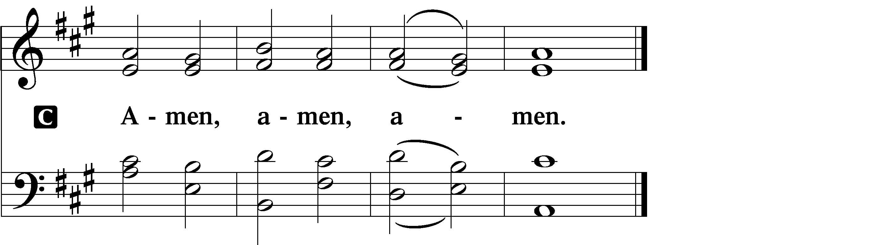

420 Christ, the Life of All the Living sts. 1–2
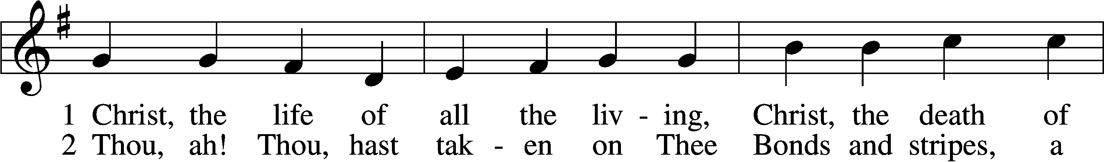
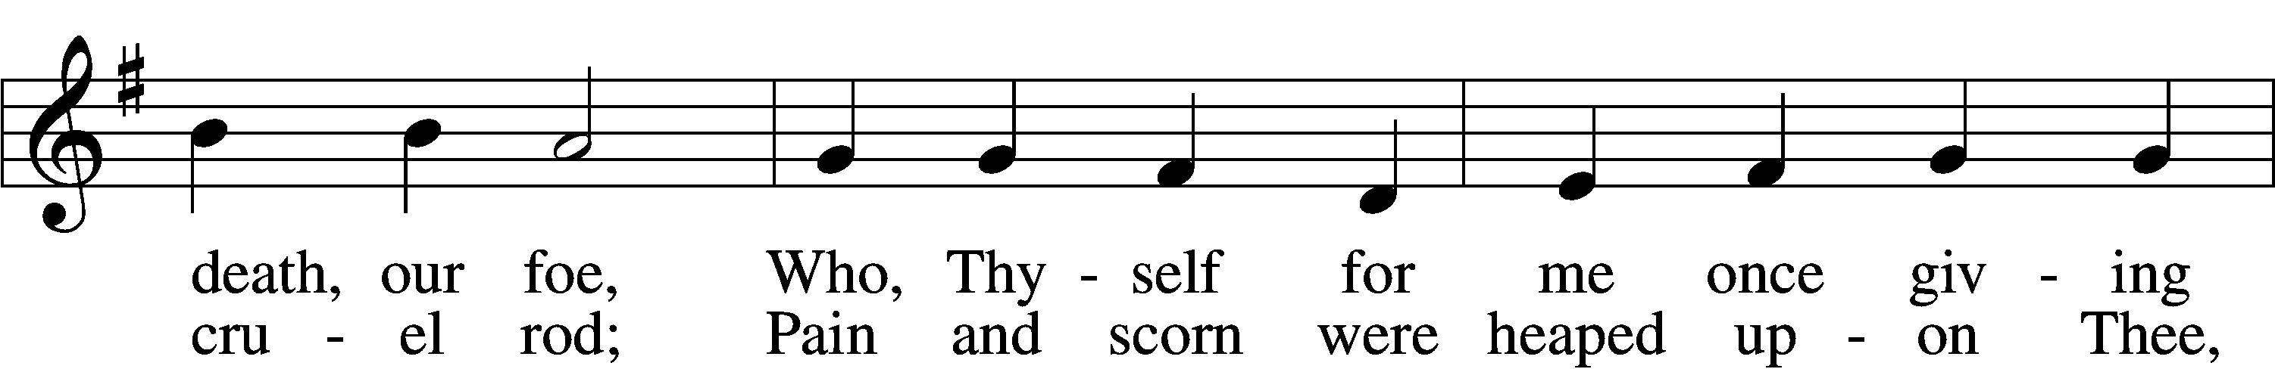
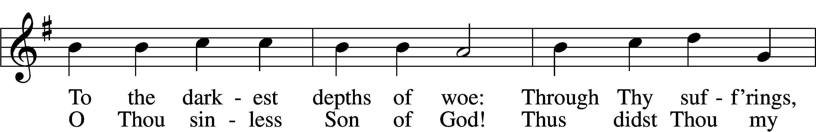
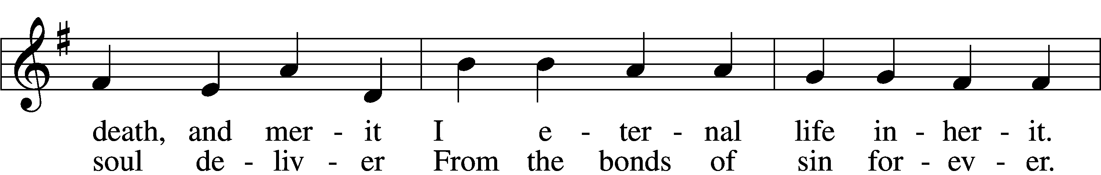
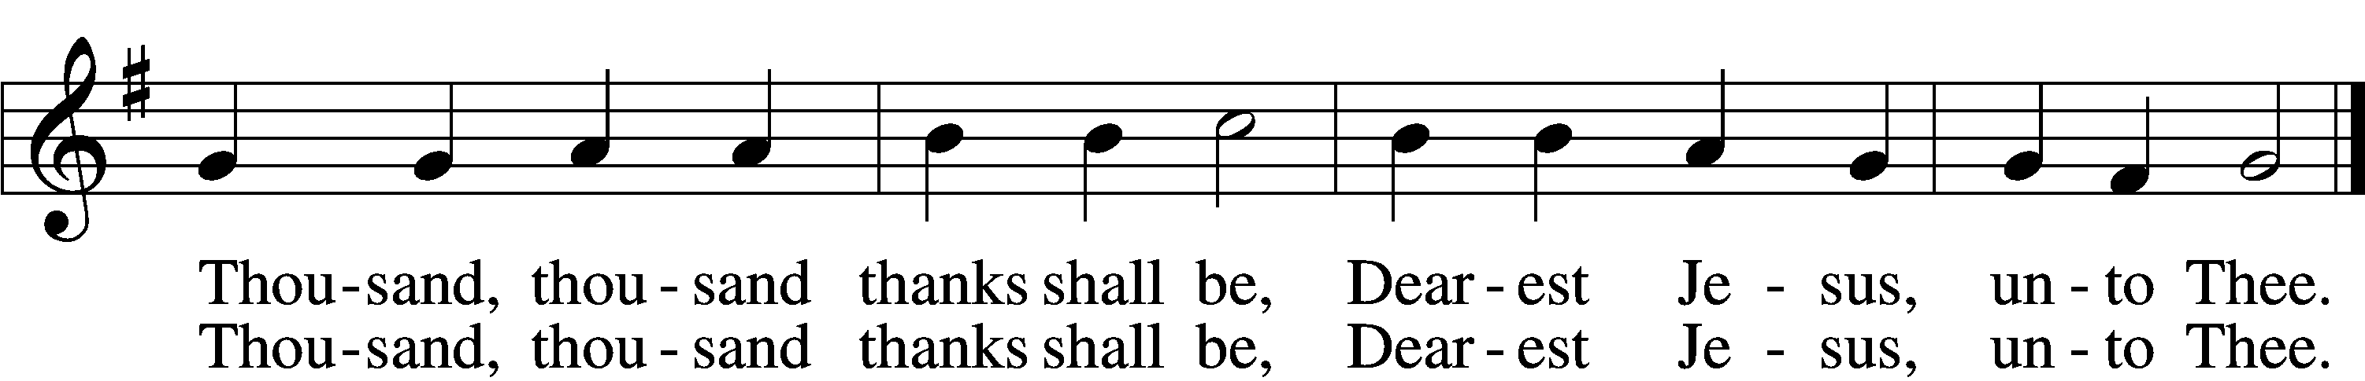

Announcements

Join us after the service in the fellowship hall for refreshments.
and Bible Study.

Pastor Vogel will conduct service next Sunday and October 5th and 19th.

We will be having our annual Yard Sale on Saturday September 27th. See flyer on narthex table.

If not taking your bulletin home, please leave on table in the narthex when leaving so it can be recycled. Thank you.

St. John’s Lutheran Church
810 Broad St., Clifton, NJ 07013
StJohnsClifton.Org
PrayingHands810@gmail.com

