Fifth Sunday after the Epiphany February 8, 2026– Lectionary Series A
St. John’s Lutheran Church

Order of Worship
by
Lutheran Service Builder

848 Lord, Whose Love through Humble Service

Stand

Confession and Absolution

The sign of the cross may be made by all in remembrance of their Baptism.

Invocation

Exhortation LSB 151

Silence for reflection on God’s Word and for self-examination.

Confession of Sins LSB 151

Absolution LSB 151

Service of the Word

Introit Psalm 119:9–16; antiphon: v. 12
Blessèd are you, O Lord;
teach me your statutes!
How can a young man keep his way pure?
By guarding it according to your word.
With my whole heart I seek you;
let me not wander from your commandments!
I have stored up your word in my heart,
that I might not sin against you.
Blessèd are you, O Lord;
teach me your statutes!
With my lips I declare
all the just decrees of your mouth.
In the way of your testimonies I delight
as much as in all riches.
I will meditate on your precepts
and fix my eyes on your ways.
I will delight in your statutes;
I will not forget your word.
Glory be to the Father and to the Son
and to the Holy Spirit;
as it was in the beginning,
is now, and will be forever. Amen.
Blessèd are you, O Lord;
teach me your statutes!

Kyrie LSB 152

This Is the Feast LSB 155

Salutation and Collect of the Day

Sit

Old Testament Reading Isaiah 58:3–9a
“‘Why have we fasted, and you see it not?
Why have we humbled ourselves, and you take no knowledge of it?’
Behold, in the day of your fast you seek your own pleasure,
and oppress all your workers.
Behold, you fast only to quarrel and to fight
and to hit with a wicked fist.
Fasting like yours this day
will not make your voice to be heard on high.
Is such the fast that I choose,
a day for a person to humble himself?
Is it to bow down his head like a reed,
and to spread sackcloth and ashes under him?
Will you call this a fast,
and a day acceptable to the Lord?
“Is not this the fast that I choose:
to loose the bonds of wickedness,
to undo the straps of the yoke,
to let the oppressed go free,
and to break every yoke?
Is it not to share your bread with the hungry
and bring the homeless poor into your house;
when you see the naked, to cover him,
and not to hide yourself from your own flesh?
Then shall your light break forth like the dawn,
and your healing shall spring up speedily;
your righteousness shall go before you;
the glory of the Lord shall be your rear guard.
Then you shall call, and the Lord will answer;
you shall cry, and he will say, ‘Here I am.’”

A This is the Word of the Lord.
C Thanks be to God.

Epistle 1 Corinthians 2:1–16
And I, when I came to you, brothers, did not come proclaiming to you the testimony of God with lofty speech or wisdom. For I decided to know nothing among you except Jesus Christ and him crucified. And I was with you in weakness and in fear and much trembling, and my speech and my message were not in plausible words of wisdom, but in demonstration of the Spirit and of power, that your faith might not rest in the wisdom of men but in the power of God.
Yet among the mature we do impart wisdom, although it is not a wisdom of this age or of the rulers of this age, who are doomed to pass away. But we impart a secret and hidden wisdom of God, which God decreed before the ages for our glory. None of the rulers of this age understood this, for if they had, they would not have crucified the Lord of glory. But, as it is written,
“What no eye has seen, nor ear heard,
nor the heart of man imagined,
what God has prepared for those who love him”—
these things God has revealed to us through the Spirit. For the Spirit searches everything, even the depths of God. For who knows a person’s thoughts except the spirit of that person, which is in him? So also no one comprehends the thoughts of God except the Spirit of God. Now we have received not the spirit of the world, but the Spirit who is from God, that we might understand the things freely given us by God. And we impart this in words not taught by human wisdom but taught by the Spirit, interpreting spiritual truths to those who are spiritual.
The natural person does not accept the things of the Spirit of God, for they are folly to him, and he is not able to understand them because they are spiritually discerned. The spiritual person judges all things, but is himself to be judged by no one. “For who has understood the mind of the Lord so as to instruct him?” But we have the mind of Christ.

A This is the Word of the Lord.
C Thanks be to God.

Stand

Alleluia and Verse LSB 156
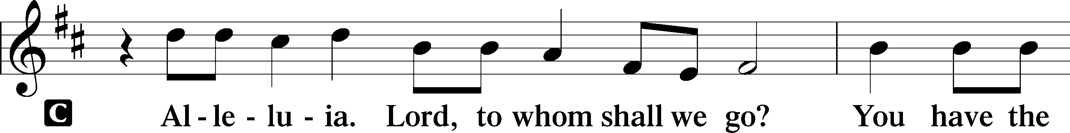
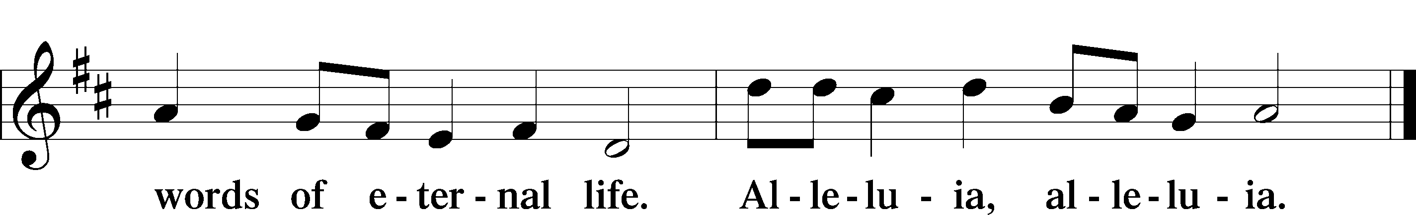

Holy Gospel Matthew 5:13–20
P The Holy Gospel according to St. Matthew, the fifth chapter.

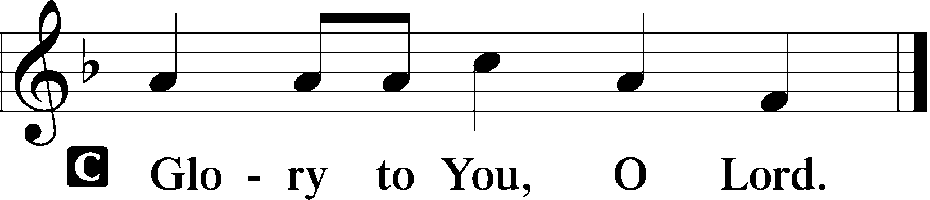

[Jesus said:] “You are the salt of the earth, but if salt has lost its taste, how shall its saltiness be restored? It is no longer good for anything except to be thrown out and trampled under people’s feet.
“You are the light of the world. A city set on a hill cannot be hidden. Nor do people light a lamp and put it under a basket, but on a stand, and it gives light to all in the house. In the same way, let your light shine before others, so that they may see your good works and give glory to your Father who is in heaven.
“Do not think that I have come to abolish the Law or the Prophets; I have not come to abolish them but to fulfill them. For truly, I say to you, until heaven and earth pass away, not an iota, not a dot, will pass from the Law until all is accomplished. Therefore whoever relaxes one of the least of these commandments and teaches others to do the same will be called least in the kingdom of heaven, but whoever does them and teaches them will be called great in the kingdom of heaven. For I tell you, unless your righteousness exceeds that of the scribes and Pharisees, you will never enter the kingdom of heaven.”

P This is the Gospel of the Lord.

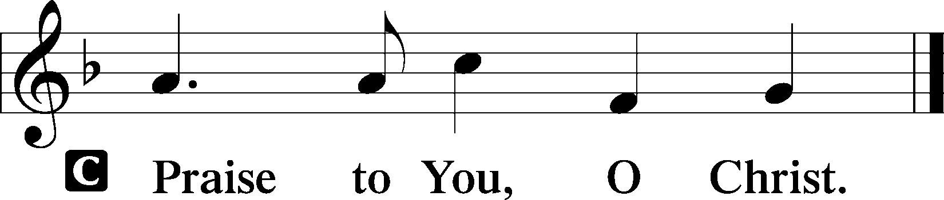

Nicene Creed

Sit

578 Thy Strong Word sts. 1–4

Sermon

Offering

Psalm for Meditation Psalm 112:1–9; antiphon: v. 4
Praise the Lord!
Blessèd is the man who fears the Lord,
who greatly delights in his commandments!
His offspring will be mighty in the land;
the generation of the upright will be blessed.
Wealth and riches are in his house,
and his righteousness endures forever.
Light dawns in the darkness for the upright;
he is gracious, merciful, and righteous.
It is well with the man who deals generously and lends;
who conducts his affairs with justice.
For the righteous will never be moved;
he will be remembered forever.
He is not afraid of bad news;
his heart is firm, trusting in the Lord.
His heart is steady; he will not be afraid,
until he looks in triumph on his adversaries.
He has distributed freely; he has given to the poor;
his righteousness endures forever;
his horn is exalted in honor.

Stand

781 We Give Thee But Thine Own sts. 1–2

Prayer of the Church

Prayer of the Church After “Lord, in Your mercy” respond with “hear our prayer.”

Service of the Sacrament

Preface LSB 160

Proper Preface (Full)

Sanctus LSB 161

Prayer of Thanksgiving LSB 161

The Words of Our Lord

Proclamation of Christ

Lord’s Prayer

Pax Domini LSB 163

Agnus Dei LSB 163

Sit

Distribution & Distribution Hymn

617 O Lord, We Praise Thee

Stand

Thank the Lord LSB 164

Post-Communion Collect

Benediction LSB 166

922 Go, My Children, with My Blessing sts. 1–4

Announcements

Join us after the service in the fellowship hall for refreshments and Bible Study

Pastor Rockett will conduct service for February 22nd.

Pastor Vogel will conduct service for March 8th.

St. John’s Lutheran Church
810 Broad St., Clifton, NJ 07013
StJohnsClifton.Org
PrayingHands810@gmail.com

