Transfiguration Sunday February 15, 2026– Lectionary Series A
St. John’s Lutheran Church

Order of Worship
by
Lutheran Service Builder
414 ’Tis Good, Lord, to Be Here
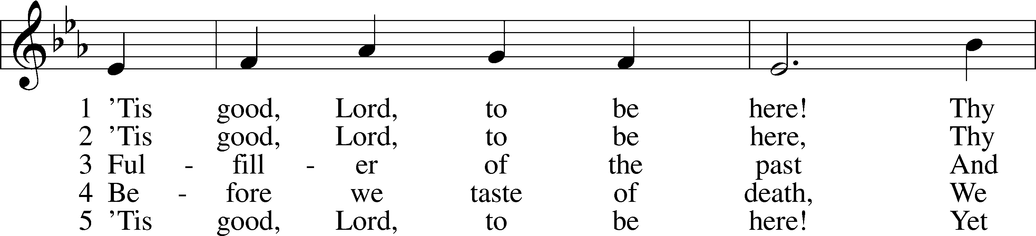
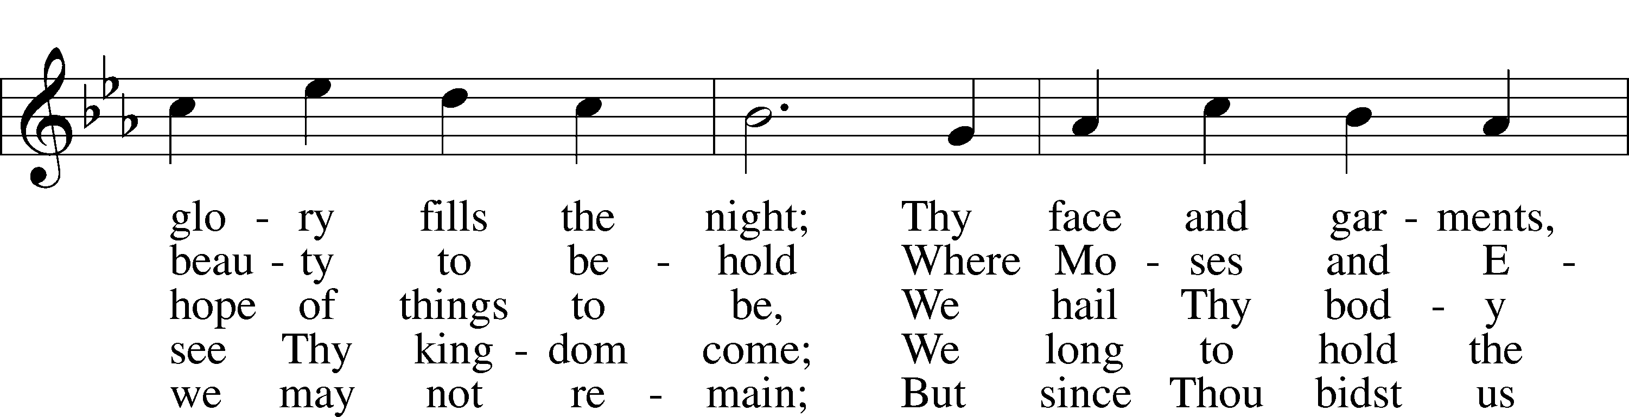
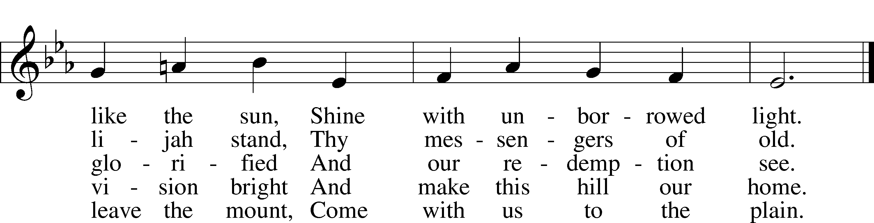

Stand for last verse

Confession and Absolution

The sign of the cross may be made by all in remembrance of their Baptism.

Invocation
P In the name of the Father and of the T Son and of the Holy Spirit.
C Amen.

Exhortation LSB 184
P Beloved in the Lord! Let us draw near with a true heart and confess our sins unto God our Father, beseeching Him in the name of our Lord Jesus Christ to grant us forgiveness.

P Our help is in the name of the Lord,
C who made heaven and earth.
P I said, I will confess my transgressions unto the Lord,
C and You forgave the iniquity of my sin.

Silence for reflection on God’s Word and for self-examination.

Confession of Sins LSB 184
P O almighty God, merciful Father,
C I, a poor, miserable sinner, confess unto You all my sins and iniquities with which I have ever offended You and justly deserved Your temporal and eternal punishment. But I am heartily sorry for them and sincerely repent of them, and I pray You of Your boundless mercy and for the sake of the holy, innocent, bitter sufferings and death of Your beloved Son, Jesus Christ, to be gracious and merciful to me, a poor, sinful being.

Declaration LSB 185
P Almighty God, our maker and redeemer, we poor sinners confess unto You that we are by nature sinful and unclean and that we have sinned against You by thought, word, and deed. Wherefore we flee for refuge to Your infinite mercy, seeking and imploring Your grace for the sake of our Lord Jesus Christ.
C Amen.

Service of the Word

Introit Psalm 99:1–5; antiphon: v. 9
Exalt the Lord our God, and worship at his holy mountain;
for the Lord our God is holy!
The Lord reigns; let the peoples tremble!
He sits enthroned upon the cherubim; let the earth quake!
The Lord is great in Zion;
he is exalted over all the peoples.
Let them praise your great and awesome name!
Holy is he!
The King in his might loves justice.
You have established equity; you have executed justice and righteousness in Jacob.
Exalt the Lord our God; worship at his footstool!
Holy is he!
Glory be to the Father and to the Son
and to the Holy Spirit;
as it was in the beginning,
is now, and will be forever. Amen.
Exalt the Lord our God, and worship at his holy mountain;
for the Lord our God is holy!

Kyrie LSB 186
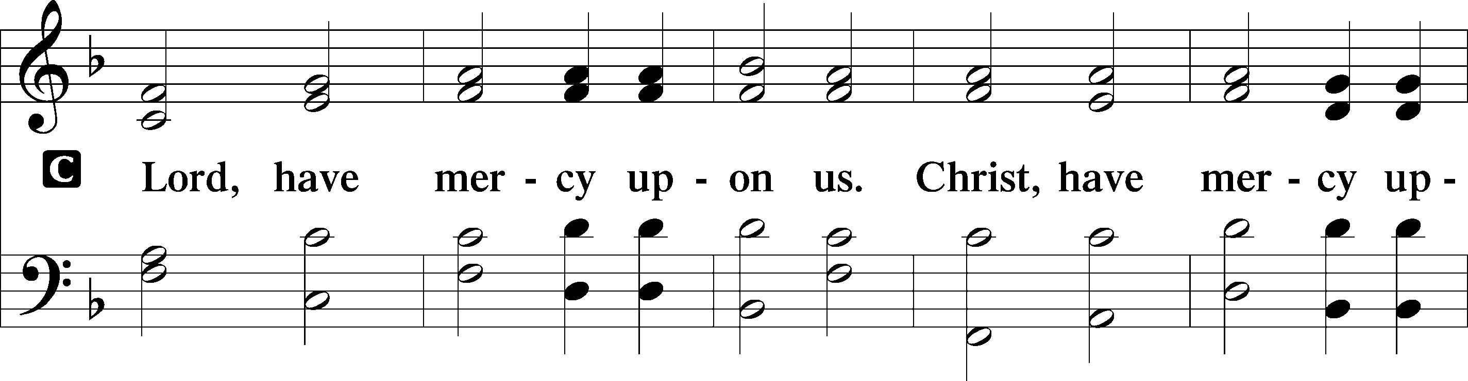
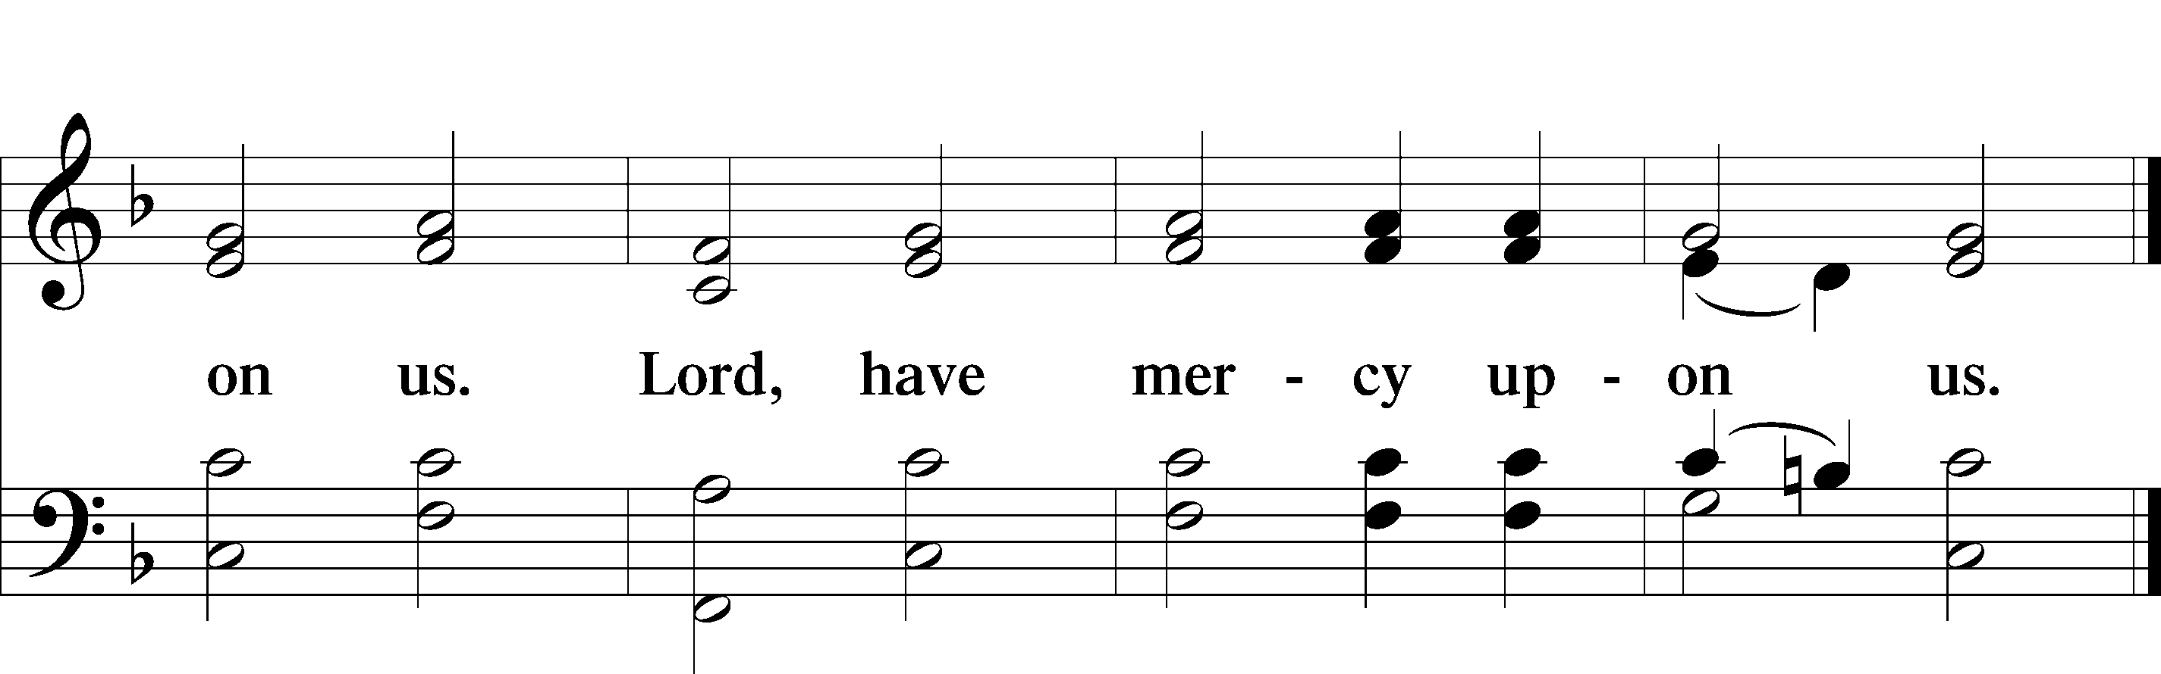

Gloria in Excelsis LSB 187
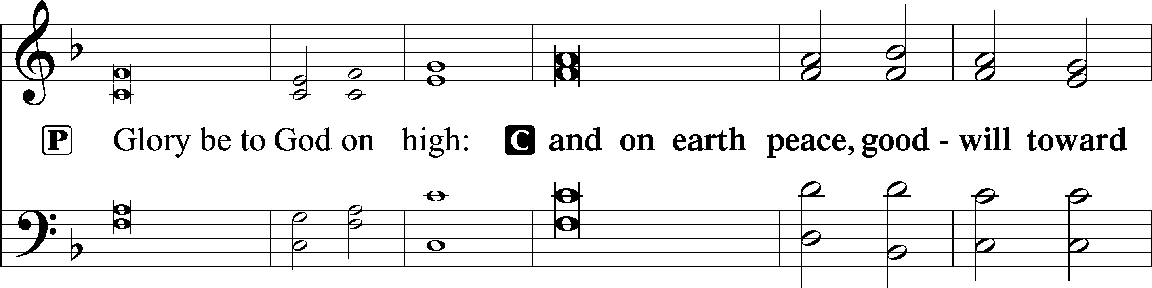
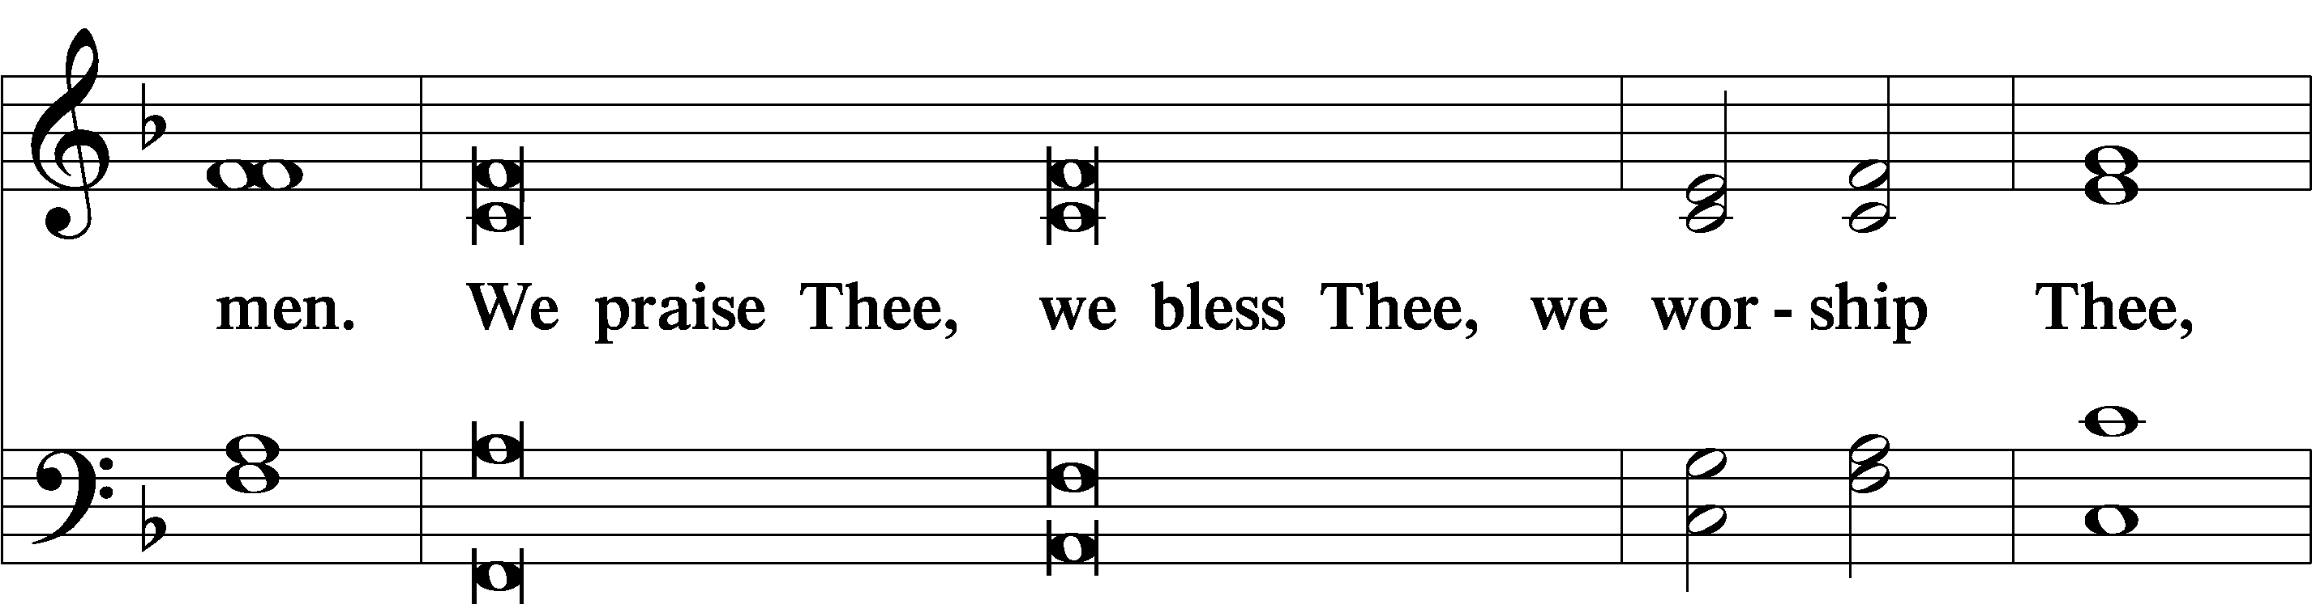
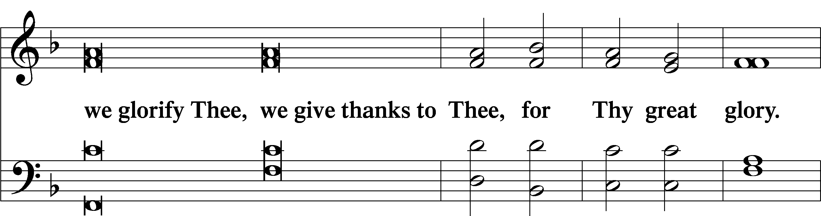
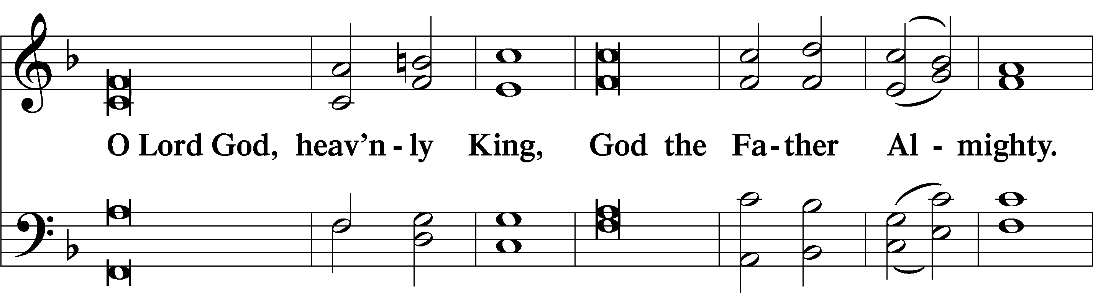
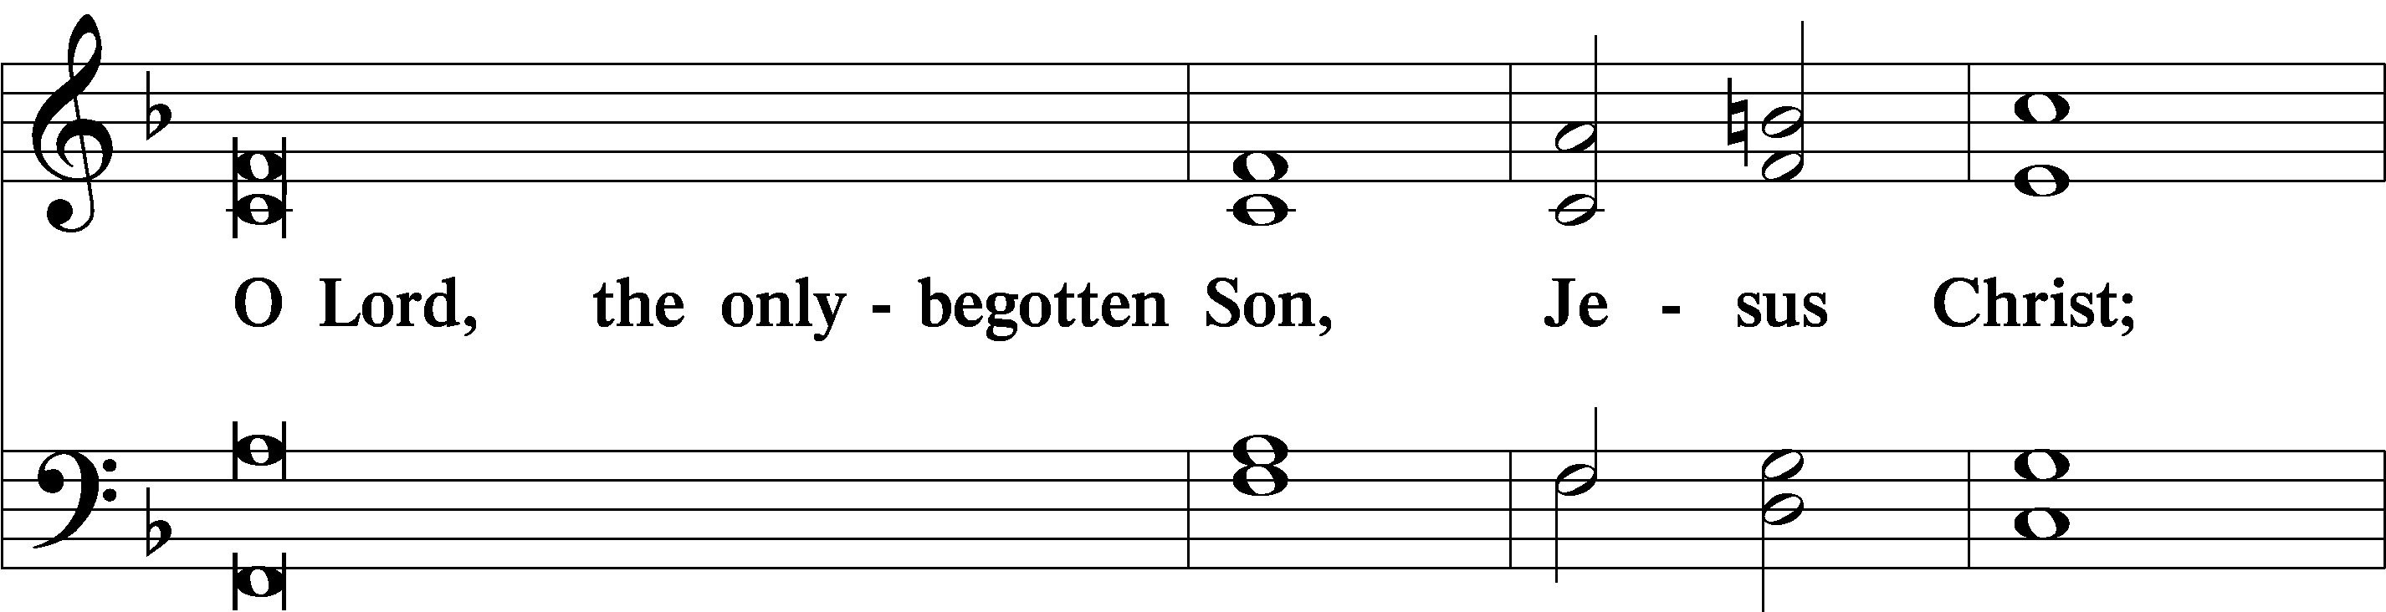
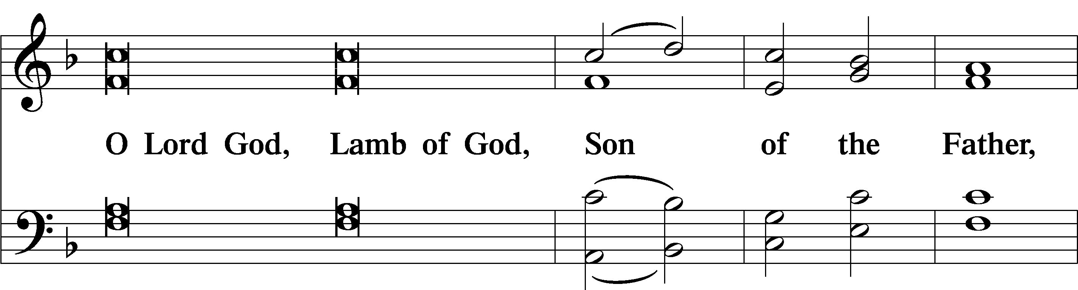
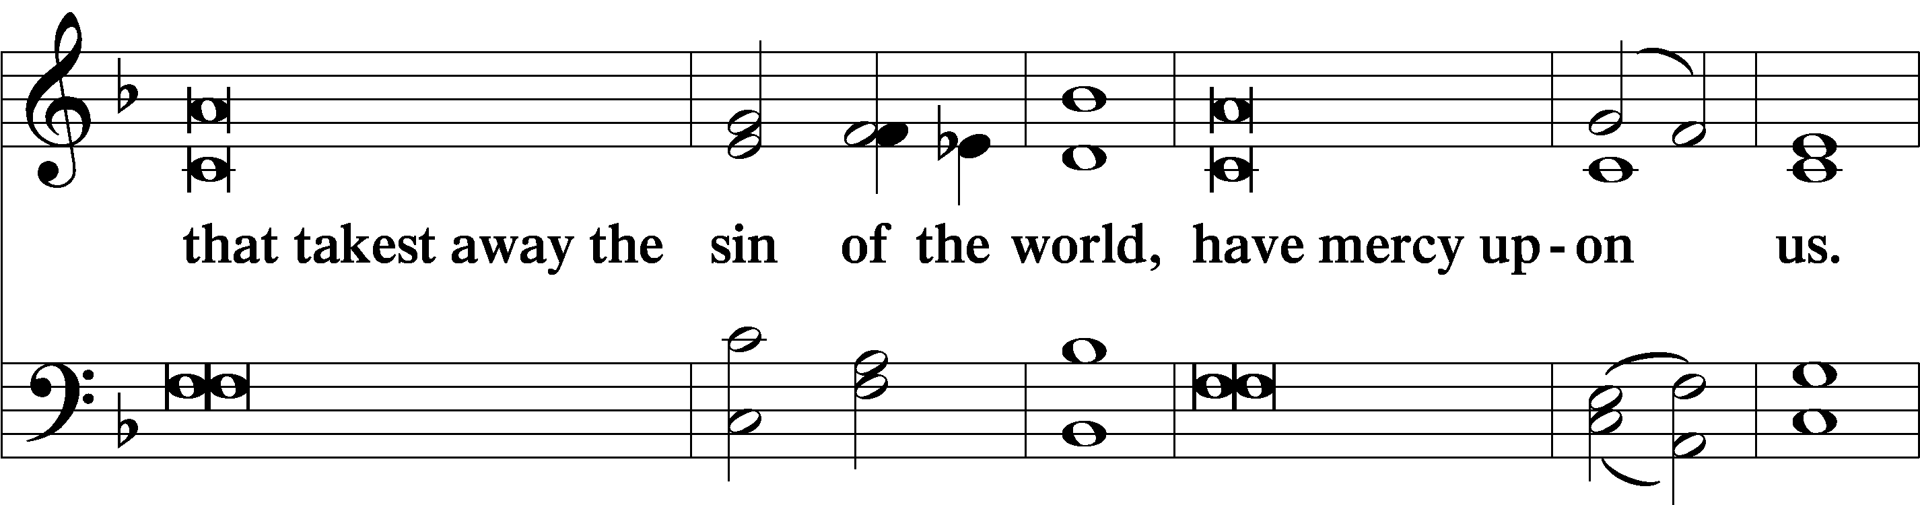
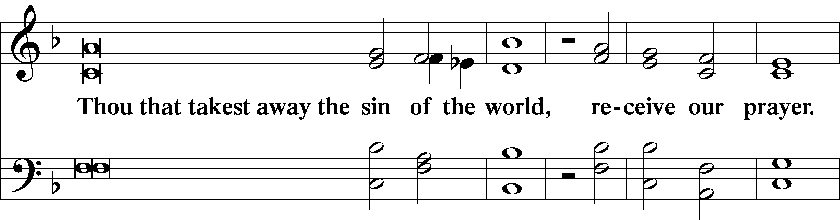
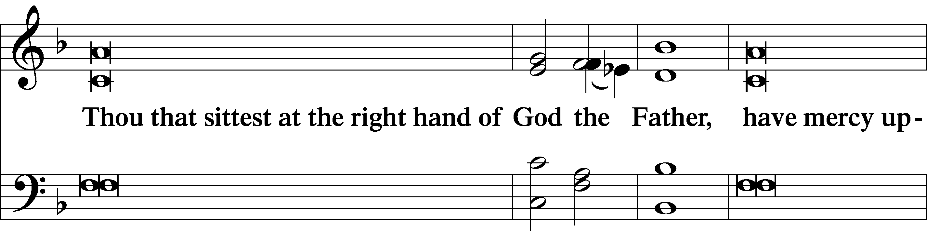
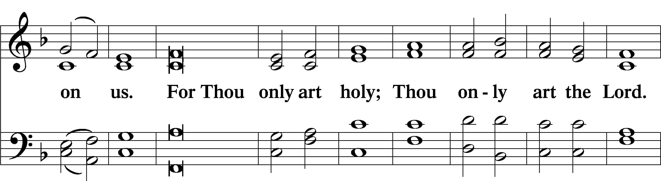
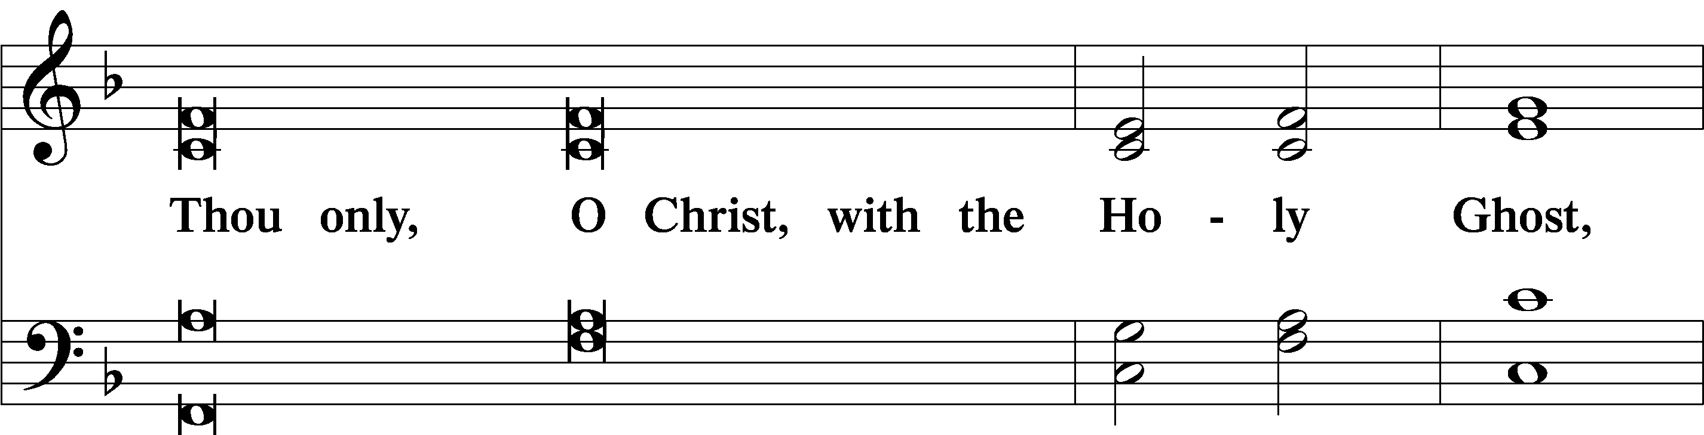
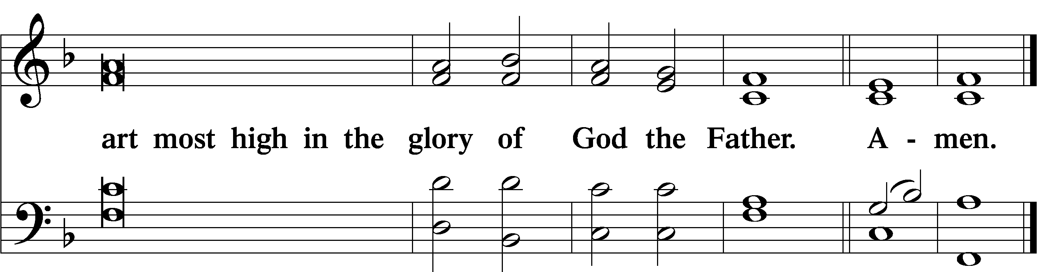

Salutation and Collect of the Day
P The Lord be with you.
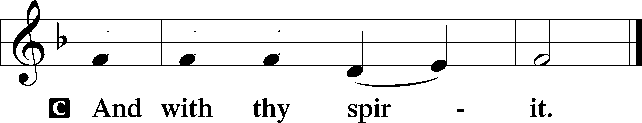

P Let us pray.
O God, in the glorious transfiguration of Your beloved Son You confirmed the mysteries of the faith by the testimony of Moses and Elijah. In the voice that came from the bright cloud You wonderfully foreshowed our adoption by grace. Mercifully make us co-heirs with the King in His glory and bring us to the fullness of our inheritance in heaven; through the same Jesus Christ, our Lord, who lives and reigns with You and the Holy Spirit, one God, now and forever.

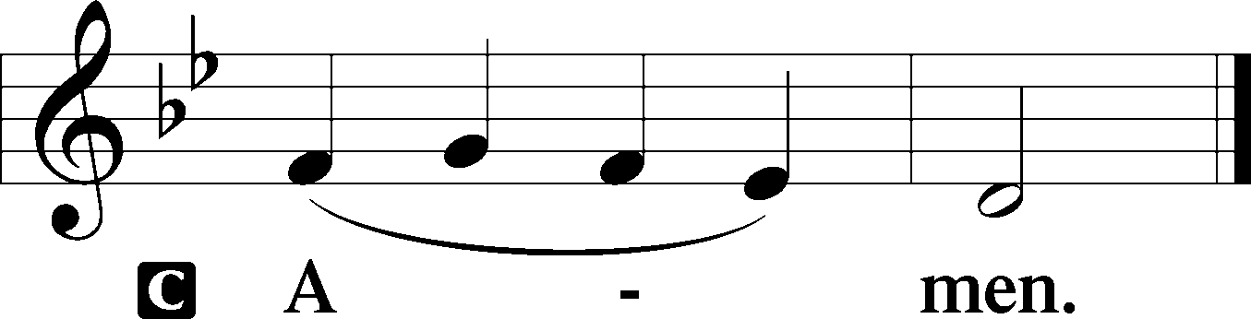

Sit

Old Testament Reading Exodus 24:8–18
And Moses took the blood and threw it on the people and said, “Behold the blood of the covenant that the Lord has made with you in accordance with all these words.”
Then Moses and Aaron, Nadab, and Abihu, and seventy of the elders of Israel went up, and they saw the God of Israel. There was under his feet as it were a pavement of sapphire stone, like the very heaven for clearness. And he did not lay his hand on the chief men of the people of Israel; they beheld God, and ate and drank.
The Lord said to Moses, “Come up to me on the mountain and wait there, that I may give you the tablets of stone, with the law and the commandment, which I have written for their instruction.” So Moses rose with his assistant Joshua, and Moses went up into the mountain of God. And he said to the elders, “Wait here for us until we return to you. And behold, Aaron and Hur are with you. Whoever has a dispute, let him go to them.”
Then Moses went up on the mountain, and the cloud covered the mountain. The glory of the Lord dwelt on Mount Sinai, and the cloud covered it six days. And on the seventh day he called to Moses out of the midst of the cloud. Now the appearance of the glory of the Lord was like a devouring fire on the top of the mountain in the sight of the people of Israel. Moses entered the cloud and went up on the mountain. And Moses was on the mountain forty days and forty nights.

A This is the Word of the Lord.
C Thanks be to God.

Epistle 2 Peter 1:16–21
For we did not follow cleverly devised myths when we made known to you the power and coming of our Lord Jesus Christ, but we were eyewitnesses of his majesty. For when he received honor and glory from God the Father, and the voice was borne to him by the Majestic Glory, “This is my beloved Son, with whom I am well pleased,” we ourselves heard this very voice borne from heaven, for we were with him on the holy mountain. And we have something more sure, the prophetic word, to which you will do well to pay attention as to a lamp shining in a dark place, until the day dawns and the morning star rises in your hearts, knowing this first of all, that no prophecy of Scripture comes from someone’s own interpretation. For no prophecy was ever produced by the will of man, but men spoke from God as they were carried along by the Holy Spirit.

A This is the Word of the Lord.
C Thanks be to God.

Stand

Alleluia LSB 190
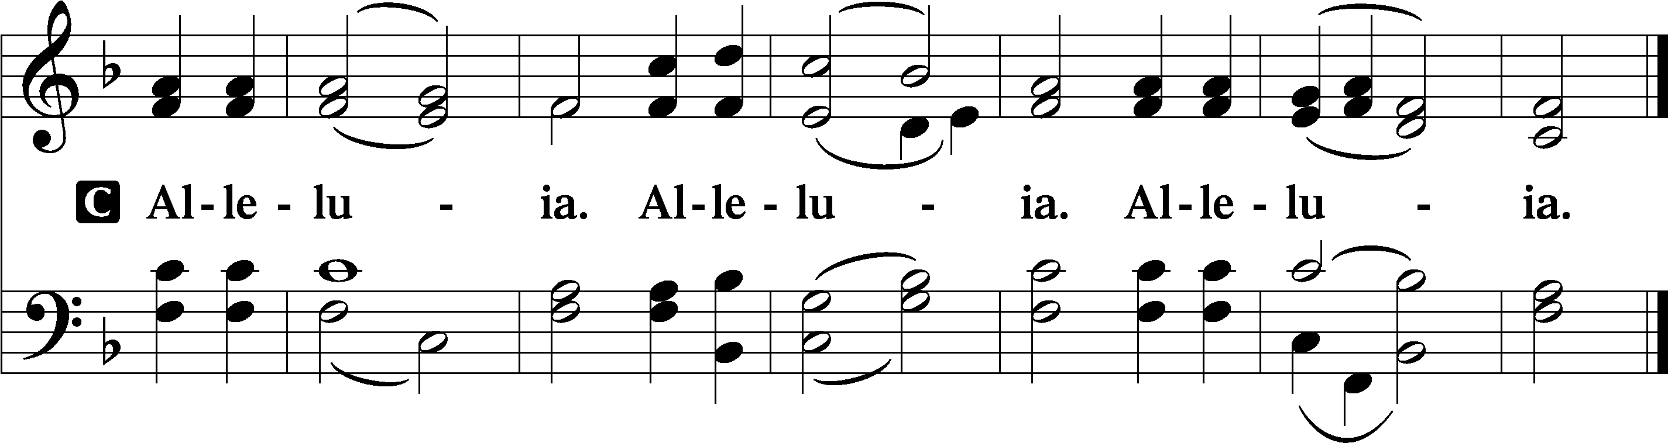

Holy Gospel Matthew 17:1–9
P The Holy Gospel according to St. Matthew, the seventeenth chapter.

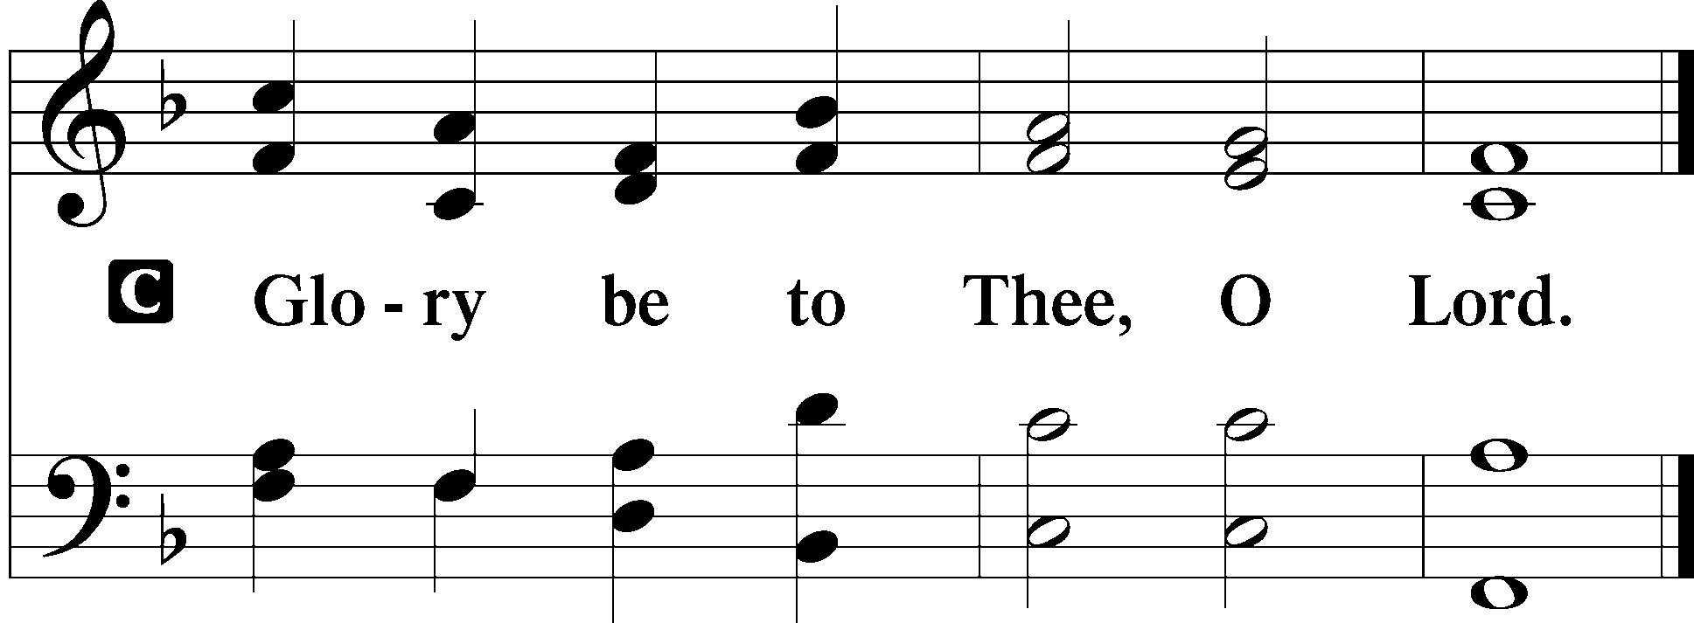

After six days Jesus took with him Peter and James, and John his brother, and led them up a high mountain by themselves. And he was transfigured before them, and his face shone like the sun, and his clothes became white as light. And behold, there appeared to them Moses and Elijah, talking with him. And Peter said to Jesus, “Lord, it is good that we are here. If you wish, I will make three tents here, one for you and one for Moses and one for Elijah.” He was still speaking when, behold, a bright cloud overshadowed them, and a voice from the cloud said, “This is my beloved Son, with whom I am well pleased; listen to him.” When the disciples heard this, they fell on their faces and were terrified. But Jesus came and touched them, saying, “Rise, and have no fear.” And when they lifted up their eyes, they saw no one but Jesus only.
And as they were coming down the mountain, Jesus commanded them, “Tell no one the vision, until the Son of Man is raised from the dead.”

P This is the Gospel of the Lord.
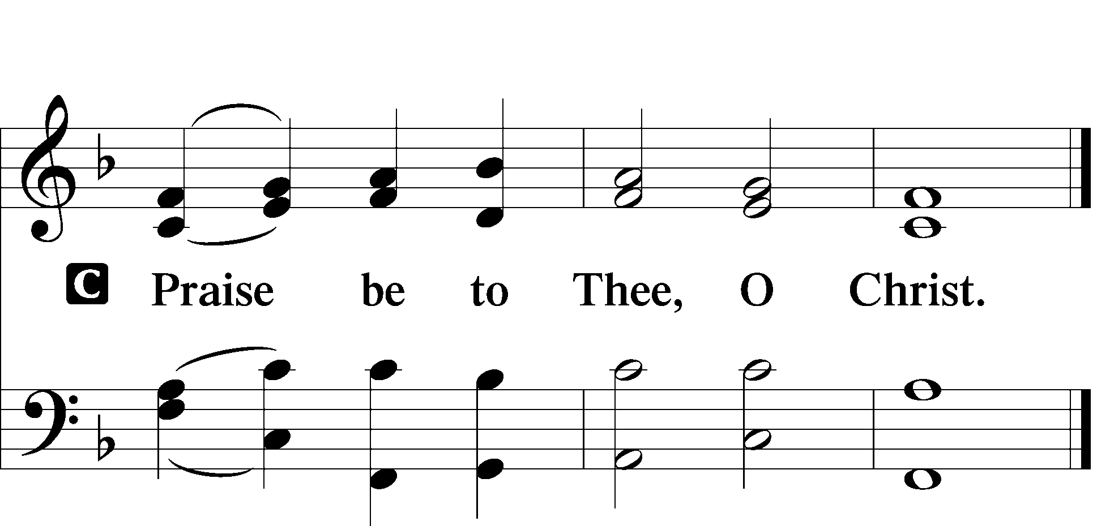

Apostles’ Creed
C I believe in God, the Father Almighty,
maker of heaven and earth.

And in Jesus Christ, His only Son, our Lord,
who was conceived by the Holy Spirit,
born of the virgin Mary,
suffered under Pontius Pilate,
was crucified, died and was buried.
He descended into hell.
The third day He rose again from the dead.
He ascended into heaven
and sits at the right hand of God the Father Almighty.
From thence He will come to judge the living and the dead.

I believe in the Holy Spirit,
the holy Christian Church,
the communion of saints,
the forgiveness of sins,
the resurrection of the body,
and the life T everlasting. Amen.

Sit

417 Alleluia, Song of Gladness
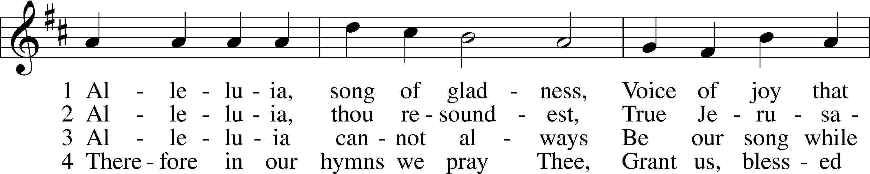
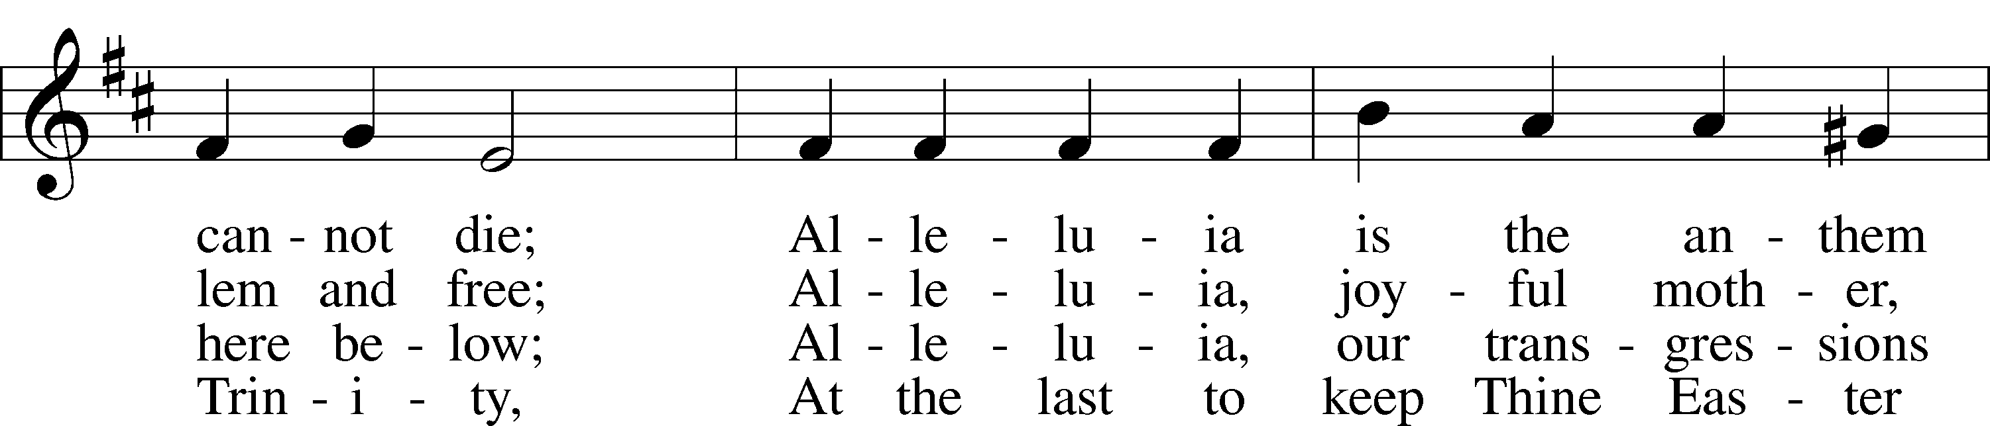
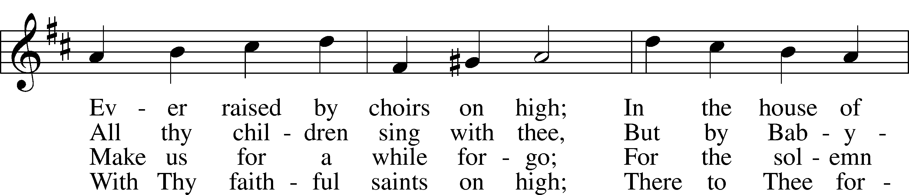
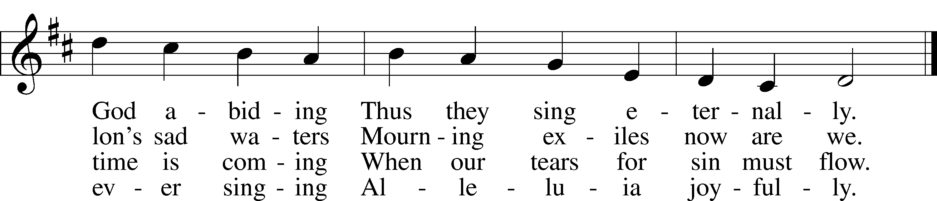

Sermon

Offering

Psalm for Meditation Psalm 2:6–12; antiphon: v. 6
“As for me, I have set my King
on Zion, my holy hill.”
I will tell of the decree:
The Lord said to me, “You are my Son;
today I have begotten you.
Ask of me, and I will make the nations your heritage,
and the ends of the earth your possession.
You shall break them with a rod of iron
and dash them in pieces like a potter’s vessel.”
Now therefore, O kings, be wise;
be warned, O rulers of the earth.
Serve the Lord with fear,
and rejoice with trembling.
Kiss the Son,
lest he be angry, and you perish in the way,
for his wrath is quickly kindled.
Blessèd are all who take refuge in him.

Stand

781 We Give Thee But Thine Own sts. 1–2
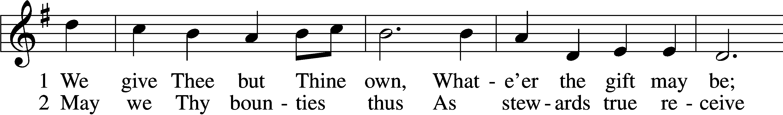
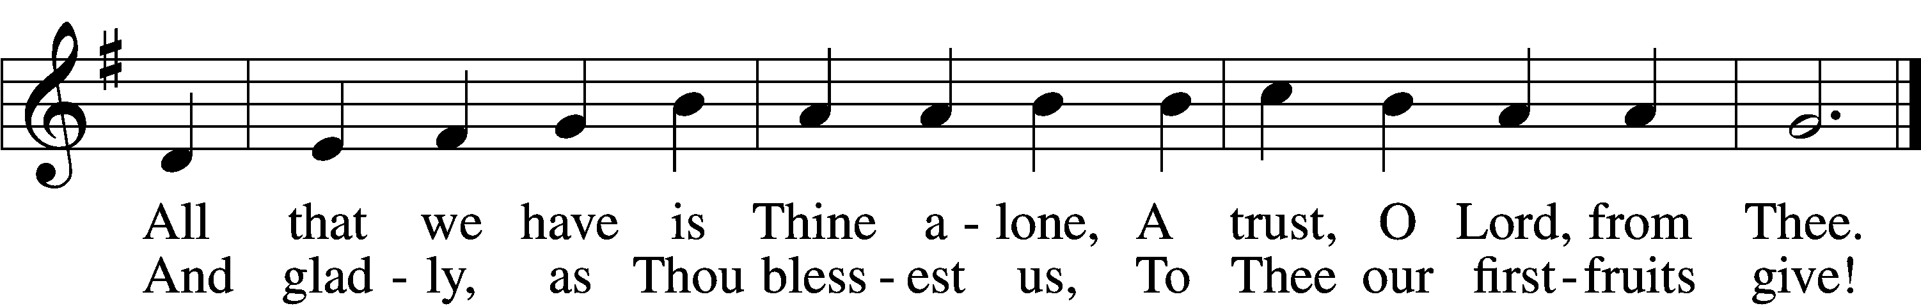

Prayer of the Church
After “let us pray to the Lord:” respond with “Lord, have mercy.”

P Let us pray for the whole people of God in Christ Jesus and for all people according to their needs.
P For the faithful proclamation of Christ’s saving name, that God’s people may be strengthened in the true faith and His kingdom extended, let us pray to the Lord:
C Lord, have mercy.
P For the holy Christian Church throughout the world and for all who confess the name of Christ, that God would guard and defend us from the temptations of the devil, the world, and our sinful nature, let us pray to the Lord:
C Lord, have mercy.
P For those who have wandered from the faith, that the Holy Spirit would use us to call them home to the Father, let us pray to the Lord:
C Lord, have mercy.
P For all who serve in worthy occupations, professions, arts, and sciences, that God would grant them skill and integrity in the performance of their responsibilities and valued service through their vocations, let us pray to the Lord:
C Lord, have mercy.
P For those who suffer from hunger, homelessness, poverty, or unemployment, that God’s great mercy and love would preserve and relieve them, let us pray to the Lord:
C Lord, have mercy.
P For those who are sick especially Kristine, Joshua, Hunter, Lorraine, Dorothy, Marge, Tony, Bill M., Patricia, Phil, Lidia, Michele, Giuseppe, Alfred, and Nancy that God would grant healing to their bodies and strength to bear their infirmities with patience and grace, let us pray to the Lord:
C Lord, have mercy.
P For those who rejoice in the rich blessings of God, that they may always remember the Giver of every gift and give Him heartfelt thanks, let us pray to the Lord:
C Lord, have mercy.
P O Lord, heavenly Father, we gratefully remember the sufferings and death of Your dear Son, Jesus Christ, for our salvation. Rejoicing in His victorious resurrection from the dead, we draw strength from His ascension before You, where He ever stands for us as our own High Priest. Gather us together from the ends of the earth to celebrate with all the faithful the marriage feast of the Lamb in His kingdom, which has no end. Graciously receive our prayers, deliver and preserve us, for to You alone we give all glory, honor, and worship, Father, Son, and Holy Spirit, one God, now and forever.
C Amen.

Lord’s Prayer LSB 196
C Our Father who art in heaven,
hallowed be Thy name,
Thy kingdom come,
Thy will be done on earth as it is in heaven;
give us this day our daily bread;
and forgive us our trespasses as we forgive those who trespass against us;
and lead us not into temptation,
but deliver us from evil.
For Thine is the kingdom and the power and the glory forever and ever. Amen.

Salutation LSB 201
P The Lord be with you.
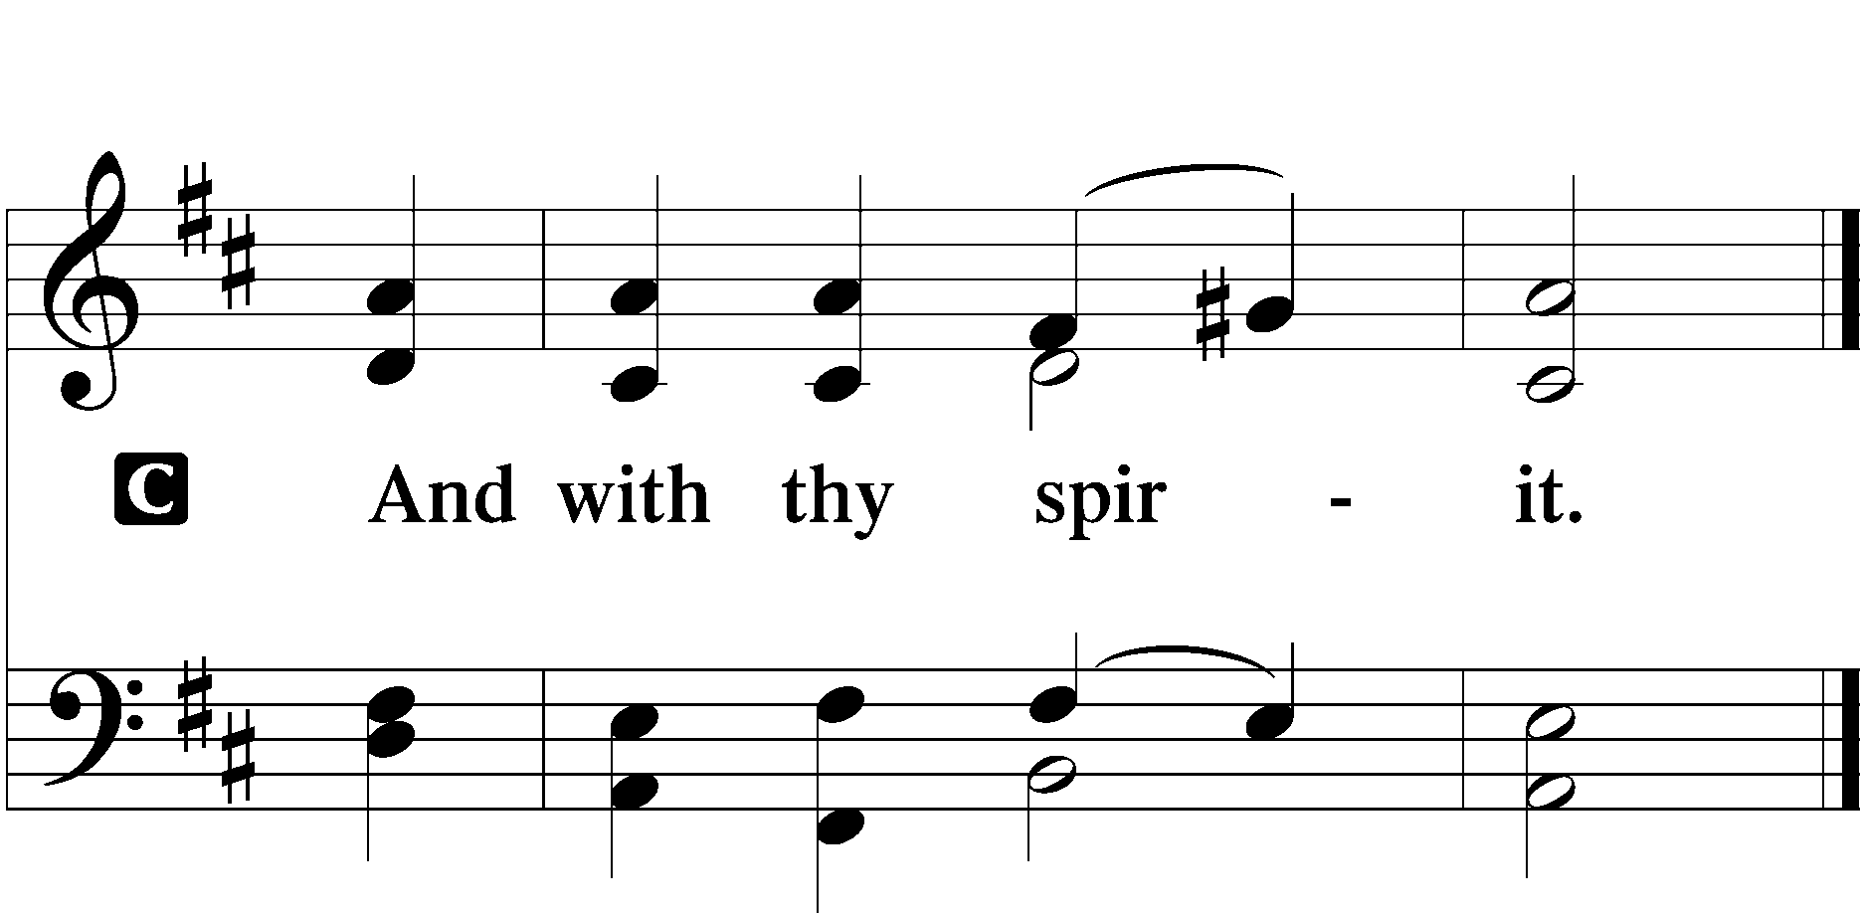

Benedicamus LSB 202
A Bless we the Lord.
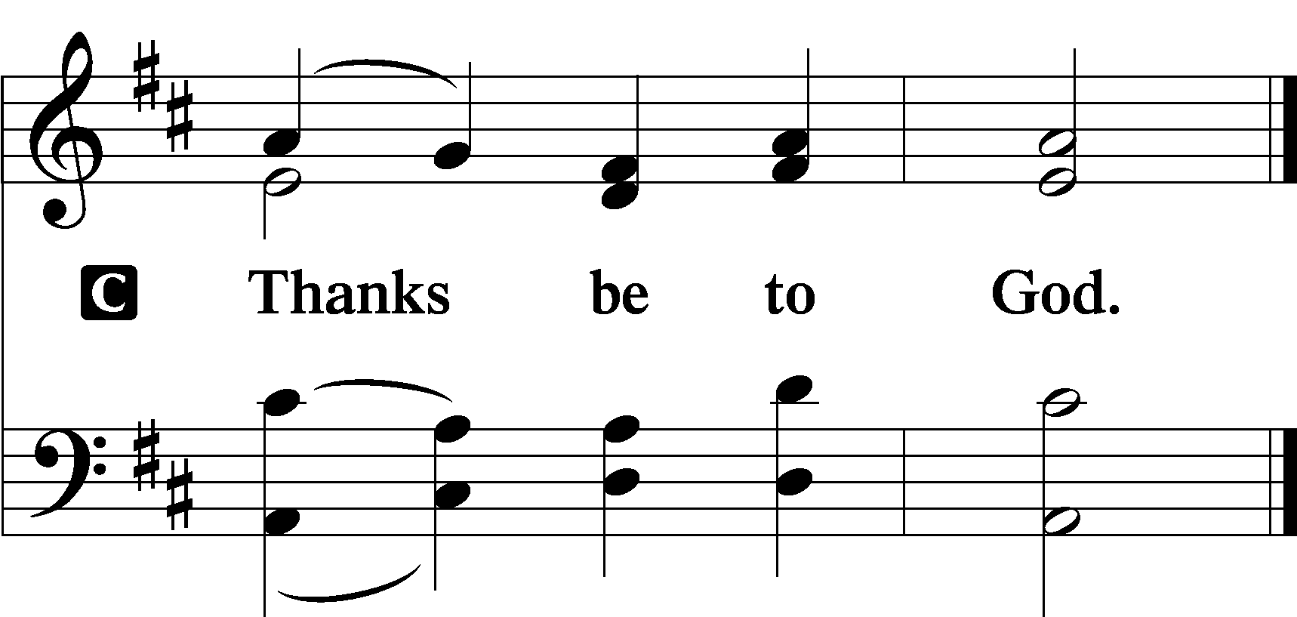

Benediction LSB 202
P The Lord bless you and keep you.
The Lord make His face shine upon you and be gracious unto you.
The Lord lift up His countenance upon you and T give you peace.
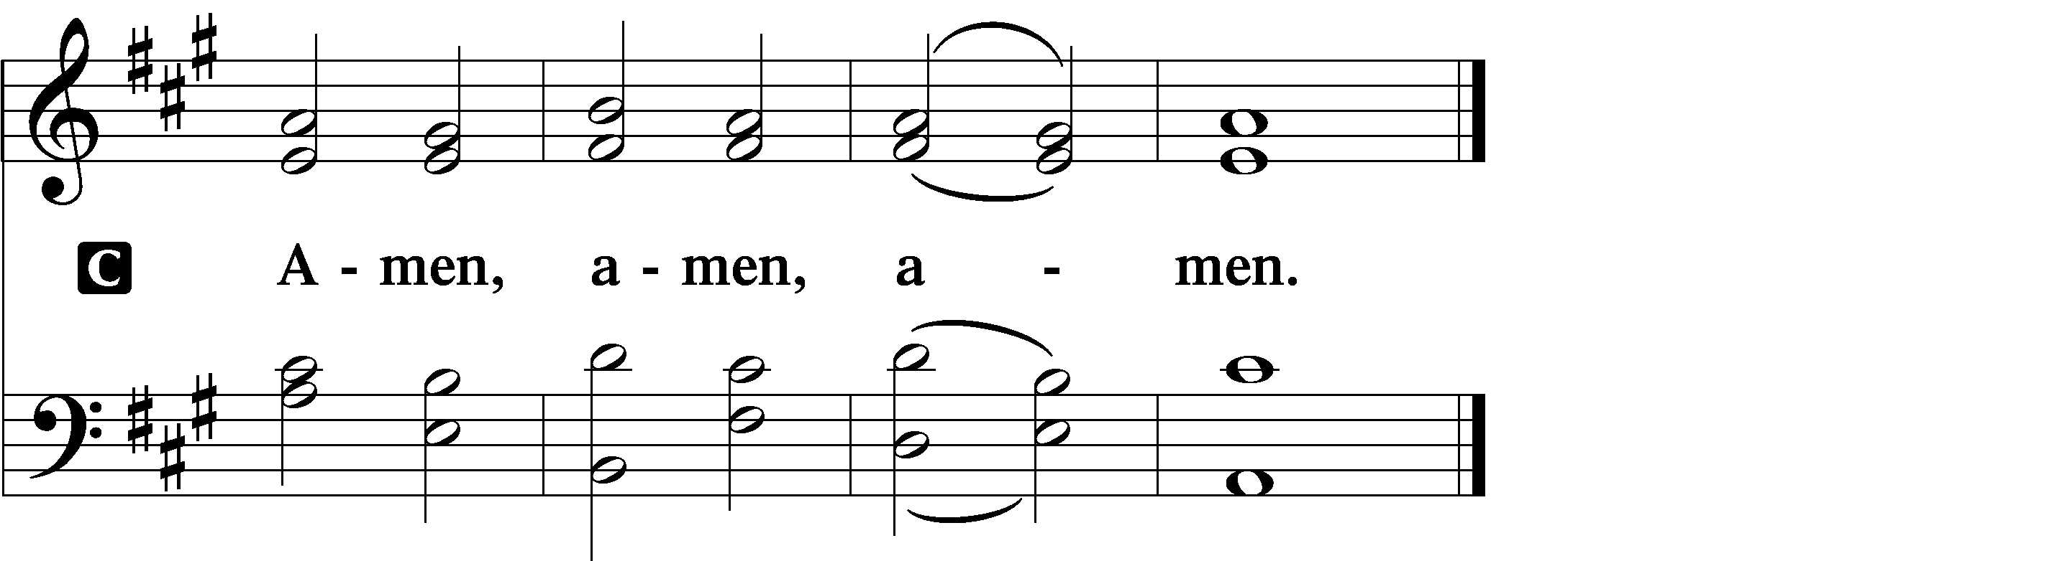

919 Abide, O Dearest Jesus sts. 1–4
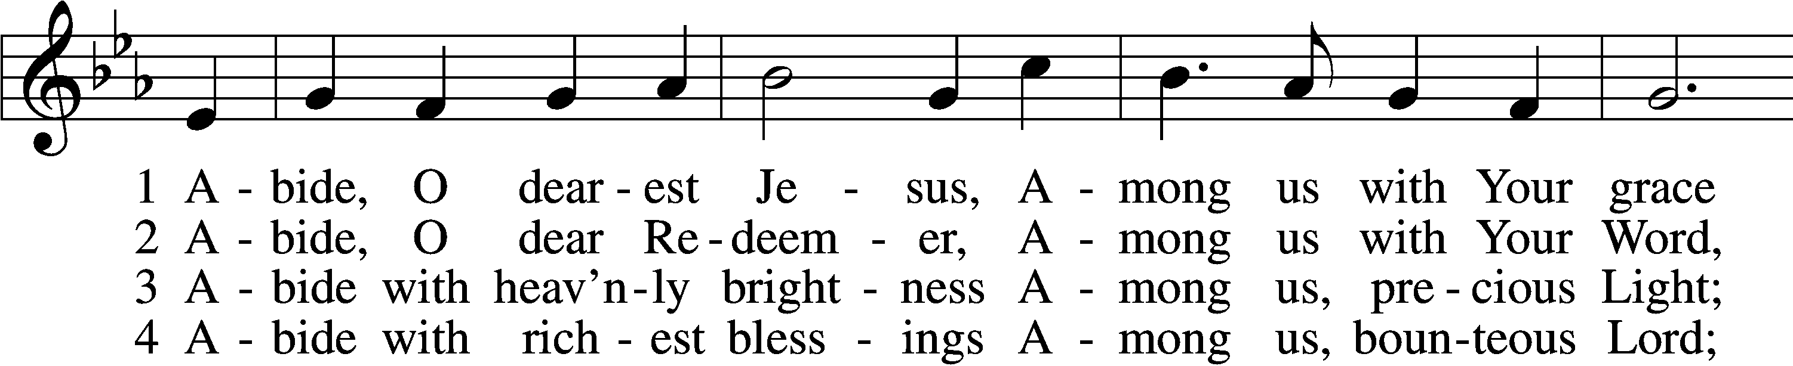
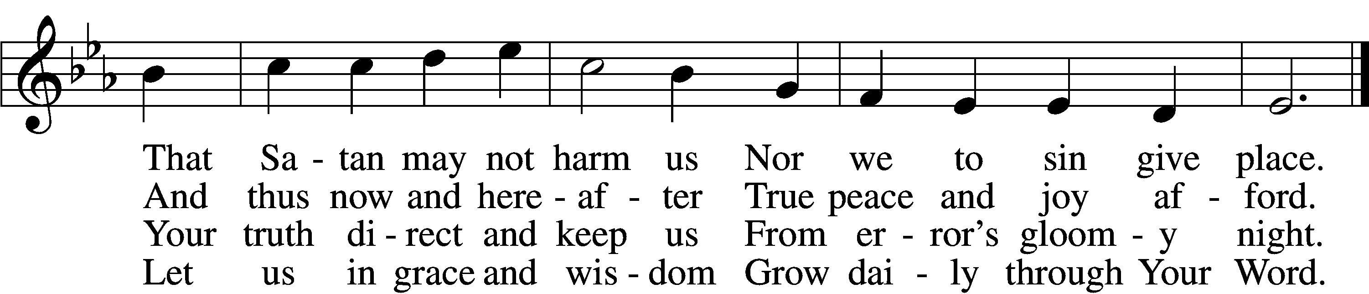

Announcements

Join us after the service in the fellowship hall for refreshments.

Pastor Rockett will conduct service for February 22nd.

Pastor Vogel will conduct service for March 8th.

We are unable to have an Ash Wednesday Service.

St. John’s Lutheran Church
810 Broad St., Clifton, NJ 07013
StJohnsClifton.Org
PrayingHands810@gmail.com

