Second Sunday in Advent December 7, 2025 – Lectionary Series C
St. John’s Lutheran Church

Order of Worship
by
Lutheran Service Builder
357 O Come, O Come, Emmanuel sts. 1, ref, 2–5
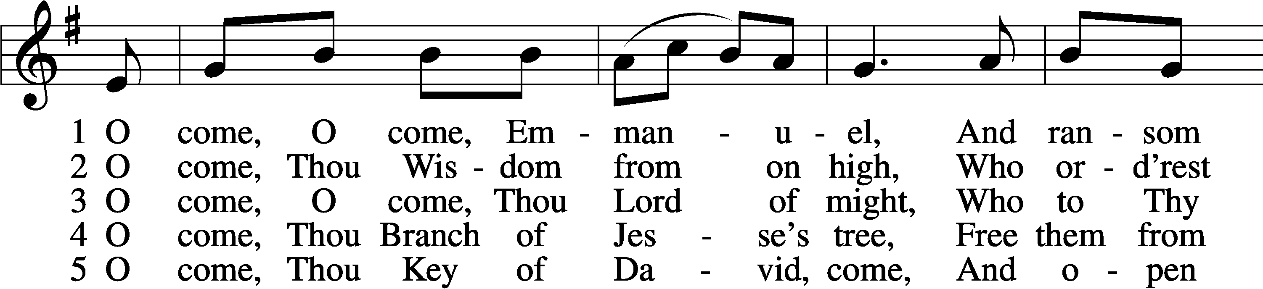
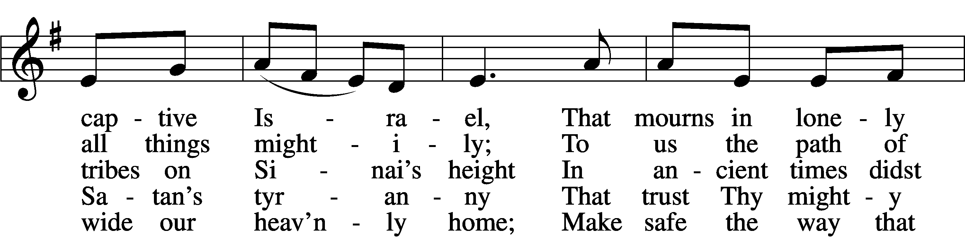
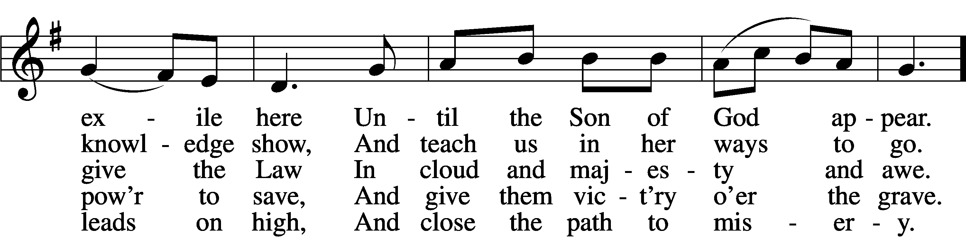
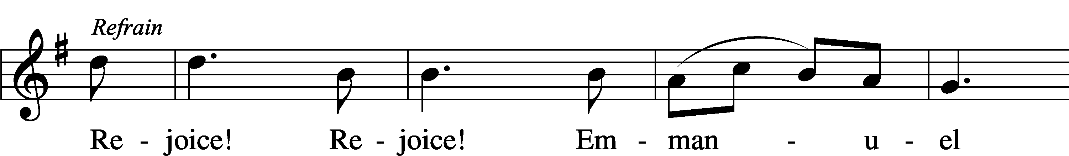
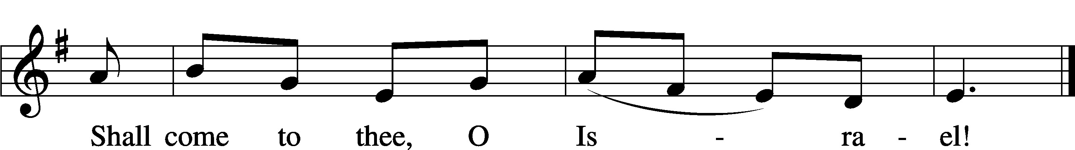

Stand for last verse

Confession and Absolution

The sign of the cross may be made by all in remembrance of their Baptism.

Invocation
P In the name of the Father and of the T Son and of the Holy Spirit.
C Amen.

Exhortation LSB 151
P If we say we have no sin, we deceive ourselves, and the truth is not in us.
C But if we confess our sins, God, who is faithful and just, will forgive our sins and cleanse us from all unrighteousness.

Silence for reflection on God’s Word and for self-examination.

Confession of Sins LSB 151
P Let us then confess our sins to God our Father.
C Most merciful God, we confess that we are by nature sinful and unclean. We have sinned against You in thought, word, and deed, by what we have done and by what we have left undone. We have not loved You with our whole heart; we have not loved our neighbors as ourselves. We justly deserve Your present and eternal punishment. For the sake of Your Son, Jesus Christ, have mercy on us. Forgive us, renew us, and lead us, so that we may delight in Your will and walk in Your ways to the glory of Your holy name. Amen.

Absolution LSB 151
P Almighty God in His mercy has given His Son to die for you and for His sake forgives you all your sins. As a called and ordained servant of Christ, and by His authority, I therefore forgive you all your sins in the name of the Father and of the T Son and of the Holy Spirit.
C Amen.

Service of the Word

Introit Psalm 105:4–8; antiphon: Isaiah 40:3b
In the wilderness prepare the way of the Lord;
make straight in the desert a highway for our God.
Seek the Lord and his strength;
seek his presence continually!
Remember the wondrous works that he has done,
his miracles, and the judgments he uttered,
O offspring of Abraham, his servant,
children of Jacob, his chosen ones!
He is the Lord our God;
his judgments are in all the earth.
He remembers his covenant forever,
the word that he commanded, for a thousand generations.
Glory be to the Father and to the Son
and to the Holy Spirit;
as it was in the beginning,
is now, and will be forever. Amen.
In the wilderness prepare the way of the Lord;
make straight in the desert a highway for our God.

Kyrie LSB 152

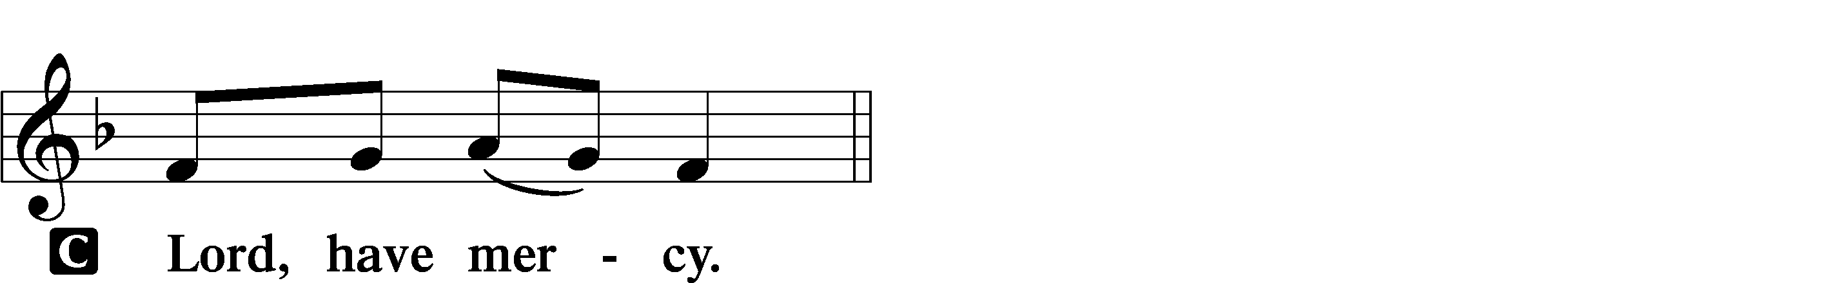

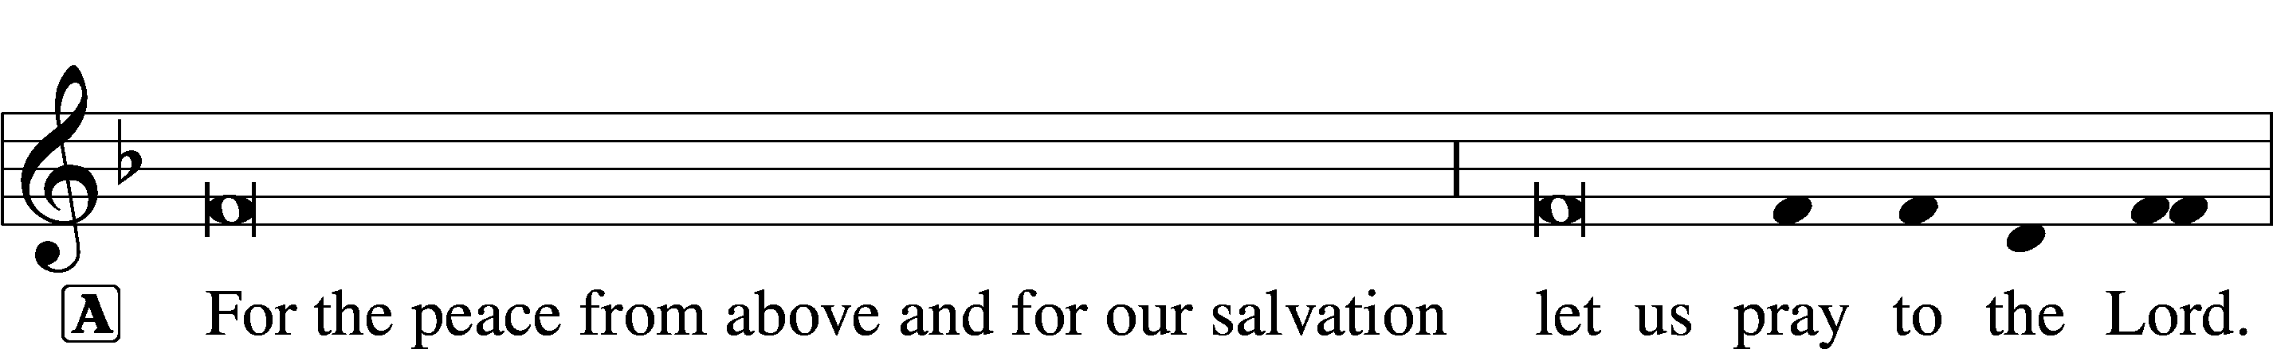
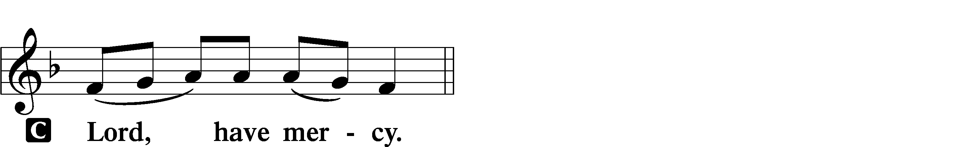

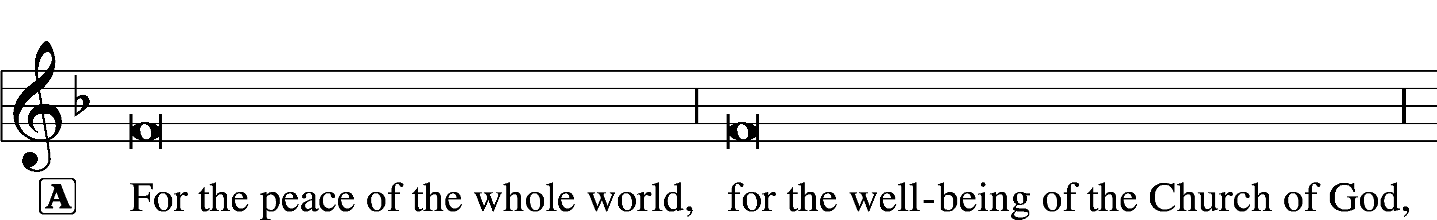
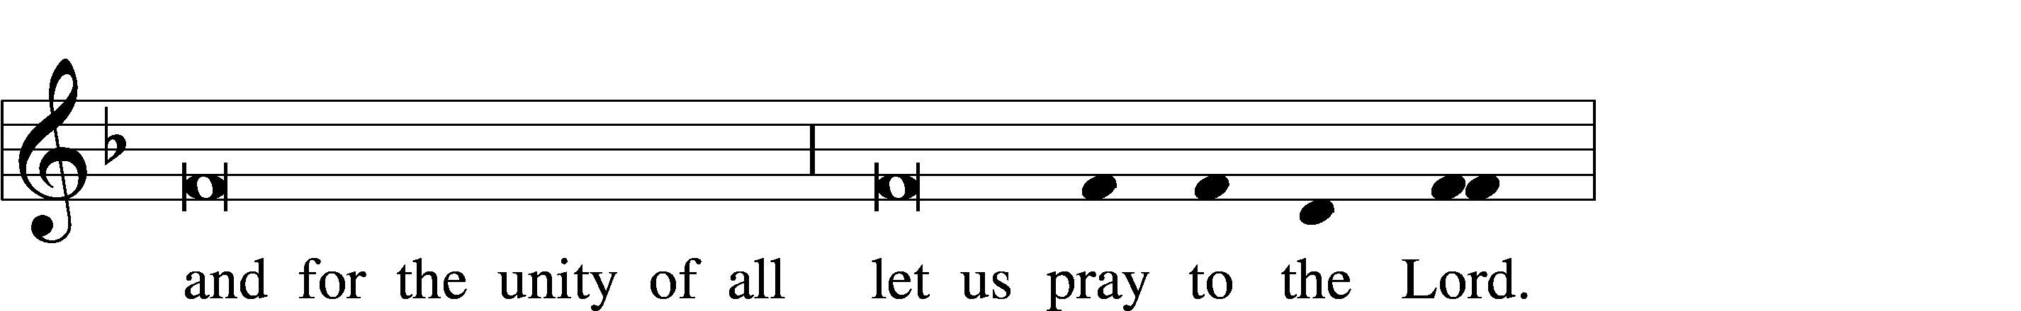
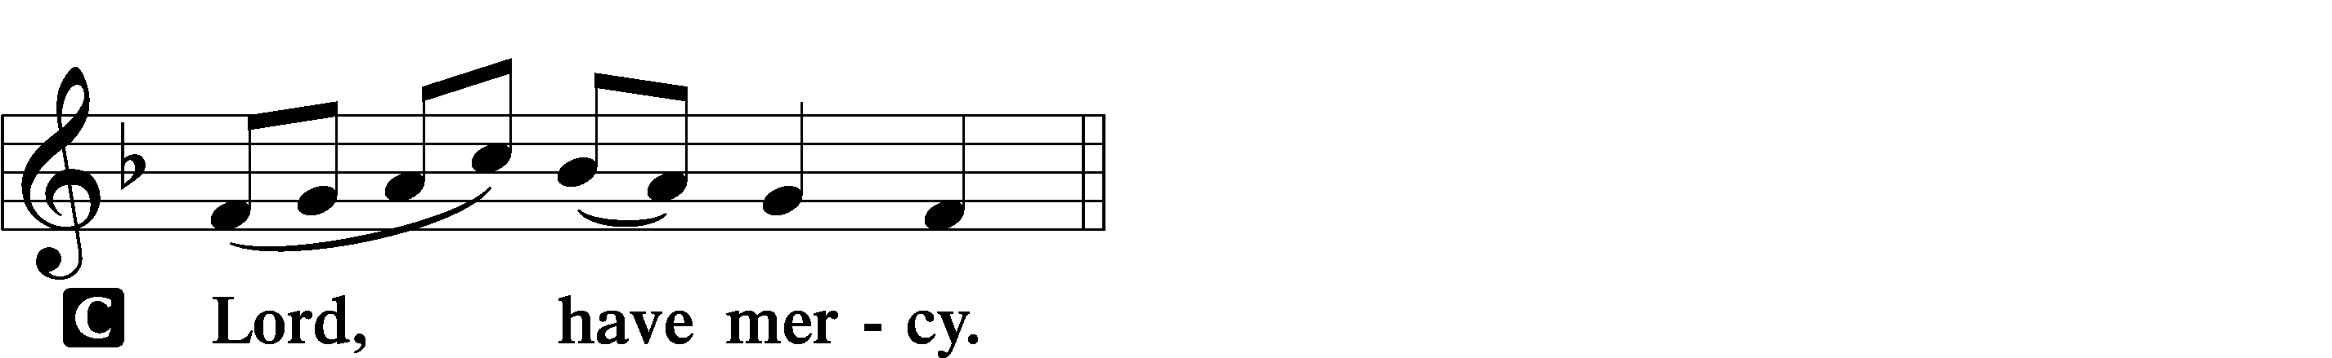

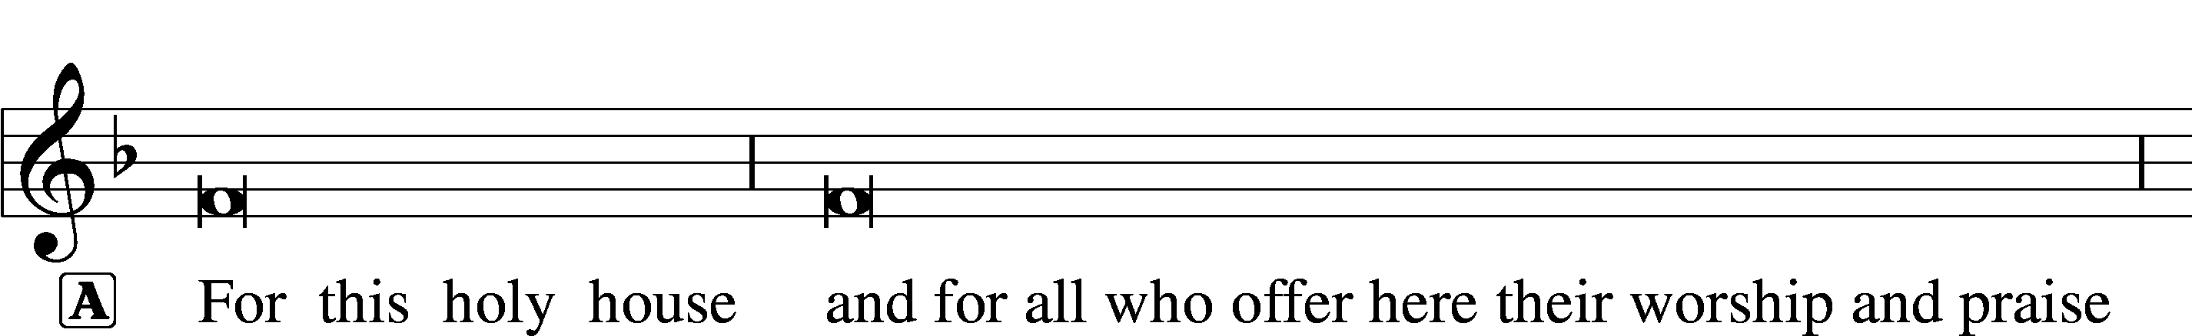

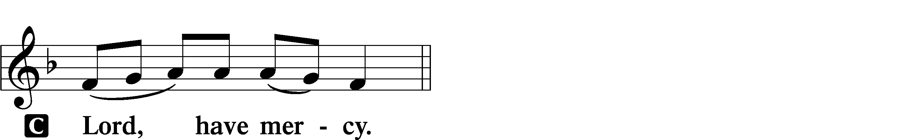




Salutation and Collect of the Day LSB 156
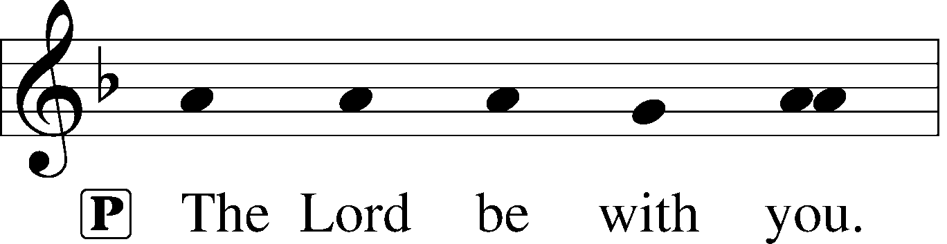
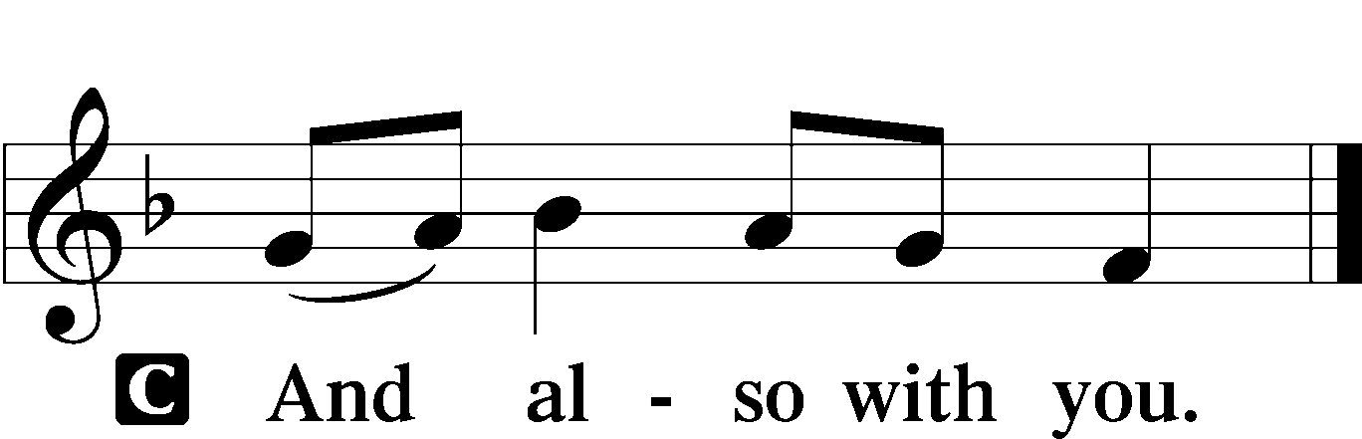

P Let us pray.
Stir up our hearts, O Lord, to make ready the way of Your only-begotten Son, that by His coming we may be enabled to serve You with pure minds; through the same Jesus Christ, our Lord, who lives and reigns with You and the Holy Spirit, one God, now and forever.

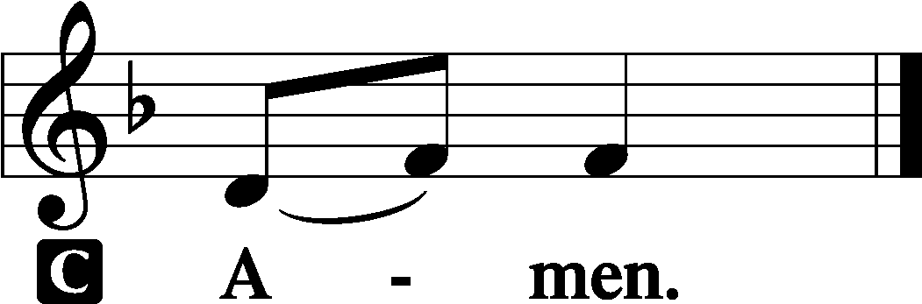

Sit

Old Testament Reading Isaiah 11:1–10
There shall come forth a shoot from the stump of Jesse,
and a branch from his roots shall bear fruit.
And the Spirit of the Lord shall rest upon him,
the Spirit of wisdom and understanding,
the Spirit of counsel and might,
the Spirit of knowledge and the fear of the Lord.
And his delight shall be in the fear of the Lord.
He shall not judge by what his eyes see,
or decide disputes by what his ears hear,
but with righteousness he shall judge the poor,
and decide with equity for the meek of the earth;
and he shall strike the earth with the rod of his mouth,
and with the breath of his lips he shall kill the wicked.
Righteousness shall be the belt of his waist,
and faithfulness the belt of his loins.
The wolf shall dwell with the lamb,
and the leopard shall lie down with the young goat,
and the calf and the lion and the fattened calf together;
and a little child shall lead them.
The cow and the bear shall graze;
their young shall lie down together;
and the lion shall eat straw like the ox.
The nursing child shall play over the hole of the cobra,
and the weaned child shall put his hand on the adder’s den.
They shall not hurt or destroy
in all my holy mountain;
for the earth shall be full of the knowledge of the Lord
as the waters cover the sea.
In that day the root of Jesse, who shall stand as a signal for the peoples—of him shall the nations inquire, and his resting place shall be glorious.

A This is the Word of the Lord.
C Thanks be to God.

Epistle Romans 15:4–13
Whatever was written in former days was written for our instruction, that through endurance and through the encouragement of the Scriptures we might have hope. May the God of endurance and encouragement grant you to live in such harmony with one another, in accord with Christ Jesus, that together you may with one voice glorify the God and Father of our Lord Jesus Christ. Therefore welcome one another as Christ has welcomed you, for the glory of God.
For I tell you that Christ became a servant to the circumcised to show God’s truthfulness, in order to confirm the promises given to the patriarchs, and in order that the Gentiles might glorify God for his mercy. As it is written,
“Therefore I will praise you among the Gentiles,
and sing to your name.”
And again it is said,
“Rejoice, O Gentiles, with his people.”
And again,
“Praise the Lord, all you Gentiles,
and let all the peoples extol him.”
And again Isaiah says,
“The root of Jesse will come,
even he who arises to rule the Gentiles;
in him will the Gentiles hope.”
May the God of hope fill you with all joy and peace in believing, so that by the power of the Holy Spirit you may abound in hope.

A This is the Word of the Lord.
C Thanks be to God.

Stand

Alleluia and Verse LSB 156
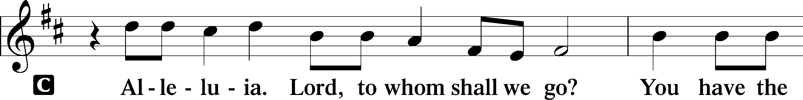
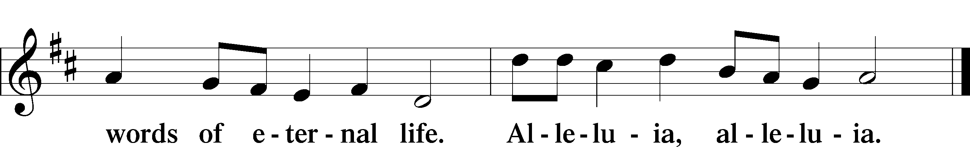

Holy Gospel Matthew 3:1–12
P The Holy Gospel according to St. Matthew, the third chapter.

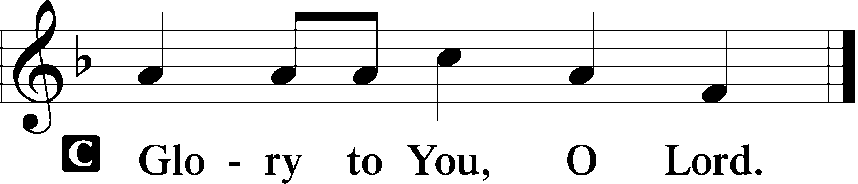

In those days John the Baptist came preaching in the wilderness of Judea, “Repent, for the kingdom of heaven is at hand.” For this is he who was spoken of by the prophet Isaiah when he said,
“The voice of one crying in the wilderness:
‘Prepare the way of the Lord;
make his paths straight.’”
Now John wore a garment of camel’s hair and a leather belt around his waist, and his food was locusts and wild honey. Then Jerusalem and all Judea and all the region about the Jordan were going out to him, and they were baptized by him in the river Jordan, confessing their sins.
But when he saw many of the Pharisees and Sadducees coming for baptism, he said to them, “You brood of vipers! Who warned you to flee from the wrath to come? Bear fruit in keeping with repentance. And do not presume to say to yourselves, ‘We have Abraham as our father,’ for I tell you, God is able from these stones to raise up children for Abraham. Even now the axe is laid to the root of the trees. Every tree therefore that does not bear good fruit is cut down and thrown into the fire.
“I baptize you with water for repentance, but he who is coming after me is mightier than I, whose sandals I am not worthy to carry. He will baptize you with the Holy Spirit and with fire. His winnowing fork is in his hand, and he will clear his threshing floor and gather his wheat into the barn, but the chaff he will burn with unquenchable fire.”

P This is the Gospel of the Lord.

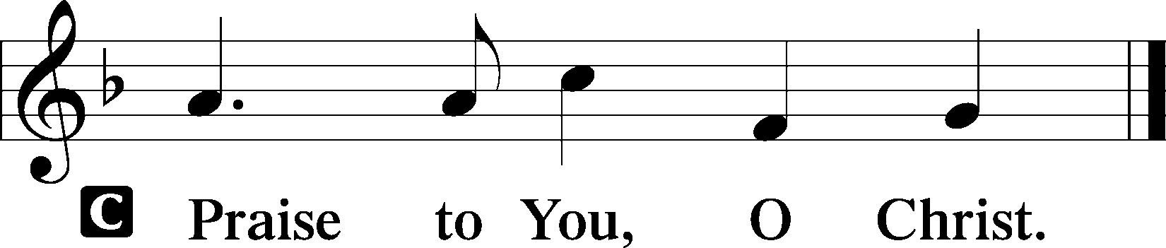

Nicene Creed
C I believe in one God,
the Father Almighty,
maker of heaven and earth
and of all things visible and invisible.

And in one Lord Jesus Christ,
the only-begotten Son of God,
begotten of His Father before all worlds,
God of God, Light of Light,
very God of very God,
begotten, not made,
being of one substance with the Father,
by whom all things were made;
who for us men and for our salvation came down from heaven
and was incarnate by the Holy Spirit of the virgin Mary
and was made man;
and was crucified also for us under Pontius Pilate.
He suffered and was buried.
And the third day He rose again according to the Scriptures
and ascended into heaven
and sits at the right hand of the Father.
And He will come again with glory to judge both the living and the dead,
whose kingdom will have no end.

And I believe in the Holy Spirit,
the Lord and giver of life,
who proceeds from the Father and the Son,
who with the Father and the Son together is worshiped and glorified,
who spoke by the prophets.
And I believe in one holy Christian and apostolic Church,
I acknowledge one Baptism for the remission of sins,
and I look for the resurrection of the dead
and the life T of the world to come. Amen.

Sit

344 On Jordan’s Bank the Baptist’s Cry
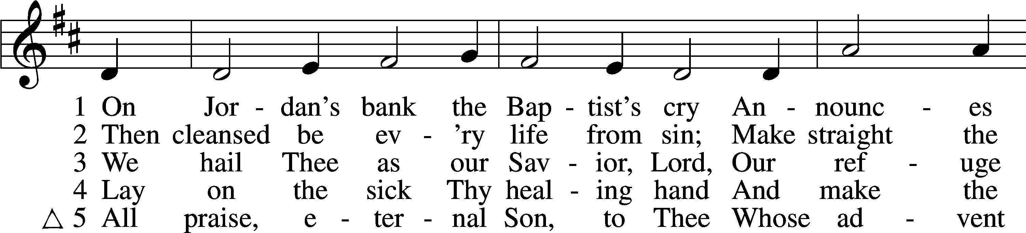
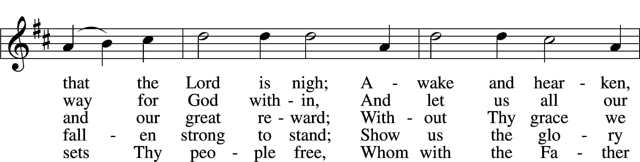
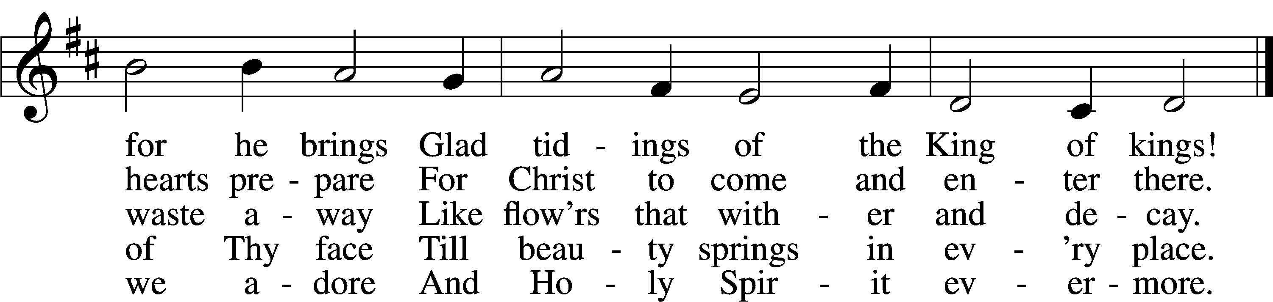

Δ – Stand for last verse

Sermon

Offering

Psalm for Meditation Psalm 72:1–7; antiphon: v. 18
Give the king your justice, O God,
and your righteousness to the royal son!
May he judge your people with righteousness,
and your poor with justice!
Let the mountains bear prosperity for the people,
and the hills, in righteousness!
May he defend the cause of the poor of the people,
give deliverance to the children of the needy,
and crush the oppressor!
May they fear you while the sun endures,
and as long as the moon, throughout all generations!
May he be like rain that falls on the mown grass,
like showers that water the earth!
In his days may the righteous flourish,
and peace abound, till the moon be no more!

Stand

781 We Give Thee But Thine Own sts. 1–2
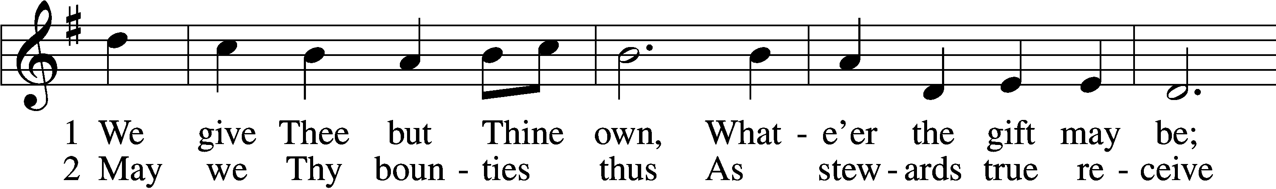
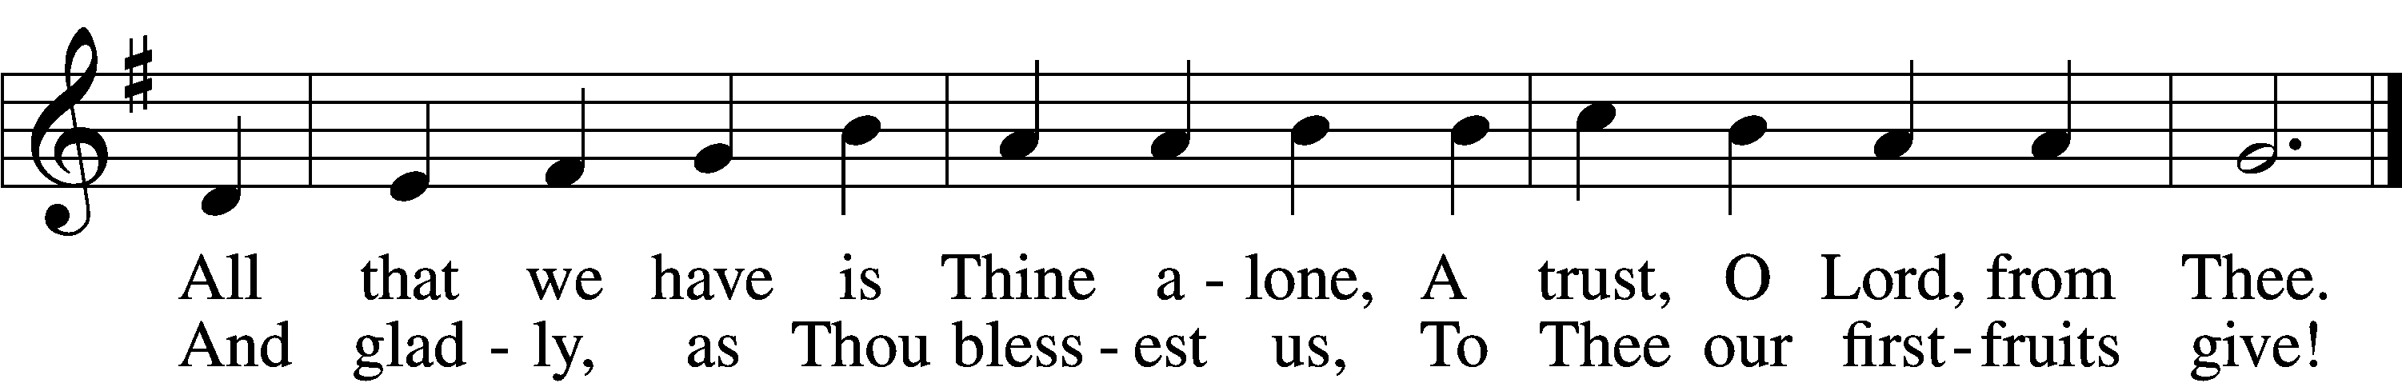

Prayer of the Church
After “Lord, in Your mercy” respond with “hear our prayer.”

Service of the Sacrament

Preface LSB 160

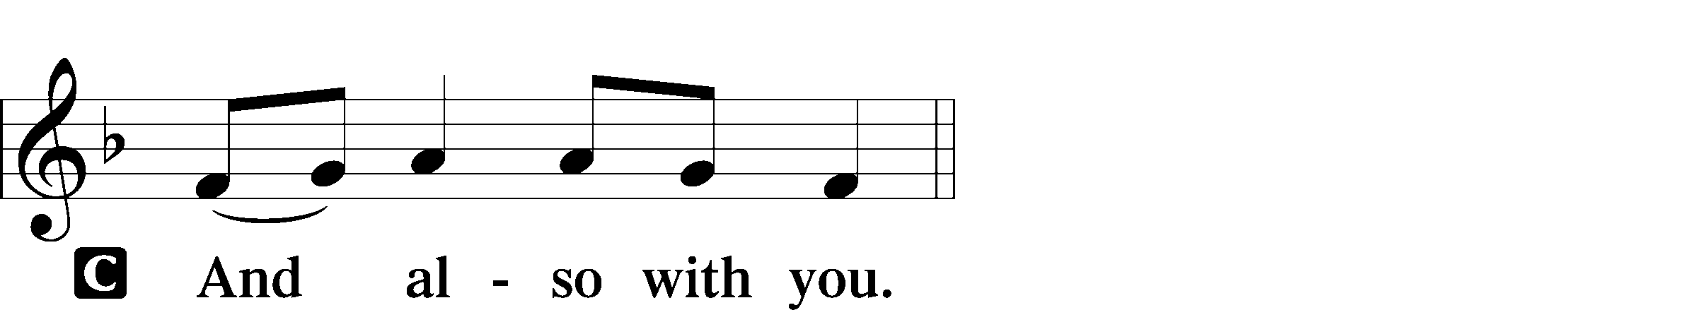
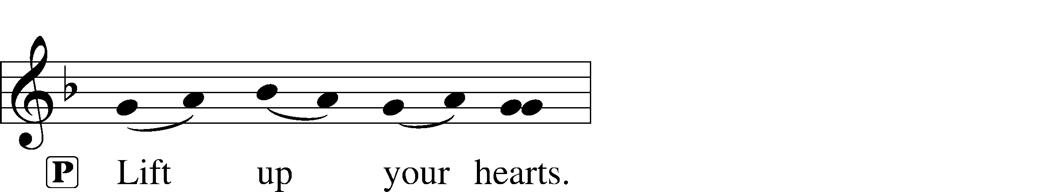

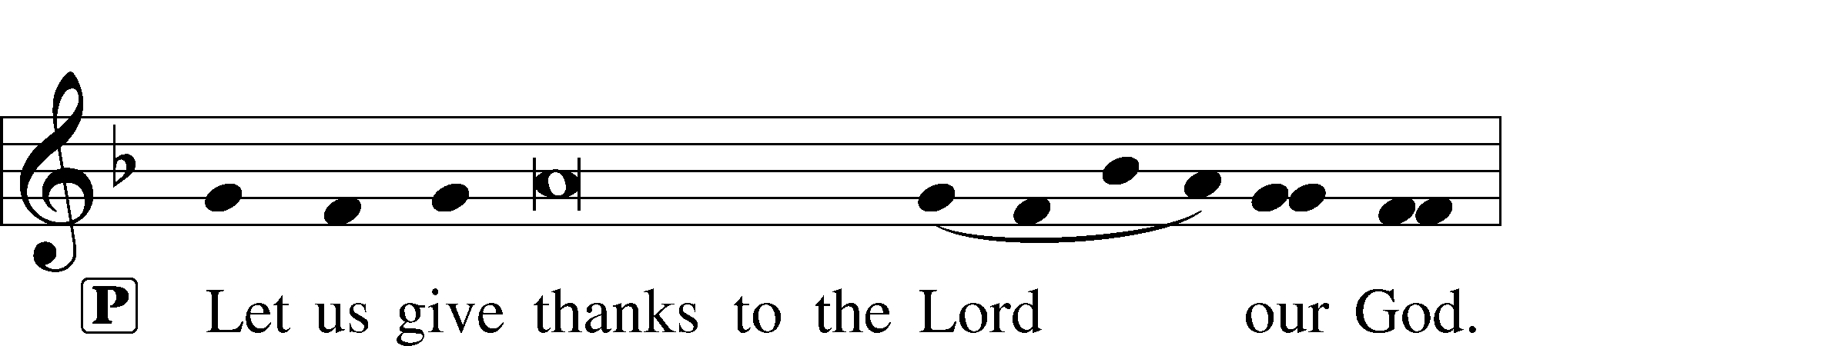
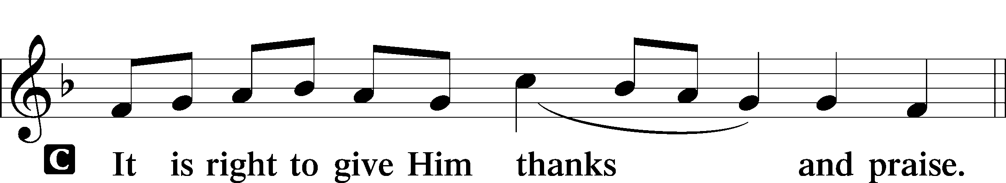

Proper Preface (Full)
P It is truly good, right, and salutary that we should at all times and in all places give thanks to You, holy Lord, almighty Father, everlasting God, through Jesus Christ, our Lord, whose way John the Baptist prepared, proclaiming Him the promised Messiah, the very Lamb of God who takes away the sin of the world, and calling sinners to repentance that they might escape from the wrath to be revealed when He comes again in glory. Therefore with angels and archangels and with all the company of heaven we laud and magnify Your glorious name, evermore praising You and saying:

Sanctus LSB 161
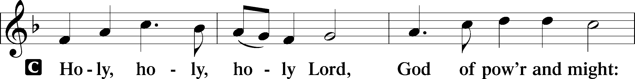
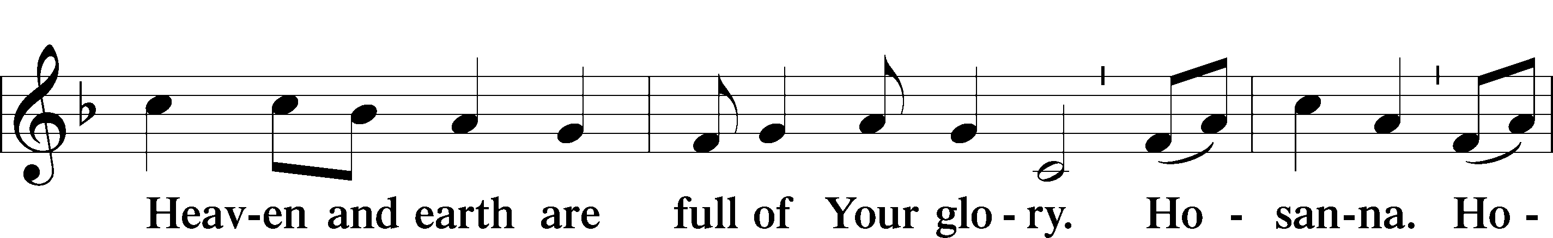
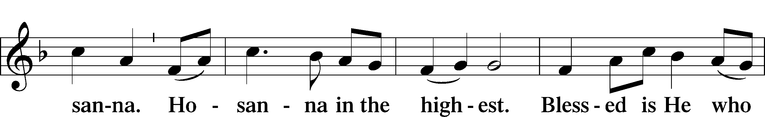
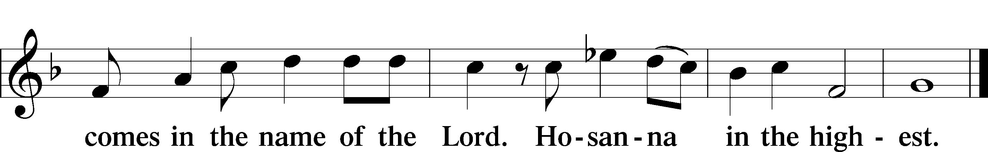

Prayer of Thanksgiving LSB 161
P Blessed are You, Lord of heaven and earth, for You have had mercy on those whom You created and sent Your only-begotten Son into our flesh to bear our sin and be our Savior. With repentant joy we receive the salvation accomplished for us by the all-availing sacrifice of His body and His blood on the cross.

Gathered in the name and the remembrance of Jesus, we beg You, O Lord, to forgive, renew, and strengthen us with Your Word and Spirit. Grant us faithfully to eat His body and drink His blood as He bids us do in His own testament. Gather us together, we pray, from the ends of the earth to celebrate with all the faithful the marriage feast of the Lamb in His kingdom, which has no end. Graciously receive our prayers; deliver and preserve us. To You alone, O Father, be all glory, honor, and worship, with the Son and the Holy Spirit, one God, now and forever.
C Amen.

The Words of Our Lord
P Our Lord Jesus Christ, on the night when He was betrayed, took bread, and when He had given thanks, He broke it and gave it to the disciples and said: “Take, eat; this is My T body, which is given for you. This do in remembrance of Me.”

In the same way also He took the cup after supper, and when He had given thanks, He gave it to them, saying: “Drink of it, all of you; this cup is the new testament in My T blood, which is shed for you for the forgiveness of sins. This do, as often as you drink it, in remembrance of Me.”

Proclamation of Christ
P As often as we eat this bread and drink this cup, we proclaim the Lord’s death until He comes.
C Amen. Come, Lord Jesus.

P O Lord Jesus Christ, only Son of the Father, in giving us Your body and blood to eat and to drink, You lead us to remember and confess Your holy cross and passion, Your blessed death, Your rest in the tomb, Your resurrection from the dead, Your ascension into heaven, and Your coming for the final judgment. So remember us in Your kingdom and teach us to pray:

Lord’s Prayer
C Our Father who art in heaven,
hallowed be Thy name,
Thy kingdom come,
Thy will be done on earth
as it is in heaven;
give us this day our daily bread;
and forgive us our trespasses
as we forgive those
who trespass against us;
and lead us not into temptation,
but deliver us from evil.
For Thine is the kingdom
and the power and the glory
forever and ever. Amen.

Pax Domini LSB 163
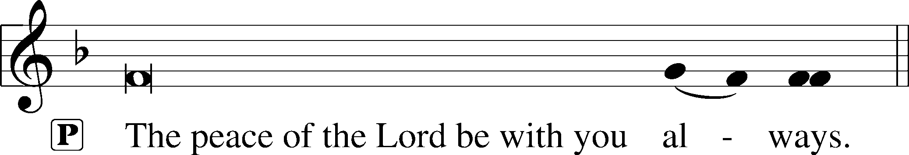


Agnus Dei LSB 163
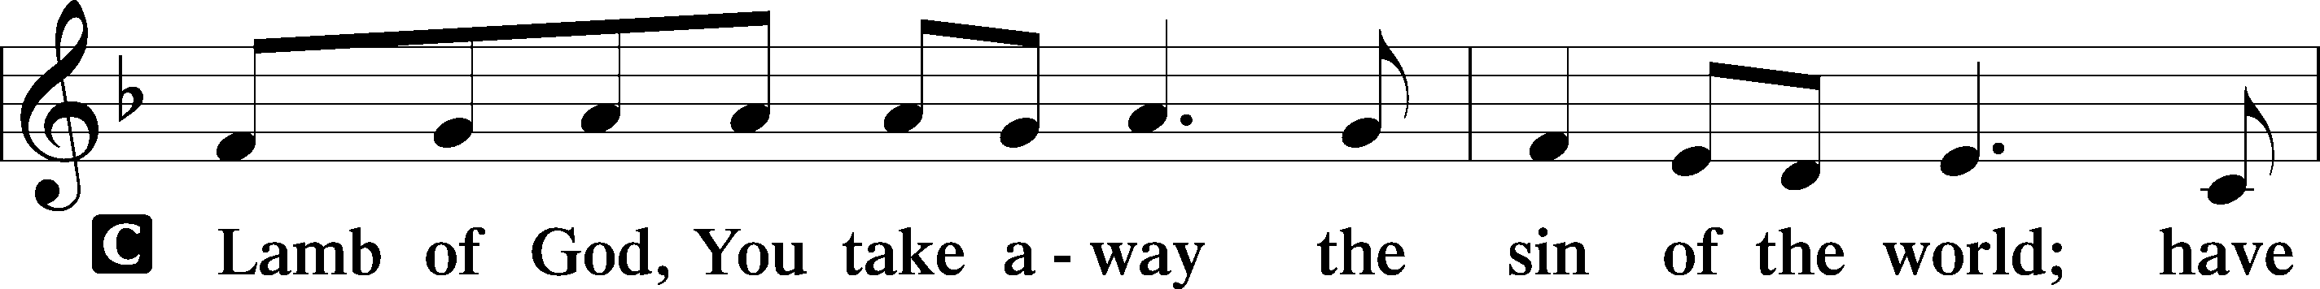
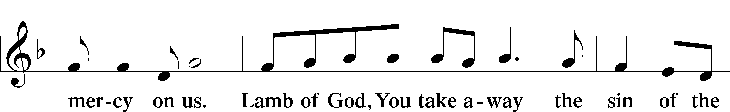
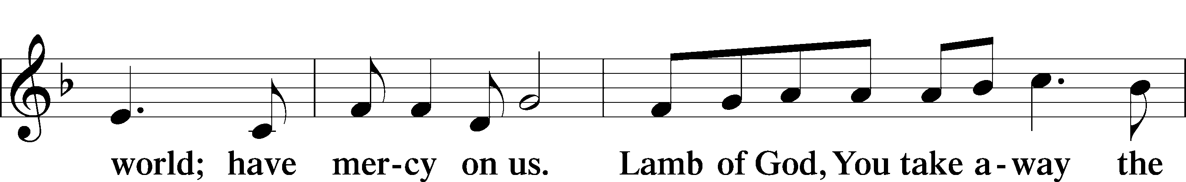
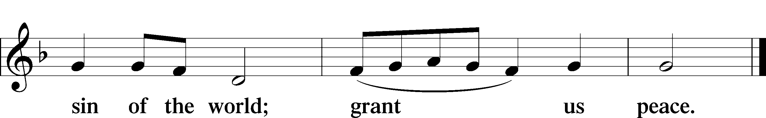

Sit

Distribution & Distribution Hymn

618 I Come, O Savior, to Thy Table sts. 1, ref, 2–4
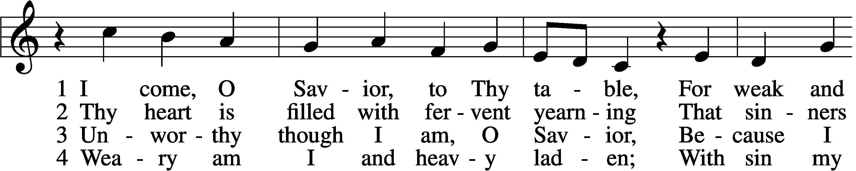
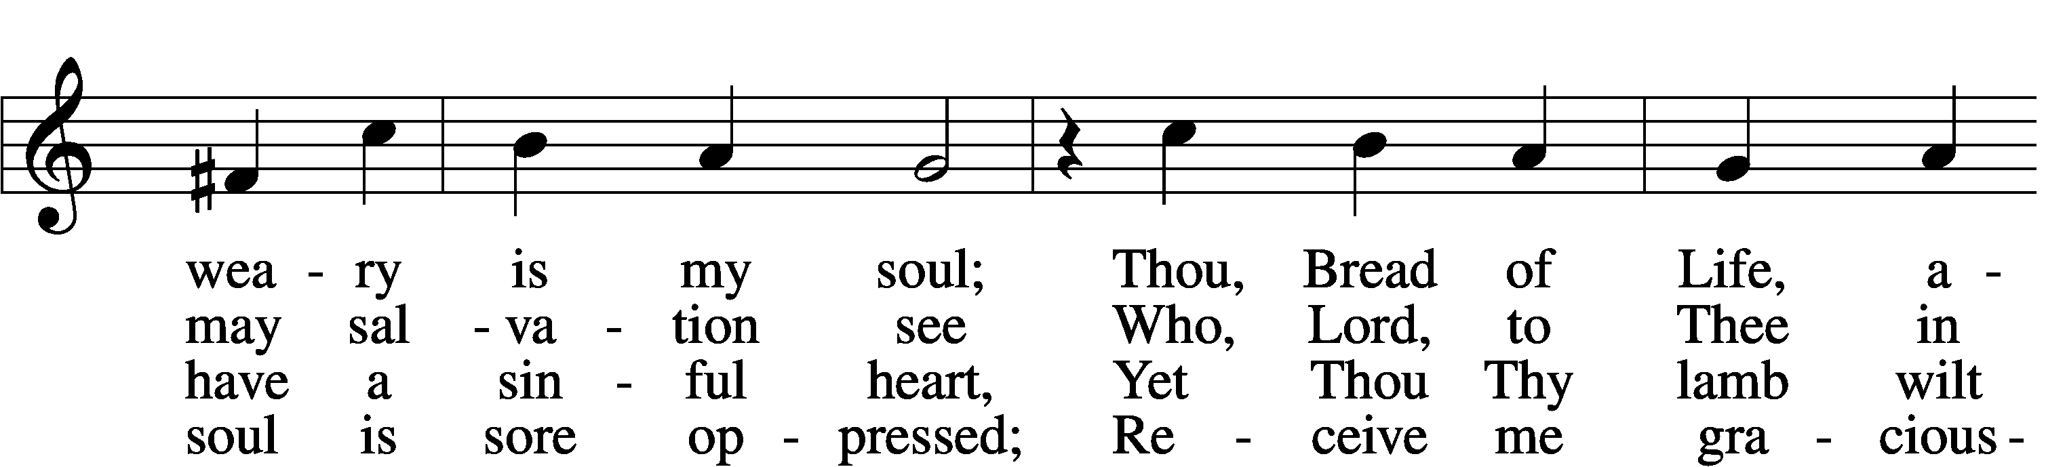
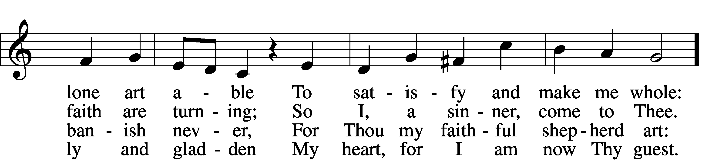
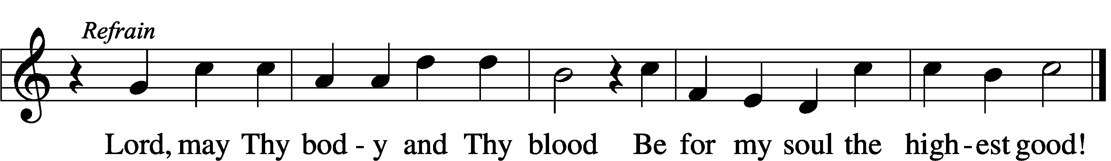

Stand

Thank the Lord LSB 164
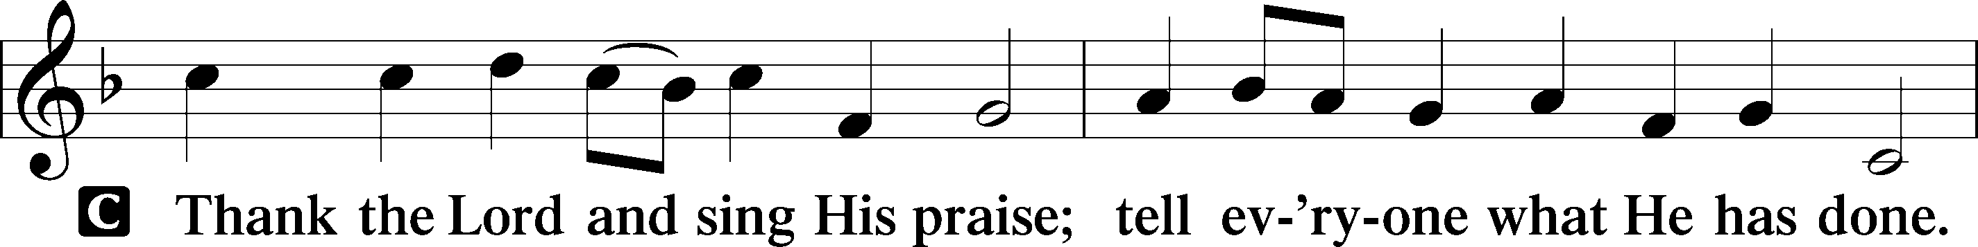
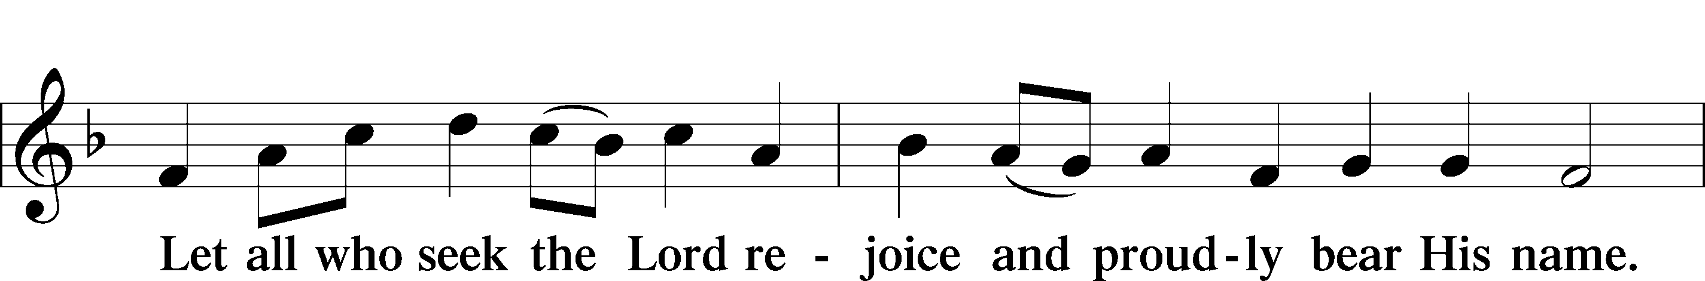
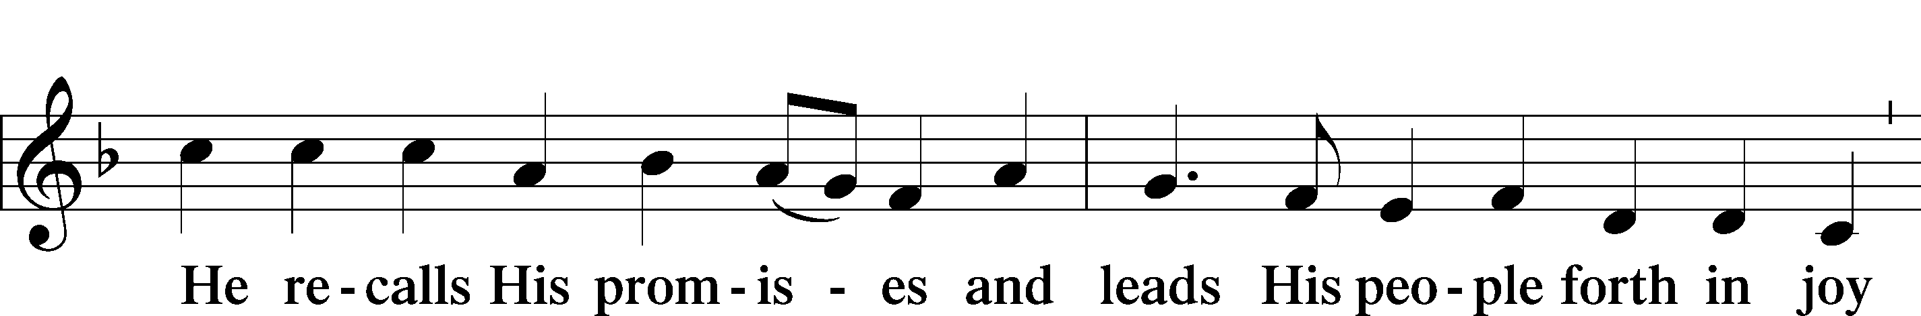
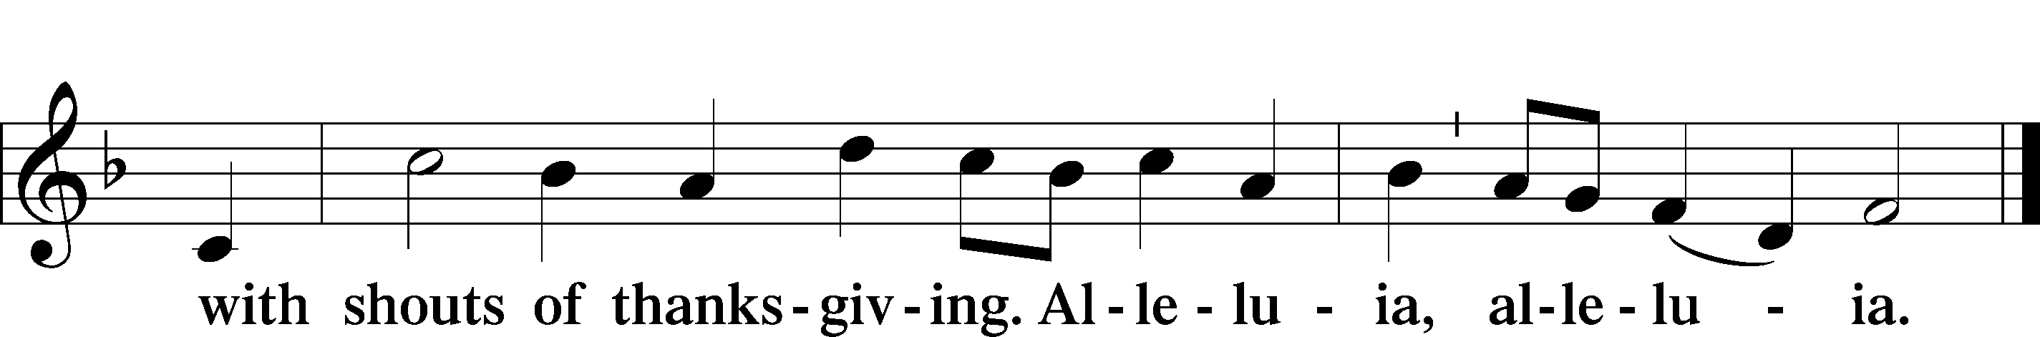

Post-Communion Collect
A Let us pray.
We give thanks to You, almighty God, that You have refreshed us through this salutary gift, and we implore You that of Your mercy You would strengthen us through the same in faith toward You and in fervent love toward one another; through Jesus Christ, Your Son, our Lord, who lives and reigns with You and the Holy Spirit, one God, now and forever.

Benediction LSB 166
P The Lord bless you and keep you.
The Lord make His face shine on you and be gracious to you.
The Lord look upon you with favor and T give you peace.


349 Hark the Glad Sound
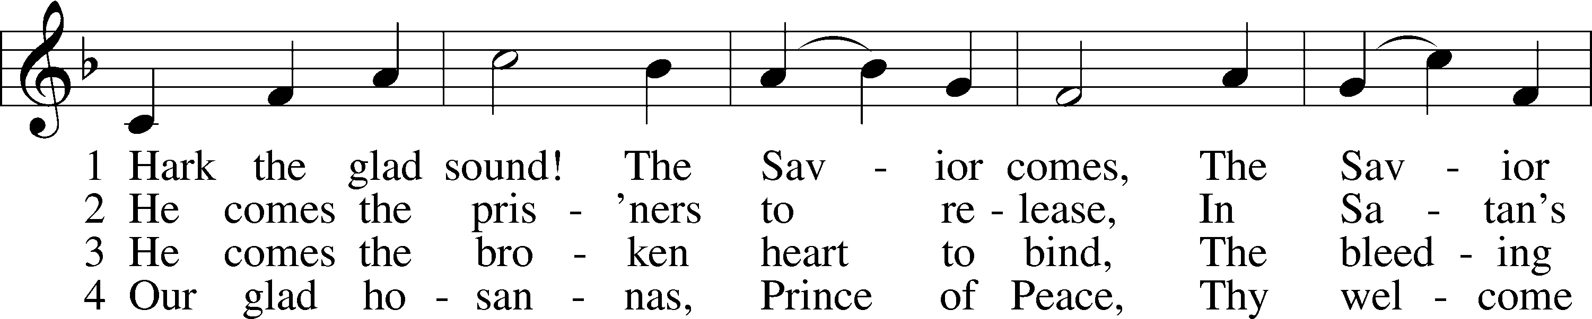
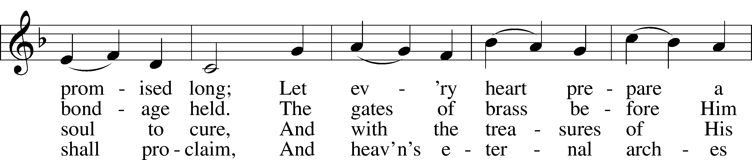
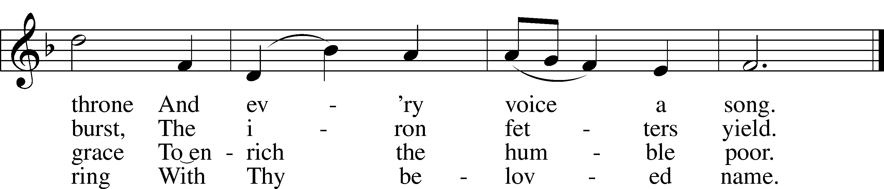

Announcements

Join us after the service in the fellowship hall for refreshments and Bible Study.

Collecting has begun for hats and mittens for our local schools, and Toys for Tots. Items will be collected until Dec. 15th.

Pastor Vogel will conduct services for Dec. 7th and 14th, and Jan. 4th, 11th and 18th.

Pastor Holsten will lead services on December 21st and on Christmas Eve afternoon at 3:00pm

Poinsettias can now be ordered from either Ellen or Carol Bender. Cost of each plant is $15.00. Checks should be payable to the “Ladies’ Guild”

Our annual Cookie Walk will be held on December 21st, after church service. If you would like to donate, please see our Kitchen Crew for details. Monetary donations are also accepted. Cookies will be available for purchase at $5.00 per container.

St. John’s Lutheran Church
810 Broad St., Clifton, NJ 07013
StJohnsClifton.Org
PrayingHands810@gmail.com

