Twenty-second Sunday after Pentecost November 9, 2025 – Lectionary Series
St. John’s Lutheran Church

Order of Worship
by
Lutheran Service Builder

711 Savior, like a Shepherd Lead Us

Stand for last verse

Confession and Absolution

The sign of the cross may be made by all in remembrance of their Baptism.

Invocation

Exhortation LSB 151

Silence for reflection on God’s Word and for self-examination.

Confession of Sins LSB 151

Absolution LSB 151

Service of the Word

Introit Psalm 115:2–4, 8, 17–18; antiphon: v. 11
You who fear the Lord, trust in the Lord!
He is their help and their shield.
Why should the nations say,
“Where is their God?”
Our God is in the heavens;
he does all that he pleases.
Their idols are silver and gold,
the work of human hands.
Those who make them become like them;
so do all who trust in them.
The dead do not praise the Lord,
nor do any who go down into silence.
But we will bless the Lord
from this time forth and forevermore. Praise the Lord!
Glory be to the Father and to the Son
and to the Holy Spirit;
as it was in the beginning,
is now, and will be forever. Amen.
You who fear the Lord, trust in the Lord!
He is their help and their shield.
Kyrie LSB 152

Gloria in Excelsis LSB 154

Salutation and Collect of the Day

Sit

Old Testament Reading Exodus 3:1–15
Now Moses was keeping the flock of his father-in-law, Jethro, the priest of Midian, and he led his flock to the west side of the wilderness and came to Horeb, the mountain of God. And the angel of the Lord appeared to him in a flame of fire out of the midst of a bush. He looked, and behold, the bush was burning, yet it was not consumed. And Moses said, “I will turn aside to see this great sight, why the bush is not burned.” When the Lord saw that he turned aside to see, God called to him out of the bush, “Moses, Moses!” And he said, “Here I am.” Then he said, “Do not come near; take your sandals off your feet, for the place on which you are standing is holy ground.” And he said, “I am the God of your father, the God of Abraham, the God of Isaac, and the God of Jacob.” And Moses hid his face, for he was afraid to look at God.
Then the Lord said, “I have surely seen the affliction of my people who are in Egypt and have heard their cry because of their taskmasters. I know their sufferings, and I have come down to deliver them out of the hand of the Egyptians and to bring them up out of that land to a good and broad land, a land flowing with milk and honey, to the place of the Canaanites, the Hittites, the Amorites, the Perizzites, the Hivites, and the Jebusites. And now, behold, the cry of the people of Israel has come to me, and I have also seen the oppression with which the Egyptians oppress them. Come, I will send you to Pharaoh that you may bring my people, the children of Israel, out of Egypt.” But Moses said to God, “Who am I that I should go to Pharaoh and bring the children of Israel out of Egypt?” He said, “But I will be with you, and this shall be the sign for you, that I have sent you: when you have brought the people out of Egypt, you shall serve God on this mountain.”
Then Moses said to God, “If I come to the people of Israel and say to them, ‘The God of your fathers has sent me to you,’ and they ask me, ‘What is his name?’ what shall I say to them?” God said to Moses, “I am who I am.” And he said, “Say this to the people of Israel, ‘I am has sent me to you.’” God also said to Moses, “Say this to the people of Israel, ‘The Lord, the God of your fathers, the God of Abraham, the God of Isaac, and the God of Jacob, has sent me to you.’ This is my name forever, and thus I am to be remembered throughout all generations.”

A This is the Word of the Lord.
C Thanks be to God.

Epistle 2 Thessalonians 2:1–8, 13–17
Now concerning the coming of our Lord Jesus Christ and our being gathered together to him, we ask you, brothers, not to be quickly shaken in mind or alarmed, either by a spirit or a spoken word, or a letter seeming to be from us, to the effect that the day of the Lord has come. Let no one deceive you in any way. For that day will not come, unless the rebellion comes first, and the man of lawlessness is revealed, the son of destruction, who opposes and exalts himself against every so-called god or object of worship, so that he takes his seat in the temple of God, proclaiming himself to be God. Do you not remember that when I was still with you I told you these things? And you know what is restraining him now so that he may be revealed in his time. For the mystery of lawlessness is already at work. Only he who now restrains it will do so until he is out of the way. And then the lawless one will be revealed, whom the Lord Jesus will kill with the breath of his mouth and bring to nothing by the appearance of his coming. . . .
But we ought always to give thanks to God for you, brothers beloved by the Lord, because God chose you as the firstfruits to be saved, through sanctification by the Spirit and belief in the truth. To this he called you through our gospel, so that you may obtain the glory of our Lord Jesus Christ. So then, brothers, stand firm and hold to the traditions that you were taught by us, either by our spoken word or by our letter.
Now may our Lord Jesus Christ himself, and God our Father, who loved us and gave us eternal comfort and good hope through grace, comfort your hearts and establish them in every good work and word.

A This is the Word of the Lord.
C Thanks be to God.
Stand

Alleluia and Verse LSB 156
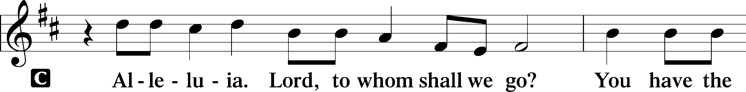
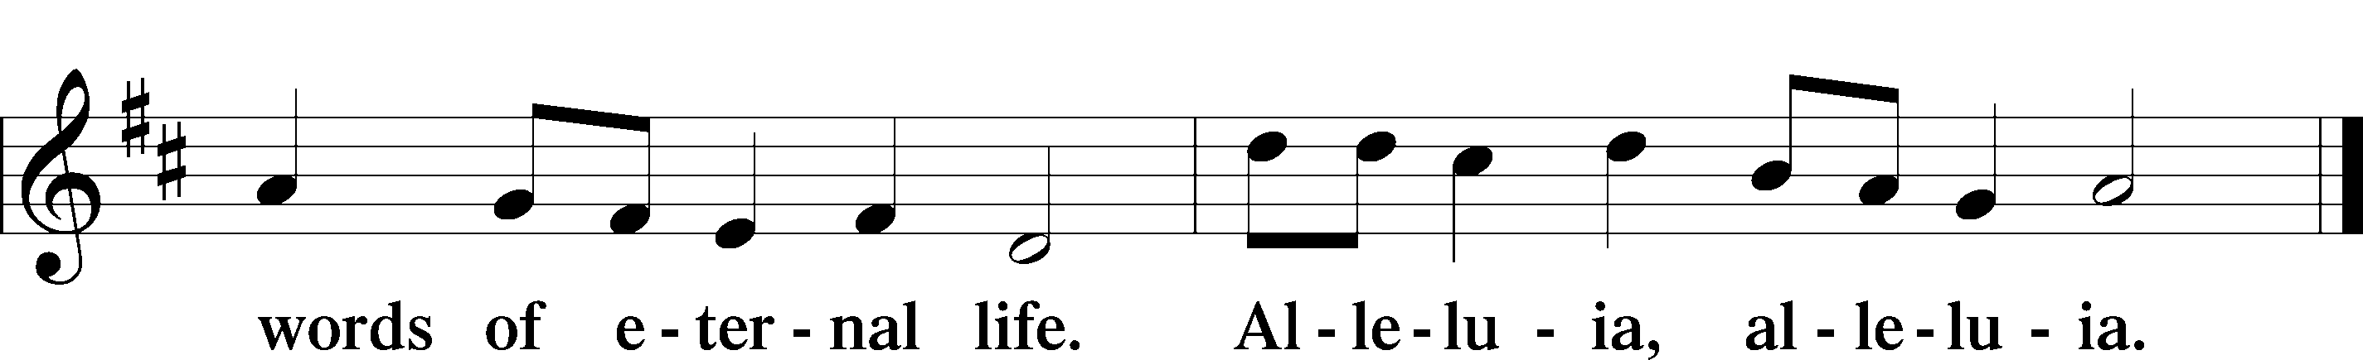

Holy Gospel Luke 20:27–40
P The Holy Gospel according to St. Luke, the twentieth chapter.

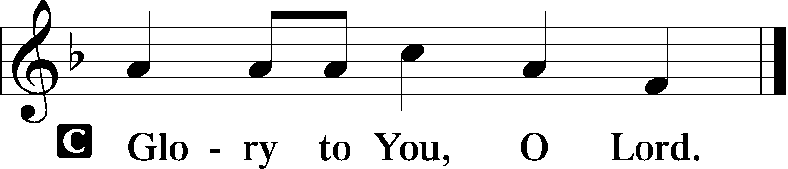

There came to [Jesus] some Sadducees, those who deny that there is a resurrection, and they asked him a question, saying, “Teacher, Moses wrote for us that if a man’s brother dies, having a wife but no children, the man must take the widow and raise up offspring for his brother. Now there were seven brothers. The first took a wife, and died without children. And the second and the third took her, and likewise all seven left no children and died. Afterward the woman also died. In the resurrection, therefore, whose wife will the woman be? For the seven had her as wife.”
And Jesus said to them, “The sons of this age marry and are given in marriage, but those who are considered worthy to attain to that age and to the resurrection from the dead neither marry nor are given in marriage, for they cannot die anymore, because they are equal to angels and are sons of God, being sons of the resurrection. But that the dead are raised, even Moses showed, in the passage about the bush, where he calls the Lord the God of Abraham and the God of Isaac and the God of Jacob. Now he is not God of the dead, but of the living, for all live to him.” Then some of the scribes answered, “Teacher, you have spoken well.” For they no longer dared to ask him any question.

P This is the Gospel of the Lord.

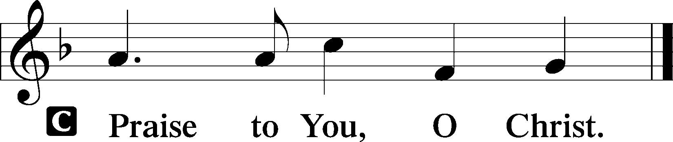

Apostles’ Creed

Sit

715 Jesus, Savior, Pilot Me

Sermon

Offering

Psalm for Meditation Psalm 148; antiphon: v. 13
Praise the Lord!
Praise the Lord from the heavens;
praise him in the heights!
Praise him, all his angels;
praise him, all his hosts!
Praise him, sun and moon,
praise him, all you shining stars!
Praise him, you highest heavens,
and you waters above the heavens!
Let them praise the name of the Lord!
For he commanded and they were created.
And he established them forever and ever;
he gave a decree, and it shall not pass away.
Praise the Lord from the earth,
you great sea creatures and all deeps,
fire and hail, snow and mist,
stormy wind fulfilling his word!
Mountains and all hills,
fruit trees and all cedars!
Beasts and all livestock,
creeping things and flying birds!
Kings of the earth and all peoples,
princes and all rulers of the earth!
Young men and maidens together,
old men and children!
Let them praise the name of the Lord,
for his name alone is exalted;
his majesty is above earth and heaven.
He has raised up a horn for his people,
praise for all his saints,
for the people of Israel who are near to him. Praise the Lord!

Stand

781 We Give Thee But Thine Own sts. 1–2

Prayer of the Church
After “Lord, in Your mercy” respond with “hear our prayer.”

Lord’s Prayer

Benediction LSB 166

644 The Church’s One Foundation sts. 1–3

Announcements

Join us after the service in the fellowship hall for refreshments and
Bible Study.

Pastor Vogel will be leading services on November 16th.

We will be decorating the church for Advent/Christmas season on Saturday, November 29th at 10 AM. Please come join us and stay for pizza and snacks afterwards, sponsored by the Ladies’ Guild.

Collecting has begun for hats and mittens for our local schools, and Toys for Tots. Items will be collected until Dec. 15th.

If not taking your bulletin home, please leave on table in the narthex when leaving so it can be recycled. Thank you.

St. John’s Lutheran Church
810 Broad St., Clifton, NJ 07013
StJohnsClifton.Org
PrayingHands810@gmail.com

