First Sunday in Advent November 30, 2025 – Lectionary Series C
St. John’s Lutheran Church

Order of Worship
by
Lutheran Service Builder
913 O Holy Spirit, Enter In
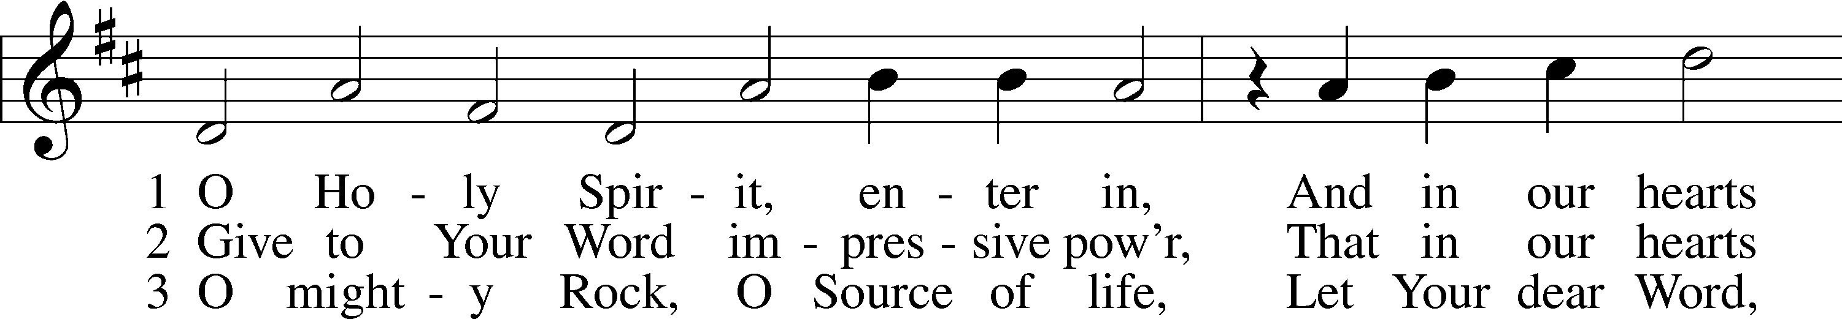
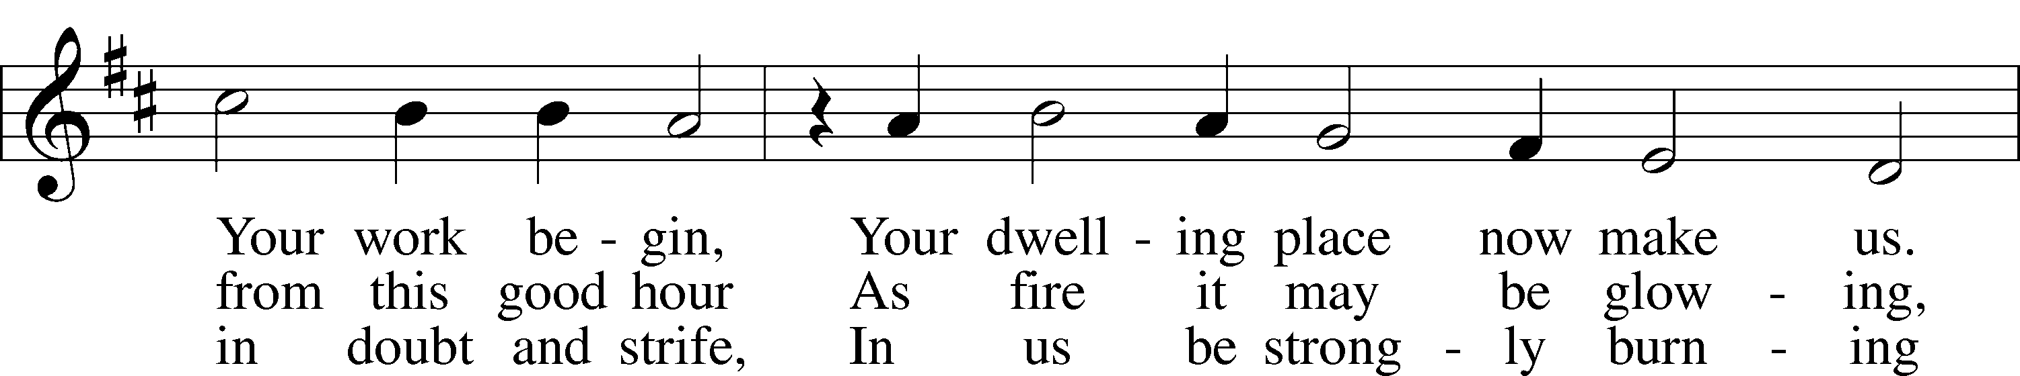
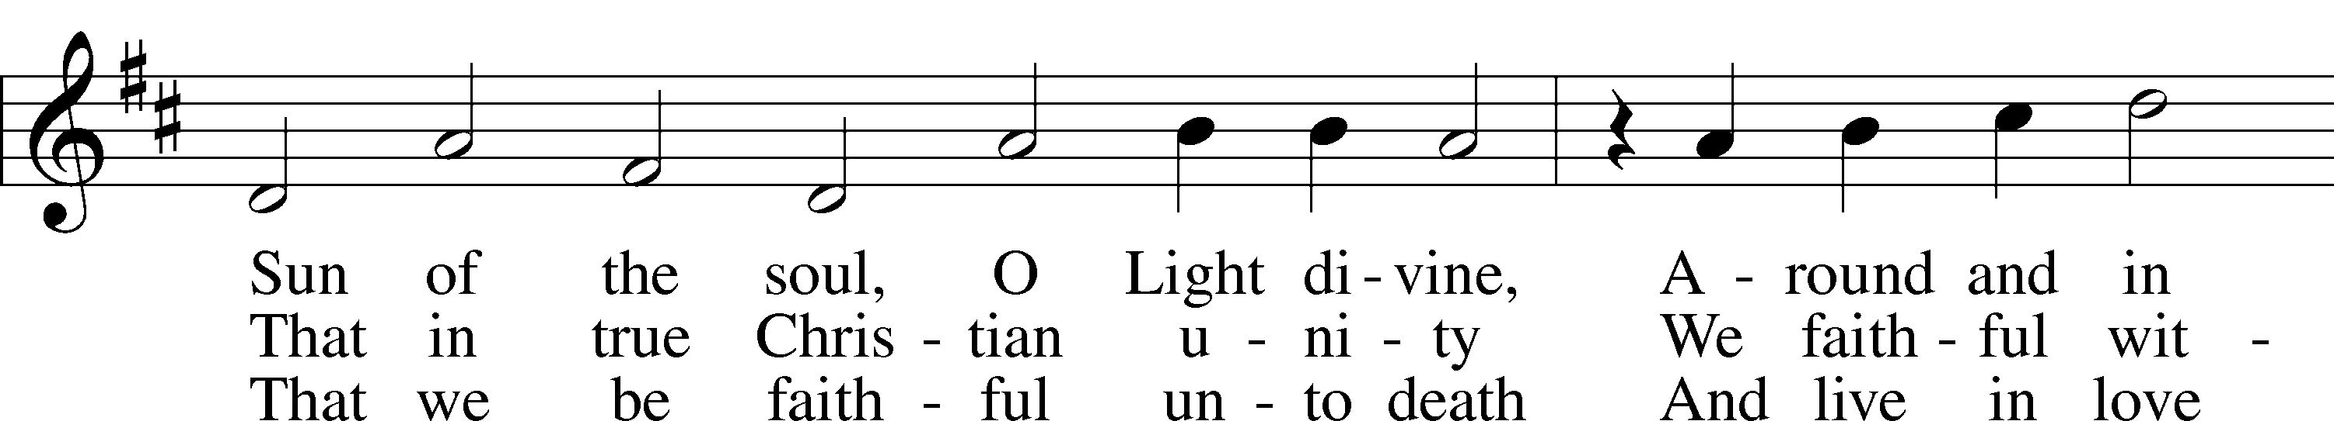
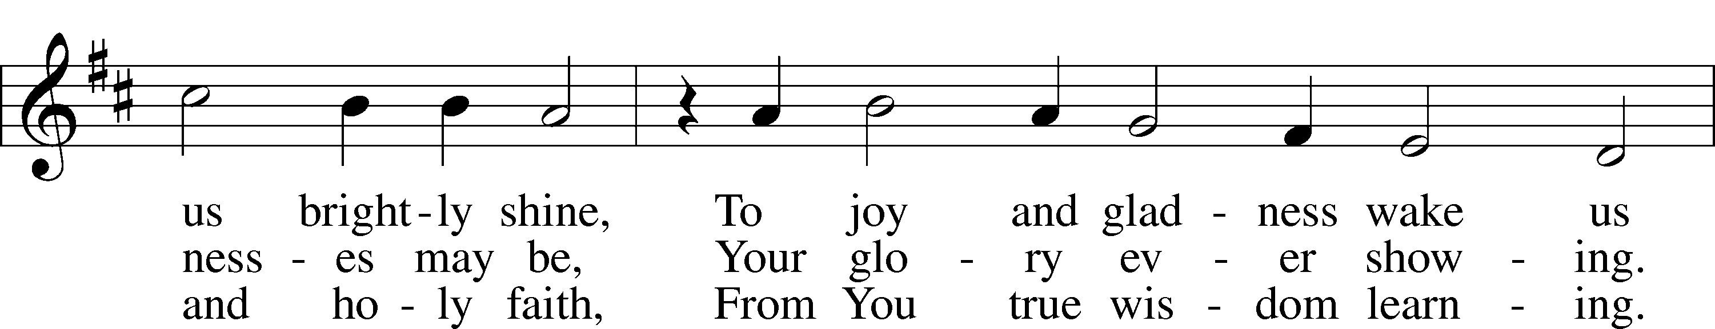
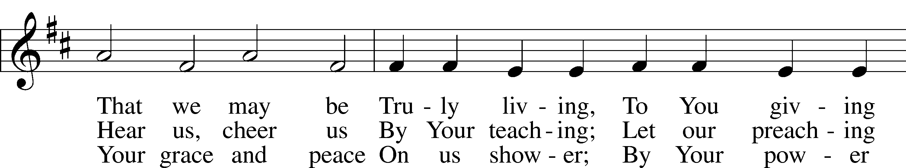
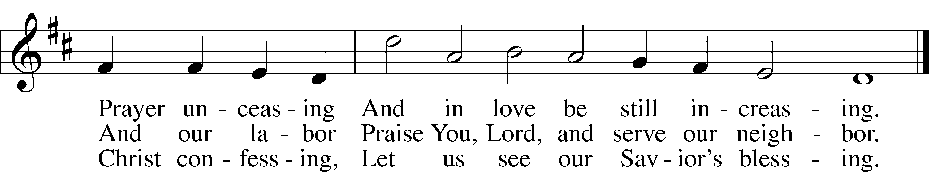

Stand for last verse

Confession and Absolution

The sign of the cross may be made by all in remembrance of their Baptism.

Invocation
P In the name of the Father and of the T Son and of the Holy Spirit.
C Amen.

Exhortation LSB 151
P If we say we have no sin, we deceive ourselves, and the truth is not in us.
C But if we confess our sins, God, who is faithful and just, will forgive our sins and cleanse us from all unrighteousness.

Silence for reflection on God’s Word and for self-examination.

Confession of Sins LSB 151
P Let us then confess our sins to God our Father.
C Most merciful God, we confess that we are by nature sinful and unclean. We have sinned against You in thought, word, and deed, by what we have done and by what we have left undone. We have not loved You with our whole heart; we have not loved our neighbors as ourselves. We justly deserve Your present and eternal punishment. For the sake of Your Son, Jesus Christ, have mercy on us. Forgive us, renew us, and lead us, so that we may delight in Your will and walk in Your ways to the glory of Your holy name. Amen.

Declaration
P In the mercy of almighty God, Jesus Christ was given to die for us, and for his sake God forgives us all our sins. To those who believe in Jesus Christ He gives the power to become the children of God and bestows on them the Holy Spirit. May the Lord, who has begun this good work in us, bring it to completion in the day of our Lord Jesus Christ.
C Amen.

Service of the Word

Introit Psalm 118:25–28; antiphon: Zechariah 9:9b, alt.
Behold, your king is coming to you;
righteous and having salvation.
Save us, we pray, O Lord!
O Lord, we pray, give us success!
Blessèd is he who comes in the name of the Lord!
We bless you from the house of the Lord.
The Lord is God, and he has made his light to shine upon us.
Bind the festal sacrifice with cords, up to the horns of the altar!
You are my God, and I will give thanks to you;
you are my God; I will extol you.
Glory be to the Father and to the Son
and to the Holy Spirit;
as it was in the beginning,
is now, and will be forever. Amen.
Behold, your king is coming to you;
righteous and having salvation.

Kyrie LSB 152
A In peace let us pray to the Lord.
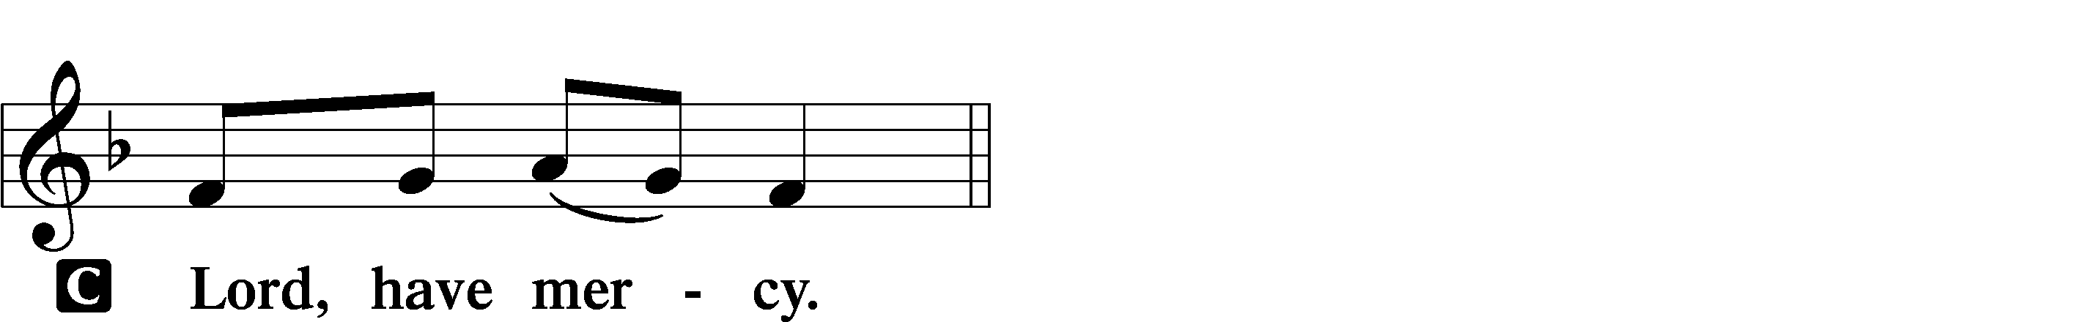

A For the peace from above and for our salvation let us pray to the Lord.
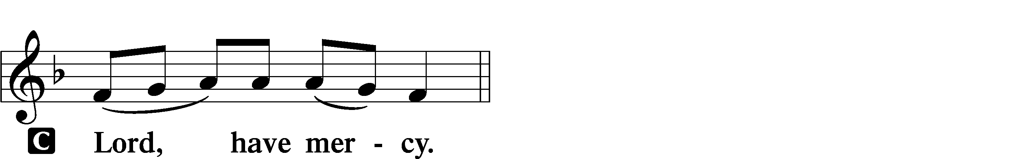

A For the peace of the whole world, for the well-being of the Church of God, and for the unity of all let us pray to the Lord.
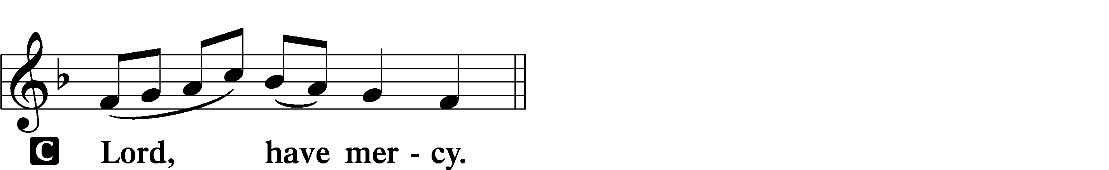

A For this holy house and for all who offer here their worship and praise let us pray to the Lord.
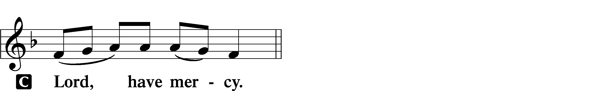

A Help, save, comfort, and defend us, gracious Lord.
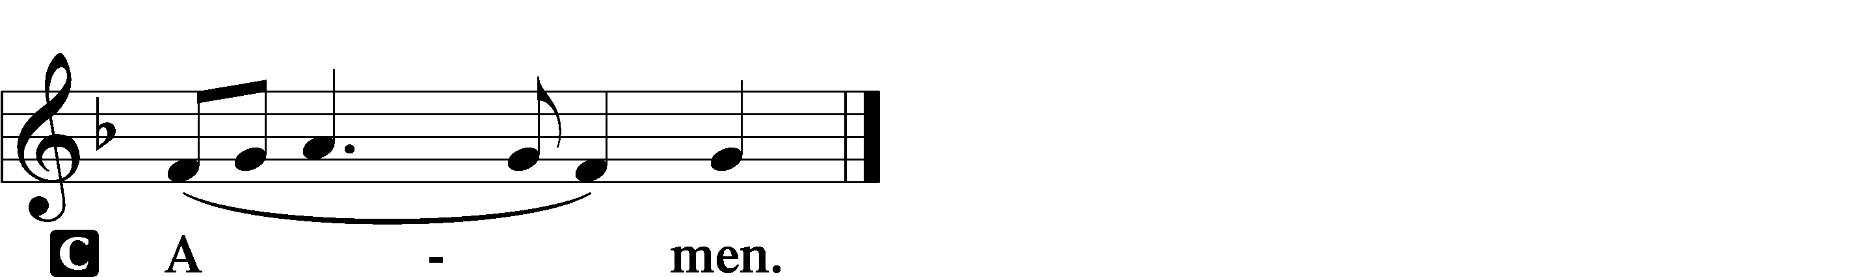

Salutation and Collect of the Day
P The Lord be with you.
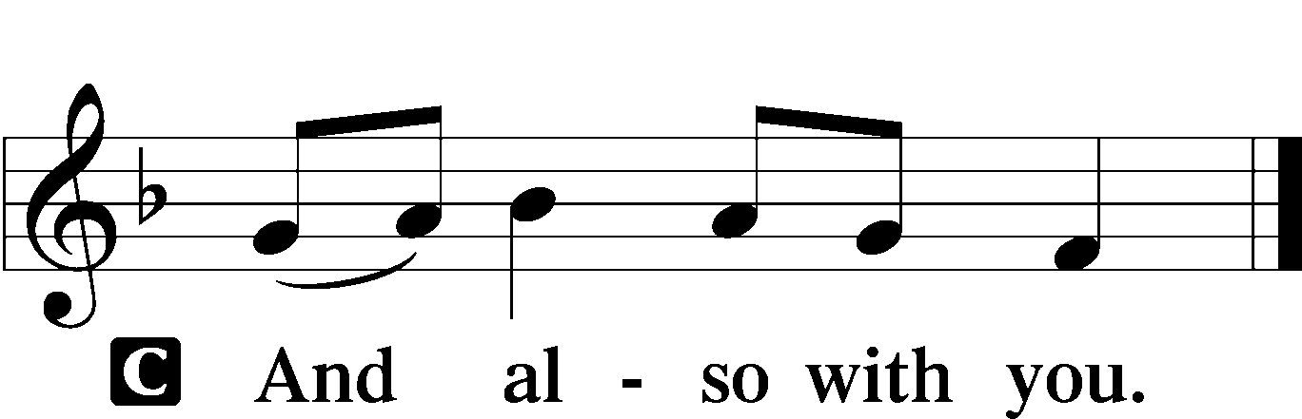

P Let us pray.
Stir up Your power, O Lord, and come, that by Your protection we may be rescued from the threatening perils of our sins and saved by Your mighty deliverance; for You live and reign with the Father and the Holy Spirit, one God, now and forever.

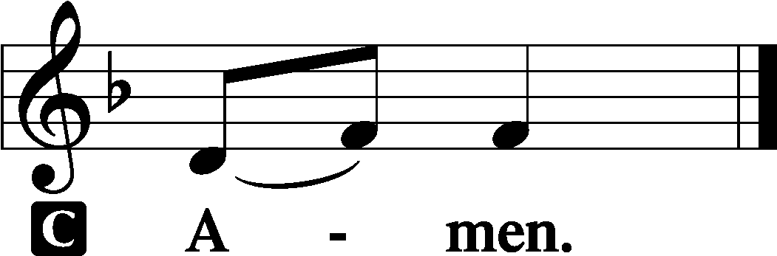

Sit

Old Testament Reading Isaiah 2:1–5
The word that Isaiah the son of Amoz saw concerning Judah and Jerusalem.
It shall come to pass in the latter days
that the mountain of the house of the Lord
shall be established as the highest of the mountains,
and shall be lifted up above the hills;
and all the nations shall flow to it,
and many peoples shall come, and say:
“Come, let us go up to the mountain of the Lord,
to the house of the God of Jacob,
that he may teach us his ways
and that we may walk in his paths.”
For out of Zion shall go the law,
and the word of the Lord from Jerusalem.
He shall judge between the nations,
and shall decide disputes for many peoples;
and they shall beat their swords into plowshares,
and their spears into pruning hooks;
nation shall not lift up sword against nation,
neither shall they learn war anymore.
O house of Jacob,
come, let us walk
in the light of the Lord.

A This is the Word of the Lord.
C Thanks be to God.

Epistle Romans 13:8–14
Owe no one anything, except to love each other, for the one who loves another has fulfilled the law. The commandments, “You shall not commit adultery, You shall not murder, You shall not steal, You shall not covet,” and any other commandment, are summed up in this word: “You shall love your neighbor as yourself.” Love does no wrong to a neighbor; therefore love is the fulfilling of the law.
Besides this you know the time, that the hour has come for you to wake from sleep. For salvation is nearer to us now than when we first believed. The night is far gone; the day is at hand. So then let us cast off the works of darkness and put on the armor of light. Let us walk properly as in the daytime, not in orgies and drunkenness, not in sexual immorality and sensuality, not in quarreling and jealousy. But put on the Lord Jesus Christ, and make no provision for the flesh, to gratify its desires.

A This is the Word of the Lord.
C Thanks be to God.

Stand

Alleluia and Verse LSB 156
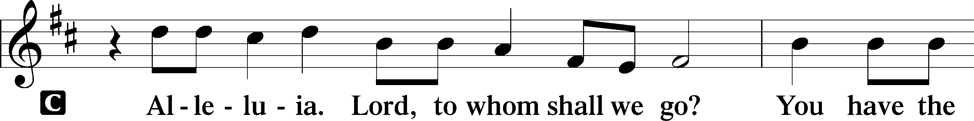
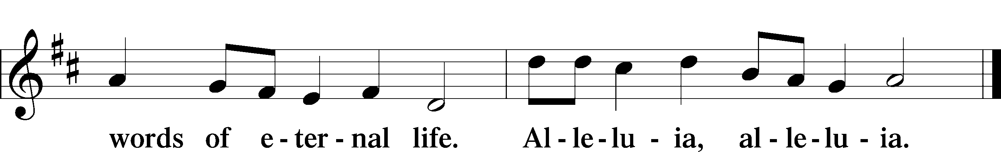

Holy Gospel Matthew 24:36–44
P The Holy Gospel according to St. Matthew, the twenty-fourth chapter.

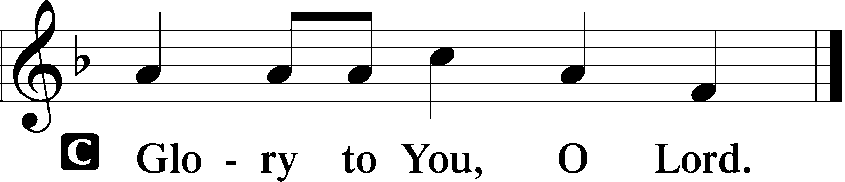

[Jesus said:] “But concerning that day and hour no one knows, not even the angels of heaven, nor the Son, but the Father only. As were the days of Noah, so will be the coming of the Son of Man. For as in those days before the flood they were eating and drinking, marrying and giving in marriage, until the day when Noah entered the ark, and they were unaware until the flood came and swept them all away, so will be the coming of the Son of Man. Then two men will be in the field; one will be taken and one left. Two women will be grinding at the mill; one will be taken and one left. Therefore, stay awake, for you do not know on what day your Lord is coming. But know this, that if the master of the house had known in what part of the night the thief was coming, he would have stayed awake and would not have let his house be broken into. Therefore you also must be ready, for the Son of Man is coming at an hour you do not expect.

P This is the Gospel of the Lord.

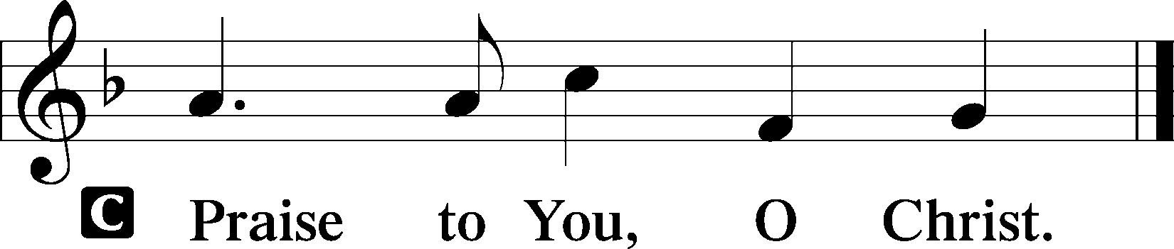

Apostles’ Creed
C I believe in God, the Father Almighty,
maker of heaven and earth.

And in Jesus Christ, His only Son, our Lord,
who was conceived by the Holy Spirit,
born of the virgin Mary,
suffered under Pontius Pilate,
was crucified, died and was buried.
He descended into hell.
The third day He rose again from the dead.
He ascended into heaven
and sits at the right hand of God the Father Almighty.
From thence He will come to judge the living and the dead.

I believe in the Holy Spirit,
the holy Christian Church,
the communion of saints,
the forgiveness of sins,
the resurrection of the body,
and the life T everlasting. Amen.

Sit

332 Savior of the Nations, Come sts. 1–4
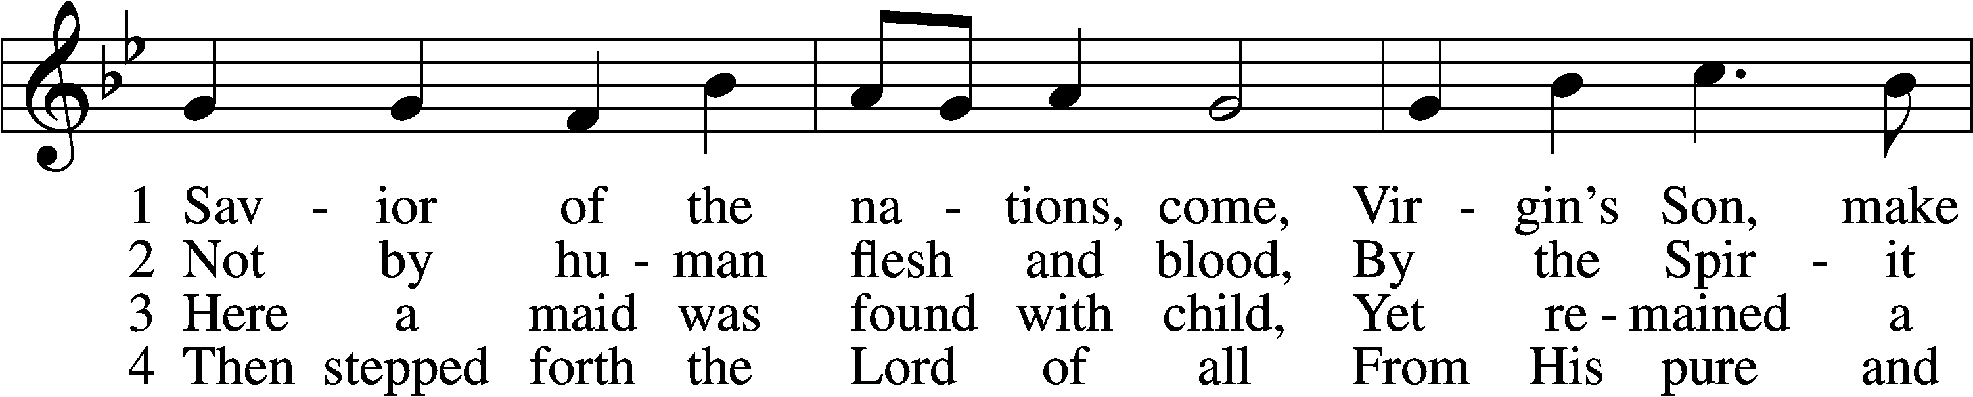
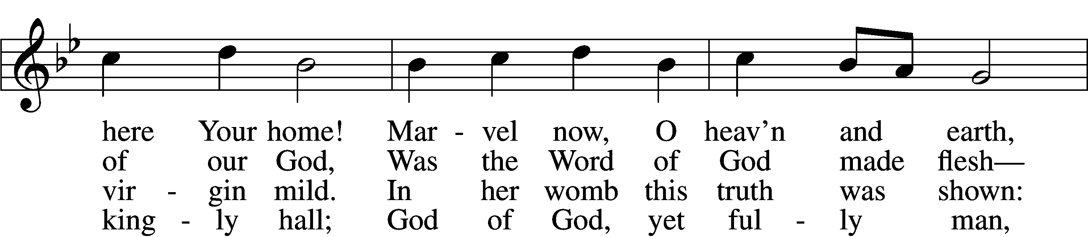
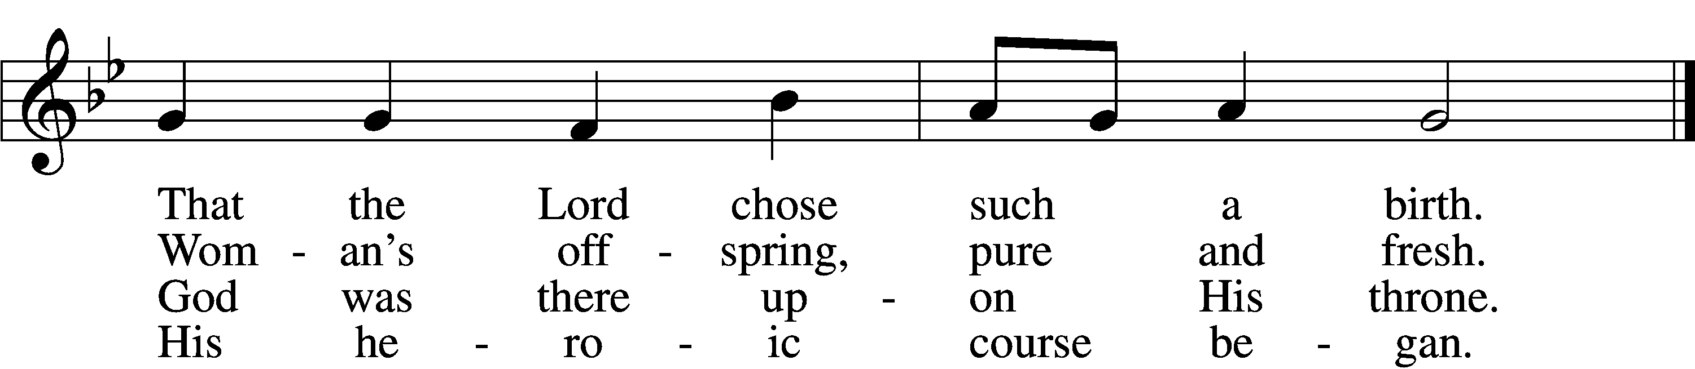

Sermon

Offering

Psalm for Meditation Psalm 122; antiphon: v. 6
I was glad when they said to me,
“Let us go to the house of the Lord!”
Our feet have been standing
within your gates, O Jerusalem!
Jerusalem—built as a city
that is bound firmly together,
to which the tribes go up,
the tribes of the Lord,
as was decreed for Israel,
to give thanks to the name of the Lord.
There thrones for judgment were set,
the thrones of the house of David.
Pray for the peace of Jerusalem!
“May they be secure who love you!
Peace be within your walls
and security within your towers!”
For my brothers and companions’ sake
I will say, “Peace be within you!”
For the sake of the house of the Lord our God,
I will seek your good.

Stand

781 We Give Thee But Thine Own sts. 1–2
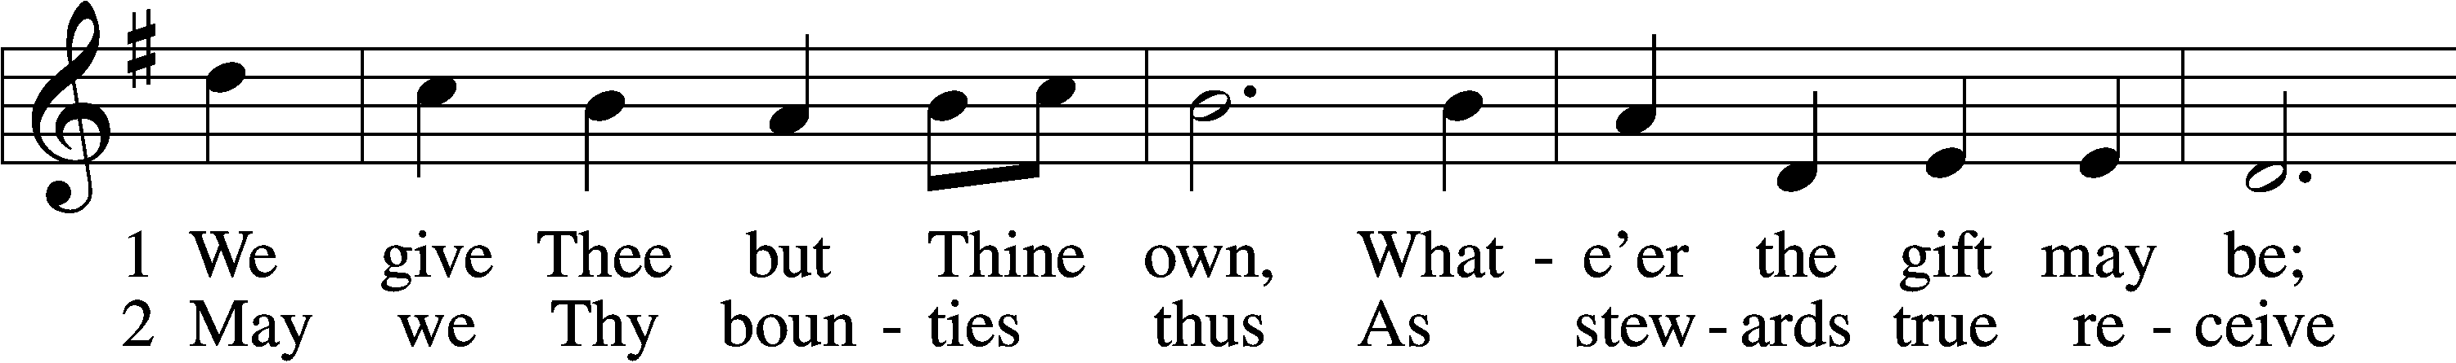
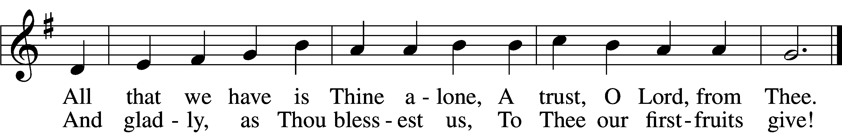

Prayer of the Church
P Let us pray for the whole people of God in Christ Jesus and for all people according to their needs.
P For the faithful proclamation of Christ’s saving name, that God’s people may be strengthened in the true faith and His kingdom extended, let us pray to the Lord:
C Lord, have mercy.
P For the holy Christian Church throughout the world and for all who confess the name of Christ, that God would guard and defend us from the temptations of the devil, the world, and our sinful nature, let us pray to the Lord:
C Lord, have mercy.
P For this congregation, its mission and its people; for the ability to meet the needs that arise as we do the work God has given us to do; and for the unity of the Spirit in the bond of peace, let us pray to the Lord:
C Lord, have mercy.
P For those who have wandered from the faith, that the Holy Spirit would use us to call them home to the Father, let us pray to the Lord:
C Lord, have mercy.
P For the government and all who have been set into positions of leadership, that they may use the authority entrusted to them honorably and for the good of the people, let us pray to the Lord:
C Lord, have mercy.
P For those who suffer from hunger, homelessness, poverty, or unemployment, that God’s great mercy and love would preserve and relieve them, let us pray to the Lord:
C Lord, have mercy.
P For those who are sick especially Barbara, Dorothy, Juliana, Marge, Tony, Bill M., Patricia, Phil, Lidia, Michele, Giuseppe, Alfred, Nancy and Braydon who is serving in the military, that God would grant healing to their bodies and strength to bear their infirmities with patience and grace, let us pray to the Lord:
C Lord, have mercy.
P For those who rejoice in the rich blessings of God, that they may always remember the Giver of every gift and give Him heartfelt thanks, let us pray to the Lord:
C Lord, have mercy.
P O Lord, heavenly Father, we gratefully remember the sufferings and death of Your dear Son, Jesus Christ, for our salvation. Rejoicing in His victorious resurrection from the dead, we draw strength from His ascension before You, where He ever stands for us as our own High Priest. Gather us together from the ends of the earth to celebrate with all the faithful the marriage feast of the Lamb in His kingdom, which has no end. Graciously receive our prayers, deliver and preserve us, for to You alone we give all glory, honor, and worship, Father, Son, and Holy Spirit, one God, now and forever.
C Amen.

Lord’s Prayer
C Our Father who art in heaven,
hallowed be Thy name,
Thy kingdom come,
Thy will be done on earth
as it is in heaven;
give us this day our daily bread;
and forgive us our trespasses
as we forgive those
who trespass against us;
and lead us not into temptation,
but deliver us from evil.
For Thine is the kingdom
and the power and the glory
forever and ever. Amen.

Benediction LSB 166
P The Lord bless you and keep you.
The Lord make His face shine on you and be gracious to you.
The Lord look upon you with favor and T give you peace.
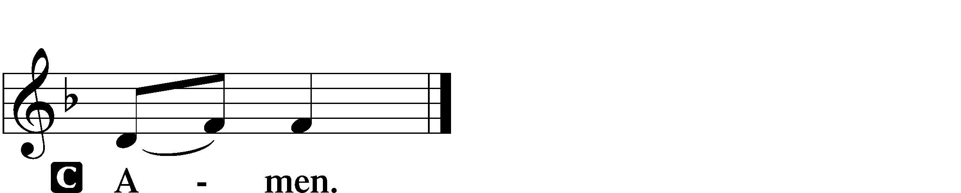

917 Savior, Again to Thy Dear Name We Raise
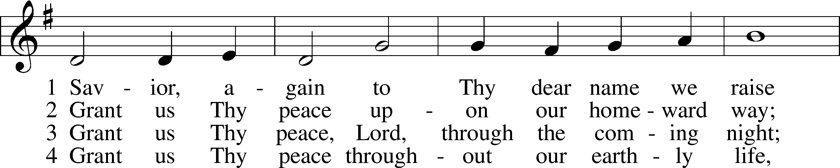
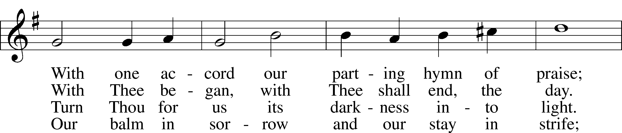
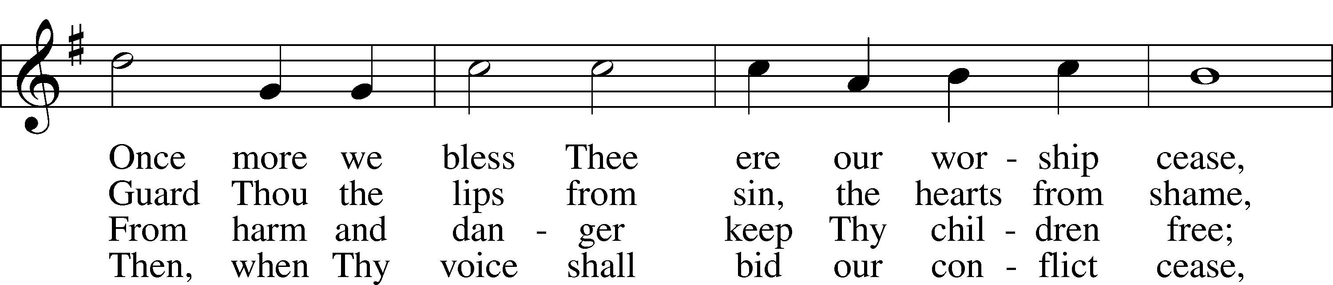
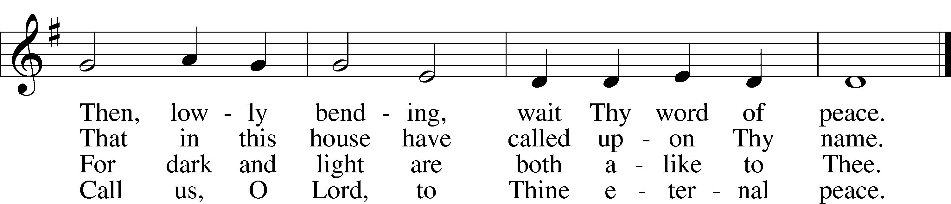

Announcements

Join us after the service in the fellowship hall for refreshments.

Collecting has begun for hats and mittens for our local schools, and Toys for Tots. Items will be collected until Dec. 15th.

Pastor Vogel will conduct services for Dec. 7th and 14th.

Pastor Holsten will lead services on December 21st and on Christmas Eve afternoon at 3:00pm

Poinsettias can now be ordered from either Ellen or Carol Bender. Cost of each plant is $15.00. Checks should be payable to the “Ladies’ Guild”

Our annual Cookie Walk will be held on December 21st, after church service. If you would like to donate, please see our Kitchen Crew for details. Monetary donations are also accepted Cookies will be available for purchase at $5.00 per contatiner.

St. John’s Lutheran Church
810 Broad St., Clifton, NJ 07013
StJohnsClifton.Org
PrayingHands810@gmail.com

