Last Sunday in the Church Year November 23, 2025 – Lectionary Series C
St. John’s Lutheran Church

Order of Worship
by
Lutheran Service Builder

912 Christ Is Our Cornerstone
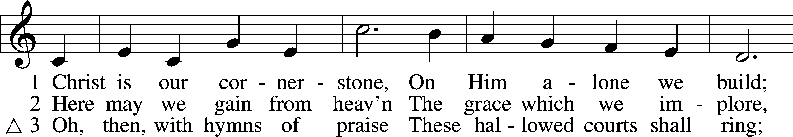
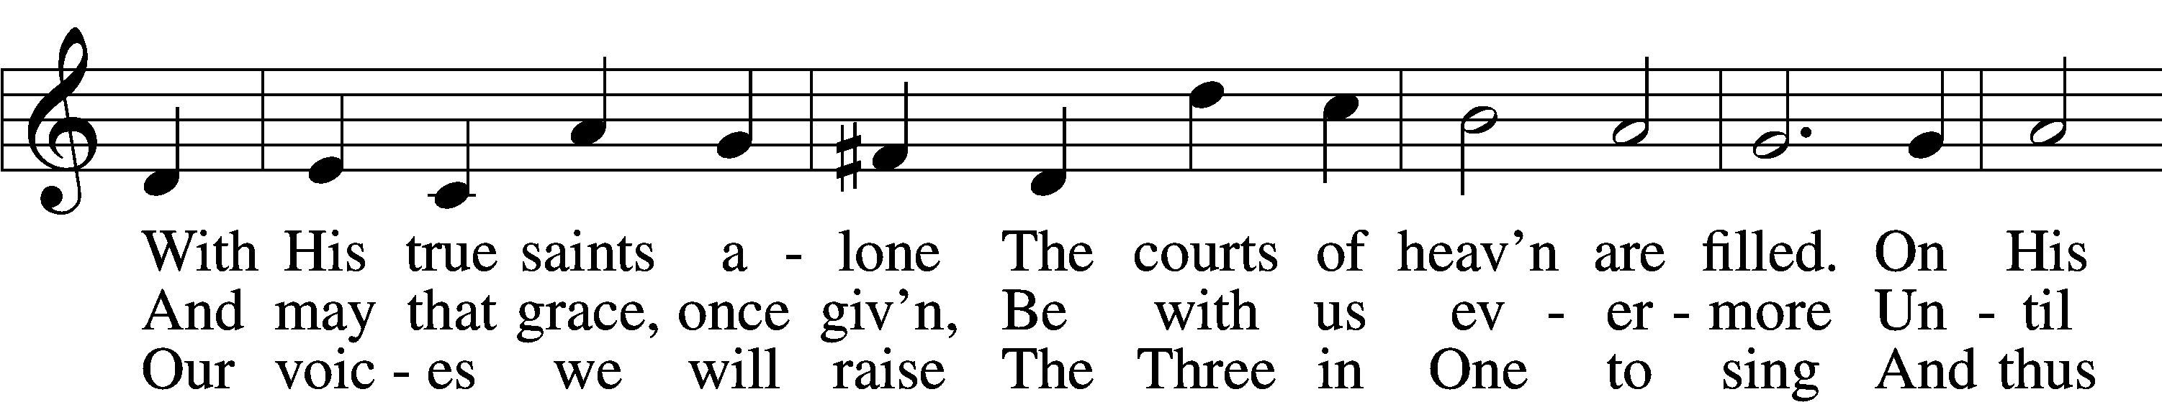
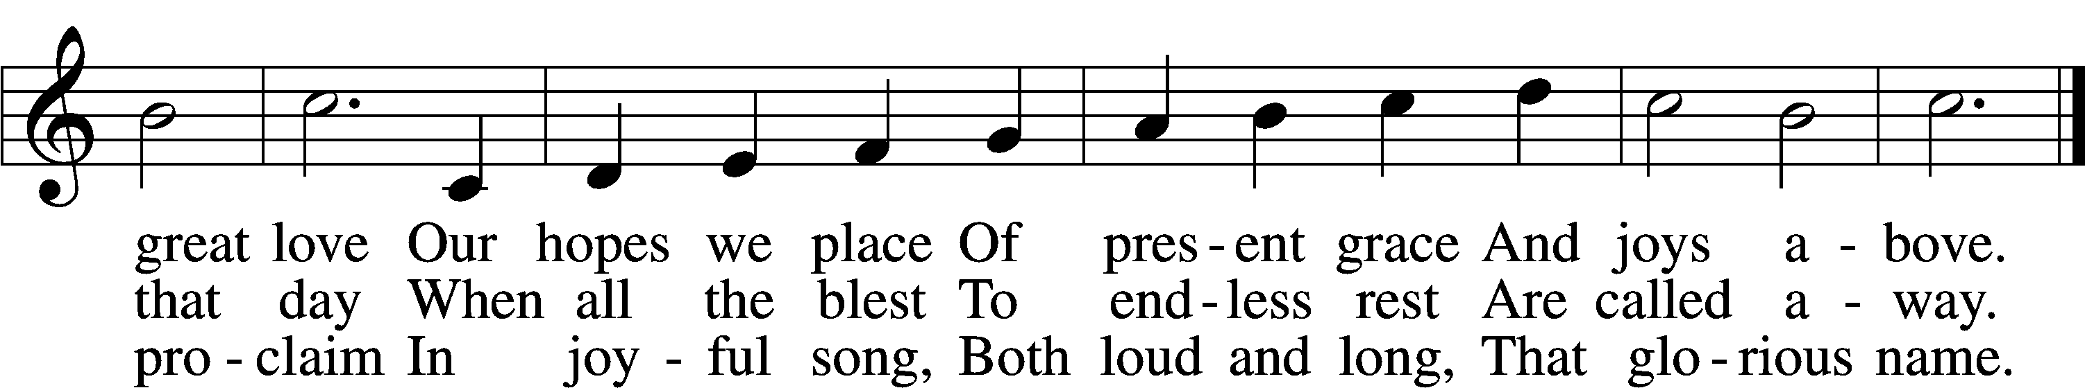

Δ – Stand for last verse

Confession and Absolution

The sign of the cross may be made by all in remembrance of their Baptism.

Invocation
P In the name of the Father and of the T Son and of the Holy Spirit.
C Amen.

Exhortation LSB 184
P Beloved in the Lord! Let us draw near with a true heart and confess our sins unto God our Father, beseeching Him in the name of our Lord Jesus Christ to grant us forgiveness.

P Our help is in the name of the Lord,
C who made heaven and earth.
P I said, I will confess my transgressions unto the Lord,
C and You forgave the iniquity of my sin.

Silence for reflection on God’s Word and for self-examination.

Confession of Sins LSB 184
P O almighty God, merciful Father,
C I, a poor, miserable sinner, confess unto You all my sins and iniquities with which I have ever offended You and justly deserved Your temporal and eternal punishment. But I am heartily sorry for them and sincerely repent of them, and I pray You of Your boundless mercy and for the sake of the holy, innocent, bitter sufferings and death of Your beloved Son, Jesus Christ, to be gracious and merciful to me, a poor, sinful being.

Absolution LSB 185
P Almighty God, our heavenly Father, has had mercy upon us and has given His only Son to die for us and for His sake forgives us all our sins. To those who believe on His name He gives power to become the children of God and has promised them His Holy Spirit. He that believes and is baptized shall be saved.
Grant this, Lord, unto us all.
C Amen.

Service of the Word

Introit Psalm 134; antiphon: Psalm 33:8
Let all the earth fear the Lord;
let all the inhabitants of the world stand in awe of him!
Come, bless the Lord, all you servants of the Lord,
who stand by night in the house of the Lord!
Lift up your hands to the holy place
and bless the Lord!
May the Lord bless you from Zion,
he who made heaven and earth!
Glory be to the Father and to the Son
and to the Holy Spirit;
as it was in the beginning,
is now, and will be forever. Amen.
Let all the earth fear the Lord;
let all the inhabitants of the world stand in awe of him!

Kyrie LSB 186
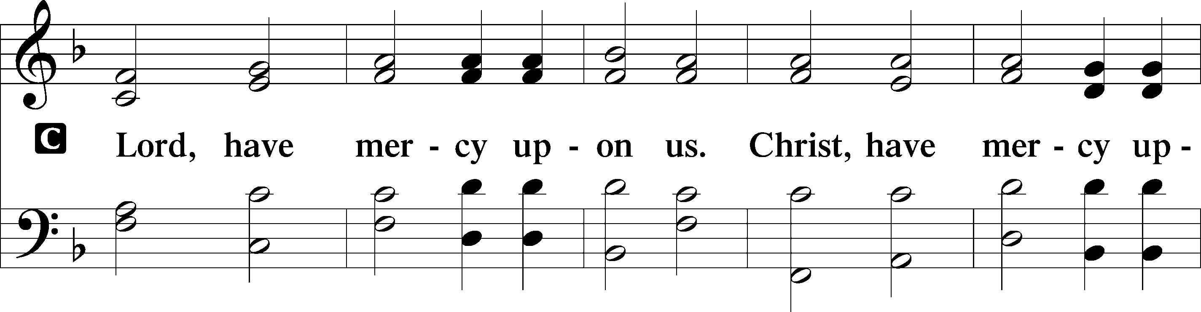
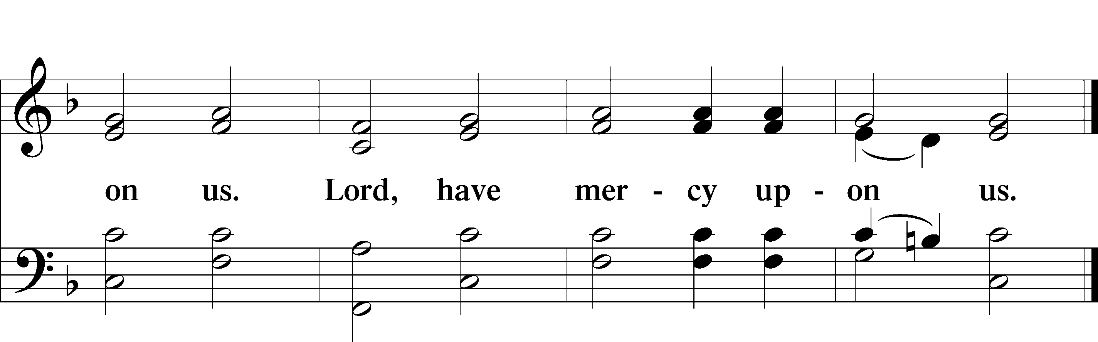

Gloria in Excelsis LSB 187
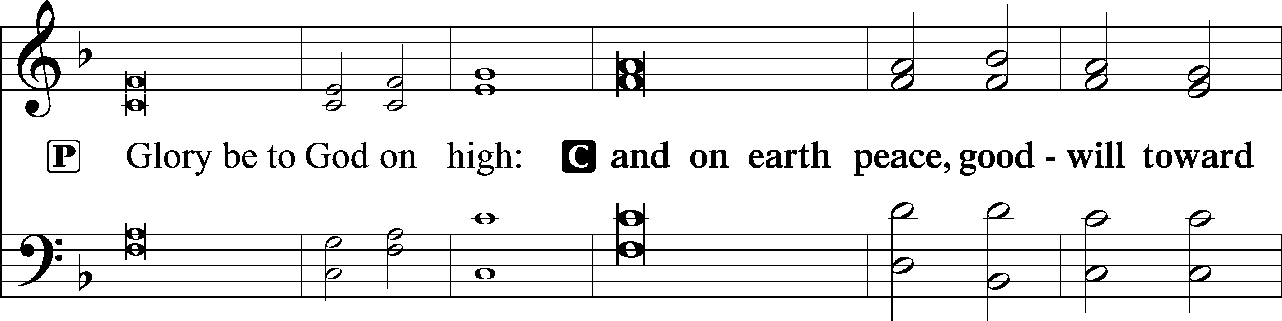
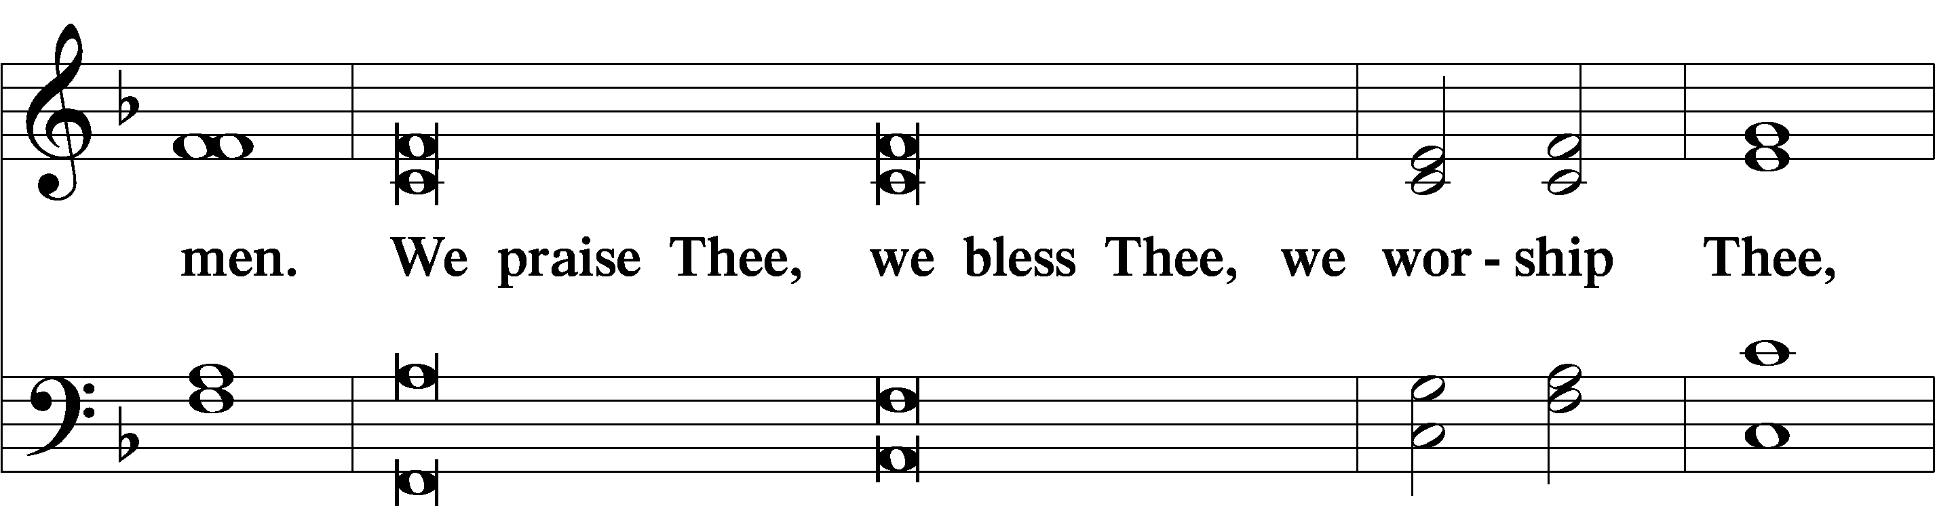
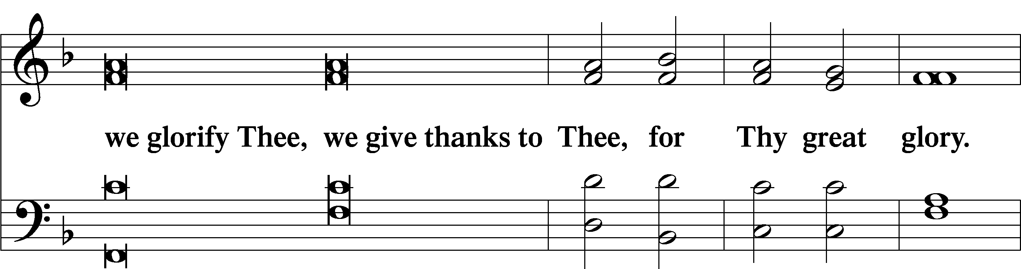
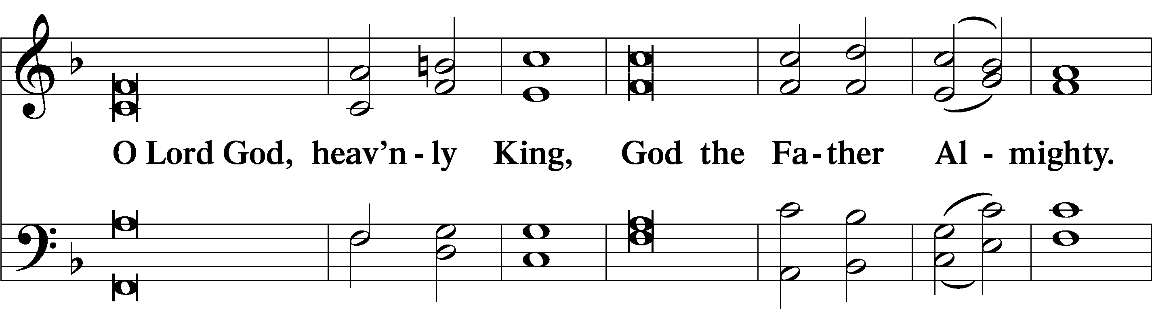
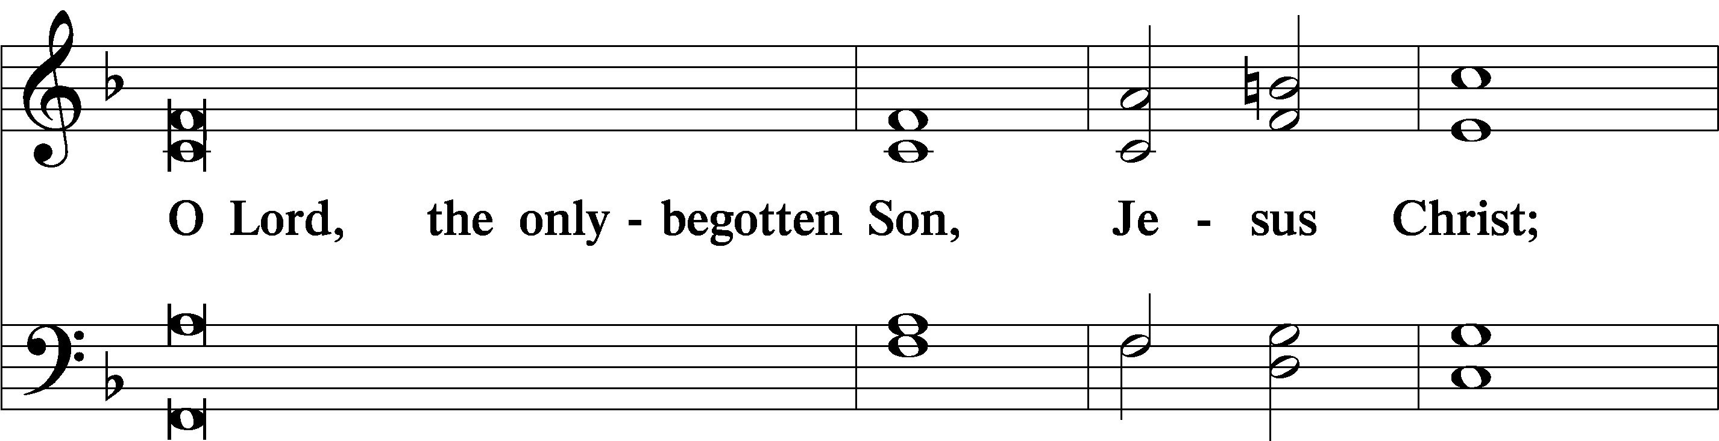
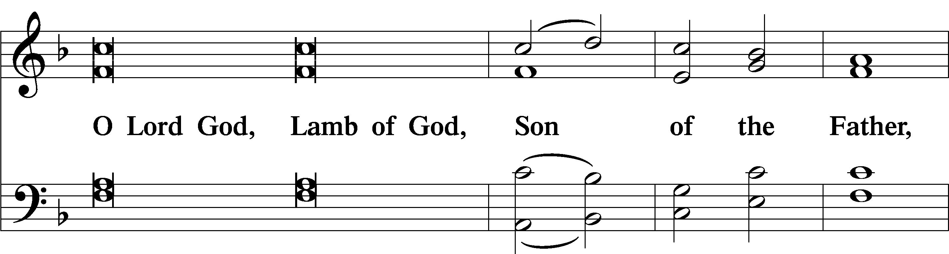
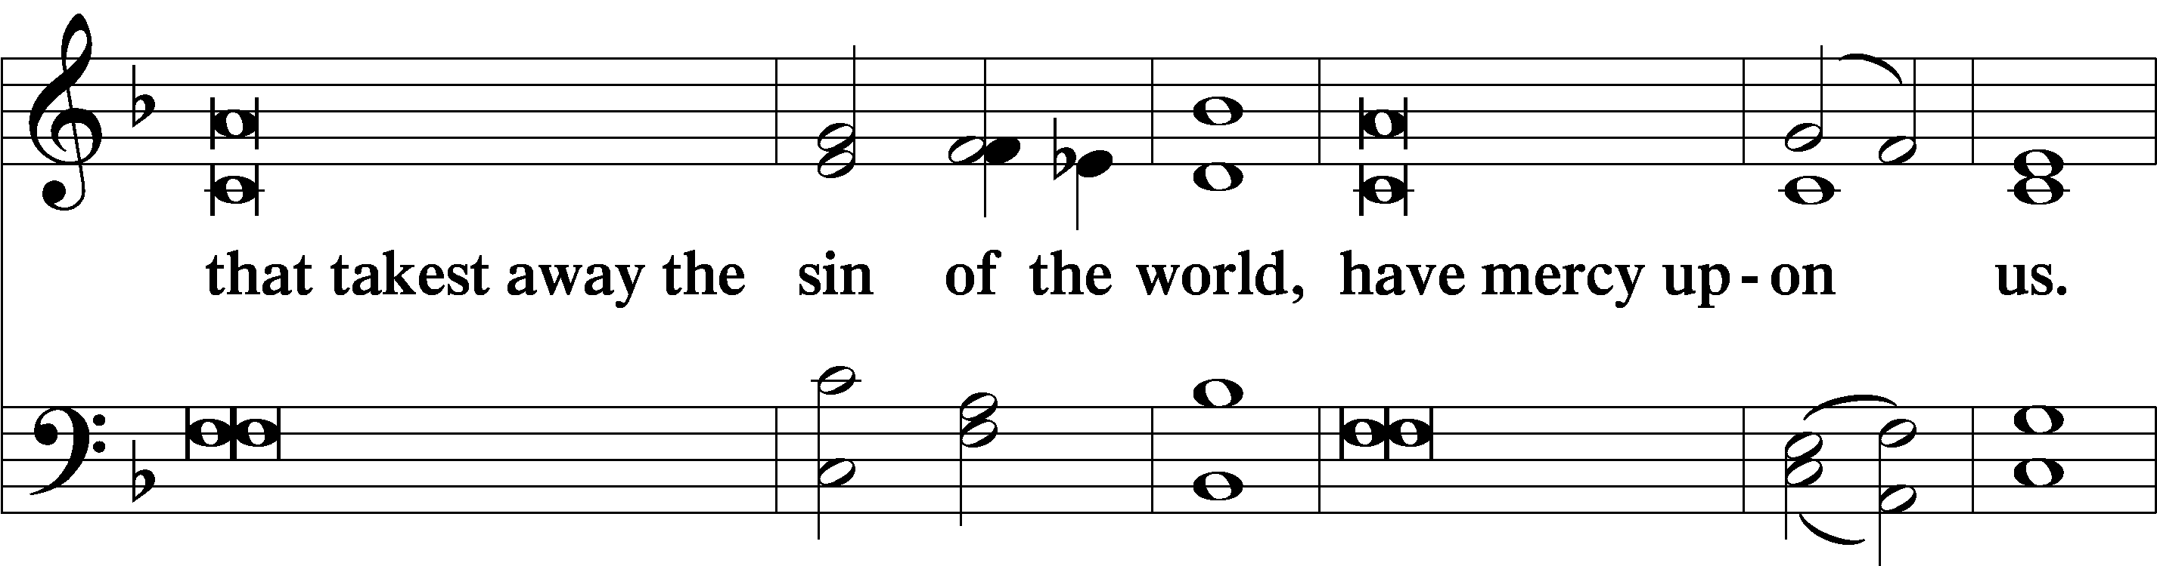
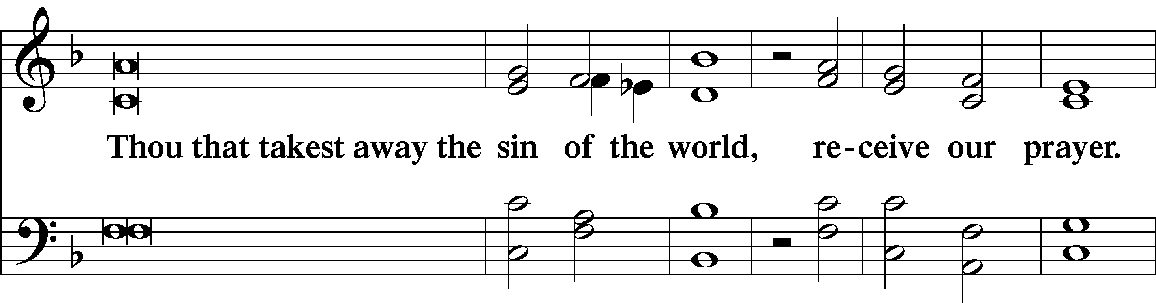
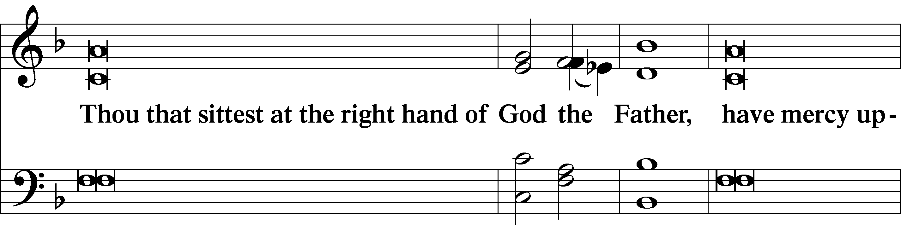
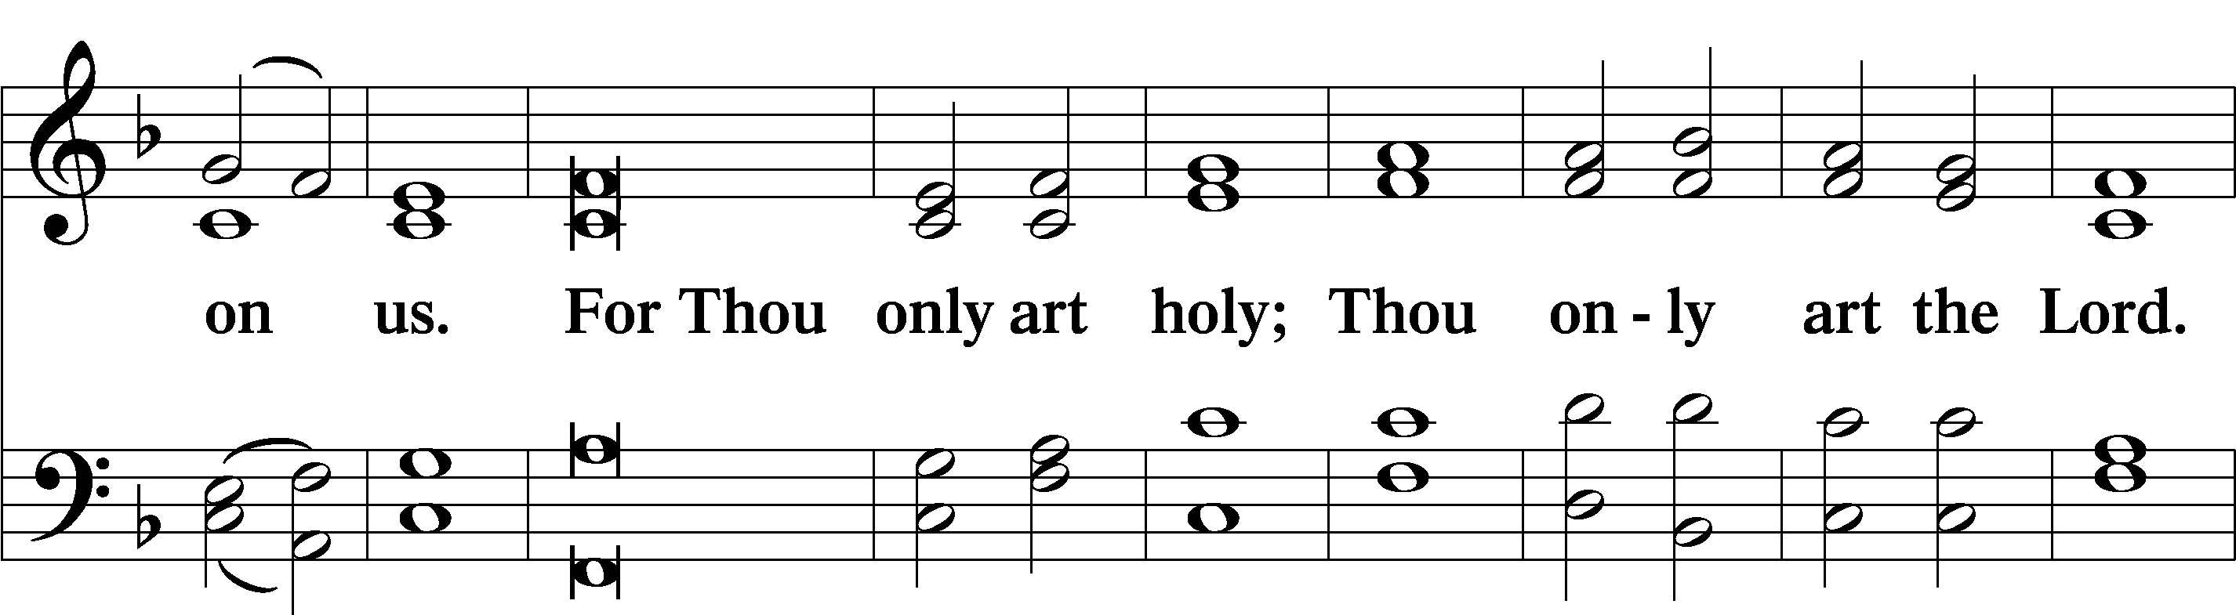
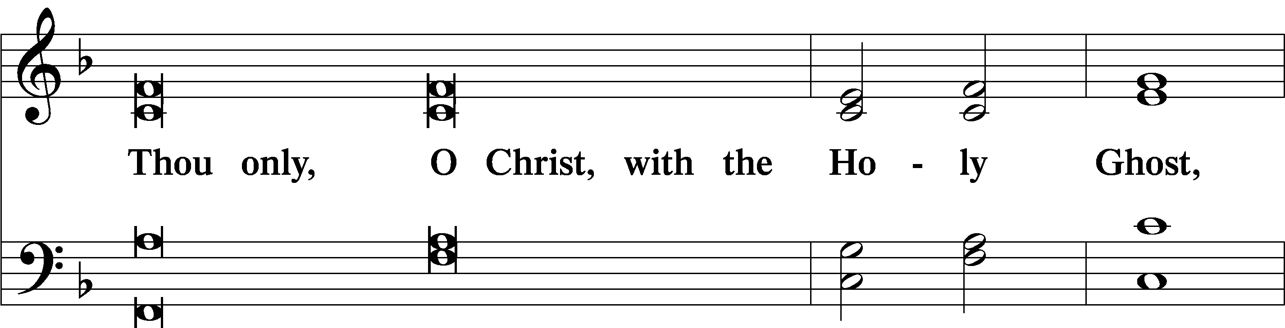
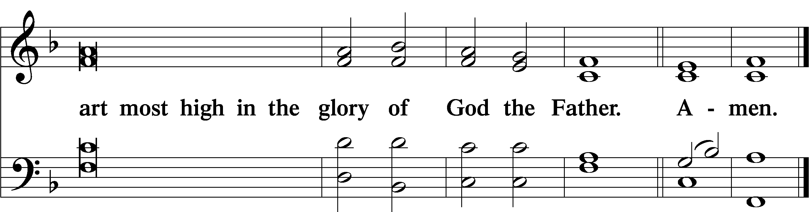

Salutation and Collect of the Day
P The Lord be with you.
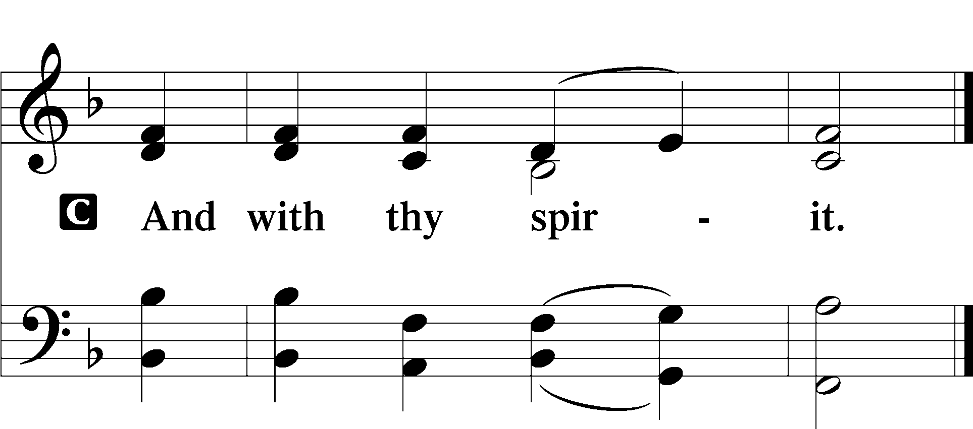
P Let us pray.
Lord Jesus Christ, You reign among us by the preaching of Your cross. Forgive Your people their offenses that we, being governed by Your bountiful goodness, may enter at last into Your eternal paradise; for You live and reign with the Father and the Holy Spirit, one God, now and forever.

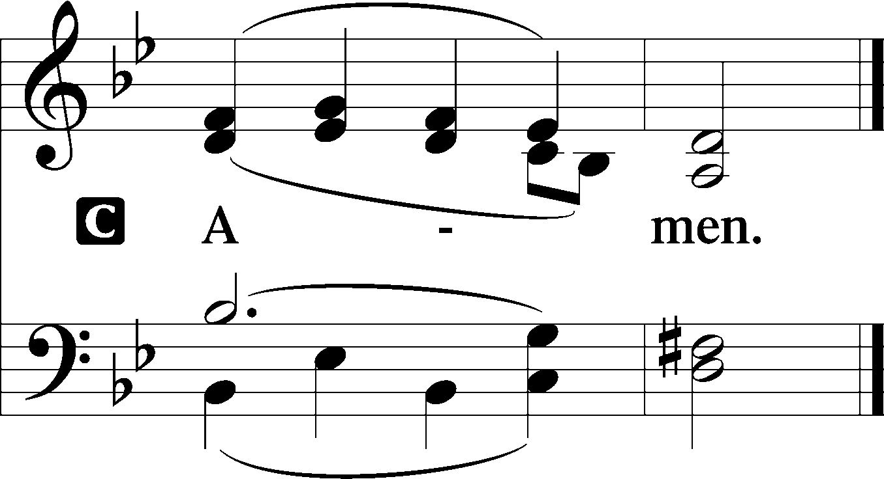

Sit

Old Testament Reading Malachi 3:13–18
“Your words have been hard against me, says the Lord. But you say, ‘How have we spoken against you?’ You have said, ‘It is vain to serve God. What is the profit of our keeping his charge or of walking as in mourning before the Lord of hosts? And now we call the arrogant blessed. Evildoers not only prosper but they put God to the test and they escape.’”
Then those who feared the Lord spoke with one another. The Lord paid attention and heard them, and a book of remembrance was written before him of those who feared the Lord and esteemed his name. “They shall be mine, says the Lord of hosts, in the day when I make up my treasured possession, and I will spare them as a man spares his son who serves him. Then once more you shall see the distinction between the righteous and the wicked, between one who serves God and one who does not serve him.”

A This is the Word of the Lord.
C Thanks be to God.

Epistle Colossians 1:13–20
He has delivered us from the domain of darkness and transferred us to the kingdom of his beloved Son, in whom we have redemption, the forgiveness of sins.
He is the image of the invisible God, the firstborn of all creation. For by him all things were created, in heaven and on earth, visible and invisible, whether thrones or dominions or rulers or authorities—all things were created through him and for him. And he is before all things, and in him all things hold together. And he is the head of the body, the church. He is the beginning, the firstborn from the dead, that in everything he might be preeminent. For in him all the fullness of God was pleased to dwell, and through him to reconcile to himself all things, whether on earth or in heaven, making peace by the blood of his cross.

A This is the Word of the Lord.
C Thanks be to God.

Stand

Alleluia LSB 190
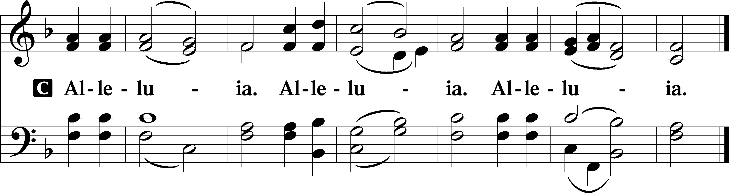

Holy Gospel Luke 23:27–43
P The Holy Gospel according to St. Luke, the twenty-third chapter.

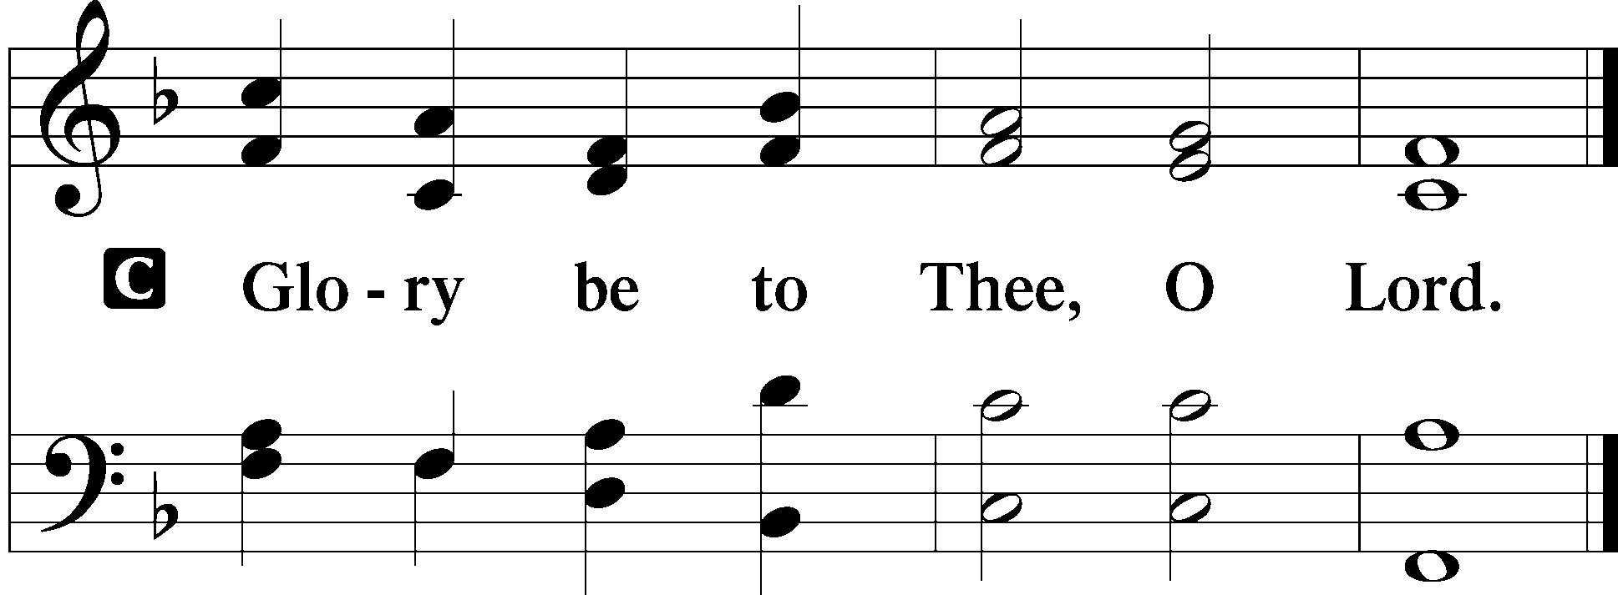

And there followed [Jesus] a great multitude of the people and of women who were mourning and lamenting for him. But turning to them Jesus said, “Daughters of Jerusalem, do not weep for me, but weep for yourselves and for your children. For behold, the days are coming when they will say, ‘Blessed are the barren and the wombs that never bore and the breasts that never nursed!’ Then they will begin to say to the mountains, ‘Fall on us,’ and to the hills, ‘Cover us.’ For if they do these things when the wood is green, what will happen when it is dry?”
Two others, who were criminals, were led away to be put to death with him. And when they came to the place that is called The Skull, there they crucified him, and the criminals, one on his right and one on his left. And Jesus said, “Father, forgive them, for they know not what they do.” And they cast lots to divide his garments. And the people stood by, watching, but the rulers scoffed at him, saying, “He saved others; let him save himself, if he is the Christ of God, his Chosen One!” The soldiers also mocked him, coming up and offering him sour wine and saying, “If you are the King of the Jews, save yourself!” There was also an inscription over him, “This is the King of the Jews.”
One of the criminals who were hanged railed at him, saying, “Are you not the Christ? Save yourself and us!” But the other rebuked him, saying, “Do you not fear God, since you are under the same sentence of condemnation? And we indeed justly, for we are receiving the due reward of our deeds; but this man has done nothing wrong.” And he said, “Jesus, remember me when you come into your kingdom.” And he said to him, “Truly, I say to you, today you will be with me in Paradise.”

P This is the Gospel of the Lord.
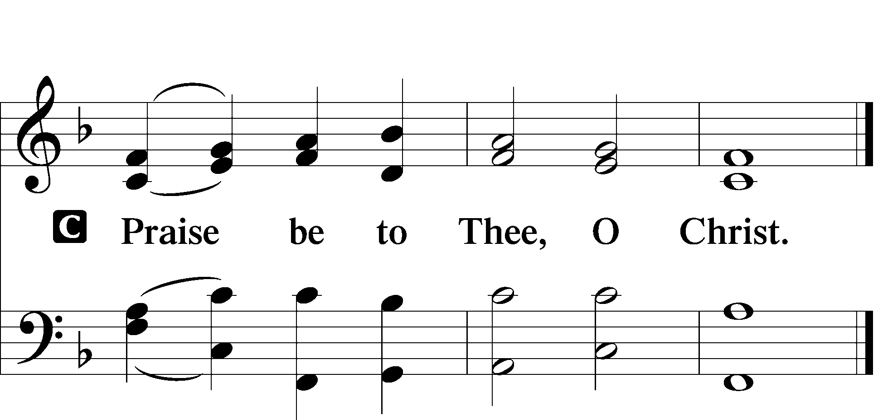

Apostles’ Creed
C I believe in God, the Father Almighty,
maker of heaven and earth.

And in Jesus Christ, His only Son, our Lord,
who was conceived by the Holy Spirit,
born of the virgin Mary,
suffered under Pontius Pilate,
was crucified, died and was buried.
He descended into hell.
The third day He rose again from the dead.
He ascended into heaven
and sits at the right hand of God the Father Almighty.
From thence He will come to judge the living and the dead.

I believe in the Holy Spirit,
the holy Christian Church,
the communion of saints,
the forgiveness of sins,
the resurrection of the body,
and the life T everlasting. Amen.

Sit

547 The Lamb
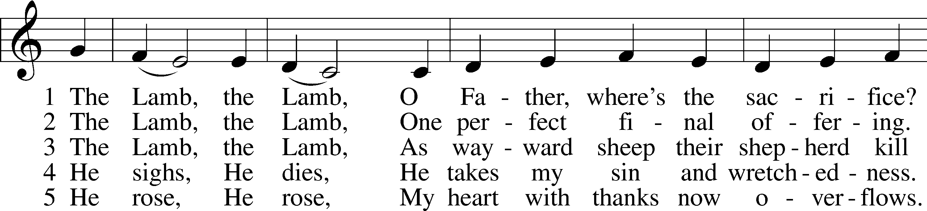
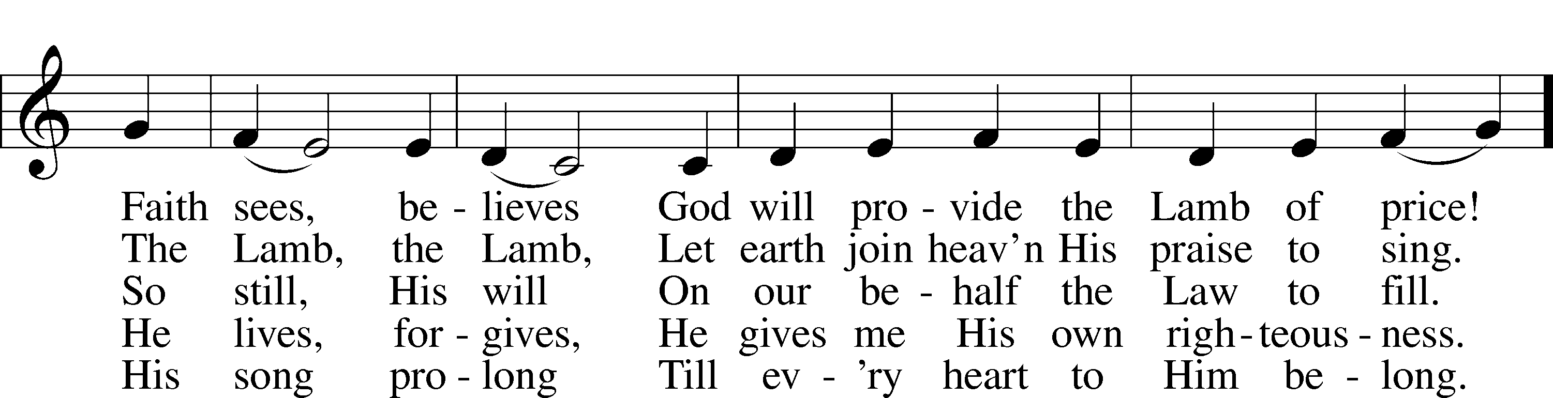
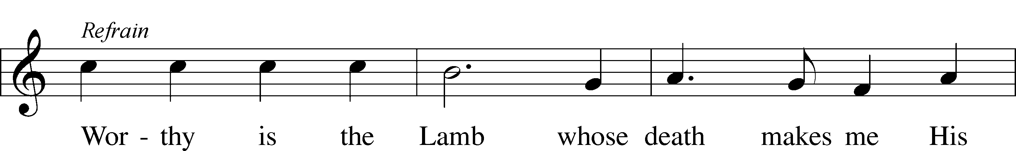
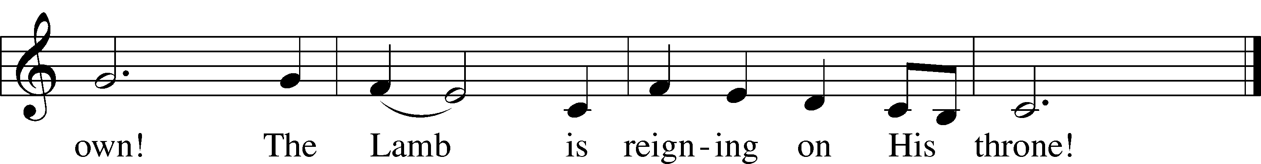

Sermon

Offering

Psalm for Meditation Psalm 46; antiphon: v. 7
God is our refuge and strength,
a very present help in trouble.
Therefore we will not fear though the earth gives way,
though the mountains be moved into the heart of the sea,
though its waters roar and foam,
though the mountains tremble at its swelling.
There is a river whose streams make glad the city of God,
the holy habitation of the Most High.
God is in the midst of her; she shall not be moved;
God will help her when morning dawns.
The nations rage, the kingdoms totter;
he utters his voice, the earth melts.
The Lord of hosts is with us;
the God of Jacob is our fortress.
Come, behold the works of the Lord,
how he has brought desolations on the earth.
He makes wars cease to the end of the earth;
he breaks the bow and shatters the spear;
he burns the chariots with fire.
“Be still, and know that I am God.
I will be exalted among the nations,
I will be exalted in the earth!”
The Lord of hosts is with us;
the God of Jacob is our fortress.

Stand

781 We Give Thee But Thine Own sts. 1–2
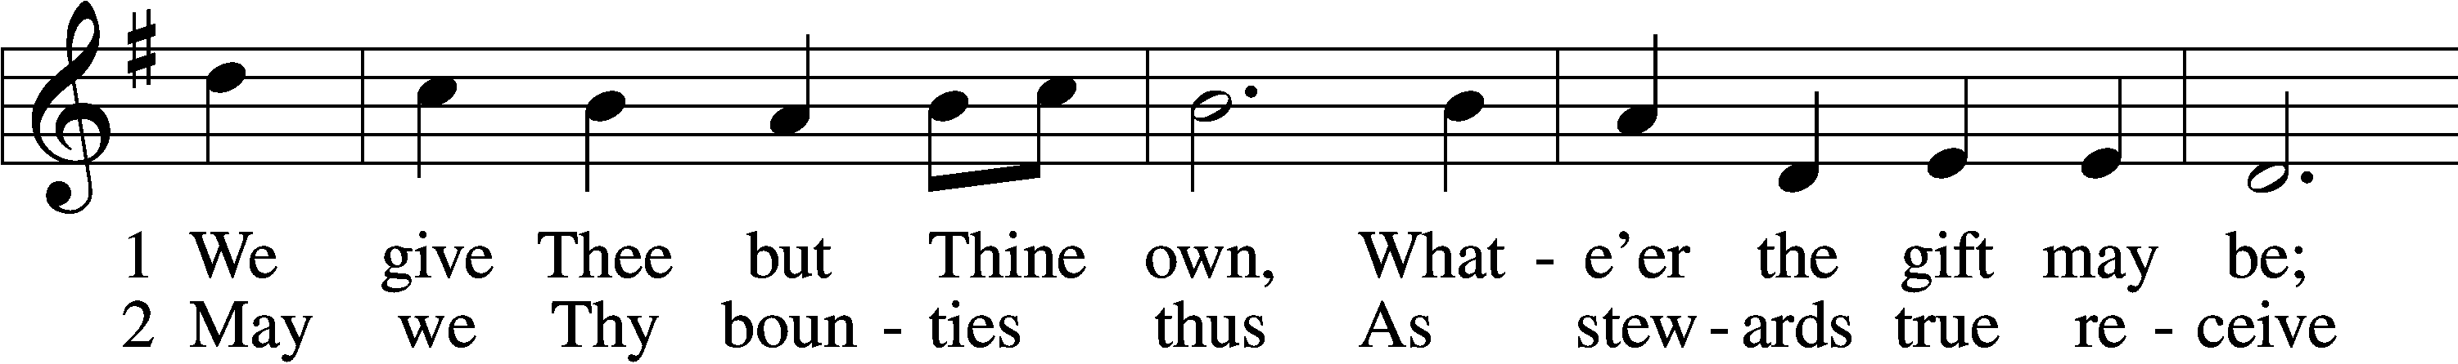
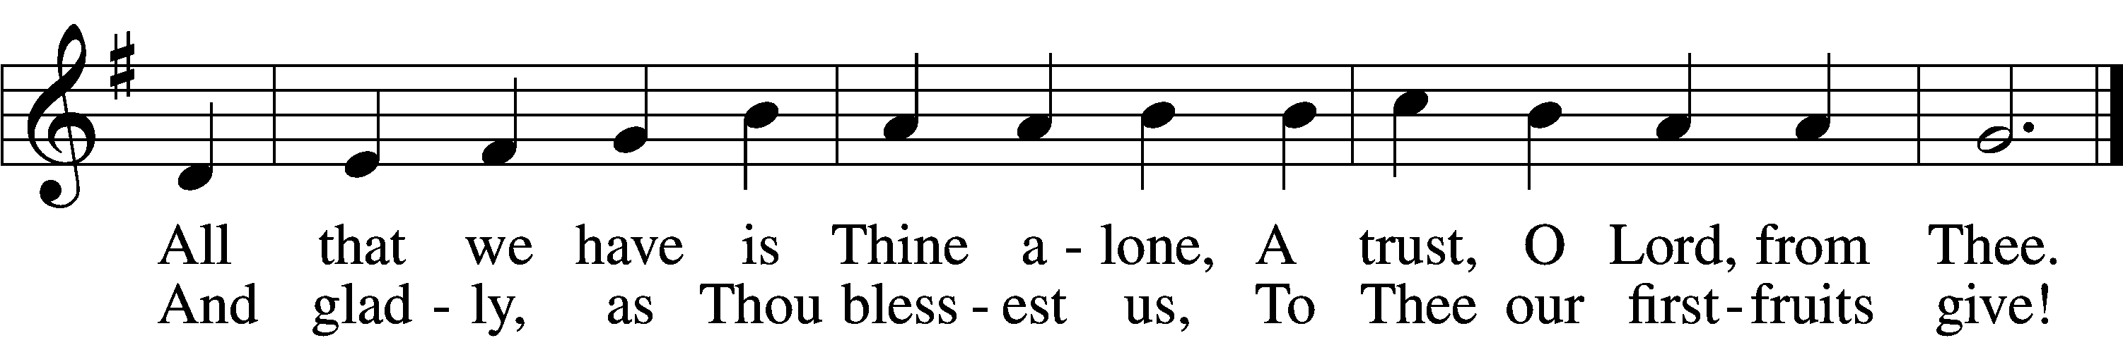

Prayer of the Church
P Almighty God, we give thanks for all Your goodness and bless You for the love that sustains us from day to day. We praise You for the gift of Your Son, our Savior, in whom we have redemption, the forgiveness of sins. We thank You for the Holy Spirit, the Comforter; for Your holy Church, for the means of grace, for the lives of all faithful and just people, and for the hope of the life to come. Help us to treasure in our hearts all that You have done for us, and enable us to show our thankfulness in lives that are wholly given to Your service. Lord, in Your mercy,
C hear our prayer.
P Grant Your wisdom and heavenly grace to all pastors and to those who hold office in Your Church that, by their devoted service, faith may abound and Your kingdom increase. Lord, in Your mercy,
C hear our prayer.
P Take from us all hatred and prejudice, give us the spirit of love, and order our days in Your peace. Prosper the labor of those who work to bring peace and justice to the nations of the world that mutual understanding and common endeavor may be increased among all peoples. Lord, in Your mercy,
C hear our prayer.
P Let Your blessing remain upon the seedtime and harvest, the commerce and industry, the leisure and rest, the arts and culture of our people. Take under Your special protection those whose work is difficult or dangerous, and be with all who put their hands to any useful task. Give them the just rewards for their labor and the knowledge that their work is a blessing in Your sight. Lord, in Your mercy,
C hear our prayer.
P By Your Word and Holy Spirit comfort all who are in sorrow or need, sickness or adversity especially Barbara, Dorothy, John W., Juliana, Marge, Tony, bill M., Patricia, Phil, Lidia, Michele, Giuseppe, Alfred, and Nancy. Be with those who suffer persecution for the faith. Bring consolation to those in sorrow, and grant to all a measure of Your love, taking them into Your tender care. Lord, in Your mercy,
C hear our prayer.
P All these things and whatever else You know that we need, grant us, Father, for the sake of Him who died and rose again and now lives and reigns with You and the Holy Spirit, one God forever.
C Amen.

Lord’s Prayer LSB 196
C Our Father who art in heaven,
hallowed be Thy name,
Thy kingdom come,
Thy will be done on earth as it is in heaven;
give us this day our daily bread;
and forgive us our trespasses as we forgive those who trespass against us;
and lead us not into temptation,
but deliver us from evil.
For Thine is the kingdom and the power and the glory forever and ever. Amen.

Salutation LSB 201
P The Lord be with you.
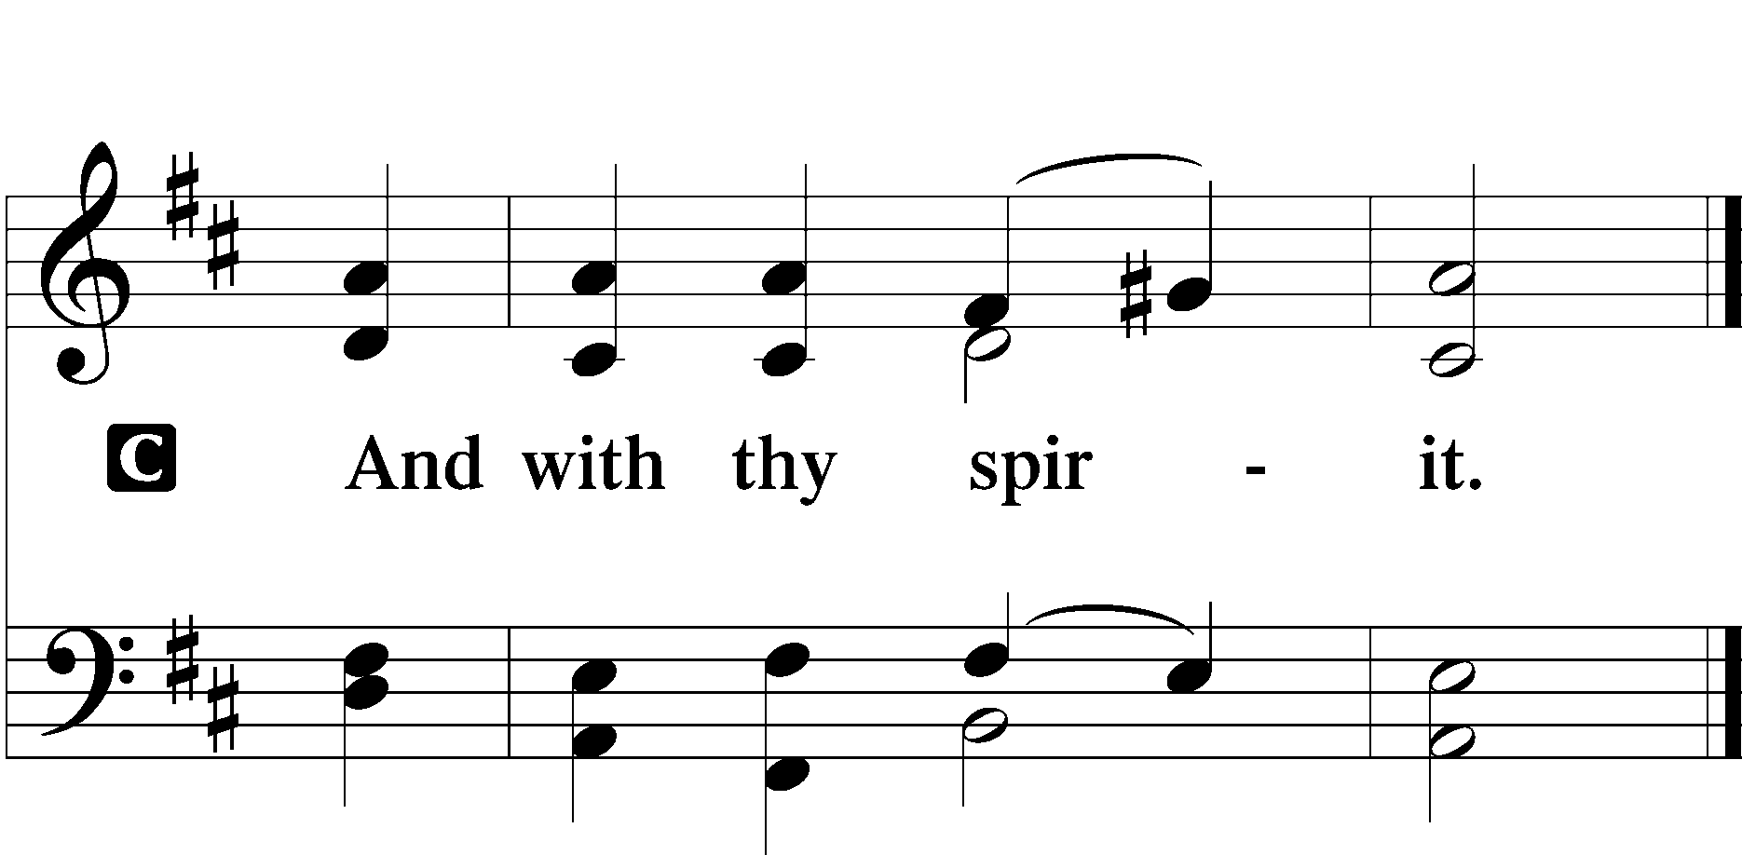

Benedicamus LSB 202
A Bless we the Lord.
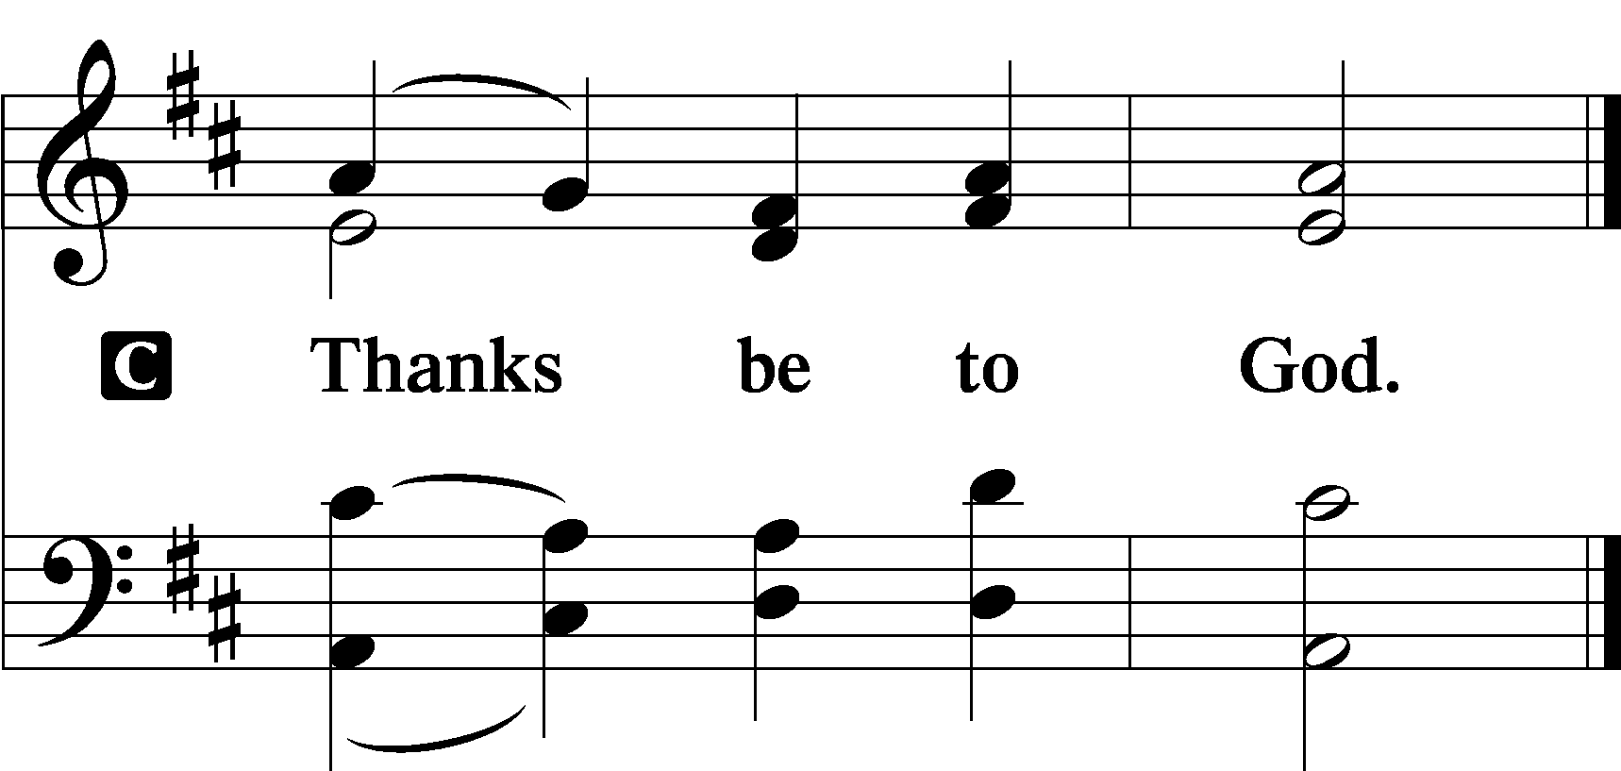

Benediction LSB 202
P The Lord bless you and keep you.
The Lord make His face shine upon you and be gracious unto you.
The Lord lift up His countenance upon you and T give you peace.
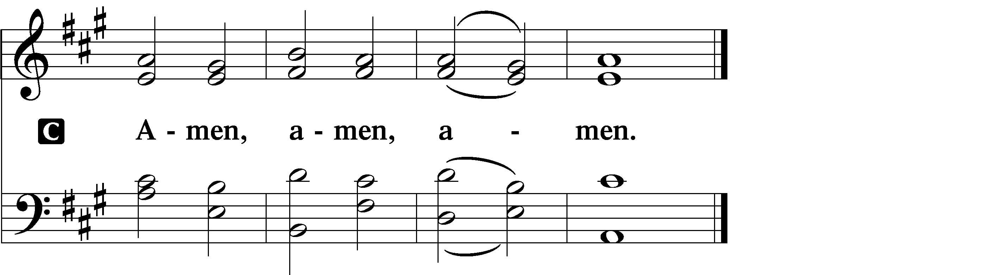

537 Beautiful Savior
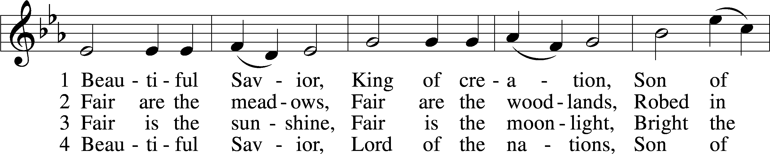
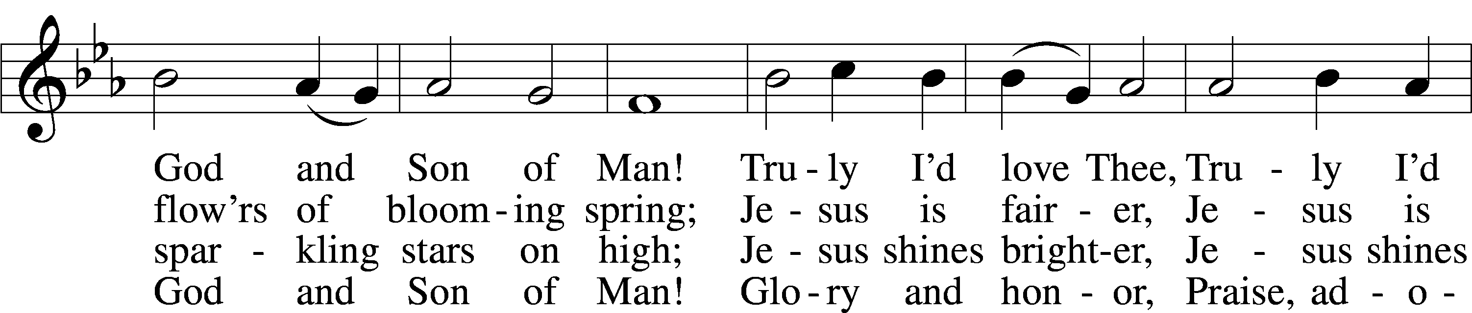
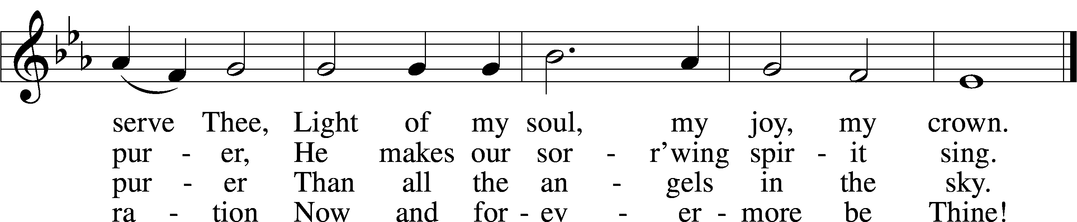

Announcements

Join us after the service in the fellowship hall for refreshments.

We will be decorating the church for Advent/Christmas season on Saturday, November 29th at 10 AM. Please come join us and stay for pizza and snacks afterwards, sponsored by the Ladies’ Guild.

Collecting has begun for hats and mittens for our local schools, and Toys for Tots. Items will be collected until Dec. 15th.

Pastor Vogel will conduct services for Dec. 7th and 14th.

St. John’s Lutheran Church
810 Broad St., Clifton, NJ 07013
StJohnsClifton.Org
PrayingHands810@gmail.com

