Reformation Sunday – November 2, 2025 – Lectionary Series
St. John’s Lutheran Church

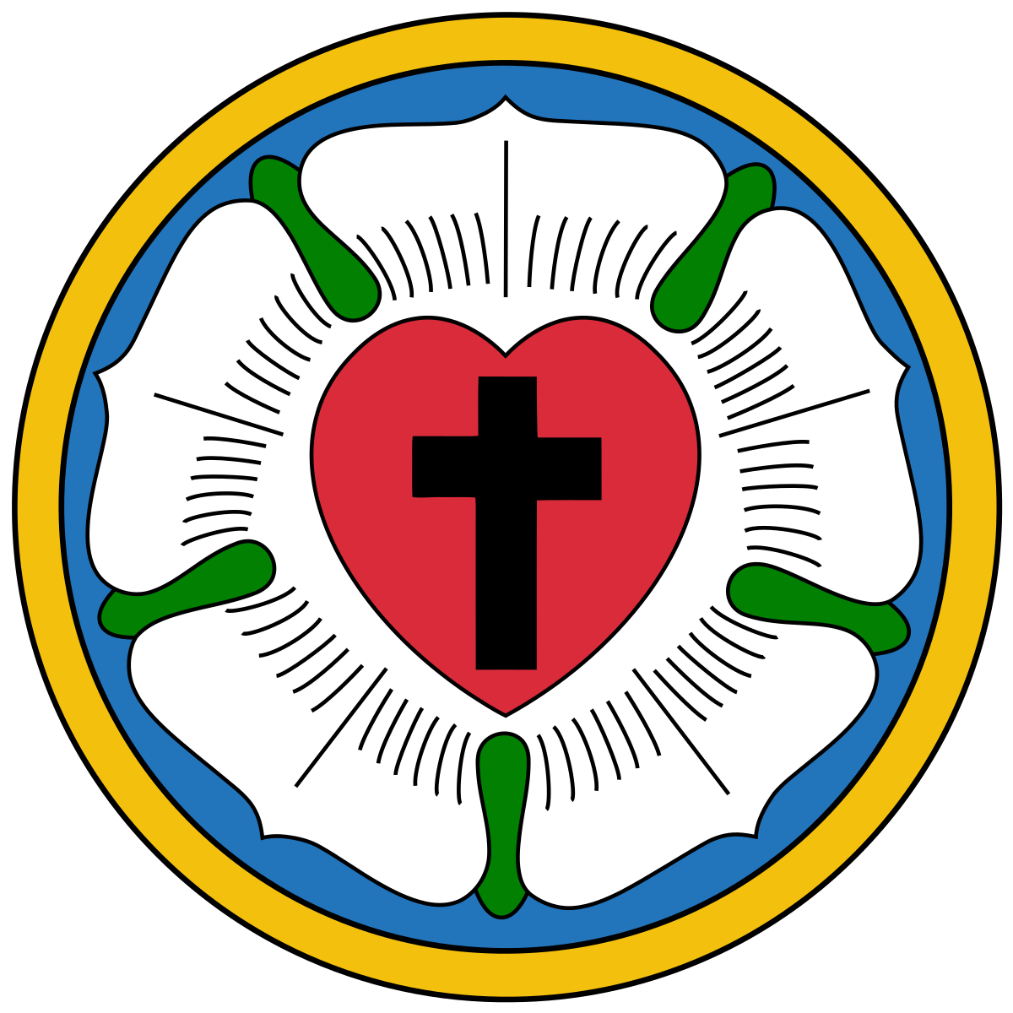

Order of Worship
by
Lutheran Service Builder
655 Lord, Keep Us Steadfast in Your Word

Stand for last verse

Confession and Absolution

The sign of the cross may be made by all in remembrance of their Baptism.

Invocation

Exhortation LSB 151

Silence for reflection on God’s Word and for self-examination.

Confession of Sins LSB 151

Absolution LSB 151

Service of the Word

Introit Psalm 34:1–2, 11, 22; antiphon: Psalm 119:46
I will speak of your testimonies before kings, [O Lord,]
and shall not be put to shame.
I will bless the Lord at all times;
his praise shall continually be in my mouth.
My soul makes its boast in the Lord;
let the humble hear and be glad.
Come, O children, listen to me;
I will teach you the fear of the Lord.
The Lord redeems the life of his servants;
none of those who take refuge in him will be condemned.
Glory be to the Father and to the Son
and to the Holy Spirit;
as it was in the beginning,
is now, and will be forever. Amen.
I will speak of your testimonies before kings, [O Lord,]
and shall not be put to shame.

Kyrie LSB 152

This Is the Feast LSB 155

Salutation and Collect of the Day

Sit

First Reading Revelation 7:9–17
After this I looked, and behold, a great multitude that no one could number, from every nation, from all tribes and peoples and languages, standing before the throne and before the Lamb, clothed in white robes, with palm branches in their hands, and crying out with a loud voice, “Salvation belongs to our God who sits on the throne, and to the Lamb! And all the angels were standing around the throne and around the elders and the four living creatures, and they fell on their faces before the throne and worshiped God, saying, “Amen! Blessing and glory and wisdom and thanksgiving and honor and power and might be to our God forever and ever! Amen.”
Then one of the elders addressed me, saying, “Who are these, clothed in white robes, and from where have they come?” I said to him, “Sir, you know.” And he said to me, “These are the ones coming out of the great tribulation. They have washed their robes and made them white in the blood of the Lamb.
“Therefore they are before the throne of God,
and serve him day and night in his temple;
and he who sits on the throne will shelter them with his presence.
They shall hunger no more, neither thirst anymore;
the sun shall not strike them,
nor any scorching heat.
For the Lamb in the midst of the throne will be their shepherd,
and he will guide them to springs of living water,
and God will wipe away every tear from their eyes.”

A This is the Word of the Lord.
C Thanks be to God.

Epistle 1 John 3:1-3
See what kind of love the Father has given to us, that we should be called children of God; and so we are. The reason why the world does not know us is that it did not know him. Beloved, we are God’s children now, and what we will be has not yet appeared; but we know that when he appears we shall be like him, because we shall see him as he is. And everyone who thus hopes in him purifies himself as he is pure.

A This is the Word of the Lord.
C Thanks be to God.

Stand

Alleluia and Verse LSB 156
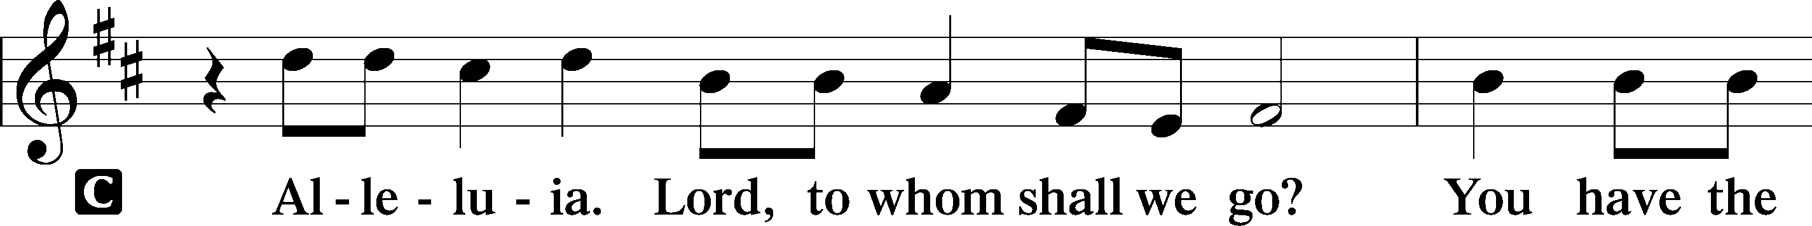
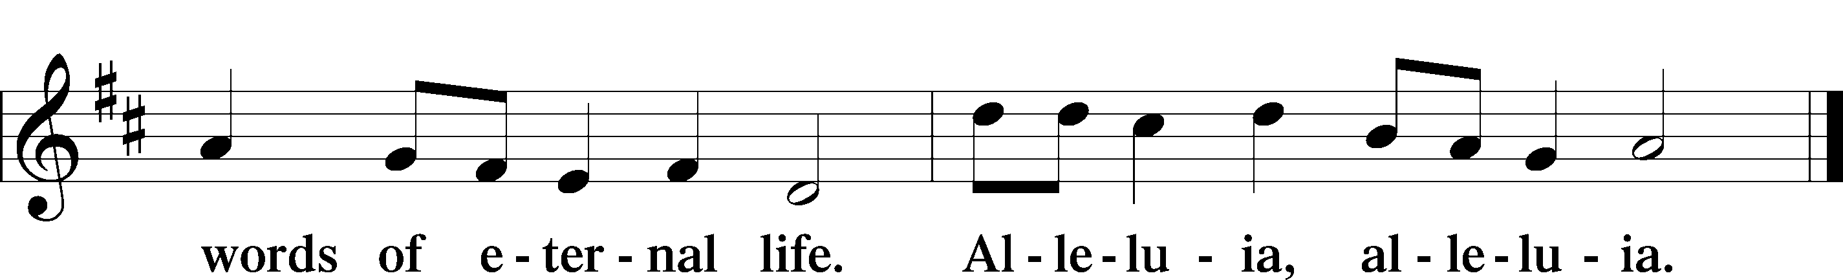

Holy Gospel Matthew 5:1-12
P The Holy Gospel according to Matthew, the fifth chapter.

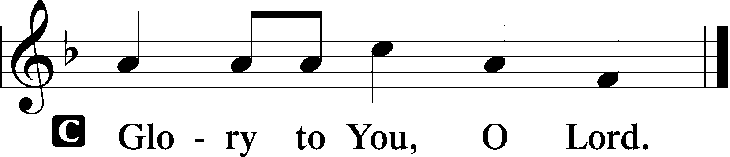

Seeing the crowds, he went up on the mountain, and when he sat down, his disciples came to him.
The Beatitudes
And he opened his mouth and taught them, saying:
“Blessed are the poor in spirit, for theirs is the kingdom of heaven.
“Blessed are those who mourn, for they shall be comforted.
“Blessed are the meek, for they shall inherit the earth.
“Blessed are those who hunger and thirst for righteousness, for they shall be satisfied.
“Blessed are the merciful, for they shall receive mercy.
“Blessed are the pure in heart, for they shall see God.
“Blessed are the peacemakers, for they shall be called sons of God.
“Blessed are those who are persecuted for righteousness’ sake, for theirs is the kingdom of heaven.
“Blessed are you when others revile you and persecute you and utter all kinds of evil against you falsely on my account. Rejoice and be glad, for your reward is great in heaven, for so they persecuted the prophets who were before you.

P This is the Gospel of the Lord.

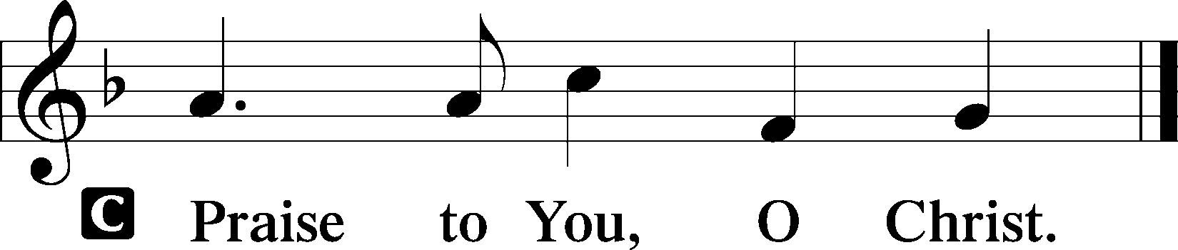

Nicene Creed

Sit

656 A Mighty Fortress Is Our God

Sermon

Offering

Psalm for Meditation Psalm 46; antiphon: v. 7
God is our refuge and strength,
a very present help in trouble.
Therefore we will not fear though the earth gives way,
though the mountains be moved into the heart of the sea,
though its waters roar and foam,
though the mountains tremble at its swelling.
There is a river whose streams make glad the city of God,
the holy habitation of the Most High.
God is in the midst of her; she shall not be moved;
God will help her when morning dawns.
The nations rage, the kingdoms totter;
he utters his voice, the earth melts.
The Lord of hosts is with us;
the God of Jacob is our fortress.
Come, behold the works of the Lord,
how he has brought desolations on the earth.
He makes wars cease to the end of the earth;
he breaks the bow and shatters the spear;
he burns the chariots with fire.
“Be still, and know that I am God.
I will be exalted among the nations,
I will be exalted in the earth!”
The Lord of hosts is with us;
the God of Jacob is our fortress.

Stand

781 We Give Thee But Thine Own sts. 1–2

Prayer of the Church
After “let us pray to the Lord:” respond with “Lord, have mercy.”

Service of the Sacrament

Preface LSB 160

Proper Preface (Full)

Sanctus LSB 161

Prayer of Thanksgiving LSB 161

The Words of Our Lord

Proclamation of Christ

Lord’s Prayer

Pax Domini LSB 163

Agnus Dei LSB 163

Sit

Distribution & Distribution Hymn

629 What Is This Bread

Stand

Thank the Lord LSB 164

Post-Communion Collect

Benediction LSB 166

948 All Glory Be to God Alone sts. 1–3

Announcements

Join us after the service in the fellowship hall for refreshments and
Bible Study.

Council Meeting will be held Friday, Nov. 7th at 10:00am.

Pastor Vogel will be leading services on November 9th, and 16th.

If not taking your bulletin home, please leave on table in the narthex when leaving so it can be recycled. Thank you.

St. John’s Lutheran Church
810 Broad St., Clifton, NJ 07013
StJohnsClifton.Org
PrayingHands810@gmail.com

