Twenty-third Sunday after Pentecost November16, 2025 – Lectionary Series
St. John’s Lutheran Church

Order of Worship
by
Lutheran Service Builder

911 Lord, This Day We’ve Come to Worship sts. 1, ref, 2–3

Stand for last verse

Confession and Absolution

The sign of the cross may be made by all in remembrance of their Baptism.

Invocation

Exhortation LSB 184

Silence for reflection on God’s Word and for self-examination.

Confession of Sins LSB 184

Absolution LSB 185

Service of the Word

Introit Psalm 121:1–2, 5, 7–8; antiphon: Luke 21:33
Heaven and earth will pass away,
but my words will not pass away.
I lift up my eyes to the hills.
From where does my help come?
My help comes from the Lord,
who made heaven and earth.
The Lord is your keeper;
the Lord is your shade on your right hand.
The Lord will keep you from all evil;
he will keep your life.
The Lord will keep your going out and your coming in
from this time forth and forevermore.
Glory be to the Father and to the Son
and to the Holy Spirit;
as it was in the beginning,
is now, and will be forever. Amen.
Heaven and earth will pass away,
but my words will not pass away.

Kyrie LSB 186

Gloria in Excelsis LSB 187

Salutation and Collect of the Day

Sit

Old Testament Reading Malachi 4:1–6
“For behold, the day is coming, burning like an oven, when all the arrogant and all evildoers will be stubble. The day that is coming shall set them ablaze, says the Lord of hosts, so that it will leave them neither root nor branch. But for you who fear my name, the sun of righteousness shall rise with healing in its wings. You shall go out leaping like calves from the stall. And you shall tread down the wicked, for they will be ashes under the soles of your feet, on the day when I act, says the Lord of hosts.
“Remember the law of my servant Moses, the statutes and just decrees that I commanded him at Horeb for all Israel.
“Behold, I will send you Elijah the prophet before the great and awesome day of the Lord comes. And he will turn the hearts of fathers to their children and the hearts of children to their fathers, lest I come and strike the land with a decree of utter destruction.”

A This is the Word of the Lord.
C Thanks be to God.

Epistle 2 Thessalonians 3:1–13
Finally, brothers, pray for us, that the word of the Lord may speed ahead and be honored, as happened among you, and that we may be delivered from wicked and evil men. For not all have faith. But the Lord is faithful. He will establish you and guard you against the evil one. And we have confidence in the Lord about you, that you are doing and will do the things that we command. May the Lord direct your hearts to the love of God and to the steadfastness of Christ.
Now we command you, brothers, in the name of our Lord Jesus Christ, that you keep away from any brother who is walking in idleness and not in accord with the tradition that you received from us. For you yourselves know how you ought to imitate us, because we were not idle when we were with you, nor did we eat anyone’s bread without paying for it, but with toil and labor we worked night and day, that we might not be a burden to any of you. It was not because we do not have that right, but to give you in ourselves an example to imitate. For even when we were with you, we would give you this command: If anyone is not willing to work, let him not eat. For we hear that some among you walk in idleness, not busy at work, but busybodies. Now such persons we command and encourage in the Lord Jesus Christ to do their work quietly and to earn their own living.
As for you, brothers, do not grow weary in doing good.

A This is the Word of the Lord.
C Thanks be to God.

Stand

Alleluia LSB 190
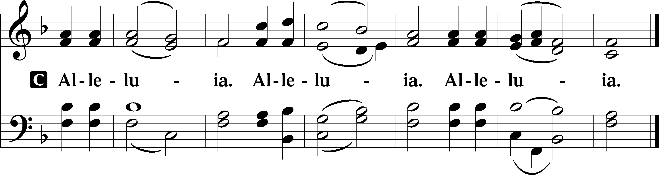

Holy Gospel Luke 21:5–28
P The Holy Gospel according to St. Luke, the twenty-first chapter.

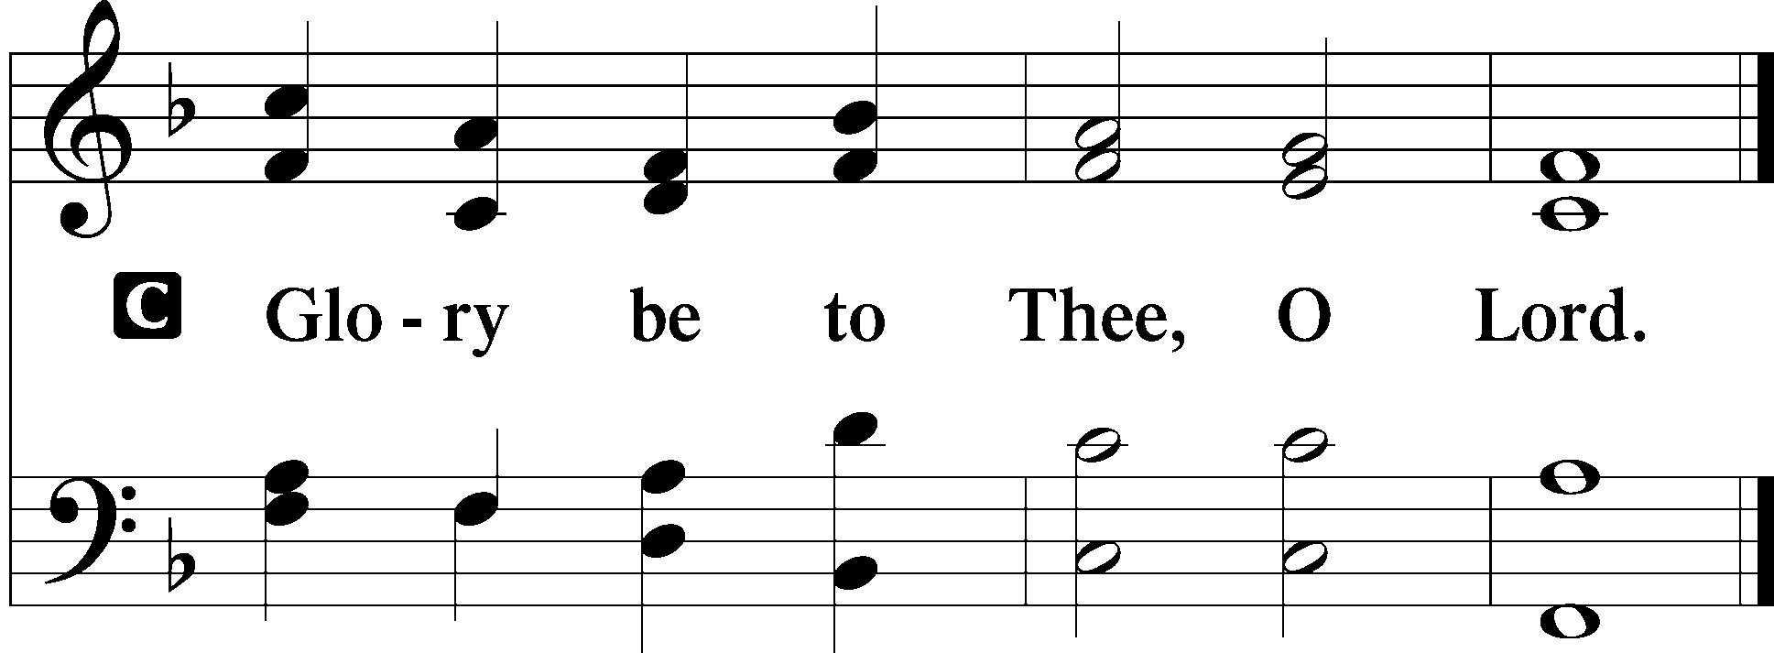

While some were speaking of the temple, how it was adorned with noble stones and offerings, [Jesus] said, “As for these things that you see, the days will come when there will not be left here one stone upon another that will not be thrown down.” And they asked him, “Teacher, when will these things be, and what will be the sign when these things are about to take place?” And he said, “See that you are not led astray. For many will come in my name, saying, ‘I am he!’ and, ‘The time is at hand!’ Do not go after them. And when you hear of wars and tumults, do not be terrified, for these things must first take place, but the end will not be at once.”
Then he said to them, “Nation will rise against nation, and kingdom against kingdom. There will be great earthquakes, and in various places famines and pestilences. And there will be terrors and great signs from heaven. But before all this they will lay their hands on you and persecute you, delivering you up to the synagogues and prisons, and you will be brought before kings and governors for my name’s sake. This will be your opportunity to bear witness. Settle it therefore in your minds not to meditate beforehand how to answer, for I will give you a mouth and wisdom, which none of your adversaries will be able to withstand or contradict. You will be delivered up even by parents and brothers and relatives and friends, and some of you they will put to death. You will be hated by all for my name’s sake. But not a hair of your head will perish. By your endurance you will gain your lives.
“But when you see Jerusalem surrounded by armies, then know that its desolation has come near. Then let those who are in Judea flee to the mountains, and let those who are inside the city depart, and let not those who are out in the country enter it, for these are days of vengeance, to fulfill all that is written. Alas for women who are pregnant and for those who are nursing infants in those days! For there will be great distress upon the earth and wrath against this people. They will fall by the edge of the sword and be led captive among all nations, and Jerusalem will be trampled underfoot by the Gentiles, until the times of the Gentiles are fulfilled.
“And there will be signs in sun and moon and stars, and on the earth distress of nations in perplexity because of the roaring of the sea and the waves, people fainting with fear and with foreboding of what is coming on the world. For the powers of the heavens will be shaken. And then they will see the Son of Man coming in a cloud with power and great glory. Now when these things begin to take place, straighten up and raise your heads, because your redemption is drawing near.”

P This is the Gospel of the Lord.
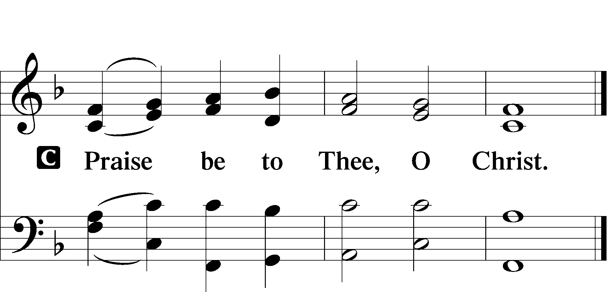

Nicene Creed

Sit

516 Wake, Awake, for Night Is Flying

Sermon

Offering

Psalm for Meditation Psalm 98; antiphon: v. 9b
Oh sing to the Lord a new song,
for he has done marvelous things!
His right hand and his holy arm
have worked salvation for him.
The Lord has made known his salvation;
he has revealed his righteousness in the sight of the nations.
He has remembered his steadfast love and faithfulness
to the house of Israel.
All the ends of the earth have seen
the salvation of our God.
Make a joyful noise to the Lord, all the earth;
break forth into joyous song and sing praises!
Sing praises to the Lord with the lyre,
with the lyre and the sound of melody!
With trumpets and the sound of the horn
make a joyful noise before the King, the Lord!
Let the sea roar, and all that fills it;
the world and those who dwell in it!
Let the rivers clap their hands;
let the hills sing for joy together
before the Lord, for he comes
to judge the earth.
He will judge the world with righteousness,
and the peoples with equity.

Stand

781 We Give Thee But Thine Own sts. 1–2

Prayer of the Church
After “let us pray to the Lord:” respond with “Lord, have mercy.”

Service of the Sacrament

Preface LSB 194

Proper Preface (Full)

Sanctus 195

Lord’s Prayer LSB 196

The Words of Our Lord 197

Pax Domini LSB 197

Agnus Dei LSB 198

Sit

Distribution

633 At the Lamb’s High Feast We Sing sts. 1–4

Stand

Nunc Dimittis LSB 199

Thanksgiving LSB 200

Post-Communion Collect

Salutation LSB 201

Benedicamus LSB 202

Benediction LSB 202

660 Stand Up, Stand Up for Jesus

Announcements

Join us after the service in the fellowship hall for refreshments and
Bible Study.

We will be decorating the church for Advent/Christmas season on Saturday, November 29th at 10 AM. Please come join us and stay for pizza and snacks afterwards, sponsored by the Ladies’ Guild.

Collecting has begun for hats and mittens for our local schools, and Toys for Tots. Items will be collected until Dec. 15th.

St. John’s Lutheran Church
810 Broad St., Clifton, NJ 07013
StJohnsClifton.Org
PrayingHands810@gmail.com

