Seventeenth Sunday after Pentecost October 5, 2025 – Lectionary Series
St. John’s Lutheran Church

Order of Worship
by
Lutheran Service Builder
913 O Holy Spirit, Enter In
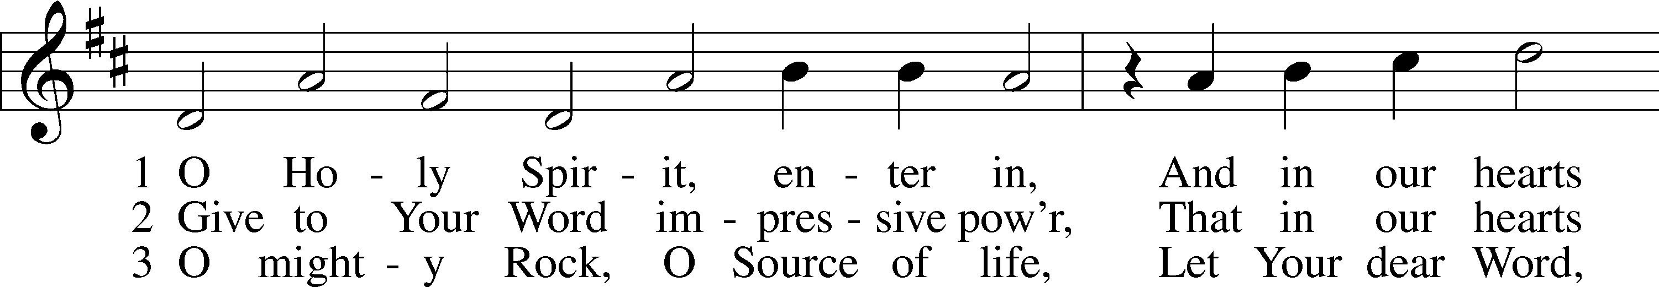
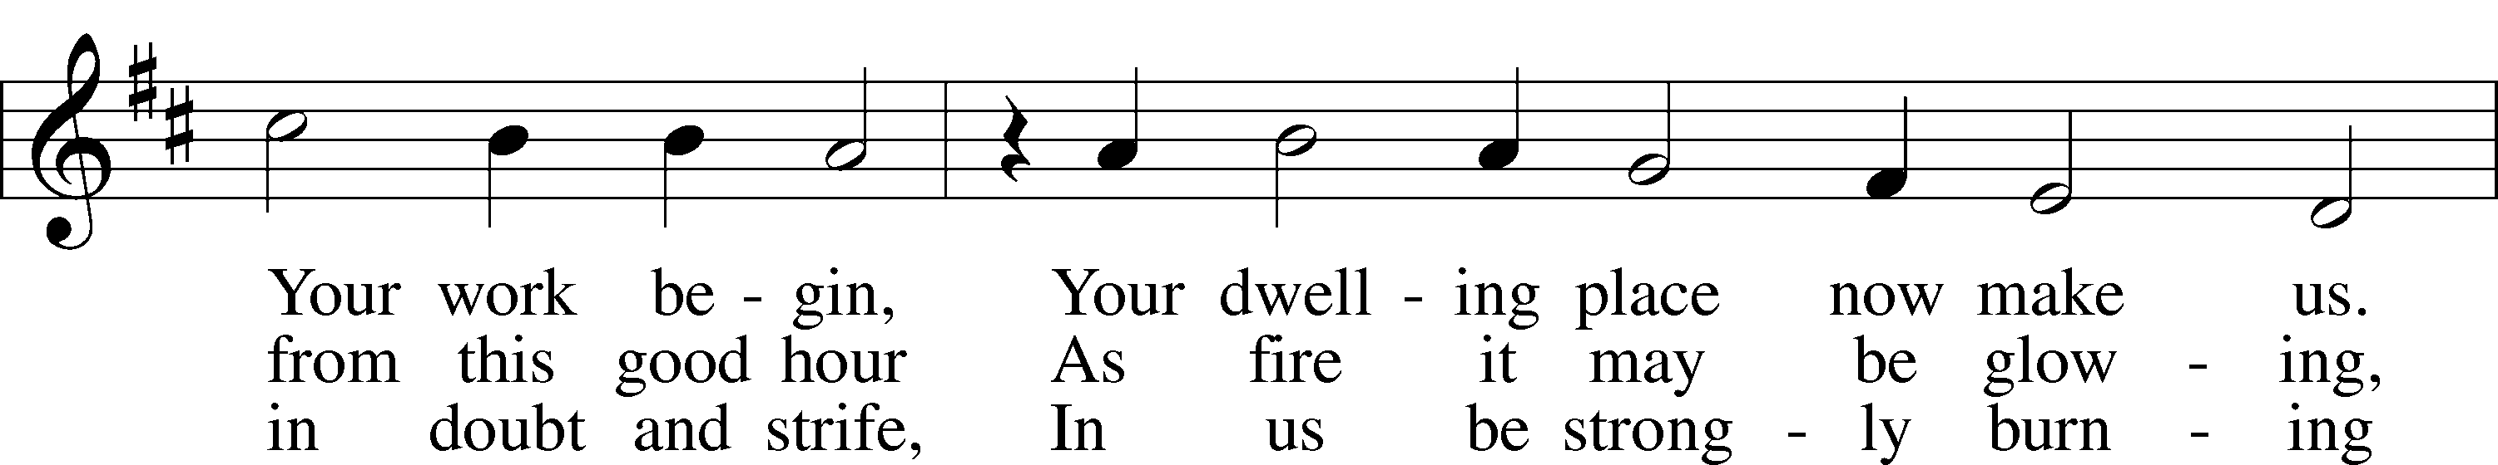
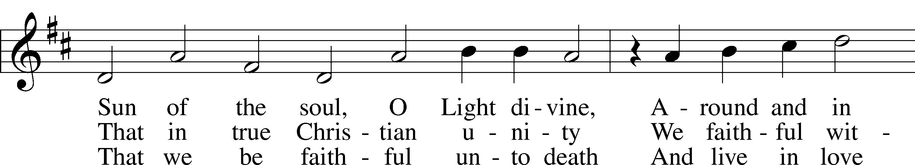
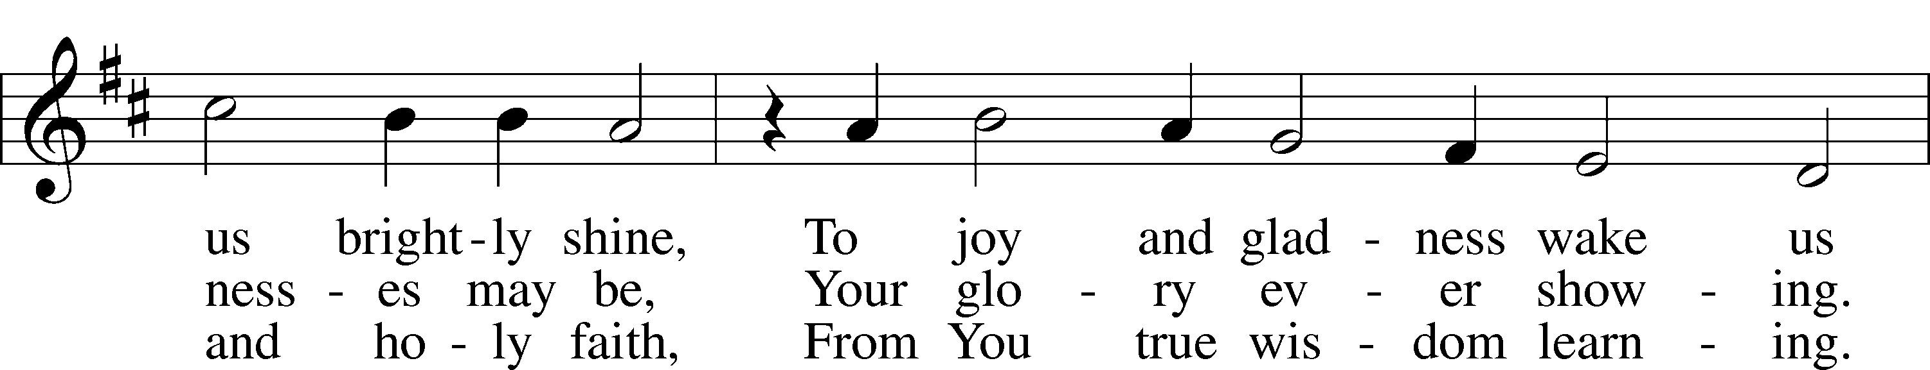
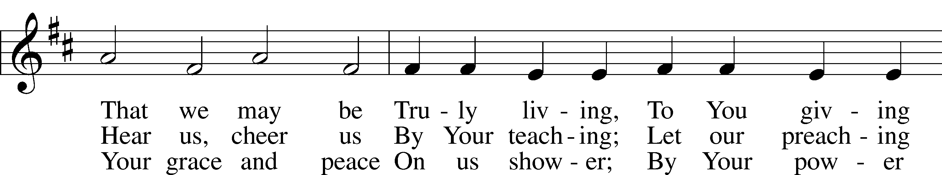
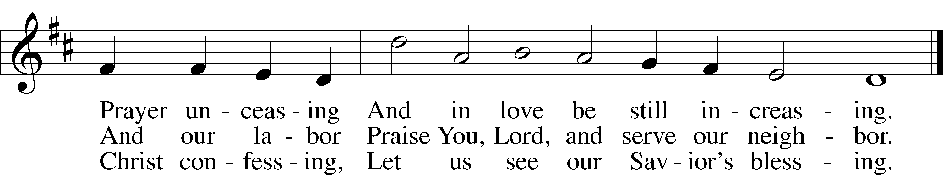

Stand for last verse

Confession and Absolution

The sign of the cross may be made by all in remembrance of their Baptism.

Invocation
P In the name of the Father and of the T Son and of the Holy Spirit.
C Amen.

Exhortation LSB 184
P Beloved in the Lord! Let us draw near with a true heart and confess our sins unto God our Father, beseeching Him in the name of our Lord Jesus Christ to grant us forgiveness.

P Our help is in the name of the Lord,
C who made heaven and earth.
P I said, I will confess my transgressions unto the Lord,
C and You forgave the iniquity of my sin.

Silence for reflection on God’s Word and for self-examination.

Confession of Sins LSB 184
P O almighty God, merciful Father,
C I, a poor, miserable sinner, confess unto You all my sins and iniquities with which I have ever offended You and justly deserved Your temporal and eternal punishment. But I am heartily sorry for them and sincerely repent of them, and I pray You of Your boundless mercy and for the sake of the holy, innocent, bitter sufferings and death of Your beloved Son, Jesus Christ, to be gracious and merciful to me, a poor, sinful being.

Declaration
P Almighty God, our heavenly Father, has had mercy upon us and has given His only son to die for us and for His sake forgives us all our sins. To those who believe on His name He gives power to become the children of God and has promised them His Holy Spirit. He that believes and is baptized shall be saved.
Grant this, Lord, unto us all. LSB 1
C Amen.

Service of the Word

Introit Psalm 119:162, 164–165, 167; antiphon: v. 166
I hope for your salvation, O Lord,
and I do your commandments.
I rejoice at your word
like one who finds great spoil.
Seven times a day I praise you
for your just and righteous decrees.
Great peace have those who love your law;
nothing can make them stumble.
My soul keeps your testimonies;
I love them exceedingly.
Glory be to the Father and to the Son
and to the Holy Spirit;
as it was in the beginning,
is now, and will be forever. Amen.
I hope for your salvation, O Lord,
and I do your commandments.

Kyrie LSB 186
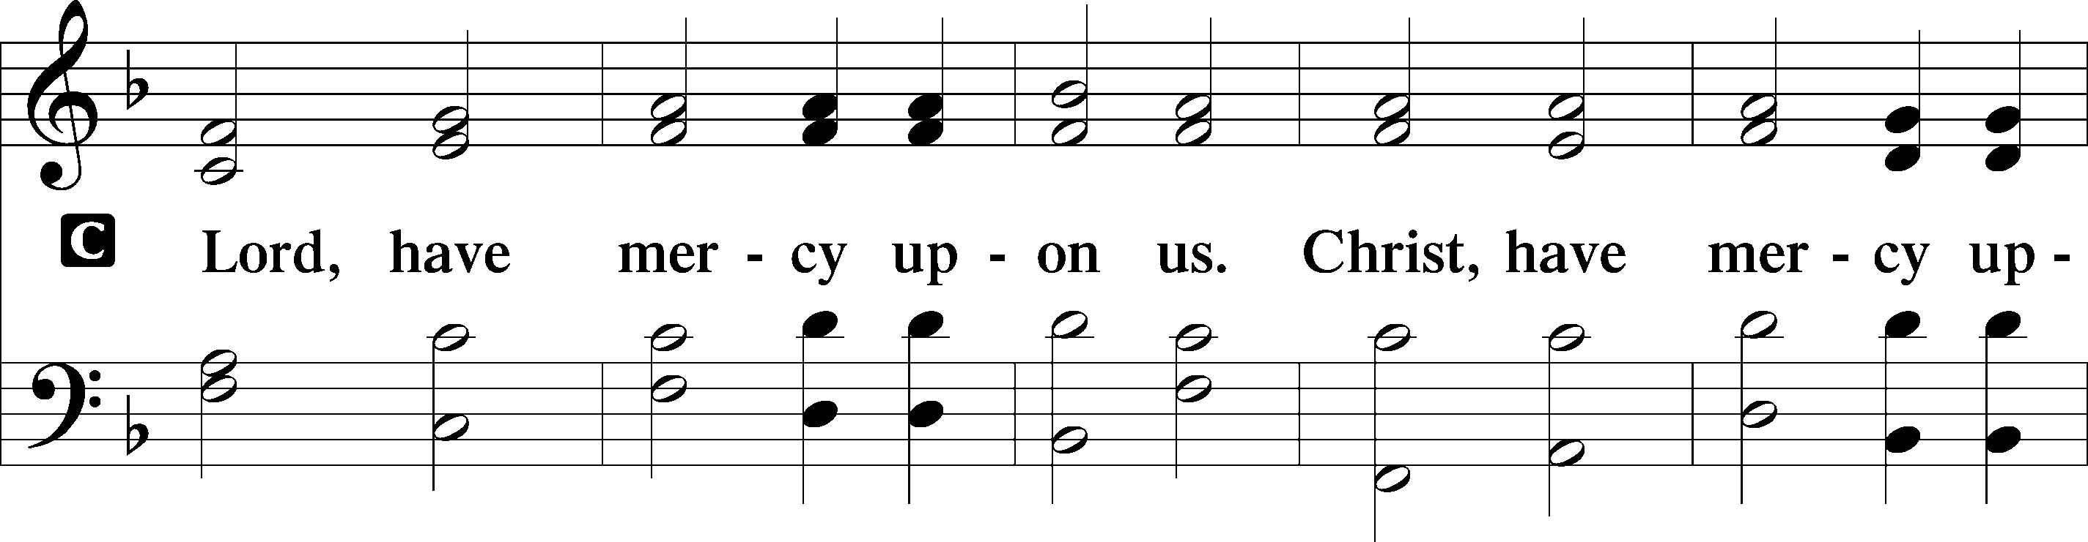
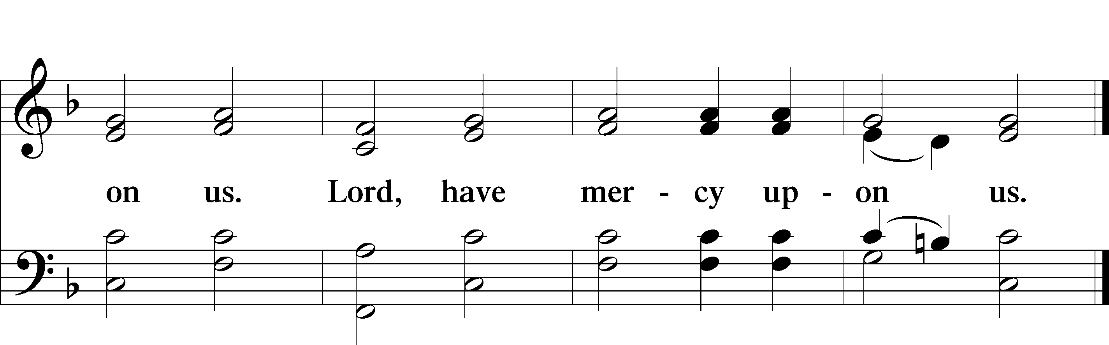

Gloria in Excelsis LSB 187
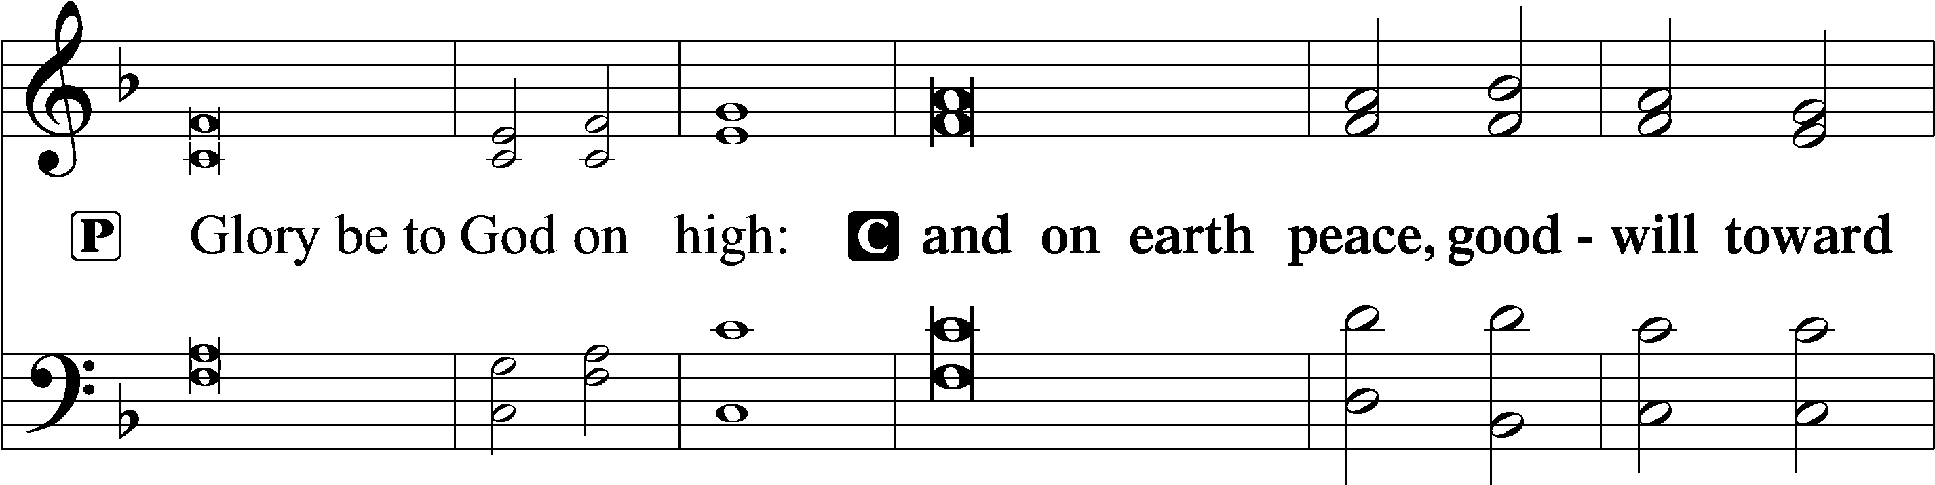
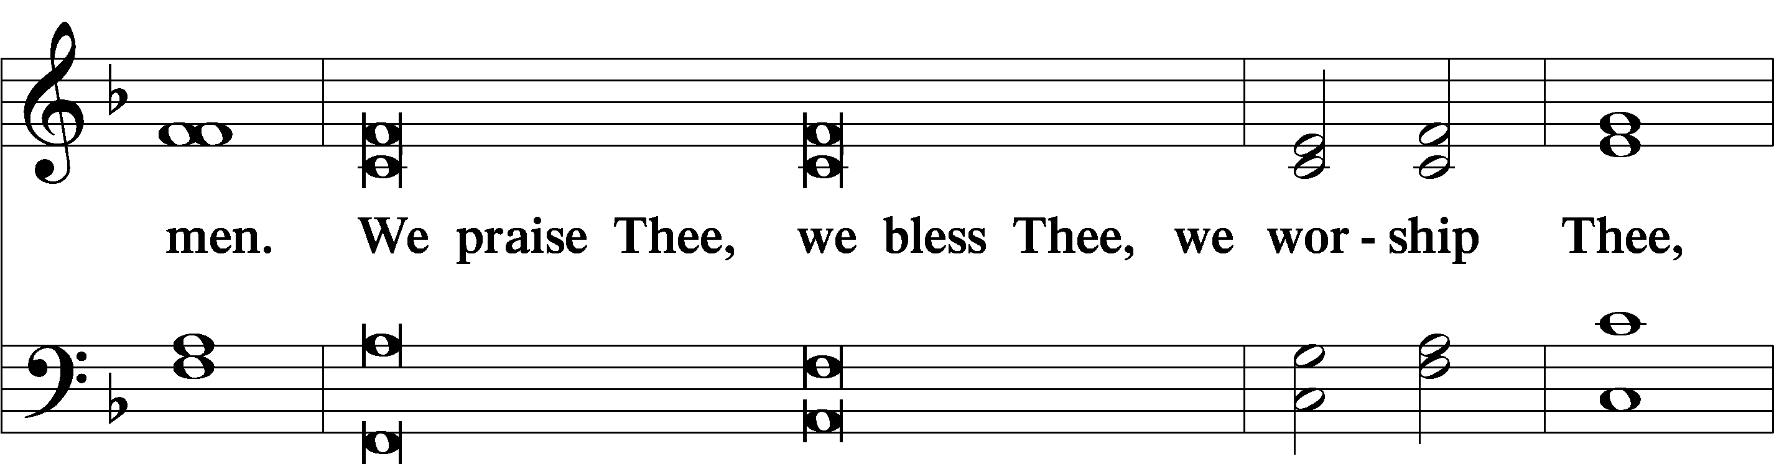
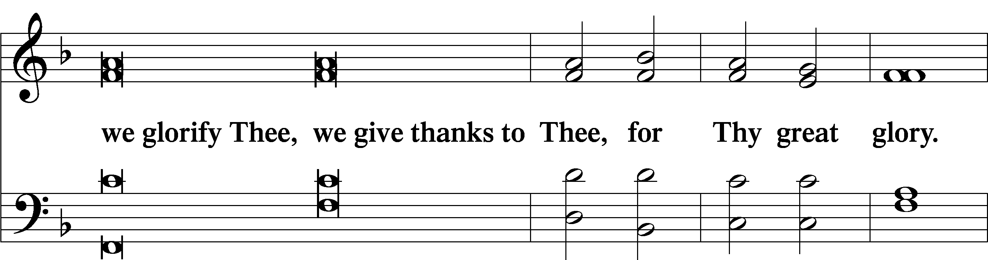
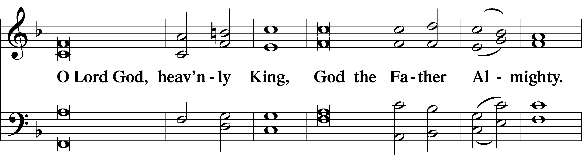
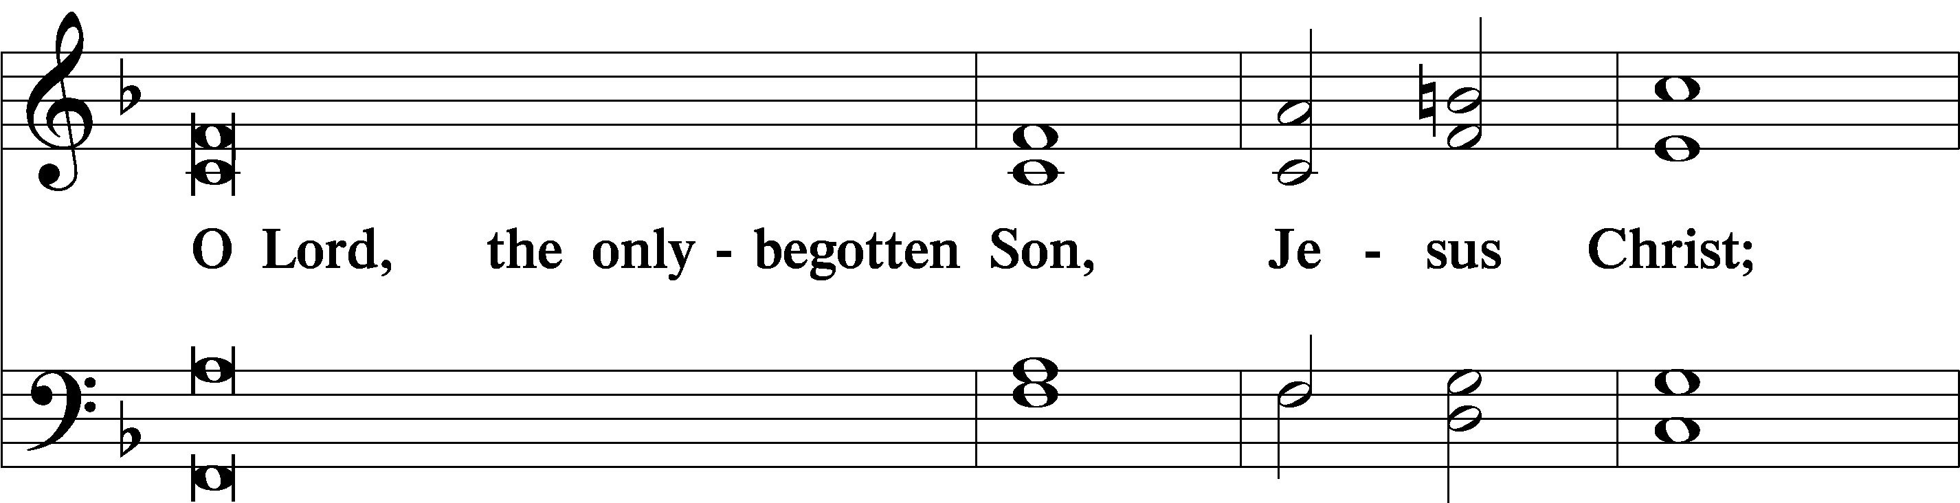
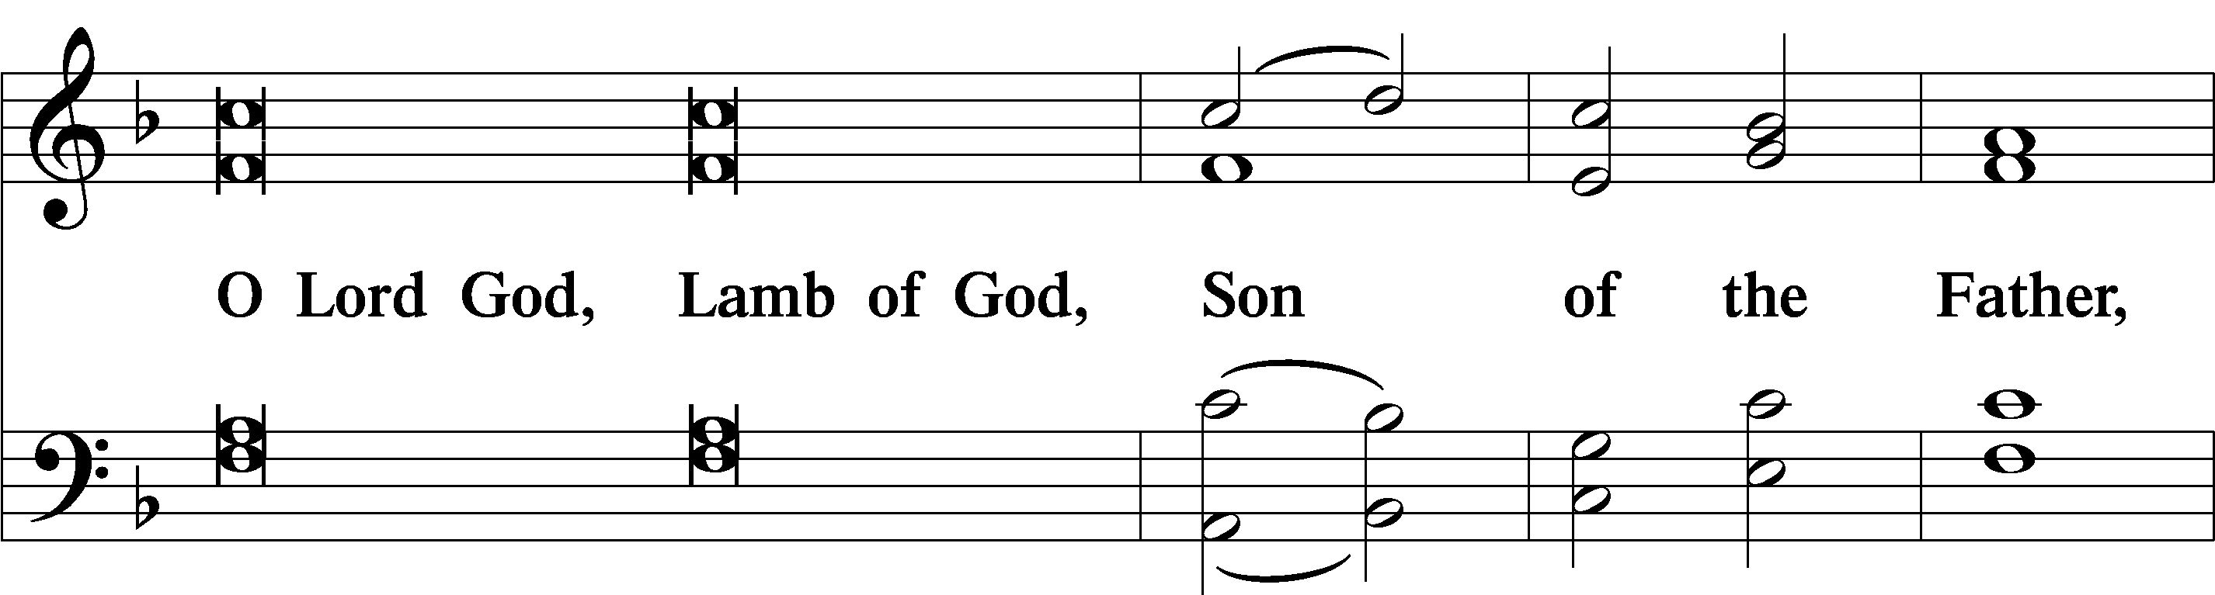
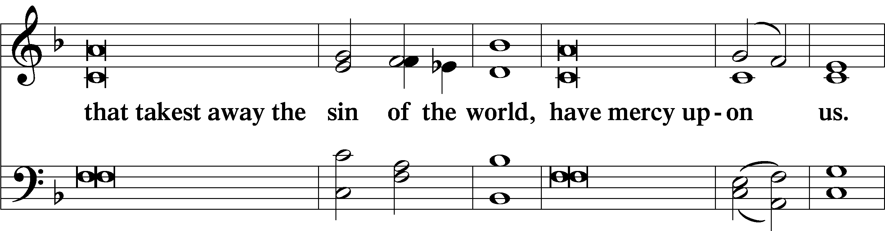
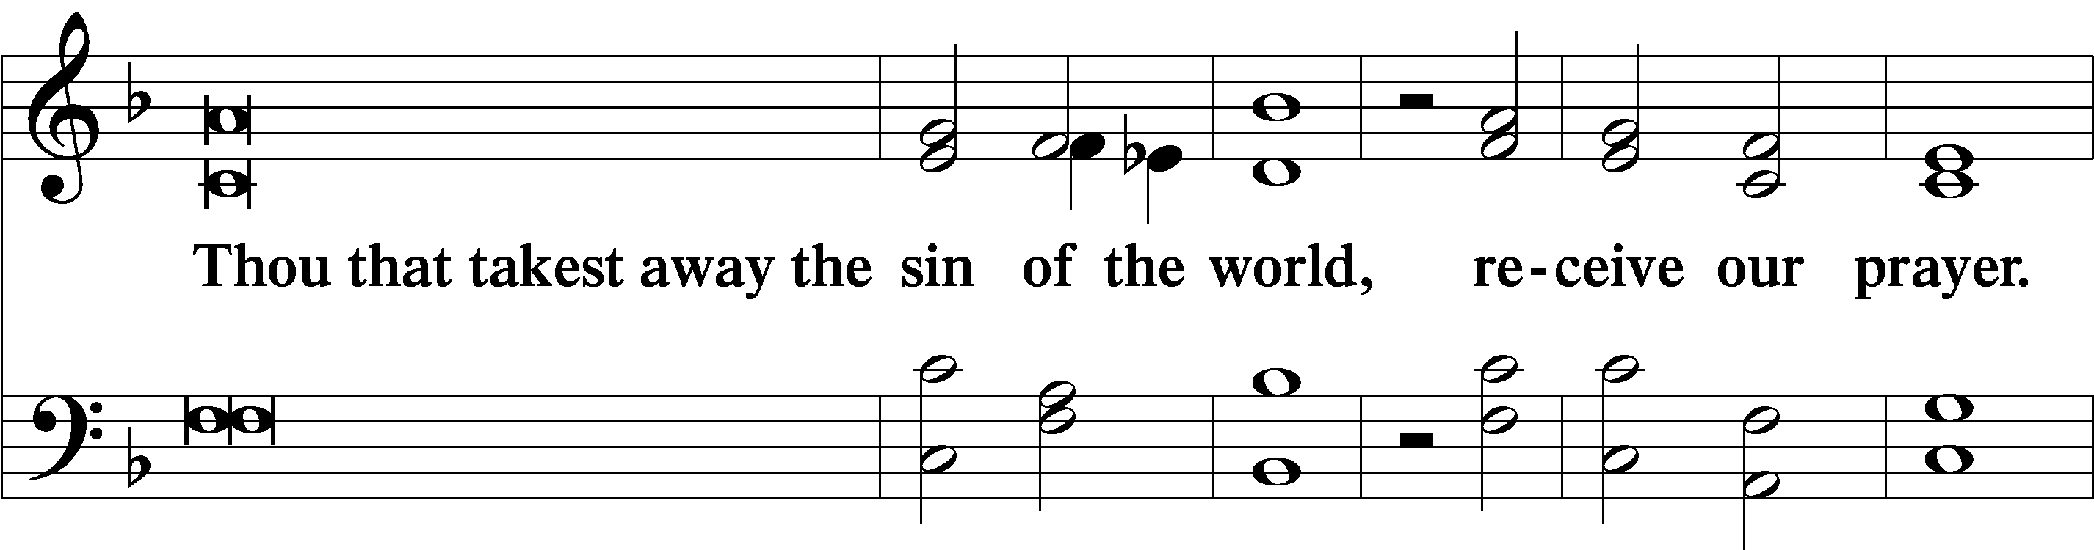
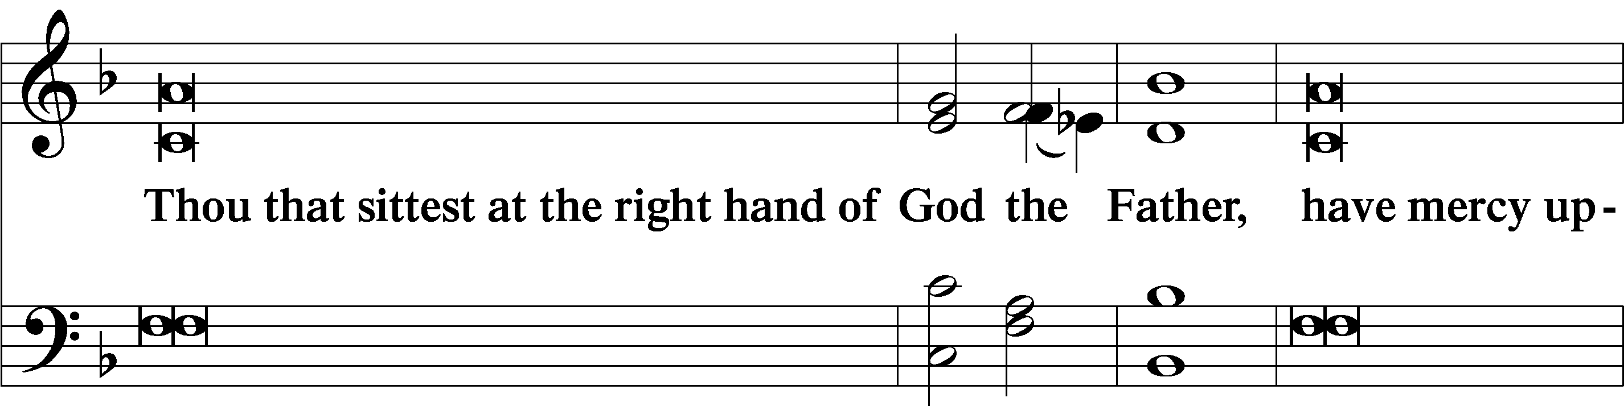
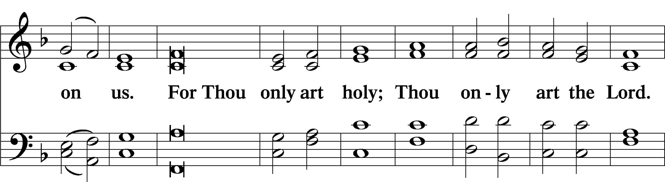
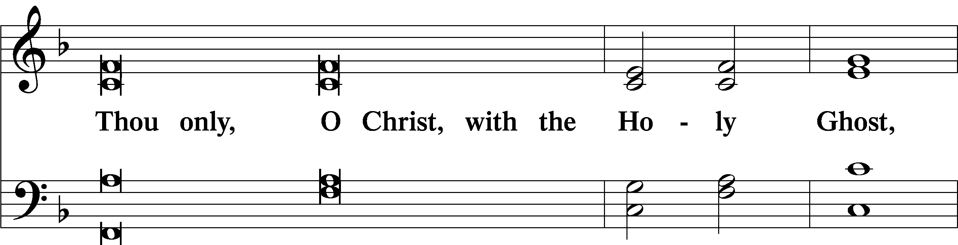
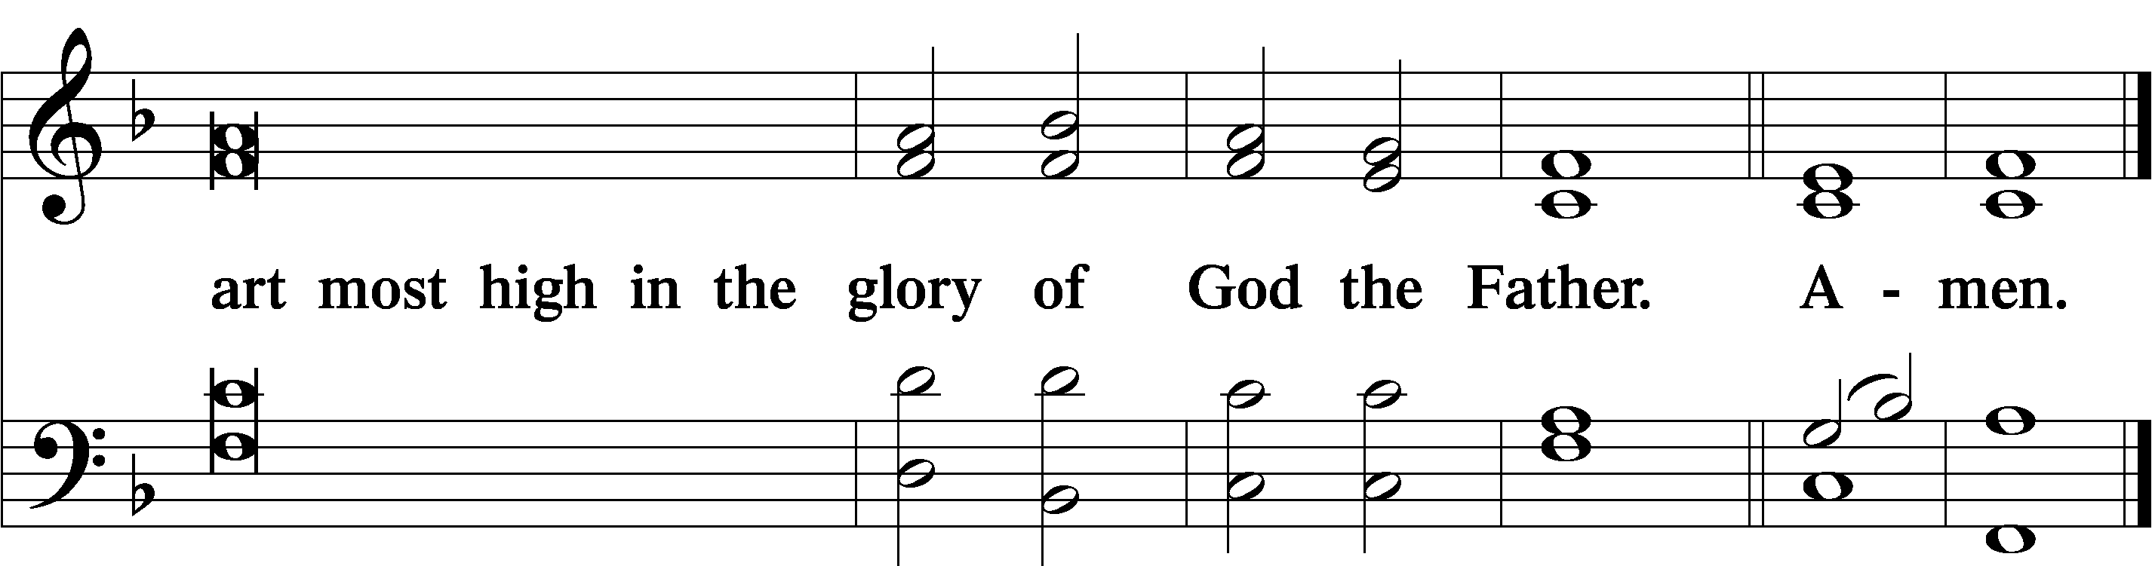

Salutation and Collect of the Day
P The Lord be with you.
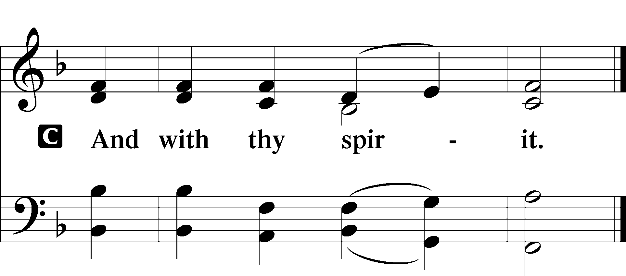
P Let us pray.
O God, our refuge and strength, the author of all godliness, by Your grace hear the prayers of Your Church. Grant that those things which we ask in faith we may receive through Your bountiful mercy; through Jesus Christ, Your Son, our Lord, who lives and reigns with You and the Holy Spirit, one God, now and forever.

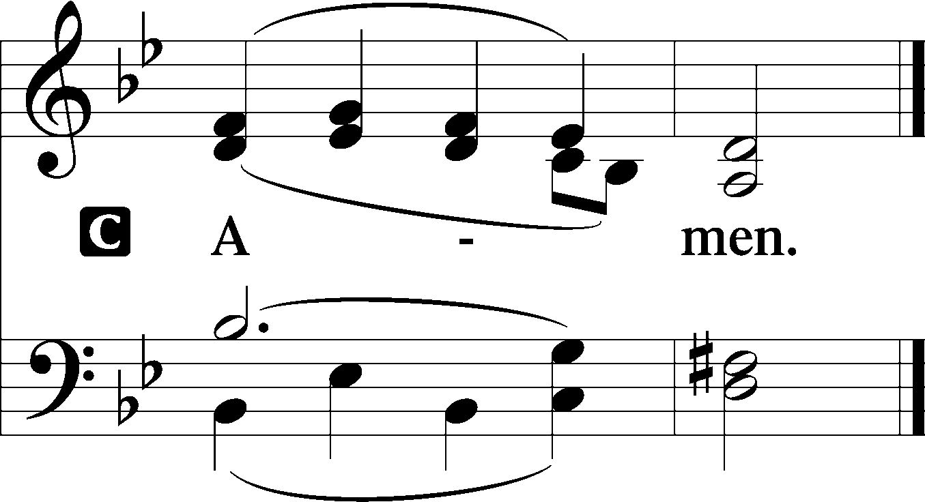

Sit

Old Testament Reading Habakkuk 1:1–4; 2:1–4
The oracle that Habakkuk the prophet saw.
O Lord, how long shall I cry for help,
and you will not hear?
Or cry to you “Violence!”
and you will not save?
Why do you make me see iniquity,
and why do you idly look at wrong?
Destruction and violence are before me;
strife and contention arise.
So the law is paralyzed,
and justice never goes forth.
For the wicked surround the righteous;
so justice goes forth perverted.
I will take my stand at my watchpost
and station myself on the tower,
and look out to see what he will say to me,
and what I will answer concerning my complaint.
And the Lord answered me:
“Write the vision;
make it plain on tablets,
so he may run who reads it.
For still the vision awaits its appointed time;
it hastens to the end—it will not lie.
If it seems slow, wait for it;
it will surely come; it will not delay.
“Behold, his soul is puffed up; it is not upright within him,
but the righteous shall live by his faith.”

A This is the Word of the Lord.
C Thanks be to God.

Epistle 2 Timothy 1:1–14
Paul, an apostle of Christ Jesus by the will of God according to the promise of the life that is in Christ Jesus,
To Timothy, my beloved child:
Grace, mercy, and peace from God the Father and Christ Jesus our Lord.
I thank God whom I serve, as did my ancestors, with a clear conscience, as I remember you constantly in my prayers night and day. As I remember your tears, I long to see you, that I may be filled with joy. I am reminded of your sincere faith, a faith that dwelt first in your grandmother Lois and your mother Eunice and now, I am sure, dwells in you as well. For this reason I remind you to fan into flame the gift of God, which is in you through the laying on of my hands, for God gave us a spirit not of fear but of power and love and self-control.
Therefore do not be ashamed of the testimony about our Lord, nor of me his prisoner, but share in suffering for the gospel by the power of God, who saved us and called us to a holy calling, not because of our works but because of his own purpose and grace, which he gave us in Christ Jesus before the ages began, and which now has been manifested through the appearing of our Savior Christ Jesus, who abolished death and brought life and immortality to light through the gospel, for which I was appointed a preacher and apostle and teacher, which is why I suffer as I do. But I am not ashamed, for I know whom I have believed, and I am convinced that he is able to guard until that Day what has been entrusted to me. Follow the pattern of the sound words that you have heard from me, in the faith and love that are in Christ Jesus. By the Holy Spirit who dwells within us, guard the good deposit entrusted to you.

A This is the Word of the Lord.
C Thanks be to God.

Stand

Alleluia LSB 190
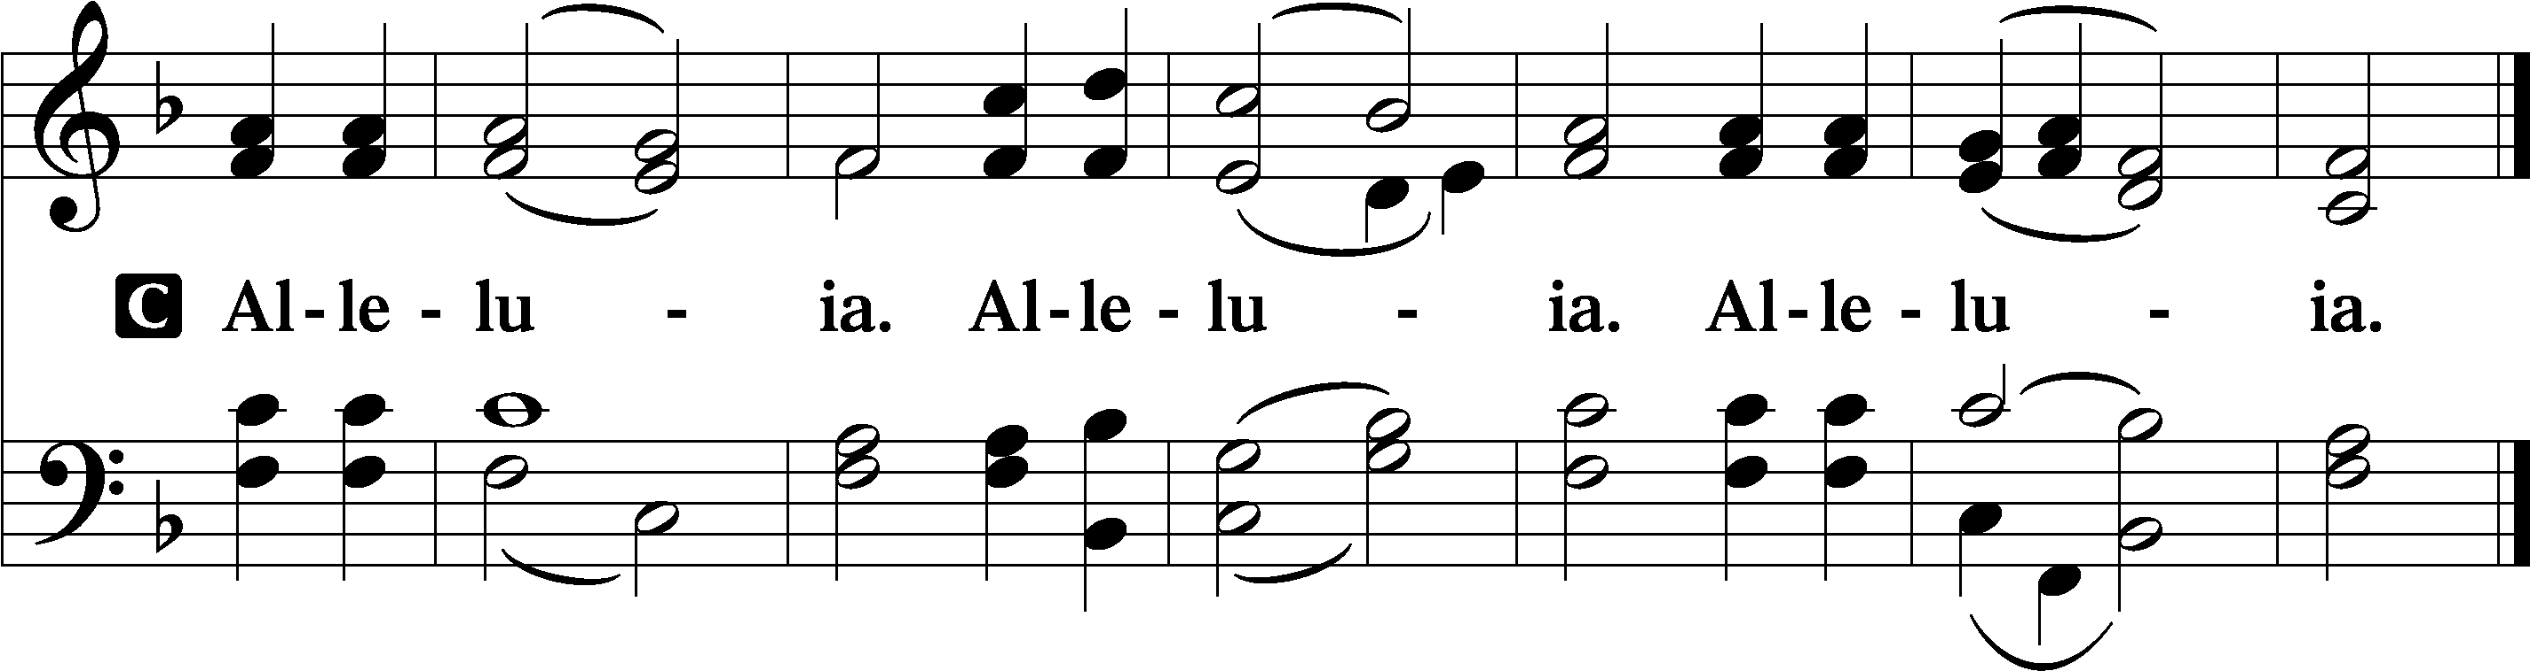
Holy Gospel Luke 17:1–10
P The Holy Gospel according to St. Luke, the seventeenth chapter.

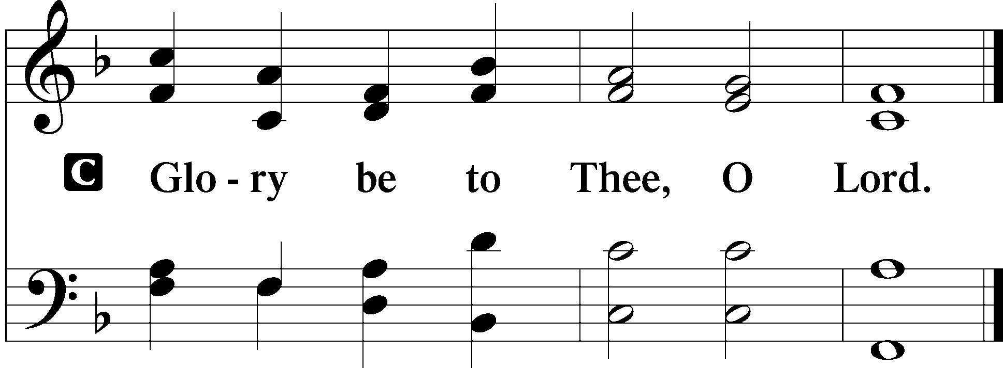

[Jesus] said to his disciples, “Temptations to sin are sure to come, but woe to the one through whom they come! It would be better for him if a millstone were hung around his neck and he were cast into the sea than that he should cause one of these little ones to sin. Pay attention to yourselves! If your brother sins, rebuke him, and if he repents, forgive him, and if he sins against you seven times in the day, and turns to you seven times, saying, ‘I repent,’ you must forgive him.”
The apostles said to the Lord, “Increase our faith!” And the Lord said, “If you had faith like a grain of mustard seed, you could say to this mulberry tree, ‘Be uprooted and planted in the sea,’ and it would obey you.
“Will any one of you who has a servant plowing or keeping sheep say to him when he has come in from the field, ‘Come at once and recline at table’? Will he not rather say to him, ‘Prepare supper for me, and dress properly, and serve me while I eat and drink, and afterward you will eat and drink’? Does he thank the servant because he did what was commanded? So you also, when you have done all that you were commanded, say, ‘We are unworthy servants; we have only done what was our duty.’”

P This is the Gospel of the Lord.
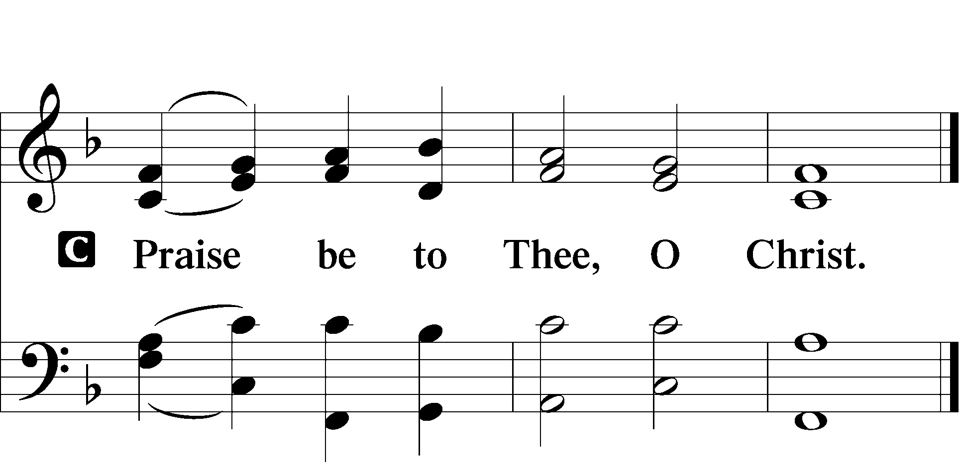

Apostles’ Creed
C I believe in God, the Father Almighty,
maker of heaven and earth.

And in Jesus Christ, His only Son, our Lord,
who was conceived by the Holy Spirit,
born of the virgin Mary,
suffered under Pontius Pilate,
was crucified, died and was buried.
He descended into hell.
The third day He rose again from the dead.
He ascended into heaven
and sits at the right hand of God the Father Almighty.
From thence He will come to judge the living and the dead.

I believe in the Holy Spirit,
the holy Christian Church,
the communion of saints,
the forgiveness of sins,
the resurrection of the body,
and the life T everlasting. Amen.

Sit

587 I Know My Faith Is Founded
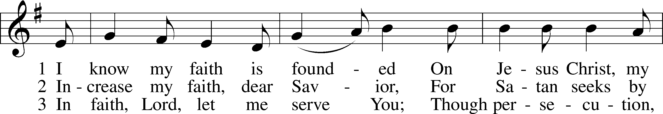
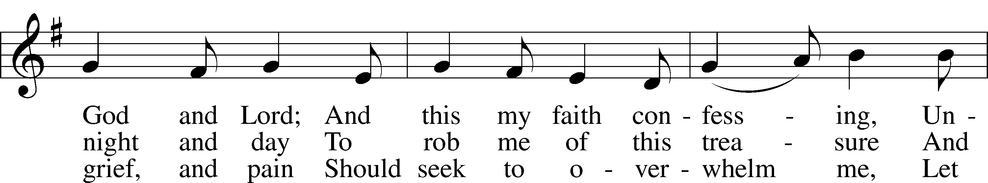
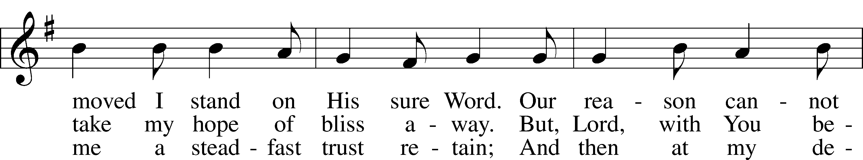
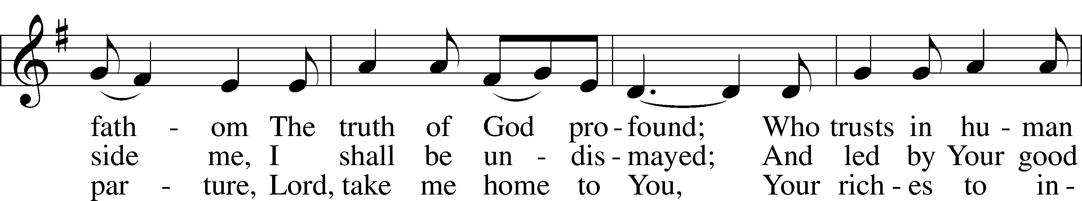
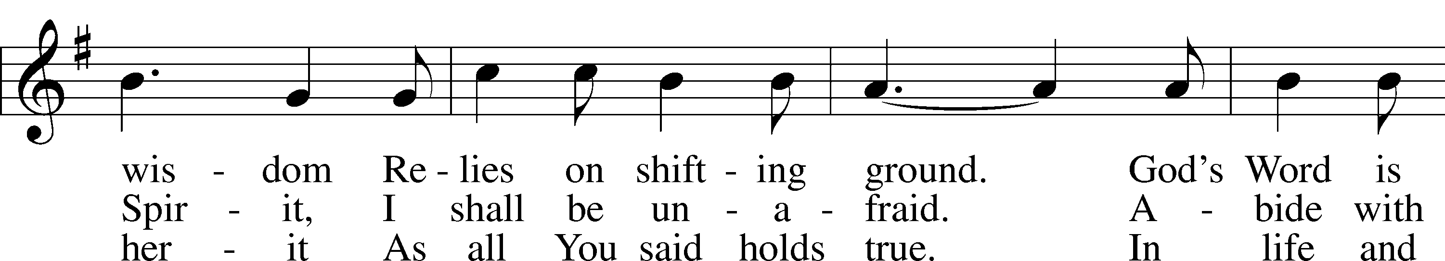
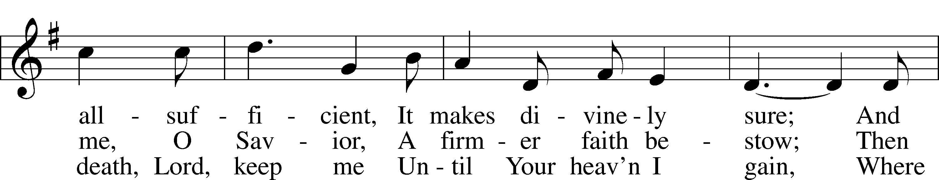
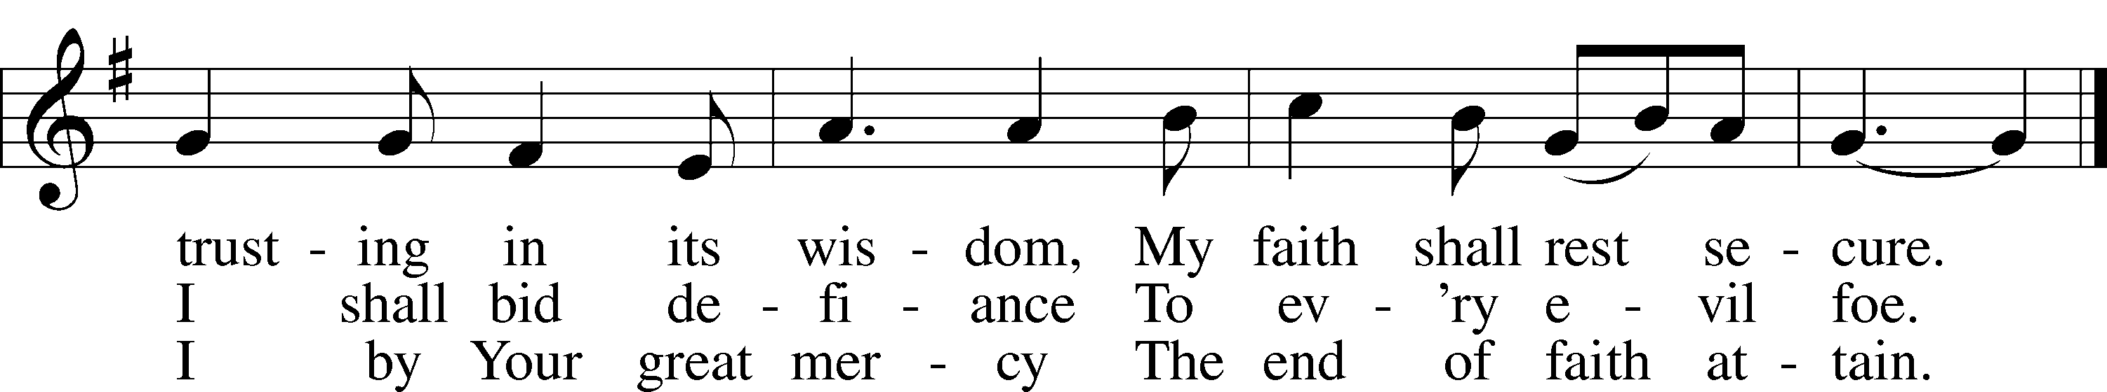

Sermon

Offering

Psalm for Meditation Psalm 62; antiphon: v. 1
For God alone my soul waits in silence;
from him comes my salvation.
He only is my rock and my salvation,
my fortress;
I shall not be greatly shaken.
How long will all of you attack a man
to batter him,
like a leaning wall, a tottering fence?
They only plan to thrust him down from his high position.
They take pleasure in falsehood.
They bless with their mouths,
but inwardly they curse.
For God alone, O my soul, wait in silence,
for my hope is from him.
He only is my rock and my salvation,
my fortress;
I shall not be shaken.
On God rests my salvation and my glory;
my mighty rock, my refuge is God.
Trust in him at all times, O people;
pour out your heart before him;
God is a refuge for us.
Those of low estate are but a breath;
those of high estate are a delusion;
in the balances they go up;
they are together lighter than a breath.
Put no trust in extortion;
set no vain hopes on robbery;
if riches increase, set not your heart on them.
Once God has spoken;
twice have I heard this:
that power belongs to God,
and that to you, O Lord, belongs steadfast love.
For you will render to a man
according to his work.

Stand

781 We Give Thee But Thine Own sts. 1–2
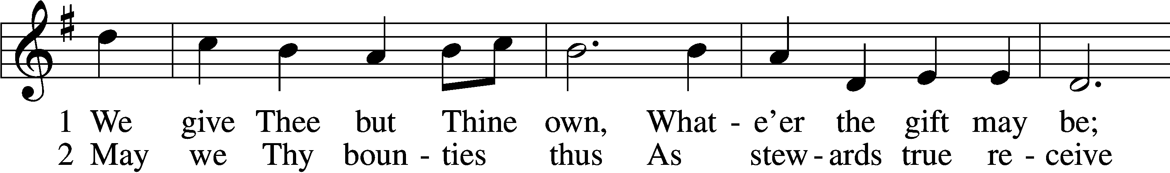
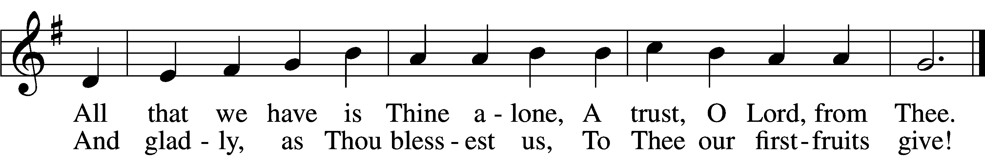

Prayer of the Church
P Let us pray for the whole people of God in Christ Jesus and for all people according to their needs.
P For the faithful proclamation of Christ’s saving name, that God’s people may be strengthened in the true faith and His kingdom extended, let us pray to the Lord:
C Lord, have mercy.
P For the holy Christian Church throughout the world and for all who confess the name of Christ, that God would guard and defend us from the temptations of the devil, the world, and our sinful nature, let us pray to the Lord:
C Lord, have mercy.
P For the government and all who have been set into positions of leadership, that they may use the authority entrusted to them honorably and for the good of the people, let us pray to the Lord:
C Lord, have mercy.
P For those who suffer from hunger, homelessness, poverty, or unemployment, that God’s great mercy and love would preserve and relieve them, let us pray to the Lord:
C Lord, have mercy.

P For those who are sick especially Betsy, John W., Juliana, Marge, Tony, Bill M., Patricia, Phil, Pat, Lidia, Michele, Giuseppe, Alfred, Nancy, and also Braydon, who is serving in the military. that God would grant healing to their bodies and strength to bear their infirmities with patience and grace, let us pray to the Lord:
C Lord, have mercy.
P O Lord, heavenly Father, we gratefully remember the sufferings and death of Your dear Son, Jesus Christ, for our salvation. Rejoicing in His victorious resurrection from the dead, we draw strength from His ascension before You, where He ever stands for us as our own High Priest. Gather us together from the ends of the earth to celebrate with all the faithful the marriage feast of the Lamb in His kingdom, which has no end. Graciously receive our prayers, deliver and preserve us, for to You alone we give all glory, honor, and worship, Father, Son, and Holy Spirit, one God, now and forever.
C Amen.

Lord’s Prayer LSB 196
C Our Father who art in heaven,
hallowed be Thy name,
Thy kingdom come,
Thy will be done on earth as it is in heaven;
give us this day our daily bread;
and forgive us our trespasses as we forgive those who trespass against us;
and lead us not into temptation,
but deliver us from evil.
For Thine is the kingdom and the power and the glory forever and ever. Amen.

Salutation LSB 201
P The Lord be with you.
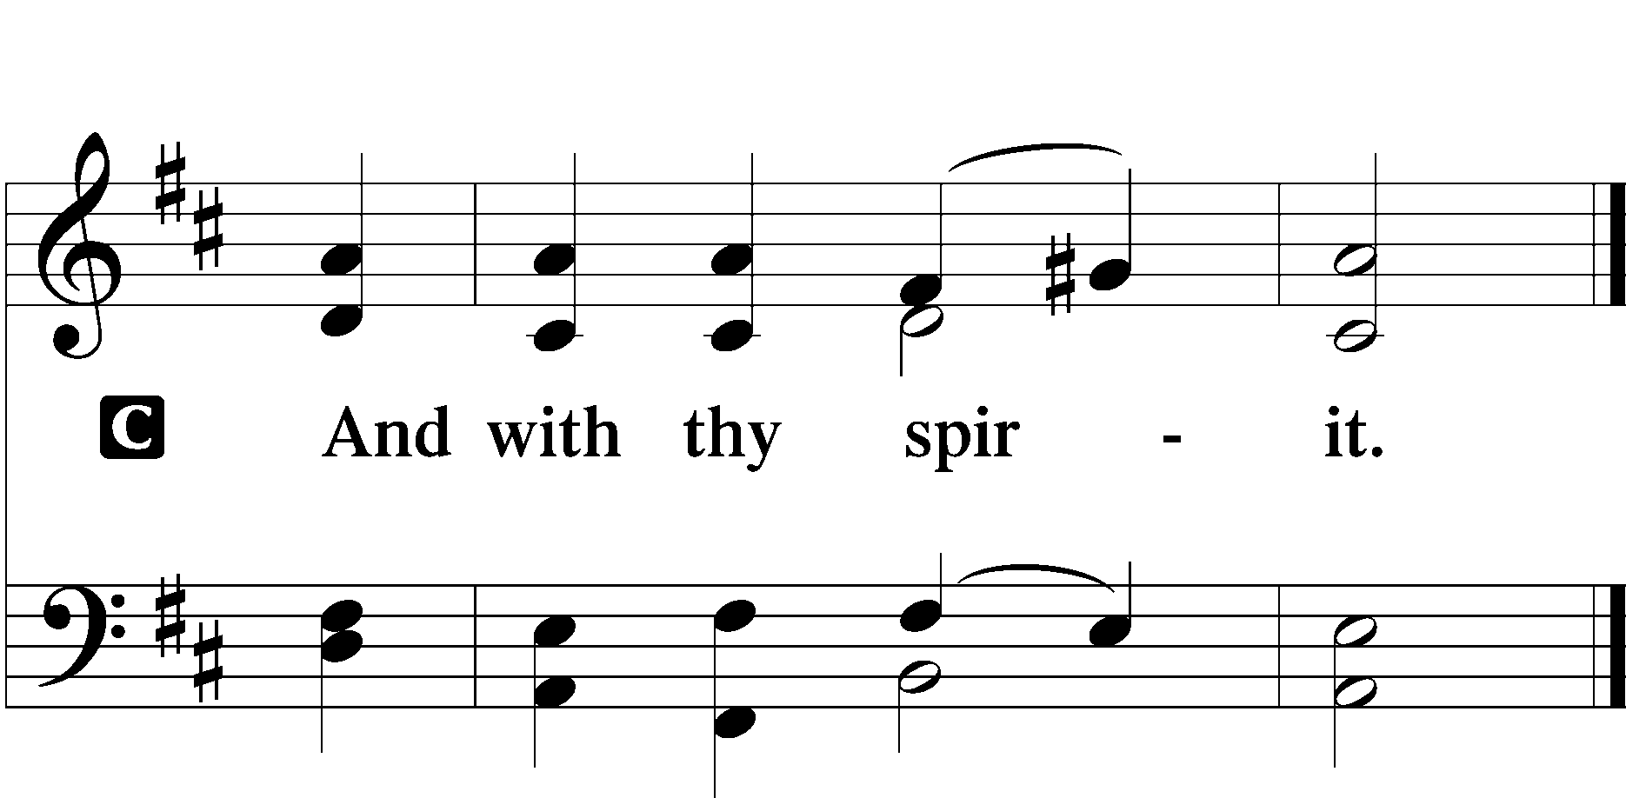

Benedicamus LSB 202
A Bless we the Lord.
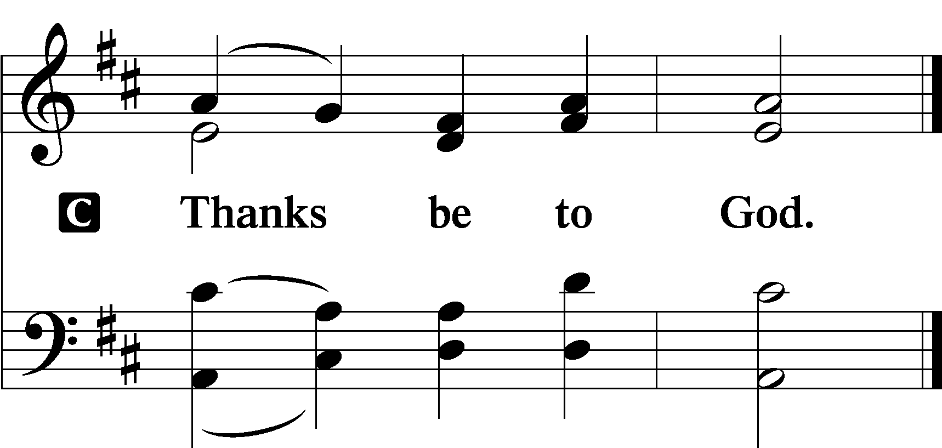

Benediction LSB 202
P The Lord bless you and keep you.
The Lord make His face shine upon you and be gracious unto you.
The Lord lift up His countenance upon you and T give you peace.
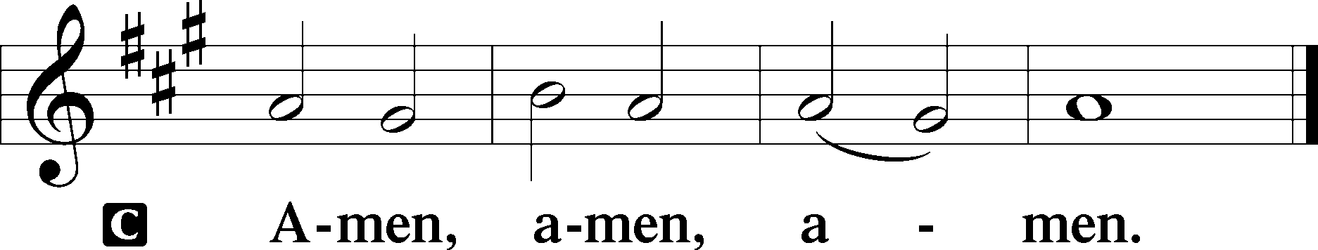

645 Built on the Rock sts. 1–2
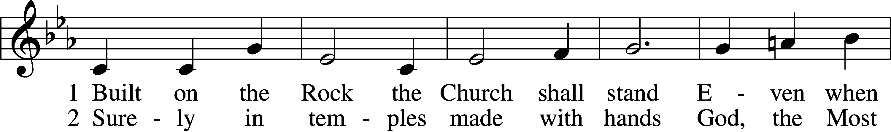
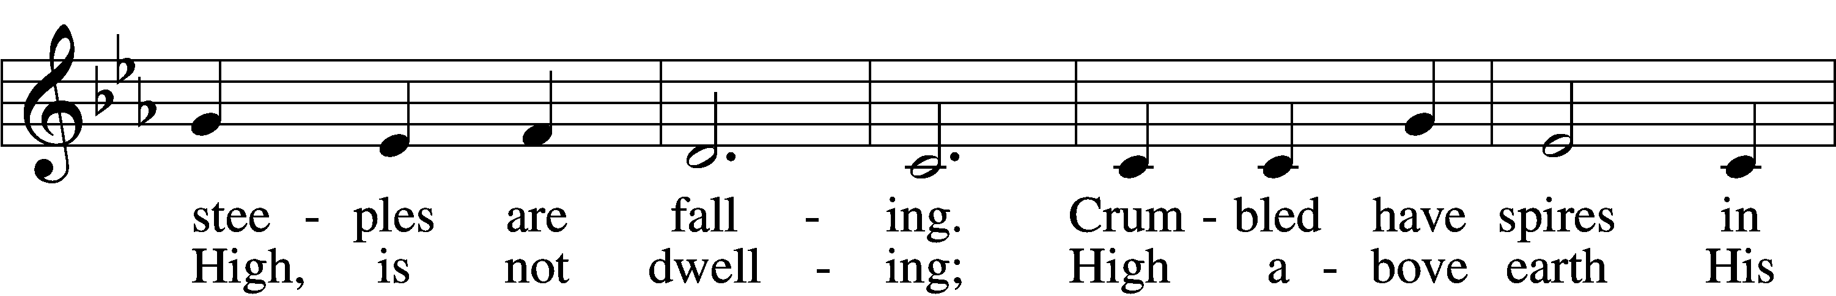
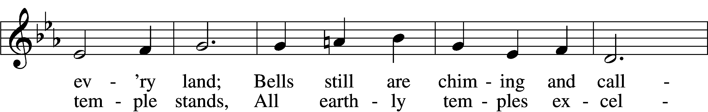
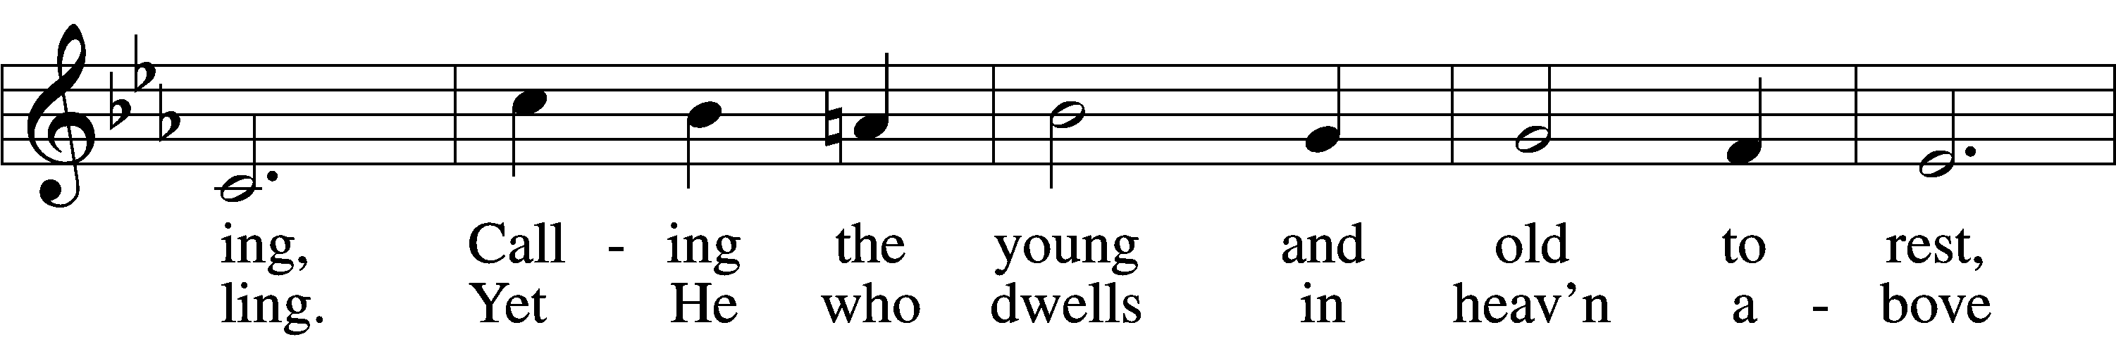
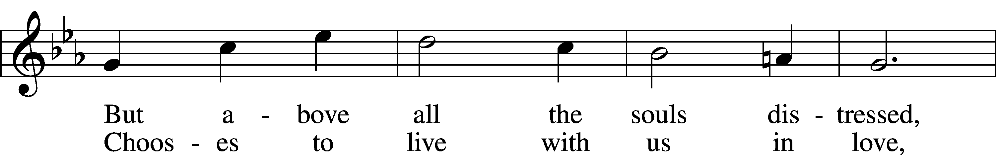
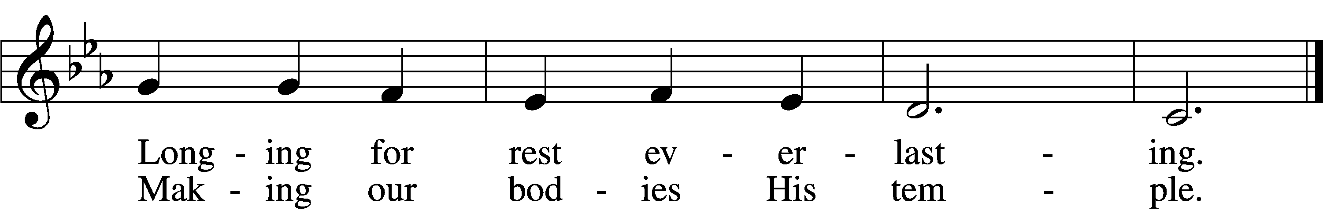

Announcements

Join us after the service in the fellowship hall for refreshments.

A Voters’ meeting is scheduled for next Sunday, October 12th after service. Important items are to be discussed.

If not taking your bulletin home, please leave on table in the narthex when leaving so it can be recycled. Thank you.

St. John’s Lutheran Church
810 Broad St., Clifton, NJ 07013
StJohnsClifton.Org
PrayingHands810@gmail.com

