Twentieth Sunday after Pentecost October 26, 2025 – Lectionary Series
St. John’s Lutheran Church

Order of Worship
by
Lutheran Service Builder
915 Today Your Mercy Calls Us
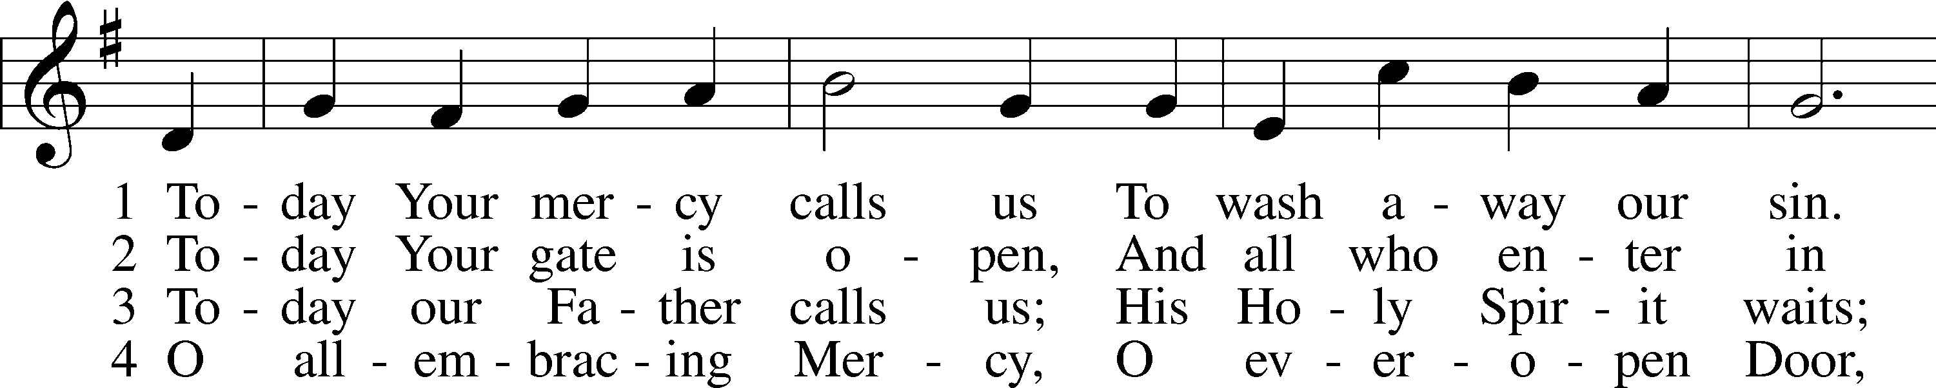
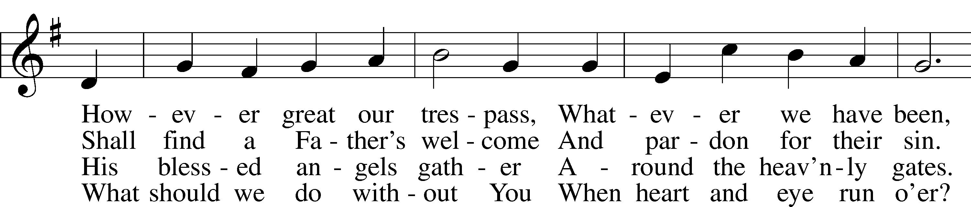
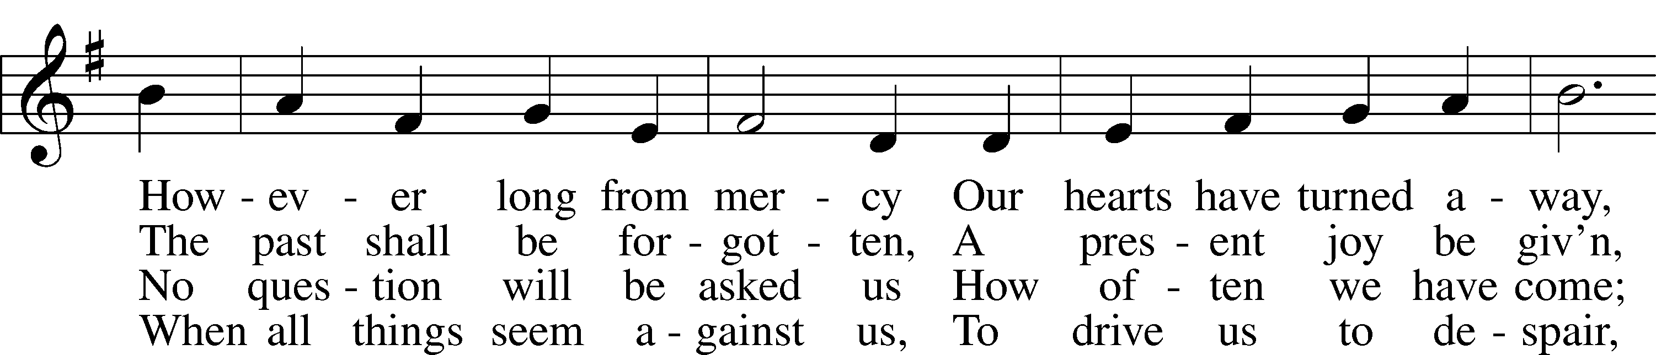
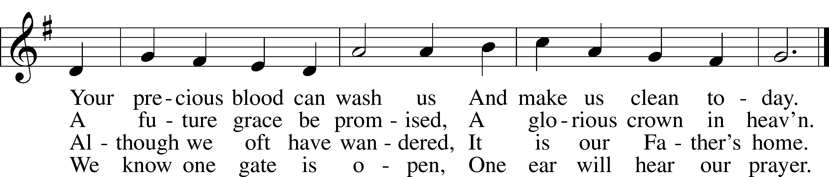

Stand for last verse

Confession and Absolution

The sign of the cross may be made by all in remembrance of their Baptism.

Invocation
P In the name of the Father and of the T Son and of the Holy Spirit.
C Amen.

Exhortation LSB 184
P Beloved in the Lord! Let us draw near with a true heart and confess our sins unto God our Father, beseeching Him in the name of our Lord Jesus Christ to grant us forgiveness.

P Our help is in the name of the Lord,
C who made heaven and earth.
P I said, I will confess my transgressions unto the Lord,
C and You forgave the iniquity of my sin.

Silence for reflection on God’s Word and for self-examination.

Confession of Sins LSB 184
P O almighty God, merciful Father,
C I, a poor, miserable sinner, confess unto You all my sins and iniquities with which I have ever offended You and justly deserved Your temporal and eternal punishment. But I am heartily sorry for them and sincerely repent of them, and I pray You of Your boundless mercy and for the sake of the holy, innocent, bitter sufferings and death of Your beloved Son, Jesus Christ, to be gracious and merciful to me, a poor, sinful being.

Absolution LSB 185
P Upon this your confession, I, by virtue of my office, as a called and ordained servant of the Word, announce the grace of God unto all of you, and in the stead and by the command of my Lord Jesus Christ I forgive you all your sins in the name of the Father and of the T Son and of the Holy Spirit.
C Amen.

Service of the Word

Introit Psalm 56:10–13; antiphon: v. 3
When I am afraid,
I put my trust in you.
In God, whose word I praise,
in the Lord, whose word I praise,
in God I trust; I shall not be afraid.
What can man do to me?
I must perform my vows to you, O God;
I will render thank offerings to you.
For you have delivered my soul from death, yes, my feet from falling,
that I may walk before God in the light of life.
Glory be to the Father and to the Son
and to the Holy Spirit;
as it was in the beginning,
is now, and will be forever. Amen.
When I am afraid,
I put my trust in you.

Kyrie LSB 186
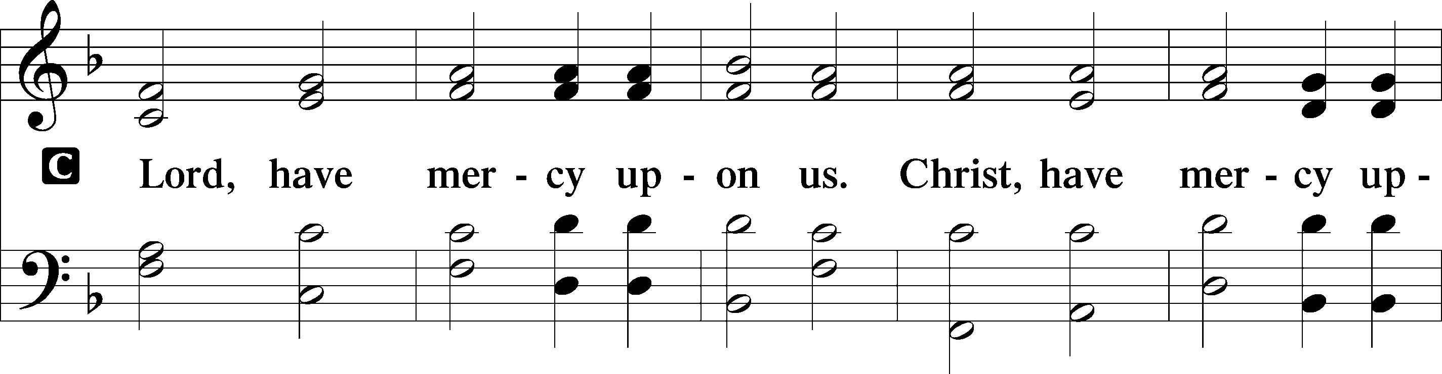
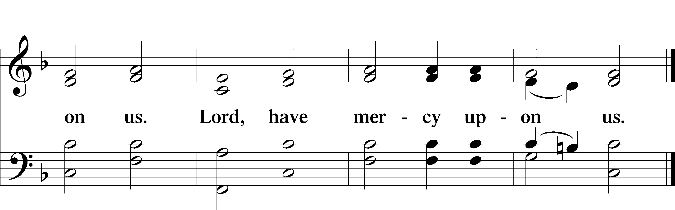

Gloria in Excelsis LSB 187
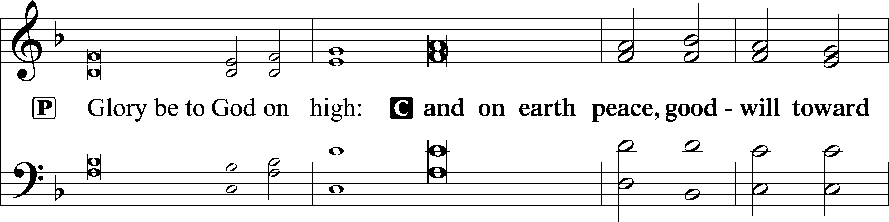
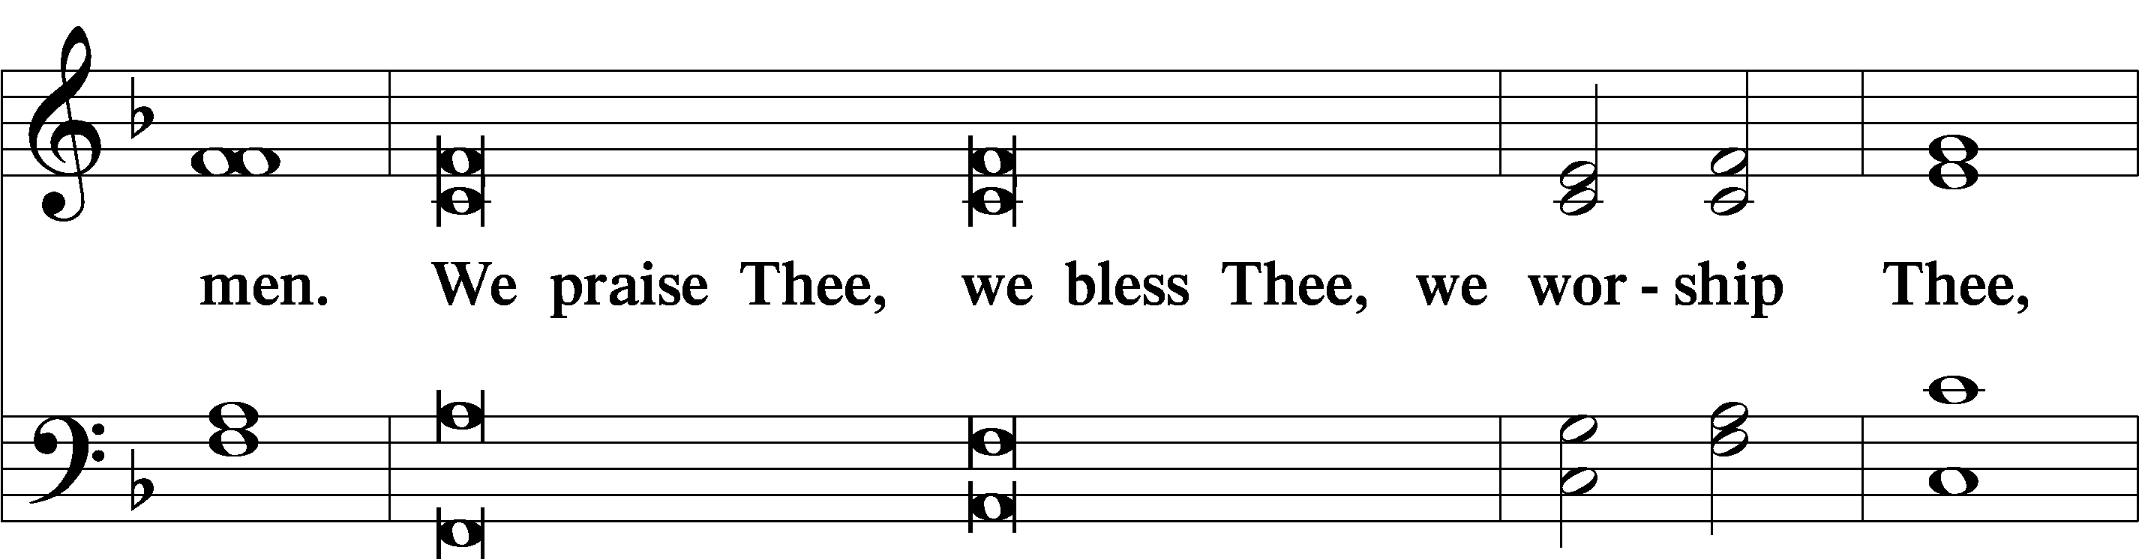
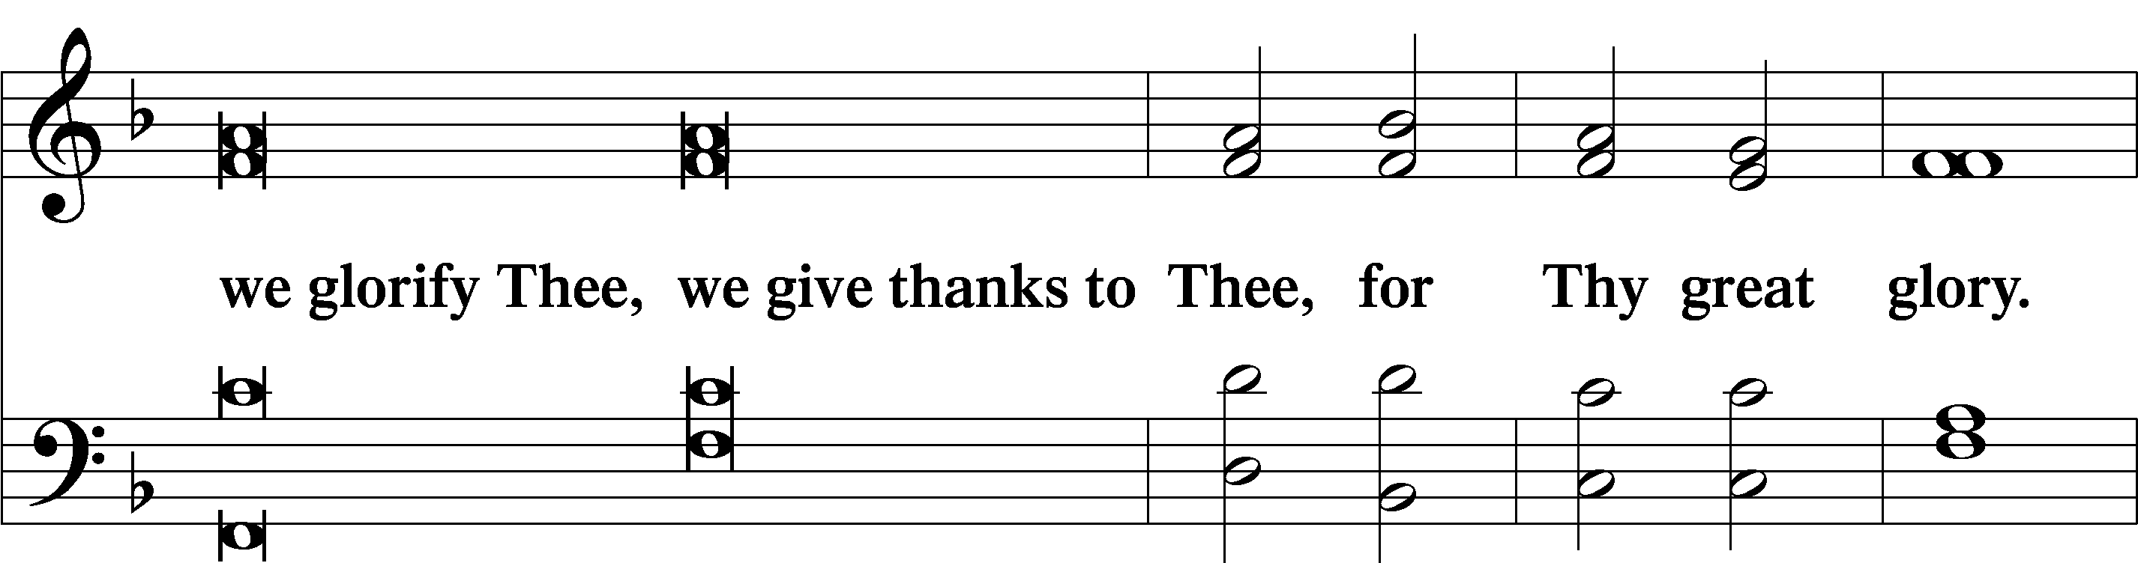
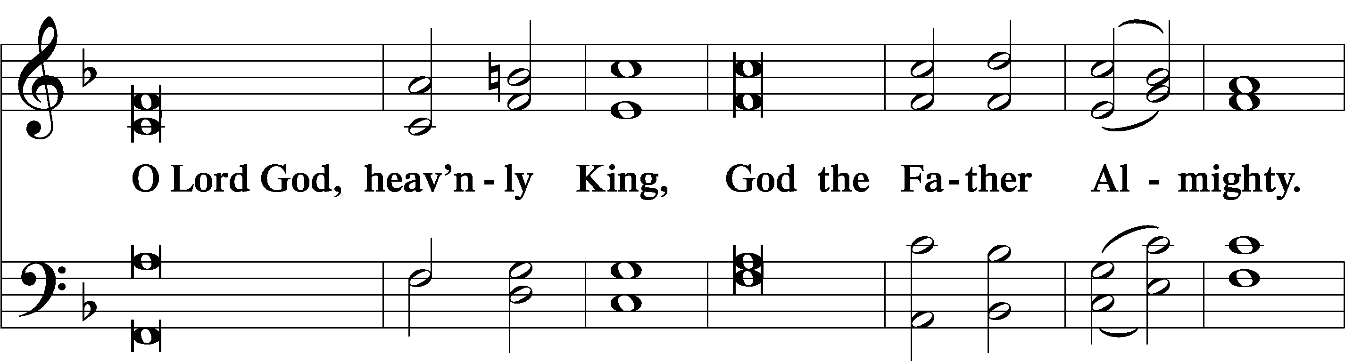
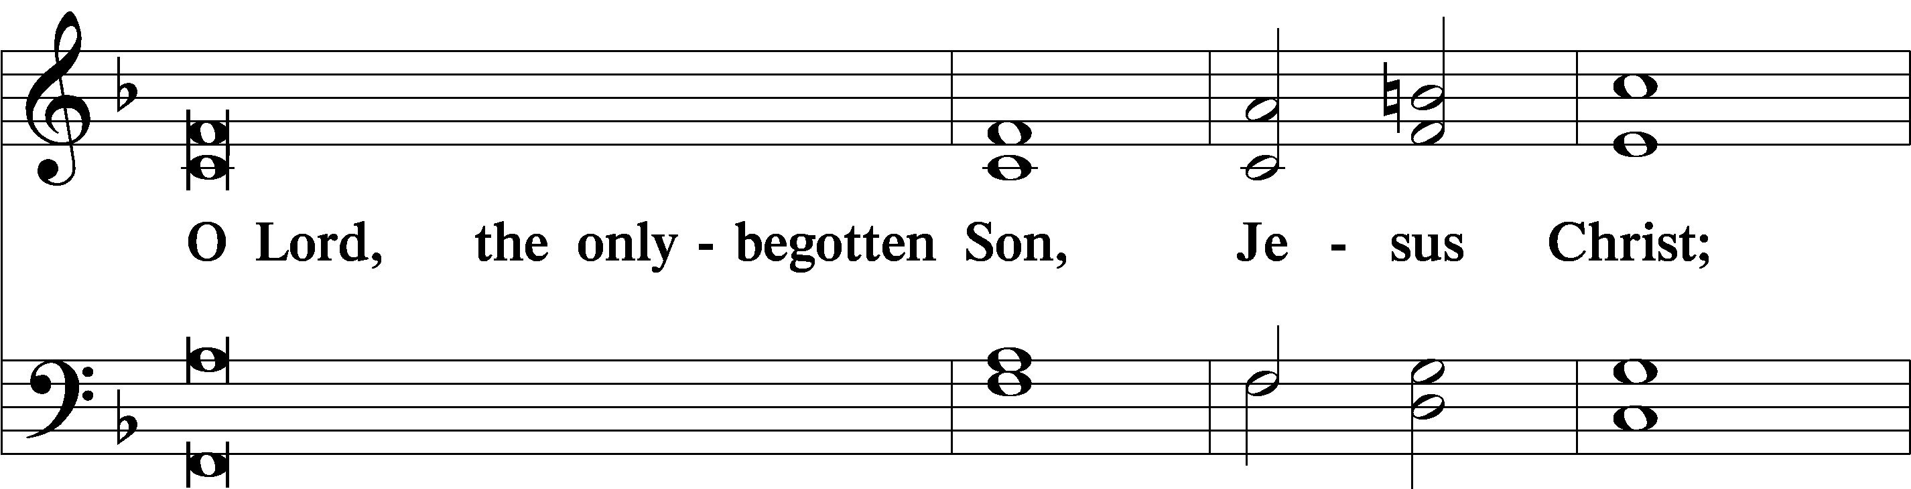
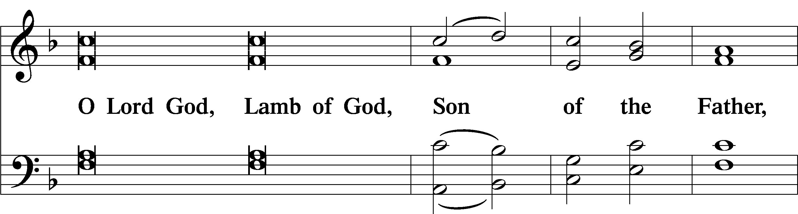
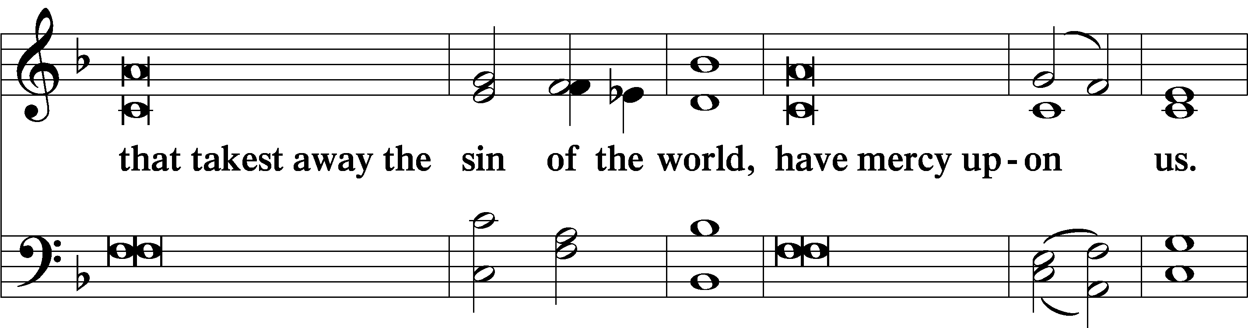
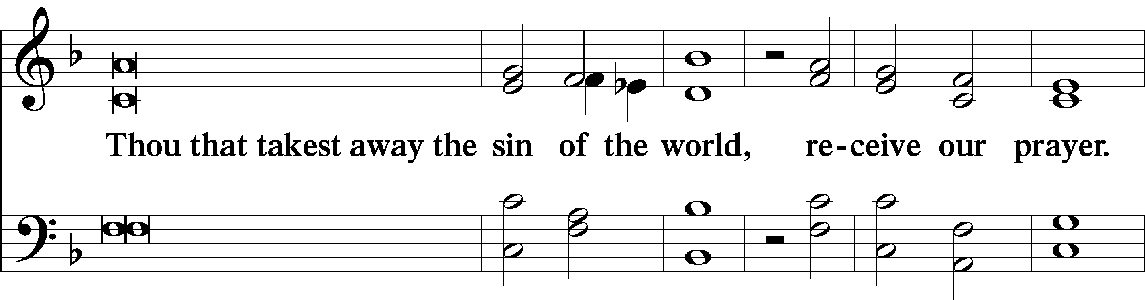
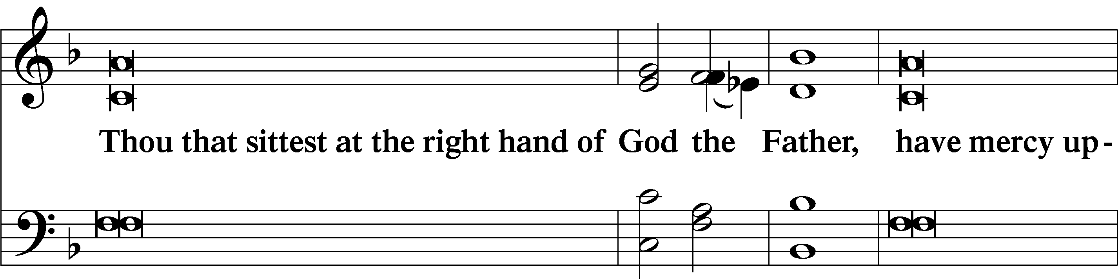
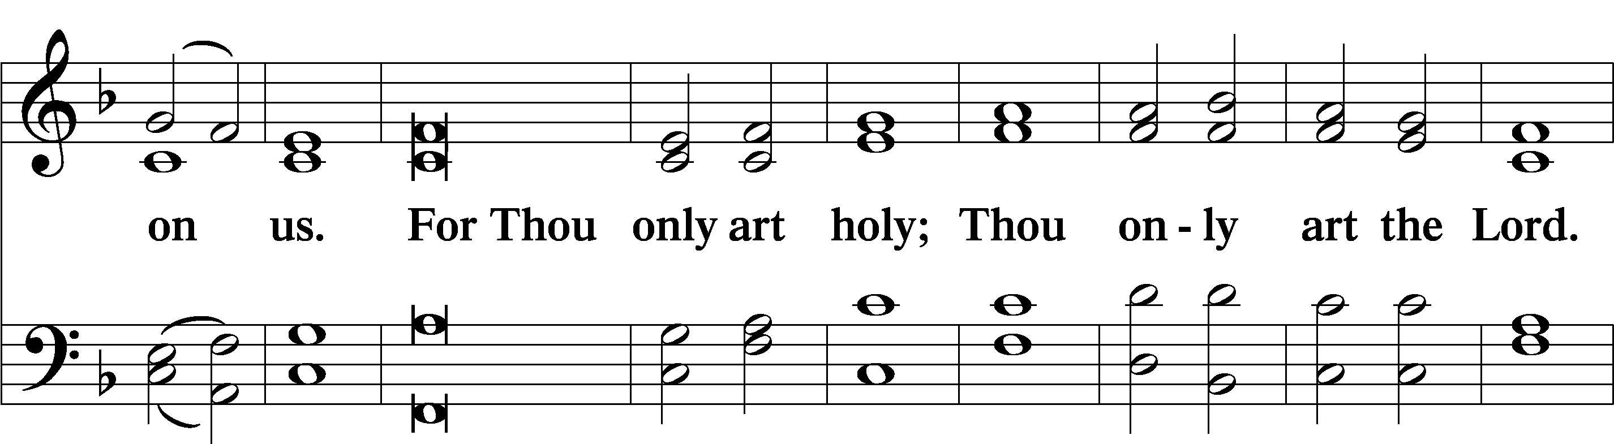
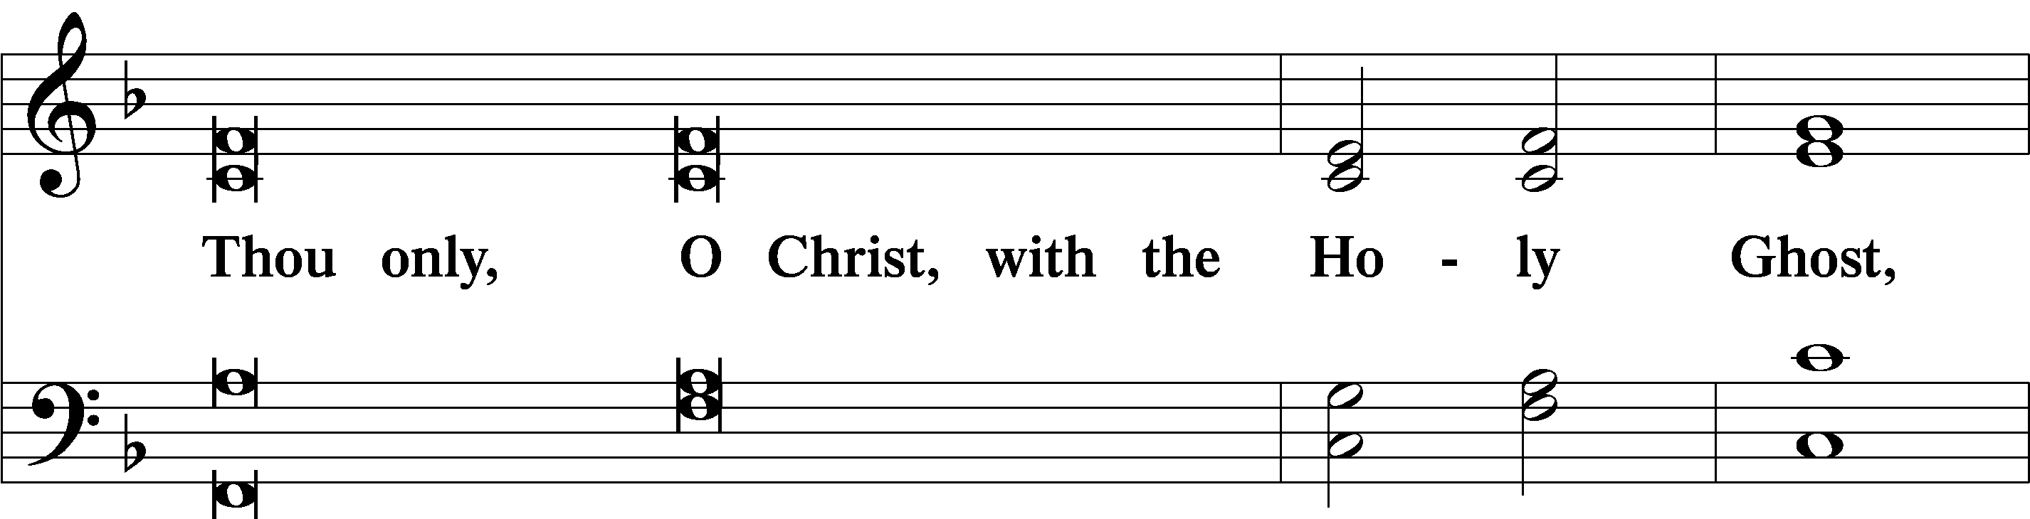
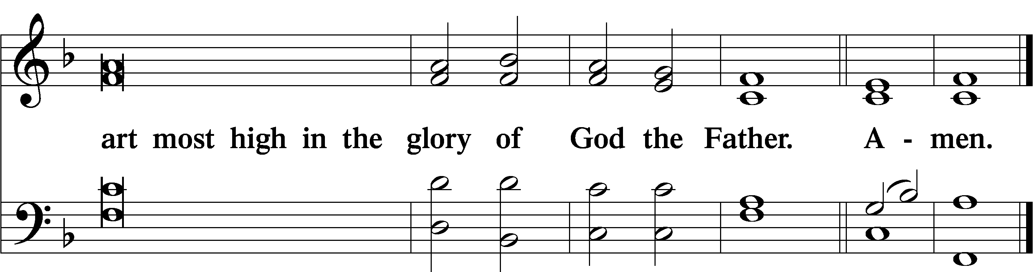

Salutation and Collect of the Day

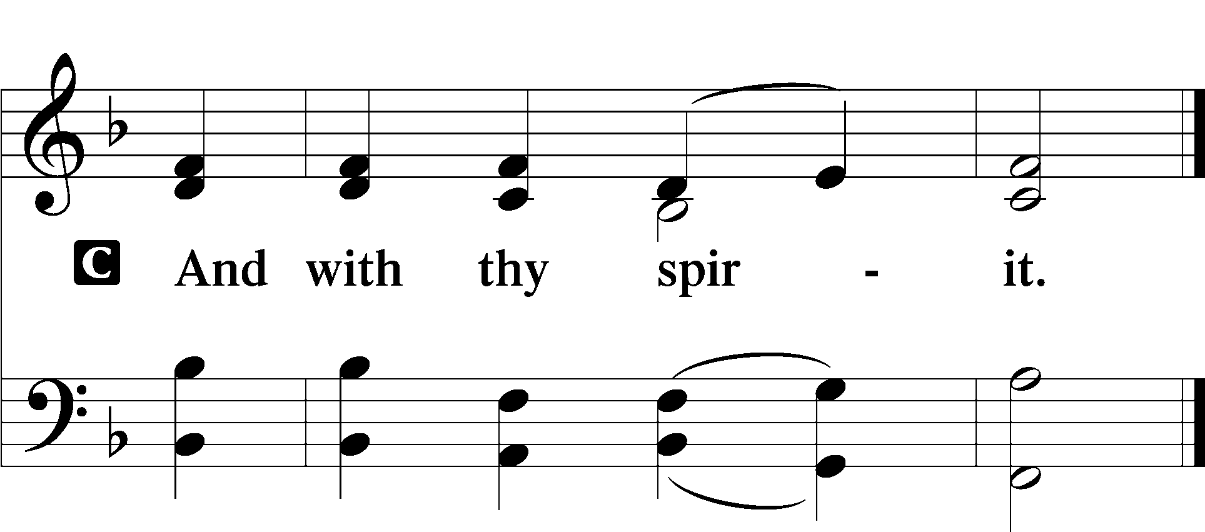
P Let us pray.

P Almighty and everlasting God, You are always more ready to hear than we to pray and always ready to give more than we either desire or deserve. Pour down on us the abundance of Your mercy; forgive us those things of which our conscience is afraid; and give us those good things for which we are not worthy to ask except by the merits and mediation of Jesus Christ, Your Son, our Lord, who lives and reigns with You and the Holy Spirit, one God, now and forever.

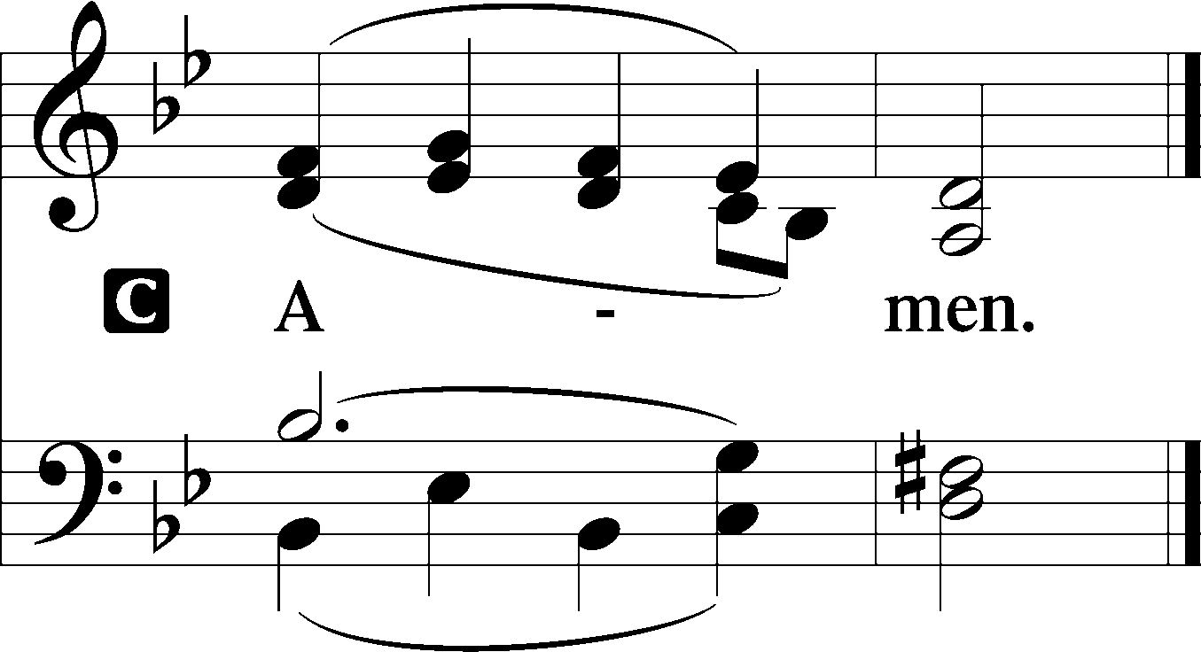

Sit

Old Testament Reading Genesis 4:1–15
Now Adam knew Eve his wife, and she conceived and bore Cain, saying, “I have gotten a man with the help of the Lord.” And again, she bore his brother Abel. Now Abel was a keeper of sheep, and Cain a worker of the ground. In the course of time Cain brought to the Lord an offering of the fruit of the ground, and Abel also brought of the firstborn of his flock and of their fat portions. And the Lord had regard for Abel and his offering, but for Cain and his offering he had no regard. So Cain was very angry, and his face fell. The Lord said to Cain, “Why are you angry, and why has your face fallen? If you do well, will you not be accepted? And if you do not do well, sin is crouching at the door. Its desire is for you, but you must rule over it.”
Cain spoke to Abel his brother. And when they were in the field, Cain rose up against his brother Abel and killed him. Then the Lord said to Cain, “Where is Abel your brother?” He said, “I do not know; am I my brother’s keeper?” And the Lord said, “What have you done? The voice of your brother’s blood is crying to me from the ground. And now you are cursed from the ground, which has opened its mouth to receive your brother’s blood from your hand. When you work the ground, it shall no longer yield to you its strength. You shall be a fugitive and a wanderer on the earth.” Cain said to the Lord, “My punishment is greater than I can bear. Behold, you have driven me today away from the ground, and from your face I shall be hidden. I shall be a fugitive and a wanderer on the earth, and whoever finds me will kill me.” Then the Lord said to him, “Not so! If anyone kills Cain, vengeance shall be taken on him sevenfold.” And the Lord put a mark on Cain, lest any who found him should attack him.

A This is the Word of the Lord.
C Thanks be to God.

Epistle 2 Timothy 4:6–8, 16–18
For I am already being poured out as a drink offering, and the time of my departure has come. I have fought the good fight, I have finished the race, I have kept the faith. Henceforth there is laid up for me the crown of righteousness, which the Lord, the righteous judge, will award to me on that Day, and not only to me but also to all who have loved his appearing. . . .
At my first defense no one came to stand by me, but all deserted me. May it not be charged against them! But the Lord stood by me and strengthened me, so that through me the message might be fully proclaimed and all the Gentiles might hear it. So I was rescued from the lion’s mouth. The Lord will rescue me from every evil deed and bring me safely into his heavenly kingdom. To him be the glory forever and ever. Amen.

A This is the Word of the Lord.
C Thanks be to God.

Stand

Alleluia LSB 190
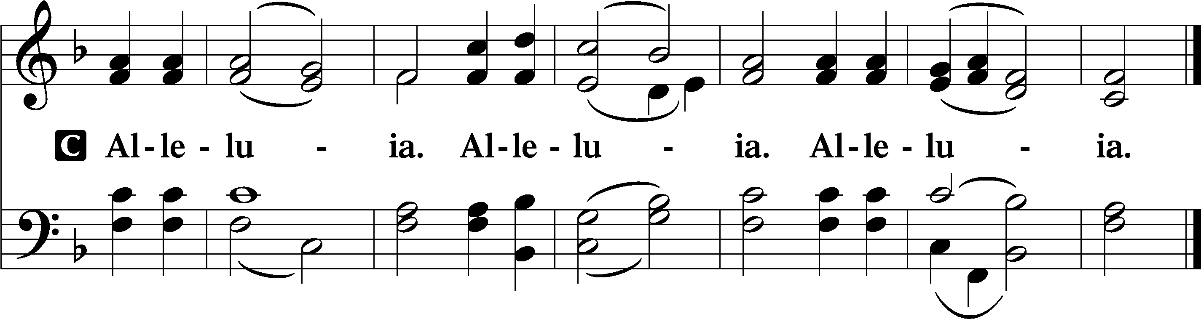

Holy Gospel Luke 18:9–17
P The Holy Gospel according to St. Luke, the eighteenth chapter.

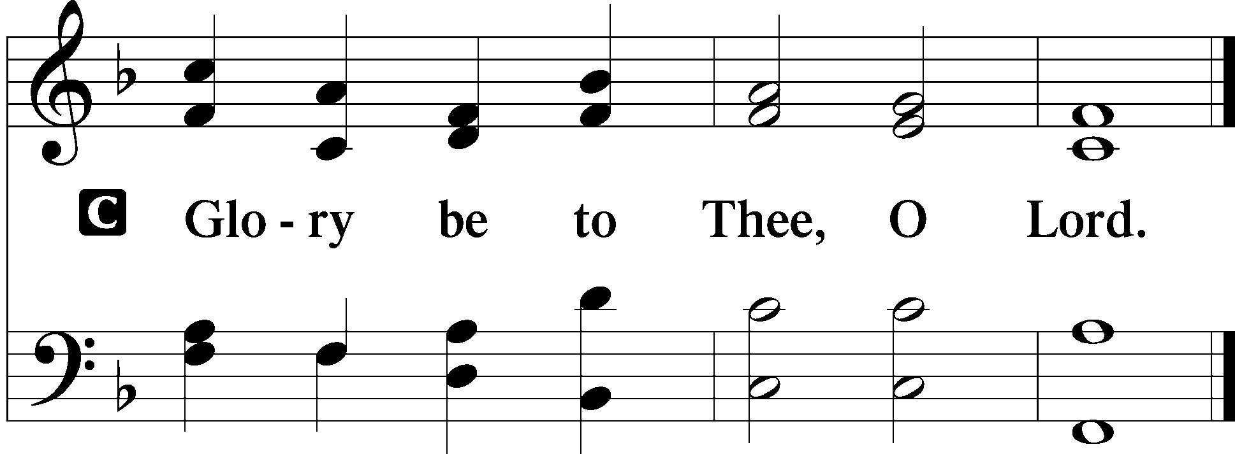

[Jesus] also told this parable to some who trusted in themselves that they were righteous, and treated others with contempt: “Two men went up into the temple to pray, one a Pharisee and the other a tax collector. The Pharisee, standing by himself, prayed thus: ‘God, I thank you that I am not like other men, extortioners, unjust, adulterers, or even like this tax collector. I fast twice a week; I give tithes of all that I get.’ But the tax collector, standing far off, would not even lift up his eyes to heaven, but beat his breast, saying, ‘God, be merciful to me, a sinner!’ I tell you, this man went down to his house justified, rather than the other. For everyone who exalts himself will be humbled, but the one who humbles himself will be exalted.”
Now they were bringing even infants to him that he might touch them. And when the disciples saw it, they rebuked them. But Jesus called them to him, saying, “Let the children come to me, and do not hinder them, for to such belongs the kingdom of God. Truly, I say to you, whoever does not receive the kingdom of God like a child shall not enter it.”

P This is the Gospel of the Lord.
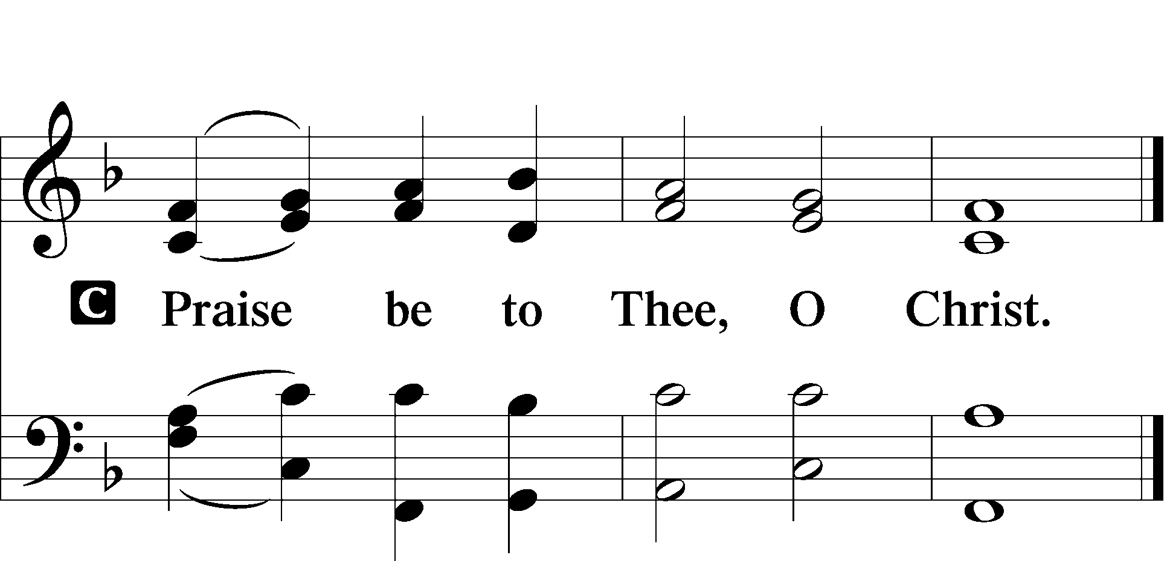

Apostles’ Creed
C I believe in God, the Father Almighty,
maker of heaven and earth.

And in Jesus Christ, His only Son, our Lord,
who was conceived by the Holy Spirit,
born of the virgin Mary,
suffered under Pontius Pilate,
was crucified, died and was buried.
He descended into hell.
The third day He rose again from the dead.
He ascended into heaven
and sits at the right hand of God the Father Almighty.
From thence He will come to judge the living and the dead.

I believe in the Holy Spirit,
the holy Christian Church,
the communion of saints,
the forgiveness of sins,
the resurrection of the body,
and the life T everlasting. Amen.

Sit

745 In God, My Faithful God
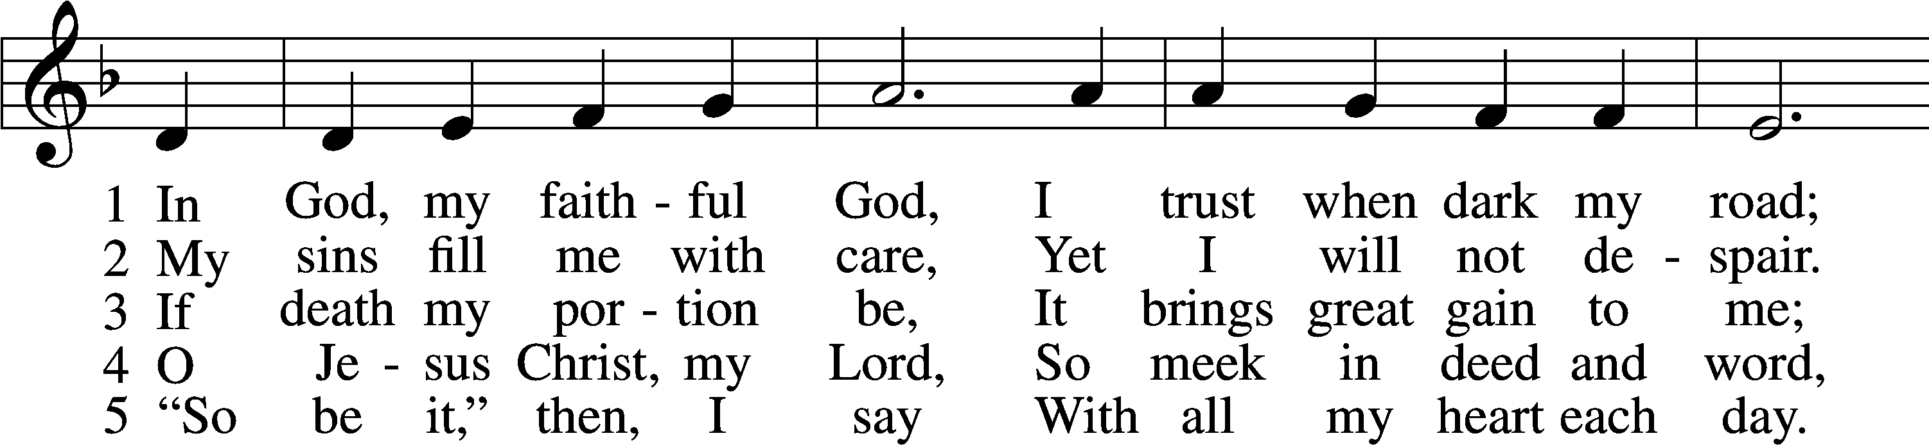
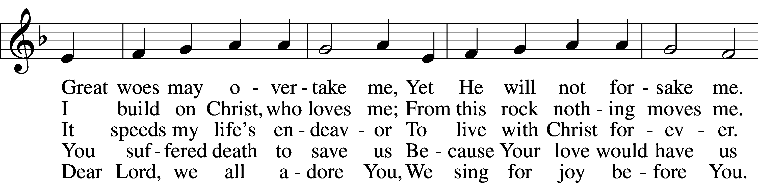
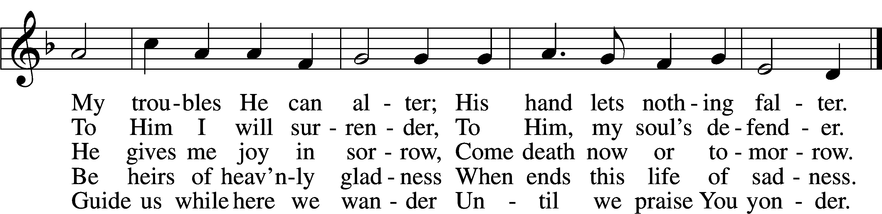

Sermon

Offering

Psalm for Meditation Psalm 5; antiphon: v. 11a
Give ear to my words, O Lord;
consider my groaning.
Give attention to the sound of my cry,
my King and my God,
for to you do I pray.
O Lord, in the morning you hear my voice;
in the morning I prepare a sacrifice for you and watch.
For you are not a God who delights in wickedness;
evil may not dwell with you.
The boastful shall not stand before your eyes;
you hate all evildoers.
You destroy those who speak lies;
the Lord abhors the bloodthirsty and deceitful man.
But I, through the abundance of your steadfast love,
will enter your house.
I will bow down toward your holy temple
in the fear of you.
Lead me, O Lord, in your righteousness
because of my enemies;
make your way straight before me.
For there is no truth in their mouth;
their inmost self is destruction;
their throat is an open grave;
they flatter with their tongue.
Make them bear their guilt, O God;
let them fall by their own counsels;
because of the abundance of their transgressions cast them out,
for they have rebelled against you.
But let all who take refuge in you rejoice;
let them ever sing for joy,
and spread your protection over them,
that those who love your name may exult in you.
For you bless the righteous, O Lord;
you cover him with favor as with a shield.

Stand

781 We Give Thee But Thine Own sts. 1–2
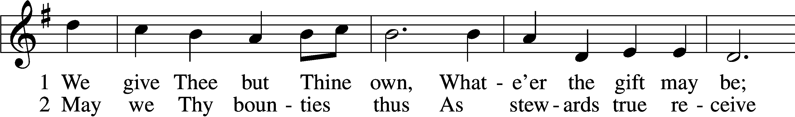
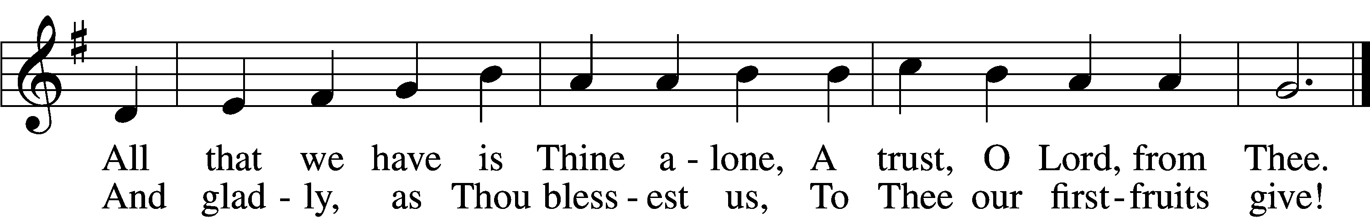

Prayer of the Church
After “Lord, in Your mercy” respond with “hear our prayer.”

Lord’s Prayer LSB 196
C Our Father who art in heaven,
hallowed be Thy name,
Thy kingdom come,
Thy will be done on earth as it is in heaven;
give us this day our daily bread;
and forgive us our trespasses as we forgive those who trespass against us;
and lead us not into temptation,
but deliver us from evil.
For Thine is the kingdom and the power and the glory forever and ever. Amen.

Salutation LSB 201
P The Lord be with you.

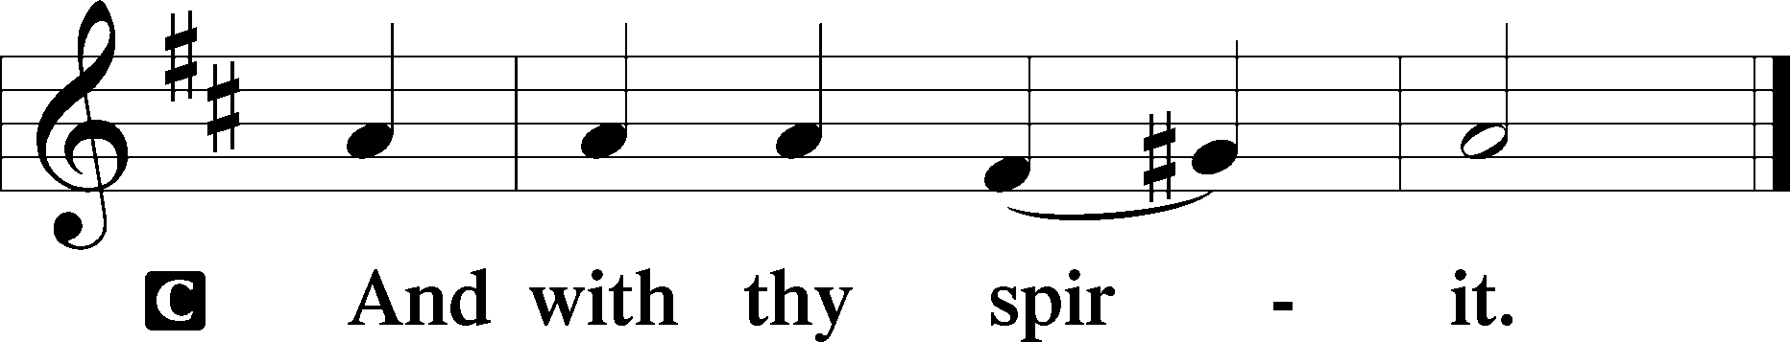

Benedicamus LSB 202
A Bless we the Lord.

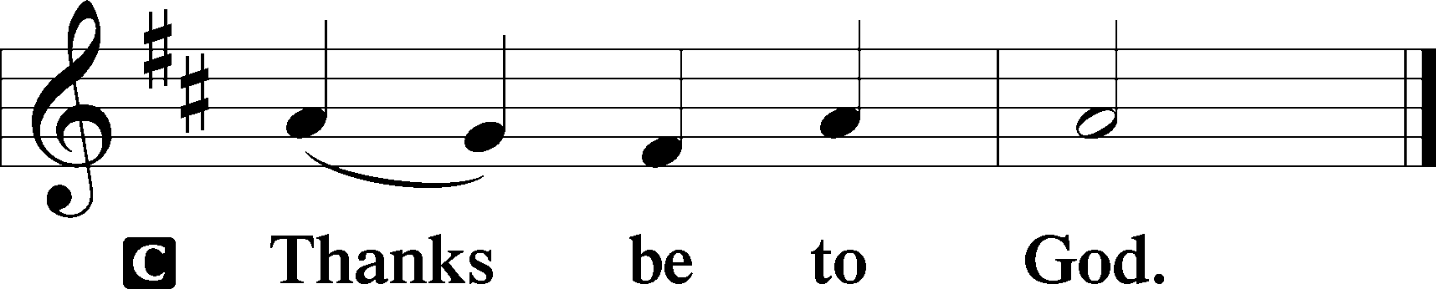

Benediction LSB 202
P The Lord bless you and keep you.
The Lord make His face shine upon you and be gracious unto you.
The Lord lift up His countenance upon you and T give you peace.
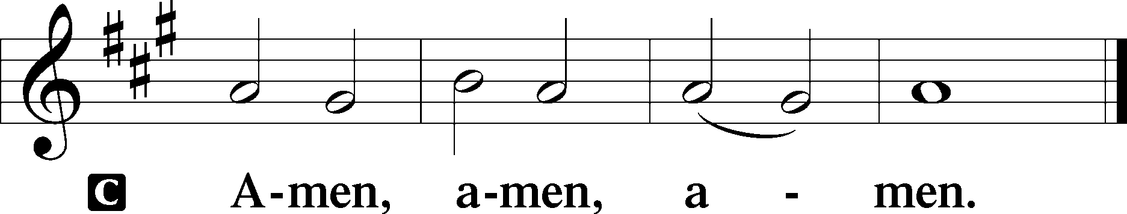

644 The Church’s One Foundation sts. 1–3
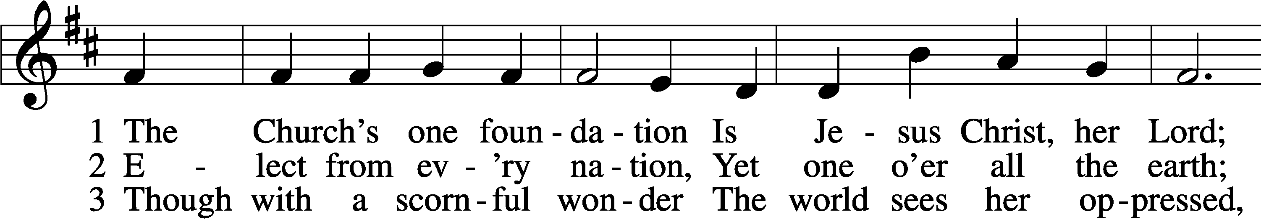
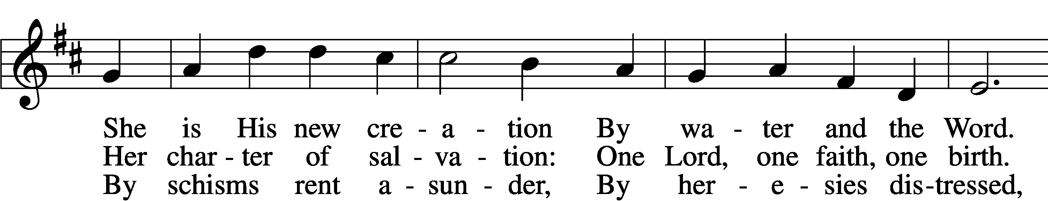
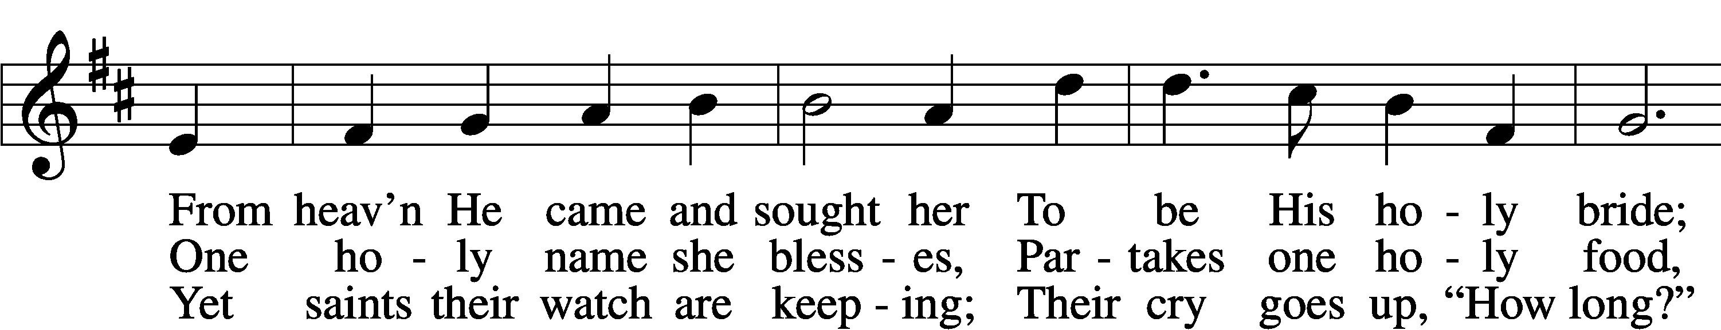
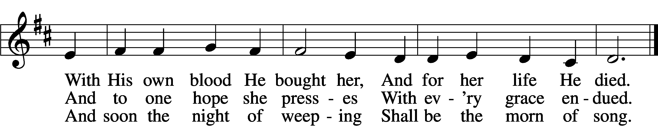

Announcements

Join us after the service in the fellowship hall for refreshments.

Pastor Vogel will be leading services on Oct. 26th and November 2nd, 9th, and 16th.

Reminder: Turn you clocks BACK 1 hour next Saturday night so
you are not at church too early.

If not taking your bulletin home, please leave on table in the narthex when leaving so it can be recycled. Thank you.

