Eighteenth Sunday after Pentecost October 12, 2025 – Lectionary Series
St. John’s Lutheran Church

Order of Worship
by
Lutheran Service Builder
914 Light of Light, O Sole-Begotten
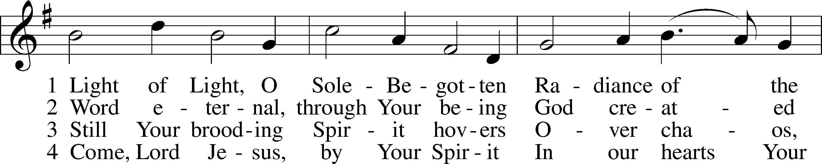
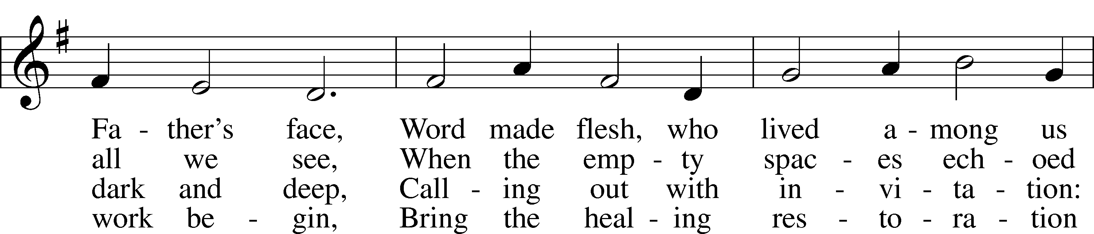
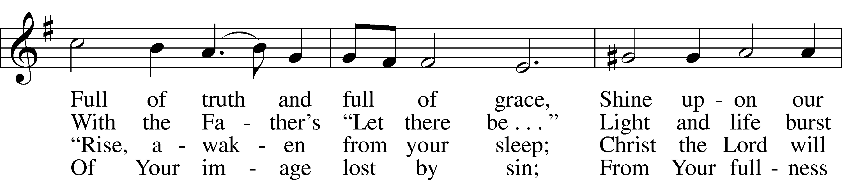
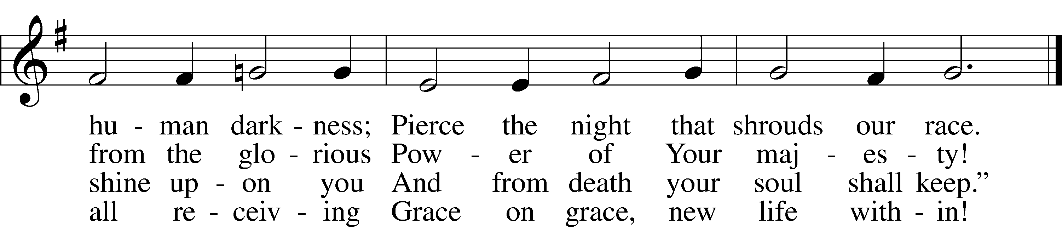

Stand for last verse

Confession and Absolution

The sign of the cross may be made by all in remembrance of their Baptism.

Invocation
P In the name of the Father and of the T Son and of the Holy Spirit.
C Amen.

Exhortation LSB 151
P If we say we have no sin, we deceive ourselves, and the truth is not in us.
C But if we confess our sins, God, who is faithful and just, will forgive our sins and cleanse us from all unrighteousness.

Silence for reflection on God’s Word and for self-examination.

Confession of Sins LSB 151
P Let us then confess our sins to God our Father.
C Most merciful God, we confess that we are by nature sinful and unclean. We have sinned against You in thought, word, and deed, by what we have done and by what we have left undone. We have not loved You with our whole heart; we have not loved our neighbors as ourselves. We justly deserve Your present and eternal punishment. For the sake of Your Son, Jesus Christ, have mercy on us. Forgive us, renew us, and lead us, so that we may delight in Your will and walk in Your ways to the glory of Your holy name. Amen.

Declaration
P In the mercy of almighty God, Jesus Christ was given to die for us, and for his sake God forgives us all our sins. To those who believe in Jesus Christ He gives the power to become the children of God and bestows on them the Holy Spirit. May the Lord, who has begun this good work in us, bring it to completion in the day of our Lord Jesus Christ.
C Amen.

Service of the Word

Introit Psalm 34:2–4, 17; antiphon: Psalm 48:1a
Great is the Lord and greatly to be praised
in the city of our God!
My soul makes its boast in the Lord;
let the humble hear and be glad.
Oh, magnify the Lord with me,
and let us exalt his name together!
I sought the Lord, and he answered me
and delivered me from all my fears.
When the righteous cry for help, the Lord hears
and delivers them out of all their troubles.
Glory be to the Father and to the Son
and to the Holy Spirit;
as it was in the beginning,
is now, and will be forever. Amen.
Great is the Lord and greatly to be praised
in the city of our God!

Kyrie LSB 152
A In peace let us pray to the Lord.


A For the peace from above and for our salvation let us pray to the Lord.


A For the peace of the whole world, for the well-being of the Church of God, and for the unity of all let us pray to the Lord.


A For this holy house and for all who offer here their worship and praise let us pray to the Lord.


A Help, save, comfort, and defend us, gracious Lord.


Gloria in Excelsis LSB 154
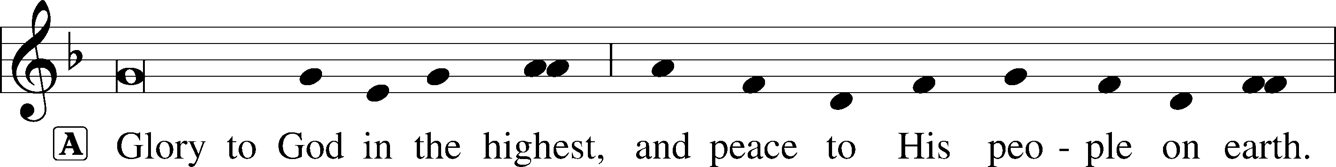
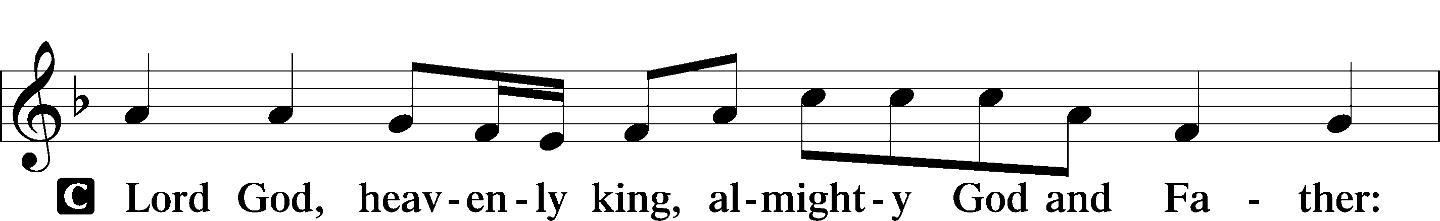

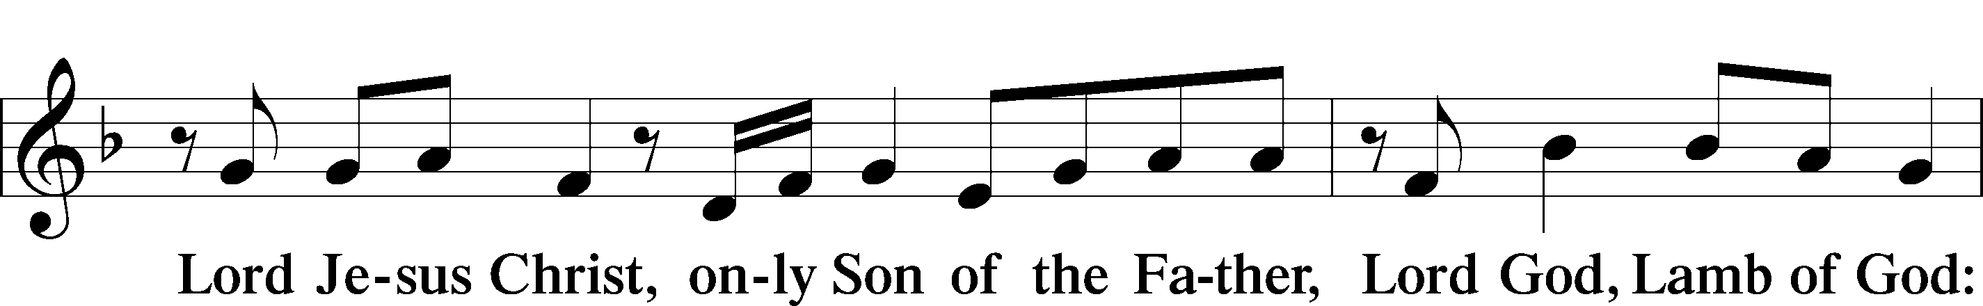
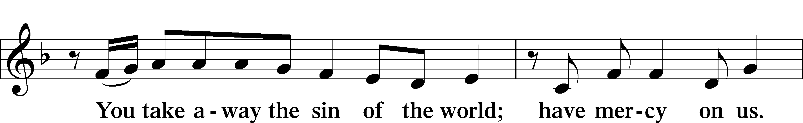
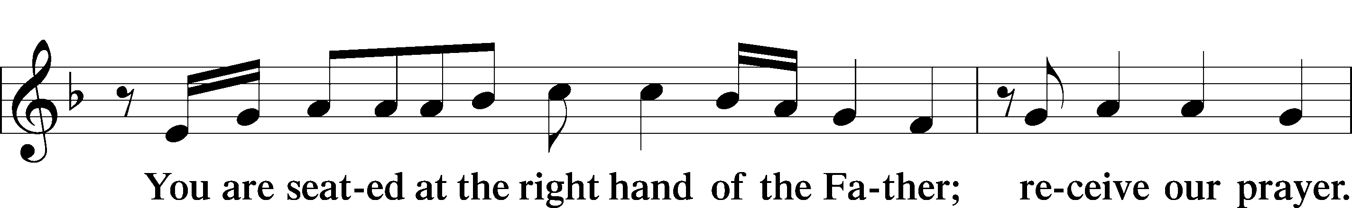
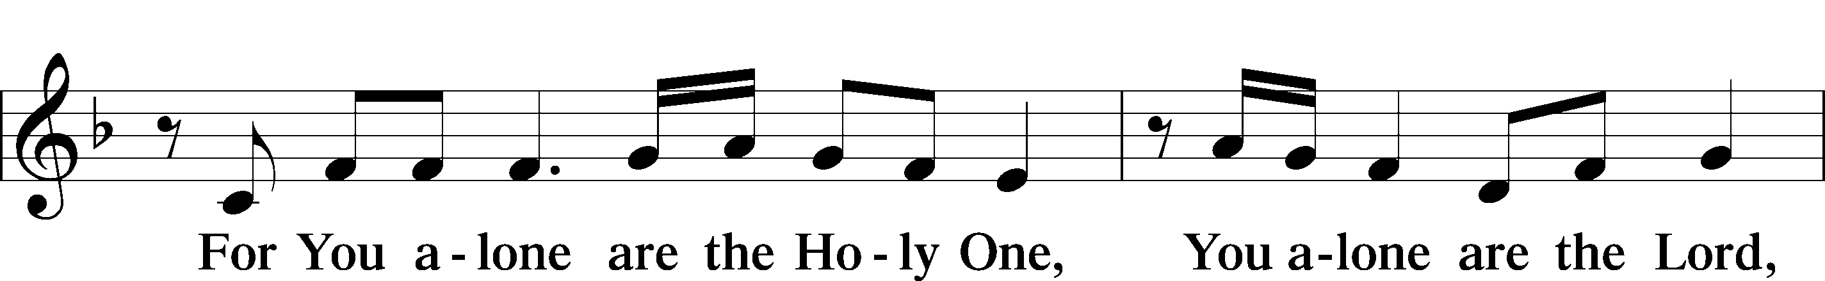
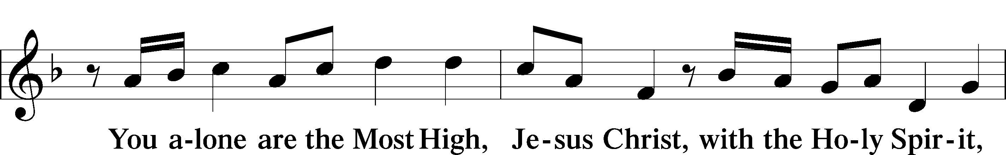
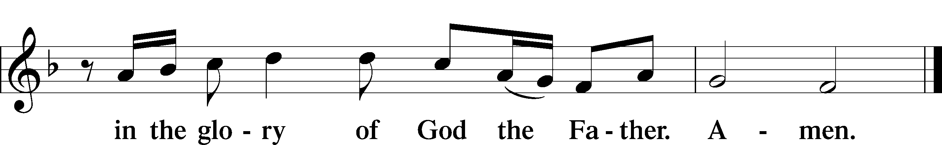

Salutation and Collect of the Day
P The Lord be with you.
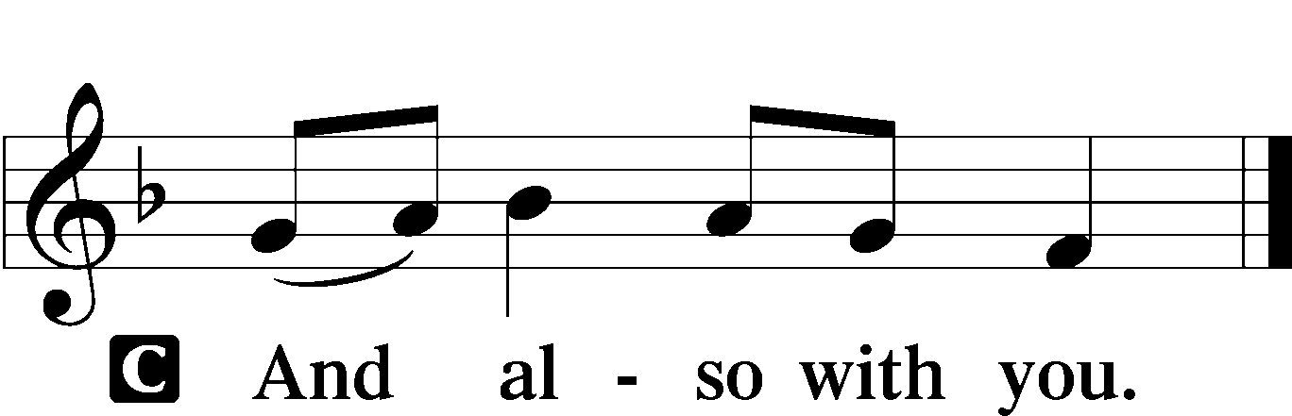

P Let us pray.
Almighty God, You show mercy to Your people in all their troubles. Grant us always to recognize Your goodness, give thanks for Your compassion, and praise Your holy name; through Jesus Christ, Your Son, our Lord, who lives and reigns with You and the Holy Spirit, one God, now and forever.

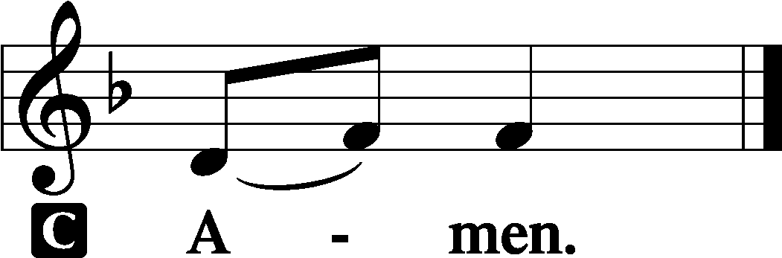

Sit

Old Testament Reading Ruth 1:1–19a
In the days when the judges ruled there was a famine in the land, and a man of Bethlehem in Judah went to sojourn in the country of Moab, he and his wife and his two sons. The name of the man was Elimelech and the name of his wife Naomi, and the names of his two sons were Mahlon and Chilion. They were Ephrathites from Bethlehem in Judah. They went into the country of Moab and remained there. But Elimelech, the husband of Naomi, died, and she was left with her two sons. These took Moabite wives; the name of the one was Orpah and the name of the other Ruth. They lived there about ten years, and both Mahlon and Chilion died, so that the woman was left without her two sons and her husband.
Then she arose with her daughters-in-law to return from the country of Moab, for she had heard in the fields of Moab that the Lord had visited his people and given them food. So she set out from the place where she was with her two daughters-in-law, and they went on the way to return to the land of Judah. But Naomi said to her two daughters-in-law, “Go, return each of you to her mother’s house. May the Lord deal kindly with you, as you have dealt with the dead and with me. The Lord grant that you may find rest, each of you in the house of her husband!” Then she kissed them, and they lifted up their voices and wept. And they said to her, “No, we will return with you to your people.” But Naomi said, “Turn back, my daughters; why will you go with me? Have I yet sons in my womb that they may become your husbands? Turn back, my daughters; go your way, for I am too old to have a husband. If I should say I have hope, even if I should have a husband this night and should bear sons, would you therefore wait till they were grown? Would you therefore refrain from marrying? No, my daughters, for it is exceedingly bitter to me for your sake that the hand of the Lord has gone out against me.” Then they lifted up their voices and wept again. And Orpah kissed her mother-in-law, but Ruth clung to her.
And she said, “See, your sister-in-law has gone back to her people and to her gods; return after your sister-in-law.” But Ruth said, “Do not urge me to leave you or to return from following you. For where you go I will go, and where you lodge I will lodge. Your people shall be my people, and your God my God. Where you die I will die, and there will I be buried. May the Lord do so to me and more also if anything but death parts me from you.” And when Naomi saw that she was determined to go with her, she said no more.
So the two of them went on until they came to Bethlehem.

A This is the Word of the Lord.
C Thanks be to God.

Epistle 2 Timothy 2:1–13
You then, my child, be strengthened by the grace that is in Christ Jesus, and what you have heard from me in the presence of many witnesses entrust to faithful men who will be able to teach others also. Share in suffering as a good soldier of Christ Jesus. No soldier gets entangled in civilian pursuits, since his aim is to please the one who enlisted him. An athlete is not crowned unless he competes according to the rules. It is the hard-working farmer who ought to have the first share of the crops. Think over what I say, for the Lord will give you understanding in everything.
Remember Jesus Christ, risen from the dead, the offspring of David, as preached in my gospel, for which I am suffering, bound with chains as a criminal. But the word of God is not bound! Therefore I endure everything for the sake of the elect, that they also may obtain the salvation that is in Christ Jesus with eternal glory. The saying is trustworthy, for:
If we have died with him, we will also live with him;
if we endure, we will also reign with him;
if we deny him, he also will deny us;
if we are faithless, he remains faithful—
for he cannot deny himself.

A This is the Word of the Lord.
C Thanks be to God.

Stand

Alleluia and Verse LSB 156
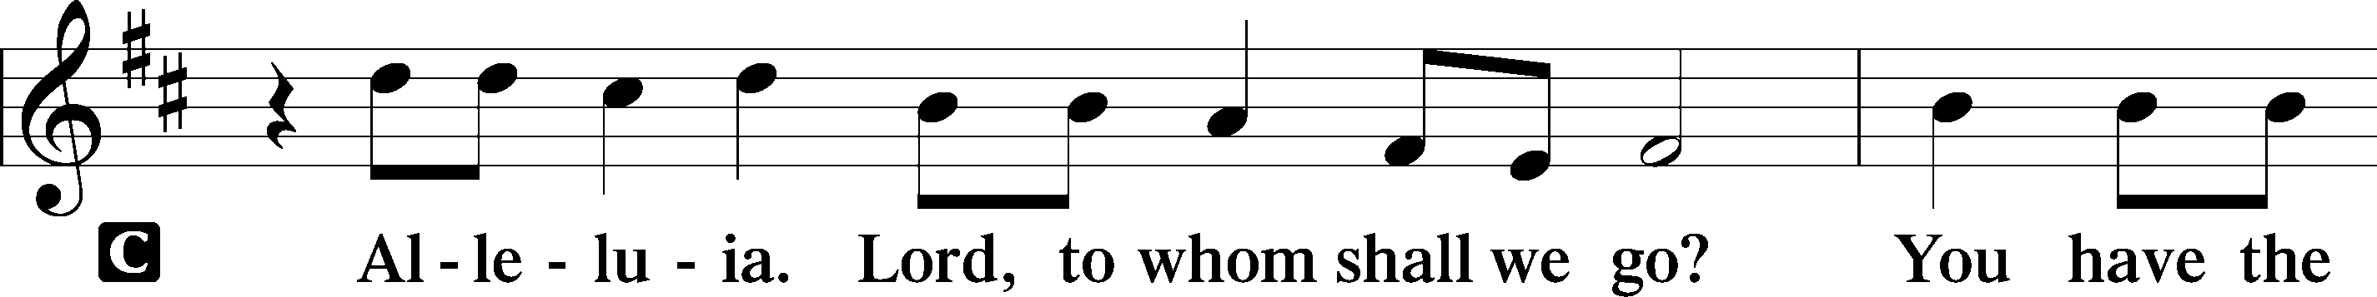
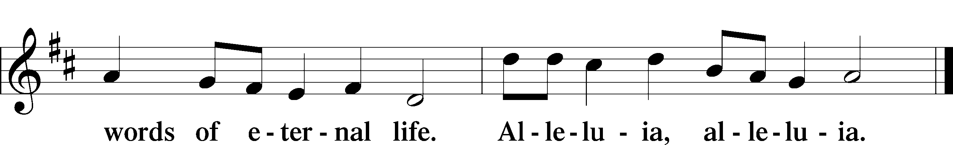

Holy Gospel Luke 17:11–19
P The Holy Gospel according to St. Luke, the seventeenth chapter.

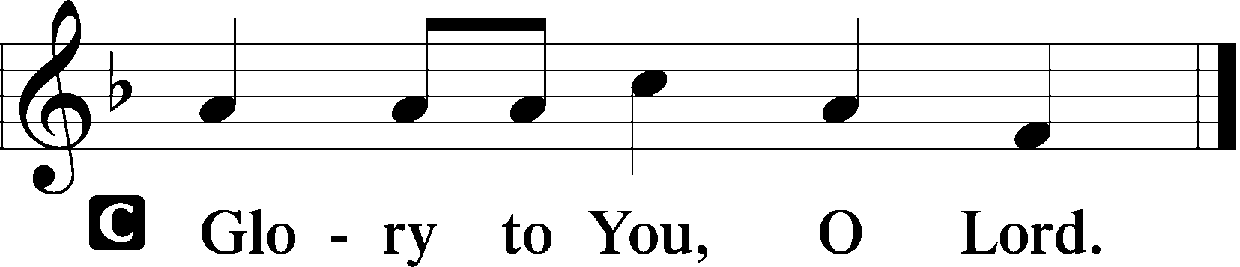

On the way to Jerusalem [Jesus] was passing along between Samaria and Galilee. And as he entered a village, he was met by ten lepers, who stood at a distance and lifted up their voices, saying, “Jesus, Master, have mercy on us.” When he saw them he said to them, “Go and show yourselves to the priests.” And as they went they were cleansed. Then one of them, when he saw that he was healed, turned back, praising God with a loud voice; and he fell on his face at Jesus’ feet, giving him thanks. Now he was a Samaritan. Then Jesus answered, “Were not ten cleansed? Where are the nine? Was no one found to return and give praise to God except this foreigner?” And he said to him, “Rise and go your way; your faith has made you well.”

P This is the Gospel of the Lord.

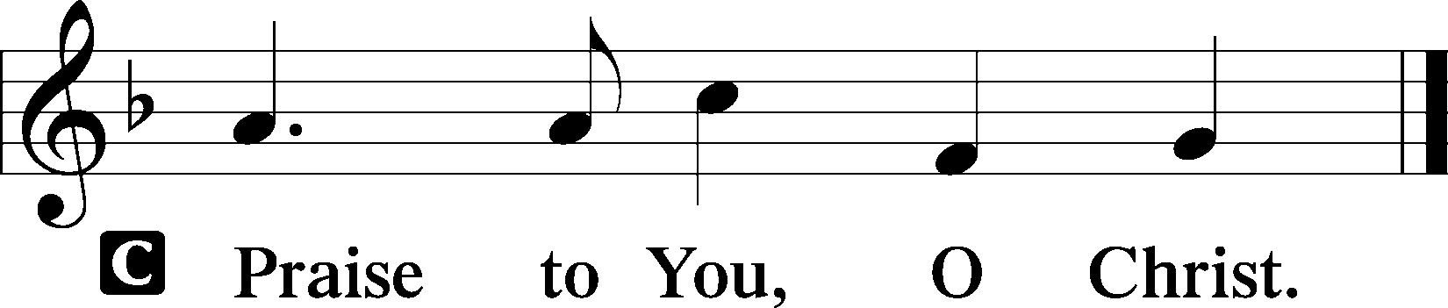

Apostles’ Creed
C I believe in God, the Father Almighty,
maker of heaven and earth.

And in Jesus Christ, His only Son, our Lord,
who was conceived by the Holy Spirit,
born of the virgin Mary,
suffered under Pontius Pilate,
was crucified, died and was buried.
He descended into hell.
The third day He rose again from the dead.
He ascended into heaven
and sits at the right hand of God the Father Almighty.
From thence He will come to judge the living and the dead.

I believe in the Holy Spirit,
the holy Christian Church,
the communion of saints,
the forgiveness of sins,
the resurrection of the body,
and the life T everlasting. Amen.

Sit

844 Lord of All Nations, Grant Me Grace sts. 1–4
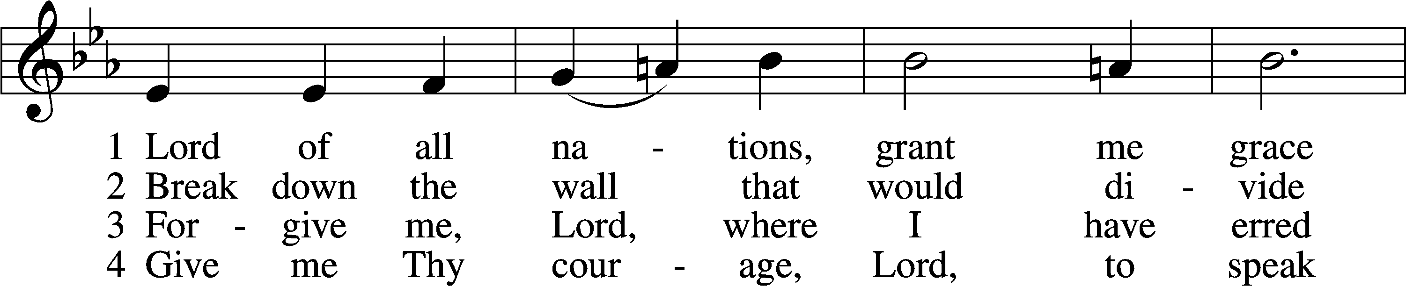
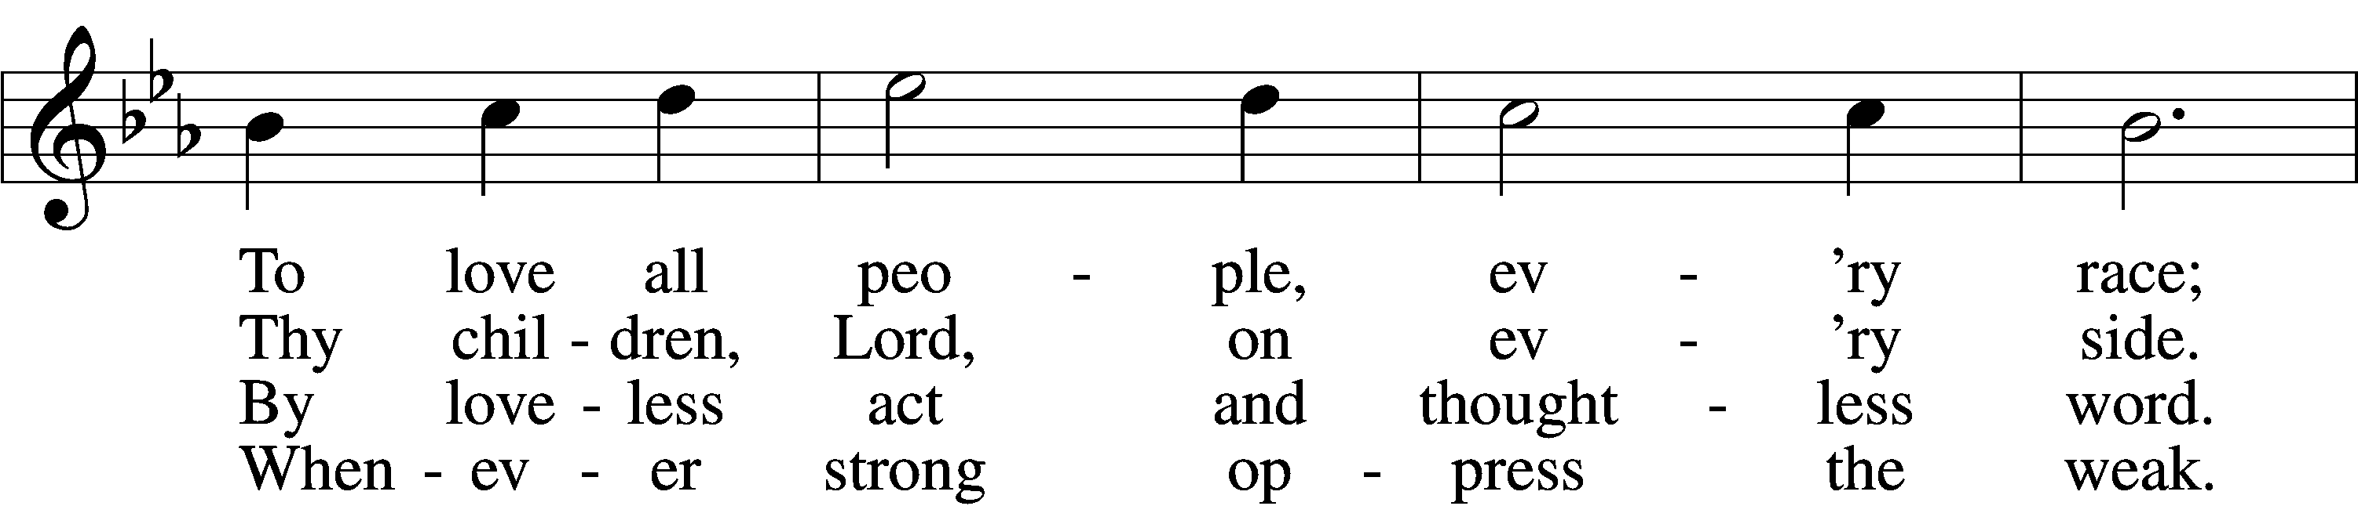
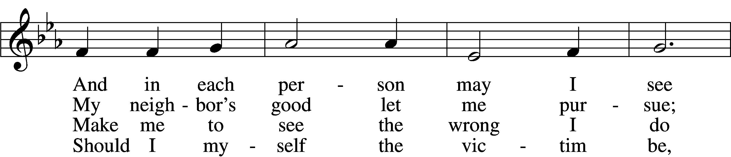
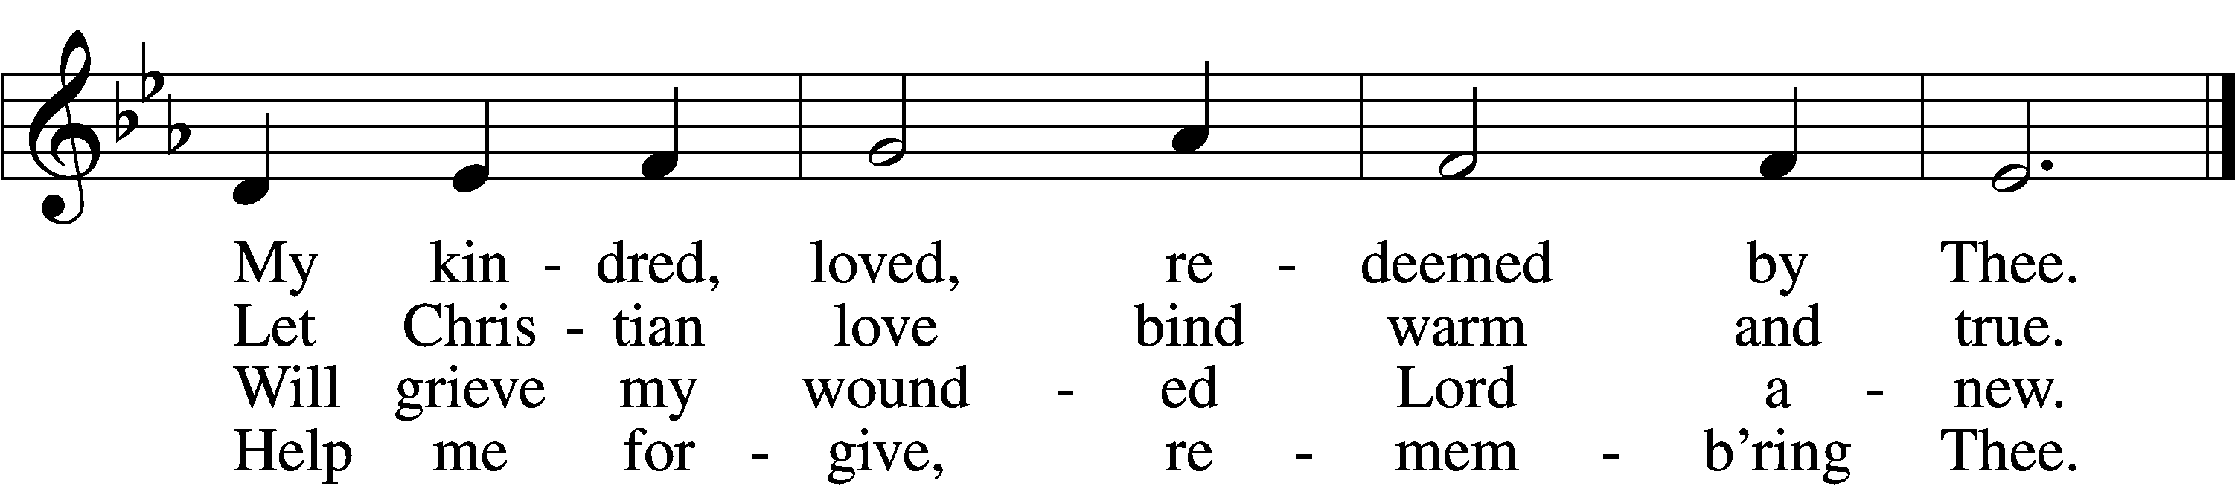

Sermon

Offering

Psalm for Meditation Psalm 111; antiphon: v. 10
Praise the Lord!
I will give thanks to the Lord with my whole heart,
in the company of the upright, in the congregation.
Great are the works of the Lord,
studied by all who delight in them.
Full of splendor and majesty is his work,
and his righteousness endures forever.
He has caused his wondrous works to be remembered;
the Lord is gracious and merciful.
He provides food for those who fear him;
he remembers his covenant forever.
He has shown his people the power of his works,
in giving them the inheritance of the nations.
The works of his hands are faithful and just;
all his precepts are trustworthy;
they are established forever and ever,
to be performed with faithfulness and uprightness.
He sent redemption to his people;
he has commanded his covenant forever.
Holy and awesome is his name!
The fear of the Lord is the beginning of wisdom;
all those who practice it have a good understanding.
His praise endures forever!

Stand

781 We Give Thee But Thine Own sts. 1–2
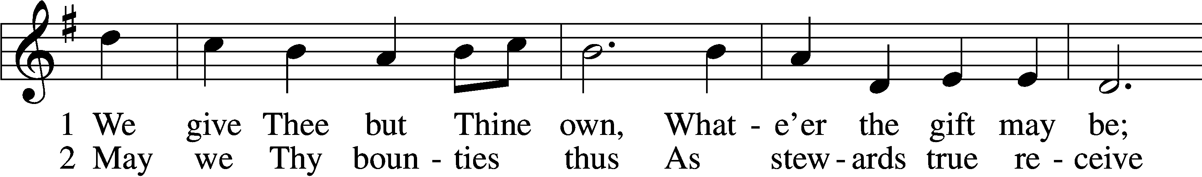
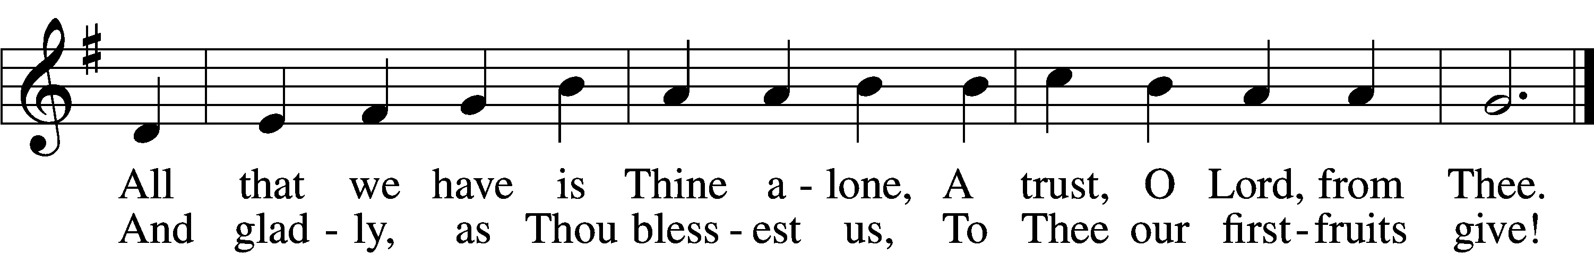

Prayer of the Church
P Almighty God, we give thanks for all Your goodness and bless You for the love that sustains us from day to day. We praise You for the gift of Your Son, our Savior, in whom we have redemption, the forgiveness of sins. We thank You for the Holy Spirit, the Comforter; for Your holy Church, for the means of grace, for the lives of all faithful and just people, and for the hope of the life to come. Help us to treasure in our hearts all that You have done for us, and enable us to show our thankfulness in lives that are wholly given to Your service. Lord, in Your mercy,
C hear our prayer.
P Grant Your wisdom and heavenly grace to all pastors and to those who hold office in Your Church that, by their devoted service, faith may abound and Your kingdom increase. Lord, in Your mercy,
C hear our prayer.
P Send the light of Your truth into all the earth. Raise up faithful servants of Christ to advance the Gospel both at home and in distant lands. Lord, in Your mercy,
C hear our prayer.
P Take from us all hatred and prejudice, give us the spirit of love, and order our days in Your peace. Prosper the labor of those who work to bring peace and justice to the nations of the world that mutual understanding and common endeavor may be increased among all peoples. Lord, in Your mercy,
C hear our prayer.
P Sanctify our homes with Your presence, and bless them with joy. Keep our children in the covenant of their Baptism, and enable their parents to bring them up in lives of faith and devotion. Unite the members of all families in a spirit of affection and service that they may show Your praise in our land and in all the world. Lord, in Your mercy,
C hear our prayer.
P Let Your blessing remain upon the seedtime and harvest, the commerce and industry, the leisure and rest, the arts and culture of our people. Take under Your special protection those whose work is difficult or dangerous, and be with all who put their hands to any useful task. Give them the just rewards for their labor and the knowledge that their work is a blessing in Your sight. Lord, in Your mercy,
C hear our prayer.
P By Your Word and Holy Spirit comfort all who are in sorrow or need, sickness or adversity especially Betsy, John W., Juliana, Marge, Tony, Bill M., Patricia, Phil, Lidia, Michele, Giuseppe, Alfred, Nancy, and also Braydon, who is serving in the military. Be with those who suffer persecution for the faith. Bring consolation to those in sorrow, and grant to all a measure of Your love, taking them into Your tender care. Lord, in Your mercy,
C hear our prayer.
P All these things and whatever else You know that we need, grant us, Father, for the sake of Him who died and rose again and now lives and reigns with You and the Holy Spirit, one God forever.
C Amen.

Lord’s Prayer
C Our Father who art in heaven,
hallowed be Thy name,
Thy kingdom come,
Thy will be done on earth
as it is in heaven;
give us this day our daily bread;
and forgive us our trespasses
as we forgive those
who trespass against us;
and lead us not into temptation,
but deliver us from evil.
For Thine is the kingdom
and the power and the glory
forever and ever. Amen.

Benediction LSB 166
P The Lord bless you and keep you.
The Lord make His face shine on you and be gracious to you.
The Lord look upon you with favor and T give you peace.


702 My Faith Looks Up to Thee
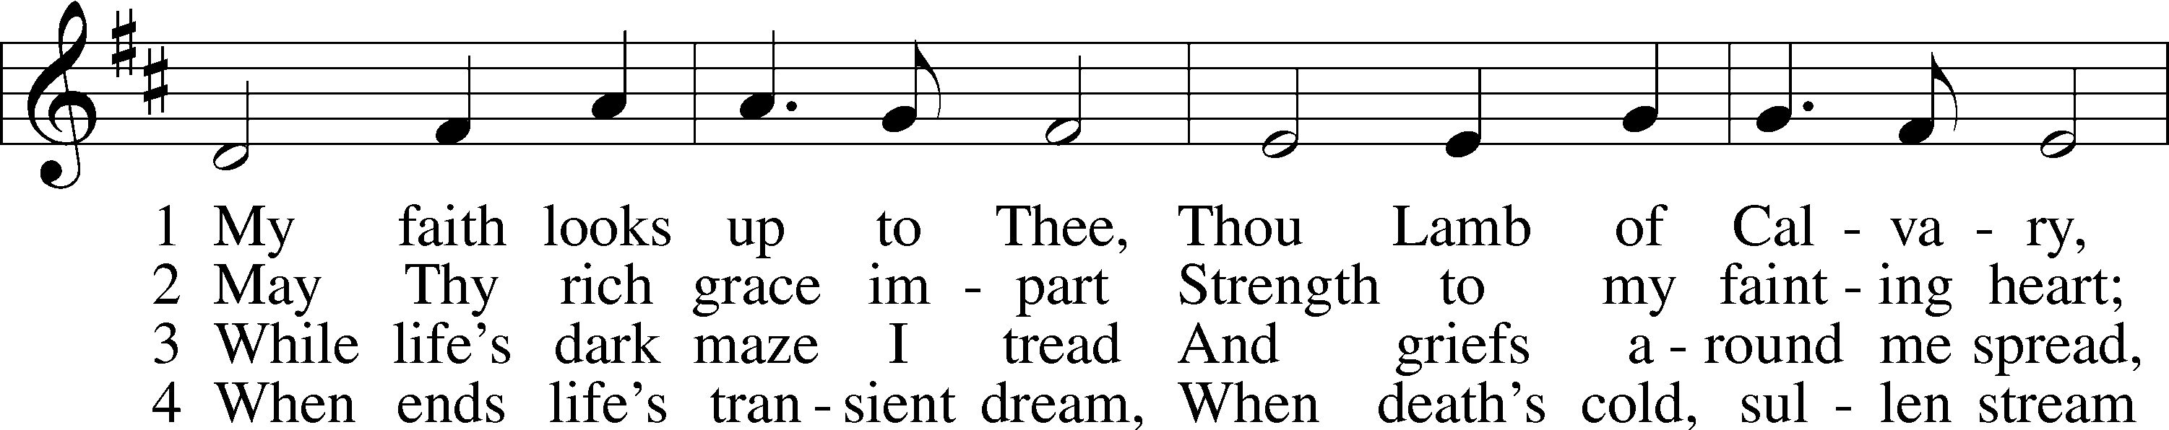
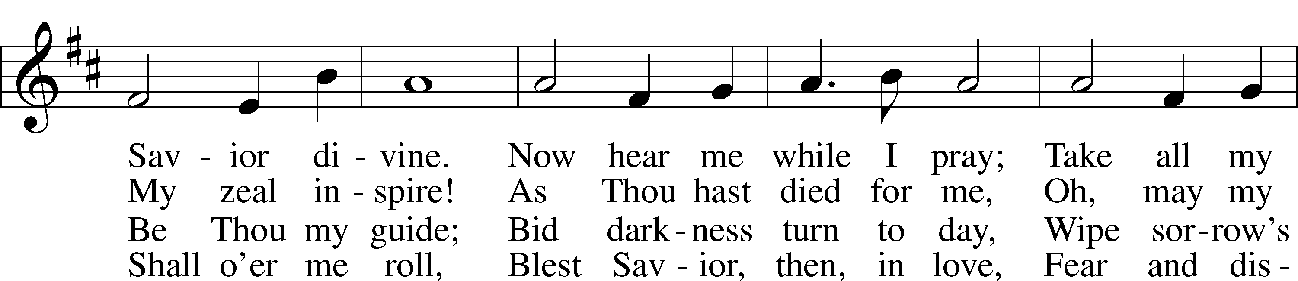
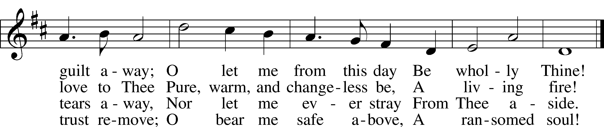

Announcements

Join us after the service in the fellowship hall for refreshments.

A Voters’ meeting is scheduled for today after service. Important items are to be discussed.

Pastor Vogel will be leading services on Oct. 19th and 26th.

If not taking your bulletin home, please leave on table in the narthex when leaving so it can be recycled. Thank you.

St. John’s Lutheran Church
810 Broad St., Clifton, NJ 07013
StJohnsClifton.Org
PrayingHands810@gmail.com

