Third Sunday of Epiphany January 18, 2026– Lectionary Series A
St. John’s Lutheran Church

Order of Worship
by
Lutheran Service Builder

900 Jesus! Name of Wondrous Love sts. 1–4

Stand for last verse

Confession and Absolution

The sign of the cross may be made by all in remembrance of their Baptism.

Invocation

Exhortation LSB 184

Silence for reflection on God’s Word and for self-examination.

Confession of Sins LSB 184

Absolution LSB 185

Service of the Word

Introit Psalm 89:1, 5, 15–16; antiphon: Psalm 119:46
I will speak of your testimonies before kings, [O Lord,]
and shall not be put to shame.
I will sing of the steadfast love of the Lord, forever;
with my mouth I will make known your faithfulness to all generations.
Let the heavens praise your wonders, O Lord,
your faithfulness in the assembly of the holy ones!
Blessèd are the people who know the festal shout,
who walk, O Lord, in the light of your face,
who exult in your name all the day
and in your righteousness are exalted.
Glory be to the Father and to the Son
and to the Holy Spirit;
as it was in the beginning,
is now, and will be forever. Amen.
I will speak of your testimonies before kings, [O Lord,]
and shall not be put to shame.

Kyrie LSB 186

Gloria in Excelsis LSB 187

Salutation and Collect of the Day

Sit

First Reading Acts 4:8–13
Then Peter, filled with the Holy Spirit, said to them, “Rulers of the people and elders, if we are being examined today concerning a good deed done to a crippled man, by what means this man has been healed, let it be known to all of you and to all the people of Israel that by the name of Jesus Christ of Nazareth, whom you crucified, whom God raised from the dead—by him this man is standing before you well. This Jesus is the stone that was rejected by you, the builders, which has become the cornerstone. And there is salvation in no one else, for there is no other name under heaven given among men by which we must be saved.”
Now when they saw the boldness of Peter and John, and perceived that they were uneducated, common men, they were astonished. And they recognized that they had been with Jesus.

A This is the Word of the Lord.
C Thanks be to God.

Epistle 2 Peter 1:1–15
Simeon Peter, a servant and apostle of Jesus Christ,
To those who have obtained a faith of equal standing with ours by the righteousness of our God and Savior Jesus Christ:
May grace and peace be multiplied to you in the knowledge of God and of Jesus our Lord.
His divine power has granted to us all things that pertain to life and godliness, through the knowledge of him who called us to his own glory and excellence, by which he has granted to us his precious and very great promises, so that through them you may become partakers of the divine nature, having escaped from the corruption that is in the world because of sinful desire. For this very reason, make every effort to supplement your faith with virtue, and virtue with knowledge, and knowledge with self-control, and self-control with steadfastness, and steadfastness with godliness, and godliness with brotherly affection, and brotherly affection with love. For if these qualities are yours and are increasing, they keep you from being ineffective or unfruitful in the knowledge of our Lord Jesus Christ. For whoever lacks these qualities is so nearsighted that he is blind, having forgotten that he was cleansed from his former sins. Therefore, brothers, be all the more diligent to make your calling and election sure, for if you practice these qualities you will never fall. For in this way there will be richly provided for you an entrance into the eternal kingdom of our Lord and Savior Jesus Christ.
Therefore I intend always to remind you of these qualities, though you know them and are established in the truth that you have. I think it right, as long as I am in this body, to stir you up by way of reminder, since I know that the putting off of my body will be soon, as our Lord Jesus Christ made clear to me. And I will make every effort so that after my departure you may be able at any time to recall these things.

A This is the Word of the Lord.
C Thanks be to God.

Stand

Alleluia LSB 190
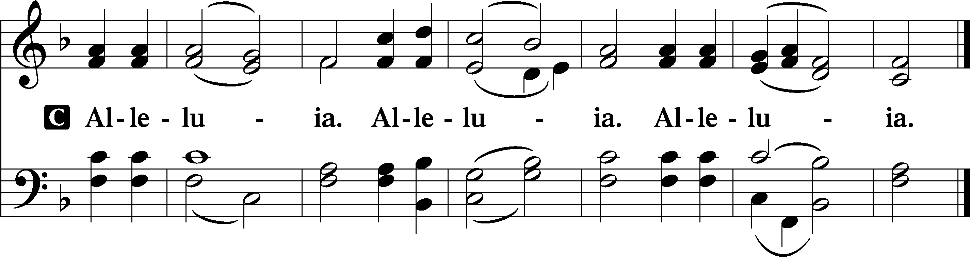

Holy Gospel Mark 8:27–35
P The Holy Gospel according to St. Mark, the eighth chapter.

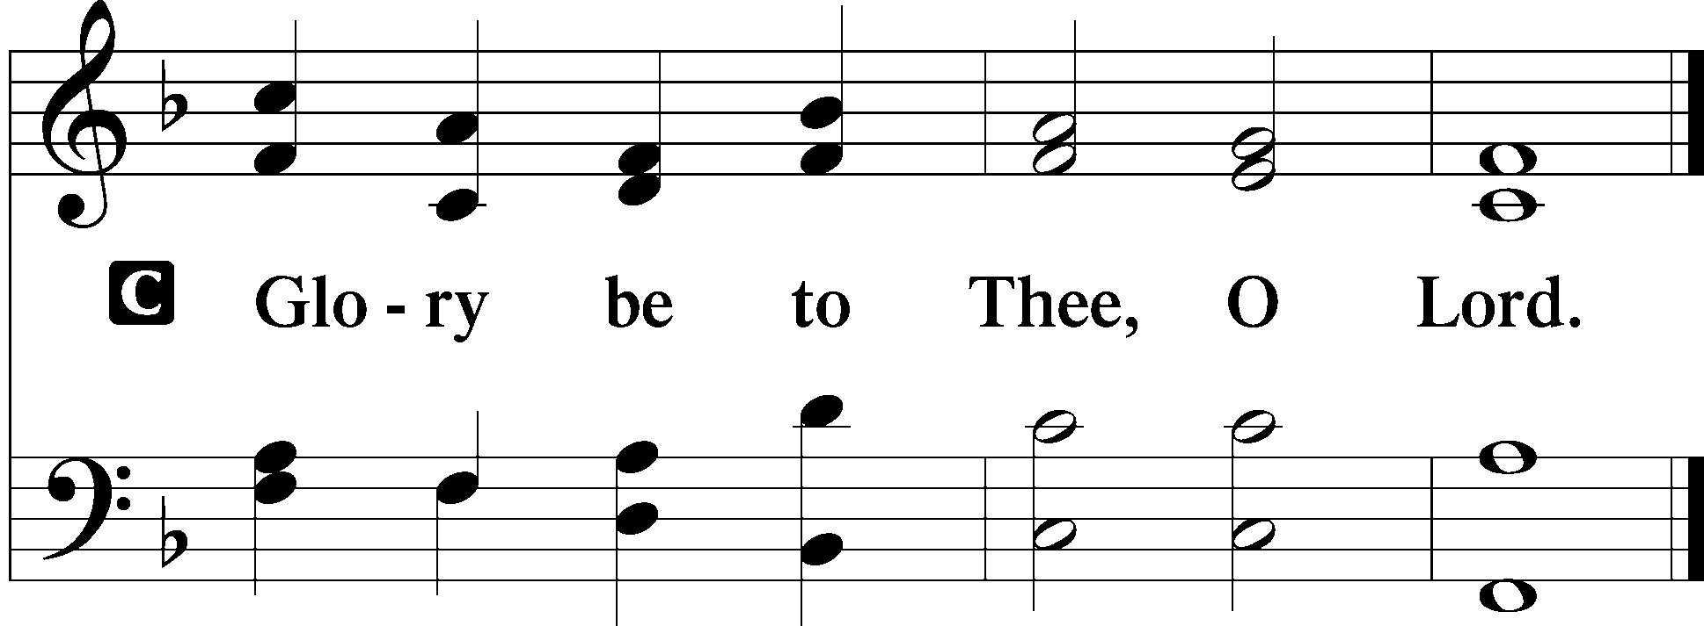

And Jesus went on with his disciples to the villages of Caesarea Philippi. And on the way he asked his disciples, “Who do people say that I am?” And they told him, “John the Baptist; and others say, Elijah; and others, one of the prophets.” And he asked them, “But who do you say that I am?” Peter answered him, “You are the Christ.” And he strictly charged them to tell no one about him.
And he began to teach them that the Son of Man must suffer many things and be rejected by the elders and the chief priests and the scribes and be killed, and after three days rise again. And he said this plainly. And Peter took him aside and began to rebuke him. But turning and seeing his disciples, he rebuked Peter and said, “Get behind me, Satan! For you are not setting your mind on the things of God, but on the things of man.”
And he called to him the crowd with his disciples and said to them, “If anyone would come after me, let him deny himself and take up his cross and follow me. For whoever would save his life will lose it, but whoever loses his life for my sake and the gospel’s will save it.”

P This is the Gospel of the Lord.
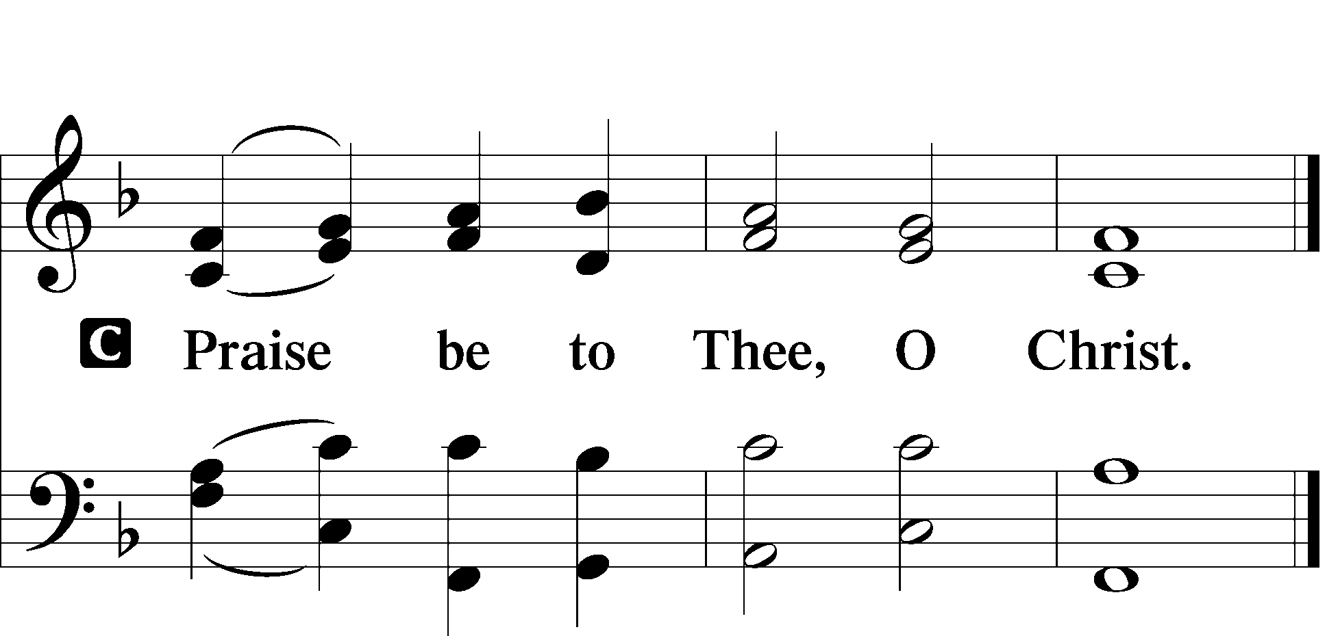

Nicene Creed

Sit

516 Wake, Awake, for Night Is Flying

Sermon

Offering

Psalm Psalm 118:19–29; antiphon: v. 26
Open to me the gates of righteousness,
that I may enter through them
and give thanks to the Lord.
This is the gate of the Lord;
the righteous shall enter through it.
I thank you that you have answered me
and have become my salvation.
The stone that the builders rejected
has become the cornerstone.
This is the Lord’s doing;
it is marvelous in our eyes.
This is the day that the Lord has made;
let us rejoice and be glad in it.
Save us, we pray, O Lord!
O Lord, we pray, give us success!
Blessèd is he who comes in the name of the Lord!
We bless you from the house of the Lord.
The Lord is God,
and he has made his light to shine upon us.
Bind the festal sacrifice with cords,
up to the horns of the altar!
You are my God, and I will give thanks to you;
you are my God; I will extol you.
Oh give thanks to the Lord, for he is good;
for his steadfast love endures forever!

Stand

781 We Give Thee But Thine Own sts. 1–2

Prayer of the Church

Prayer of the Church After “Lord, in Your mercy” respond with “hear our prayer.”

Service of the Sacrament

Preface LSB 194

Proper Preface (Full)

Sanctus 195

Lord’s Prayer LSB 196

The Words of Our Lord 197

Pax Domini LSB 197

Agnus Dei LSB 198

Sit

Distribution

637 Draw Near and Take the Body of the Lord

Stand

Nunc Dimittis LSB 199

Thanksgiving LSB 200

Post-Communion Collect

Salutation LSB 201

Benedicamus LSB 202

Benediction LSB 202

643 Sent Forth by God’s Blessing

Announcements

Join us after the service in the fellowship hall for refreshments and Bible Study.

Pastor Vogel will conduct services for February 8th.

St. John’s Lutheran Church
810 Broad St., Clifton, NJ 07013
StJohnsClifton.Org
PrayingHands810@gmail.com

