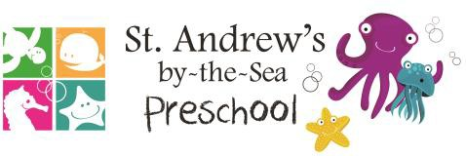

Curriculum  Months & Theme | Traits | Letters & Numbers | Color & Shape
September  Friends and Feelings | Respect | A, B, C  1 & 11
October  My Amazing Body | Polite | D, E, & F  2 & 12
‘’  November  On The Go | Thankful | G, H  3 & 13
December  Holiday Fun | Loving | I, J  4 & 14
January  Winter Wonderland | Responsible | K, L, & M  5 & 15
February  Food & Fitness | Kind | N, O & P  6 & 16
March  Blast Off to Space | Patient | Q, R & S  7 & 17
April  Bees & Butterflies | Forgiving | T, U, & V  8 & 18
May  Growing Gardens | Honest | W, X & Y  9 & 19
June  Ocean Commotion | Graceful | Z  10 & 20
July  Zoo Animals | Compassionate | Vowels  I, E & A  10 & 20 | 
August  Dinosaurs | Brave | Vowels  O & U  10 & 20

