October 2, 2026
Hello,
Grace and peace be with you! As we look around our community of faith, we are filled with gratitude. Each smile, each prayer, each act of service, each time we gather reminds us that the life we share together is truly good news in a world that longs for hope!
“Good news” is a phrase we often associate with Scripture—but it’s also something we witness every day in our life together. It asks us to pay attention: Where is God moving? What signs of hope are emerging? What glimpses of grace are breaking through? Scripture reminds us that we are created with purpose and called to share God’s love (Ephesians 2:10). And when we look closely, we see that God is already revealing good news among us.
In 2026 your generosity helped us glimpse that good news in powerful ways. We see it in the growing energy of our Family Ministries under the leadership of Jessica Wernau. We hear and feel it when we experience the music led by Smith Graham and our new pianist, Nathan Richard. We celebrate the dedication of our Office Manager, Colette Hughes. We see it in the care offered by our Nursery Attendant, Brenna Youngbauer. We see it in the meals served, the neighbors supported, and the compassion extended week after week. We celebrated the good news as Mission del Sol marked its 40th anniversary. Thank you for helping us share good news with our community.
We also launched the Legacy Campaign. Together, we pledged $305,000 towards our 3-year goal of establishing a solid reserve fund to maintain our beautiful church home. This year, we continue to see good news through Casa del Sol Affordable Housing, Inc. (501c3), our nonprofit dedicated to permanent supportive housing in the East Valley. New partnerships, new conversations, and new opportunities are emerging—signs of hope that remind us God is at work. We invite your support and involvement as we take exciting next steps.
Through your time, talents and treasures, Mission del Sol continues to be a place of hope, peace and transformation. When you give, you are not just supporting programs—you are investing in lives changed, faith strengthened, and God’s kingdom built here on earth. Our 2027 budget reflects this commitment: supporting staff, giving to Mission, and continuing the vibrant ministry you make possible.
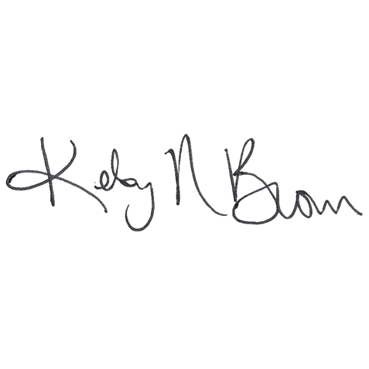
Included with this letter, you will find a brochure with more information about the church life and ministries you can get involved in, a pledge card, and an At-a-Glance Calendar of this year’s programs. Please save the dates on your family calendar and attend the events that speak to you. Come on October 11th with your pledge card and on October 25th to sign up at the Time and Talent Fair following Worship. Thank you for prayerfully considering your commitments to next year’s ministries!
Blessings,


Pastor Kelsy Brown Elder Stephanie Kinsey
Pastor Stewardship Commission Chair

