September 24, 2025

Hello,

Grace and peace be with you! As we look around our community of faith, we are filled with gratitude. Each smile, each prayer, each act of service, each time we gather reminds me that the life we share together is truly worth it!

“Worth” is a big word. It asks us what deserves our time, our talents and our financial resources—when so many things are competing for our attention. Scripture reminds us we are already worth it: loved, valued, and created with purpose by God (Ephesians 2:10). Not only are we worth it, but the work we do together as a church is worth it too. Every act of worship, every song of praise, every meal shared, every child nurtured, every act of service, every gift given—it all points to God’s love at work in the world.

In 2025 your generosity has made a difference. It was worth it to hire staff who help our ministries flourish—like our Nursery Attendant, Kayla Oliver, and our new Family Ministries Coordinator, Jessica Wernau. It was worth it to focus on community by welcoming new groups into our space, making Mission del Sol a gathering place for all. It was worth it to serve our neighbors every week of the year. Thank you for believing Mission del Sol is worth it!

We are also completing our final two-year Vision Campaign to reduce the mortgage, expand mission, and care for our property. Together we pledged $222,430 toward our $300,000 goal—an incredible step forward. One final payment will be made in December 2025 to lower our principal, freeing up more resources for ministry. If you haven’t had a chance to give, we invite you to join in. It is worth it to invest in the future of Mission del Sol.

This year we also celebrate the progress of Casa del Sol Affordable Housing, Inc. (501c3), our non-profit dedicated to permanent supportive housing in the East Valley. We have made lots of connections! We believe this ministry is worth it, too, and invite your support and involvement as we take exciting next steps.

Through your time, talents and treasures, Mission del Sol continues to be a place of hope, peace and transformation. When you give, you are not just supporting programs—you are investing in lives changed, faith strengthened, and God’s kingdom built here on earth. Our 2026 budget reflects this commitment: supporting staff, raising mission giving, and continuing the vibrant ministry you make possible.

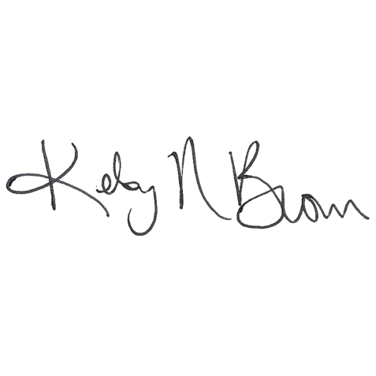Included with this letter, you will find a *brochure* with more information about the church life and ministries you can get involved in, a *pledge card*, and an *At A Glance Calendar* of this year’s programs. Please save the dates on your family calendar and attend the events that you think are worth it! Come on **October 5th** with your pledge card and on **October 26th** to sign up at the **Time and Talent Fair** following Worship. Thank you for prayerfully considering your commitments to next year’s ministries!

Blessings,



Pastor Kelsy Brown Elder Stephanie Kinsey

Pastor Stewardship Commission Chair