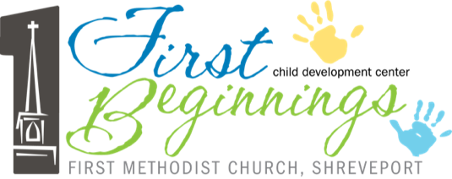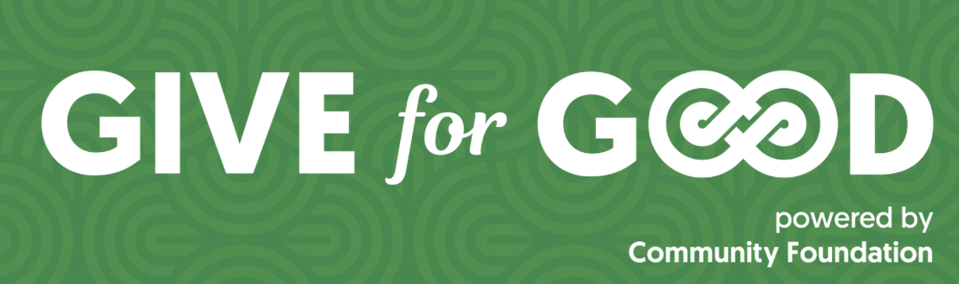

Community Foundation of North Louisiana offers a fun and efficient way to donate to nonprofits via the online Give For Good platform. First Beginnings has a goal of $45,000 for our 2026 campaign.

What methods of payment are accepted? The minimum donation amount is $10. Accepted forms of payment include Credit/Debit cards, Google Pay, Apple Pay, Paypal and Venmo, and ACH.
Please note, your donation(s) will show up as Mightycause Charitable Foundation or MCF on your bank statement.

How much of the donations go to the organizations? There is a credit card processing fee of 2.9% + $0.30 per transaction made on the Give For Good platform. The ACH processing fee is 1% + $1.50 per transaction. In addition, there is 4% Mightycause (online giving platform) fee to cover operational costs and disbursement processing by the Mightycause Charitable Foundation. As a donor, you may also elect to cover the fee so that it is not deducted from your donation.

Are donations tax-deductible? All gifts made through the Give For Good platform are 100% tax-deductible, and receipts for these deductions are issued immediately. Under IRS requirements, the value of any benefit received is not tax-deductible. Mightycause will not issue receipts including the value of any benefit received. Thus, nonprofits are not allowed to offer benefits for any funds received.

When will I receive my tax receipt? A tax receipt will be emailed to you after you make your donation on the platform. Be sure to enter the correct email address when making your donation. If you have trouble accessing your tax receipt, please email support@mightycause.com for assistance.

How do I get involved?
- Be a matching donor- Match donations during a pre-determined time of the giving days. You can set an upper limit on your tax-deductible donation.
- Campaign as a team member- Create a personal fundraiser for First Beginnings on our Team Page. If that sounds daunting, sharing our social media posts helps tremendously!
- Give during “giving days”- Early giving begins on April 21, 2026 and ends on May 5, 2026. You can visit https://www.giveforgoodnla.org/ >> select Donor>> Find a cause>> search for First Beginnings>> Donate
- Create a Donor Advised Fund through Community Foundation- If a donor wishes to give $5,000 or more during Give For Good, the Community Foundation accepts donations through Donor Advised Funds. DAF gifts require no fee, which means 100% of your donation goes to the organization(s).

