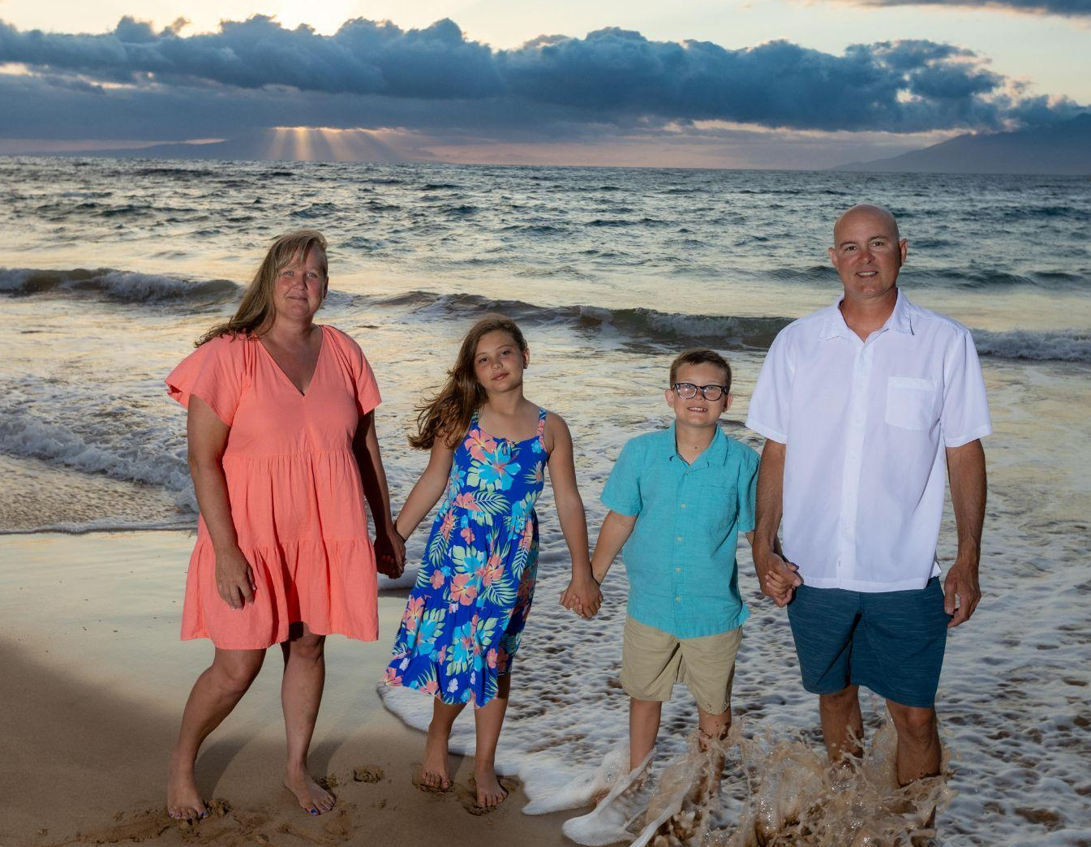
Tricia Poppy
Youth Group Coordinator

I was born and raised in Southern California, growing up in the Lutheran Church where I learned from a young age that I enjoyed helping children grow in their faith. I taught Sunday School and Vacation Bible School while I was still in high school. I attended Concordia University (Christ College Irvine) as an undergraduate where I earned my Bachelor’s Degree and Teaching Certificate. A highlight in college was visiting different churches and facilitating youth programs. In 2021, I went back to school and graduated from Boise State University with a Master of Arts in Education, Curriculum, and Instruction.

After I completed my undergraduate work in 1996, I was called to be a teacher at Trinity Lutheran Church in Colorado. While teaching, I also volunteered with the youth group. One of my favorite memories was chaperoning our youth to the National Youth Gathering. To see so many young people on fire for God was inspiring! I continued living and teaching in Colorado for 11 years. It was there where I fell in love with the mountains and experiencing God in nature.

From Colorado, I moved to Texas for a couple years to be close to my family. I continued to teach and was active in my church community. During this time, I reconnected with Ken who was my next door neighbor growing up. At the time, Ken lived in Boise, Idaho. Ken’s first message to me was, “We should have been married with kids by now!” Sure enough, I moved to Idaho and we got married.

We have been married for 15 years. We are blessed with two children. Joshua is 12, and Emma is 11. Joshua and Emma love participating in sports and youth group activities. As a family, one of our favorite things is attending Christian concerts. We love worshipping together. Especially during the summer, you will find us enjoying time out on the lake in Cascade or camping with friends.

It is a privilege to be the Youth Group Coordinator. I am passionate about supporting our youth and their families in their faith journey. I look forward to creating meaningful and fun Bible lessons. I will also nurture their faith through providing opportunities to serve others. There is a saying that one small act of kindness starts a ripple, and little ripples make big waves. Let’s make big waves together by loving God and loving others!

