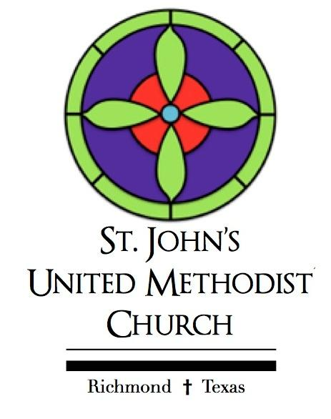

ORDER OF WORSHIP
TRINITY SUNDAY
CONFIRMATION SUNDAY
MAY 31, 2026
8:30 & 11:00AM

INSTRUCTIONS FOR LIVE WORSHIP
You are invited to use this bulletin during our live worship service at 11:00am on Sunday morning. To access our live worship, please click here.

PRELUDE

GREETING AND ANNOUNCEMENTS

CALL TO WORSHIP
Leader: Happy Trinity Sunday! Today, we are here to celebrate our three-in-one God—Father, Son, and Holy Spirit.
All: We praise the God who builds us up, saves us, and keeps the whole world spinning.
Leader: We are jumping headfirst into the beautiful mystery of who God is.
All: We want a deeper, stronger faith in the Creator, Redeemer, and Sustainer of everything.
Leader: We are here to see how perfectly the Trinity works together, moving in a beautiful divine dance.
All: We are all invited to join in on that same rhythm.
Leader: Come on in, let’s worship our three-in-one God together!
All: Let's praise the One who makes, saves, and takes care of it all.

SONG OF PRAISE
“This is My Father’s World” | #144
This is my Father's world, and to my listening ears
All nature sings and round me rings
The music of the spheres
This is my Father's world: I rest me in the thought
Of rocks and trees, of skies and seas;
His hand the wonders wrought.

This is my Father's world, the birds their carols raise
The morning light, the lily white,
Declare their Maker's praise.
This is my Father's world: He shines in all that's fair
In the rustling grass I hear Him pass,
He speaks to me everywhere.

This is my Father's world. O let me ne'er forget
That though the wrong seems oft so strong,
God is the Ruler yet.
This is my Father's world:
Why should my heart be sad?
The Lord is King; let the heaven’s ring!
God reigns; let the earth be glad!
© Words: Public Domain Music: Public Domain CCLI License # 901579

AFFIRMATION OF FAITH
I believe in God, the Father Almighty, maker of heaven and earth; And in Jesus Christ his only Son, our Lord; who was conceived by the Holy Spirit, born of the Virgin Mary, suffered under Pontius Pilate, was crucified, dead, and buried;*
The third day he rose from the dead; he ascended into heaven, and sitteth at the right hand of God the Father almighty; from thence he shall come to judge the quick and the dead. I believe in the Holy Spirit, the holy catholic** church, the communion of saints, the forgiveness of sins, the resurrection of the body, and the life everlasting. Amen.

GLORIA PATRI
Glory be to the Father, and to the Son, and to the Holy ghost! As it was in the beginning, is now and ever shall be. World without end. Amen. Amen.

SCRIPTURE LESSON
Genesis 1:1-2:4a

CONFIRMATION
Madison Grace Lenz
Karley Rae Pfeffer
Mason James Wilson

PASTORAL PRAYER

LORD’S PRAYER
Our Father, Who art in heaven, hallowed be thy name. Thy Kingdom come, thy will be done, on earth as it is in heaven. Give us this day our daily bread. And forgive us our trespasses, as we forgive those who have trespassed against us. And lead us not into temptation. But deliver us from evil. For thine is the kingdom, and the power, and the glory forever. Amen.

SONG OF REFLECTION
“We’ve a Story to Tell to the Nations” | #569
We've a story to tell to the nations,
That shall turn their hearts to the right,
A story of truth and mercy,
A story of peace and light, a story of peace and light

For the darkness shall turn to dawning,
And the dawning to noonday bright;
And Christ's great kingdom shall come on earth,
The kingdom of love and light.

We've a song to be sung to the nations,
That shall lift their hearts to the Lord,
A song that shall conquer evil
And shatter the spear and sword,
And shatter the spear and sword.

We've a message to give to the nations,
That the Lord who reigneth above,
Hath sent us His Son to save us,
And show us that God is love,
And show us that God is love.

We've a Savior to show to the nations,
Who the path of sorrow hath trod,
That all of the world's great peoples
Might come to the truth of God,
Might come to the truth of God.
© Words: Public Domain Music: Public Domain CCLI License # 901579

PASSING THE PEACE OF CHRIST

CHILDREN'S SERMON

OFFERING OUR GIFTS and TITHES
(Thank you for your generosity! To contribute electronically, please see the QR code.)

SHARING OUR GIFTS

DOXOLOGY
Praise God from whom all blessings flow;
Praise him all creatures here below;
Praise him above, ye heavenly host;
Praise Father, Son, and Holy Ghost. Amen.

SCRIPTURE LESSON
Matthew 28:16-20

SERMON
“Trinity Sunday” Barrett Walker Jr.

INVITATION TO DISCIPLESHIP

SONG OF INVITATION
“Holy, Holy, Holy” | #64
Holy, holy, holy! Lord God Almighty
Early in the morning our song shall rise to Thee
Holy, holy, holy! Merciful and mighty,
God in three persons, blessed Trinity

Holy, holy, holy! All the saints adore Thee,
Casting down their golden crowns
Around the glassy sea
Cherubim and seraphim falling down before Thee
Which wert, and art, and evermore shalt be
Holy, holy, holy! Though the darkness hide Thee
Though the eye of sinful man thy glory may not see
Only Thou art holy; there is none beside Thee
Perfect in power, in love and purity

Holy, holy, holy! Lord God Almighty
All Thy works shall praise Thy name,
In earth and sky and sea
Holy, holy, holy! merciful and mighty!
God in three Persons, blessed Trinity.
© Words: Public Domain Music: Public Domain CCLI License # 901579

SENDING FORTH

CHORAL RESPONSE
“We Are the Church”
I am the church! You are the church!
We are the church together!
All who follow Jesus, all around the world!
Yes, we’re the church together!

GOING FORTH
Blessed by God’s love and strengthened by God’s Grace, let us be the church to the people we are with. Amen.

The altar flowers are given to the Glory of God by Cathy Kemper in loving memory of her late husband William L. Kemper Jr.

QR Code provided for your tithes and offerings. Thank you.



St. John’s Youth
Call to Worship - Nolan Raska
Scripture 1 - James King
Prayer - Madison Lenz/Mason Wilson
Children's Sermon - Cady Langford
Scripture 2 - Chloe Woodfin
Sermon - Barrett Walker Jr.
Sending Forth - Richard Luna
Worship Director - Owen Scherer
AV - MJ Boswell, William Hillis
Ushers - Brooke Raska, Sophia Scherer, Hayes Cruikshank

