First United Presbyterian Church
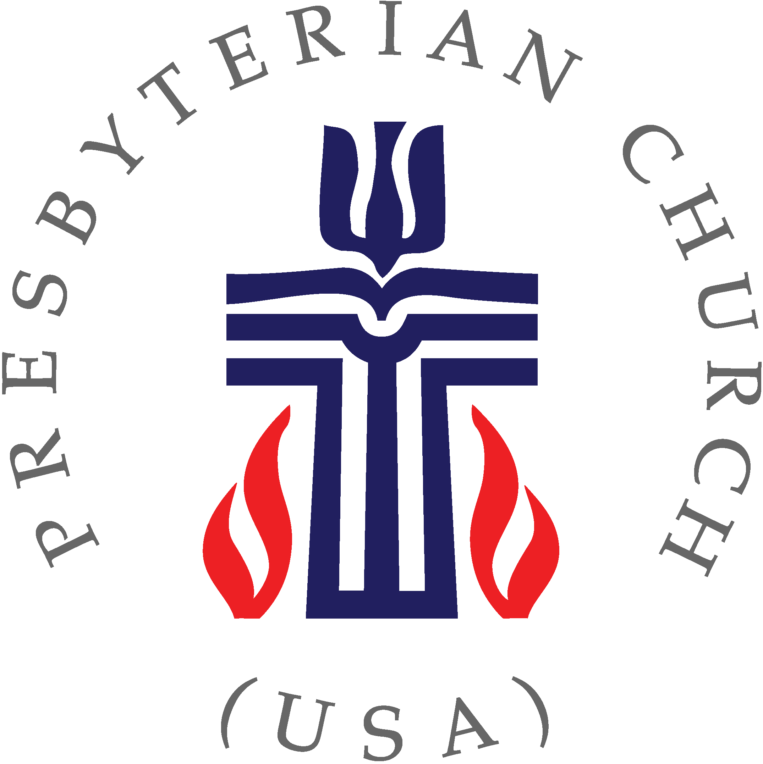

SAND DOLLARS FELLOWSHIP GROUP

Ministry Description

Objective: You will help FUPC to glorify God through faithful service and nurturing fellowship by participating in a group of 25-35 singles and couples who seek to get to know new members and visitors to FUPC, grow in faith and service to the lord, conduct mission and service projects throughout the church and local community and raise monies to help fund other church activities and ministries.
Result #1: Sand Dollars meet the first Friday of the month (January-May & September- November) in Eversull Hall for food, fun, and fellowship. During the summer months a variety of social activities occur and in December the Christmas party is held at a local venue.

Result #2: After a time of greeting and fellowship, a potluck dinner is served and a program and business meeting usually follows.

Result #3: Sand Dollars host the annual Easter Bunny Breakfast held the day before Easter Sunday. Around 200 kids of all ages attend, not only to participate in the big egg hunt; but to enjoy a continental breakfast, face painting, and a performance by “Harvey the Juggler”.

Result #4: The annual Fall Kick-Off Picnic is held at the church picnic pavilion the Saturday following Labor Day.

Result #5: The Sand Dollars serve as “hospitality hosts” about six times a year during Sunday mornings

Result #6: Leadership opportunities are provided as there are four elected office positions (Skippers, Log Keepers, Pursers and Chaplains) as well as several appointed committee positions which enable members to grow and develop their management and administrative skills and abilities.

Result #7: The group holds its major fund raiser in November working at the annual Woodcarver’s Show held at the St Clair County Fairgrounds; and in helping to cleanup after the Woodcarvers yearly dinner in May at the church.

Team Composition (number): 25-35 members

Time Commitment: 2-4 hours per month.

Special Talents and Skills Preferred: Friendly, outgoing personality.

Spiritual Gifts: Hospitality, Evangelism, Administration, Helps,

Support and Accountability: The elected officers identified above.

Resources and Training Provided: Any member can provide the guidance that might be needed.

Thank you for considering this important ministry.

