ST. PAUL’S LUTHERAN CHURCH
COME GROW SERVE
SUNDAY, SEPTEMBER 20, 2026
Season of Creation: Land & Prairie Sunday
Welcome to St. Paul’s Lutheran Church!
Welcome to St. Paul’s! We come today to renew our relationship with our Creator and with our fellow creatures, all who dwell in this fragile sanctuary called Earth. We come to hear the Spirit’s voice through the voice of this land and its ancient custodians. We go back to the beginning, and remember the goodness of creation, and the need for reciprocity in the Creator’s big family of life.
Praise the Lord from the earth…mountains and all hills, fruit trees and all cedars! Wild animals and all cattle and flying birds! –Psalm 148

Words printed in bold are spoken by all. Visitors are invited to sign the guest registry in the Narthex or fill out a pew card and place it in the offering plate.

THIS SERVICE IS LIVE STREAMED. TELL YOUR FRIENDS!
GATHERING
WELCOME
LAND ACKNOWLEDGMENT
On this Sunday that praises God as creator and source of the blessed gift of the earth’s Land, St. Paul’s Lutheran Church wishes to acknowledge and honor the Myaamia, Ho-Chunk, Potawatomi, Kickapoo, Peoria and Oceti Sakowin peoples upon whose ancestral homelands we gather for worship this morning, as well as all our Indigenous siblings who have and continue to care for this place—this land—and call it their home.
PRELUDE Joyful, Joyful, We Adore Thee Kevin Sadowski

The assembly is invited to stand.
CALL TO WORSHIP
P: In the name of the Creator, the fountain of life, in the name of Christ ☩, the pulse of life, and in the name of the Spirit, the breath of life.
All: Amen. Holy! Holy! Holy! Earth is filled with God’s presence.

P: Christ, we come into your presence today to worship in this sanctuary called Earth,
All: a planet filled with your presence: majestic in the forests, potent in the land, steadfast through the wilderness, resplendent with the rivers.

P: God, reveal yourself to us in this place, and show us your face in all creation.
All: Holy! Holy! Holy! Earth is filled with God’s presence.

P: We invite the land to worship with us:
All: wildflowers and groundcovers, swirling grasses and goldenrods.

P: We invite the farmlands to sing with us:
All: wheat fields, orchards, and vineyards, corn fields, gardens, and wetlands.

P: We join with all the fauna of the fields in praising God:
All: horses, sheep, and cattle, grass snakes and grasshoppers, eagles and crows.

P: We invite the ground to stir deep below:
All: life-giving microbes restoring the soil, beetles and worms preparing our food.

P: We celebrate the song of the soil!
All: Sing, soil, sing!

CONFESSION AND FORGIVENESS
P: Blessed be the holy Trinity, ☩, one God, who so loves the world and all who live in it. Amen. Let us confess our sin in the presence of God, Creation, and one another.

Silence is kept for reflection.

P: Reconciling God,
All: we expect nature to serve our needs, and we have damaged it in the process. We trample every wild place and pollute your waters. We abuse your good Earth until it cries out in pain. Forgive us, loving God. Remind us of the covenant you made with the whole Earth. Nourish us so we can restore your awe-inspiring Creation. Amen.
P: Christ, the one who was buried into the heart of the Earth and then raised up to new life, forgives you all your sins. Freed from your burdens, be led by the Spirit to do God’s healing work in the world. Amen
All: Shalom! Shalom! Within us and all creation, shalom!

GATHERING HYMN Now the Green Blade Rises ELW 379

GREETING
P: The grace of our Lord Jesus Christ, the love of God, and the communion of the Holy spirit be with you all.
All: And also with you.

PRAYER OF THE DAY
A: Let us pray.
Gracious God, sculptor of the land, we in our brokenness have damaged your Earth. Restore our relationship with the land, as Christ heals all of Creation. We pray in the name of Christ the Redeemer, who lives and reigns with you and the Holy Spirit, one God now and forever.
All: Amen.
The assembly is invited to be seated.
WORD

FIRST READING: Genesis 3:14-19, 4:8-16
A reading from the Book of Genesis.
¹⁴ The Lord God said to the serpent,
“Because you have done this,
cursed are you among all animals
and among all wild creatures;
upon your belly you shall go,
and dust you shall eat
all the days of your life.
¹⁵ I will put enmity between you and the woman
and between your offspring and hers;
he will strike your head,
and you will strike his heel.”
¹⁶ To the woman he said,
“I will make your pangs in childbirth exceedingly great;
in pain you shall bring forth children,
yet your desire shall be for your husband,
¹⁷ And to the man he said,
“Because you have listened to the voice of your wife
and have eaten of the tree
about which I commanded you,
‘You shall not eat of it,’
cursed is the ground because of you;
in toil you shall eat of it all the days of your life;
¹⁸ thorns and thistles it shall bring forth for you;
and you shall eat the plants of the field.
¹⁹ By the sweat of your face
you shall eat bread
until you return to the ground,
for out of it you were taken;
you are dust,
and to dust you shall return.”
⁸ Cain said to his brother Abel, “Let us go out to the field.” And when they were in the field, Cain rose up against his brother Abel and killed him. ⁹ Then the Lord said to Cain, “Where is your brother Abel?” He said, “I do not know; am I my brother’s keeper?” ¹⁰ And the Lord said, “What have you done? Listen, your brother’s blood is crying out to me from the ground! ¹¹ And now you are cursed from the ground, which has opened its mouth to receive your brother’s blood from your hand. ¹² When you till the ground, it will no longer yield to you its strength; you will be a fugitive and a wanderer on the earth.” ¹³ Cain said to the Lord, “My punishment is greater than I can bear! ¹⁴ Today you have driven me away from the soil, and I shall be hidden from your face; I shall be a fugitive and a wanderer on the earth, and anyone who meets me may kill me.” ¹⁵ Then the Lord said to him, “Not so! Whoever kills Cain will suffer a sevenfold vengeance.” And the Lord put a mark on Cain, so that no one who came upon him would kill him. ¹⁶ Then Cain went away from the presence of the Lord and settled in the land of Nod, east of Eden.

Word of God. Word of Life.
All: Thanks be to God.

PSALM 139:7-12 [Read responsively; congregation in bold]
⁷ Where can I go from your spirit?
Or where can I flee from your presence?
⁸ If I ascend to heaven, you are there;
if I make my bed in Sheol, you are there.
⁹ If I take the wings of the morning
and settle at the farthest limits of the sea,
¹⁰ even there your hand shall lead me,
and your right hand shall hold me fast.
¹¹ If I say, “Surely the darkness shall cover me,
and night wraps itself around me,”
¹² even the darkness is not dark to you;
the night is as bright as the day,
for darkness is as light to you.
SECOND READING: Romans 5:12-17
A reading from Paul’s letter to the Romans.

¹² Therefore, just as sin came into the world through one man, and death came through sin, and so death spread to all because all have sinned—¹³ for sin was indeed in the world before the law, but sin is not reckoned when there is no law. ¹⁴ Yet death reigned from Adam to Moses, even over those who did not sin in the likeness of Adam, who is a pattern of the one who was to come.
¹⁵ But the free gift is not like the trespass. For if the many died through the one man’s trespass, much more surely have the grace of God and the gift in the grace of the one man, Jesus Christ, abounded for the many. ¹⁶ And the gift is not like the effect of the one man’s sin. For the judgment following one trespass brought condemnation, but the gift following many trespasses brings justification. ¹⁷ If, because of the one man’s trespass, death reigned through that one, much more surely will those who receive the abundance of grace and the gift of righteousness reign in life through the one man, Jesus Christ.

Word of God. Word of Life.
All: Thanks be to God.
The assembly is invited to stand for the reading of the Gospel.

GOSPEL ACCLAMATION
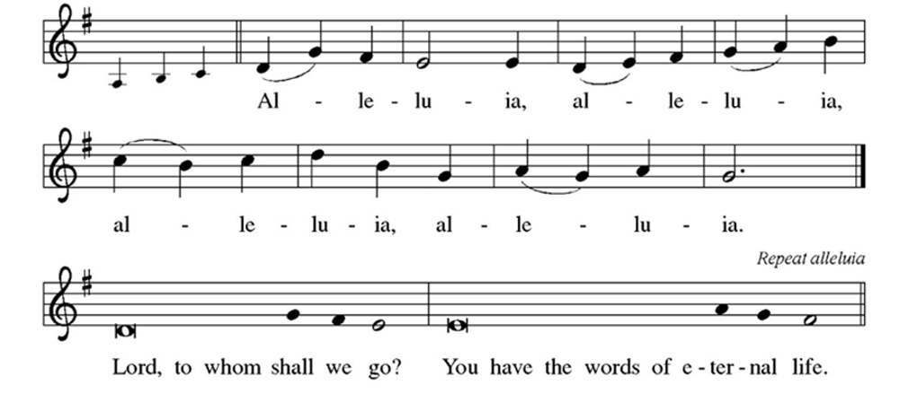

GOSPEL: Matthew 12:38-46

The Holy Gospel according to Matthew.
All: Glory to you, O Lord.

³⁸ Then some of the scribes and Pharisees said to him, “Teacher, we wish to see a sign from you.” ³⁹ But he answered them, “An evil and adulterous generation asks for a sign, but no sign will be given to it except the sign of the prophet Jonah. ⁴⁰ For just as Jonah was three days and three nights in the belly of the sea monster, so for three days and three nights the Son of Man will be in the heart of the earth. ⁴¹ The people of Nineveh will rise up at the judgment with this generation and condemn it, because they repented at the proclamation of Jonah, and indeed something greater than Jonah is here! ⁴² The queen of the South will rise up at the judgment with this generation and condemn it, because she came from the ends of the earth to listen to the wisdom of Solomon, and indeed something greater than Solomon is here!
⁴³ “When the unclean spirit has gone out of a person, it wanders through waterless regions looking for a resting place, but it finds none. ⁴⁴ Then it says, ‘I will return to my house from which I came.’ When it returns, it finds it empty, swept, and put in order. ⁴⁵ Then it goes and brings along seven other spirits more evil than itself, and they enter and live there, and the last state of that person is worse than the first. So will it be also with this evil generation.”
⁴⁶ While he was still speaking to the crowds, his mother and his brothers were standing outside, wanting to speak to him.

The Gospel of the Lord.
All: Praise to you, O Christ.
Please be seated.
SERMON Pr. Peg Otte
Please stand as you are able
HYMN OF THE DAY Touch the Earth Lightly ELW 739

PRAYERS OF INTERCESSION
A: Let us pray for the revealing of the reign of God in the world, now and always.

A period of silence is kept

A: Breath of life, receive our thanks for the beauty of our local habitat and all who dwell in it, and grant us the wisdom and will to conserve it. God, Giver of life,
All: hear our prayer.

PM: Source of life, heal and redeem the wounds of your creation, and visit the places and people who suffer from our indifference, neglect, and greed. God, Giver of life,
All: hear our prayer.

A: Author of nature, receive our gratitude for places of restoration and healing, and continue to bless those places that feed our lives and spirits. God, Giver of life,
All: hear our prayer.

PM: Divine Physician, heal our communities, especially those where neglect, greed, or violence inflict suffering upon people and other creatures. God, Giver of life,
All: hear our prayer.

A: Comforter of all the earth, sustain the people of this community and this assembly who desire or need your presence and help, embracing this day all whom we now name silently or aloud (pause) God, Giver of life,
All: hear our prayer.

PM: Rock and refuge of all your creatures, receive into everlasting mercy all those who have died, remembering today those we name in our hearts and with our voices….[time is given to welcome these names] God, Giver of life,
All: hear our prayer.

PM: Bountiful God, you call us to labor with you in tending the earth: Where we lack +
love, open our hearts to the world; where we waste, give us discipline to conserve; where we neglect, awaken our minds and wills to insight and care. May we with all your creatures honor and serve you in all things for you live and reign with Christ, Redeemer of all, and with your Holy Spirit, one God, now and forever.
All: Amen.

PEACE

PM: Peace with yourself. Peace with Creation. Peace with one another. The peace of Christ be always with you..
All: And also with you.
The assembly is invited to be seated.

MEAL
THE OFFERING An offering is gathered and the Table is set.

MUSICAL OFFERING He's Got the Whole World arr. Keith Hampton
Mackenzie Minguillo, soprano; Nicholas Marotta, mezzo-soprano

OFFERING PRAYER
A: Let us pray.
Loving God, we offer at your table the gifts of our hearts. Help us take heart in you and share freely of your love, so that all creation can taste your abundance. We ask this in the name of Jesus, through the Spirit abiding with us now and forever.
All: Amen.

GREAT THANKSGIVING
P: The Lord be with you.
All: And also with you.
P: Lift up your hearts.
All: We lift them to the Lord.
P: Let us give thanks to the Lord our God.
All: It is right to give our thanks and praise.
P: It is indeed right, our duty and our joy, that we should at all times and in all places give thanks and praise to you, almighty and merciful God, through your eternal Word, the Wisdom from on high by whom you created all things: our Savior, Jesus Christ. You laid the foundations of the world and enclosed the sea when it burst out of the womb. You brought forth all creatures of the earth and gave breath to humankind.
Wondrous are you, Holy One of Blessing; all you create is a sign of hope for our journey. And so as the morning stars sing your praises, with the heavenly beings and all creation, we praise your name and join their unending hymn:

HOLY, HOLY, HOLY
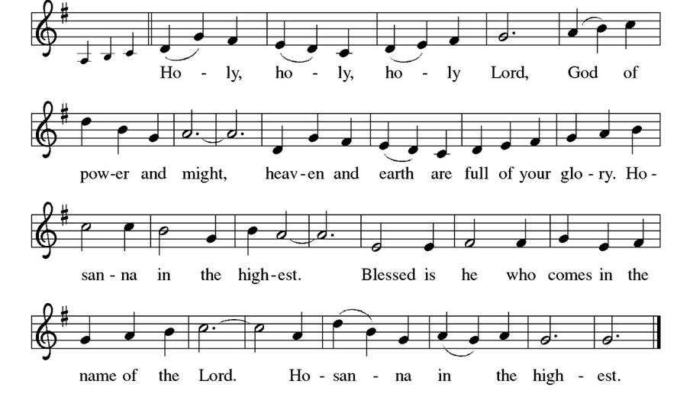

EUCHARISTIC PRAYER
P: O God, how majestic is your name in all the earth. Over the eons your merciful might evolved our home, a fragile tree of life. Here by your wisdom are both life and death, growth and decay, the nest and the hunt, sunshine and storm, darkness and light. Sustained by these wonders, we creatures of dust join in the ancient song: The earth is full of your glory.
All: The earth is full of your glory.

P: O God, you took on our flesh in Jesus our healer. In Christ you bring life from death;
we remember his cross, we laud his resurrection. Broken like bread, he enlivens our body. Outpoured like wine, he fills the earth with goodness. Receiving this mystery, we mortals sing our song: The earth is full of your glory.
All: The earth is full of your glory.
P: We praise you for the heart of Jesus, so filled with your love for this earth. In the night in which he was betrayed, our Lord Jesus took bread, and gave thanks; broke it, and gave it to his disciples, saying:
Take and eat; this is my body, given for you.
Do this for the remembrance of me.

Again, after supper, he took the cup, gave thanks, and gave it for all to drink, saying:
This cup is the new covenant in my blood,
shed for you and for all people for the forgiveness of sin.
Do this for the remembrance of me.

Gathered around this table, we your children unite in this song: The earth is full of your glory.
All: The earth is full of your glory.

P: O God triune, you create the worlds, you uphold the living, you embrace the dead. Send forth your Spirit and renew the face of the earth. Strengthen us for our journey with this meal, the body and blood of Christ. Give us a future that trusts in you and cares for your earth. Empowered by your promises, we rise from our deaths to praise you again: The earth is full of your glory.
All: The earth is full of your glory.

P: Amen, and amen.
All: Amen, and amen.

THE LORD’S PRAYER
P: Together as one body, we pray the prayer Jesus taught us.
All: Our Father in heaven, hallowed be your name, your kingdom come, your will be done, on earth as in heaven. Give us today our daily bread. Forgive us our sins, as we forgive those who sin against us. Save us from the time of trial, and deliver us from evil. For the kingdom, the power, and the glory are yours,
now and forever. Amen

INVITATION TO COMMUNE
P: The gifts of creation for God’s beloved creatures. Come and share.

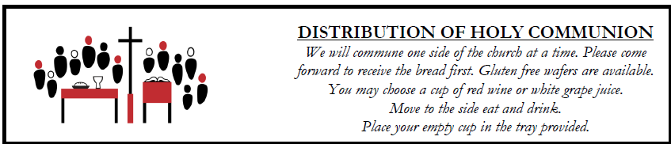
All are welcome at Christ’s Table. We believe Jesus is the host and the gifts of God are for everyone. Child-ren will be offered communion unless otherwise indicated by parents. The wine is red and grape juice is white.

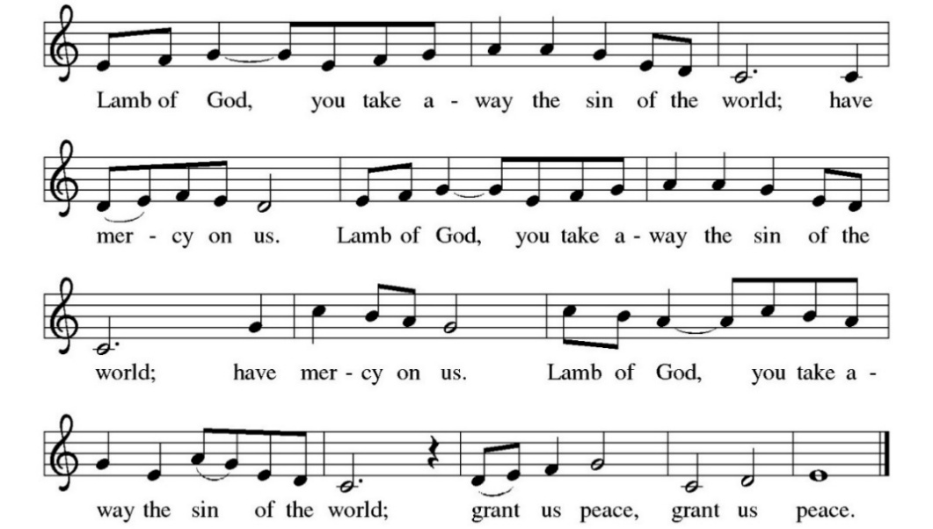
LAMB OF GOD

COMMUNION HYMN God Extends an Invitation ELW 486
Lord Let My Heart Be Good Soil ELW 512

Please stand as you are able.
TABLE BLESSING
P: Now may the power of Christ’s body and blood reach deep into your heart, your mind, and your body to heal your wounds and, through your healing to all the earth. In Jesus’ name,
All: Amen.

PRAYER AFTER COMMUNION
A: Let us pray.
God of our salvation, we give you thanks for this meal that restores our souls, reconciles us to you, and strengthens us for the journey. Through the body and blood of your Son, may we become Christ’s body in the world, bearing witness to your love for all creation, through Jesus Christ, our Savior and Lord.
All: Amen.

SENDING
Please be seated for the announcements.
ANNOUNCEMENTS
The assembly is invited to stand.
SENDING BLESSING
P: God of the galaxies, God of the starburst and sunlit morning, God of the forest and ocean, God of the blooming desert and rolling grasslands, shine on us today and bless us ☩ with your presence.
All: Amen.

SENDING HYMN To Be Your Presence ELW 546

The congregation will recess out during the sending hymn.

DISMISSAL
A: Go in peace. Flourish with creation.
All: Thanks be to God.

PASSING THE UNWORKED FIELD
Queen Anne’s lace
is hardly
prized but
all the same it isn’t
idle look
how it
stands straight on its
thin stems how it
scrubs its white faces
with the
rags of the sun how it
makes all the
loveliness
it can. ~Mary Oliver

THANK YOU
To our musicians, Mackenzie Minguillo, soprano and Nicholas Marotta, mezzo-soprano.
To LuAnne Kastilahn for donating flowers for her father’s (Robert P. Origer) heavenly 96th birthday.

PRAYER REQUESTS
For Joan Brandt.
For Jan Rock, as she recovers from stenoses.
For Bill Kastilahn, recovering from eye interaction with medication.
For Joe Berube, husband of Sue Murphy (director of Interfaith Action), as he
undergoes cancer treatment.
For Deborah Green, friend of LuAnne Origer, as she recovers from brain surgery.
For the family of Sue Salisbury as they mourn the death of her uncle, Gernard
“Bud” Drayer.



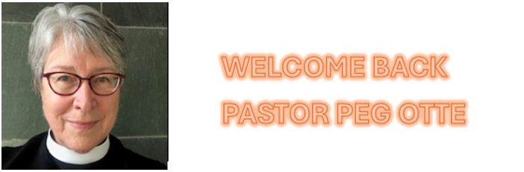

PASTORAL FELLOW: PEG OTTE

We are thrilled to have Pastor Peg return a second time to St. Paul's this year as Pastoral Fellow. She will lead us through the Season of Creation (some new twists this year!) and be with us from September 13 though October 11.
Pr. Peg is well-known and greatly loved at St. Paul's, having led us as pastoral fellow multiple times over the years. Most recently, she led us through the Epiphany season. She has previously led us as fellow for Lent-Easter (2025), Eastertide (2024), and for Season of Creation (2023). Prior to that, she served as our interim pastor during 2019 after Pr. Tim McKenzie moved to North Carolina.
Pr. Peg and her husband Randy are long-time Evanston residents who raised their three now-adult children here. Pr. Peg previously served at Lutheran Church of the Good Shepherd in Prospect Heights and St. John’s Lutheran Church in Wilmette, has served as an interim minister in this synod, and for many years, served during winter at Shepherd by the Sea. She is delighted to return to St. Paul’s this year for the beloved Season of Creation.

