COME GROW SERVE
ST. PAUL’S LUTHERAN CHURCH
SUNDAY, FEBRUARY 1, 2026
Fourth Sunday of Epiphany
Welcome to St. Paul’s Lutheran Church!
Who are the blessed ones of God? For Micah, they are those who do justice, love kindness, and walk humbly with God. For Paul, they are the ones who find wisdom in the weakness of the cross. For Jesus, they are the poor, the meek, the merciful, the pure in heart, the peacemakers, those who mourn, and those who hunger for righteousness. In baptism we find our blessed identity and calling in this countercultural way of living and serving.
Words printed in bold are spoken by all. Visitors are invited to sign the guest registry in the Narthex or fill out a pew card and place it in the offering plate.
THIS SERVICE IS LIVE STREAMED. TELL YOUR FRIENDS!
GATHERING
WELCOME PM: Welcome to those who are joining us online. Welcome to worship at St. Paul’s!

PRELUDE Oh Morning Star, How Fair and Bright Max Drischner
arr. Kurt Westerberg
Diane Mues, viola; Stefan Westerberg, cello

The assembly is invited to stand.
THANKSGIVING FOR BAPTISM
P: Joined to Christ in the waters of baptism, clothed with God’s mercy and forgiveness, let us give thanks for the gift of baptism.

Holy God, fountain of living water, source of mercy, tender and mighty, you are clothed with majesty and splendor. Your steadfast love fills the earth.
All: Your steadfast love fills the earth.

P: Your love flows through water, satisfying the thirst of all living things, sustaining life in this community, nourishing and delighting us. We bless you for these gifts of water: Lake Michigan, the Chicago River, and the Skokie Lagoon. Your steadfast love fills the earth.
All: Your steadfast love fills the earth.

P: Your love flows through water, a sign of your saving power: Noah and the animals survive the flood, Hagar discovers your well. The Israelites escape through the sea, and they drink from your gushing rock. Naaman washes his leprosy away, and the Samaritan woman will never be thirsty again. Your steadfast love fills the earth.
All: Your steadfast love fills the earth.

P: Your love flows through the water of baptism joined to your life-giving Word: your well of mercy and cleansing flood, your sea of deliverance from death into life, your healing river washing sin away, your living water springing up to eternal life. Your steadfast love fills the earth.
All: Your steadfast love fills the earth.

P: Shower us with your Holy Spirit. Fill us with your love. Clothe us and all your people with grace. Embolden us to do justice. Bless us to love mercy. Guide us to walk humbly with you, whom we thank and praise, through Jesus Christ, in the unity of the Holy Spirit, now and forever.
All: Amen.

GATHERING HYMN As We Gather at Your Table ELW 522

GREETING
P: The grace of our Lord Jesus Christ, the love of God, and the communion of the Holy Spirit be
with you all.
All: And also with you.

PRAYER OF THE DAY
A: Let us pray.
Holy God, you confound the world’s wisdom in giving your kingdom to the lowly and the pure in heart. Give us such a hunger and thirst for justice, and perseverance in striving for peace, that in our words and deeds the world may see the life of your Son, Jesus Christ, our Savior and Lord.
All: Amen.
The assembly is invited to be seated.
WORD
FIRST READING: Micah 6:1-8
A reading from Micah.
¹ Hear what the Lord says:
Rise, plead your case before the mountains,
and let the hills hear your voice.
² Hear, you mountains, the case of the Lord,
and you enduring foundations of the earth,
for the Lord has a case against his people,
and he will contend with Israel.
³ “O my people, what have I done to you?
In what have I wearied you? Answer me!
⁴ For I brought you up from the land of Egypt
and redeemed you from the house of slavery,
and I sent before you Moses,
Aaron, and Miriam.
⁵ O my people, remember now what King Balak of Moab devised,
what Balaam son of Beor answered him,
and what happened from Shittim to Gilgal,
that you may know the saving acts of the Lord.”
⁶ “With what shall I come before the Lord
and bow myself before God on high?
Shall I come before him with burnt offerings,
with calves a year old?
⁷ Will the Lord be pleased with thousands of rams,
with ten thousands of rivers of oil?
Shall I give my firstborn for my transgression,
the fruit of my body for the sin of my soul?”
⁸ He has told you, O mortal, what is good,
and what does the Lord require of you
but to do justice and to love kindness
and to walk humbly with your God?

Word of God. Word of Life.
All: Thanks be to God.
PSALM 15
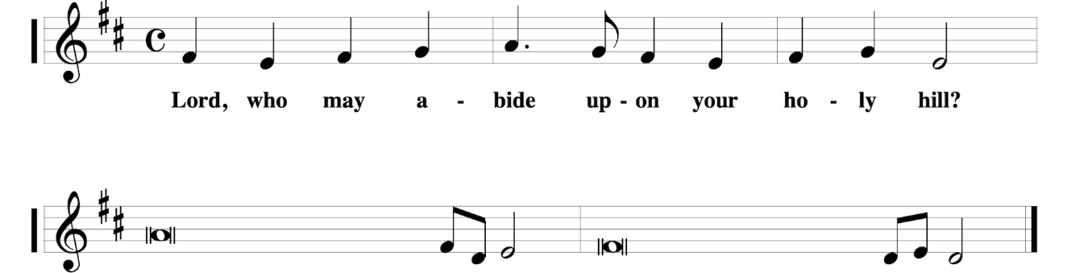
¹ Lord, who may dwell in your | tabernacle?
Who may abide upon your | holy hill?
² Those who lead a blameless life and do | what is right,
who speak the truth | from their heart; R
³ they do not slander with the tongue, they do no evil | to their friends;
they do not cast discredit up- | on a neighbor.
⁴ In their sight the wicked are rejected, but they honor those who | fear the Lord.
They have sworn upon their health and do not take | back their word.
⁵ They do not give their money in hope of gain, nor do they take bribes a- | gainst the innocent.
Those who do these things shall never be | overthrown. R

SECOND READING: 1 Corinthians 1:18-31
A reading from First Corinthians.
¹⁸ The message about the cross is foolishness to those who are perishing, but to us who are being saved it is the power of God. ¹⁹ For it is written,
“I will destroy the wisdom of the wise,
and the discernment of the discerning I will thwart.”
²⁰ Where is the one who is wise? Where is the scholar? Where is the debater of this age? Has not God made foolish the wisdom of the world? ²¹ For since, in the wisdom of God, the world did not know God through wisdom, God decided, through the foolishness of the proclamation, to save those who believe. ²² For Jews ask for signs and Greeks desire wisdom, ²³ but we proclaim Christ crucified, a stumbling block to Jews and foolishness to gentiles, ²⁴ but to those who are the called, both Jews and Greeks, Christ the power of God and the wisdom of God. ²⁵ For God’s foolishness is wiser than human wisdom, and God’s weakness is stronger than human strength.
²⁶ Consider your own call, brothers and sisters: not many of you were wise by human standards, not many were powerful, not many were of noble birth. ²⁷ But God chose what is foolish in the world to shame the wise; God chose what is weak in the world to shame the strong; ²⁸ God chose what is low and despised in the world, things that are not, to abolish things that are, ²⁹ so that no one might boast in the presence of God. ³⁰ In contrast, God is why you are in Christ Jesus, who became for us wisdom from God, and righteousness and sanctification and redemption, ³¹ in order that, as it is written, “Let the one who boasts, boast in the Lord.”

Word of God. Word of Life.
All: Thanks be to God.
The assembly is invited to stand for the reading of the Gospel.
GOSPEL ACCLAMATION
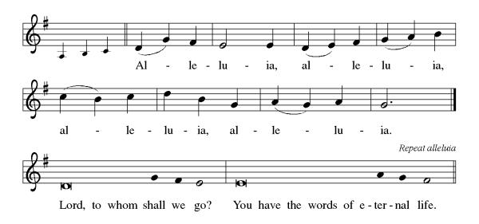
GOSPEL: Matthew 5:1-12
The Holy Gospel according to Matthew.
All: Glory to you, O Lord.

¹ When Jesus saw the crowds, he went up the mountain, and after he sat down, his disciples came to him. ² And he began to speak and taught them, saying:
³ “Blessed are the poor in spirit, for theirs is the kingdom of heaven.
⁴ “Blessed are those who mourn, for they will be comforted.
⁵ “Blessed are the meek, for they will inherit the earth.
⁶ “Blessed are those who hunger and thirst for righteousness, for they will be filled.
⁷ “Blessed are the merciful, for they will receive mercy.
⁸ “Blessed are the pure in heart, for they will see God.
⁹ “Blessed are the peacemakers, for they will be called children of God.
¹⁰ “Blessed are those who are persecuted for the sake of righteousness, for theirs is the kingdom of heaven.
¹¹ “Blessed are you when people revile you and persecute you and utter all kinds of evil against you falsely on my account. ¹² Rejoice and be glad, for your reward is great in heaven, for in the same way they persecuted the prophets who were before you.”

The Gospel of the Lord.
All: Praise to you, O Christ.

Please be seated.
SERMON Pr. Peg Otte
Please stand as you are able.
HYMN OF THE DAY

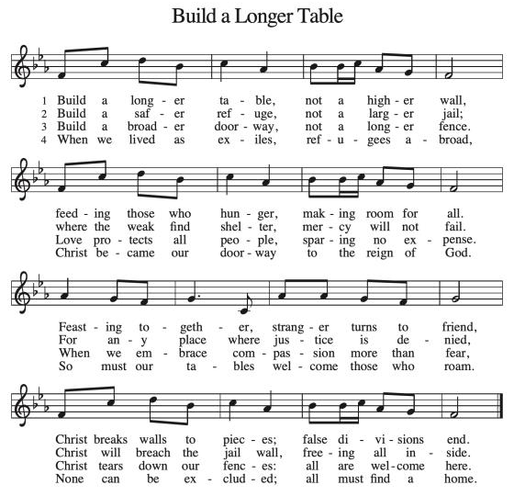

PRAYERS OF INTERCESSION

PM: As God’s beloved children united in Christ, let us pray for the church, the whole human community, and the well-being of the earth, our home.

A brief silence.

PM: God our wisdom, renew the church in the power of the Spirit, that it may do justice, love kindness, live humbly, and boldly proclaim Christ crucified. We pray for social justice and humanitarian aid ministries. Merciful God,
All: receive our prayer.

A: God our source, we honor you by caring wisely for your creation. We pray for the health of old growth forests, ice caps, and ocean currents. Preserve the diversity of life on earth. Merciful God,
All: receive our prayer.

PM: God our righteousness, raise up visionary leaders who serve with integrity and respect human rights. Increase freedom in every nation. Protect educators, journalists, artists, and religious activists who are reviled for speaking truth. Merciful God,
All: receive our prayer.
A: God our advocate, you give hope to all who suffer because of persecution, poverty, or war. Reunite separated families and bring orphaned children to safety. Comfort any who grieve or suffer in any way, especially those on our prayer list and those we pray for either silently or aloud (pause). Merciful God,
All: receive our prayer.
PM: God our blessing, we pray for the children and youth of this congregation, and for parents, grandparents, mentors, teachers, and youth ministers who model love for their neighbor and care for others. Merciful God,
All: receive our prayer.

A: God our joy, we give thanks for the lives of those before us who journeyed humbly with you. Merciful God,
All: receive our prayer.

PM: Confident that the Holy Spirit receives our prayers and answers us, we commend all for whom we pray to God’s loving-kindness made known to us in Christ Jesus our Savior.
All: Amen.

PEACE

PM: The peace of the Lord be with you always.
All: And also with you.

The assembly is invited to be seated.

MEAL
THE OFFERING An offering is gathered and the Table is set.

MUSICAL OFFERING Jesus, the Light of the World George D. Elderkin
arr. Kurt Westerberg
Libby Harrison, soprano; Nicholas Marotta, mezzo-soprano

Please stand as you are able.

OFFERING PRAYER
A: Let us pray.
God of majesty, no eye has seen, no ear has heard what you have prepared for those who love you,
yet in this meal you reveal the wideness of your mercy. Use what we have gathered to feed us with the reign of God come near, Jesus Christ, our Savior and Lord.
All: Amen

GREAT THANKSGIVING
P: The Lord be with you.
All: And also with you.
P: Lift up your hearts.
All: We lift them to the Lord.
P: Let us give thanks to the Lord our God.
All: It is right to give our thanks and praise.
P: It is indeed right, our duty and our joy, that we should at all times and in all places give thanks and praise to you, almighty and merciful God, through our Savior Jesus Christ. By the leading of a star he was shown forth to all nations; in the waters of the Jordan you proclaimed him your beloved Son; and in the miracle of water turned to wine he revealed your glory. And so, with all the choirs of angels, with the church on earth and the hosts of heaven, we praise your name and join their unending hymn:
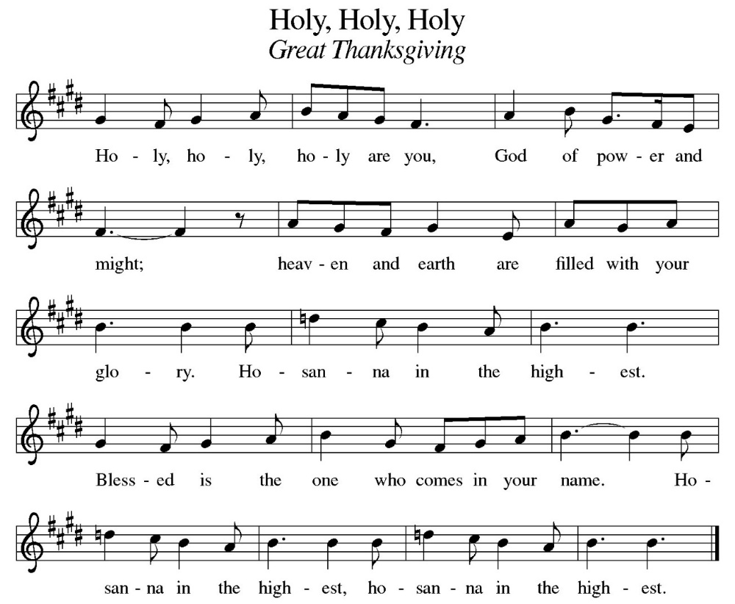

EUCHARISTIC PRAYER
P: God of our weary years, God of our silent tears, you have brought us this far along the way.
In times of bitterness you did not abandon us, but guided us into the path of love and light. In every age you sent prophets to make known your loving will for all humanity. The cry of the poor has become your own cry; our hunger and thirst for justice is your own desire. In the fullness of time, you sent your chosen servant to preach good news to the afflicted, to break bread with the outcast and despised, and to ransom those in bondage to prejudice and sin.
In the night in which he was betrayed, our Lord Jesus took bread, and gave thanks; broke it, and gave it to his disciples, saying: Take and eat; this is my body, given for you. Do this for the remembrance of me.
Again, after supper, he took the cup, gave thanks, and gave it for all to drink, saying: This cup is the new covenant in my blood, shed for you and all people for the forgiveness of sin. Do this for the remembrance of me.
For as often as we eat of this bread and drink from this cup we proclaim the Lord’s death until he comes.
All: Christ has died. Christ is risen. Christ will come again.

P: Remembering, therefore, his death and resurrection, we await the day when Jesus shall return to free all the earth from the bonds of slavery and death. Come, Lord Jesus! And let the church say, Amen.
All: Amen.

P: Send your Holy Spirit, our advocate, to fill the hearts of all who share this bread and cup with courage and wisdom to pursue love and justice in all the world. Come, Spirit of freedom! And let the church say, Amen.
All: Amen.

P: Join our prayers and praise with your prophets and martyrs of every age, that, rejoicing in the hope of the resurrection, we might live in the freedom and hope of your Son. Through him, with him, in him, in the unity of the Holy Spirit, all glory and honor is yours, almighty Father, now and forever.
All: Amen.

THE LORD’S PRAYER
P: Together as one body, we pray the prayer Jesus taught us.
All: Our Father, who art in heaven, hallowed be thy name. Thy kingdom come, thy will be done on earth as it is in heaven. Give us this day our daily bread; and forgive us our trespasses as we forgive those who trespass against us; and lead us not into temptation, but deliver us from evil. For thine is the kingdom, the power, and the glory, forever and ever. Amen.

INVITATION TO COMMUNE
P: Here is the Lamb of God who takes away the sin of the world! Come to the table; taste and see.

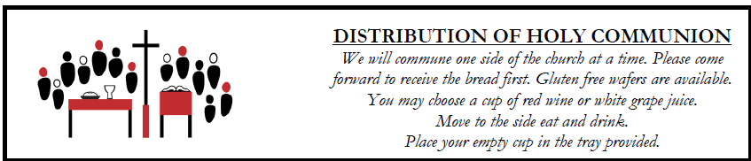

All are welcome at Christ’s Table. We believe Jesus is the host and the gifts of God are for everyone. Children will be offered communion unless otherwise indicated by parents. The wine is red and grape juice is white.
Please be seated.

LAMB OF GOD
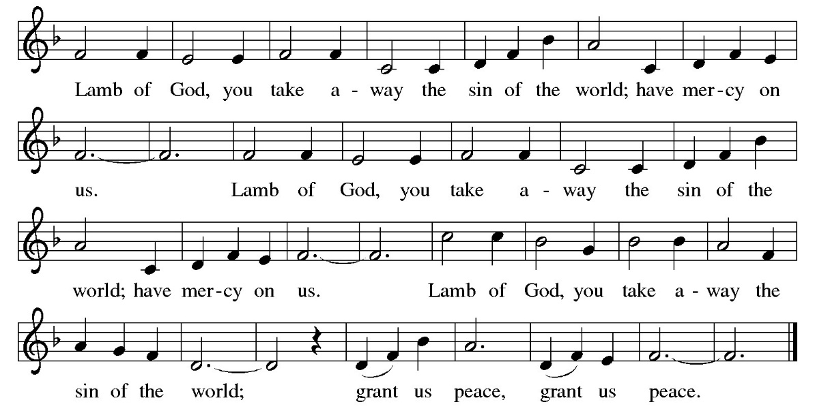

COMMUNION HYMN Blest Are They ELW 728
Please stand as you are able.

TABLE BLESSING
P: Now may the power of Christ’s body and blood reach deep into your heart, your mind, and your body to heal your wounds and, through your healing to all the earth. In Jesus' name,
All: Amen.
PRAYER AFTER COMMUNION
A: Let us pray.
Radiant God, we have seen your glory in the face of Jesus Christ. In the sacrament of his body and blood you have drawn us to your heart. Send us from this table with delight, that our lives may reflect the beauty of your love, and bear witness to all we have seen and heard, through Jesus Christ, our Savior and Lord.
All: Amen.
SENDING
Please be seated for the announcements.
ANNOUNCEMENTS
The assembly is invited to stand.
SENDING BLESSING
P: May the triune God, who has put a new song in your mouth and tuned your heart for praise ☩ bless you now and forever.
All: Amen.

SENDING HYMN To Be Your Presence ELW 546, v. 1-3

DISMISSAL
A: Go in peace. Do justice. Love mercy.
All: Thanks be to God.

POSTLUDE Movement IV, Presto, from Concerto in G Major G. P. Telemann
Diane Mues, viola

MARK YOUR CALENDAR:
ANNUAL MEETING
Sunday, February 8th, immediately after service.
Enjoy a delicious and healthy potluck lunch immediately following worship as we give thanks for St. Paul’s journey over the past year, and discern together our vision for the coming year.
In the past few years, our focus necessarily has been on how we at St. Paul’s can “do church” in new ways, given new realities. This year, in contrast, we will focus more on how St. Paul’s—as an individual Christian congregation—along with the ELCA—acts in a world that is increasingly unjust, cruel, oppressive, and chaotic. We will consider how we can courageously challenge disorder and injustice and be Christ’s witness in our immediate community and larger world. Specifically, at our annual meeting, we will decide what we pragmatically can and will do in 2026 to ensure God’s “kingdom is come” in our immediate context.

THANK YOU
To our musicians: Libby Harrison, soprano; Nicholas Marotta, mezzo-soprano; Diane Mues, viola;
Stefan Westerberg, cello.
To Harvey Wolf for hosting coffee fellowship.
To Mark Pinguey and Jen Buehn for clearing our sidewalks of all the snow last Sunday!

PRAYER REQUESTS
For Joan Ehrenberg, suffering from a broken wrist and bruising.
For Jan Rock, as she recovers from stenoses.
For Renee Carlson, our florist, battling cancer.
For Peter Hanson recovering from surgery.



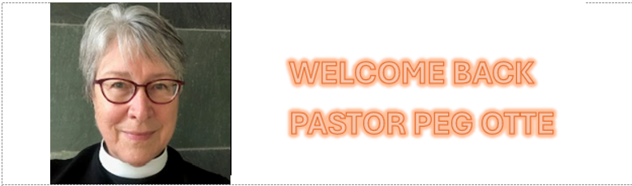

We are thrilled to welcome back our good friend, Pr. Peg Otte, as our Pastoral Fellow for the Epiphany season (Jan. 4 – Feb. 15). We’ve been blessed to have Pr. Peg’s leadership many times over the years – as our Pastoral Fellow in each of 2023, 2024 and 2025, and prior to that, as our interim pastor during 2019 after Pr. Tim McKenzie moved to North Carolina. Pr. Peg and her husband Randy are long-time Evanston residents who raised their three now-adult children here. Pr. Peg previously served at Lutheran Church of the Good Shepherd in Prospect Heights and St. John’s Lutheran Church in Wilmette, has served as an interim minister in this synod, and for many winters, served at Shepherd by the Sea, a joint Episcopal/Lutheran congregation in Gualala, California. She is delighted to return to St. Paul’s this year for the beloved season of Epiphany.

