Before he finished his third and last missionary journey, Paul had a couple more stops.

I. ____________ STOPS. Acts 21:1-3

This text read like a captain’s logbook, recording the progress of the trip, port by port. In summary, Paul sailed from Miletus, to Caesarea, near Jerusalem.

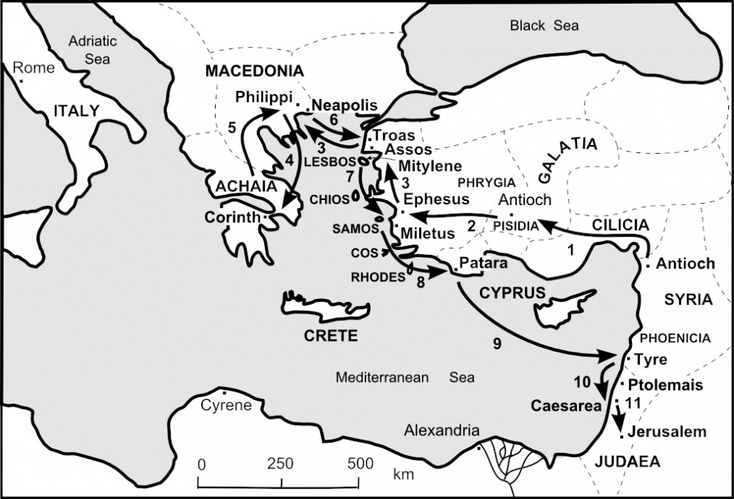

In these stops his commitment to face what awaited him was tested! His first warning came in Acts 20:22; the second…

II. ____________ GO! Acts 21:4-9

The daughters had the gift of foretelling or forthtelling. Once again, they warned Paul not to go.

III. YET ANOTHER ______________. Acts 21:10-13

Paul knew he was expendable! We all are! Paul’s conclusion: “The will of the Lord be done.”

IV. THE GOOD ___________: Acts 21:15-20

Paul gave a glowing report on his journeys: BUT…there was also bad news!

V. THE ________ NEWS: Acts 21:21-25

RUMORS!

VI. ARRESTED! Acts 21:26-32

VII. BOUND WITH ____________. Acts 21:33-40

†††

WHAT HAVE WE LEARNED TODAY?

1. All good things come to an end. 3rd Missionary journey.

2. Paul knew danger awaited him in Jerusalem, but he was determined to go. He was willing to pay the price.

3. God’s work continues after we are gone.

4. He made his report, clearing up some false rumors.

5. Paul was arrested and bound in chains.

Next Week:

“Paul’s Testimony”

Ans: Final; Don’t; Warning; News; Bad; Chains.

