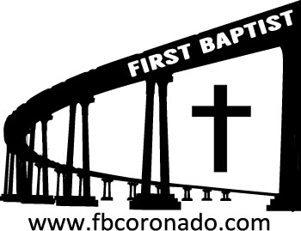

Reach Up, Reach Out, Reach Our World

445 C Ave
Coronado, CA 92118
(619) 435-6588
fbcoronado.com
Jim W. Baize, Pastor
Julie Burkhart, Secretary, Childcare Coordinator
Patsy Lower, Treasurer
Laura Stecher, Children’s Ministry
Jason & Jennifer Griffith – Jr. High Youth Ministry
Rachel Gorken, Ladies’ Ministry
Dan Malcolm, Men’s Ministry/VIP Ministry
Monica Medina, Convalescent Ministry
Julie Ziegler, Fellowship Ministry
Sheerah Haywood, Worship Ministry
Bobby Greer, Maintenance
Our mission is to produce fully devoted followers of Jesus Christ. If we can be of any help to you, feel free to give us a call.

First Baptist Church Coronado

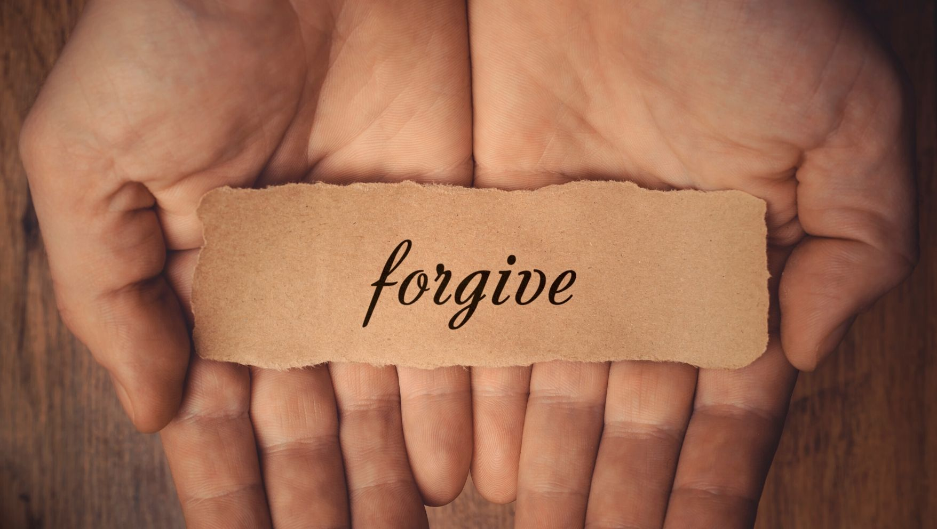

Family Series, Part 3
“Forgiveness, Key to
A Great Marriage”

Pastor Jim W. Baize
September 5, 2021

FORGIVENESS

One word. It doesn’t sound too complicated. I think we all know what it means. I think. But do we? Here is a formal, theological definition offered by Baker’s Encyclopedia of the Bible:

Ceasing to feel resentment for wrongs and offenses; pardon, involving restoration of broken relationships. Primarily, forgiveness is an act of God, releasing sinners from judgment and freeing them from the divine penalty of their sin. Since only God is holy, only God can forgive sin (Mk 2:7; Lk 5:21). Forgiveness is also a human act toward one’s neighbor, given new incentive and emphasis in the NT because of God’s forgiveness in the death of Christ. Hence forgiveness is a uniquely Christian doctrine.

In other religions, forgiveness does not have the same force. In animism, there is no awareness of a personal relationship with God. In Hinduism, all have to pay the inexorable consequences of karma in the wheel of reincarnations. Buddhism likewise knows nothing of a forgiving God. The idea is present in Islam, but there is no personal God and Father. Even in Judaism, forgiveness remains a limited experience, though forgiveness as developed in the NT adds dimension to the teaching of the OT.

Forgiveness is a wonderful thing, both when it is received and when it is given! When received from God it lifts the heavy weight of sin, regret, guilt, and remorse. When given to others, it removes an entirely different weight! Be thankful forgiveness is available – and be ready to give it away as freely as it was given to you!

Pastor Jim W. Baize

Welcome to First Baptist Church Coronado!

Adult Sunday School 8:45
Windsurfers Jr. High 9:00
Worship Service & Communion 10:00
Children’s Sunday School 10:15

Ladies’ Bible Studies This Week:

Wednesday bible study in the park 4:00-5:30 p.m.
Centennial Park 1101 First Street in Coronado, bring a blanket or chair
Contact Rachel Gorken Rachelgorken@gmail.com or Lily Namwanga
619-607-9269
Thursday morning home bible study at 10:30
“The Life of King David” will be studied
Contact Nancy Trotter for location & details 619-437-1971

Friday morning bible study 9:45 – Noon
“Everything is Possible With God” by Rick Warren
Led by Monica Olivares 619-242-6001
Books and childcare provided

Ladies' Bible Study Fellowship begins Wednesday, September 15th!
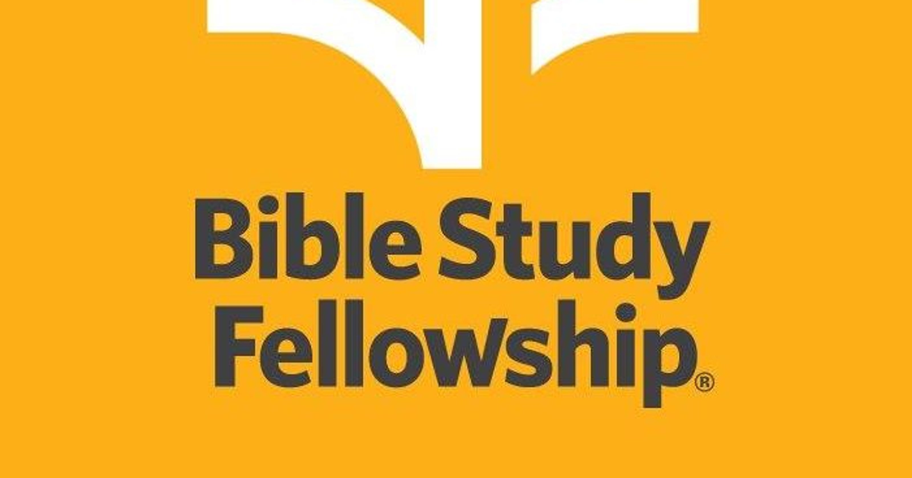
10:00 - 11:30 a.m.
To sign up email bsf.ca1134@gmail.com and request Coronado location.
Questions: Contact BSF leader Nicole Malcolm 619-850-1324.
No childcare is available for this class.

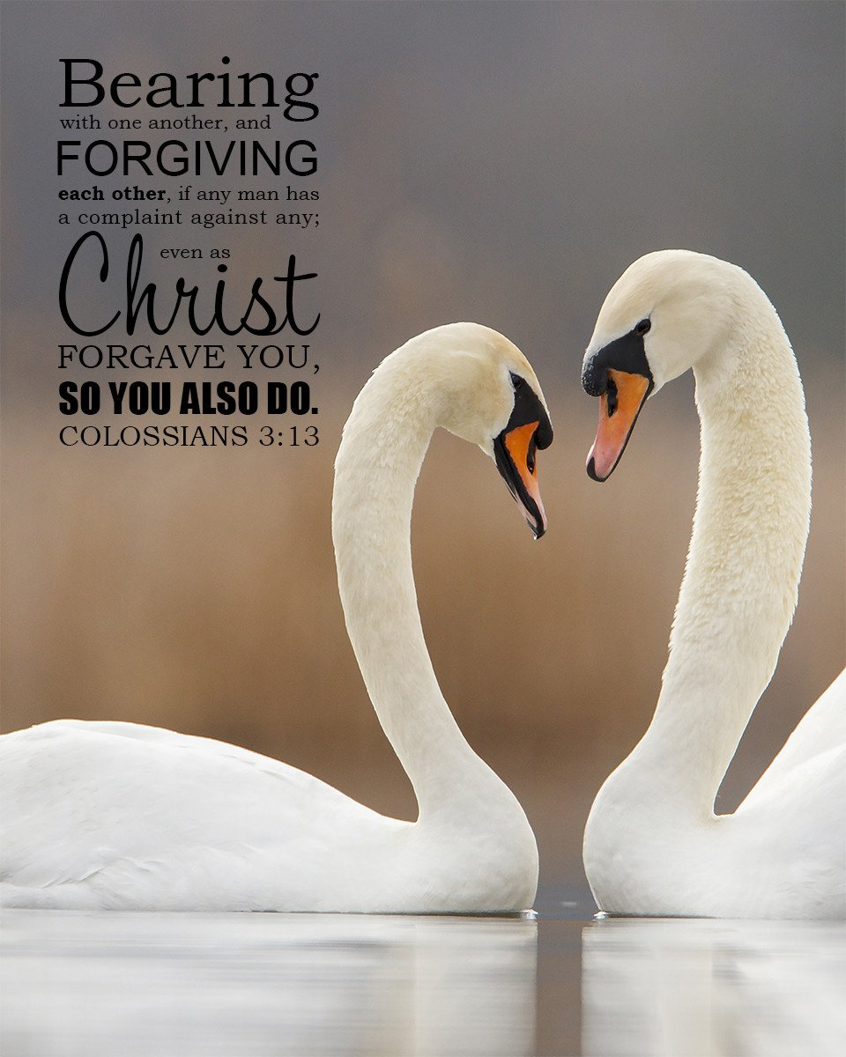

Wi-Fi password: salvation

Houston, J. M. (1988). Forgiveness. In Baker encyclopedia of the Bible (Vol. 1, p. 810). Grand Rapids, MI: Baker Book House.

