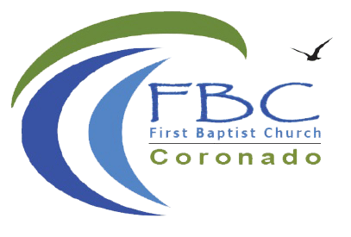

Reach Up, Reach Out, Reach Our World

445 C Ave
Coronado, CA 92118
(619) 435-6588
fbcoronado.com
Jim W. Baize, Pastor
Julie Burkhart, Secretary, Childcare Coordinator
Fitz Lee, Treasurer
Cathy Joy, Children’s Ministry
Rachel Gorken, Ladies’ Ministry
Dan Malcolm, Men’s Ministry/VIP Ministry
Monica Medina, Convalescent Ministry
Julie Ziegler, Fellowship Ministry
Sheerah Haywood, Worship Ministry
Bobby Greer, Maintenance
Our mission is to produce fully devoted followers of Jesus Christ. If we can be of any help to you, feel free to give us a call.

If you wish to serve in a ministry, we are looking for YOU!

First Baptist Church
Coronado

“Places You DON’T

Want to Be!” Part Two

Pastor Jim W. Baize

July 28, 2019

“SEVEN WAYS TO PREPARE FOR THE SERMON”

Uh, that’s MY job as a pastor, right? But what if YOU made time each week to prepare for the Sunday sermon? I read an article months ago where a preacher, Thom Rainer, proposes that very idea. With a few modifications, here is what YOU can do:

1. Pray for the sermon. Ask God to use it for His glory.

2. Pray for the Pastor. Ask God to guide him in his preparation and preaching.

3. Pray to have “ears to hear” what God is saying to you in the sermon.

4. Read the Biblical text with the Pastor. BRING YOUR BIBLES. Yes, electronic Bibles count! But read the text and ask God to use it for the duration of the message.

5. Take notes. That’s why we put them in the bulletin. If you reinforce what you hear by writing it down, you will retain it much better. You will have better focus during the preaching and you can review your notes later in the week.

6. Seek the application for your life. It always amazes me that God can meet a variety of peoples’ needs with one message! The applications can be different, but effective. With every verse there should be interpretation, illustration, and application.

7. If possible, share with your Pastor the main take-away you had from his message. That encourages him!

The preaching of God’s Word is central to the life of the church. It makes sense that pastors should give it the highest priority – and I do! But doesn’t it also make sense that church members should prepare as well?

May God bless us all today and all week long!

Your Pastor, Jim W. Baize

This Week at FBC Coronado:

Saturday
Grace Yoga with Cindy Sanger 8:30 a.m.

Upcoming:
Sunday, August 4th Communion Sunday
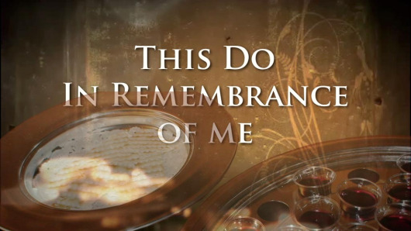

Saturday, August 10th Men’s Breakfast & Study 8:00 a.m.
Arrive at 7:00 if you would like to help set-up and cook!
All men welcome, bring a friend.

Verse of the Week:
Psalm 119:11
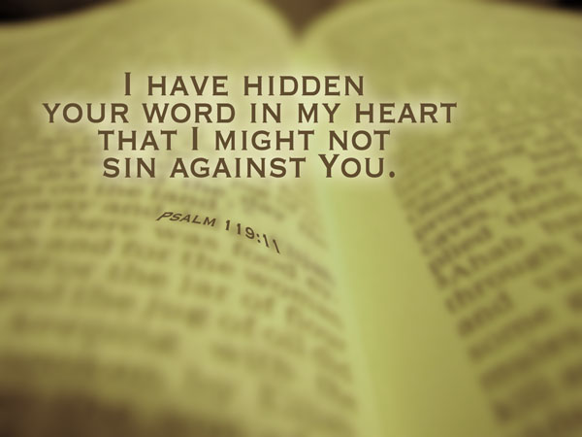

Have you misplaced something?? Please check the lost and found bins located near the Ladies’ Rest Room. All items will soon be donated to The Rescue Mission.

