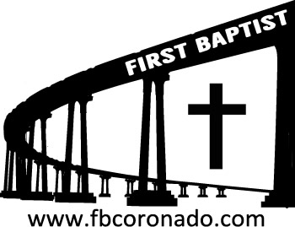

Reach Up, Reach Out, Reach Our World
445 C Avenue
Coronado, CA 92118
(619) 435-6588
fbcoronado.com
Jim W. Baize, Pastor
Julie Burkhart, Secretary, Childcare Coordinator
Patsy Lower, Treasurer
Laura Stecher, Children’s Ministry
Dan Malcolm, Men’s Ministry/VIP Ministry
Cindy Wilson, Women’s Ministry
Monica Medina, Convalescent Ministry
Sheerah Haywood, Worship Ministry
Bobby Greer, Maintenance
Our mission is to produce fully devoted followers
of Jesus Christ. If we can be of any help to you,
feel free to give us a call.

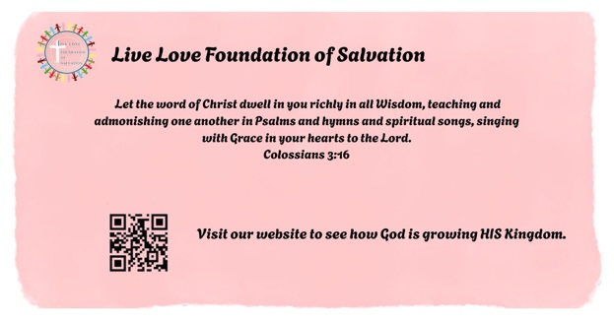

First Baptist Church
of Coronado

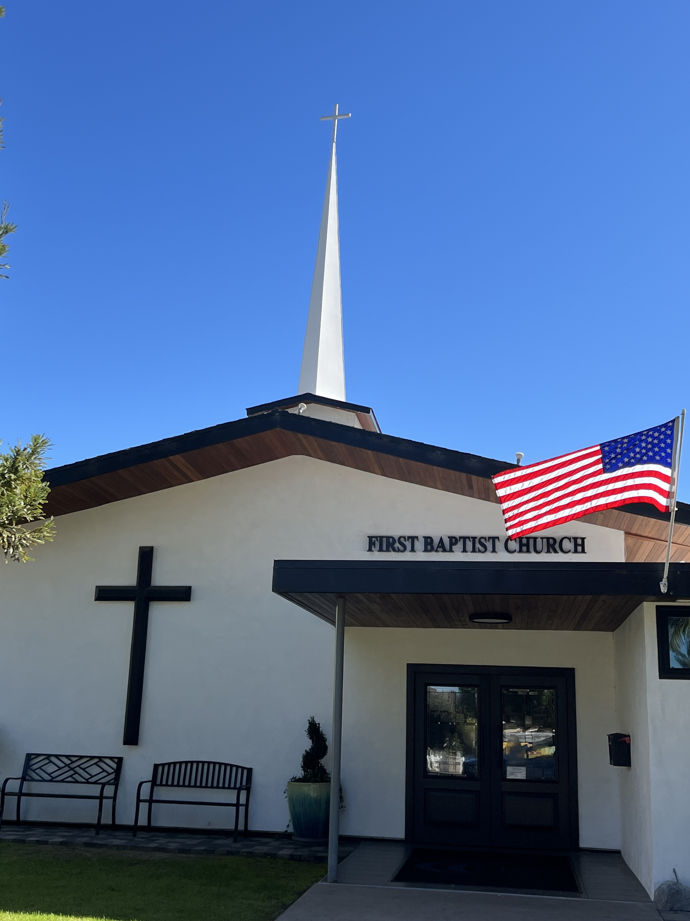

A NEGLECTED BIBLE THEME:
SANCTIFICATION
Pastor Jim W. Baize
October 25, 2026

LET’S BE BAPTICOSTAL!

I am a Baptist. I believe in our Baptist “Faith and Practice” statement of faith because it is biblical! I am not onboard with some of what goes on in some Pentecostal churches. I do not agree with the “prosperity gospel.” God will not be obligated to make you wealthy if you tithe to a church, a preacher, or some worthy cause. I don’t think what happens in our modern tongues movement is what the apostles experienced on Pentecost. I believe in Divine healing but not in divine healers (other than God!) I believe the pastoral ministry is a calling for men of God whom He has chosen and set-apart for the purpose of preaching the Gospel.

But I believe in being filled with the Holy Spirit! I believe in being sanctified by the Father, Son, and Holy Spirit. I also believe we should seek to be filled by His Spirit by offering ourselves as living sacrifices, HOLY and acceptable unto God (Romans 12:1).

Too many Baptists are satisfied with the status quo. They relax in their eternal security and are happy with their salvation by grace without works. We forget we are in an on-going project of becoming more like Jesus!

I believe in eternal security and that salvation is by grace through faith...BUT...where is our holiness? Our purity? Our separation from evil? Our dedication to God?

Sanctification is a process. How are we doing? Let’s get a little more Pentecostal in our quest for holiness while clinging to our Baptist doctrine!

Let’s be Bapticostal!

Welcome to First Baptist Church of Coronado!

Adult Sunday School 8:45
Worship Service 10:00
Children’s Sunday School 10:15
Ladies’ Christmas Tea meeting 11:15

Bible Studies This Week

Tuesday
Oaks Int. Military Bible Study
6-8 p.m. Childcare provided

Wednesday
Women’s BSF 10:00-11:30
Childcare provided

Thursday
Women’s Bible Study 10:30-Noon

Saturday
Men’s Coffee & Bible Study
Grounds & Grace
Brothers in the Word helping iron sharpen iron.
Invite a friend.

Candy Needed!
FBCC’s 8th Annual Fall Outreach is Halloween from 4-9 pm and we are collecting candy! Lots of candy! If you are able, please bring candy to the church office.

Samaritan’s Purse Operation Christmas Child
Shoe boxes are available to take home and fill with suggested items. If you have questions about this project, contact Monica Medina. Help us spread the love of Jesus this Christmas!

Ladies’ Christmas Tea
FBC’s annual Ladies’ Christmas Tea will be held Friday, December 11th from 5-8 pm. Tickets are $20 and will go on sale Sunday, November 1st. There will be a meeting following the worship service today for all ladies interested regarding general information and volunteer needs – table hostesses, ticket sales, menu and event setup.
There will be a meeting on Saturday, November 7th following the Men’s Breakfast for all men interested in volunteering. We need 16 servers and 6 food prep men!

