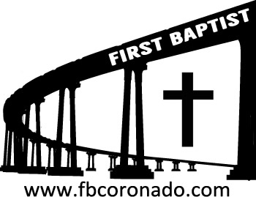

Reach Up, Reach Out, Reach Our World
445 C Avenue
Coronado, CA 92118
(619) 435-6588
fbcoronado.com
Jim W. Baize, Pastor
Julie Burkhart, Secretary, Childcare Coordinator
Patsy Lower, Treasurer
Laura Stecher, Children’s Ministry
Dan Malcolm, Men’s Ministry/VIP Ministry
Cindy Wilson, Women’s Ministry
Monica Medina, Convalescent Ministry
Sheerah Haywood, Worship Ministry
Bobby Greer, Maintenance
Our mission is to produce fully devoted followers
of Jesus Christ. If we can be of any help to you,
feel free to give us a call.

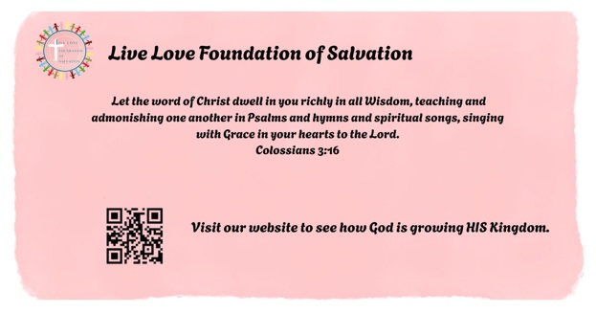

First Baptist Church
of Coronado

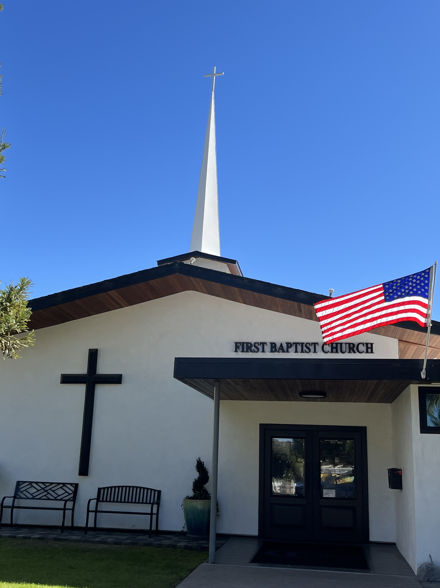

BORN ONCE, DIE TWICE!
BORN TWICE, DIE ONCE!
Pastor Jim W. Baize
October 18, 2026

BRAZEN SERPENTS!

“And the LORD said unto Moses, Make thee a fiery serpent, and set it upon a pole: and it shall come to pass, that every one that is bitten, when he looks upon it, shall live.” (Numbers 21:8)
This might seem an incredible story, but it was confirmed by none other than the Lord Jesus Himself: “As Moses lifted up the serpent in the wilderness, even so must the Son of man be lifted up: That whosoever believes in him should not perish, but have eternal life” (John 3:14-15).
A plague of poisonous snakes had infested the camp of Israel, sent as a divine judgment because of their complaints and ingratitude, and many people had died. When they confessed their sin and Moses prayed for their deliverance, God in His grace prescribed this unique remedy.
There is, of course, no naturalistic process that can heal a deadly snakebite merely by a look. Neither, of course, is there a naturalistic explanation for the salvation of a sin-poisoned soul merely by looking with faith upon the crucified Son of man. Both are mighty miracles, with the first being beautifully designed by God to be a prophetic foreshadowing of the other.
The symbolism is striking. The brass serpent impaled on the pole represented the poisonous serpents slain, but it also spoke of “that old serpent, which is the Devil, and Satan,” eventually cast forever into the lake of fire (Revelation 20:2, 10). Thus, it also symbolized the judgment on sin itself and its final banishment from God’s creation.
All of this, however, was only the symbol. The real deliverance required Christ to be made “sin for us, who knew no sin; that we might be made the righteousness of God in him” (2 Corinthians 5:21). The Son of man must be lifted up on the cross, and then all who see Him, and believe, receive life instead of death. HMM.ICR. 7.25.22

Welcome to First Baptist Church of Coronado!

Adult Sunday School 8:45
Worship Service 10:00
Children’s Sunday School 10:15

Bible Studies This Week

Tuesday
Oaks Int. Military Bible Study
6-8 p.m. Childcare provided

Wednesday
Women’s BSF 10:00-11:30
Childcare provided

Thursday
Women’s Bible Study 10:30-Noon

Saturday
Men’s Coffee & Bible Study
Grounds & Grace
Brothers in the Word helping iron sharpen iron.
Invite a friend.

Candy Needed!
FBCC’s 8th Annual Fall Outreach is Halloween from 4-9 pm and we are collecting candy! Lots of candy! If you are able, please bring candy to the church office. If you are interested in volunteering your time for this event a sign-up sheet will be circulated Sunday mornings.

Samaritan’s Purse Operation Christmas Child
Shoe boxes are available to take home and fill with suggested items. If you have questions about this project, contact Monica Medina. Help us spread the love of Jesus this Christmas!

