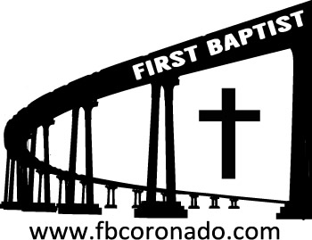

Reach Up, Reach Out, Reach Our World
445 C Avenue
Coronado, CA 92118
(619) 435-6588
fbcoronado.com
Jim W. Baize, Pastor
Julie Burkhart, Secretary, Childcare Coordinator
Patsy Lower, Treasurer
Laura Stecher, Children’s Ministry
David Preston, Youth Ministry
Dan Malcolm, Men’s Ministry/VIP Ministry
Cindy Wilson, Women’s Ministry
Monica Medina, Convalescent Ministry
Sheerah Haywood, Worship Ministry
Bobby Greer, Maintenance
Our mission is to produce fully devoted followers
of Jesus Christ. If we can be of any help to you,
feel free to give us a call.

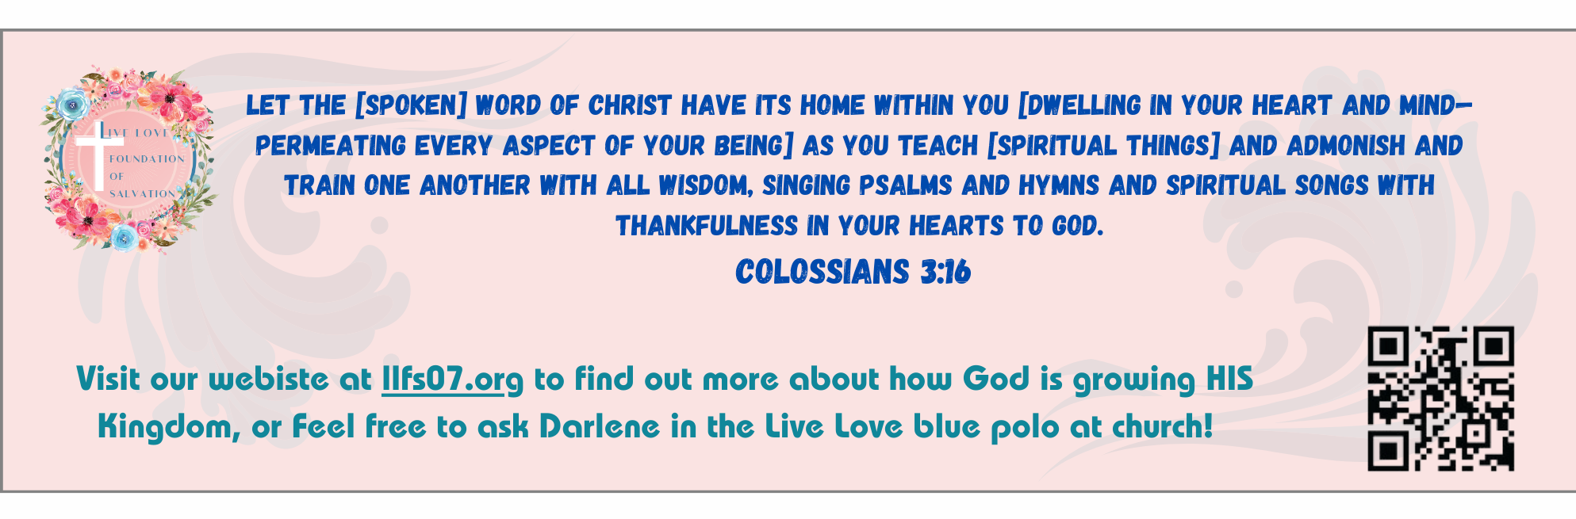
First Baptist Church
of Coronado

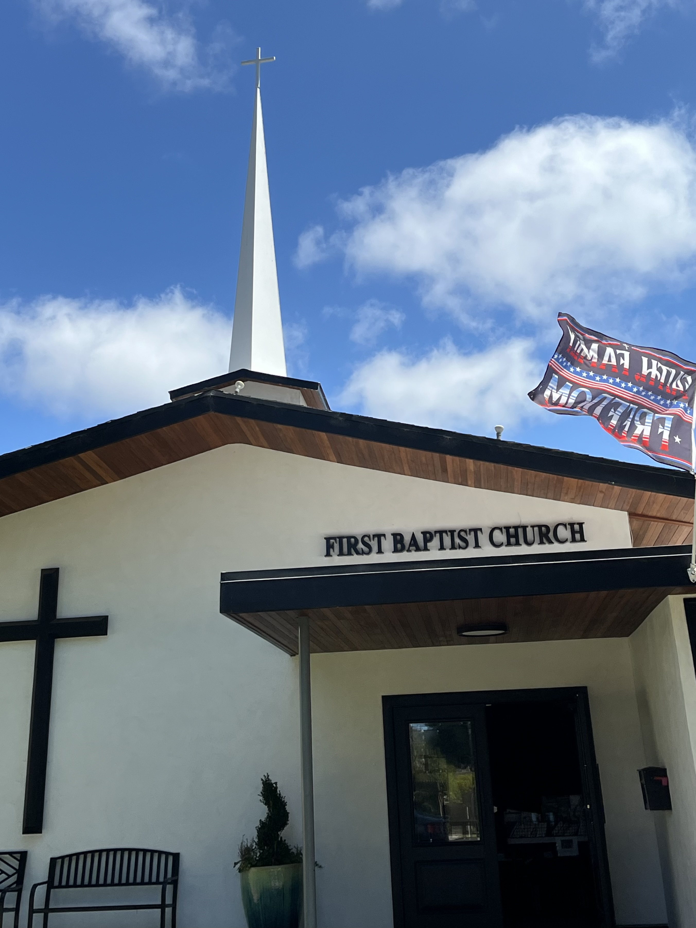

The Storms of Life
Pastor Jim W. Baize
December 7, 2025

THE END OF THE ACTS!

Do you realize we spent most of ten months on the book of the Acts of the Apostles in 2025! Only occasionally did we break away from that schedule for a message not out of the Acts.

I hope it has been a profitable series for you. I have learned a lot over the last year. Some of it was a review of things I had learned before, but a significant amount of it was things I had never preached or heard preached prior to this series.

I think my biggest take-away from Acts is that we are to remain faithful to Christ and the Gospel, no matter the circumstances. That is what the early disciples did. That is what persecuted Christians have done down through the ages (and are doing now in some countries!) That is what we are to do today!

For the rest of December, we will be in Christmas mode. In January we will focus on a spiritual tune-up. Then, beginning in February, I am planning on preaching a series on “Major Bible Themes.”

2025 was an expository study; 2026 will be a topical/expository study of the important doctrines found in the Word of God.

May God bless us richly now and into the new year!

Welcome to First Baptist Church of Coronado!

Adult Sunday School 8:45
Worship Service 10:00
Children’s Sunday School 10:15
Active-Duty Military Lunch 11:30

Bible Studies This Week

Tuesday
Oaks Int. Military Bible Study at FBCC
6-8 p.m.
Childcare provided

Wednesday
Ladies’ Bible Study Fellowship at FBCC 10:00
Childcare provided

Thursday
Ladies’ Bible Study at FBCC 10:30

Saturday
Men’s Coffee Club 8:00
Coffee, fellowship, and prayer

Join us for our Christmas Eve Candlelight Service 5-6 pm
Childcare will be provided
Make sure to take home some invitations to give to family, friends and neighbors

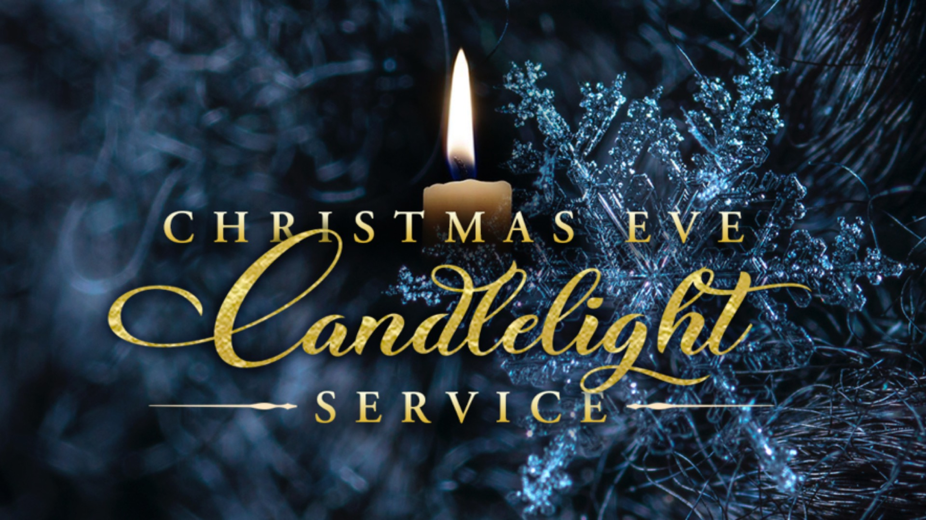

Interested in a serving opportunity at FBCC? We are looking for a few people to help provide meals to our Active-Duty military personnel after the worship service on Sundays. You don’t have to cook! Food can be ordered whether it be pizzas, sandwiches, burritos etc. All expenses will be reimbursed. If you are interested in helping once a month, please see Julie Burkhart for full details!

