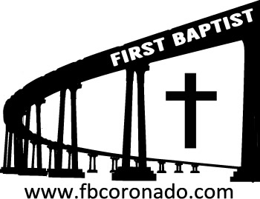

Reach Up, Reach Out, Reach Our World
445 C Avenue
Coronado, CA 92118
(619) 435-6588
fbcoronado.com
Jim W. Baize, Pastor
Julie Burkhart, Secretary, Childcare Coordinator
Patsy Lower, Treasurer
Laura Stecher, Children’s Ministry
David Preston, Youth Ministry
Dan Malcolm, Men’s Ministry/VIP Ministry
Cindy Wilson, Women’s Ministry
Monica Medina, Convalescent Ministry
Sheerah Haywood, Worship Ministry
Bobby Greer, Maintenance
Our mission is to produce fully devoted followers
of Jesus Christ. If we can be of any help to you,
feel free to give us a call.

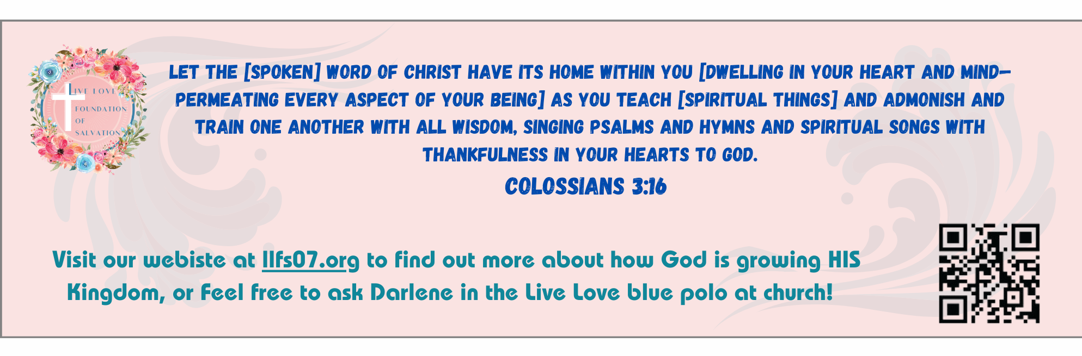

First Baptist Church
of Coronado



“The Storms of Life”
Pastor Jim W. Baize
January 28, 2025

THE HAPPIEST TIME OF THE YEAR, REALLY?
(Tips to avoid holiday depression.)

Contrary to popular thought, the holidays can be very sad for a lot of people for a lot of reasons. Here are some things we can do to mitigate holiday depression:

1. Lower your expectations. Holidays are not magic.
2. Limit the time you spend with difficult people. We are to love everyone, but we don’t have to spend too much time with people who drag us down.
3. Don’t spend money you don’t have! (Too late?)
4. Adopt a family to help during this time. Find someone who is having a rough time. Be a blessing to them.
5. Give yourself away. Do volunteer work somewhere. Feed the hungry. Work at a mission. Take warm clothes to the homeless.
6. Be sure to get good rest. Don’t over schedule your calendar.
7. Don’t drink alcohol or take drugs! They are not solutions; they often cause other problems.
8. Avoid too many sweets. (I know…)
9. Be careful of places you don’t need to be. The world and its sins will not help.
10. Spend time with God! Be in His Word. Attend a gospel-preaching church. Celebrate with other believers!

Holiday stresses don’t have to get us down. Follow the above guidelines and “…the peace of God, which passes all understanding, shall keep your hearts and minds through Christ Jesus…and the God of peace shall be with you. Phil 4:7, 9

Have a blessed New Year!

Welcome to First Baptist Church of Coronado!

Adult Sunday School 8:45
Worship Service 10:00
Children’s Sunday School 10:15

Bible Studies This Week

Tuesday
Oaks Int. Military Bible Study at FBCC
6-8 p.m.
On break until January 13th, 2026

Wednesday
Ladies’ Bible Study Fellowship at FBCC 10:00
On break until January 14th, 2026

Thursday
Ladies’ Bible Study at FBCC 10:30
On break until January 8th, 2026

Saturday
Men’s Breakfast Club 8:00
Coffee, fellowship, and prayer

Men’s Breakfast Saturday
Saturday, January 3rd 8:00
Great food and fellowship!
Invite a friend



