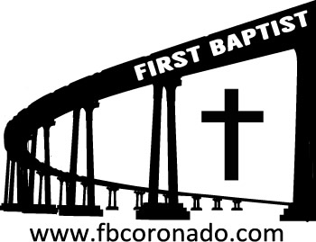

Reach Up, Reach Out, Reach Our World
445 C Avenue
Coronado, CA 92118
(619) 435-6588
fbcoronado.com
Jim W. Baize, Pastor
Julie Burkhart, Secretary, Childcare Coordinator
Patsy Lower, Treasurer
Laura Stecher, Children’s Ministry
David Preston, Youth Ministry
Dan Malcolm, Men’s Ministry/VIP Ministry
Cindy Wilson, Women’s Ministry
Monica Medina, Convalescent Ministry
Sheerah Haywood, Worship Ministry
Bobby Greer, Maintenance
Our mission is to produce fully devoted followers
of Jesus Christ. If we can be of any help to you,
feel free to give us a call.

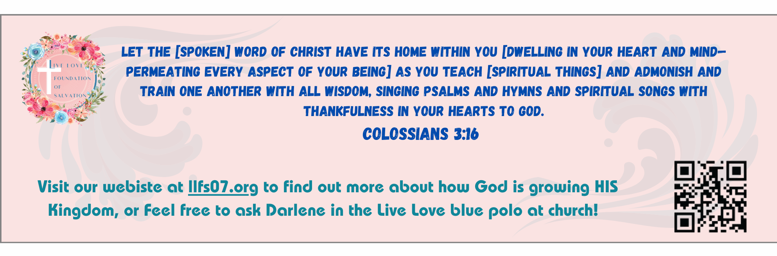

FOR OUR VETERANS…

Borrowed:

I HAVE DONE THINGS
THAT HAUNT ME AT NIGHT
SO YOU CAN SLEEP IN PEACE.

I HAVE BEEN AWAY
FROM MY FAMILY A LONG TIME
SO THAT YOURS CAN BE SAFE.

I HAVE SACRIFICED
A LOT IN MY LIFE
SO THAT YOU MAY LIVE FREE.

I HAVE DONE THESE THINGS
BECAUSE I HAVE SWORN AN OATH
TO MY COUNTRY.

AND I WILL LIVE BY THIS OATH
UNTIL THE DAY I DIE
BECAUSE I AM AND ALWAYS WILL BE…

A U.S. VETERAN!

Pat and I are honored to have known so many patriotic and devoted military personnel in our 50+ years of ministry in Imperial Beach, San Diego, and Coronado!

Thank you all for paying such a high price.

John 15:13 Greater love has no one than this, than to lay down one’s life for his friends.

Welcome to First Baptist Church of Coronado!

Adult Sunday School 8:45
Worship Service 10:00
Windsurfers Youth Group 10:00
Children’s Sunday School 10:15
Active-Duty Military Lunch 11:30

Bible Studies This Week

Tuesday
Oaks Int. Military Bible Study at FBCC
6-8 p.m.
Childcare provided

Wednesday
Ladies’ Bible Study Fellowship at FBCC 10:00
Childcare provided

Thursday
Ladies’ Bible Study at FBCC 10:30

Saturday
Men’s Coffee Club 8:00
Coffee, fellowship, and prayer

Upcoming

Samaritan’s Purse Operation Christmas Child
Please return your boxes as soon as possible. Also, please DO NOT tape boxes shut because they must be inspected. Boxes can be closed with rubber bands or yarn. If you would like another box text Monica Medina @ 619-547-5018.

