

Reach Up, Reach Out, Reach Our World
445 C Avenue
Coronado, CA 92118
(619) 435-6588
fbcoronado.com
Jim W. Baize, Pastor
Julie Burkhart, Secretary, Childcare Coordinator
Patsy Lower, Treasurer
Laura Stecher, Children’s Ministry
David Preston, Youth Ministry
Dan Malcolm, Men’s Ministry/VIP Ministry
Cindy Wilson, Women’s Ministry
Monica Medina, Convalescent Ministry
Sheerah Haywood, Worship Ministry
Bobby Greer, Maintenance
Our mission is to produce fully devoted followers
of Jesus Christ. If we can be of any help to you,
feel free to give us a call.

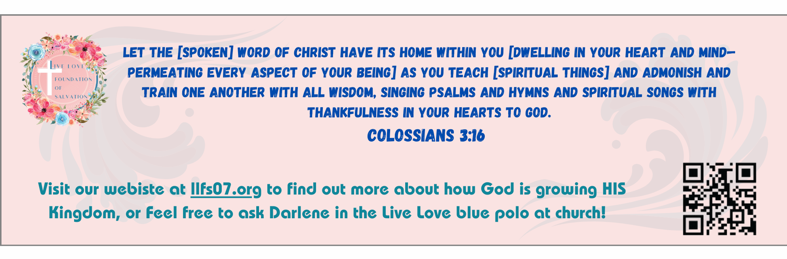

FROM A BABE IN THE MANGER, TO THE SON OF MAN…

“And I looked, and behold a white cloud, and upon the cloud one sat like unto the Son of man, having on his head a golden crown, and in his hand a sharp sickle.” (Revelation 14:14)
This is the last of some 87 New Testament references (84 in the four gospels, one in Acts, none in the epistles, two in Revelation) to Christ as the Son of man. Here we see the Son of man coming on a white cloud from heaven (just as He had ascended into heaven after His resurrection) as the conquering King of all the earth.
What a contrast this is to the first New Testament reference to the Son of man. “The foxes have holes, and the birds of the air have nests; but the Son of man hath not where to lay his head” (Matthew 8:20). From humility and poverty on Earth to power and riches in heaven, and for all eternity—this was His journey when Christ left His heavenly glory to join the human family.
In between the poverty and the power lay the whole human experience, for He “was in all points tempted like as we are, yet without sin” (Hebrews 4:15). Finally, as Son of man He must die for man’s sin, for “the Son of man must be delivered into the hands of sinful men, and be crucified, and the third day rise again” (Luke 24:7). Even in heaven He is still the Son of man, for Stephen saw Him thus: “Behold, I see the heavens opened, and the Son of man standing on the right hand of God” (Acts 7:56).
There is, indeed, a great man in the glory! Christ called Himself “the Son of man” much more often than “the Son of God,” though He will eternally be both – the God/man. He delights to identify with those whom He has redeemed, for He “is not ashamed to call them brethren” (Hebrews 2:11). “Whom do men say that I the Son of man am?” asked Jesus. Then we say with Peter, “Thou art...the Son of the living God” (Matthew 16:13, 16). HMM. ICR. 7.14.23

Welcome to First Baptist Church of Coronado!
Felix, Festus, & Agrippa
Pastor Jim W. Baize
November 30, 2025

Adult Sunday School 8:45
Worship Service 10:00
Children’s Sunday School 10:15
Active-Duty Military Lunch 11:30

Bible Studies This Week

Tuesday
Oaks Int. Military Bible Study at FBCC
6-8 p.m.
Childcare provided

Wednesday
Ladies’ Bible Study Fellowship at FBCC 10:00
Childcare provided

Thursday
Ladies’ Bible Study at FBCC 10:30

Saturday
Men’s Coffee Club 8:00
Coffee, fellowship, and prayer

Christmas Eve/Christmas Sunday Service
Christmas is right around the corner! We have designed beautiful invitations for Christmas Sunday service on 12/21/25 and Christmas Eve Candlelight service on 12/24/25. These will be ready for you to take on Sunday, November 30th to distribute to family, friends and neighbors.

